The relationship between the formation of clouds and relative humidity
MEI-WEN WU、YI-HSUAN HSU、 CHIA-LING HSU、YUNG-HSIN HSIAO
Summary
Observation if there have relation between clouds cover and relative humidity? We use Taiwanese National Miaoli Senior High School globe’s observational data, make the ADC map of cloud cover and relative humidity . In addition, we use the GLOBE Web site observe whether clouds cover have relationship with the relative humidity ? We use Taiwan's Miaoli school globe observations to do cloud cover and relative humidity correlation coefficient map , in addition to the correlation coefficient Figure 4 other countries .Besides,we choose the cloud cover and relative humidity’s data of other country on the globe website ,and do its ADC map to deserve weather it have absolutely positive relation
Besides,we choose the cloud cover and relative humidity’s data of other country on the globe website ,and do its AOD map to deserve weather it have absolutely positive relation
Research questions
- What factors will influence the formation of clouds?
- The amount of cloud cover and whether the relationship between the relative humidity?
- With the same humidity, do the temperature would affect the amount of cloud cover?
Assume
1.On this study , we assume that the atmospheric relative humidity will affect cloud formation , then do the next step of verification .
2.Suppose the temperature will affect the relative humidity and cloud
Research process or method
First, after the Integration of data on the Internet, we find what factors influence the formation of clouds species
Second, compared to the correlation coefficient map of the foreign cities ( Wellington, New Zealand , New York , Moscow, Russia , London, UK ) from. February to March in 2016 , and observe its relevance.
Third, then we find temperature and humidity coverage between 50% to 60% from our school'sGLOBE data , and use a chart to compare the association.
Fourth, we find the 2014 / 3 / 18-2014 / 12 / 3 air humidity and cloud coverage ( but still a few lake of data ) from Miaoli school GLOBE meteorological data , the use of these materials excel to make the correlation coefficient map.
Research facilities and equipment
- source
a.openweathermap
February 2016 to March screenshots (New Zealand, Moscow, New York and London), sorting out the related chart
b. Observations from Miaoli Senior High School GLOBE
Conclusion

The clouds cover range in picture | The clouds cover range
0％ | 0％
5％ | 0~10％
15％ | 10~25％
35％ | 25~50％
75％ | 50~90％
95％ | 90~100％
100％ | 100％

1. The cloud coverage in the same range's relative humidity , the amount of coverage increases , there tends to be improved.
2.Although the coverage is low, the relative humidity in many places is still more than 50 %, so we speculatell maybe because of the temperature of the day is relatively low , the relative humidity is high , and we found the same situation with Moscow 's chart , so we speculate the latitude of Moscow is higher than Taiwan .
3. When the relative humidity is above 70% , we find its cloud cover approximately 50-90% of the distribution of this range . 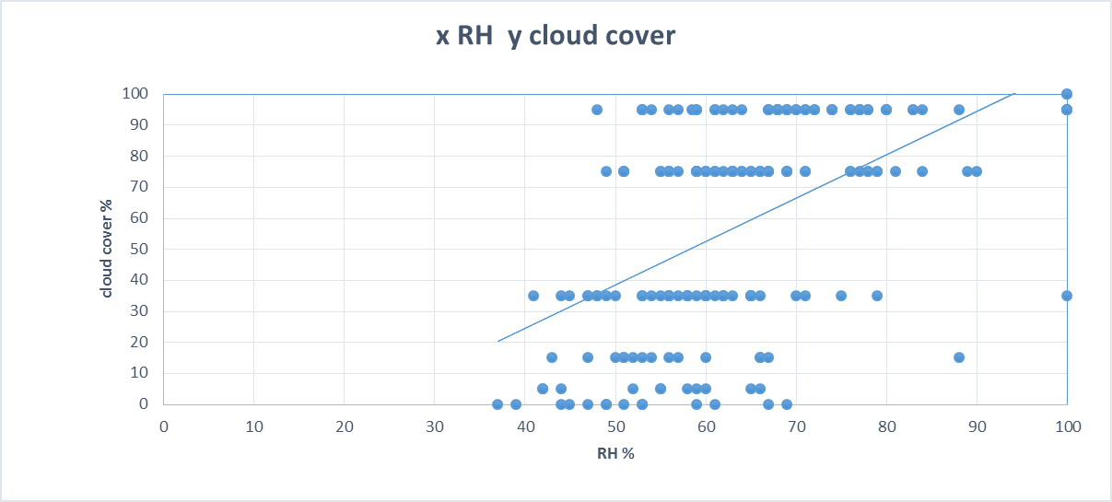
(The information from MLSH globe club)

＊Because of Wellington has higher humidity , we infer Wellington more cloudy. ( X RH Y clouds cover)

(The information from openweathermap)

＊Because of London has higher humidity ,we speculate London more rainy
( X RH Y clouds cover)
(The information from openweathermap)

＊Moscow humidity is very high, the amount of cloud cover is quite high
( X RH Y clouds cover)
(The information from openweathermap)

＊According to chart,we know that the cloud cover most between 50％~90％ in New York ( X RH Y clouds cover)

(The information from openweathermap )

＊This picture is in the same range of humidity (50% to 60%), the relationship between relative humidity and clouds cover. We found from the figure in the document data to the temperature of the atmosphere into a horizontal line (the temperature difference between the temperature of each table isn＇t differs greatly ), but the amount of cloud cover is presenting the state of ups and downs, great range of distribution.

Conclusion
1.From the pictures, there is no great difference between Taiwan and the four other regions to make the correlation coefficient map, so if look at the relative humidity and the amount of cloud cover and can not see the obvious correlation.
2.We can know that comparing Taiwan’s atmosphere with the other countries’ is belond to minister in area.
3.The figure shows that when it’s at the same humidity，temperature and the clouds cover is no absolute positive correlation，because the different data but the temperature is the same，the clouds cover is belong to different ranges.For example，in the March 26’s data and April 13’s data,their humidity are 59 percent,while the temperatures are just little gap,but the clouds cover is respectively in the range of 0% and 75%,a very the obvious difference,so we deduce if you look at the temperature and clouds cover is unable to determine the exact relationship.
4.From the above the cloud cover with the amount of relative humidity and temperature with humidity and cloud cover a small amount of these two conclusions, we hypothesized that if only looking at a single temperature or relative humidity, and can not see that they have very definitely on cloud formation relationship. However, if the above research data to be combined with a number of factors into cloud formation were discussed, there may be a different conclusion is observed absolute correlation

Instrument limit
1.As a result of the hygrometer’s limit in Miaoli senior High Schoolvcan not be measured in hygrometer to 100%, so when it rains, it will visually write humidity is 100%.
2.Owing to the amount of cloud cover is a range, and the range is quite extensive, and is visually, and likely to have errors.

Quote
＊The information from openweathermap
＊Observations from Miaoli Senior High School GLOBE
Division of work
MEI-WEN WU ：Charting
YI-HSUAN HSU ：Document Making
CHIA-LING HSU ：Translation
YUNG-HSIN HSIAO：Production PPT
Influences
Through the web science fair, let us answer the doubt in his heart, but still there are many unknown things waiting for us to discover, to find, to understand the secret, hoping to pioneer by our guide as we make more Miaoli more high school students to become interested in science fairs.

Foreign data
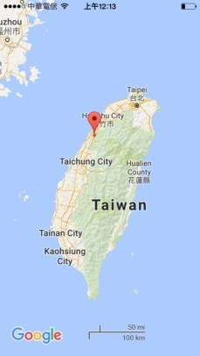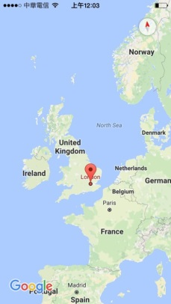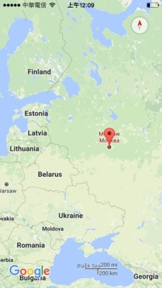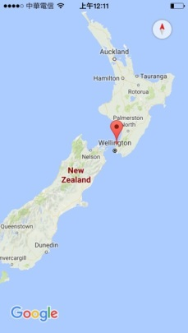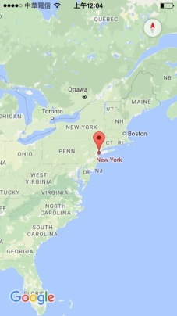
The pictures sequentially is Miaoli Taiwan、London UK、Moscow Russia、Wellington New Zealand、New York USA.

