**NOTRE DAME SCHOOL**

Science Fair 2018/2019

**Human Activity and the Quality of Water of the Ozama River**

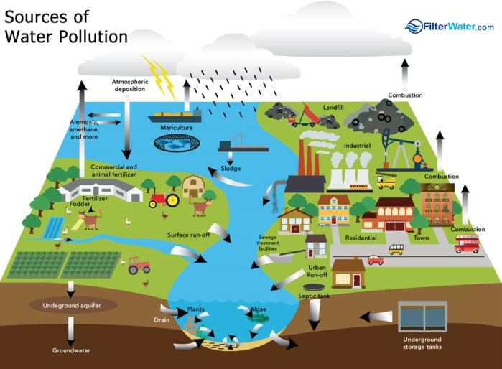

Members:

Alejandro Alba Velázquez

Ian Slaiman

Kevin De Oleo Fat

Miguel Ángel Velázquez,

Grade/Section: 6th A

Teacher: Laura Peña

Santo Domingo, 2019.

**Table of Contents**

**Content Page #**

Introduction ---------------------------------------------------------------------------------- 3

Background Information ------------------------------------------------------------------- 3

Objective ------------------------------------------------------------------------------------- 4

Problem -------------------------------------------------------------------------------------- 4

Questions ------------------------------------------------------------------------------------- 4

Hypothesis ----------------------------------------------------------------------------------- 5

Variables ------------------------------------------------------------------------------------- 6

Materials -------------------------------------------------------------------------------------6-8

Procedure ------------------------------------------------------------------------------------8-11

Results ----------------------------------------------------------------------------------------11-19

Data Analysis --------------------------------------------------------------------------------19

Conclusion ----------------------------------------------------------------------------------- 20

Discussion ------------------------------------------------------------------------------------ 20

Future Research ------------------------------------------------------------------------------20

Acknowledgements -------------------------------------------------------------------------- 20

References ------------------------------------------------------------------------------------- 21

**Introduction**

Our water resources face a host of serious threats, all of which are caused primarily by human activity. They include sedimentation, pollution, climate change, deforestation, landscape changes, and urban growth.

One of the most serious threats to water resources is the degradation of ecosystems, which often takes place through changes to landscapes such as the clearance of forests, the conversion of natural landscapes to farmland, the growth of cities, the building of roads, and surface mining. Each type of change to a landscape will have its own specific impact, usually directly on natural ecosystems and directly or indirectly on water resources.

For this research, we investigated the Ozama River as an example. This experiment was done to see the quality of our river channels. We will compare the pollution from the beginning of the river to the end of the river. The knowledge that already exists about the topic is that some parts of the river might be more polluted than the other part. Some rivers are being polluted by humans with: Gas, petroleum, garbage and more .Our specific objective is to find out how human activities affect the quality of water in our river channels.

**Background Information**.

River pollution occurs when pollutants are not removed from effluent water and are discharged into the river. River water is a very important source of freshwater required to sustain life. We need a constant supply of fresh water for drinking, cooking and washing. Animals living near the river, as well as fishes and aquatic plants, also depend on clean river water.

When heavy rainfall occurs, pollutants accumulated within the boundaries of the catchment area may be washed into river channels. These pollutants include a variety of agrochemicals like fertilizers and insecticides.

Waste water containing cleaning detergents, grease and other pollutants like industrial waste may be discharged into the river channel through our drainage systems; Industrial waste may contain sulfur, thereby augmenting the acidity of the river water. Sometimes, rubbish (eg. plastic bags and bottles) are also washed into the river channel.

This are similar experiments and studies like:

* Which method is the most effective for treating water for chemicals, heavy metals and bacteria?
* What affects the rate of evaporation of water?
* The influence of a big factory beside of the rivers channel

**Definitions of Key Vocabulary**

* **PH**: in chemistry, pH (/piːˈeɪtʃ/) (potential of hydrogen) is a numeric scale used to specify the acidity or basicity of an aqueous solution.
* **PPM:** indicates the total dissolved solids (TDS) of a solution, i.e. the concentration of dissolved solid particles.
* **Turbidity:** is the cloudiness or haziness of a fluid caused by large numbers of individual particles that are generally invisible to the naked eye, similar to smoke in air. The measurement of turbidity is a key test of water quality.
* **Temperature:** is a physical quantity expressing hot and cold. Temperature is measured with a thermometer, historically calibrated in various temperature scales and units of measurement. The most commonly used scales are the Celsius scale, denoted in °C (informally, degrees centigrade), the Fahrenheit scale (°F), and the Kelvin scale
* **Ammonia:** is a compound of nitrogen and hydrogen with the formula NH3. The simplest nitrogen hydride, ammonia is a colorless gas with a characteristic pungent smell. It is a common nitrogenous waste, particularly among aquatic organisms, and it contributes significantly to the nutritional needs of terrestrial organisms by serving as a precursor to food and fertilizers.
* **Nitrate:** a salt or ester of nitric acid, containing the anion NO3− or the group —NO3. is a chemical compound that includes nitrogen and oxygen. Nitrates are used as fertilizers in agriculture.
* **Conductivity**: is a measurement of the ability of water to conduct an electrical current. Conductivity is measured in microsiemens per centimeter (symbolized as: μS/cm).

**Objective**

The purpose of this experiment is to find out how human activities affect the quality of water in our Ozama river channels.

**Problem**

Our experiment is important because with it we can help to create awareness in humans for the preservation and cleanliness of our Ozama River since we need water to be able to live.

Human beings have an impact on Ozama river ecosystems. A number of forces continue to seriously affect our natural water resources. Many of these are primarily the result of human actions and include ecosystem and landscape changes, sedimentation, pollution, over-abstraction and climate change. This makes the waters of our river polluted and cannot be used by humans in their daily tasks and for their consumption.

**Questions**

The questions that will guide our experiment are:

1. Is the water of the Ozama River good for consumption?

2. How contaminated is the water of the Ozama River?

3. How the human activities affect the Ozama River?

**Hypothesis**

The water sample taken upstream (where there is less human activity) will contain less pollutants compared to the water sample taken downstream.

**Variables**

The independent variable for this experiment is the location at which the water sample is taken. The dependent variable is the pH reading, turbidity, ammonia content and the nitrate content of the water sample.

This is determined using the pH meter, turbidity meter and the freshwater test kit (Ammonia and nitrate). The constant (control variables) are the amount of the water in each sample, and the river from which the samples are obtained.

**Materials**

The materials required for this science fair project are:

- 10 empty resealable bottles

- Transportation

- PH paper

- A turbidity meter

- A freshwater test kit (Ammonia and Nitrate)

- 1 marker pen

- Latex Gloves

- Big Bucket

**Procedure**

We will locate at Ozama river which originates from an unpopulated hill. We will ensure that downstream the river passes through, or near a town (ie: densely populated area) Then collect 5 samples of the river water upstream, Using an empty bottle to do this, and labeling it “upstream”.

We will collect 5 sample of the river water downstream. We are going to use and empty bottle to do this and label it “downstream”.

The 10 bottles of water are then tested for their acidity using the pH paper and their turbidity is also tested using the turbidity meter. The fresh water test kit will be used to test for the water’s ammonia and nitrate content. The results of the tests are going to be recorded in the table.

Upstream Ozama River

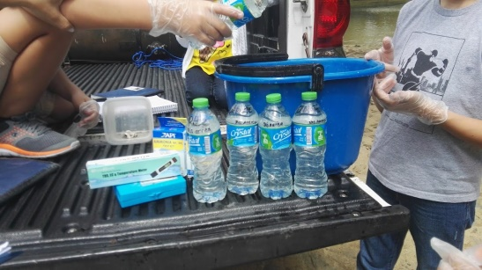 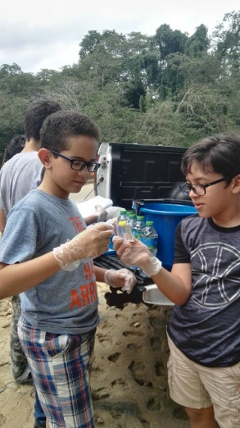 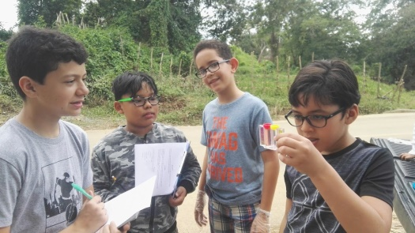

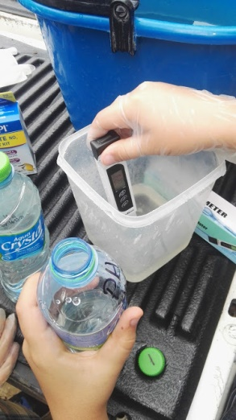 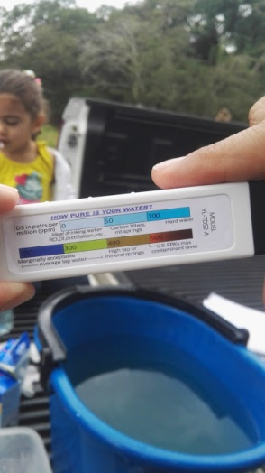 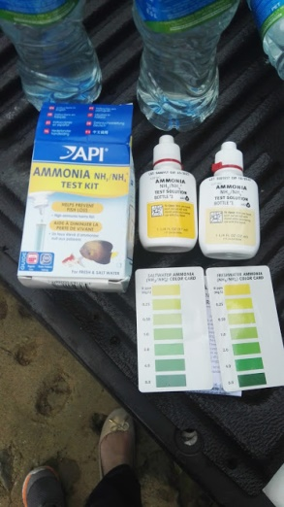 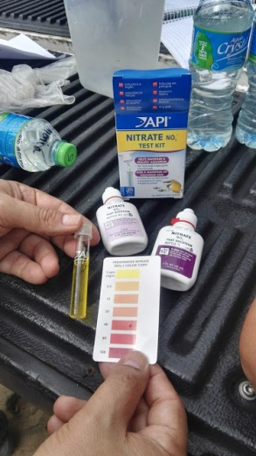

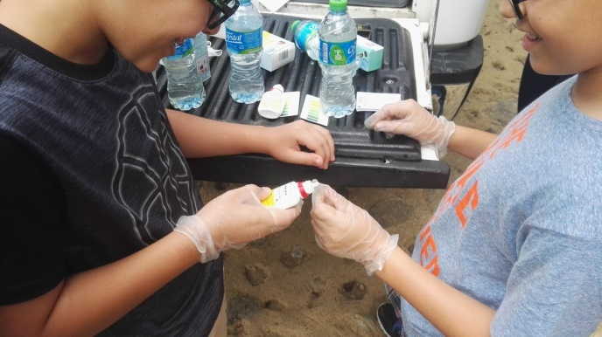 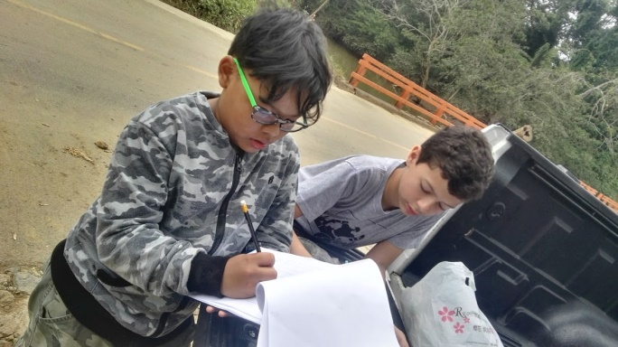

Downstream Ozama River

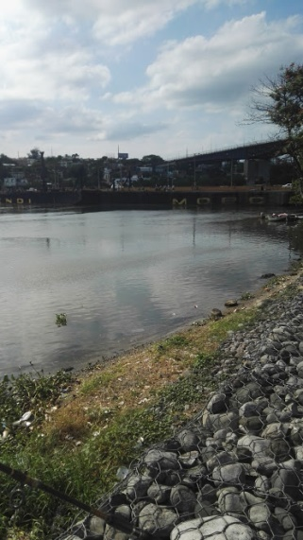 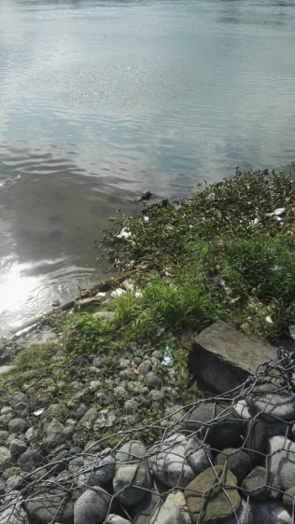 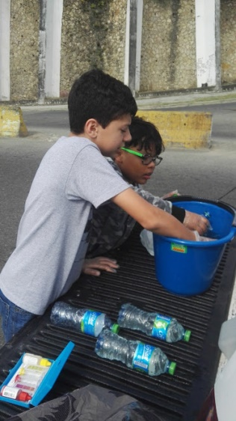 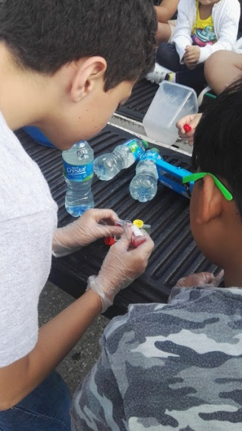

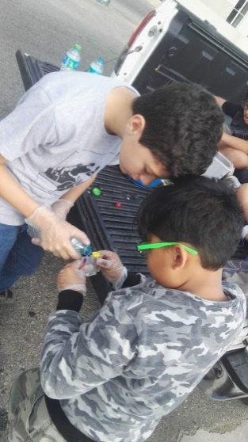 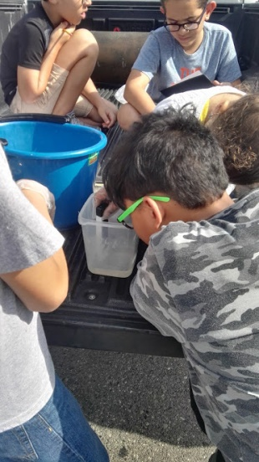 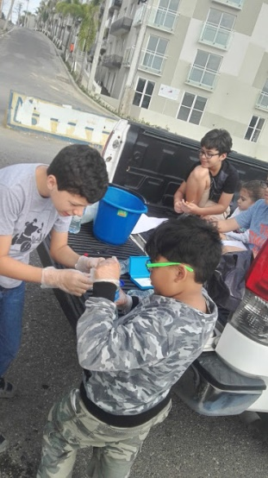 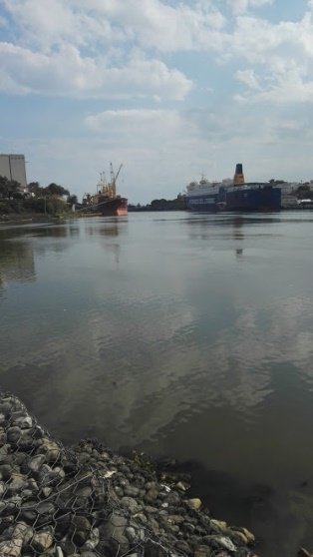

We used the GLOBE protocol on measuring water acidity (pH) to measure the alkalinity of water using our alkalinity test kit.

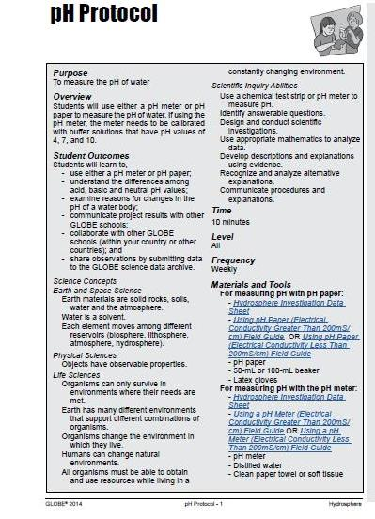

**Results**

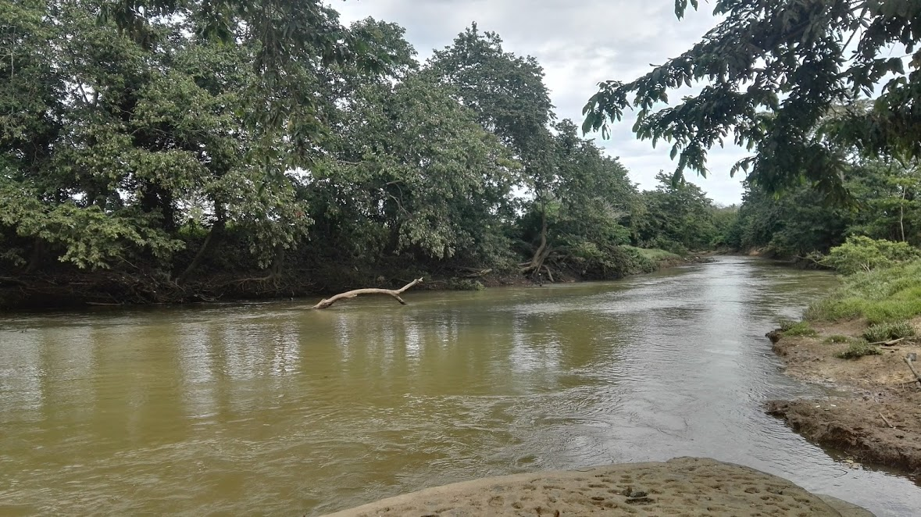 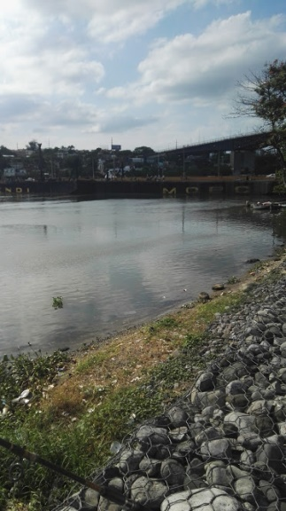

Ozama River Upstream Ozama River Upstream

Annex the results obtained from the different samples taken Upstream in the Ozama River:







Annex the results obtained from the different samples taken downstream in the Ozama River:







**Data Analysis**

The acidity of the downstream water samples is higher than that of the upstream water samples. The turbidity, ammonia content and PPM content of the downstream water samples are also higher.

We analyzed the conductivity of the water samples in the Agriculture Laboratory of Fertilizantes Químicos Dominicanos.

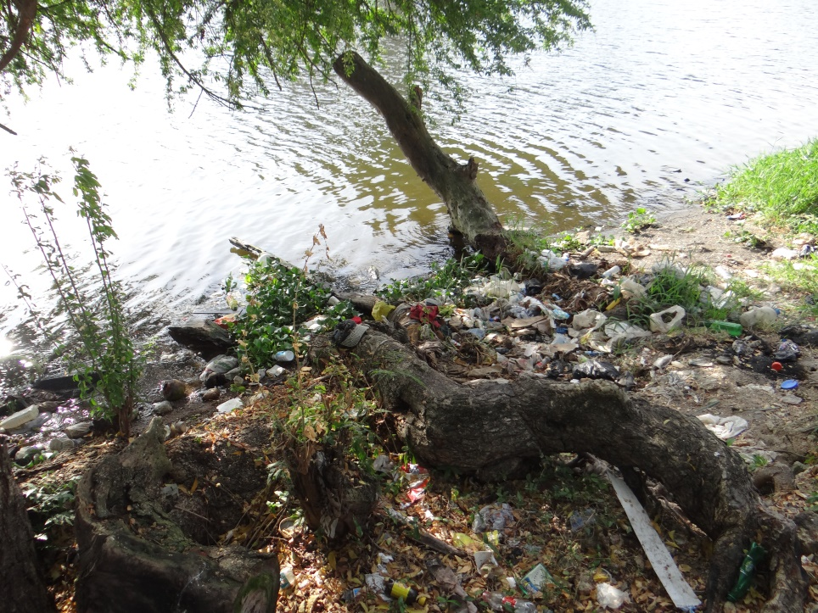

Trash in upstream Ozama River

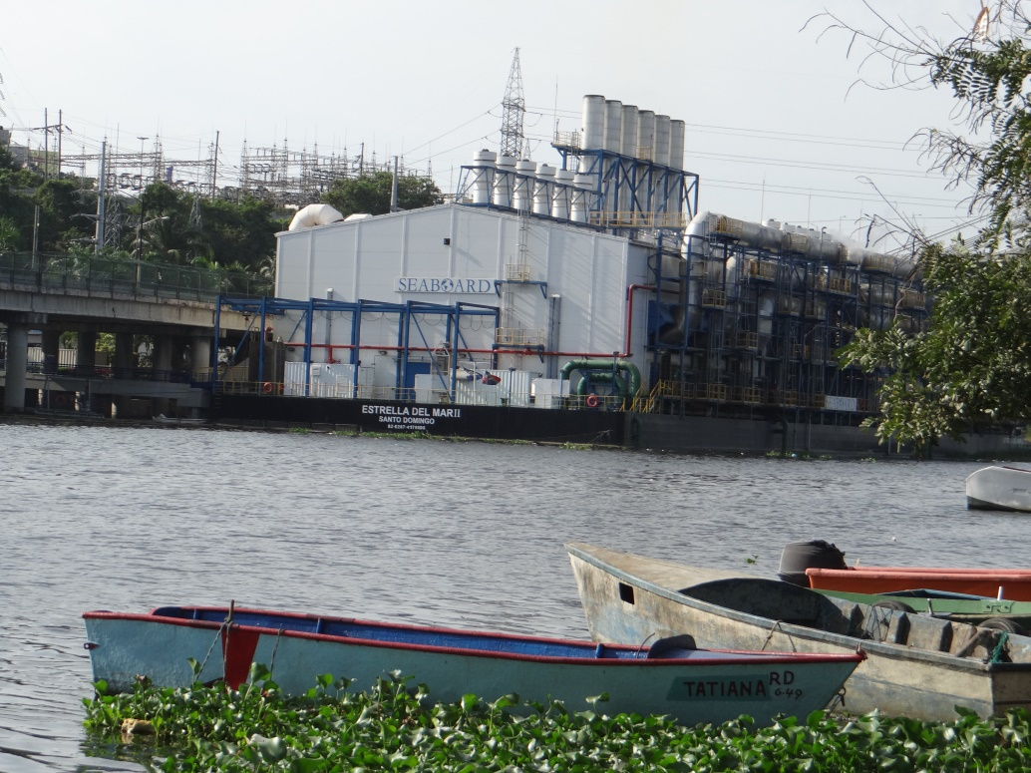

Industrial activities at downstream Ozama River

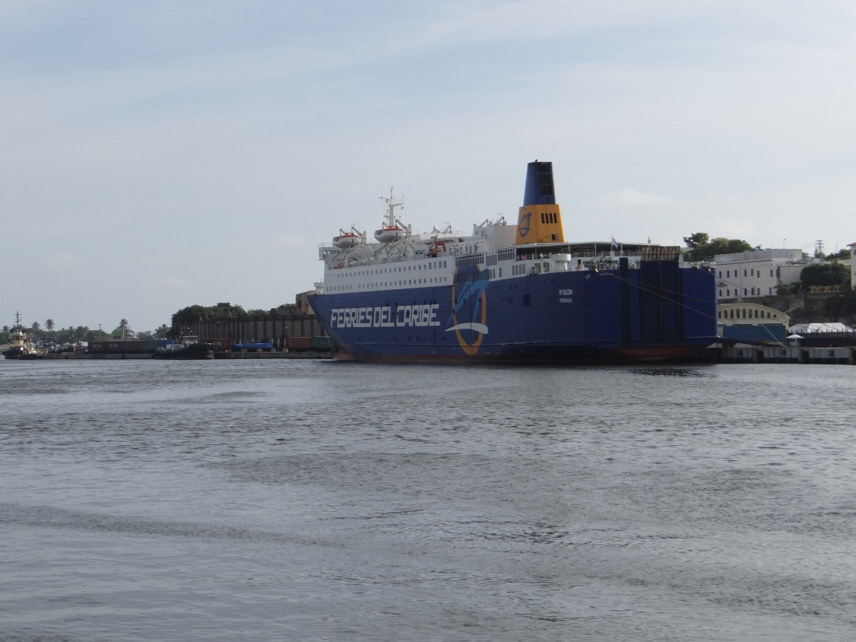

Industrial activities at downstream Ozama River

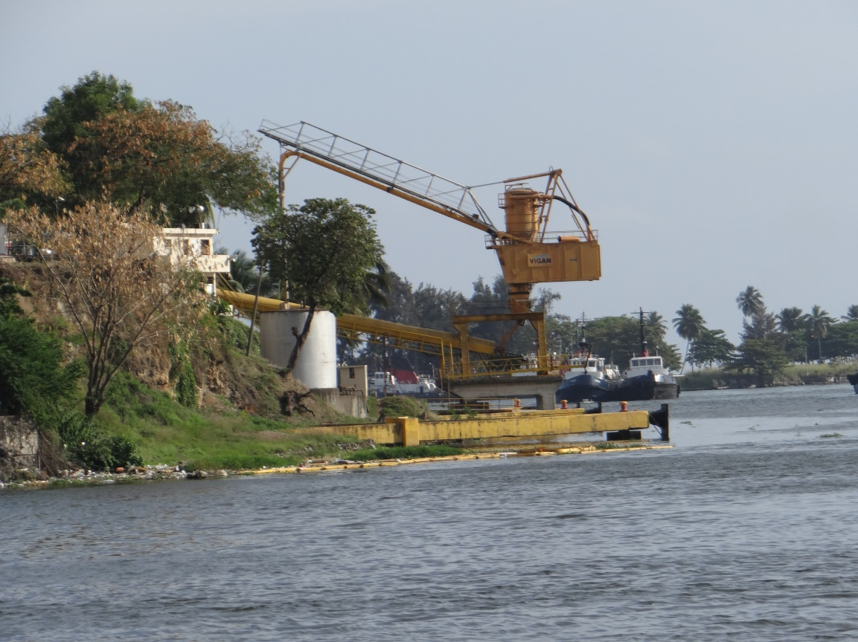

|  |  |  |  |
| --- | --- | --- | --- |
| Conductivity in Water | | | |
| Samples | **Upstream** | **Samples** | **Downstream** |
| 1 | 210 | 6 | 13,450 |
| 2 | 210 | 7 | 13,370 |
| 3 | 210 | 8 | 13,460 |
| 4 | 210 | 9 | 13,420 |
| 5 | 210 | 10 | 13,280 |
| Average μS/cm | 210 |  | 13,396 |
| Comparison |  |  | 6379% |

Conductivity is not a pollutant itself, but serves as an indicator of the presence of pollutants. The conductivity of water is affected by the presence of dissolved substances in the water, including salts and heavy metals. Some of these substances are harmful to aquatic life and to humans, especially at high concentrations.

According to EPA (Environmental Protection Association), values above 500 μS/cm is harmful for aquatic life. The average value found in downstream sample was 13396.

**[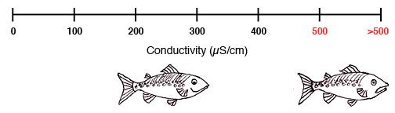](http://www.ace-project.org/water-quality-101/conductivityfish/)**

|  |  |  |  |
| --- | --- | --- | --- |
| PPM in Water | | | |
| Sample | **Upstream** | **Sample** | **Downstream** |
| 1 | 105 | 6 | 716 |
| 2 | 104 | 7 | 716 |
| 3 | 105 | 8 | 901 |
| 4 | 103 | 9 | 685 |
| 5 | 99 | 10 | 666 |
| Average PPM | **103** |  | **737** |
| Comparison |  |  | **714%** |

The PPM found in downstream samples was seven times more than PPM found in upstream samples. This confirms that the water was more polluted.



According to EPA, the samples taken from Ozama River are not drinkable. The samples taken from downstream exceed EPA’s maximum contaminant level.

The average pH levels of the samples taken from both point of the river are within the EPA criterion for freshwater pH that is 6.0 – 9.0.

We observed that pH level tend to increase in downstream. The increase of acidity in the water can be harmful for many forms of aquatic life. Besides affecting aquatic life, acidic water can damage man-made structures such as bridges, pipes and wells, and may contaminate drinking water supplies.

|  |  |  |  |
| --- | --- | --- | --- |
| pH in Water | | | |
| Sample | Upstream | Sample | Downstream |
| 1 | 7.2 | 6 | 7.6 |
| 2 | 7.2 | 7 | 7.7 |
| 3 | 7.2 | 8 | 7.8 |
| 4 | 7.6 | 9 | 7.7 |
| 5 | 7.6 | 10 | 7.8 |
| Average pH | **7.4** |  | **7.7** |
| Comparation |  |  | **105%** |

The increase of the turbidity found in downstream was exaggerated. It changed from an average of 219 to 5663.

|  |  |  |  |
| --- | --- | --- | --- |
| Turbidity in Water | | | |
| Sample | Upstream | Sample | Downstream |
| 1 | 223 | 6 | 9,242 |
| 2 | 221 | 7 | 9,242 |
| 3 | 223 | 8 | 7,058 |
| 4 | 219 | 9 | 1,589 |
| 5 | 210 | 10 | 1,182 |
| Average Turbidity | **219** |  | **5,663** |
| Comparison |  |  | **2583%** |

The temperature in the water from downstream was 9% higher than water from upstream. This can be a consequence of the high pollution.

|  |  |  |  |
| --- | --- | --- | --- |
| Temperature in Water | | | |
| Sample | Upstream | Sample | Downstream |
| 1 | 28 | 6 | 30 |
| 2 | 28 | 7 | 30 |
| 3 | 28 | 8 | 30 |
| 4 | 28 | 9 | 31 |
| 5 | 28 | 10 | 30 |
| Average °C | **28** |  | **30** |
| Comparison |  |  | **109%** |

The concentration of Ammonia and Nitrate found in downstream samples was much higher than upstream samples.

|  |  |  |  |
| --- | --- | --- | --- |
| Ammonia in Water | | | |
| Sample | Upstream | Sample | Downstream |
| 1 | 0.25 | 6 | 0.50 |
| 2 | - | 7 | 1.00 |
| 3 | 0.25 | 8 | 0.50 |
| 4 | - | 9 | 1.00 |
| 5 | 0.25 | 10 | 1.00 |
| Average PPM | **0.15** |  | **0.80** |
| Comparison |  |  | **533%** |

|  |  |  |  |
| --- | --- | --- | --- |
| Nitrare in Water | | | |
| Sample | Upstream | Sample | Downstream |
| 1 | - | 6 | 20.00 |
| 2 | - | 7 | 5.00 |
| 3 | - | 8 | 20.00 |
| 4 | - | 9 | 5.00 |
| 5 | - | 10 | 5.00 |
| Average PPM | **-** |  | **11.00** |
| Comparison |  |  |  |

Attached the Chart of the results obtained from the different samples taken Upstream in the Ozama River:





Attached the Chart of the results obtained from the different samples taken downstream in the Ozama River:







Attached the chart of the results obtained from the different samples taken Downstream and Upstream in the Ozama River:









**Discussion**

Water pollution is caused by many factors including (but certainly not limited to): uncontrolled construction sites, leaking sewer lines, storm water runoff, accidental spills and leaks, improper discharge of wastes, mining activities, foundries, animal waste, and others.

We should educate people about the pollution in the rivers water. The temperature of the water is rising up to 30C, hot enough to burn our skin. We should discuss with the government in order to implement laws to stop people from throwing trash and polluting the rivers.

**Conclusion**

The hypothesis was proven because the samples of Ozama river water taken upstream are less polluted than the samples of the river water taken downstream.

While many of the solutions for water pollution need to be applied on a broader macro-level, we have listed seven simple water pollution solutions that individuals, companies, and communities can take to have a significant and responsible impact on the water quality around them.

1. Practice Responsible Use of Fertilizer, Herbicides and Pesticides
2. Minimize Storm water Runoff
3. Filter Runoff
4. Contain Spills
5. Protect Curb Inlets and Drains
6. Capture and Dispose of Floating Pollution in the river
7. Capture and Filter Sediment Laden Water in the river

**Future Research**

This research raised questions like:

* Can this part of the river be saved if we take care of it?
* Can life forms be healthier than they are now?
* What could we do to make the river healthier?

We would also like to change the river we are studying and improve the method of taking the samples of the water.

**Acknowledgements**

The success and final outcome of this project required a lot of guidance and assistance from many people and we are extremely privileged to have got this all along the completion of our project.

Nevertheless, we express our gratitude toward our families and teachers for their kind co-operation and encouragement which help us in completion of this project.

**References**

* Globe PH Protocol: <https://www.globe.gov/documents/11865/42e3b8fe-847c-429a-a105-d18691d99e32>
* <https://www.greenfacts.org/en/water-resources/l-3/4-effect-human-actions.htm#0p0>
* <http://www.umgeni.co.za/water_education/wpwq.asp>
* <https://www.nationalgeographic.com/environment/habitats/freshwater-threats/>
* <https://www.sciencelearn.org.nz/resources/440-human-impact-on-rivers>
* <https://www.americangeosciences.org/critical-issues/faq/what-affects-quality-surface-and-groundwater>
* <https://www.pca.state.mn.us/sites/default/files/wq-iw3-21.pdf>
* Water pollution - http://en.wikipedia.org/wiki/Water_pollution
* Common water measurements - http://ga.water.usgs.gov/edu/characteristics.html
* Earth’s water- rivers and sediment - <http://ga.water.usgs.gov/edu/earthriverssed.html>