The effect of different
amount of concentrated
ethereal oil from the Ruta on the number of
mosquitoes around.

השפעת ריכוזים שונים של השמן האתרי מצמח הפיגם על מספר היתושים בסביבה.  חקר שיתופי לתלמידי בתי ספר : יסודי "הרצל" בת –ים , יסודי ד' טורעאן | Cooperative research project for pupils of both schools Herrzel in Bat-Yam and Turan d' elmentry school-turan

The presenters students:
Turan d' school: roaa naser, hamed dahle, mosha abu diba, ruth abu rahal.
"Hertsel" school: mishel, shira, maaian, sofia k. lior, noam, shon, ron, eden, ariel, liel, ori, yehontan, ambar.
Teachers: islam shibel, shlomit mazliah, idan karo.

Context
The Schools…………………………………………………………………………………………………………1
Tura’an School d 1
Hertzel School Bat-Yam 1
:Background for Choosing The Research Topic 2
Introduction…………………………………………………………………………………………………………2
Research Question 2
Reading Sources 3
Ruta graveolens 3
Scientific classification 3
Culex pipiens complex 4
Scientific classification 4
The independent variable 5
The goal of the research 5
The research question 5
The assumptions 5
methodology The research 5
Permanent conditions – 5
Description of experiment 6
Procedure of experiment in each school 6
and Results Outcomes 7
Table no' one 7
Table no' 2 7
Conclusions……………………..…………………………………………………………………………………8
Appendix………. 10
The research and cooperation………………………………………………………………………………10

The Schools

Tura’an School d
It is located in the north of Israel ,in the Lower Galilie .It was established in 2012 and has 300 pupils,24 teachers and 12 classes from 1st to 6th grade.
Mrs.Rose Sha’aban is the principal. The school is like a bee hive and fulfils all pupils’ needs through deep meaningful musical education ,fostering intelligences ,implementing social values and empathy by the spirit of co-existence – Jews and Arabs in one state.
The school chose the Glob program for being a perfect match for school belief which contributes for aspects such as independent and creative learners. In this program school won the photography contest locally and globally. One of the chosen photos appears on the yearly Glob calendar.

Hertzel School Bat-Yam

It is located in Bat-Yam city, in the central of Israel. It was established more than 40 years ago. Mrs. Hani Jana is the principal. It has 360 pupils,32 teachers and 14 classes from 1st to 6th grade including special education classes. The school unique is in science and physical health. It reinforces strengths of each and every pupil, and sees the way to success as the main goal confronting difficulties and obstacles. This is the third year for school to take part in Glob program ,and pupils from different levels of learning participate –special education and special needs kids and excellent ones. They cooperate wonderfully. The Glob program helps reinforcing the process of learning and research science topics ,the bond between the different pupils, and enabling a great platform for collaborated research, learning and meeting the Arab pupils.

Background for Choosing The Research Topic

The pupils in both schools found out that the mosquitoes problem bothers the people who live in both different parts of Israel. These areas do not share the same climate and environment and yet suffer from the same problem – the mosquitoes. They decided to investigate this issue together and try to find ideas for solution. As a result of many discussions among the pupils ,they came up with the idea to research the effect of the ethereal oil from the Ruta plant on mosquitoes and other insects.

They read and learnt that in the past people used the Ruta plant for defeating mosquitoes in Galilei, the northern area in Israel.
We hope that collaboration of both parties in this first scientific experiment will contribute to find an organic –biological solution to reduce the number of mosquitoes and minimize the annoyance. It also might create a way to use only biological pesticide and not chemical one ,which harms many other organisms and changes the balance of environment.
We also believe that this cooperative research will contribute to make better relations between Arabs and Jews, boys and girls and adults. We hope to make a difference in small which might impact in big.

Introduction
The mosquitoes annoyance exists in many places around the world and in Israel as well. The bites are the most bothering. The mosquitoes known as disease transmitters and mainly the malaria. This disease is still one of the main death causes in the world .In 2009 225 million people got sick and in 2010 , 655,000 people died. Most death happened in Africa and southern the Sahara. The pioneers in Israel hoped by planting eucalyptus to defeat the Anopheles mosquitoes the carriers of malaria. Using DDT and other means helped reducing the number of sick people and for the last 40 years there is no malaria in Israel. There are no Anopheles and no sick people. The more common mosquito these days is the Culex pipiens. It is the kind which bites and bathers the most all over Israel. In the past we could find mosquitoes only in an environment which provided heat , humidity and water for the reproduction. These conditions are common to most people living areas. Lately , the mosquitoes are everywhere and during all seasons. This fact shows that mosquitoes have a significant ability of adapting changes of environment and as a result can be active all along the year .It also increases the disease transmit, and many people died in the past two years from the Zika illness transmitted by mosquitoes.
This research paper facing the need for finding an organic friendly use solution such as biological pesticide.

Research Question
"What Is the effect of different amount of concentrated ethereal oil from the Ruta plant, on the number of mosquitoes around?"
Each school will investigate the effect of the ethereal oil from the Ruta plant on the number of mosquitoes around. The pupils will use 3 different amount of concentrated ethereal oil.
We hope and look for effective results which might bring an ecological solution rather than chemical one. We take care of humans health and will do our best to help.

Reading Sources

Scientific classification

Ruta graveolens
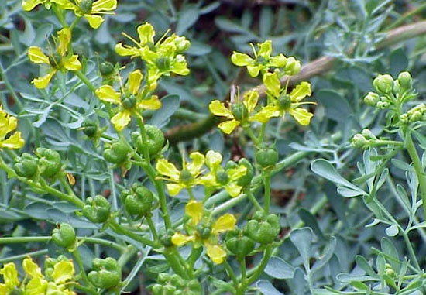
Scientific classification
Scientific name - Ruta graveolens
Kingdom- Plantae
Phylum- Angiospermae
Class- Magnoliopsida
Order- Sapindales
Family- rutaceae
Genus-ruta
Spicies- R.graveolens

The Ruta is a dark green bluish tint color perennial bush .It has soft branches and many small leaves. It is flowering during summer . Its flowers are small and yellow with serrated petals .The plant size is about 40cm to 80 cm. It grows in some of the Middle East countries. The plant has variety of names which come from different cultures. The Ruta secretes ethereal oil which defeats and even kills insects and its leaves have strong pungent odor as a result of the oil. This oil and its smell serve as a natural survival mechanism . Many animals such as dogs, cats, flies, snakes and mosquitoes who have a sharp sense of smelling are affected by the odor. This smell protects the plant from the animals, and the animals do not approach the plant. In the ancient times of Rome people used to apply the oil of the Ruta on their bodies to defeat insects and snakes especially during the summer. It was also common among farmers to apply it on their farm animals’ bodies. It served for defeating fleas and ticks and against snakes sting.

Culex pipiens complex

Scientific classification
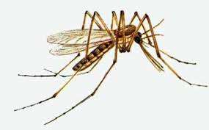
In the pictures we can see: and of one student that hold mate mosquitos. And the Culex pipiens mosquito
Scientific name - Culex pipiens
Kingdom- Animalia
Phylum- Arthropoda
Class- Insecta
Order- Diptera
Family- Culicidae
Genus- Culex
Spicies- C. pipiens

This is the domestic most common mosquito which is found almost everywhere. It is fed from vertebrates with hot blood and can be a vector for variety of diseases. It is not small comparatively and its wing size about 3.5-4 mm. The mosquitoes are considered the most deadly animal on earth. They are also the first in carrying diseases to human beings such as the malaria and Zika. The mosquitoes are attracted to environments of water, heat and light. They have a unique sense that helps them to get to heat sources and their sense of smelling is strong ,accurate and sensitive. This sense serves them as a navigator while searching for food. For example, they prefer the smell of lactic acid which exists in people’s sweat rather than butyric acid. The mosquitoes are mainly active during night in areas with water or humidity ,heat and light.

The independent variable
different amount of ethereal oil from the Ruta which is sprayed in each cage till zero amount.

The goal of the research
Investigating the options of defeating mosquitoes in 2 different climate eras – 2 schools located apart from each other on the map of Israel. The cages are placed near people’s living eras which support the existence of mosquitoes around. Increasing the ability to defeat mosquitoes by using organic-biological pesticide which is friendly use to environment and reduces the need of using chemicals which harm the natural balance of the environment.

The research question
What are The effect of different amount of concentrated ethereal oil from the Ruta on the number of mosquitoes around?

The assumptions
The Ruta plant’s oil defeats insects and its leaves have very strong odor there for we assume the following:
1.The higher the amount of oil is the cage the smaller the number of mosquitoes.
2.The results in both schools will be pretty similar despite the different location and climate.

methodology The research

The procedure – in each school all 4 cages were identical .The only different was the climate and weather since of different areas in the country.
Measuring the dependent variable – counting the number of mosquitoes in each cage every day and night.

Permanent conditions –
- The cages – square 1 cubic meter each and the net that covers them.
- Light – natural sun day light, electric light at night from the same bulbs and the same amount.
- Water – in each bucket of each cage 10 litters water. Adding water once every 3 days because of water steaming.
- Temperature – natural outdoor in school area.
- Location – in one place, 3 meters between each cage.
- Control- one cage with no oil at all, done by the researchers.
- Check –up – in each check one cage only.
- Oil spraying – only once. Checking every 2 days for 10 days.

Description of experiment

Metireals

assence of rue oil , alcohol 70%, tap water.

Equipment
4 wood cages equal size (1 m³ ), spray tool (1 litter), Injector 80ml, white mosquitos net, 4 flash lights 60W, 4 10L water black buckets.

Time and location
The experiments bigan on 11th march in both schools. The lest test was on 16th march (6 days long).
There were 5 counting of the mosquitos in the cages in similar dates on both schools

Procedure of experiment in each school
- we covered the 4 cages with mosquitos net and set the cages in the same location in equal distance between the cages.
- In every cage we connected 60w light ball
- In every cage we left 10 litters water gallon
- We thin the oil with same cc of alcohol as we can see in the next table:

Cage nomber | The amount of concentrated ethereal oil from the Ruta Diluted in alcohol.
 | Alcohol in cc | Ethereal oil frome ruta in cc
1 external control | 150cc | 0cc
2 | 150cc | 50cc
3 | 150cc | 100cc
4 | 150cc | 150cc

Outcomes and Results

After the period of the research and the testes of the finding, we discovered that the amount of the mosquitos fly is getting down already in the first cage that in it the conecetration of the oil was low. We can see it In the next tow tables:

Table no' one

The effect of different amount of concentrated ethereal oil from the Ruta on the number of mosquitoes around.in turan school:
Cage nomber | The amount of concentrated ethereal oil from the Ruta Diluted in alcohol. |  | The number of mosquitoes in the difference cages by the testing days
 | Alcohol in cc | Ethereal oil frome ruta in cc | 11.3 | 12.3 | 13.3 | 14.3 | 15.3 | 16.3
1 external control | 150cc | 0cc | The beginning of process and the oil sprayimng. | 11 | 8 | 15 | 25 | 19
2 | 150cc | 50cc |  | 0 | 0 | 0 | 2 | 1
3 | 150cc | 100cc |  | 0 | 0 | 0 | 0 | 0
4 | 150cc | 150cc |  | 0 | 0 | 0 | 0 | 0

Table no' 2

The effect of different amount of concentrated ethereal oil from the Ruta on the number of mosquitoes around.in "hertsel" school:

Cage nomber | The amount of concentrated ethereal oil from the Ruta Diluted in alcohol. |  | The number of mosquitoes in the difference cages by the testing days
 | Alcohol in cc | Ethereal oil frome ruta in cc | 11.3 | 12.3 | 13.3 | 14.3 | 15.3 | 16.3
1 external control | 150cc | 0cc | The beginning of process and the oil sprayimng. | 10 | 9 | 11 | 15 | 20
2 | 150cc | 50cc |  | 0 | 1 | 0 | 8 | 6
3 | 150cc | 100cc |  | 0 | 0 | 0 | 0 | 0
4 | 150cc | 150cc |  | 0 | 0 | 0 | 0 | 0

Verbose description
As we can see in the tow tables we can recognize that the number of mosquitoes was high in the first cage- the external control ( only alcohol).
In the second cage with the 50 cc of oil, we can see that the number of mosquitoes get low in the finals tests.
In both schools the third cage and the fourth cage we can see zero mosquitoes.

We connected the different tables to one chart for preview the conclusions:

Conclusions

The goals of the research are the developing effective organic way to removal of environmental nuisance of mosquitos which adopt different environments. We do so by trying to preserve te environment and reduce damages to other organism.

From the results, we can conclude that we can use the ethereal oil of the rue for mosquitos removal. The results are match to our assumptions that a small amount of oil can reduce mosquitos. Never the less we assume, if we will change the way of spraing it (not necessary with alcohol) the results will by better.
We can defiantly say that the rue oil or plants, by taking advance its biological ingrediency can be effective biologic exterminator.

By the results, the conclusions ant long dissections on the results we surprised of the effectivity of rue oil on number of mosquitos and we are recommending about more researches.
- The effectiveness ethereal rue oil on mosquitos larva in sweet water.
- The influence of rubbing rue oil on the skin to reduce mosquitos bites.
- The influence of the rue ethereal oil on some spices of bugs to reduce bugs from fields without damage the lend or harm other good bugs or organism.
The matching tests could be exsist only because the cooperation between two schools in different claimants and geographic locations. All above confirm the hypothesis.

Bibliography
The bibliography by books in Hebrew:

שניידר, ט. 2004 . " גן עדן בפתח הבית" . עמ' 312-59 הוצאת שומרה לסביבה טובה.

אלון, ע. 1983 . החי והצומח של ארץ ישראל. כרכים:1, 6, 10 ו-12 ) 1-. משרד הביטחון.

פינברון- דותן נ. ודנין א., 1991. המגדיר לצמחי בר בארץ ישראל, כנה,ירושלים.

יעקובי, י. ו- אילון- מור, ע. 2010, "השבת צמחי בר של ארץ ישראל ושיקום הגן הבוטני", בריאות הסביבה, בריאות האדם ומה שבניהם, הכנס השנתי ה-10 לחינוך סביבתי. משרדי חינוך וסביבה, בית ברל וסמינר הקיבוצים.

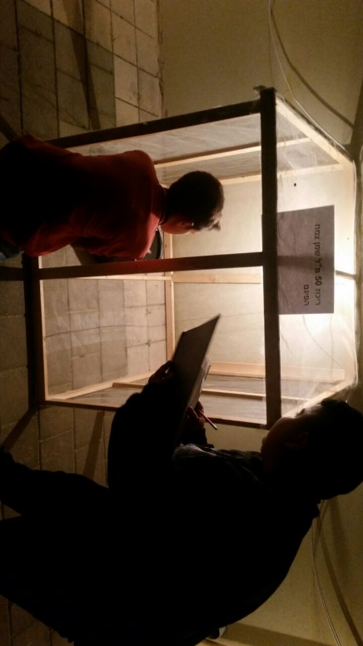
Appendix

The research and cooperation

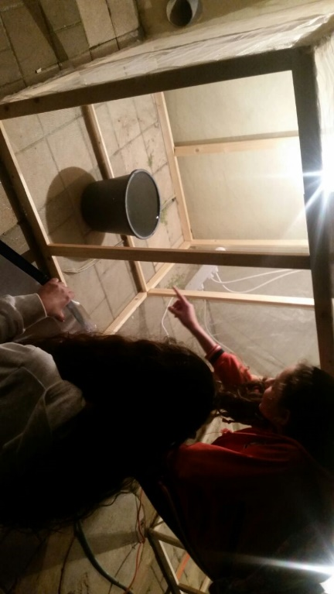
Those images illustrate the researchat night in primary school "d" Turan

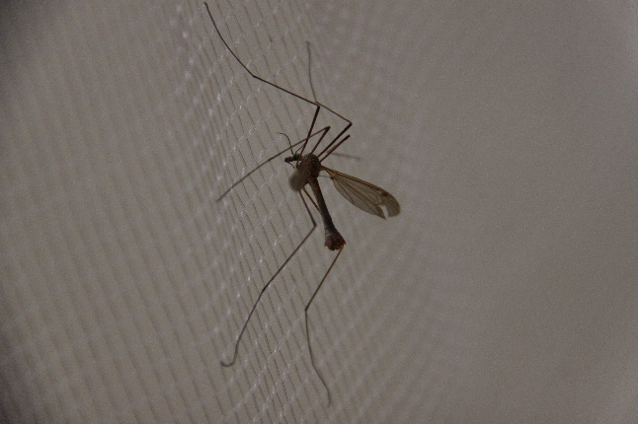
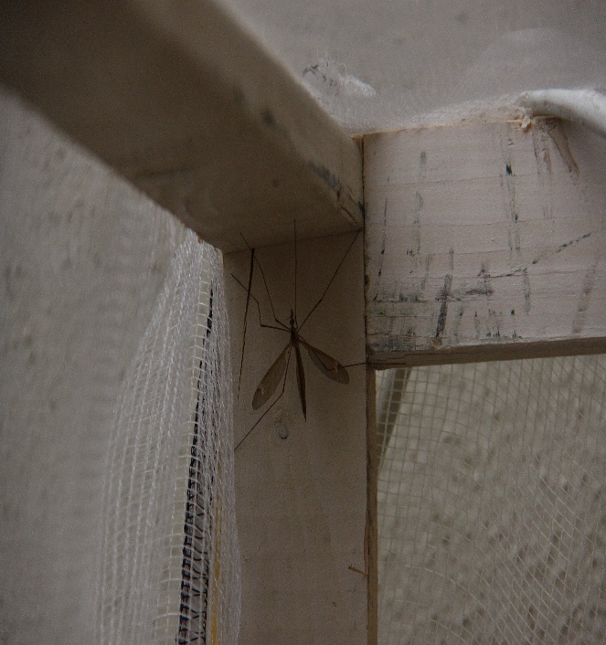

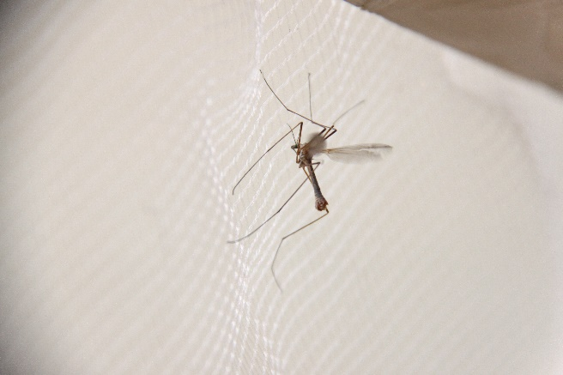

Mosquitose in the net

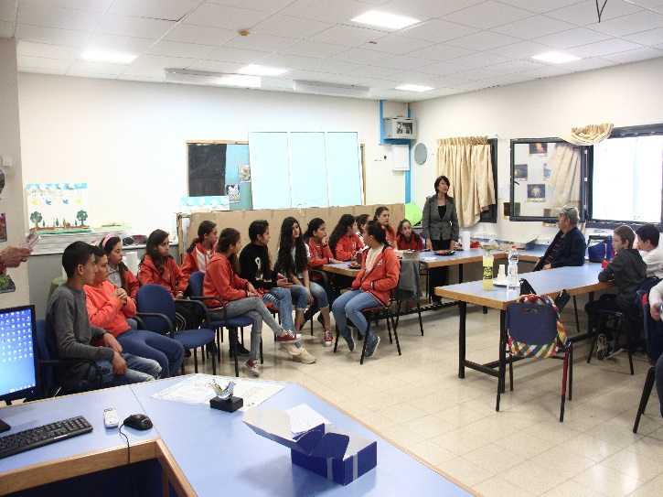
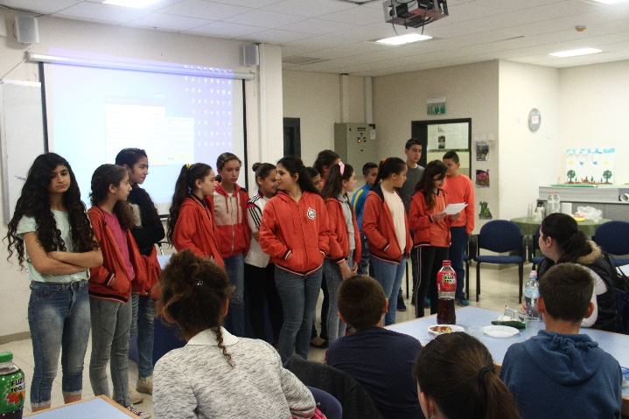
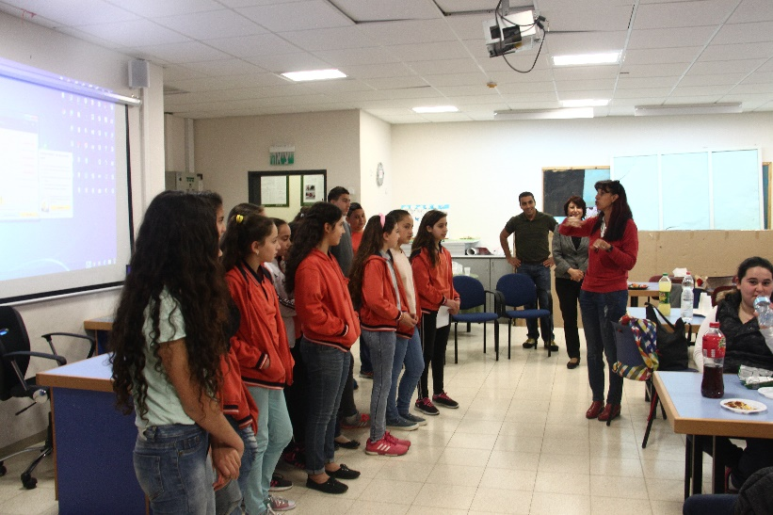
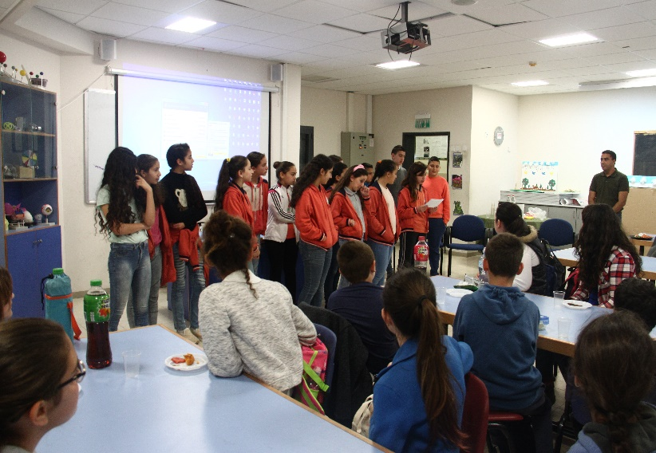

The meeting ant preferment of the conclusions
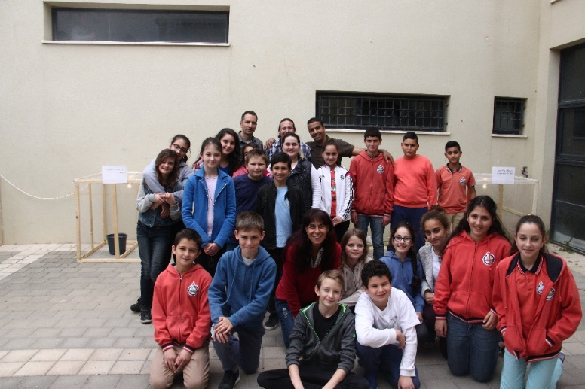

Near the cages Mating in "Herzl" school grounds

