O. P .F GIRLS COLLEGE
F-8/2, ISLAMABAD

STUDY TOUR TO SHAHADRA STREAM ,
NEAR QUAID e AZAM UNIVERSITY ISLAMABAD,
TO MEASURE HYDROLOGY PROTOCOLS

A research tour was organized by The Globe Team of O. P. F Girls College F-8/2,Islamabad Madam Shaheena Masood , to Shahadra stream on 1st February 2018 on Thursday.It was a short trip and took 30 minutes drive from College to the stream.

The main objective of the trip was to measure Hydrology Protocols and Integrated Atmosphere Protocols.The Globe team comprised of 12 students and four teachers.The students were well equipped and well-trained to perform all hydrology protocols under the supervision of the Globe teacher Ms Saima Qureshi.
As the team reached the stream ,the girls were scattered in different groups. Each group was assigned a particular protocol to measure and record the data. There were 8 groups in all for each protocol measurement and each group consist of three girls whereas the level of all students was of grade 8th.Following protocols were performed and the readings were measured on the stream :
1. Transparency
2. Temperature
3. pH
4. Dissolved oxygen test
5. Alkalinity test
6. Nitrate ion test
7.Conductivity of water test
8. Depth of water
9. Integrated Atmosphere test
Some samples of water were also collected and then the team packed up and left the stream at 1:00 pm sharp.
It was a very useful trip as in a very short time period of 45 minutes the students not only recorded and performed various Hydrology Protocols. But they also presented their knowledge about each protocol as well as the significance of each test carried out. Special thanks to our Principal and Globe Co-ordinator in Pakistan Madam Shaheena Masood for providing us the facilities .

HYDROLOGY –BASIC CONCEPTS
HYDROLOGY is the science of the waters of the earth and its atmosphere.It deals with occurrence,circulation,distribution and movements of these waters over the globe and their interaction with the physical and biological environments
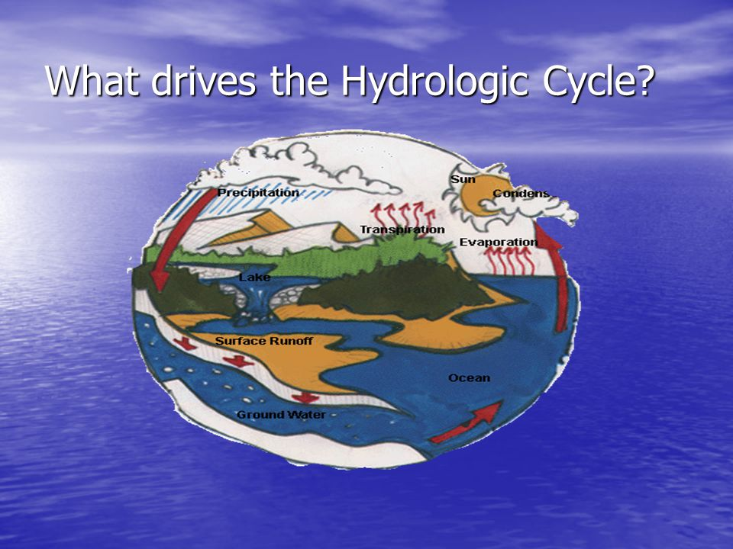

Hydrosphere Investigation
Data Sheet
School name: O P F Girls College Islamabad F-8/2, Islamabad
Class or group name: Grade 8th
Name(s) of Student(s) collecting data:
Measurement Time: 12:15*
Year: 2018 Month: February Day: Thursday Time: 1215(UT) Time: (Local)
Name of Site : Shahadra Stream
Source of Data
GPS
Latitude 33⁰ 46.391′ Longitude 073⁰ 10.488′
Water State: Normal Flooded Dry Frozen Unreachable
Note:If Normal is selected, continue below; all other selections stop here
Sky Conditions (Check one):
Clear (no Clouds Visible)
Clouds Visible (1% to 100% Covered by Clouds or Contrails)
Obscured (More than 25% of the Sky is not Visible)
Note: selecting Obscured will prevent data entry on clouds and contrails; therefore skip the cloud type and cover and the contrail type and cover sections and proceed to the Obscured section. If clouds and contrails are visible in non- obscured areas of the sky, these data can be entered in the Metadata field.
If Clouds are Visible select all Cloud Types Seen
High (in the sky):
(Check all types seen)
Middle (of the sky):
(Check all types seen)
Low (in the sky):
(Check all types seen)
Rain or Snow Producing Clouds:
(Check all types seen)
Cirrus Cirrocumulus Cirrostratus
Altostratus Altocumulus
Stratus Stratocumulus Cumulus
Nimbostratus Cumulonimbus
What Percent of the Sky is Covered by Clouds? (Check One) Three-quarters or
More of the Sky is Visible:
Cloud Cover (Check One)
No Clouds Clear Isolated Scattered Broken Overcast

0% >0 to10% 10 to 25% 25 to 50% 50 to 90% >90%
Are There Contrails in the Sky? (Check One) No Contrails Contrails are Visible
If Contrails are Visible Record the Number of Each Type Seen
What Percent of the Sky is Covered by Contrails? (Check one):
0 to10% 10 to 25% 25 to 50% >50%
If you Selected Obscured (> 25% of the Sky is not Visible) (Check all that apply):
Number Observed Number Observed Number Observed
Blowing Snow Heavy Snow Heavy Rain Fog
Sand Spray Volcanic Ash Smoke
Dust Haze

Transparency Tube
Transparency Tube Test 1 112cm
Greater than depth of Transparency Tube
Transparency Tube Test 2 112cm
Greater than depth of Transparency Tube
Transparency Tube Test 3 113cm
Greater than depth of Transparency Tube
The average transparency of the stream recorded is 112.5cm.
Water Temperature:
Measured with (check one) alcohol-filled thermometer probe
Temperature Test 1: 27⁰C
Temperature Test 2 28⁰C
Temperature Test 3 24⁰C
The average Temperature of the stream water recorded is 26.333⁰C

Dissolved Oxygen:
Dissolved Oxygen kit: Manufacturer __Lamotte______ Model _EDO______ CODE _7414__
Dissolved Oxygen Test 1: _15.3___ (mg/L)
Dissolved Oxygen Test 2: _12.3___ (mg/L)
Dissolved Oxygen Test 3:__13.8__ (mg/L)
The amount of dissolved oxygen in the water is found to be 13.8mg/l .

Electrical Conductivity:
Temperature of water sample being tested: _25__°C
Conductivity of standard: ____ MicroSiemens/cm (μS/cm)
Conductivity Test 1:_514___ μS/cm
Conductivity Test 2:__513__ μS/cm
Conductivity Test 3:__515__ μS/cm
The conductivity of stream water is found to be 513 µS/cm

Water pH: Measured with: (check one) pH Paper pH Meter
1. 5.3
2. 5.3
3. 5.4
The pH of stream water is found to be 5.35 which shows that the stream water is slightly acidic .

Alkalinity:
Alkalinity kit: manufacturer LaMotte model DR-A Code 3467
Kit used reads alkalinity directly
Alkalinity Test 1 185mg/L as CaCO3
Alkalinity Test 2 195mg/L as CaCO3
Alkalinity Test 3 195mg/L as CaCO3
The alkalinity of stream water is found to be 190mg/L.
Nitrate
Nitrate kit: manufacturer Hach model NI-14 Cat. No 1416-00
Nitrate and Nitrite (mg/L NO3-N + NO2-N) Nitrate (mg/L NO2-N) Optional
Test 1 0.5ppm
Test 2 0.5ppm
Test 3 0.5ppm
Depth of water
6.3 inches
6.5 inches
6.5 inches

