Kingdom of Saudi Arabia
Ministry of education
Educational Performance Agency
Public Administration Education
in Hail
Educational Affairs
Student activity department

Pollution in Hail! Where is it going?

GLOBE international virtual exhibit
for science 2019

Prepared by:
Dhai Abdullah Al-Sheeb
Salma Mubarak Alshartaan
Raghad Saleh Alombalee
Under the supervision of GLOBE teacher:
Badriyah Abdulrahman Alhamad

Safeyah Bint Abdulmottaleb Secondary School (Al-Nayseyah)
Academic Year: 1440 H – 2019 G

Content Index
Subject | Page
Content index | B
Photos and figures index | C
Research Abstract | 1
Introduction | 1
Research Objective | 2
Research hypotheses | 2
Literature review | 3-4
Theoretical framework | 6-7
Materials and method | 8-9
data analysis | 9
Conclusions | 9-10
Recommendations | 10
Acknowledgments | 10
References | 11
Figures Index
Figure No. | Figure Title | Page No.
1 | Explains the study conducting site | 7
2 | Questionnaire Answer | 7
3 | Charts about Pollution | 7
4 | Photos | 7
5 | Contributions and results | 8

Abstract
Within the context of global and local attention to the need to achieve environmental balance, Saudi Arabia has adopted strategies to encourage the consolidation of this concept in its various cities.
The research discusses the forms of environmental pollution in Hail region, which may make it lose its beauty, it's gorgeous nature and its natural characteristics. The research focuses on the importance of preserving the crucial issues such as the air we breathe, the water we drink, the soil in where we grow our food and the natural habitats upon which millions depend on in their livelihoods. However, it Reflects the extent of damage and encourage us to exert the effort to adopt the immediate processing procedures
This research, which is titled "Pollution in Hail! Where is it going" came. The research problem focused on an important question as follow:
- How to reduce the problem of environmental pollution of all kinds in the Hail region until we reach sufficient self-awareness and increase the environmental awareness, and the seriousness of human misconduct on the environment, through the media, newspapers, blogs, marches and social media sites, and video clips showing how dangerous is the environmental pollution.
Introduction
The terrain and plants combine in the formation of the general view of Hail region, these are the two main elements in the formation of the desert natural landscape, which in turn consists the most important factor in the overall value of the region, including that the geographical location and the location of Hail region is distinctive because it is in the middle of the northern part of the Kingdom, and it is an area of a distinctive landscape and includes sedimentary rock formations. It includes valleys covered with sand and rocks and surrounded by mountains on three sides, and the Nefud desert on the north side. The area has an aesthetic view and its height and width varies from place to another, (Hail ! nature, magic, beauty)
In order to keep the beauty of the region and for the protection of the natural resources, and protecting its population from the risk of disease, we did this research.
if we looked at the cases of kidney failure and cancer diseases in the region, we will find a large proportion, all of which occur for many reasons, as mentioned by a consultant at King Faisal Specialist Hospital and Research Center in Riyadh.
There is trust for the advancement of the region in various sectors and fields to reach progress and development, with the support and guidance of the governors, God preserves them, in order to reach a solution, (what happened to it?) means Hail.
Research Objectives:
1. To reduce the problem of environmental pollution of all kinds in Hail.
2. To increase self-awareness and increase environmental awareness.

Research Hypotheses
This research was motivated by our right to enjoy a healthy environment like other areas.
And the questions were !
- How to reduce the problem of environmental pollution of all kinds in Hail?
- What are the easiest ways to solve the problem of drinking water in Hail city which is besieged and threatened by radiation and sewage water, the fear is from the mix of sewage water with groundwater, which is the only source of drinking water for the region.
- Is there Uranium in the water of the region? and who confirmed the existence of it is the team of King Abdulaziz City for Science and Technology in 1421 and its danger on the waters of the region.
- Is there absence to the proper management of the solid waste, and what is the impact of random dumps in exposed places on the public health?
- How to instill the concept of environmental conservation among young people and members of society and to spread the environmental awareness?
Hail (North Bride) is beautiful and getting more beautiful by awareness-raising of the importance of cleanliness of land sites and keeping it away form the pollutants.

Literature Review:
Academic study: "Hail soil" is able to purify sewage water
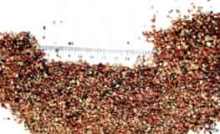
First, a study conducted by King Saud University on the Hail soil from which Alrasf vally forms revealed its ability to purify the secondary treated sewage water to be suitable for use in unrestricted agricultural irrigation and for recreational purposes.
The researcher, who is a professor of environmental engineering at the university's civil engineering department, Dr. Walid Al-Zahid, explained that his experiment aimed at finding local sand that can be used for triple treatment plants. He selected two samples from the local soil, the first is from Wadi Alrasf (3 km southwest of Hail) and the second from the area of ​​Thamamah in Riyadh, and the preliminary examination concluded the unserviceability of the soil of Thamamah , because it does not comply with the specification of the filtration sand, while Hail soil was full compatible with all the conditions he set, pointing out that this will contribute to stop pollution caused by sewage pouring into the swamps east of the city, which has become close to residential plots, and is considered a serious source threatening the public health in Hail.
Alzahid explained what the study reprted, The percentage of acids soluble in Al-Rasf sample was 0.8%, less than 2.5%, and the specific weight of the soil granules was 2.6 - greater than 2.5 - and the percentage of the substances smaller than 75 micro meter was 0.06% less than 2%, explaining that the study revealed that Hail sand is suitable for the filtration of biologically treated wastewater with biocompressors at filtration rates of 4, 8 and 12 m/h, where it is possible to get filtrated water with quality that meets Saudi standards for the quality of the treated water for the purposes of unrestricted irrigation.
Second:
From the contributions :
- Jbl News - Editing: A seminar organized by Dr. Nasser bin Ibrahim Al-Rasheed chair of the studies of Hail region discussed yesterday the environmental pollution and the ways of reducing it in the region with the participation of Dr. Abdullah Al-Shammari and Dr. Khalid Asiri. Dr. Khaled Asiri talked about the concept of agricultural pollution and its causes from Chemical pesticides and their types, and the risk of using them in large quantities in the Hail region farms, pointing out some solutions that limit the pollution of the region. However, Dr. Abdullah Al-Shammari talked about the causes of environmental pollution in Hail city, the spread of pollutants in a large number and from different sources that may lead in the near future to major risks facing the future generations, emphasizing on that it is possible to address the causes of pollution and their effects on humans and other living organisms. Many attendants participated In asking their questions about the technical steps of government agencies to address the environmental pollution and contribute with the developed countries in maintaining a clean environment on the surface of the earth, and did not talk about the crushers as they are the most important causes of environmental pollution.
- Twasol- Editing team:
Abdulrahman Al-Fadhli, Minister of Environment, Water and Agriculture, expressed his happiness with the initiative of the citizen Saud Al-Ajlan of distributing 1500 seedlings of local trees to citizens after Friday prayer in Hail. "Environmental voluntary works that we rejoice every day and emphasize on a growing environmental awareness," Fadhli said through his official Twitter account on Friday. He added "It is always important to choose the local trees and proper utilization of water resources"

Theoretical framework:
- Air pollution occurs when harmful gases, dust and smoke enter the atmosphere, which causing physical, biological or chemical changes in the air, which affect on the lives of the living organisms live on the Earth.
- Water pollution results from the human activities that lead to the entry of harmful substances into water bodies such as lakes, pools, oceans, rivers, tanks, etc. Water pollution may result from natural causes such as volcanoes, earthquakes and tsunamis. This type of Pollution affect on the life of the living organisms and plants that live in or near water, and drinking polluted water causes infecting people of many diseases.
- land and soil pollution means deterioration or destruction of land surface and soil, directly or indirectly, as a result of human activities, which limiting the land productivity and its quality as an ideal place for agriculture, forests, construction, etc.

Materials and Method
  - The study was conducted in the Hail region, which is located in the north of the Kingdom and has a population of about people. It is an agricultural area and started establishing some industries. A random sample of the community was selected (n = 50)
  - Methods of data collection:
  - Questionnaire
  - A questionnaire was designed to collect data from the sample under study. It included several sections, which included the democratic condition, the model, practices and behavior of the sample towards the environmental pollution in Hail. The simple statistical analysis was used and the results were presented as graphs.
  - https://docs.google.com/forms/d/15PsHhaTQO4XxUdkF7kxpn_7XzGymh4twmwdmapsG1Ow/viewform?pli=1&edit_requested=true
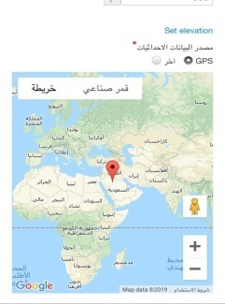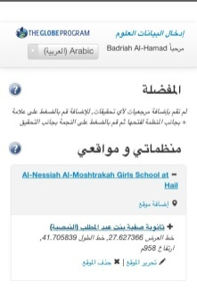
Figure (1) Location coordinates

Figure (2) Charts ratios to the answer of the questionnaire questions
Figure (3) chart for pollution
Figure (4) chart for pollution

Since It is necessary to look for the causes of Hail pollutants, especially when pollutants enters into the natural landscape, disrupts its balance, negatively affects the life of living organisms, and exceeds the natural levels.
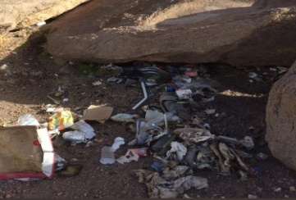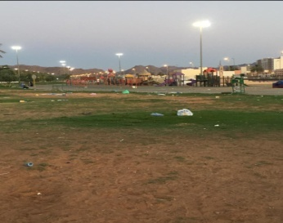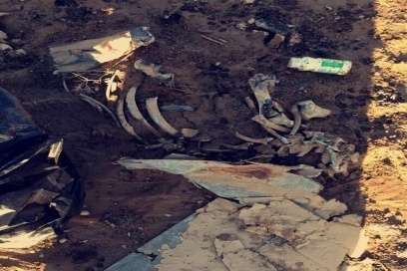

Data analysis and interpretation of results

The answers of the questionnaire, submitted to public population living in the region, were analyzed and were as follows:
In Figure (1), the location from which the female researchers (students of the Globe) started which is Al-Naiseyyah secondary school.

In Figure (2), answering the questions of the questionnaire that is conducted on a sample of the members of the community. The answer rate of the first question is positive and it is possible to reduce the pollution problem in Hail with percentage of 82%.
The answer for the second question is 85% and the answer to the fourth question is 75% and that this doesn’t suit our environment.
In Figure (3) (4)
Chart of Pollution Types in Hail, Air pollution 10% Water pollution 17% Air, water and soil pollution 20%

Since 82.1% chose "Yes", I concluded that the population of Hail had learned about the risks of pollution.

Conclusions
The research results indicated that:
In this research, we have identified the environment, when pollution occurs, types of pollution, including air pollution, water pollution, land and soil pollution. To avoid these effects there are several solutions and procedures, for Example:
- To put cameras in the streets which capture photos for the polluters and a fine shall be applied on them, and this offense (fine) shall not be removed from the person except after one or more violations have been monitored by the person himself, to reduce such pollution.
- Self-awareness, each person shall have self awareness, and thus we will eliminate pollution problems in Hail region, and this will be by joining volunteers and spreading environmental awareness
- Volunteer work is one of the most effective works that contribute to the preservation of the ecosystem, whether by a group of volunteers, donors with their efforts and time, or through non-profit organizations. The following are Some of the voluntary methods that reduce the environmental pollution.
- Joining a non-profit legal environmental organization, and may also join a group of people whose goal is to preserve the environment and reduce the environmental pollution. Increase environmental awareness, and the seriousness of the wrong human behavior on the environment through the media, newspapers, blogs, marches and social media sites. Also, through making Video clips showing the seriousness of environmental pollution.

From the contributions of Hail in the preservation of the environment

Hail carried out many contributions regarding environmental awareness, including the campaign "Hail needs from us" , and many has interacted with this campaign and it was applied in schools and these are models about this campaign
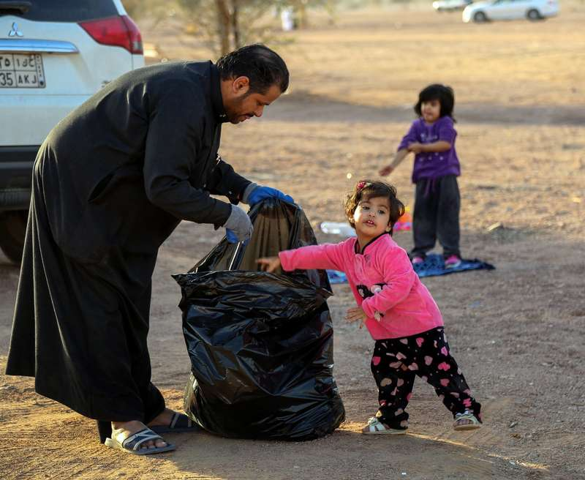

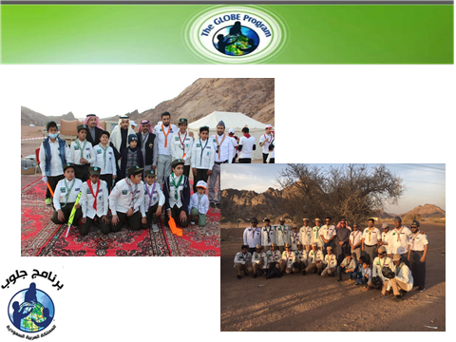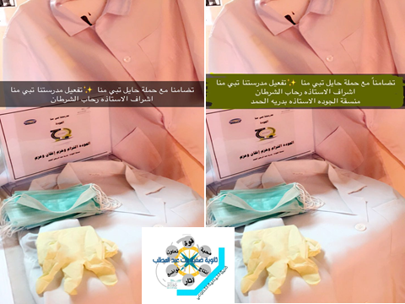

ACKNOWLEDGMENT
- We thank those who contributed to the research
- Nas American company and GLOBE environment community.
- Hail University represented by Mr. / Hamed Noreen
- Students activity Management (Girls) , the supervisor / Wadhaa Alzwemel
- Cooperating Schools: "Seventeenth Secondary School and Twenty-fourth Intermediate school.
- We thank Mrs. Badrih Al-Hamad for her contribution in holding a course about the scientific research and explaining the standards of the GLOBE International Virtual Exhibit for Science (2019)

References
- https://www.pme.gov.sa/ar/Pages/default.aspx
- Center of Meteorology and Environmental Protection in Hail.
- Hail Higher Development Authority.
- http://www.hail.org.sa/
- Globe Environmental site.
- Environmental Pollution for the Authors: Abdul Hadi Yahya Al-Sayegh - Arwa Shazel Taka, Publisher: Contemporary Library
- Dr. Bushra Ahmed Al-Hammad - Books in the field of ecology - Member sites
- Official website of Hail tourism.

