Analysis of Aerosol Optical Thickness Data During the Fall and Winter Michigan Months

Student Researchers:
Maysam Aidibi, Leanne Alawieh, Ali Eter, Sara Komaiha, and Hana Salami

School:
Crestwood High School, Dearborn Heights, MI 48127

High School Science Teacher:
Mrs. Diana Johns

Table of Contents

- Abstract - page 3 and 4
- Research Questions & Null Hypotheses - page 4
- Investigation Plan- page 5
- Introduction and Review of the Literature- page 5
- Research Methods- pages 6 to 9
- Results- pages 9 to 14
- Discussion- pages 14 to 15
- Conclusion- pages 15 and 16
- Bibliography- pages 16 and 17
- Addendum- page 17
- Citations- page 18
Acknowledgements:
We’d like to thank the GLOBE program for making our research possible and for giving us a place to store our data. We thank the staff of Tenum for manufacturing the Calitoo that provided for us another device to compare our results and ensure accurate findings. Also, we’d like to thank Dr. Margaret Pippin for pointing out possible errors in our data that enabled us to go back and fix our mistakes. Finally, a special thanks to Dr. David R. Brooks for his assistance of answering all our questions regarding aerosols and working vigorously with us to make sure everything was as accurate as can be. This project wouldn’t be possible without all this special help!

Analysis of Aerosol Optical Thickness Data During the Fall and Winter Michigan Months

Maysam Aidibi, Leanne Alawieh, Ali Eter, Sara Komaiha, Hana Salami.
Crestwood High School, Dearborn Heights, MI, USA

Diana R. Johns, High School Science Teacher.
Crestwood High School, Dearborn Heights, MI, USA

Abstract:
Aerosols are tiny, suspended particles in the atmosphere. They can be naturally occurring, such as from forest fires, or anthropogenic. A group researched the effects of barometric pressure, particulate matter, and sulfates on aerosols. Two handheld devices were used to take this data continuously over a four month period. Sky conditions such as cloud coverage or haze disallow the taking of measurements, as they block the sun. The readings the GLOBE photometer provided were inputted into the GLOBE data website (GLOBE.gov) to calculate the AOT (Aerosol Optical Thickness) value, while the Tenum’s Calitoo calculated this value directly. However, errors in the website did not give accurate information and so the use of scientist David Brooks’ device to calculate AOT was necessary to complete the comparison. To efficiently compare AOT with barometric pressure, particulate matter, and sulfate particles, the data was plotted and a paired t-test was conducted to find how strongly they correlate. The data showed r-values that were very close to zero for all of the research. From these r-values, it can be concluded that there is little to no correlation with any of these factors. It was also found that the GLOBE photometer and the Calitoo had only some correlations. From here, the group can further understand the topic of aerosols by working with other sites that are taking measurements similar to the ones being taken at Crestwood High School to potentially identify causes of this problem, such as Tehnicka Skola Daruvar in Croatia which has been inputting data in GLOBE during the course of this project using similar wavelengths. After graphing the data and conducting a paired t-test, a correlation between the two sites was evident. In the end, the goal of working with more sites will bring more attention to the topic of aerosols.

Research Questions:
-Initial Research Question: Does barometric pressure correlate with Aerosol Optical Thickness (AOT)? How accurate are the devices currently used in comparing AOT? To what extent does aerosols correlate with particulate matter? Does it correspond with sulfate particles? Will AOT vary if tested at another site?
-Null Hypotheses: Null Hypothesis 1: Barometric pressure does not correlate with AOT. Null Hypothesis 2: There are no differences between the calculated AOT of the GLOBE sun photometer and the Calitoo. Null Hypothesis 3: Aerosols and particulate matter have no correlation with one another. Null Hypothesis 4: Sulfate particles do not correspond with atmospheric aerosols. Null Hypothesis 5: There are no variations in the AOT values taken by Crestwood High School and the site Tehnicka Skola Daruvar in Croatia.
-Why this is important: Comparing the two devices ensures accuracy of the data. Researching barometric pressure and particulate matter can give researchers a better understanding of some of the factors that contribute to aerosols. Finally, sulfate particles can be grouped with particulate matter and if there is a correlation, this can be an indicator of air pollution. Comparing data from Crestwood with data from a site in Croatia will show how AOT varies at different sites.

Investigation Plan:
A team of researchers measured aerosols, weather parameters, and particulate matter over the months of October through March. Since measurements could only be taken in the presence of sunlight, data was not recorded during days with high percentages of cloud coverage or haze. Additional weather parameters were measured in order to study their significance and potential effect on the data. Measurements were taken each day (with proper conditions) and entered into a spreadsheet to organize the data. All data was uploaded to the GLOBE website for sharing, visualization and to calculate the AOT value that was later compared to that of the Calitoo device.

Introduction and Review of the Literature:
Aerosols are a global problem. This is mainly because aerosols can travel over large areas. According to NASA, aerosols such as dust that form in the Sahara can travel all the way to the Caribbean, unless it rains and the air is “cleansed” (Simmon). Anthropogenic or natural sources of aerosols anywhere can make their way across the globe. The reason that this is such a huge issue and is very significant is that aerosols are thought to have an effect not well understood by humans- global “cooling” rather than global “warming”-because of their ability to absorb sunlight (“Atmospheric Aerosols”). While this could reverse the drastic effects of global warming, if aerosols build up, it can have other, but regardless still crucial effects. University of Eastern Finland concluded that another way aerosols impact global cooling is that it can add to the number of light cloud droplets in the atmosphere that reflect sunlight (Atmospheric Aerosols Can Significantly Cool Down Climate). Nevertheless, aerosols have a number of ways to affect the environment and therefore are crucial to be researched further.

Research Methods: The aerosol research site is located at Crestwood High School, clearly marked by two GLOBE flags next to the teachers’ parking lot. This site is near the school, which is convenient considering the short amount of time the researchers had to leave class and take data. The site provides a direct view to the sun. Data was taken on both the Calitoo and the GLOBE sun photometer simultaneously to accurately compare the results from each device. The researchers took their measurements as close to solar noon as possible for consistent controls. In the end, about 45 samples were taken compared to the nearly 6 months attempted due to the strict conditions that allowed for the taking of measurements. In addition to collecting data from the photometers, certain weather parameters such as barometric pressure, temperature, dew point, cloud coverage, and humidity were collected from the school’s weather station by using the WeatherBug system which continuously gives accurate readings. Afterwards, the data collected
was inputted into a GLOBE data sheet and then into a Google spreadsheet to organize the data. 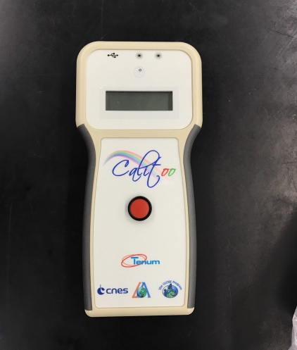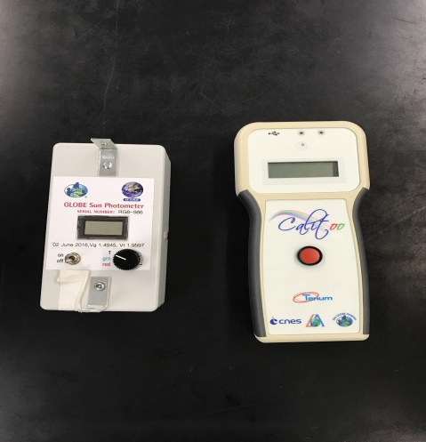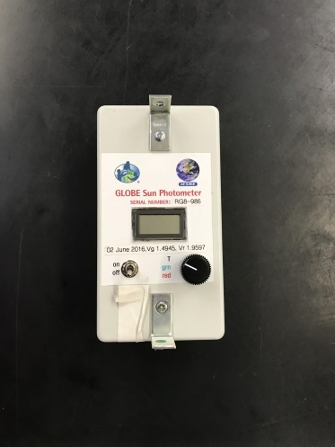
Figures 1-3: Figure 1 shows the GLOBE sun photometer (pictured on the left) and Figure 2 shows Tenum’s Calitoo which calculates AOT directly (pictured in the middle). Figure 3 shows both photometers compared side by side.

Figures 4 & 5: Figures 4 and 5 indicate the area where measurements were taken (Crestwood High School, Dearborn Heights, MI 48127). Exact location: 42.320672 N, 83.293938 W.
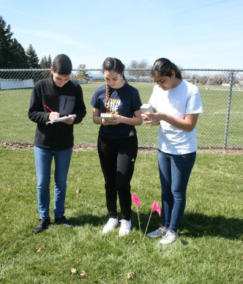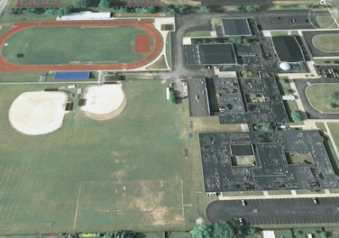

Figure 6: Unlike the GLOBE photometer, the Calitoo stores measurements directly after they are recorded. Data shown in this figure is from measurements taken in November. Data is downloaded and then entered into the GLOBE website and the spreadsheet. 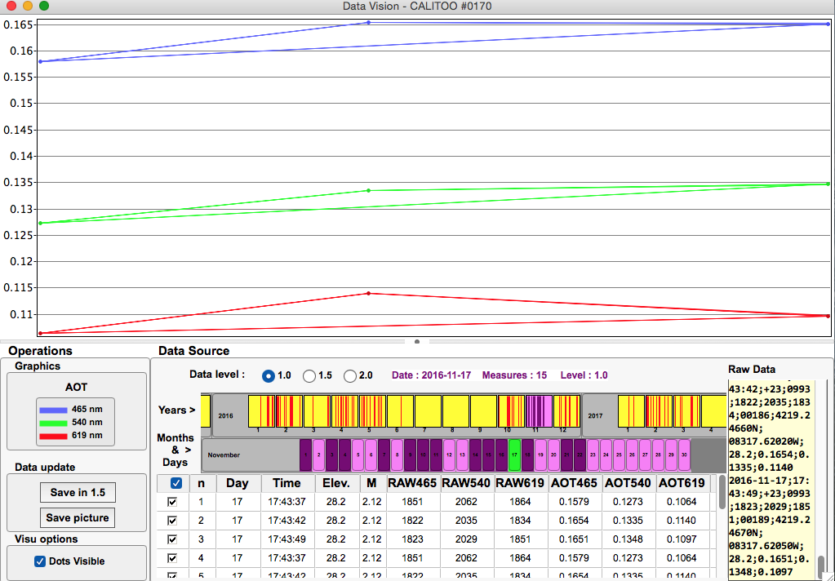

-GLOBE Data and Data Entry:
The readings on the GLOBE photometer are only accurate when the sun is out and the sky is not obscured. Fluctuations in the data may be due to a cloud passing over the sun while measurements were being taken or other incidents where the sun may not be fully visible. Similarly, Tenum’s Calitoo also takes data when the sun is out and automatically stores it, making it accessible to download. In addition to the data measured by the two photometers, surface conditions were recorded such as the presence of snow, ice, and standing water.

Table 1: Table 1 shows data stored in GLOBE’s database from Nov. 1st-Nov. 10th.

Figure 7: Figure 7 shows the surface conditions in the GLOBE data sheet. 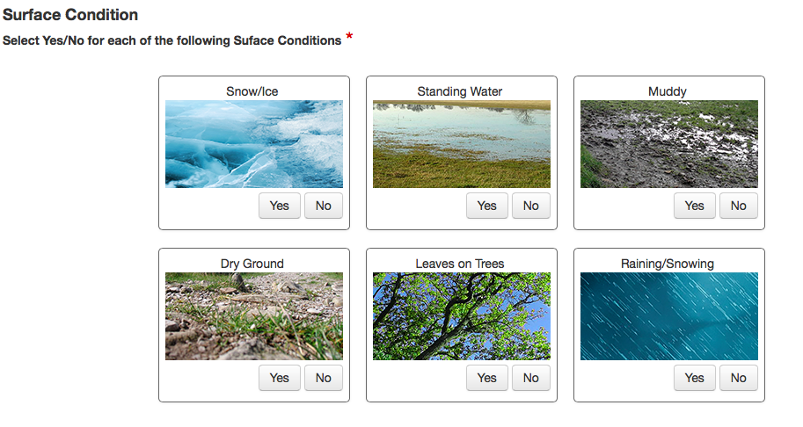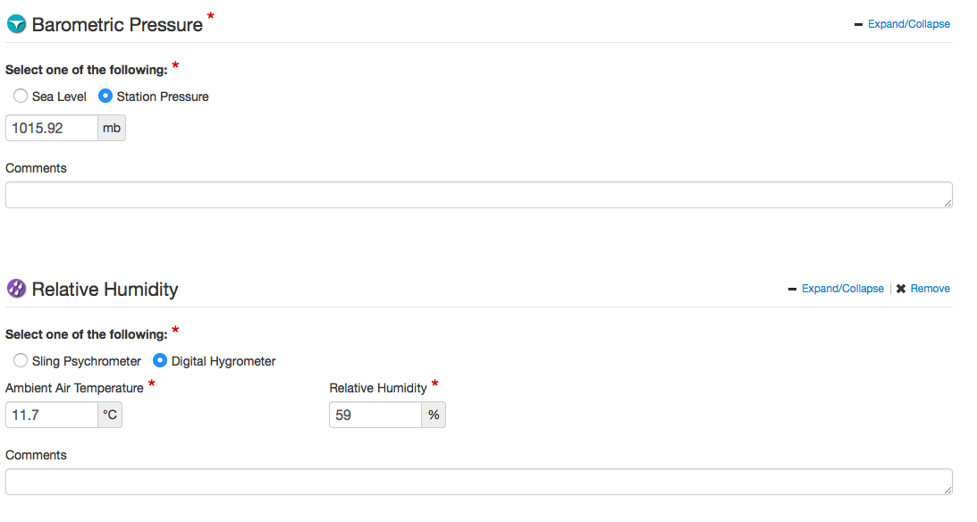
Figure 8: Figure 8 shows weather parameters in the GLOBE data sheet, excluding cloud coverage.
Results:
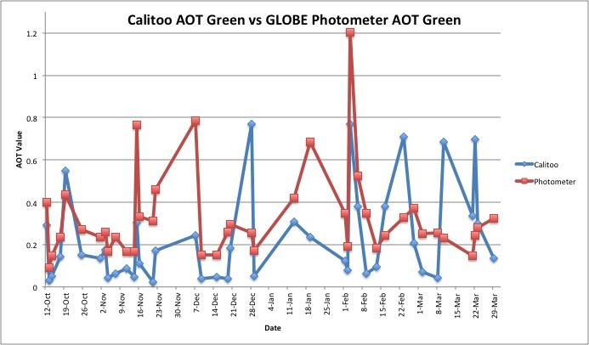
Figure 9: Tenum’s Calitoo and the GLOBE sun photometer are the two devices used throughout the year to test for AOT values. To verify these findings, a paired t-test was conducted and it was found that the p-value of 0.48906987 was greater than the alpha level of 0.05. This means that although the difference between the two green AOT measurements is not equal to zero, the data shows that the GLOBE photometer and the Calitoo collect very similar AOT values. However, more research is required to attempt to find if a difference is present. 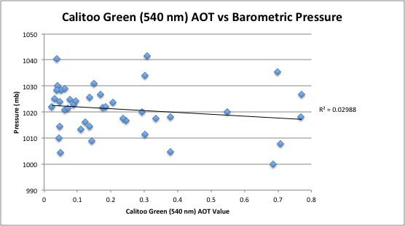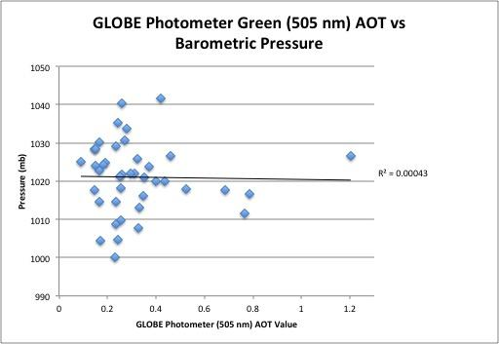
Figure 10 and 11: Barometric pressure is a weather parameter that has been measured throughout the year. The reason it was believed that there would be a correlation is that with increasing pressure comes clear, sunny skies and with low pressure comes cloudy conditions. As stated previously, aerosol measurements can only be taken on sunny days and so it was expected that there would have been more data on higher pressure days. After plotting the wavelength of 540 and 505 nm of the two devices in relation with barometric pressure, it was found that the r-squared value was very close to zero indicating no correlation.
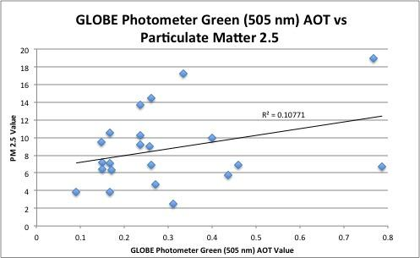
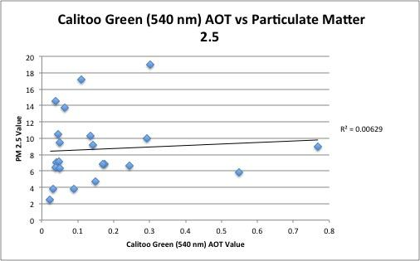
Figure 12 and 13: Researching particulate matter was important because correlation would mean that aerosol measurements could be an indicator of air pollution. Ultra fine particles (2.5 PPM) had no comparison with either the GLOBE photometer or the Calitoo. The data shown in the graph is only from data collected in the final months of 2016. Data of particulate matter was acquired from AirNow, a website that takes accurate readings of air quality for the area.
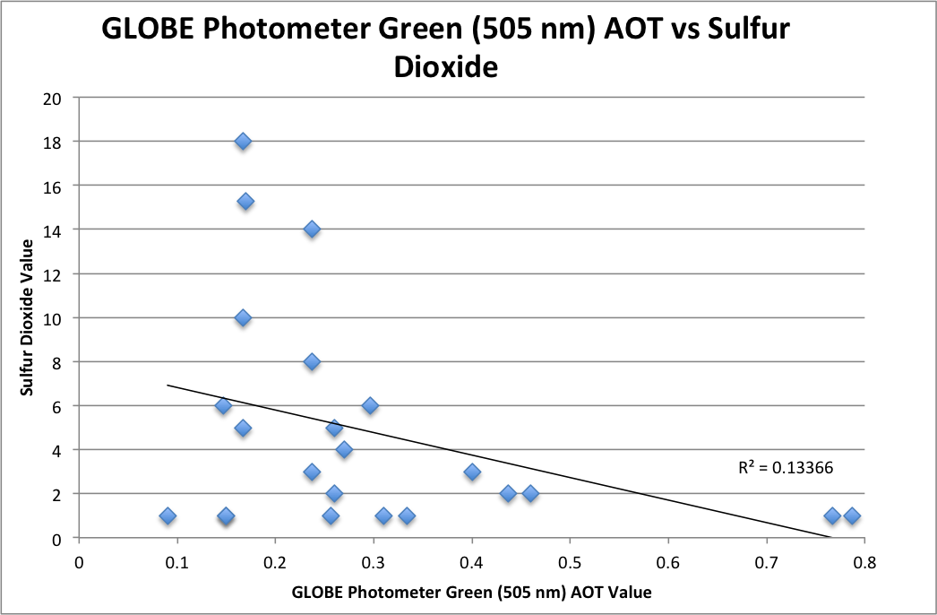
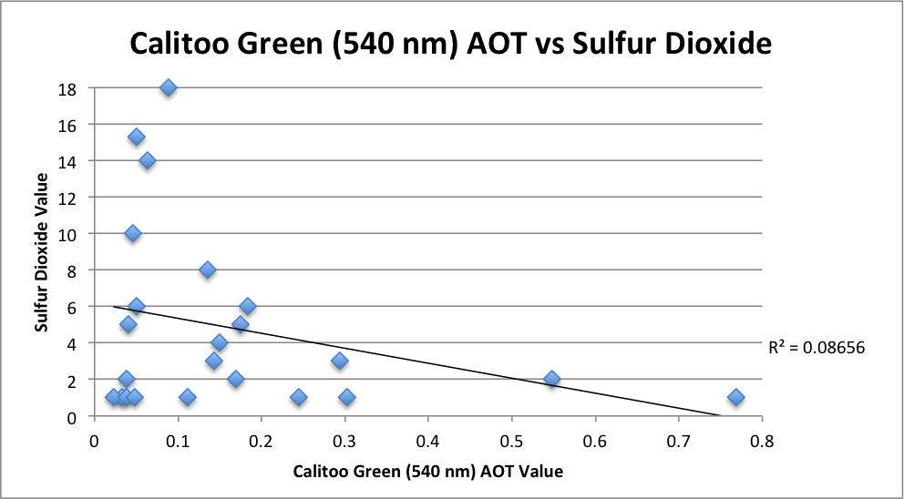
Figure 14 and 15: Sulfate particles are a form of particulate matter that can actually reverse global warming effects and so it was imperative to see their influence on aerosols. Sulfate particles did not correlate with data from any of the photometers as shown with a very low r-squared value. It is nowhere near the values of positive or negative one that expresses strong correlation. Data for sulfate particles was also collected from AirNow.
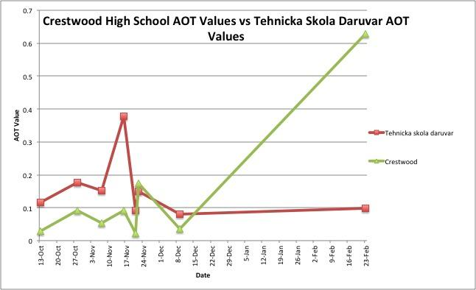
Figure 16: Data from Tehnicka Skola Daruvar, a site in Croatia, that used the same wavelengths was retrieved from GLOBE.gov and used to compare with Crestwood’s data. Only the days that both Crestwood and Tehnicka took measurements on were used to compare results, thus there were only eight days to compare between the two sites. After a paired t-test was conducted, a value of 0.799246192 demonstrates the failure to reject the null hypothesis that there is no variation between Crestwood’s data and the data from Tehnicka Skola Daruvar because the p-value is greater than the alpha value of 0.05. This indicates that the difference in means between the two sites is zero. As seen in the graph, an outlier in Crestwood’s measurements possibly lowered the likeliness for a more clear relationship between the two sites, which could have been a result of insufficient weather conditions such as a cloud blocking the path between the sun photometer and the sun at the time of the measurement. Also, because the data was only plotted if the measurements were taken on a common day, there were large gaps between the days, such as the three-month gap between the last points on the graph. Knowing this, it’s difficult to tell if the last point is really an outlier or if the AOT values were gradually rising, or if Tehnicka had any outliers.

Discussion:
After researching, no correlation was found between aerosols and barometric pressure, particulate matter, and sulfate particles, but there was a relationship between the two different devices and the two sites that data was collected from. This lead to the failure of rejecting all null hypotheses. However, there are various potential errors that could have affected the results and therefore made them inaccurate. Dr. Margaret Pippin made a contribution to the team’s research by pointing out negative AOT values in the GLOBE database. After several attempts by the team to interpret what caused this, Dr. David Brooks was finally contacted and he helped the team work the problem out. He also answered several questions that helped the researchers get a better understanding of aerosols. The problem was immediately fixed and the correct AOT values were calculated. The GLOBE website caused some difficulties, for the wavelengths of “red” and “green” on the Calitoo kept switching, although they are supposed to be constants. This can be further understood by looking at Figures 17 & 18. Another possible error could be a cloud passing over while measurements were being taken or hazy skies. This can cause fluctuations in data which will then lead to outliers in the research and inconsistent data.
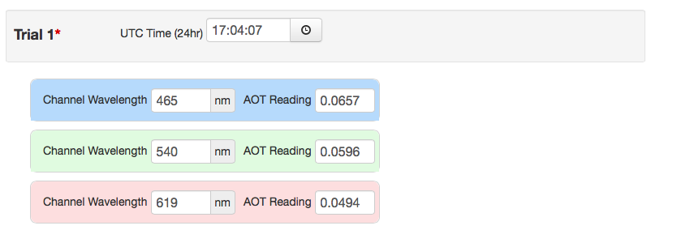
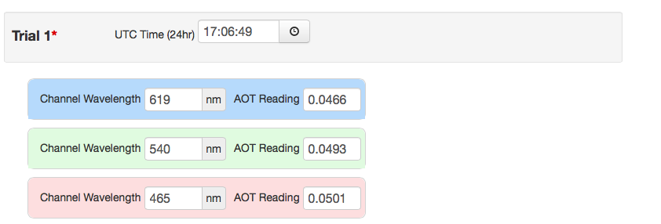
Figure 17 & 18: As mentioned in the discussion, the GLOBE website changed the wavelengths of the Calitoo several times, leading to a possible potential error. Each day was looked at individually and switched back to the normal wavelengths, but there still may be a chance of the website switching the wavelengths even after they’ve been looked over.

Conclusions:
To begin, similarities were measured between the two devices used to take data, Tenum’s Calitoo and the GLOBE photometer. After meeting the conditions of the paired t-test such as the paired data assumption, independence assumption, and the approximately normal test, it was found that the p-value was much greater than the 0.05 significance level. This means that the null hypothesis cannot be rejected. The p-value of 0.48906987 is not significant enough to claim that the devices have no differences but they do have some similarities. Nonetheless, it is important to compare these devices to ensure accurate data is being recorded on a topic that is already not well understood. In regards to the effect of barometric pressure on aerosols, it seemed likely there would be a correlation due to the trends of atmospheric conditions with high/low pressure systems. After measuring air pressure throughout the school year and then conducting statistical tests, it was found that the r-value is so close to 0 that there is no correlation between the two. As for particulate matter and sulfur dioxide, research was conducted because a correlation between the two could lead to a further understanding of the effect aerosols have on air pollution. However, after graphing and studying the r-values of the graphs, it was confirmed there is no correlation. The GLOBE photometer had a stronger relation with particulate matter and sulfur dioxide, whereas the Calitoo was more comparable to barometric pressure. Data shown in this paper was measured between October and March, at the same time each day whenever possible. These tests enabled the researchers to discover the influences of some atmospheric conditions on aerosols and the comparison of two prominent devices that are currently being used to study aerosols to ensure accurate data. In the future, the group members hope to be able to measure aerosols at a site with higher levels of air pollution such as an airport to see the effect of them there. However, the group was able to compare its results with another site in Croatia, in which they found a correlation between the AOT values of the two sites. Therefore they were unable to reject the null hypothesis that there wouldn’t be any variations amongst the two sites. They also hope to test how aerosols can vary seasonally and what factors may contribute to this. Overall, they are pushing for more attention brought to this very significant topic.

Bibliography:
To conduct this research, several materials were used. Tenum’s Calitoo and the GLOBE sun photometer were both used to take data. An app downloaded called WeatherBug and “weather.gov” gave several weather parameters that were used to convert to the necessary units such as inches of pressure to millibars. The data was then input to the website “Globe.gov.” On the GLOBE site, red VOs, green VOs, sun voltage, pressure, cloud coverage, humidity, temperature, etc., were entered and recorded. After the data was sent, the GLOBE website calculated the AOT value. The data was later put into a spreadsheet on Google Sheets. With the help of Dr. Brooks, his excel file calculator also determined the correct red and green AOT values. Also, AirNow, EPA, OSS, and Earth Observatory were all used to research aerosols and get a better understanding in what they are and their true impact on the environment.

Addendum:
The group that conducted this research consisted of five members who all contributed in their own unique way. Hana Salami took the data using the Calitoo while Ali Eter took measurements using the sun photometer simultaneously to be as accurate as possible. Maysam Aidibi recorded the values of the sun photometer in a notebook and documented the everyday weather conditions. Leanne Alawieh and Sara Komaiha later inputted this data daily onto the GLOBE database analyzing the data as time went on. The group as a whole graphed the data and took notice on the differences and similarities.

Works Cited:
"Atmospheric Aerosols Can Significantly Cool down Climate." Phys.org - News and Articles on
Science and Technology. N.p., 5 Apr. 2013. Web. 02 Apr. 2017.
Chambers, Lin. "Latest News and Events." Home - GLOBE.gov. NASA, n.d. Web. 02 Apr. 2017.
Ichoku, Charles. "Earth Observatory." NASA. NASA, n.d. Web. 02 Apr. 2017.
Marshall, Bob. "WeatherBug." Local and National Weather Forecasts, Radar & News. Robert S.
Marshall, n.d. Web. 02 Apr. 2017.
Pruitt, Scott. "AirNow." EPA. Environmental Protection Agency, 29 Mar. 2016. Web. 02 Apr.
2017.
Pruitt, Scott. "Download Daily Data." EPA. Environmental Protection Agency, 13 Mar. 2017.
Web. 02 Apr. 2017.
Reisman, John P. "Atmospheric Aerosols." OSS Foundation. N.p., 15 Feb. 2014. Web. 02
Source: “Crestwood High School.” 42.320672 N and 83.293938 W. Google Earth. April 03, 2017.
Uccellini, Dr. Louis W. "National Weather Service." National Weather Service. Mary C.
Erickson, n.d. Web.c c

