

**NOTRE DAME SCHOOL**

Science Fair 2019

How Can You Make Your Own Solar-Powered Oven?

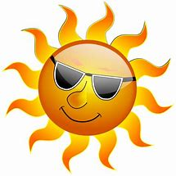 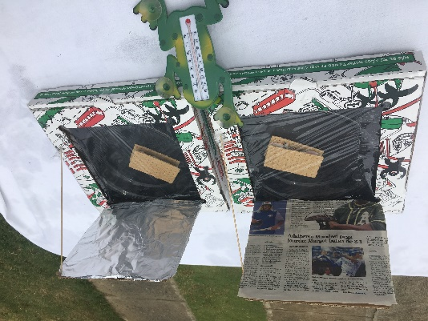

**Members:**

Carolina Dauhajre

Kevin De Oleo

Fredy Fernández

Sebastián Magadan

Ian Slaiman

**Grade/Section:**

7th A

**Teachers:**

Ms. Nadejda Kennedy

Ms. Katherine Bernier

Santo Domingo, April 25th, 2019.

**Table of Contents**

Abstract 3

Research Questions 3

Introduction 4

Methods 5

Materials 5

Procedure 6

Results 6

Discussion 10

Conclusion 11

Acknowledgements 11

References 12

## Abstract

Our project is about building a solar-powered oven. By using a cardboard box, aluminum foil and varying insulation materials, we'll find out a version allowed for the greatest change in temperature, and thus the greatest amount of solar energy captured. Both ovens must be identical in structure and have the same food to be cooked, placed under the sun next to each other the only difference will be the type of material used to boost their cooking power. We thought that the oven with the aluminum foil booster will be the most efficient one, and after running some trials we were proved right; S’mores actually cooked and average of 11 minutes faster than newspaper booster oven.

Our experiment is important because it could help people save money and survive, it also helps the planet by protecting the environment. Living in a country located in the Equator, the sun is available to use all year round.

The future goal will be to make a more efficient and durable solar cooking to help the environment while helping people save money.

Key words: **Solar energy, cooking, environment, temperature**.

## Research Questions

The purpose of this experiment is to try to use solar energy for cooking occasionally or during an emergency. Solar power is free and clean energy that doesn’t hurt the environment, normal ovens uses fossil fuels to function harming the environment and it is also a limited resource. With simple materials a solar oven can be created, but how can you make the most powerful solar oven using pizza boxes? It would be the one with the newspaper booster or the one with the aluminum foil booster.

After thinking about it, we stablished that our hypothesis will be that the oven with the aluminum foil booster will cook faster than the newspaper one.

## Introduction

With the threat of climate change, renewable energy is becoming increasingly important year by year. The sun produces both heat and light energy, which make the Earth bright and hot during the day. Solar-powered ovens harvest that energy from the sun, they could use it for camping, for a picnic day, or to cook when a natural disaster happens. There are 4 main components to most solar cookers Concentration (of the sun's rays is performed most often by reflecting panels, petals and such surfaces that can "focus" or concentrate the rays of light (UV) to a point or concentration), Absorption (ability to attract or hold heat of the sun's energy), Retention (means or capacity to retain heat, allowing it to accumulate and to "build up" to sufficiently high enough levels to be able to effectively cook) and Transparency (This ability of the sun to penetrate is usually achieved by using clear glass, or plastic coverings on a solar cooker lid/door/enclosure which then in turn acts as an inhibitor, trapping the heat as well). The reason behind this experiment is that the Dominican Republic is affected by hurricanes from time to time, and when a hurricane strikes, all systems are shut down, sometimes during weeks, so we thought that by doing this experiment families could at least cook during this time without affecting the environment using timber or coal. Our idea is based on some studies, like “Recent Investigations in the Use of Solar Energy for Cooking” (G. Lof, George O. 1963) and Baking in the Sun (Curtis, Darwin. 2001). Solar cookers were discussed and presented as an alternative of conventional ovens in under develop areas of the world.

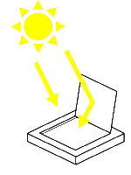

Illustration 1: Solar cooking

## Methods

The Independent variable of this research is the type of material used to boost the oven, meaning the newspaper and the aluminum foil. The dependent variable is the cooking time, which will give us the result of which oven version cooks better. For the control variables we have the type of food to be cooked and the basic structure of the oven, being really important to have exact pair of everything to have accurate results.

Below the weather conditions according to our school weather station:

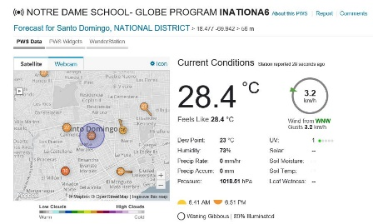

The experiment was made in “Los Prados” neighborhood approximately 1.2 kms from this weather station on March 23, 2019. Because of the weather conditions 3 attempts were made in order to generate accurate results.

Materials

1. Two pizza boxes of the same size.
2. A stack of flyers on a table

   Description automatically generatedAluminum foil to line the inside of one box, including the lid.
3. Black paper to line the bottom of both boxes.
4. Newspaper to line the inside of the other box, including the lid.
5. Plastic wrap to cover the top of both boxes.
6. 1 roll of masking tape.
7. Glue sticks.
8. A thin stick to prop the lid open.
9. Scissors.
10. Clock or stopwatch.
11. Two clear glass plates of the same size and shape.
12. Thermometer and digital thermal thermometer.
13. Marshmallow, Graham Cookies, Chocolate.

## Procedure

First, prepare your boxes by cutting a three-sided flap, one inch from each side of the box lid. You should have a flap that can be lifted up out of the lid. Next, line the inside of one box and the inside of the flap you cut with aluminum foil. Glue the foil in place. Line the second box but repeat this step with newspaper instead of aluminum foil. Glue one piece of black paper to the bottom of both boxes. Now, assemble your raw S'mores. Place one marshmallow and one piece of chocolate on one graham cracker. Cover it with another graham cracker. Make two S'mores. Place your S'mores inside each box. Open the flap on top of the box and cover the opening with plastic wrap. Seal the plastic wrap with masking tape. Use the stick to prop open the boxes an equal amount. Now, place both boxes in the sun and wait for the S'mores to cook. Then, when the marshmallow increases in size and the chocolate starts to melt, the S'more is done. Record your time in the data table. Finally analyze data and make conclusions.

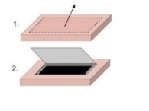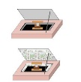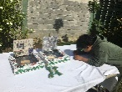

## Results

For the first attempt, it took the aluminum foil boosted oven 1 hour and 15 minutes to cook the s’more and it took the newspaper boosted oven 1 hour and 22 minutes to cook the s’more. The climate went from semi-cloudy to sunny.

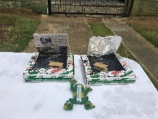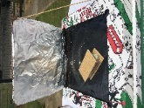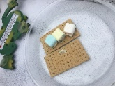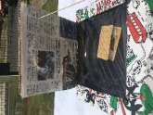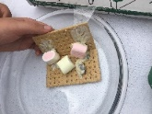

For the second attempt, it took the aluminum foil boosted oven 30 minutes to cook the s’more and it took the newspaper boosted oven 44 minutes to cook the s’more. The climate was sunny.

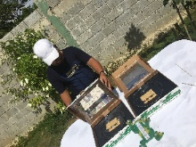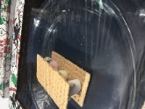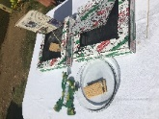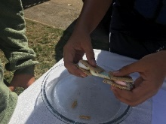

For the third attempt, it took the aluminum foil boosted oven 45 minutes to cook the s’more and it took the newspaper boosted oven an hour to cook the s’more. The climate went sunny to semi-cloudy.

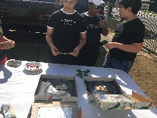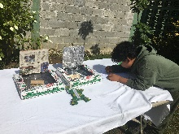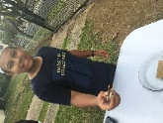

Attempt 1: Graphics results

Data table:

**← 7 minutes faster**

|  |  |
| --- | --- |
| **Material** | **Time for S'more to cook** |
| Aluminum foil | 1 hour, 15 minutes |
| Newspaper | 1 hour, 22 minutes |



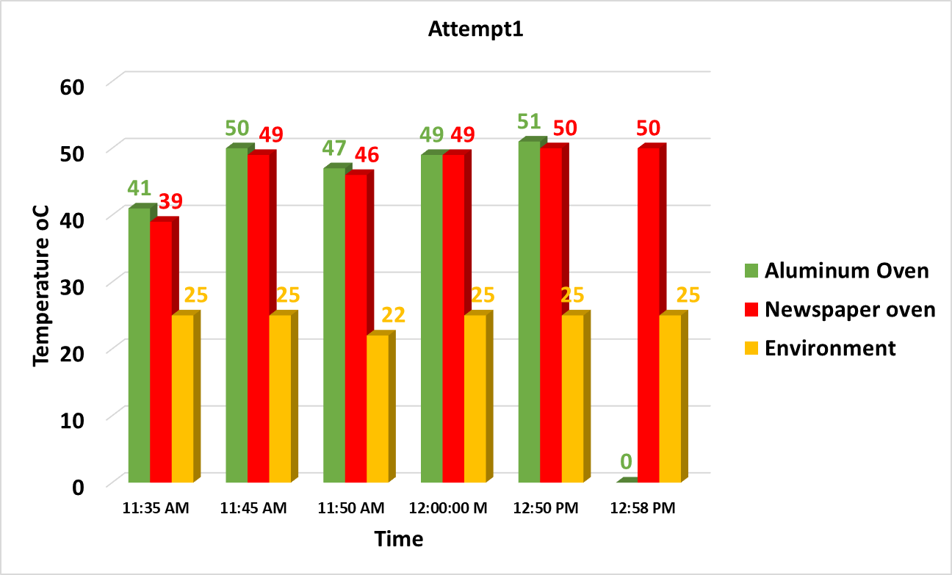

Attempt 2: Graphics results

Data table:

**← 14 minutes faster**

|  |  |
| --- | --- |
| **Material** | **Time for S'more to cook** |
| Aluminum foil | 30 minutes |
| Newspaper | 44 minutes |



Attempt 3: Graphics results

Data table:

**← 12 minutes faster**

|  |  |
| --- | --- |
| **Material** | **Time for S'more to cook** |
| Aluminum foil | 45 minutes |
| Newspaper | 57 minutes |



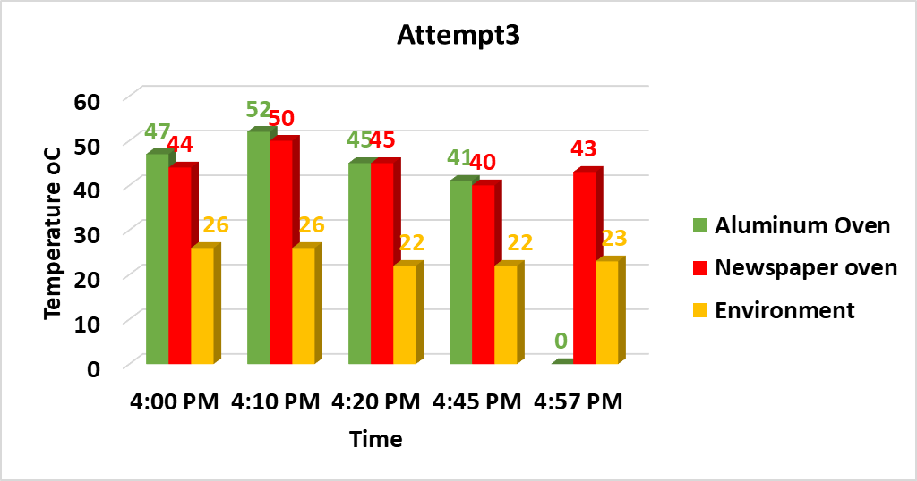

Overall: Graphics results

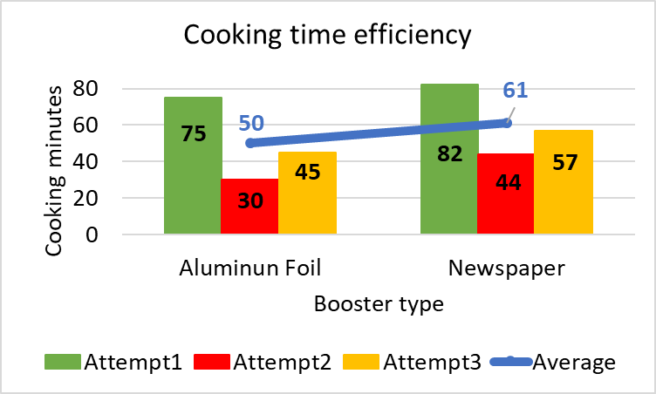

## Discussion

Even though at times it was cloudy, the ovens succeeded in cooking their s’mores. The black construction paper help keep up the heating temperatures. There was not a lot of difference between both of the ovens when it is cloudy. The plates were warm after each trial.

In the aluminum oven, we saw higher temperatures generated because the material reflects the sun to even warm more the oven. At all 3 attempts, the aluminum foil oven worked better. In the newspaper oven, when it is sunny, it doesn’t keep up as much as it does when it’s cloudy because it only works with the temperature at the moment, since newspaper can’t reflect the sunlight. Aluminum foil works better than newspaper when it is sunny.

Comparing our project to the ones cited on the introduction we discovered that in order to work efficiently solar oven must be exposure to sun light the whole time, and that a reflective surface is needed. As you can notice in the difference between Attempt 1(cloudy) and Attempt 2 (sunny)

A future research project will be to make a more efficient and durable solar cooking oven by using aluminum sheets perhaps a concave structure similar to a satellite dish.

## Conclusion

Our ovens work, no matter if it’s cloudy or sunny, but it works faster when it’s sunny. Aluminum Foil boosted oven worked better because this material reflects the sunlight giving the oven an extra source of heat to raise the cooking temperature (as its notice in attempt 2 and 3). Newspaper though, only depend of environment temperature. Our hypothesis was correct, aluminum foil worked faster than newspaper. Tested in sunny to cloudy conditions in average it cooks 11 minutes faster. Some rural communities in our country can benefit from these findings since we are located near the equator.

## Acknowledgements

We would like to thank our teachers Ms. Nadedja and Ms. Katherine for their guidance to make this project possible; and of course, our parents for the support given.

## 

## References

1. Robb, Amanda. Solar Oven Project. Retrieved from: study.com/academy/lesson/solar-oven-science-project.html.
2. Cantina west. How Does Solar Cooking Work? Retrieved from [www.solarcooker-at-cantinawest.com/solarcooking-howitworks.html](http://www.solarcooker-at-cantinawest.com/solarcooking-howitworks.html).
3. Weather Underground. “NOTRE DAME SCHOOL- GLOBE PROGRAM.”, Retrieved from www.wunderground.com/personal-weather-station/dashboard?ID=INATIONA6.
4. G. Lof, George O. (1963). Recent Investigations in the Use of Solar Energy for Cooking. SOLAR ExEnGY Vol. VII.
5. Curtis, Darwin. (2001). Baking in the Sun. Retrieved from https://earthobservatory.nasa.gov/features/RenewableEnergy/renewable_energy4.php.
6. Bartl, J and Baranek, M. Emissivity of aluminium and its importance for radiometric measurement. Institute of Measurement Science, Slovak Academy of Sciences
7. Science Reference Services. Solar Ovens and Solar Cooking. Retrieved from: https://www.loc.gov/rr/scitech/SciRefGuides/solarovens.html#tech.