Quality of ecosystem Nespolder
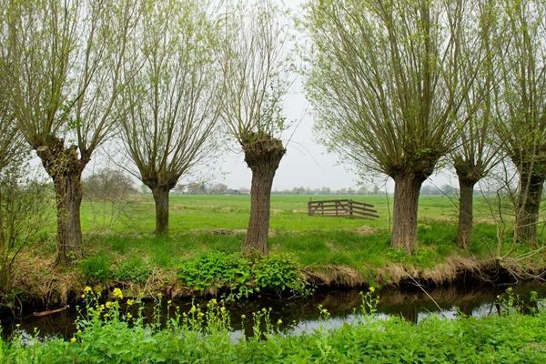

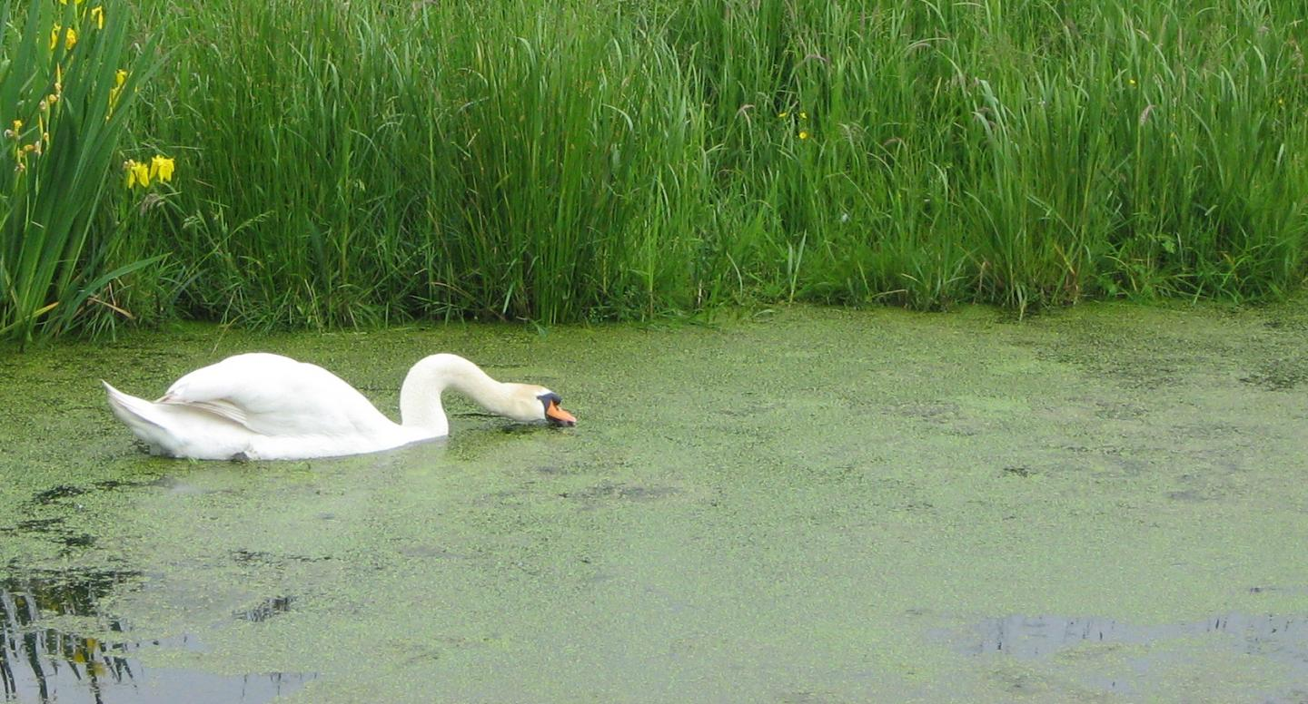

Made by: Max Halling,
Matthijs van Schaik,
Laszlo Stas
Schoonhovens college

Table of contents
Introduction 3
Research question 3
Hypothesis 3
Experiment 1 4
Introduction 4
Material 4
Method 4
Results 5
Conclusion 6
Discussion 7
Experiment 2 8
Introduction 8
Materials 8
Method 8
Results 8
Conclusion 10
Discussion 10
Experiment 3 11
Introduction 11
Materials 11
Method 11
Results 12
Conclusion 13
Discussion 13
Experiment 4 14
Introduction 14
Material 14
Method 14
Results 14
Conclusion 15
Discussion 16
End Conclusion 17
End Discussion 19
Sources 20
Logbook 21
Appendix 23

Introduction
In this experiment we’re going to be investigating if the quality of the ecosystem Nespolder in the spring of 2019 is up to par. The main factors which contribute to a well functioning ecosystem that we are going to be testing are the biodiversity of plant and animal life and the quality of the water in the Nespolder. Does the water contain enough minerals for aquatic plants and animals to thrive or is there a shortage/surplus of them. After looking at this we will be able to conclude what the quality of the ecosystem is and deduce if any changes can be made to improve the ecosystem, or in other words, if we need to adjust something in the ecosystem to put create balance between everything; animals, plants, biotic factors, abiotic factors and connections between them.

Research question
What is the quality of the ecosystem in the Nespolder and is there a biological balance?

Hypothesis
We think that the quality of the ecosystem of the Nespolder relatively good is in comparison with other similarly looking pieces of nature. This is however based solely on looks and expectations and the things an ecosystem needs to be considered healthy and in balance. We expect based on seeing a diversity of plants, animal and an overall natural look that the biological balance rather good is

Experiment 1

Introduction
The first experiment that we have conducted has consisted of measuring what abiotic factors are present in the ditches and pond and the quantity of these abiotic factors. We have measured the depth, clearity, temperature and the amount of nitrate and phosphate in the water. We have measured all of these things in multiple locations and repeated them multiple times to ensure that our results are consistent and that what the differences are between places in the ditches. The amount of minerals is very important for the growth of aquatic plants and things like temperature can depend on factors other than the ecosystem itself so these result are a combination of very important factors and factors that have almost no impact on the actual ecosystem

Material
- Waterthermometer
- Depth sounder
- Green-kit
- Waste bottle
- Net for water samples

Method
The way the experiment was executed is the following; we dipped the water thermometer is water for around 10 to 20 second and then quickly looked at the temperature to make sure that it didn’t get any higher because it was out of the water. This process was repeated multiple times to be sure of our results. After completing the first test we continued on to measure the clarity of the water with a black and white disc, We lowered the black and white disc into the water and looked at how deep we could lower it until the disc wasn’t visible anymore. The next test was to measure the depth with a depth sounder, we did this in multiple places in the ditch. We started with looking how deep the side of the pond was and continued with the middle of the ditch. This was followed up by us also taking a couple of water samples which we searched for phosphate, nitrate, the Ph level of the ditch and presence and quantity of floating debris.

Results
The first thing we researched was the amount of abiotic factors in the water, things like floating debris and the amount of mineral present. Information like this can show us what state the water part of the ecosystem is in, like what the ratio is between the amount of life and the amount of minerals in the water in short if there’s a shortage or overflow of minerals.
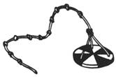
We’ve found that the clarity of the water quite a bit worse was than the clarity of lakes or rivers which is to be expected since they are a lot deeper and more difficult to have water plants grow in. The visibility was actually up to par with other ditches in the netherlands. The testing however is not completely accurate since we had to use our eyes for this test which introduces the factor of human errors. We could see the black and white disc up to a depth of 20 cm.

The next test was looking at the temperature of the water to make sure that it wasn’t unnaturally hot or unnaturally cold. The results of this are sadly a lot more dependant on the time of year and day, This results in us not knowing the change of temperature during the year or even during the day. This test was done in the spring of 2019. The water temperature was 8 degrees celsius on the water surface and 5 degrees a bit lower into the ditch.This test has been done several times at several locations to insure that the results were correct.

We also looked at the average depth of the ditches of the Nespolder, which doesn’t vary a lot between ditches since all ditches are man made. The average depth off the ditches was 15 cm deep at the water's edge and about a meter to 1,5 meters deep in the centre of the ditch. This test is also not completely accurate since we had to rely on our eyes.

The most important abiotic factor that we measured was the amount of nitrate and phosphate in the water, the entire ecosystem can’t function without those two minerals. Plants need them to form proteins and other functions, and if plants can’t live somewhere properly than neither can other forms of life (not in all cases but mostly). So a deficiency in minerals can result in the downfall of an ecosystem but a surplus of minerals is also a very big threat since eutrofiering could occur. EUtrofiëring is the phenomenon when too much nitrate and phosphate from artificial fertilisers drains into the ditches, making it possible for plants to completely take over the ditch and blocking out all sunlight from going into the water. After taking a water sample we tested the water for nitrate and phosphate, the results were indicated on a scale of 1 to 5 parts per million for phosphate. The amount of nitrate was on a similar scale but this one was from 0 - 40 parts per million. The amount of nitrate was 20 parts per million at all places where we took samples but the amount of phosphate varied in places, the amount of phosphate near the edge of the water was 2 parts per million. But there was a little bit less phosphate in between the plants and in the middle of the ditch this was about 1 to 1 ½ parts per million.

The Ph level of the ditch was in all the spots we tested the same, we measured the Ph to be 6 what means that the water is slightly acidic this perfectly aligns with most bodies of water and is ideal for life in water to grow. Natural water can never be a perfect 7 but we were pleasantly surprised to see the Ph of the ditches to be so close to the ideal Ph and it perfectly fits into place with the amount of organic growth in the water as well.

 | Water edge(surface) | In Between plants | Centre of the ditch
Amount of phosphate | 2 ppm | 2 ppm | 1,5 ppm
Amount of nitrate | 20 ppm | 20 ppm | 20 ppm
Depth | 15cm | 1m | 1,5m
Temperature | 8 degrees | 6 degrees | 5 degrees
Ph | 6 | 6 | 6

Conclusion
After looking at the balance between abiotic factors in the water in the Nespolder and comparing it to the norm of ditches in the netherlands we think that it’s safe to conclude that the quality based on the amount and kind of abiotic factors is quite good. The best possible ratio between all abiotic factors is: 20 ppm nitrate and 2 ppm phosphate and as little debris as possible, the temperature doesn’t really contribute to the quality a ditch has since some organism require colder places and other prefer warmer water. The ratio between Phosphate and Nitrate is good, the Ph is is basically perfect and the overall amount of debris in the water isn’t that high. It is quite difficult to say this with certainty since most of it is based on observing rather than gathering substances and examining them. And the location of the ditch is also very important to it’s quality, for example if a ditch is close to a farm which most are than it is easier to have a surplus of minerals in the ditch.

Discussion
Mistakes we might have made during this experiment include things like making a mistake when looking what our depth sounder says, or using our eyes to measure anything at all isn’t as reliable as actually measuring something. Another mistake we could have made with the depth sounder is the angle at which we threw it into the water, to get to the middle of the ditch the depth sounder needed to be partially diagonal. Since there was only once bridge we could only lower the sounder straight down into the water in one spot. It’s also possible that the temperature noted isn’t completely accurate since we took it out of the water to look at what temperature it said. Because of al these small mistakes it was an absolute necessity to do all of these experiment multiple times to make sure that all of our data was correct.

Experiment 2

Introduction
During this experiment we researched which and how many decomposers were in this ditch we researched. Not only did we do this on one spot, but on different places in the ditch; we think that we can find bacteria in the middle, on the sides and between the vegetation of the ditch.

Materials
For this experiment we used different materials:
- Nutrient mediums
- plastic pipettes
- Net for the water samples

Method

First we went to stand on a small bridge that went over the ditch, in this way we had a better position to reach all the different spots from the ditch. Then we took a sample from every spot in the ditch (the middle, the side and between de vegetation) from these samples we put a few drops (3ml) into different petri dishes. We numbered these dishes from 1 to 3 and we put them aside to look at later at school. These dishes were put in the stove for 24 hours at a temperature of 37 degrees. From these drops bacteria colonies have grown. We have taken a look at them with the microscope and drew some of them.

Results
After returning from the Nespolder and back at school we took a look at the grown bacteria colonies. We’ve seen that the most bacteria/fungi colonies are located between the water plants, this is actually pretty logical since the fact that this is a place in the ditch where lots of nutrients can be found for the bacteria. We were able to count a total amount of 40 different colonies in the petri dishes from the rich spots from the ditch. This came out of a pipette with a volume of 3 millimeters, which means that there are per 100 millimeters about 1333.4 bacteria. This is a good sign because this shows that there are more than enough decomposers available in the water. Without these decomposers the final step from the circle of life can not be completed.
3 milimeter | 40 bacteria
100 millimeter | 1333.4 bacteria

The second most bacteria colonies have grown out of the water drops that we took from the side of the ditch. At school we were able to count around 30 different colonies in the petri dish which were formed out of 3 millimeters of water. This means that per 100 millimeters there are about 1000 bacteria.

3 millimeters | 30 bacteria
100 millimeter | 1000 bacteria

The least amount of bacteria were to be found in the middle of the ditch. This as well makes sense because in the middle of the ditch are the least amount of plants so there are less plants which can provide nutrients and food for the bacteria to live. We were able to count 28 bacteria colonies out of the 3 millimeters of ditchwater. This means that there are around 933 bacteria in 100 millimeters of ditchwater.

3 millimeters | 28 bacteria
100 millimeters | 933 bacteria

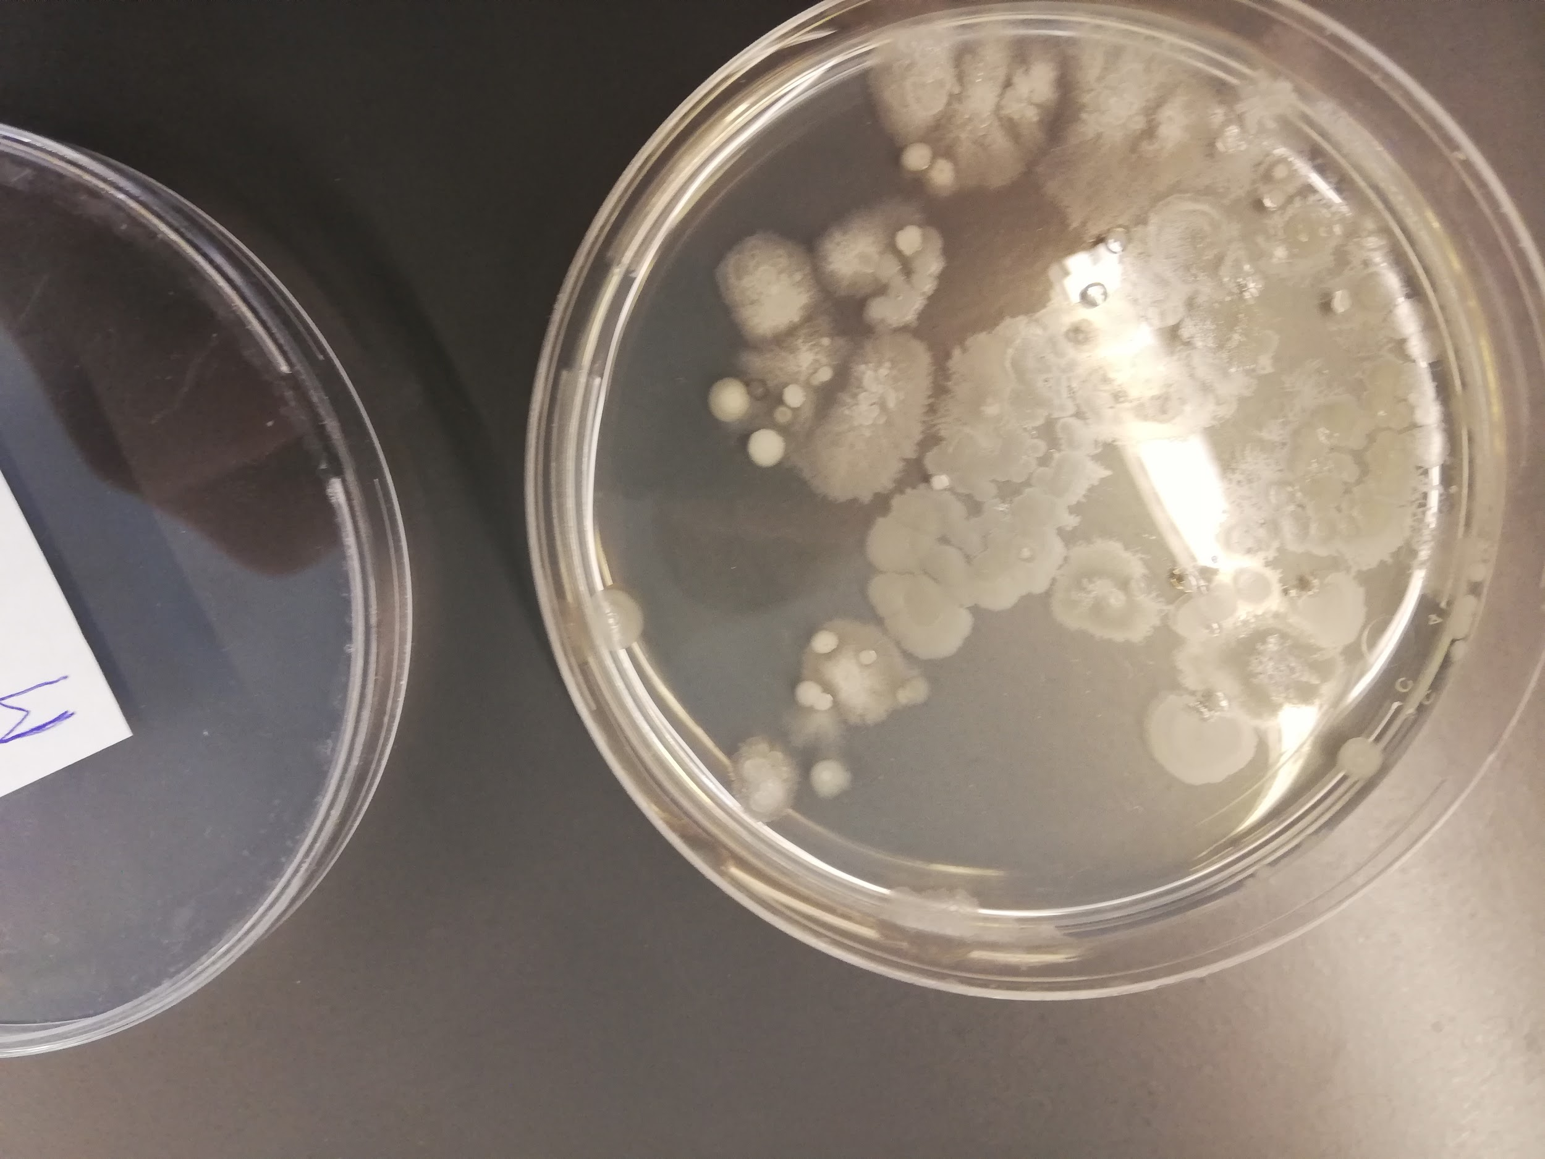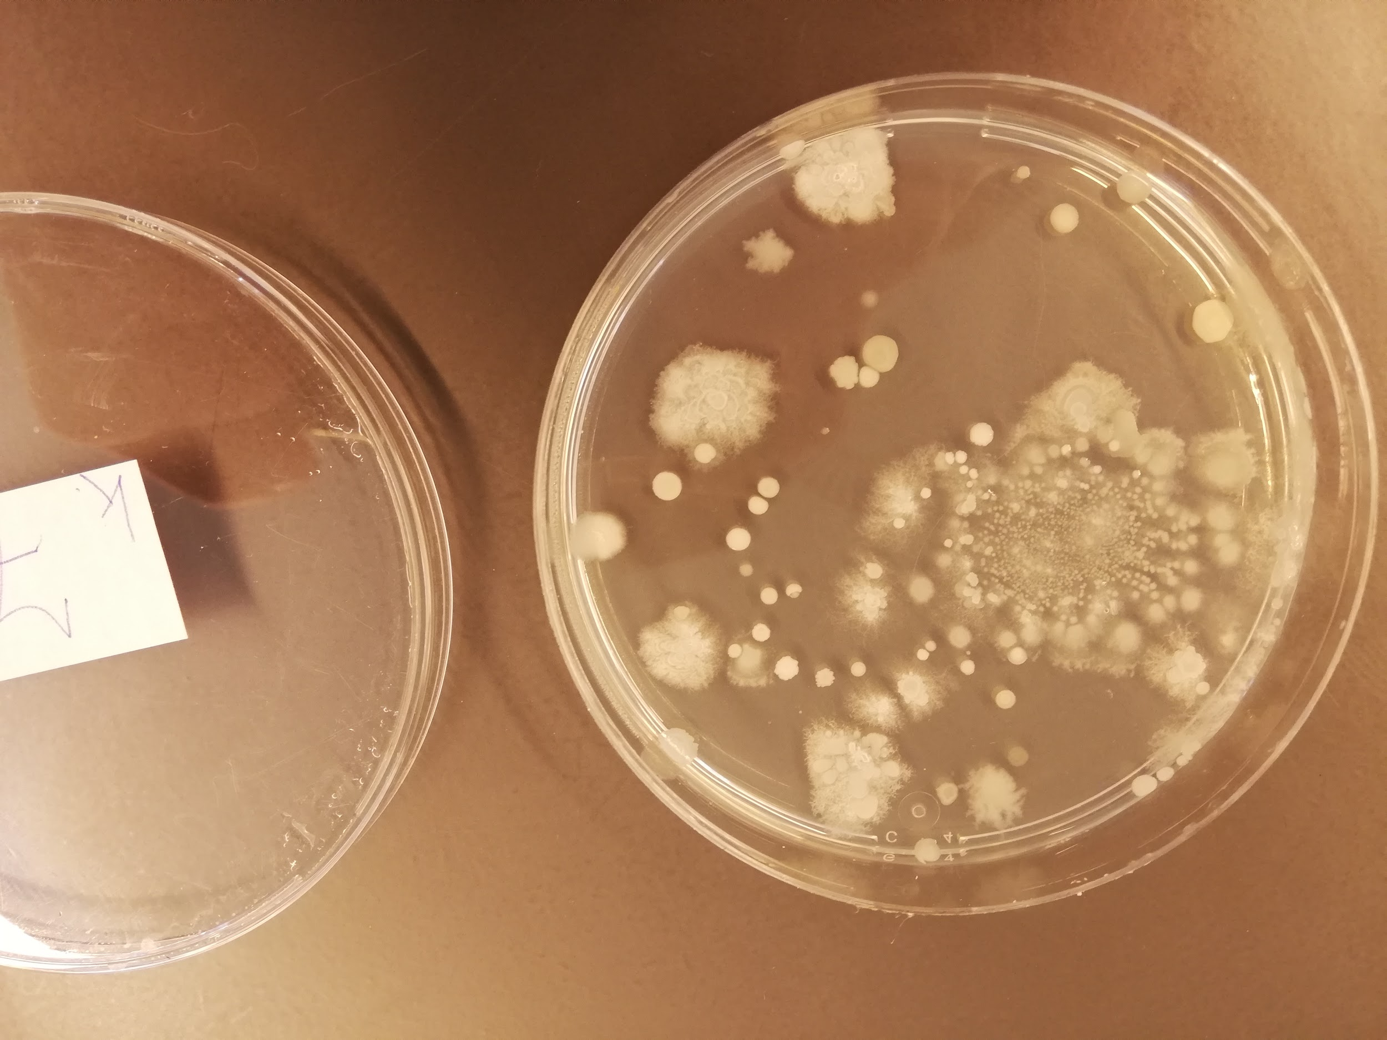
Middle of the ditch Side of the ditch
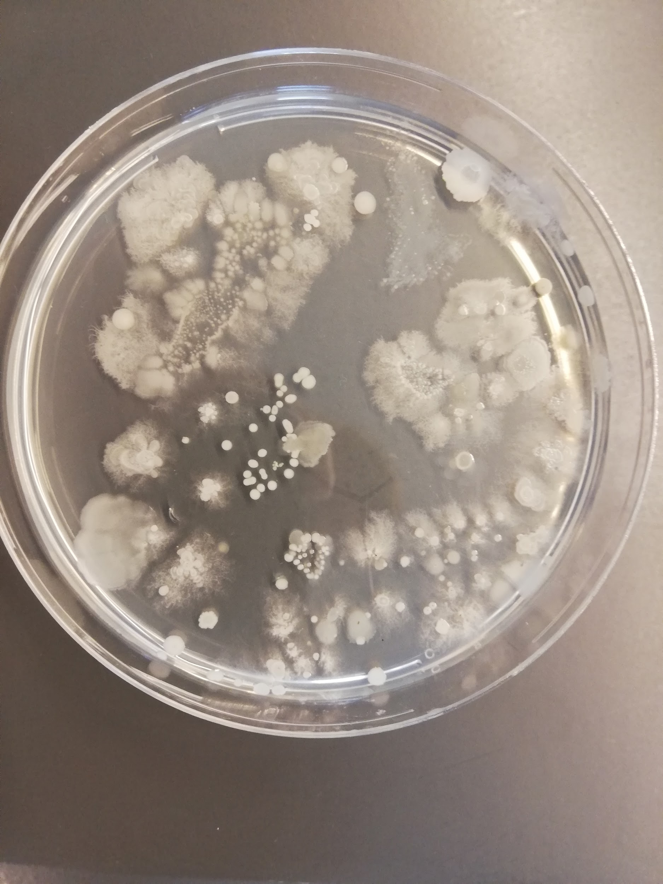Between the vegetation in the ditch

Conclusion
There are plenty of bacteria/decomposers in the ditches in the Nespolder. Because looking at the numbers it is a good amount of decomposers to have in a ditch. These contribute to a healthy ecosystem. When there wouldn’t be enough decomposers the last step of the circle of life would not be able to complete in a proper way because the dead plants and animals in the ditch will not be able to decompose. What is interesting to see is that the different kinds of bacteria/fungi are present in one water sample, as is seen from the colonies under the microscope. For the water on the side it was to be expected that there were a lot of bacteria to be found since the water on the side is warmer than in the middle or between the vegetation. Our numbers will probably not be 100% accurate, but the important thing is that we have the ratio. The most bacteria are to be found between the vegetation in the ditch, in other words; in slow to not moving water.

Discussion
This experiment is reasonably reliable, however, there are some points in which we could have worked a bit more precise. One of those points is that we have used the same net, cup and pipette for all of the three samples. There is always some water left behind in the cup and pipette, so also some bacteria. This can cause that some bacteria from the middle of the ditch ended up in the petri dish of the side of the ditch or the other way around. This has most likely not happened on a huge scale, however, it would have had a small influence on our results. Next to that, we haven’t tested this on different ditches, we have only taken three samples from one ditch. For a more accurate result we could have tested other ditches, unfortunately we had run out of petri dishes.

Experiment 3

Introduction
In the third experiment we have done research on which and how many plant and animals live around and in the ditches. We can split up these plants in 5 different categories;
- Floating plants;
- Submerged plants;
- Plants that root in the bottom of the ditch (shoreplants);
- Swamp Plants;
- Broekbos.
Before doing this experiment we thought that there would be a lot of plants on the shore and in the middle of the ditch.

Materials
We have used the following materials for this experiment:
- Cup for a water sample
- Flora
- Plants search cards
- Neat
- Near for a water sample

Method
The first important task that had to be done was to look and see if there were any species of trees or bushes that were distinct species, our objective was to find 5 to 10 of them. We looked up the names of the trees and bushes and continued on by looking for different types of flowers that grow in or near water. Not all of the species found were known by us so we had to look them up in a nature guide. A part of the experiment was to draw the plants so that it would be easy to remember what they looked like and so they are easier to describe and can confirm that the species we state we found actually lives in the Nespolder. A water sample was also taken and investigated in the lab for any types of microbiotic life forms, using a microscope a number of small aquatic plants were found.

Results
When we walked through the area we came past a great variety of trees and herbaceous plants. What surprised us is the great amount of differents species of trees that we came past, especially during the walk. Something that we have not seen is a high amount of duckweed. It did float on the water in some places but, there was no overgrowth of it. If there’s this is most of the times a sign that the ecosystem is out of balance. This is the list of plant species that we have been able to distinguish:

Tree species | Latin name
Willow | Salix alba
Poplar | Populus
Maple | Acer
Beech | Fagus
Birch | Betula
Oak | Quercus
Herbs
Field Sorrel | R. acetosa
Purple Dead Nettle | L. purpureum
Curly thistle | Carduus crispus
Daisy | Bellis perennis
Waterlily | Nymphaea alba
Rapeseed | B. napus
Stinging Nettle | U. diocia
After we searched for a variation of plant we also took some water samples, from the side of the ditch. We have looked at those samples under a microscope, by doing so we discovered that there was floating some very small duckweed in the water.
The drawings that we made from the various plants are added as an attachment, see page 23.

Conclusion
The fact that we have found various herbaceous plants and trees around the water means that there is much variability in the vegetation around the ditches. We have also found a little plant in the water with the help of a microscope, this means that there is not only vegetation outside of the water but also in the ditches. As described above we haven’t seen much duckweed in the water, This is a good sign. Too much duckweed can come to exist when there are too much ions that have washed out to the ditch. This process is called Eutrophication. When there is a lot of duckweed there comes less sunlight into the water, if that duckweed dies there comes less oxygen into the water via photosynthesis. This can result in a plethora of deaths over multiple species due to a disturbance in the food chain.

Discussion
The results from this experiment are very reliable. We have searched for a long time to find any other plants in this area that we were researching. Finally we have come to these results. If we had found an unknown plant, we would immediately grab the Flora and plants searching card to find out what plant we had just found. There is ofcourse a tiny chance that we mixed up the plants from the book and the plants that we have seen and in this way naming them wrong. However, we were very alert and concentrated so there is a really small chance that this could have happened. We could be able to

Experiment 4

Introduction
In the last experiment we looked at the amount of animals that inhabit the waters of the Nespolder. You can research this in a multitude of ways, for example by the use of a normal net or a net with a cup attach to it or you could even just take some mud from the bottom of the ditch and see if you can find any animals in that sample. It might sound strange but there are a lot of really small organisms that inhabit the muddy bottom of the ditches, they are crucial for mostly the detrivore work. We expected to catch a couple of small fishes snails or flees with these methods.

Material
- Aquatic animal search list
- Buckets
- White buckets
- Nets
- Nets for collection water samples

Method
We started by using a net to try and collect some animals, this wasn’t very successful we repeated this process and eventually had some luck and fished up a couple of small fish. The next method used was the net for collecting water samples, this was used mostly to catch the smaller organism who were small enough to just fall straight through the normal net.

Results
After searching for animals in the waters of the Nespolder we have collected the following results. We have found a mayfly larva, a frog, a gudgeon, a backswimmer, multiple mosquito larva, a water flea and multiple copepods. We were able to catch these animal species by using a regular fishing net and a fishing net with a cup on the end so that we could catch the tiny animals as well.

Just like experiment 2 we have caught the most animals on the side of the ditch. Over half of all the animals that we have caught were situated on the side. Although, we mostly caught really small organism whom were more floating than actually swimming.

Next to the caught animals, we also have encountered the remains of other animals that live in the area. For example we found the scissors of a lobster and the egg of a duck.

 | Side of the ditch | between the vegetation | in open water
water layer | 3x sampled | 3x sampled | 3x sampled
bottom | 3x sampled | 3x sampled | 3x sampled

What | Quantity
Mayfly larva | 2
Frog | 1
Gudgeon | 1
Backswimmer | 1
Mosquito larva | 10
Water fleas | 3
Copepods | 20
duck egg | 1
crawdaunt claw | 1

Conclusion
The most interesting thing that we can conclude from this experiment is that we have caught considerably more organisms near the water's edge and a reasonable amount from the bottom of the ditch, the place we didn’t actually get catch many animals is the surface of the water in the middle of the ditch. This actually makes a lot of sense when you realise that that is the most dangerous place in the ditch considering the fact that you can be attack from any side; below you, above you and from either side. This is why we have caught the most animals near the water's edge.

Discussion
By scooping water from the bottom of the ditch you spit the dirt from the ditch. This results in animals coming out of the dirt. These animals were more likely to be caught on the surface of the ditch. This will most likely have happened once during this experiment. This does not contribute to the quality of the research so it won’t have had huge consequences. Furthermore we also could have used different fishing nets for every different spot that we have sampled to prevent other tiny animals staying behind in the fishing net.

End Conclusion

After having done all these experiment we have come to the conclusion that the quality of the ecosystem in the Nespolder quite good is, as well as the biological balance, this is also very stable. The water contain enough minerals to sustain the aquatic life but doesn’t contain to much mineral so the entire system is out of balance. All of the abiotic factors were balanced out pretty well, the depth was good as expected but also the clarity and temperature were rather good. This created the ideal place for life in and around the water, this group of plants and animals is rather diverse which is another indicator for a healthy ecosystem. The animals we found are a not as diverse, there were a lot of smaller organisms and not a lot of bigger ones, this however also makes a lot of sense since this is how a food chain works. We think that our catch could have been better if we had more time to go by every ditch and fish for animals.

Our trail through the meadow has also opened our eyes to the food chain and the circle of life that is in play in the Nespolder, It looks something like this:

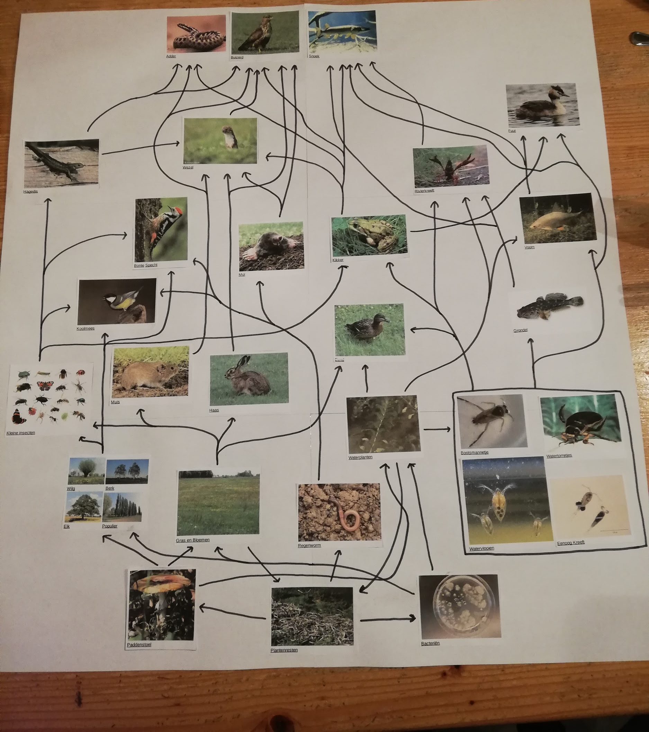
the most important thing that we have discovered is that there are enough different species of animals and plants for the ecosystem to be in balance, this shows by looking at the four experiments, the essential abiotic factors are present which means that a lot of different species of plants can grow which in turn means that a lot of animals can live in the Nespolder. And there are also enough detritivores to clean up the deceased animals so it’s and actual circle of life.

It is because of all this information that we know what state the Nespolder as an ecosystem is in, and is it possible for us to compare it with other bodies of water with similar latitude and longitude. We also know what kind of things might need change or can still be improved. All of our information has been put into Globe so that any new data can be compared with what we gathered.

End Discussion
This research is fairly reliable. We have executed the experiments carefully and multiple times. Some experiments we could have done over even more for an even more precise result. However, we did not have materials to do so. Nevertheless, we still created a very reliable result. We could even do further research with research question; What are important factors for a strong and healthy ecosystem? We then could also investigate what would happen if one of these factors would disappear of change.

The cooperation within this research was with one word “perfect”. Everyone had its own responsibility and everyone was helping each other. The research was clear for all of us and were well executed by all of us. Next to that, we had good communication within our group.

Sources
- www.bioplek.org
- Search card water animals
- Flora booklet
- Globe
- For the latin names of the trees and herbs
  - https://en.wikipedia.org/wiki/Willow
  - https://en.wikipedia.org/wiki/Populus
  - https://en.wikipedia.org/wiki/Maple
  - https://en.wikipedia.org/wiki/Beech
  - https://en.wikipedia.org/wiki/Birch
  - https://en.wikipedia.org/wiki/Oak
  - https://en.wikipedia.org/wiki/Sorrel
  - https://en.wikipedia.org/wiki/Lamium_purpureum
  - https://nl.wikipedia.org/wiki/Kruldistel
  - https://nl.wikipedia.org/wiki/Madeliefje
  - https://nl.wikipedia.org/wiki/Waterleliefamilie
  - https://en.wikipedia.org/wiki/Rapeseed
  - https://en.wikipedia.org/wiki/Urtica_dioica

Logbook

What | Who | When | For how long
Introduction | Max & laszlo | 5th of may 2019 | 20 Min
Research question | Max | 5th of may 2019 | 1 Min
Hypothesis | Max | 5 of may 2019 | 15 Min
Experiment 1  - Introduction  - materials  - method  - Results  - Conclusion  - Discussion | - Laszlo  - Laszlo  - Laszlo  - Max  - Max  - Max | - 5th of may 2019  - 5th of may 2019  - 5th of may 2019  - 6th of may 2019  - 6th of may 2019  - 6th of may 2019 | - 10 Min  - 2 Min  - 20 Min  - 30 Min  - 15 Min  - 15 Min
Experiment 2  - Introduction  - materials  - method  - Results  - Conclusion  - Discussion | - Laszlo  - Laszlo  - Laszlo  - Max  - Matthijs  - Max | - 5th of may 2019  - 5th of may 2019  - 5th of may 2019  - 5th of may 2019  - 6th of may 2019  - 6th of may 2019 | - 10 Min  - 2 Min  - 20 Min  - 30 Min  - 15 min  - 20 min
Experiment 3  - Introduction  - materials  - method  - Results  - Conclusion  - Discussion | - Laszlo  - Laszlo  - Laszlo  - Max  - Max  - Max | - 5th of may 2019  - 5th of may 2019  - 5th of may 2019  - 7th of may 2019  - 7th of may 2019  - 7th of may 2019 | - 10 Min  - 2 Min  - 20 Min  - 30 Min  - 10 Min  - 10 Min
Experiment 4  - Introduction  - materials  - method  - Results  - Conclusion  - Discussion | - Laszlo  - Laszlo  - Laszlo  - Max  - Max  - Max | - 5th of may 2019  - 5th of may 2019  - 5th of may 2019  - 7th of may 2019  - 7th of may 2019  - 7th of may 2019 | - 10 Min  - 2 Min  - 20 Min  - 30 Min  - 15 Min  - 15 Min
End Conclusion | Max | 7th of may 2019 | 20 Min
Foodweb | Matthijs | 21st of april 2019  6th of may 2019  7th of may 2019 | 30 Min  70 Min  45 Min
End Discussion | Max, Matthijs, Laszlo | 8th of may 2019 | 25 Min
Input Globe data | Max  Matthijs | 8th of may 2019  8th of may 2019 | 15 Min  5 Min
Sources | Max, Matthijs, Laszlo | 7th of may 2019  8th of may 2019 | 3 Min  2 Min
Logbook | Max, Matthijs, Laszlo | 7th of may 2019  8th of may 2019 | 10 Min  2 Min
Translating | Max,Laszlo | 26th of may 2019  27th of may 2019  28th of may 2019 | 240 min

Appendix
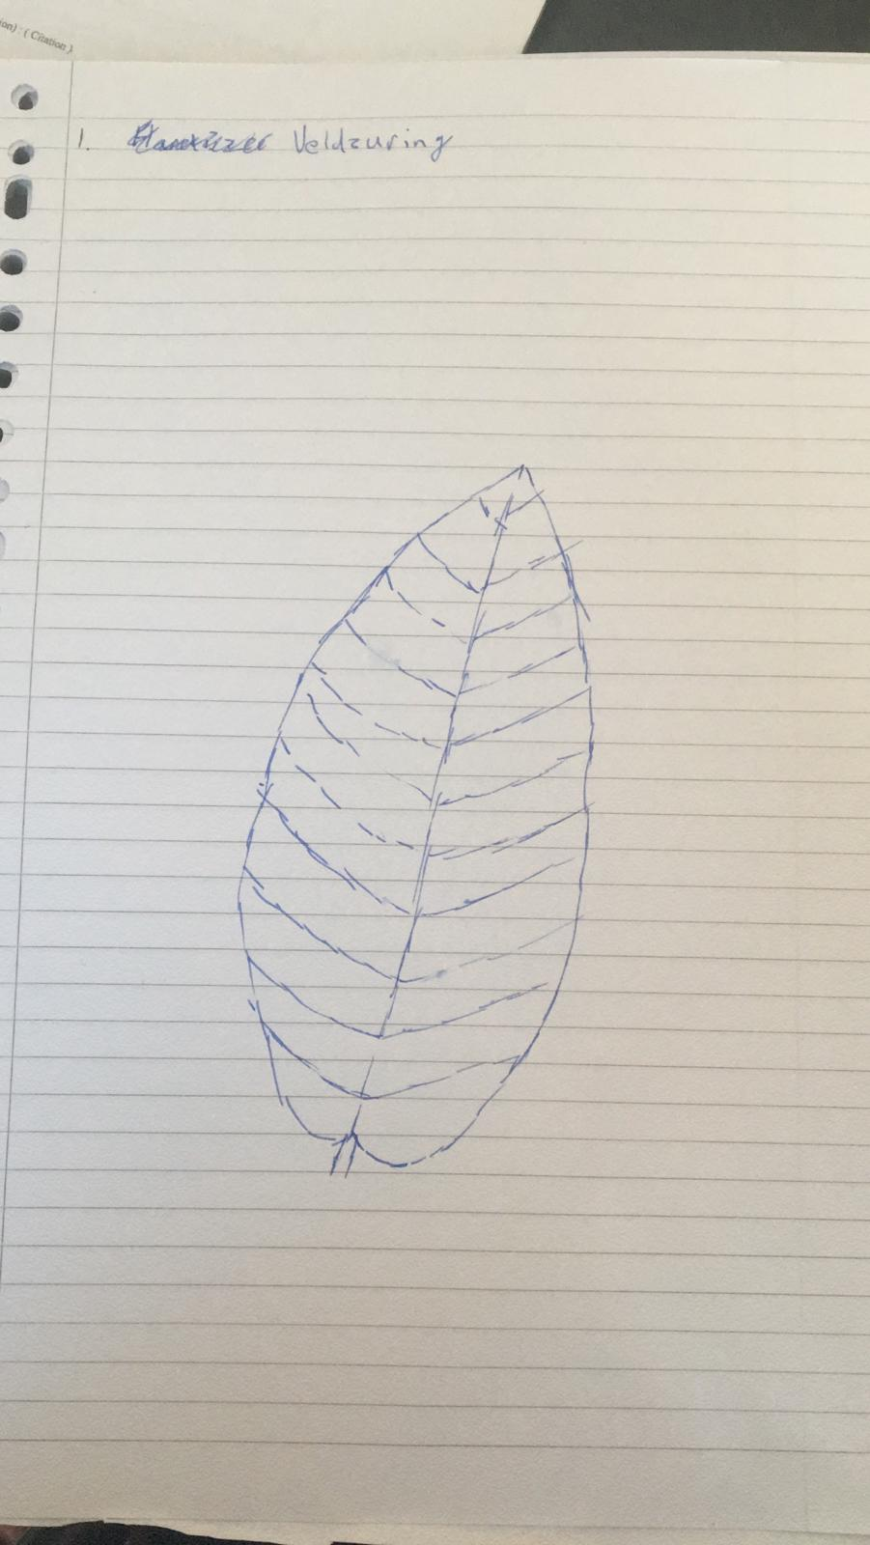
- Field Sorrel
- Purple Dead Nettle
- Curly Thistle
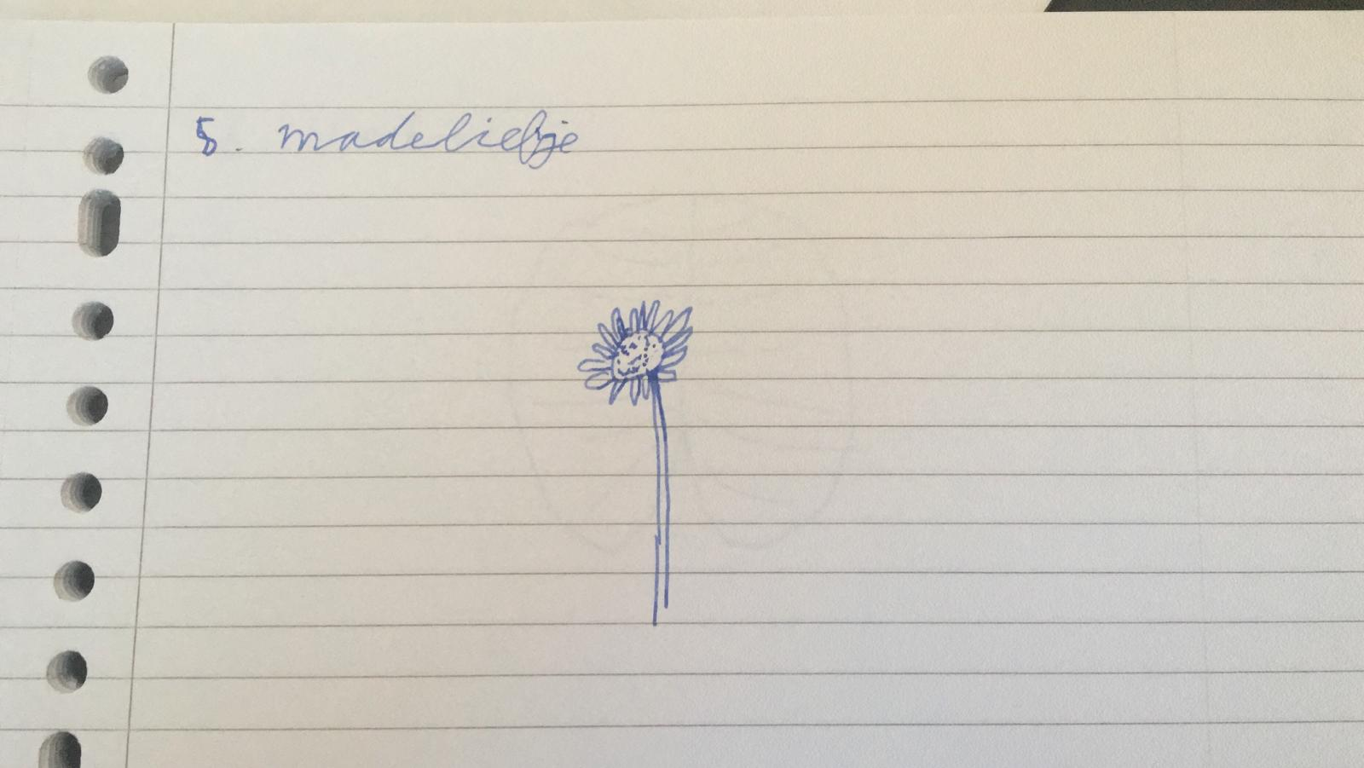
- Daisy
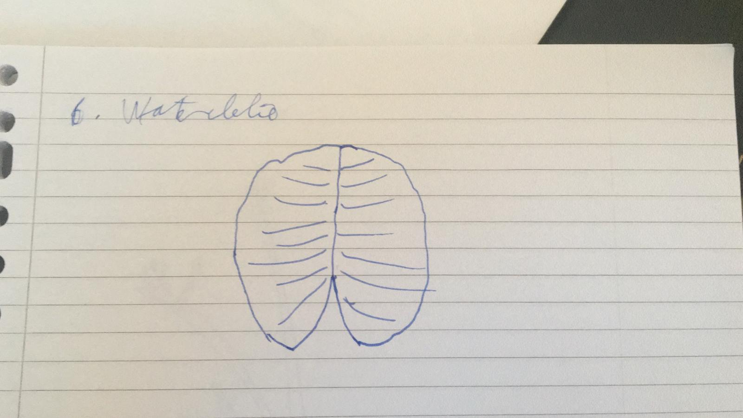
- Waterlily
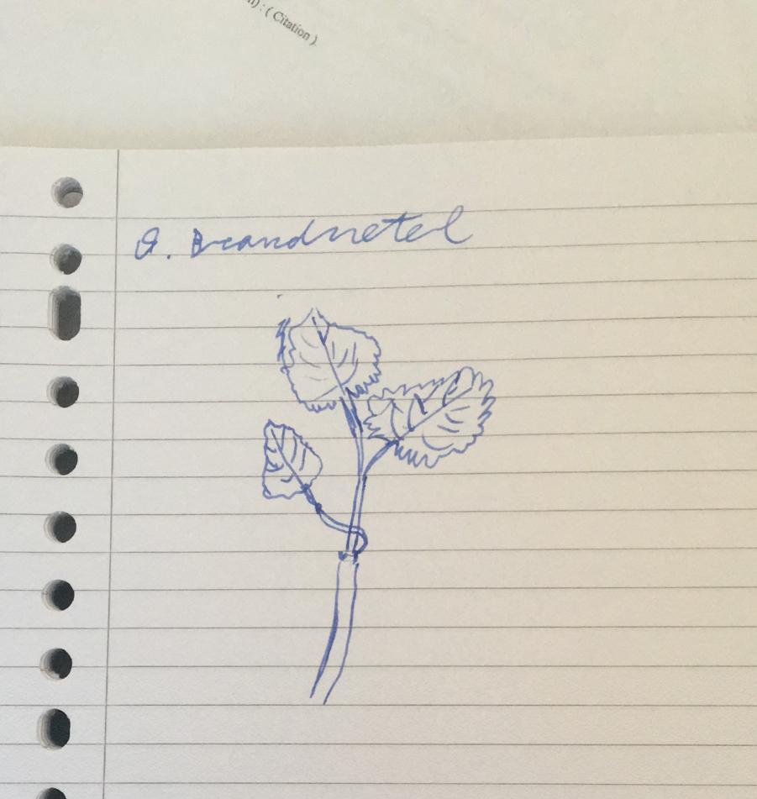
- Stinging Nettle

