Hello

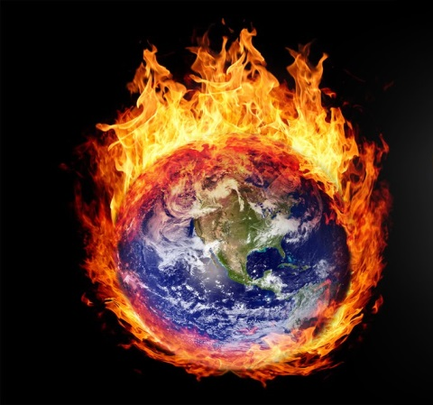
Today will talk about global warming

: Sources of information within search

Wikipedia

mawdoo3

Work of students:
Moaaz AL-HARBI -Qusay Alasad- Zaid Al-shinkitey

My observation of nature

From my observation of the nature and observational temperature of Wright it's growing and purely on the subject and my attention was and it is global warming

questions
1-What is the cause of high temperatures?

2- What is the cause of global warming?

what is global warming

Global warming increases average surface temperature with increasing amount of carbon dioxide and other gases in the atmosphere. These gases are known as greenhouse gases

Causes of global warming
. Industrial, commercial and human activity usually changes the proportion of natural gases in the Earth's atmosphere. Raise carbon dioxide from its normal level, classify all these gases in a category known as greenhouse gases,

Answers to questions

After collecting data, it became clear to us that the cause of global warming was pollution and factory smoke

1 - the use of renewable energy: such as solar energy, hydropower, wind and nuclear energy

2- Reduction of oil consumption: in terms of increasing the efficiency of transport and communications; the invention of engines consume less fuel and for large distances and result in reduced greenhouse gas emissions

3- Planting trees: This is to reduce the risk of carbon dioxide. Trees can retain a percentage of carbon dioxide in the atmosphere, thereby reducing carbon dioxide in the atmosphere. They also have a negative impact when destroyed. They make up 30% of greenhouse gases. In the world

