2020 International Virtual Science Symposium

Minas Gerais School Science Club: Juliana Karina Villela, Andreia Silva, Laís Oliveira, Tayná Cristina Santos, Beatriz Lima, Ana Sophia Pereira da Silva, Camille Santos, Vitoria Lima Mol and Sara de Souza Penna.

School: Minas Gerais Public School.

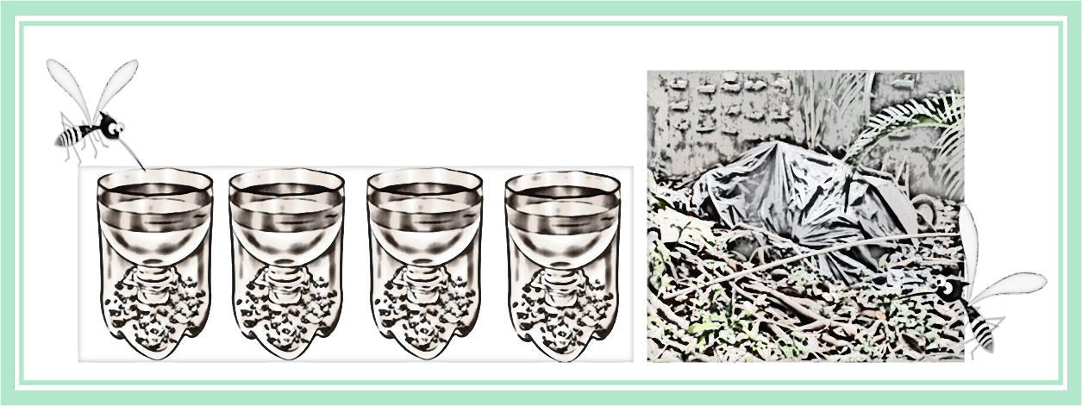
1. TITLE: DOES THE PRESENCE OF RECONSTRUCTION WASTE AT SCHOOL INCREASE THE INCIDENCE OF MOSQUITO LARVAE IN CAPTURE TRAPS?
Figure 1. Does the presence of construction waste at school increase the incidence of mosquito larvae in capture traps?

Rio de Janeiro /RJ – Brazil
Teacher: Inês Mauad
E-mail: inmauad@gmail.com
03 March 2020

2. ABSTRACT

Aedes aegypti is the mosquito that transmits arboviruses dengue, Chikungunya and Zika virus. The Aedes aegypti mosquito is a domestic species. It is born and reproduces in standing water, preferably in human-made containers, such as empty cans and bottles, tires, gutters, uncovered water tanks, household waste, debris or any other object that can store rainwater, in or near of human dwellings.
Rubble and garbage deposited in the open can bring diseases to the population, as they attract cockroaches, rats, flies, mosquitoes and other disease vectors. It is important that the garbage and debris from construction works in homes, schools and buildings are properly disposed of, in closed bags and in the appropriate place for collection by public cleaning agencies.
One of the situations that most facilitate the proliferation of Aedes aegypti is the accumulation of water in debris and accumulation of garbage and disposal material from reconstruction.
The use of traps to detect the presence of Aedes aegypti is a technique from the time of Oswaldo Cruz, and the campaigns of the beginning of the 19th century already used larval research in suitable places for the laying of this mosquito.
Does the presence of reconstruction waste at school increase the incidence of mosquito larvae in capture traps? bOur research is about the increased incidence of mosquitoes in capture traps in the presence of debris from works such as broken tiles abandoned in the school gardens, remnants of a renovation the school has undergone in the past two years.
The method applied for data collection and research was the GLOBE Mosquito Habitat Mapper (MHM) app, which helped to identify the larvae found and make it possible to reduce the breeding grounds of mosquitoes with mosquito-borne diseases.
In a deposit competition, it was found possible a higher incidence of mosquitoes in capture traps in school areas (number of larvae) in the period from Feb. / 2019 to Sept. / 2019 due to the presence of reconstruction debris to the detriment of the same period in 2018 . Presenting a positive correlation with the increase of free breeding sites around the capture traps (transparent 1,5 L PET bottle traps filled with fish food).
Keywords: Aedes aegypti, traps, reconstruction, disposal material, breeding sites, diseases.
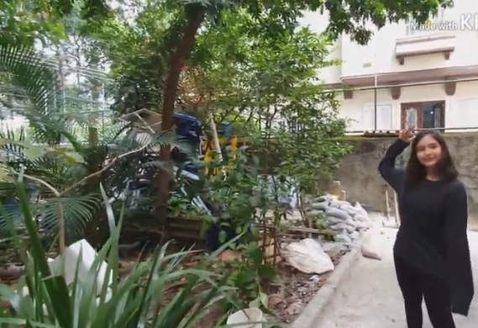
3. RESEARCH QUESTION AND HYPOTHESIS

Question
The presence of construction waste at the school would increase the incidence of mosquitoes in artificial breeding grounds – captives traps (transparent 1,5 L PET bottle traps filled with fish food)
Figure 2. Waste from school Reconstruction.
Hypothesis
The presence of waste from reconstruction such as leftover garbage, wood waste and broken tiles would increase the incidence of mosquitoes in school areas – yards and gardens – (number of larvae) and thus show a positive correlation in artificial breeding sites – captives traps, (transparent 1,5 L PET bottle traps filled with fish food) in the period of February to September 2019.
The recent increase in ecological and environmental changes due to agricultural activities and urbanization has been observed to contribute to the appearance of various mosquito species and to increase genus where were not possible before. (Brazilian Journal of Health Research (2008), Vol. 10)
Often, the materials produced by reconstruction are not immediately removed from the sites, attracting other types of dumping, and the most diverse objects are discarded in these areas. Then, there is a significant accumulation of materials in improper locations. With the incidence of rain, these places inevitably become the focus of Aedes aegypti proliferation. (portal.fiocruz.br/)
In this paper, it is demonstrated for a better understanding the comparison of the presence of larvae and mitigated breeding sites and mosquito habitat between two distinguee periods: from Feb / 2018 to Sept / 2018 and Feb / 2019 to Sept / 2019 using artificial captivity deposits traps (transparent 1,5 L PET bottle traps filled with fish food). The second period – Feb / 2019 to Sept / 2019 –is in the presence of leftover of reconstruction in the school area.
In an egg-laying competition for the female mosquito, the increase in the mosquito's habitat and the mitigation of breeding sites are positive in the period when there is material for re-construction such as broken tiles and wood scraps. It was possible to demonstrate and calculate the increase of the incidence of mosquitoes in capture traps in the presence of debris from reconstruction such as broken tiles abandoned in the school gardens and yard from Feb / 2019 to Sept / 2019.

4. INTRODUCTION (Research History)

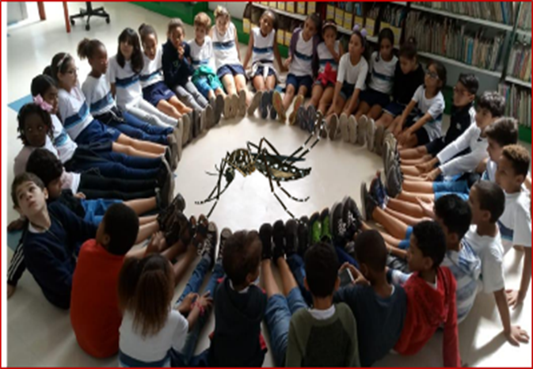
Figure 3. The mitigation of Aedes aegypti breeding sites is our main concern.

The modification of the environment by human actions, disordered urban growth, the globalization process of international exchange and climate change are some factors that have been facilitating the emergence and spread of human infectious diseases transmitted by vectors. (http://www.rsp.fsp.usp.br/)
There are several arboviruses worldwide, but in Brazil dengue, zika and chikungunya stand out mainly because they are transmitted by the same vector, the Aedes aegypti mosquito (CDC, 2016).Transmitted by mosquito vector widely distributed in the national territory and associated with man, the Brazilian population is exposed to infection by these three arboviruses. In the absence of an effective vaccine and specific treatment, it is important to maintain and integrate continuous entomological and epidemiological surveillance, in order to direct methods of control and prevention against these arboviruses in the country. Those are real challenges for Public Health and the all the society in the country. (http://www.scielo.br/pdf/rsp/v50/pt)
Faced with this problem, the eradication of these diseases and their prevention through measures to combat mosquitos' transmitters demand the participation and mobilization of all the community. The school as a space for health education is a strong tool for disseminating information to the entire community, guiding the population on how to act in the fight of this vector.
Smaller than ordinary mosquitoes, Aedes aegypti is a black with white stripes on the trunk, head and legs and has translucent wings. The male, like any species, feeds exclusively on fruit. The female, however, needs blood for the maturation of the eggs that are deposited separately on the internal walls of the objects, close to surfaces of standing water, a place that offers them better conditions of survival: heat and rain.
The Aedes aegypti mosquito is a domestic species. It is born and breeds in clean, still water, preferably in human-made containers, such as empty cans and bottles, tires, gutters, uncovered water tanks, household waste, debris that holds water, dishes under plant pots or any other object that can store rainwater, inside or near human dwellings. (FIOCRUZ)
Rubble and garbage deposited in the open can bring diseases to the population, as they attract cockroaches, rats, flies, mosquitoes and other disease vectors. It is important that the garbage and rubble from construction works in homes, schools and buildings is properly disposed of, in closed bags and in the appropriate place for collection by the city. In this way, it is prevented that diseases like arboviruses dengue, Chikungunya and Zika virus proliferate in the community. One of the situations that most facilitate the proliferation of Aedes aegypti is the accumulation of water in debris and garbage to be collected.
The use of captive traps to detect the presence of Aedes aegypti is a technique from Oswaldo Cruz's time. During the campaigns of the early 19th century, larval research was already used in places suitable for laying this mosquito. (WHO - World Health Organization 2012)
Our research is about the increased incidence of mosquitoes in capture traps (transparent 1,5 L PET bottle traps filled with fish food) in the presence of debris from works such as broken tiles abandoned in the school gardens, remnants of a renovation the school has undergone in the past last year. The method applied for data collection and research was the GLOBE Mosquito Habitat Mapper (MHM) application, which helped to identify the larvae found and make it possible to reduce the breeding grounds of mosquitoes with mosquito-borne diseases.
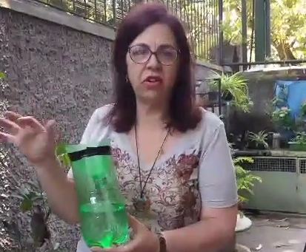
In a deposit competition, it was found possible a higher incidence of mosquitoes in capture traps in school areas (number of larvae) in the period from Feb / 2019 to Sept / 2019 due to the presence of construction debris and waste to the detriment of the same period in 2018 ( that there wasn’t any waste left in the school area) .
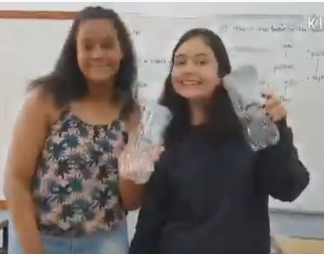
Presenting a positive correlation with the increase of free breeding sites around the captive traps (transparent 1,5 L PET bottle traps filled with fish food).

Figure 4. captive traps (transparent 1,5 L PET bottle traps filled with fish food)

5. MATERIALS AND METHODS
Figure 5. Location of the study site in Minas Gerais School, Urca district, Rio de Janeiro city, RJ/ Brazil.
The city, and also the entire state of Rio de Janeiro, are completely inserted in the Atlantic Forest. The climate of the Atlantic Forest is predominantly humid tropical, influenced by the humid air masses coming from the Atlantic Ocean. ... Its average temperatures and air humidity are high throughout the year and the rains are regular and well distributed. The relief of the state of Rio de Janeiro is formed by plateaus (or Serra Fluminense), by the lowlands (Baixada Fluminense), as well as by the coastal massifs. The latter are rock formations along the coast. Thus, the climate of Rio de Janeiro varies according to the region of the state and its proximity to the sea. In the Serra Fluminense, for example, the tropical climate of altitude predominates, with mild temperatures. On the other hand, in the Baixada Fluminense the predominant climate is the semi-humid tropical, with an average annual temperature of 24 ° C. In general, rainfall is abundant in the state. (https://escolaeducacao.com.br/geografia-do-estado-do-rio-de-janeiro/)
The study site was located at Escola Municipal Minas Gerais, in Urca district, Rio de Janeiro /RJ – Brazil (22°95’ S, 43°17’W, cf. Figure 5). The research was conducted from February to September. Observations were made using:
Materials
- Traps (transparent 1,5 L PET bottle traps filled with fish food) for mosquito larvae.
- Mosquito Habitat Mapper app.
- GLOBE Collection Kit for field capture.
- Graphics elaborated by students according to GLOBE data platform.
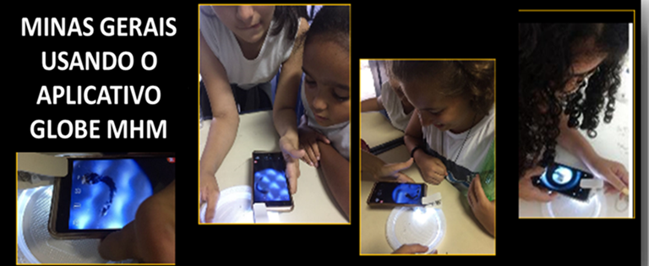
Figure 6. Student using the GLOBE Mosquito Habitat Mapper app (MHM)

Research Methods

- The experiment was carried out at Minas Gerais School, in the Urca neighborhood, south of the city of Rio de Janeiro.
- Four capture traps (transparent 1,5 L PET bottle traps) filled with fish food were installed to capture larvae of the Aedes aegypti mosquito whose female is the main transmitter of diseases: Dengue, Chikungunya and Zika.
- These traps were monitored, first, every 10 days, and after May weekly. The trap network was installed to cover the entire length of the school - yards and gardens.
- The method applied for data collection and research was the GLOBE Mosquito Habitat Mapper (MHM) app, which helped to identify the larvae found and make it possible to decrease the breeding grounds for mosquitoes carrying these deadly diseases.
- Our research compared the larvae trap data from February to September 2019 and the same period in 2018 collected in our previous projects and stored on the GLOBE data platform.
- Remembering that zero is always important, as it determines the appearance / return of the mosquito to the studied areas.
Data Summary and Analysis

An important part of this resaech was the way of storing, treating and visualizing the data, since a study like this generates a large amount of data, requiring specific tools; for this, was used the GLOBE Mosquito Habitat app, mosquito larvae hydrology protocols and GLOBE website as tools to data visualization and graphics production.
The research compared data from larvae traps (transparent 1,5 L PET bottle traps filled with fish food) at Minas Gerais School from February to September 2019 and the same period of 2018, using 2018 data collected from our previous projects stored on the GLOBE data platform.

6. RESULTS
The school unit underwent a renovation, and faced problems, such as debris from abandoned works and tiles, and leftover materials used scattered around the gardens, which allowed the increase of mosquitoes in the discarded materials and thus a greater incidence of larvae in the capture traps (transparent 1,5 L PET bottle traps filled with fish food) .
In the data collected by the GLOBE Mosquito Habitat Mapper app, was found possible a higher incidence of mosquitoes in capture traps in school areas in the period from Feb / 2019 to Sept / 2019 due to the presence of construction debris and waste to the detriment of the same period in 2018 ( that there wasn’t any waste left in the school area) .
Presenting a positive in the trap correlation with the increase of construction debris and waste in the school areas.
The graphic of figure 9 and 10, shows, in the data collected by the MHM app, a higher positivity of mosquitoes in the artificial capture breeding sites - traps, in the presence of tiles and materials for the disposal.
The comparative analysis when we cross the data collected by the MHM app, shows increased incidence and proliferation of mosquitoes among captive trap (transparent 1,5 L PET bottle traps filled with fish food) larvae in the school areas, in the period from February to September 2019 when compared to the same period in 2018.
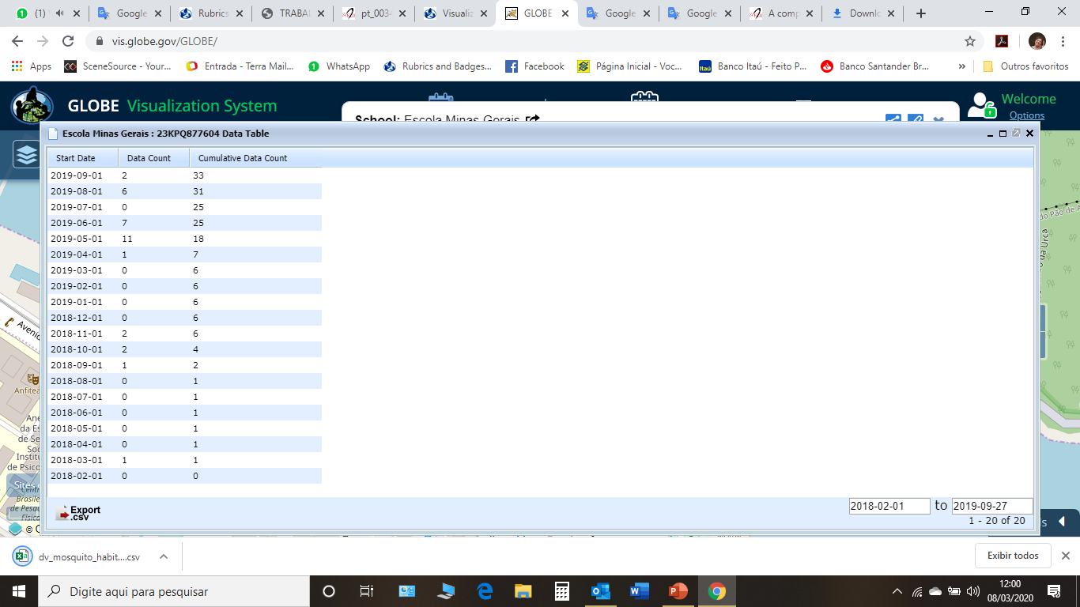

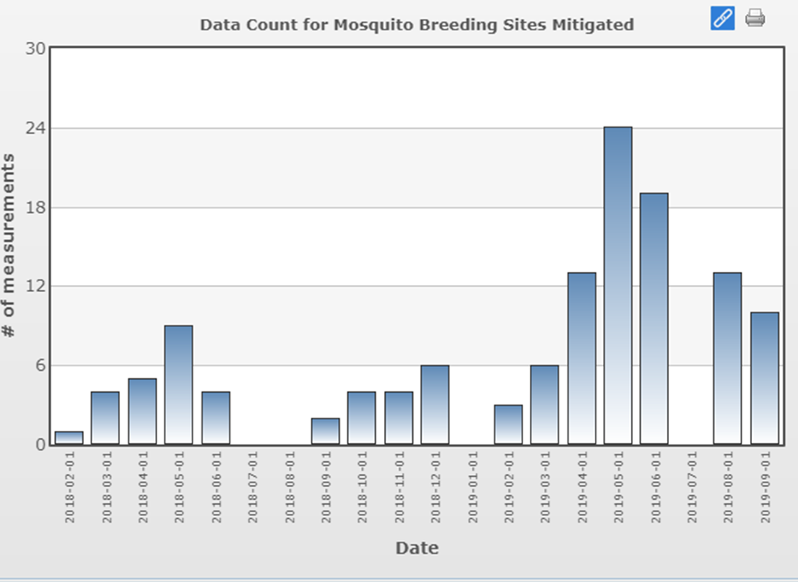
Figure 11 - Data collected – breeding site mitigated from February 2018 to September 2019 by E. M. Minas Gerais - SOURCE: globe.gov

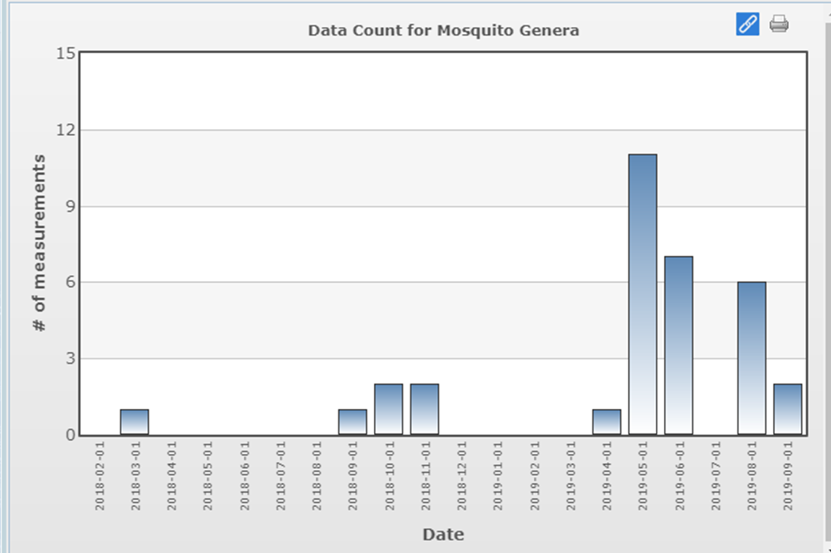
Figure 12 - Data collected – mosquito genera from February 2018 to September 2019 by E. M. Minas Gerais - SOURCE: globe.gov

Our results have made us support our hypothesis

The data collected does not show a great diversity of mosquitoes in the measured breeding sites. The vast majority are composed of mosquitoes of the genus Aedes. The samples of the observed days with higher incidence of larvae showed a diversity of mosquitoes, with specimens of the genera Aedes and Culex.
After which data observation, we performed the analysis and interpretation of the results found through comparative graphics, spreadsheets, research on sites FIOCRUZ and GLOBE and reports of incidence of diseases in the Municipal Health Department.
In Brazil, Aedes aegypti larvae research is used to calculate the level of mosquito infestation and, therefore, to estimate the risk of epidemics of diseases, as recommended by the World Health Organization. For this, traps (transparent 1,5 L PET bottle traps filled with fish food) are used to develop larvae of Aedes aegypti mosquitoes, in the monitoring and control of mosquitoes that transmit dengue, chikungunya and Zika Virus.

7. DISCUSSION
The school unit underwent a renovation and faced many problems, such as construction debris, abandoned tiles and leftover materials used scattered in the school gardens.
In Brazil, the search for Aedes aegypti larvae is used to calculate the level of mosquito infestation and thereby estimate the risk of disease epidemics, as recommended by the World Health Organization (WHO). To this end, traps (transparent 1,5 L PET bottle traps filled with fish food) are used for the development of larvae of Aedes aegypti mosquitoes, in the monitoring and control of the mosquito that transmits Dengue, Chikungunya and Zika diseases.
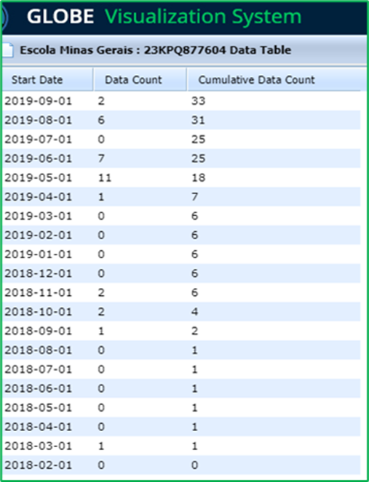
Figure 13 - Data collected – breeding site mitigated from February 2018 to September 2019 by E. M. Minas Gerais - SOURCE: globe.gov

It was observed, in the data collected by the GLOBE Mosquito Habitat Mapper app, a higher positivity of mosquitoes in the school areas (number of larvae) in the artificial capture breeding sites – traps (transparent 1,5 L PET bottle traps filled with fish food) , from February to September 2019 (period of accumulation of debris in the gardens school) to the detriment of the same period last year.
Rainy days and inadequate waste disposal do not result in a good combination. Garbage and rubble on land and flower beds can contribute to the proliferation of the Aedes aegypti mosquito, which transmits dengue, Chikungunya and the Zika.
The school unit underwent a renovation, and faced problems, such as construction rubble and abandoned tiles and leftover materials used scattered around the gardens, which allowed the increase of mosquitoes in the discarded materials and thus a higher incidence of larvae in the capture traps(transparent 1,5 L PET bottle traps filled with fish food) .
The data table (Figure 13) above shows an increase in the incidence of mosquitoes in the collection of samples from capture traps, mainly in the period of May and June 2019, in that period a greater amount of construction debris, abandoned tiles and leftover materials was found. used in school gardens and patios.
The samples from May, despite the large number of mosquito larvae found, did not present a great diversity of mosquitoes, all of them of the Aedes genus. The same situation was observed in the sample of other days. Remembering that zero is always important, as it determines the appearance / return of the Aedes aegypti mosquito to the studied areas around the school.

8. CONCLUSION
Often, the materials produced by the construction leftover are not immediately removed from the sites, the debris that accumulates in the yards and gardens may become breeding grounds for mosquitoes, especially Aedes aegypti, and the local community will suffer the risk of contracting diseases and , thus, enabling the circulation of arboviruses such as Dengue, Zika and Chikungunya throughout the community.
Our research used traps (transparent 1,5 L PET bottle traps filled with fish food) for capturing larvae in school areas in the presence of a large amount of debris and remains of reconstruction carried out at the school. To do this, collect and gather data and information on the incidence, quantity and diversity of mosquitoes in the breeding of larvae in captivity - capture traps.
We concluded that in a competition for deposits, there is a greater positivity of mosquitoes in the artificial capture breeding sites – traps (transparent 1,5 L PET bottle traps filled with fish food) , in the presence of tiles and garbage abandoned in the period from February to September 2019 in detriment to the same period of the previous year.
The figures 11, 12 and 13 show that the number of larvae collected increases considerably in captive traps (transparent 1,5 L PET bottle traps filled with fish food) in the period from February to September 2019, occasion of reconstruction at school with accumulation of waste materials such as construction rubble and abandoned tiles and leftovers of the materials used scattered around the gardens, which allowed the increase of mosquitoes in the discarded materials.
It was verified, in our research, that there is no greater variety of mosquitoes in the artificial capture deposits, the majority being of the genus Aedes.
The presence of debris from works such as garbage and broken tiles increases the incidence of mosquitoes in school areas - patios and gardens - (number of larvae) and thus has a positive correlation in artificial capture breeding sites - traps, from February to September 2019 , occasion of reconstruction at school.
Why do we need mosquito data?
We think it would be important to point out to the researchers of the Aedes aegypti mosquito and the diseases transmitted by it – dengue, chikungunya and zika – and to the Public Health Offices, as well as other students and the general population. Globally, there is a major effort to use satellite data to predict the onset, decline, and spread of vector-borne diseases. Reliable soil-based data are useful for the development of realistic computational models based on satellite data.
In most parts of the world, soil verification data are simply not available - so GLOBE observations are extremely important in tracking and controlling disease. These satellites cannot distinguish between the places in your community - we need the "eyes in the sky", but also the "boots on the ground"! And the use of traps simulating containers artificial free, like tires and tanks of water, are the favorites of the mosquitoes and therefore can be safety use to know he data in regions and places that they are not available to collect directly from the free mosquito breeding sites. (CODSI, Renee)

Summary and Solutions

The use of traps to detect the presence of Aedes aegypti is a technique from the time of Oswaldo Cruz, through larval research and collection of adult mosquitoes. More recently, the increase in diseases - Dengue, Chikungunya and Zika -, transmitted by the Aedes aegypti mosquito, created the need for permanent surveillance at land, sea and air terminals. This sparked interest in the development of traps capable of detecting any introduction of Aedes aegypti, as soon as possible.
Our research collected data on the increase in the incidence of mosquitoes in capture traps (transparent 1,5 L PET bottle traps filled with fish food) in the presence of debris from works such as broken tiles and waste abandoned in the period from February to September 2019 and thus obtain information on the incidence, quantity and proliferation of mosquitoes in school areas (gardens and patios) in order to compare their results with those of captive larvae collected in the same period of 2018.
The results show that in a comparison of data in the two periods, there is a greater positivity of mosquitoes in the artificial capture breeding sites - traps, in the presence of tiles and garbage abandoned in the period from February to September 2019 in detriment to the same period of the previous year.
Acknowledgements
We thank Minas Gerais, Principals Deinze Marzal and Tania Campos, FIOCRUZ (Elimina dengue Project), Go Mosquito Community, GLOBE Mission Mosquito, Dr. Russanne Low and Renee Codsi from Institute for Global Environmental Strategies, AEB Brazilian Space Agency, Nadia Sacenco.

1. BRAZILIAN JOURNAL OF HEALTH RESEARCH (2008), Vol. 10. Access: 20/02/2020.

2. CAMARA, Tamara Nunes Lima. Revista de Saúde Pública. Universidade de São Paulo. São Paulo, SP, Brasil. <http://www.scielo.br/pdf/rsp/v50/pt_0034-8910-rsp-S1518-87872016050006791.pdf> Access: 20/02/2020.

3. CODSI, Renee. https://www.arca.fiocruz.br/xmlui/handle/icict/18318. Acess: 23/03/2019.

4. FIOCRUZ, Instituto Oswaldo Cruz, Aedes X Pernilongo comum,
<http://www.ioc.fiocruz.br/dengue/textos/aedexculex.html>. Acess: 10/02/2019.
- Graphs of Research Institutions (FIOCRUZ).
- Portal ENSP - Projeto ZDC/ Escola Nacional Sergio Arouca – Fiocruz

5. GLOBE. GOV. Graphs made by students according to GLOBE data.
<https://vis.globe.gov/GLOBE/> Acess:02/02/2020.
- GLOBE Science Protocols – Atmosphere » air temperature, precipitation.
- Hydrosphere » Mosquito Larvae.

6. GLOBE Mosquito Habitat Mapper App to Locate Mosquito Larvae.
<https://mosquito.strategies.org/index.php/pt/pagina-inicial/app-brasil/>

7. GO MOSQUITO Community – <https://mosquito.strategies.org/index.php/en/>. Acess: 20/02/2020.

8. MEMÓRIAS DO Inst. Oswaldo Cruz vol.108 no.8 Rio de Janeiro Dec. 2013 Epub Nov 28, 2013.< https://doi.org/10.1590/0074-0276130128> Access:24/02/2020.

9. WHO - World Health Organization 2012. Acess: 22/02/2020.
7. Optional Badges for Scientist Skills

Collaboration
All the students worked together to provide a good work. During the development of the project, each of the student could stand out in their best performance. Therefore, they were able to show their specials skills.
- Juliana Villela, Fábio França and Andreia Silva: data collect, project summary, video elaboration, theoretical part and research on the subject.
- Gabriel Moraes, Tayná Santos, Camille Santos collection and production of exploitable data.
- Tayná Santos, Beatriz Lima, Sara Penna, Ana Sophia Pereira da Silva: art and preparation of the video.
- Ana Sophia Pereira da Silva, Sara Penna, Camille Santos, Lais Oliveira: drafting of the project.
- All group: Video Presentation.

Community impact
Use of local data from the GLOBE Mosquito Habitat Mapper app and Globe site data collect from our school district makes it possible to characterize that the leftover from the school reconstruction brought a lot of mosquitoes to school areas, and therefore, the extremally need to their mitigation. The use of GLOBE data from others site in Brazil and data from Municipal Health Department makes possible to show and compare that the Urca is a district that has Aedes aegypti and their density is higher in artificial containers, preferentially near leftover from reconstruction- the female mosquito preference - and the importance of data zero to contain mosquito development in the schools and all the district.

STEM Storyteller

The GLOBE Mosquito Habitat Mapper was the application used in our research. The data collected and recorded as well as all field documentation of possible habitat, genus identification and mosquito species, destruction of breeding sites - help students and scientists to investigate more effectively and more promptly the proliferation of enemies in support of our battle to combat mosquitoes of diseases such as dengue fever, yellow fever, chikungunya and the Zika virus.
We thought it would be important to highlight that we carried out a campaign to fight the mosquito in a large SCIENCE FAIR and a GAMIFICATION EVENT with the guiding line was the AEDES CORDEL, kind of northwest literature that tells the mosquito cycle in rhymes and also talks about the garbage and debris that attracted the Aedes aegypti mosquito and which were eliminated in September 2019 to do so, we invited the entire school community and health agents responsible for his publicity related to the proliferation of mosquitoes to reaffirm the importance of the need for the destruction of breeding sites and the Aedes aegypti mosquito.

