Do Clouds cover Affect the air temperature?

Student researcher:

Maheshi wikramasuriya and Maheshika Dambagolla

School:

K/Pushpadana Girls’ College

Kandy,

Sri Lanka.



Teacher:

Mrs.Shirani Renuka

k/Pushpadana Girls College

Kandy,

Sri Lanka.

**Contents**

Abstract………………………………………………………………………………………..01

Introduction………………………………………………………………………………….02

Research question and Hypothesis……………………………………………………………………………………03-04

Materials and Method………………………………………………………………….05-08

Results, conclusion, discussion……………………………………………………..09

Reference…………………………………………………………………………………….10

**Abstract**

Clouds are familiar parts of human environment and affect our daily plans. The objective of this research is how cloud cover Affects to the air temperature. By observing clouds, we sought to investigation the role of local atmospheric weather condition, latitude and different clods cover with aerosol optical thickness. Data was collected on percent cloud coverage, air temperature, humidity percentage and barometric pressure during January 6th to January 31st, 2020.we practice the particle method of observing the clouds and identifies the categories of high, low, and middle clouds observe about how the clouds are scattered in the sky. We are investigating the atmosphere with this research because it clouds help us predict more dangerous weather and help save lives in the path of that weather. We understand that the temperature changes according to the clouds cover and their density. We have been collecting surface and air temperature as well as clouds type and other select atmospheric parameters. We learn to draw inferences from observations and use them to make and test prediction. And we could say weather changes from day to day and over the seasons. The clouds cover gets reduce waves are reflected, earth’s surface. Then air temperature gets increased. Clouds tell us something about air temperature in the sky, related to weather.

01

**Introduction**

The research is done at the pushpadana Girls’ College. We selected some location in the school, and during solar noon students observed clouds. In the meantime, air temperature, wet and dry temperature and barometric pressure were measured. These data were taken throughout a month and the obtained data were represented in tables and graphs Observation was made strictly using a camera, to collect data. We took the observation during the periods 6 -21 January 2020and 22-31 January 2020. According to the obtained data, charts and tables the conclusion was reached.

02

**Research question and Hypothesis**

Clouds are a big part of our environment and life on earth. Clouds can form when the temperature is hot, warm and cold. The amount of water present also affects how clouds form. Clouds have a major impact on the earth’s climate, weather and energy. The global community can determine weather patterns and destructive weather. Clouds physically form in the atmosphere. Different type of clouds form in different levels in the atmosphere.

Our research question is “clouds cover affects the air temperature.” According to the high, low, and middle cloud type, the temperature prevailed throughout the day change. We were able to observe that the air temperature, wet and dry bulb temperature prevail throughout the day change according to the high, low, and middle cloud types. Meantime the according to the scattered of the clouds too responded for the above changes the barometric pressure too changes accordingly.

When there is a low cloud scattering the air, temperature decreased as a result wet bulb temperature displayed low temperature and barometer reading was high. On day to day basis we want to know many things about the weather and encounter the day. The density of the air is so reduced that many different phenomena. begin to be important, at these heights, absorption of x-ray and extreme ultra violet light from the sun ionizes the gases of the atmosphere and heats the air.

03

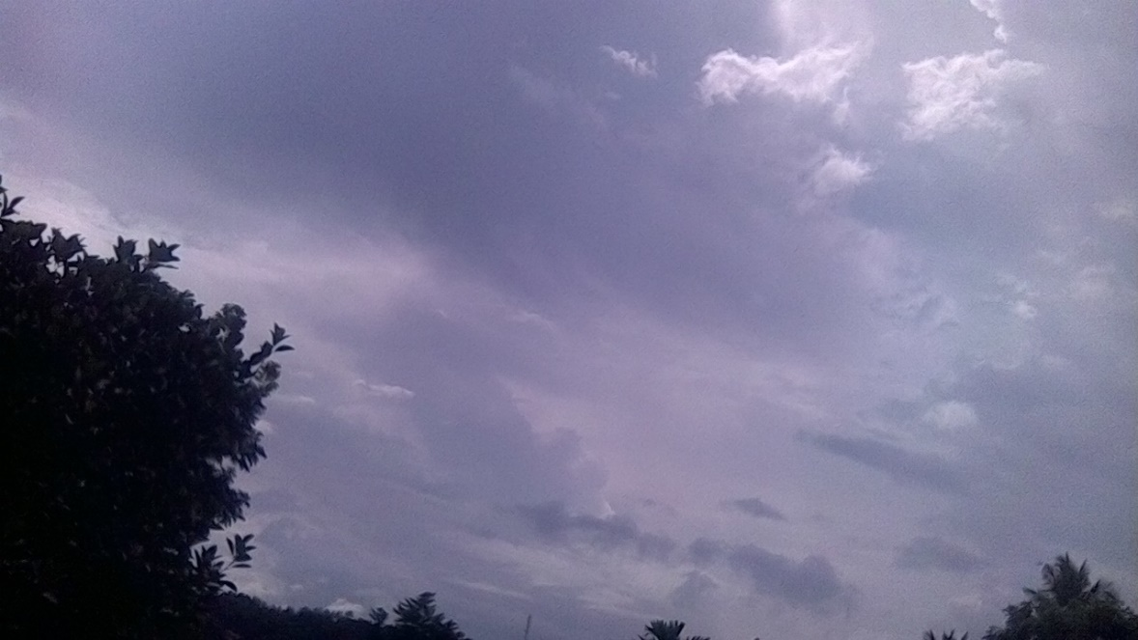

Figure 1: Clouds watching in the location.

04

**Materials and Method**

Our study site is located in Kandy,Sri Lanka ,and around the world (latitude 7.29-north,longitude 80.63-east,elevation 504.8)the temperature has changed at the site during the investigation. The globe clouds protocol was used, clouds with the sky viewer and clouds indemnification chart and the NASA earth system data. Observation were made strictly using a camera, to collect evidence of possible origin of the cloud observation. According to NASA cloud observation guide collected the data of clouds, temperature and barometric pressure. All readings and observation were obtained from the U.S weather service.



We took observation during one-month period from 6-21 January 2020 to 22-31january2020.We were particular in interested observation in cloud type, cloud cover for how to changed temperature.

According to NASA data sheet, we collected the data.

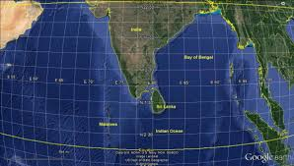 

Figure 2: Location of the research is shown above in a Google maps photo.

05

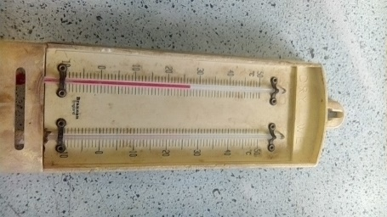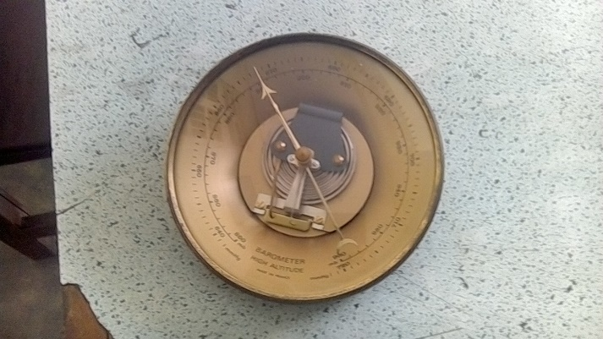

Figure 3: Atmospheric pressure device and temperature device.



06

**Data summary and Analysis**



|  |  |  |  |  |  |  |  |  |  |  |  |
| --- | --- | --- | --- | --- | --- | --- | --- | --- | --- | --- | --- |
| Cumulus % | 10 | 10 | 50 | 50 |  |  |  |  | 10 | 10 |  |
| Cirrostratus% |  |  |  | 50 |  |  |  |  |  |  |  |
| Stratus% |  |  |  |  | 90 |  |  | 90 |  |  |  |
| Cirrus% |  |  |  |  |  | 10 |  |  |  |  |  |
| No clouds |  |  |  |  |  |  | 0 |  |  |  | 0 |
| Air temper(c) | 26 | 26 | 23 | 22 | 21 | 27 | 29 | 21 | 26 | 26 | 29 |
| Wet bulb tem (c) | 25 | 25 | 21 | 21 | 20 | 25 | 26 | 20 | 25 | 25 | 27 |
| Humidity% | 92 | 92 | 83 | 83 | 91 | 84 | 78 | 91 | 92 | 92 | 81 |
| barome.pres | 892 | 892 | 892 | 891 | 890 | 892 | 892 | 891 | 891 | 891 | 891 |
| date | 6/1 | 7/1 | 8/1 | 9/1 | 13/1 | 14/1 | 16/1 | 17/1 | 20/1 | 21/1 | 22/1 |

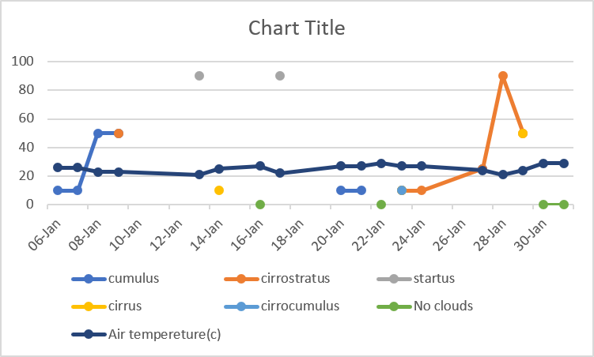****Figure 4: Data analyzes-06.01.2020-22.01.2020

Figure 5: -clouds type and air temperature



07

Figure 6: -clouds cover and air temperature.

08

**Result, conclusion and discussion**

Our conclusion is supported by the research question, because our hypothesis was ‘If the clouds cover decrees in the sky, the sun light comes to earth surface and heat the earth. “By observing cloud, we can get information about temperature, moisture at different heights in the atmosphere. Waves are reflected, from earth, keeping the planet cooler than it would be otherwise. At the earth’s surface and release some of this heat back toward the ground keeping earth’s surface warmer than it would be otherwise.

Clouds are a big part of our environment and life on Erath. Clouds can form when the temperature is hot, warm and cold.Differant type Some clouds form only in fair weather while other bring showers on tundersorms.Cloud type can indicate a trend in the weather.by paying attention to the clouds, soon we may be able to use cloud observation to forecast the weather. Clouds are the source of precipitation, that affect the amount of energy from the sun that reaches earth’s surface, and insulate earth’s surface and lower atmosphere. At any given time about 70% of the earth’s surface is covered by clouds that reflect some of the sun light away

Clouds affect the temperature of the earth and air and also can help protect us from solar radiation and heat waves. Air temperature varies throughout the day in response to direct solar heating and from day to day as weather systems move around the globe. We can see most changes in cloud cover between warmer and colder areas on the planet.so we can say cloud cover and the type affects to the surface temperature.

09

**Reference**

* Data visualization: - https://www.visiblearth.nasa.gov
* clouds protocol in NASA-: https://www.globe.gov
* observing clouds type: - https:// www.scied.ucar.edu
* Globe cloud chart in NASA: - https://www.globe.gov
* Geothermal energy- Dayan Karunaratne, research officer,

Green project, Sri Lanka.

* Changing temperature in the earth https:-//www.en.m.wikipedia.org
* Type of clouds https:-//www.scijinks.gov
* climate change- senior lecture H.K.N.karunarathna university of Colombo, sri Lanka .

10