The impact of climatic changes and the grades in this research ,
we examine the changes in temperature and the amount of rainfall and humidity to high temperatures in the city of Taif 88 rainfall returning for several reasons detect had reached Anna: **General Diseases,bone fragility. **Soil drought because of the lack of rain **underestimation of water Champions Trophy Lack of moisture
Climatic changes grades obey those laws

. the names of the students participating in this research
1-Abdullah Mohammed Jaber Al Maliki 2. Helped Talal Helped Al juaid 3-Saad Ali Al-Shamrani this research under the supervision of the instructor:
Profesoud saud Al-shubaily. School commander
: Professor/Khaled almalki

Questions and research hypotheses
Q1 / Why is the temperature rising or falling in the past five years?

Q2 / Why has the amount of rain decreased in the last five years, knowing that it is falling heavily on the city of Taif?

Q3 / Why is the humidity slightly or moderately moderate in Taif?

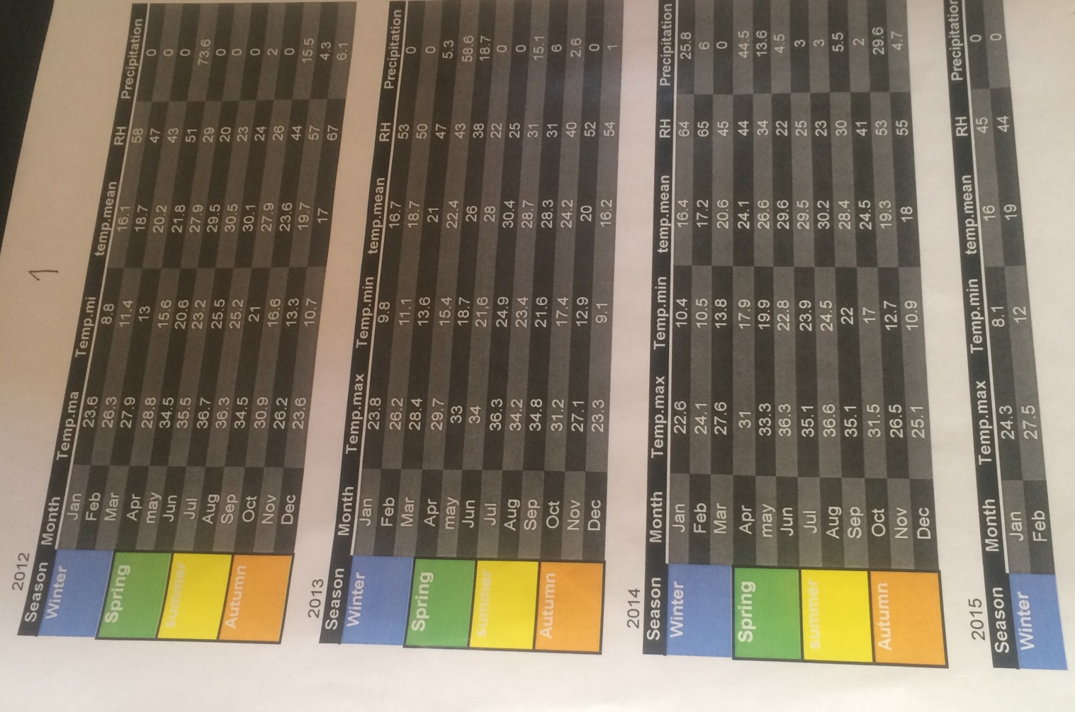

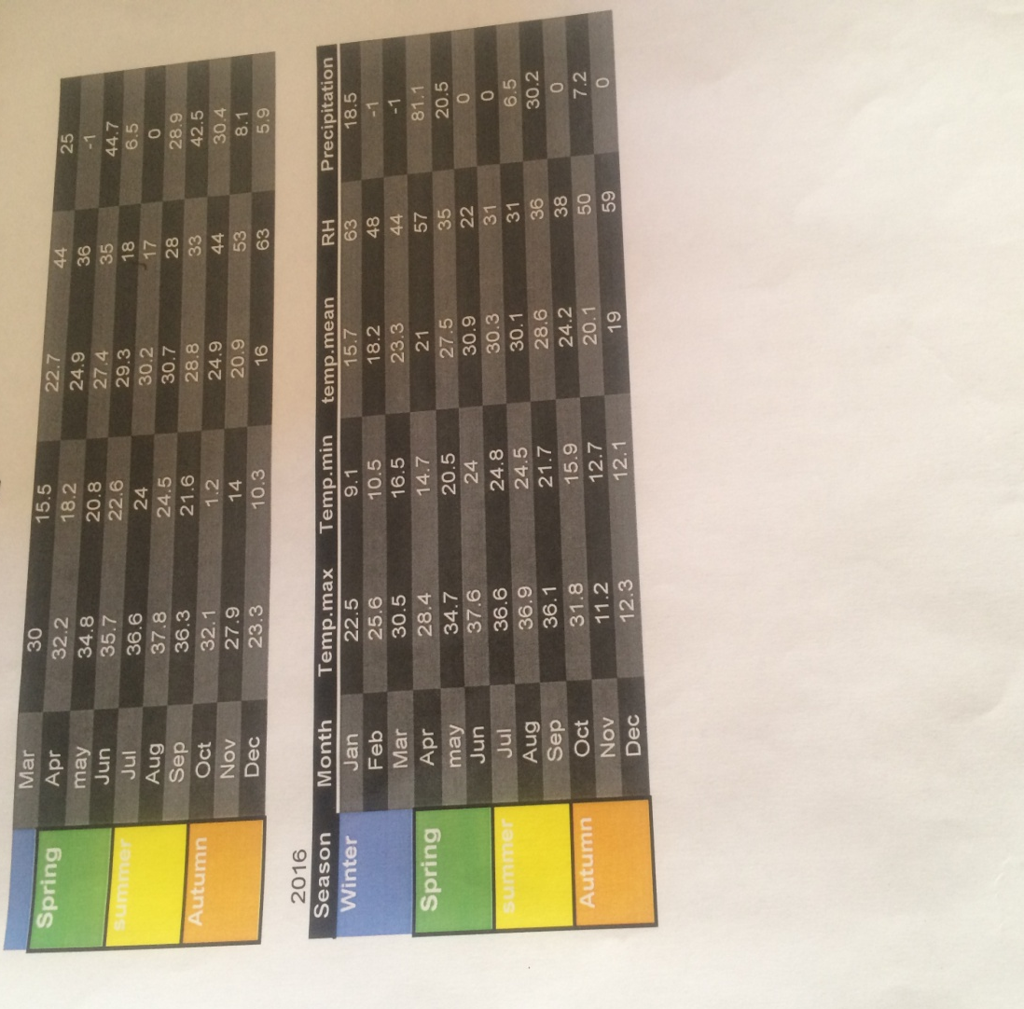

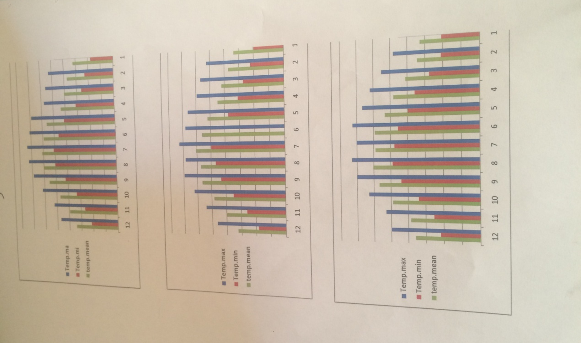

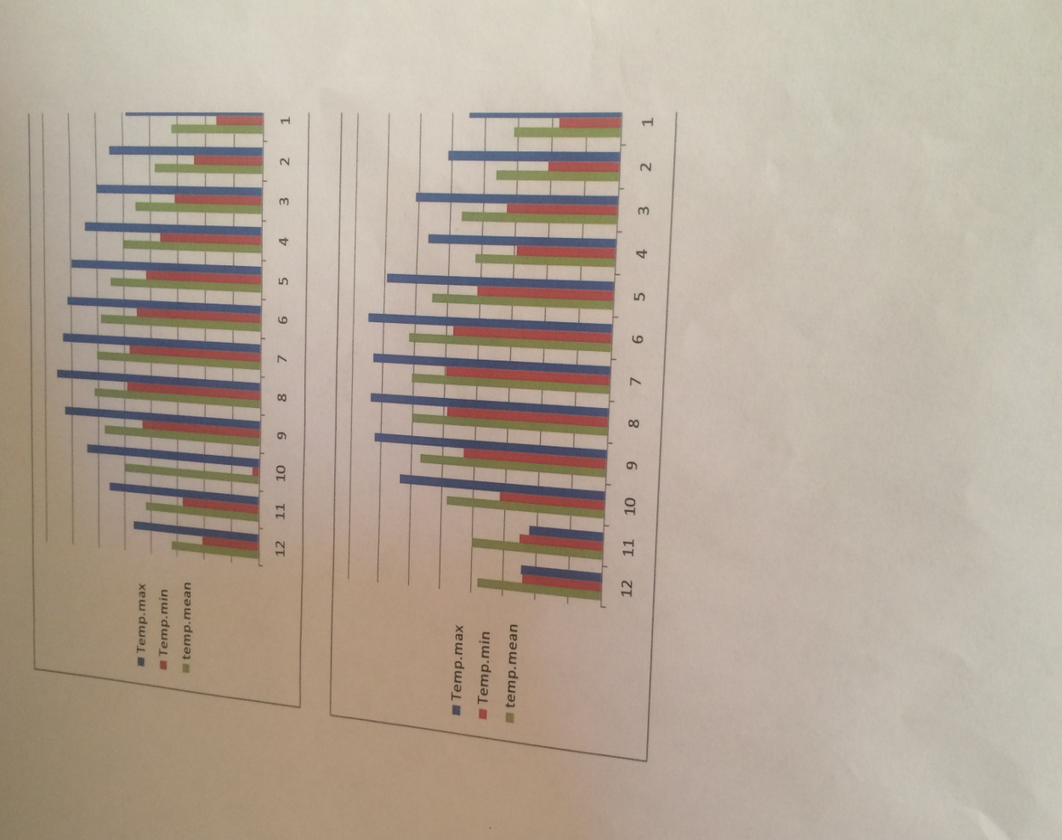

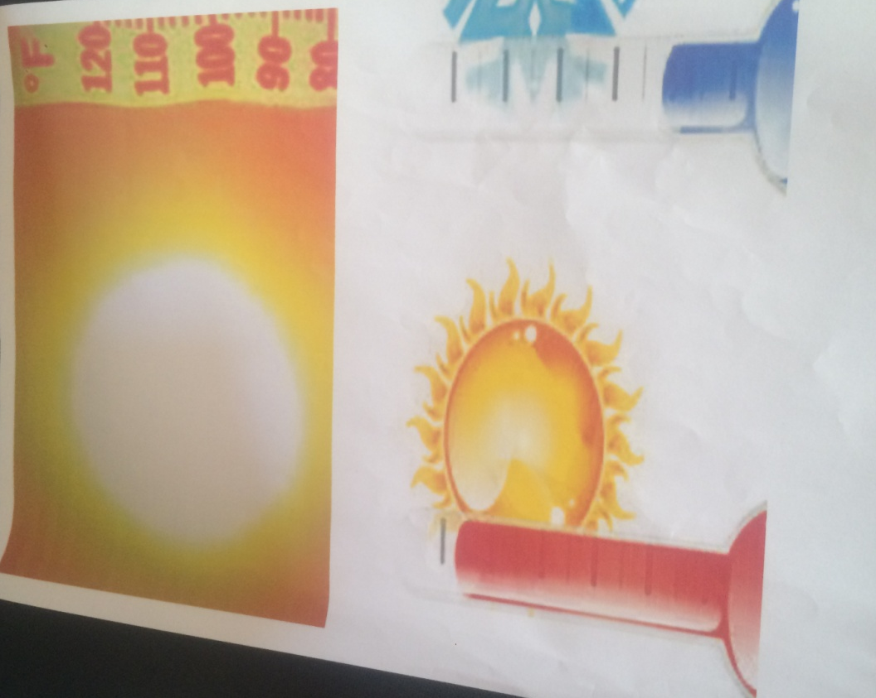

Analysis and results
1 - Temperature difference is an important factor with respect to the diversity of temperature with different time of day, the variation of temperature with different time of day in the largest near the surface of the Earth. The high desert areas, typically, the largest level of temperature variations with Different time of day. Low and wet areas are often characterized by the lowest levels of diversity. This explains why the temperature is high.
2 - the amount of rain falling on the surface of the Earth is associated with the amount of water vapor in the atmosphere as well as the momentum of air masses carrying this steam if the proportion of these two factors result in this occurrence
Rainfall This occurs due to several factors:
Increase pressure from the normal range in high pressure systems.ϖ
Winds are loaded with warm continental air masses instead of surrounding air massesϖ
There are some natural obstacles in the high pressure zone, such as mountains, which prevent the activity of stormy storms or rainfall on a particular area.ϖ

- 3 - Meteorologists confirmed the effect of weather factors in the sense of heat as this relationship is related to the wind speed in the cooling caused by the evaporation of sweat and then the temperature of the skin is associated with temperature and humidity of the air.
- 4. Thermal islands / temperature rises by ten degrees in cities
- Because of the phenomenon called thermal islands and this phenomenon is caused by the components of cities such as: streets and buildings that absorb the temperature, which leads to high temperature.
- Conclusions and solutions
- 1 - Use of reflective panels of sunlight in buildings and the use of light colored materials.
- 2 - the use of light colors in the pavement of the streets.
- 3 - the multiplication of plant cultivation, especially trees in the streets and roofs of buildings and their buildings.
- - Rainfall: Clouds are revised with a chemical mixture of sodium, magnesium and calcium chloride.

Thanks and gratitude to those who were accomplished in this scientific research
** The leader of the school Professor: Khalid al-Maliki ..
It is not necessary to write many and many of the words that belong to thanks as much as you are required to write many of the wonderful sentences that we design the most beautiful in order to give it to the director to find in himself what he is able to stimulate it was with us heart and mold was help in this research
** The leader of this research is Prof.
Saud Al-Shabaili.
Our distinguished professor gives you all the appreciation and praise for the number of drops of rain and the fragrance of perfume for all your efforts for us and for your precious efforts in order to advance our educational process. We thank you for your efforts and appreciate your work. You are truly worthy of excellence. We have learned from you that success is the secret and impossible to achieve in our work. Whoever instills it in our minds, we thank you very much for the valuable efforts you have made.

Thanks to whoever has a base for research and a basis for informationϖ
Dr. Abdullah Al - Sulaie.

References
This research is based on references:
• University of Taif, with the consensus of doctors specialists.
• The free encyclopedia.
• EXL program by displaying data.
• Theme site: from which I took some important information.

The image is searchable

