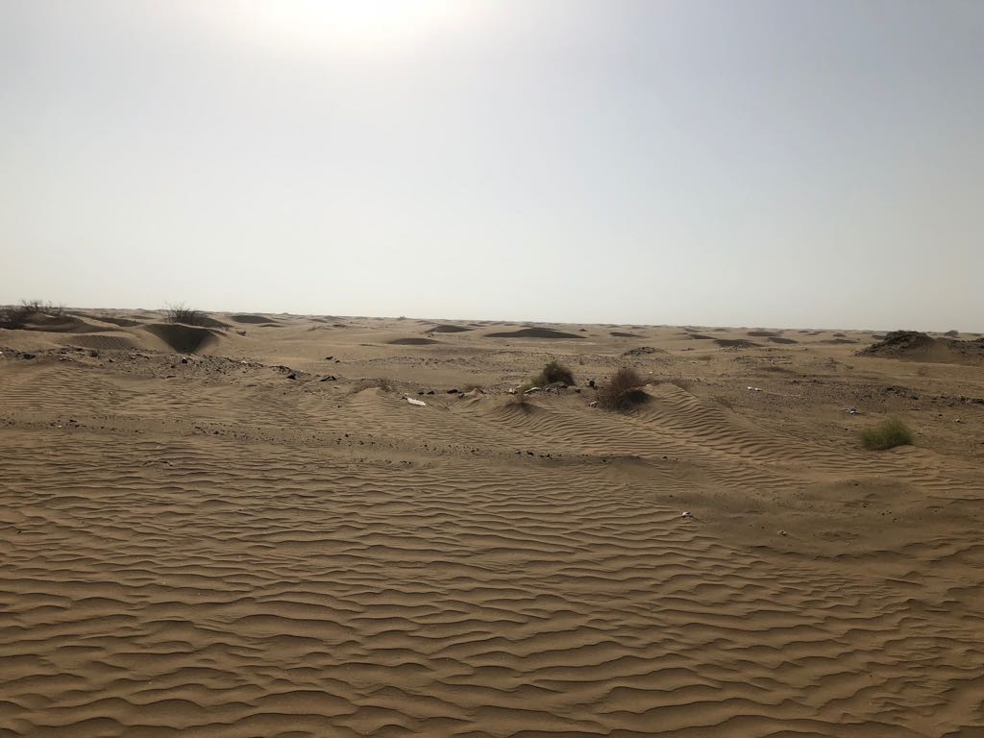
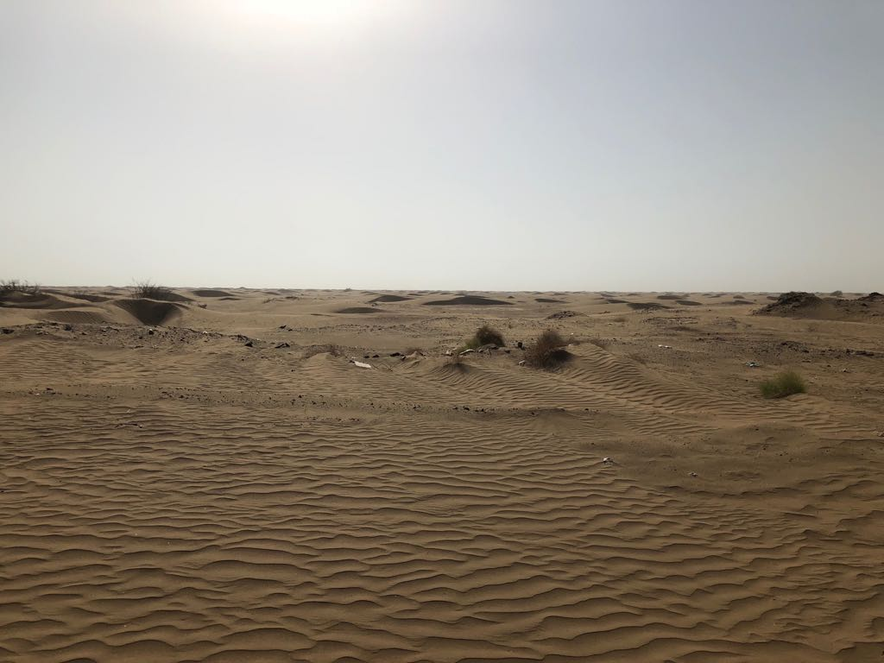
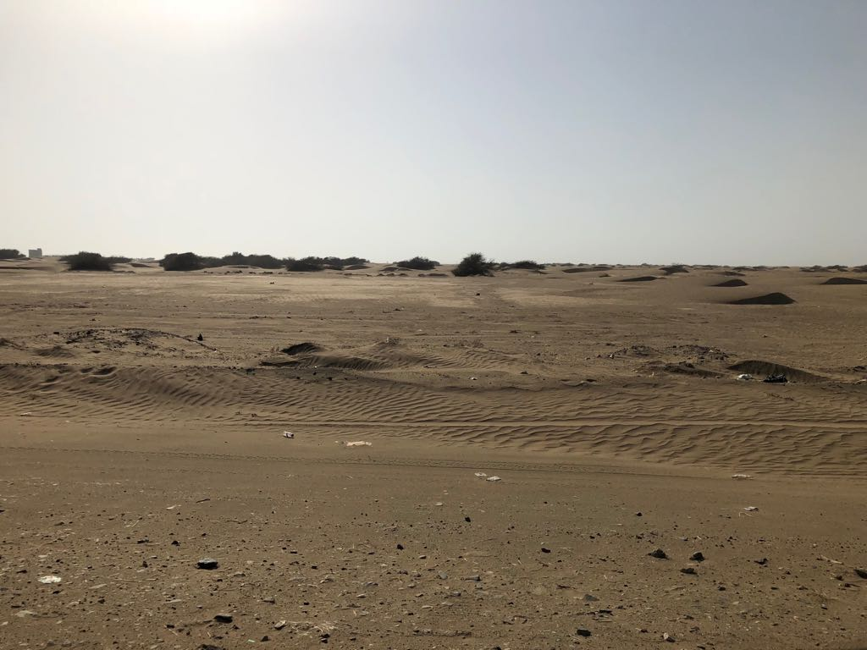
( Problem or Goal )
Environmental degradation and desertification
(Results )
( Problem or Goal )
1- The causes of desertification that you see.
2. Lack of rainfall
3 - repeated drought phenomenon.
4. High temperature.
5. Degradation of vegetation.
6. Water drifting and wind blowing
( Future Research )
1. Climate protection.
2. Disseminate social and economic behaviors that preserve the environment and implement international conventions that aim to reduce gas emissions to maintain the equilibrium of the gas atmosphere.
3- Study of vegetation cover.
4 - Develop scientific solutions to reduce the spread of desertification.
( References )
1- Encyclopedia of Wikipedia

( Project Title )
Desertification and global warming

( Procedures )
1. Comparison of temperature before measurement in the 18th and 20th century.
2- High gas rates.

Pictures

( Hypothesis )
Desertification is the scourge of Arabs and the world. The total desert area in the world is 46 million square kilometers, which means that the capacity of the land's biological production and the degradation of soil fertility will decrease.
( Variaables )
Radical changes Vichy climate is called human increase in the proportion of fine gases?
The names of the participating students
1- Muhannad Hussein Al-Qahtani
2-Salem Ali Bamhadi
Supervision of the teacher / Hassan Musa Al-Merbi
School leader
Hassan Hashem Bamouss
Al Hussein Bin Ali School - Al Qunfudah

