

Sultanate of Oman
The Ministry of Education
Abdul Rahman bin Abi Bakr School for Basic Education (5- 9)

A comparative study of Al- naghal palm tree
In the village of Al-Bayd and village Al-Fulaij
Sultanate of Oman



Preparing students:
1- Abdul Rahman Abdullah Hamid Al-Dawi
2- Salem Hamad Salem Al-Mamari
3- Mohammed Salem Mohammed Al-Harthi

Supervision of the teacher: Ali Rashid Salem Al-Jufaili
Contents

Topic | the page
Summary | 3
Key terms | 4
Introduction and literature review | 4-5
Importance and research questions | 5-6
Search Plan | 6- 9
Study site | 7-9
Data collection | 10-12
data analysis | 13- 16
Presentation and discussion of results | 17-18
Conclusion | 18
Acknowledgment | 19
The appendices | 20 - 22

Summary

The aim of the study is to study the comparison of the ripening of a palm tree's ripening maturity in Al-Bayd village in the state of Dima and Al-Ta'ayin and the village of Al-Fulaij in Ibra state in the North Eastern Governorate in the Sultanate of Oman, by answering the following research questions :
1- Does the high temperature contribute to the rapid formation of wet palm trees?
2- How does high humidity affect the speed of wetness in palm trees?
3- Did the geographical location contribute to the rapid formation of wet palm trees?
4- Are there practices practiced by farmers that contributed to the rapid formation of wet for palm trees?
After two villages were identified to carry out the research on them, and longitude and latitude were identified, the temperatures in these two villages were searched for long periods by reference to the General Directorate of Meteorology at the General Authority of Civil Aviation, and the owners of farms were also used, where interviews were conducted to find out about the practices towards the palm.
The data was collected and analyzed to obtain the results. The results showed the effect of high temperature and low humidity, which contributed to the rapid formation of wet for palm trees in the village of El Baid, compared to the village of Al-Fulaij.
The research recommendation came to review the experience of planting a million palm trees in the Sultanate of Oman, which is implemented by the Diwan of Royal Court, which relies on studies and scientific experiments to care for palms and choose the appropriate place for them.
Key terms:
Palm: one of the perennial trees, which is characterized by a long and thick stalk that may reach thirty meters in length and result in fruits.
Al-naghal Palm tree: It is one of the palm trees that has a head start in wet formation and is found in a large number in the Sultanate of Oman.
Al-Rutb: It is the stage that comes after the sight, and it is characterized by the abundance of water in it and its crust begins to disappear somewhat from its pulp, and then it turns into dates.
Temperature: is an indication of the amount of heat energy the body stores.
Relative humidity: A term used to estimate the mass of water vapor in a given block of air.
Introduction and literature review:
We look and read annually on news of high prices for the sale of wet palm trees from the state of Dima and Al-Ta’ayin, where the price of a wet grain of 5 trees reaches 7 Omani riyals (Al-Maamari, 2018), and the price of a wet kilogram reaches 500 Omani riyals, while the fruits of the palm tree are sold One bungalow is between 300 to 2000 Omani riyals (Al-Maamari, 2017), and in 2015 the palm tree fruits were sold for 1350 Omani rials (Ministry of Agriculture and Fisheries, 2015). This occurs in the villages of Wilayat Dima and Al-Ta'i, including the village of al-Bayd, one of the two sites for this research. Which called for the search for reasons for the progress of wet harvest palm trees in this state compared to other states.

In previous studies carried out by the researcher Abdel Amir, which was titled the effect of climatic factors on the productivity of the palm in Iraq, it was concluded that the solar brightness is an important primary factor in the productivity of the palm, especially during flowering, as the length of the optical period helps to prepare the palm for production, and the researcher observed a difference in the number of radiation hours Solar in the study areas in Iraq where the hours of solar radiation in the southern regions are less than the northern regions according to the variation in the length of the day and that the period of fruit production was faster in the northern regions compared to the southern regions. The researcher found that the rise in temperature is affected T clear on the productivity of the Palm, especially when pollination and flowering stage, Valtmr does not produce only at a temperature of up to (18 ° C). (Rain, 1991) .

The results of the studies that were conducted for three regions in the Sultanate of Oman (Al-Dhahirah, Eastern, Interior) are targeted to grow one million palm trees and during the period from March to September and for the years 2005 to 2010, it was found for the engineers that the temperature in the winter has a direct impact on the growth, development and openness of the pollen and the flowering, Warm winter, early summer, and high temperature are reflected in the effect of early flowering as well as early ripening of fruits in that season, while when winter is cold and temperature is low and summer is late, this causes delayed flowering and ripening of fruits. (Diwan of Royal Court, 2019) .
The importance of research appears in both
1- The need to find a scientific explanation for the reason for the progress of the maturity of Rutba, the palm tree in Al-Bayd village in the state of Dima and Al-Ta’i, before Al-Fulaij village in the state of Ibra.
2- This research assists farmers in providing a suitable environment for palm tree ripening in different regions.
3- Benefiting from the experience of farmers and specialists in their
cultivation of palm trees and caring for them.
The research aims to answer the following research questions:
1- Does the high temperature contribute to the rapid formation of wet palm trees?
2- How does high humidity affect the speed of wetness in palm trees?
3- Did the geographical location contribute to the rapid formation of wet palm trees?
4- Are there practices practiced by farmers that contributed to the rapid formation of wet for palm trees?
Research plan:
- Setting the schedule

The work performed | the month
Determine the title of the research | October
Choose my study site | November
Reading in literature related to the research | November
Communication with the official authorities designated for the search application  Atmospheric protocol application | November
Field visit to the two sites + application of the two protocols (water + soil).  + Conducting interviews with farmers and specialists | December
Data analysis and writing the results and recommendations | January + February

- Distributing work roles to the research team in preparing tools and field work

Implementation responsibility | Work
Students  +  Supervising teacher | - Formulation of research problem and identification of tools  And prepare it.  - Searching for related studies
Supervising teacher  +  Abdul-Rahman Al-Dawi  Salem Al-Maamari | Data collection by:  • Communicate with the meteorologist, to obtain the temperatures, the amount of rain, and the percentage of humidity in the two sites by applying the atmosphere protocol.  • Field visit to the two sites and the application of the (soil + water) protocol.  • Interview the farmers.
Students  +  Supervising teacher | Reaching conclusions through data  Collected and written research

3- Study site:
Two locations were identified for the study:
- The first site, Al-Baidh Village, in the state of Dima and Al-Taaiyin, which was characterized by precedent in the ripening of a wet palm tree.

- The coordinates of the site
longitude | Latitude
58.592120° E ( 58°3531.43 )  East | 23.059616° N ( 23°334.58 )  North

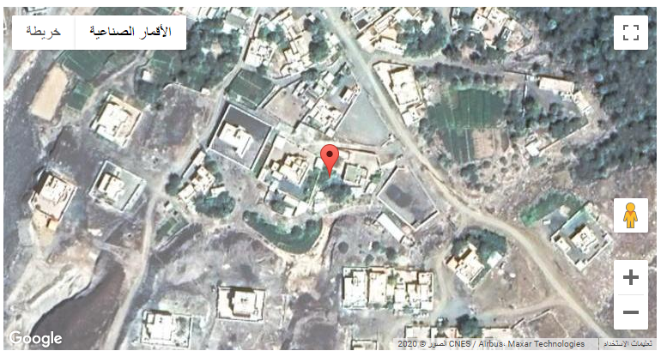
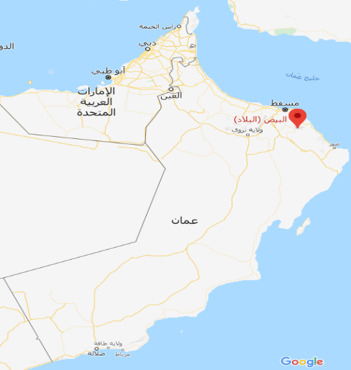

- The second location, Al-Fulaij village in Ibra state, in which the wet maturity of the palm tree is delayed compared to the first site.

- The coordinates of the site

longitude | Latitude
58.460511E ( 58°27 37 )  East | 22.809554N ( 22°48 34 )  North
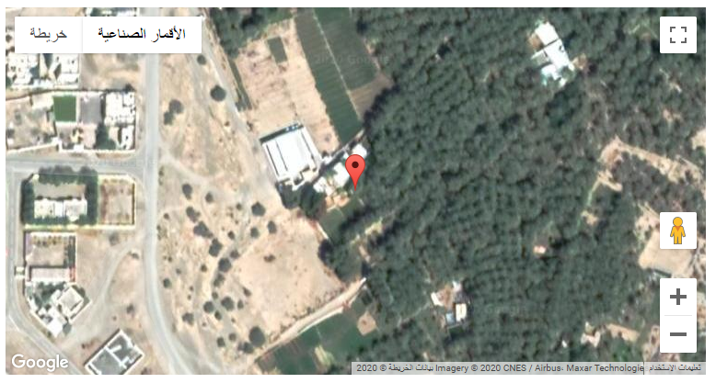
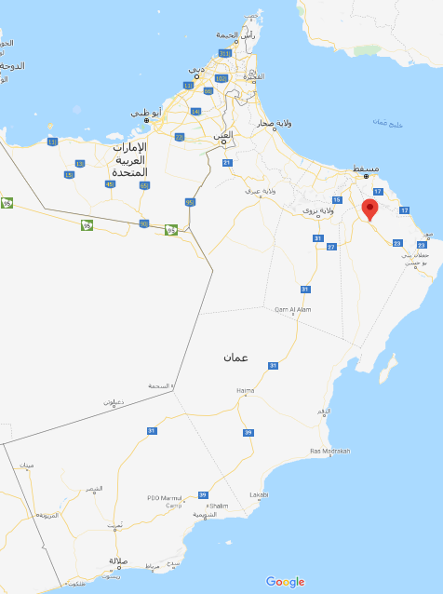

4- Data Collection and Employment of Protocols Globe:
Apply the Atmosphere Protocol to answer research questions (1-2).
To answer the first research question:
The atmosphere protocol was implemented by obtaining the temperature of the two sites through the General Directorate of Meteorology at the General Authority of Civil Aviation for the past three years.
Where these degrees were compared, and the time period required for the palm tree to mature in its fruits was analyzed (there are tables in Appendix 1)

To answer the second research question:
The atmosphere protocol was implemented by obtaining the moisture content of the two sites through the General Directorate of Meteorology at the General Authority of Civil Aviation for the past three years. (Attached in the appendices)

And answer the third research question:
The nature of the two sites was studied, after our visit to the two sites, where we noticed that the mountains were surrounded by the village of Al-Bayd, and the village of Al-Fulaij is located far from the mountains.
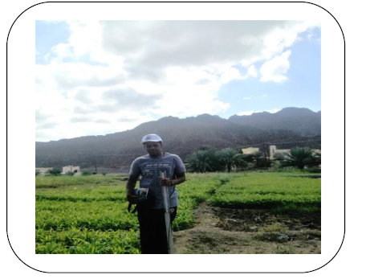
The first site (village of Al-Bayd )
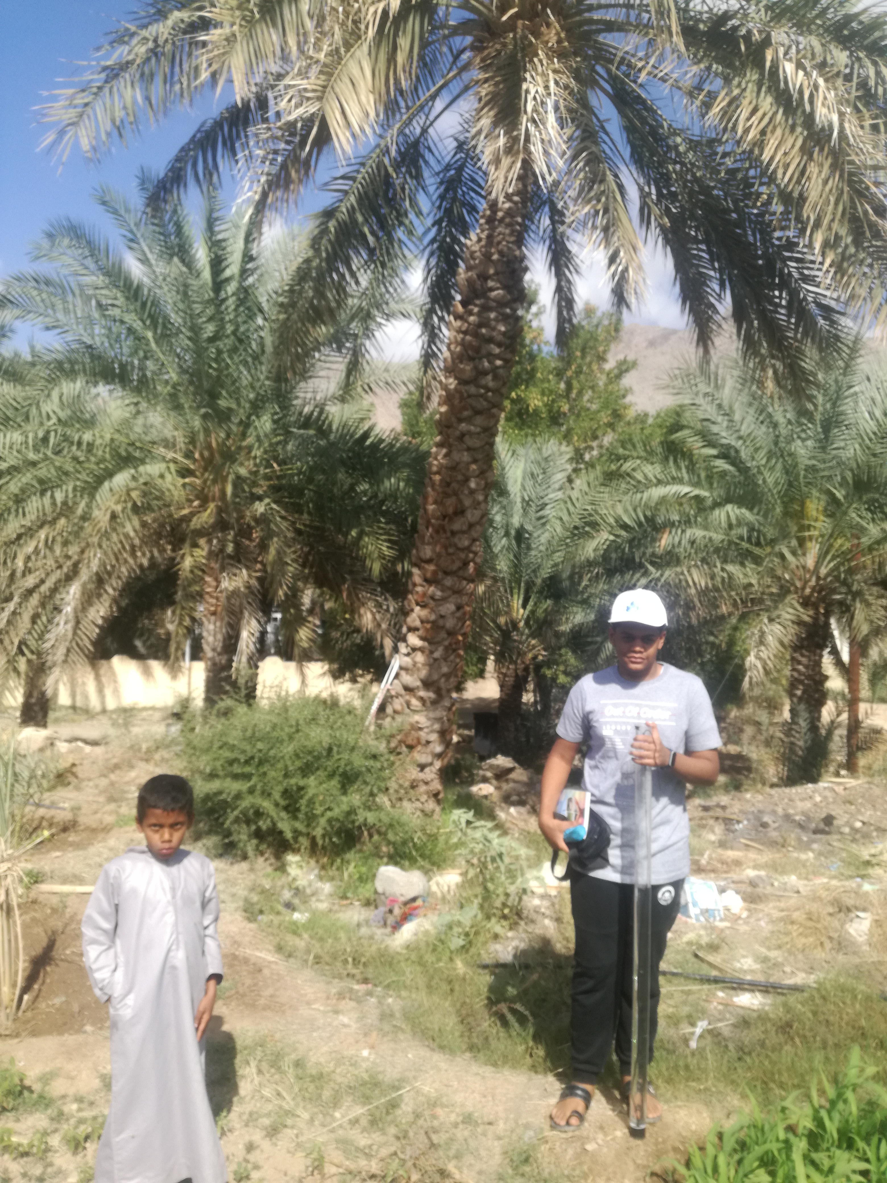

The second location (Al-Fulaij village)

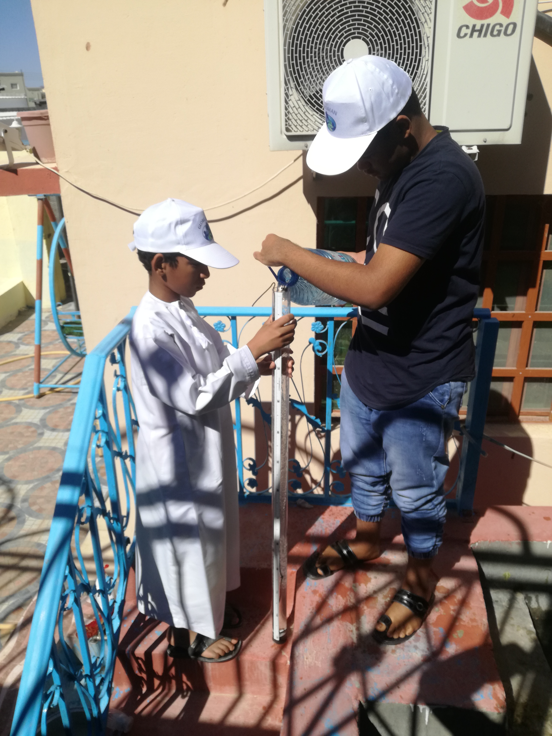
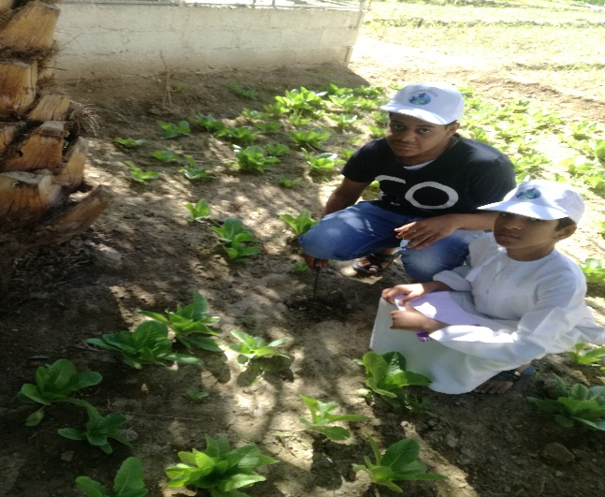

And answer the fourth research question:
We conducted a direct interview with farmers in the two villages on their farms:

Where he was from the village of Al-Bayd in the state of blood and Taa'i farms Khamis bin Obaid bin Salem al-Sabqi, and from the village of Al-Fulaij in the state of Ibra farms Nasser bin Rashid bin Masoud Al Khleifin.
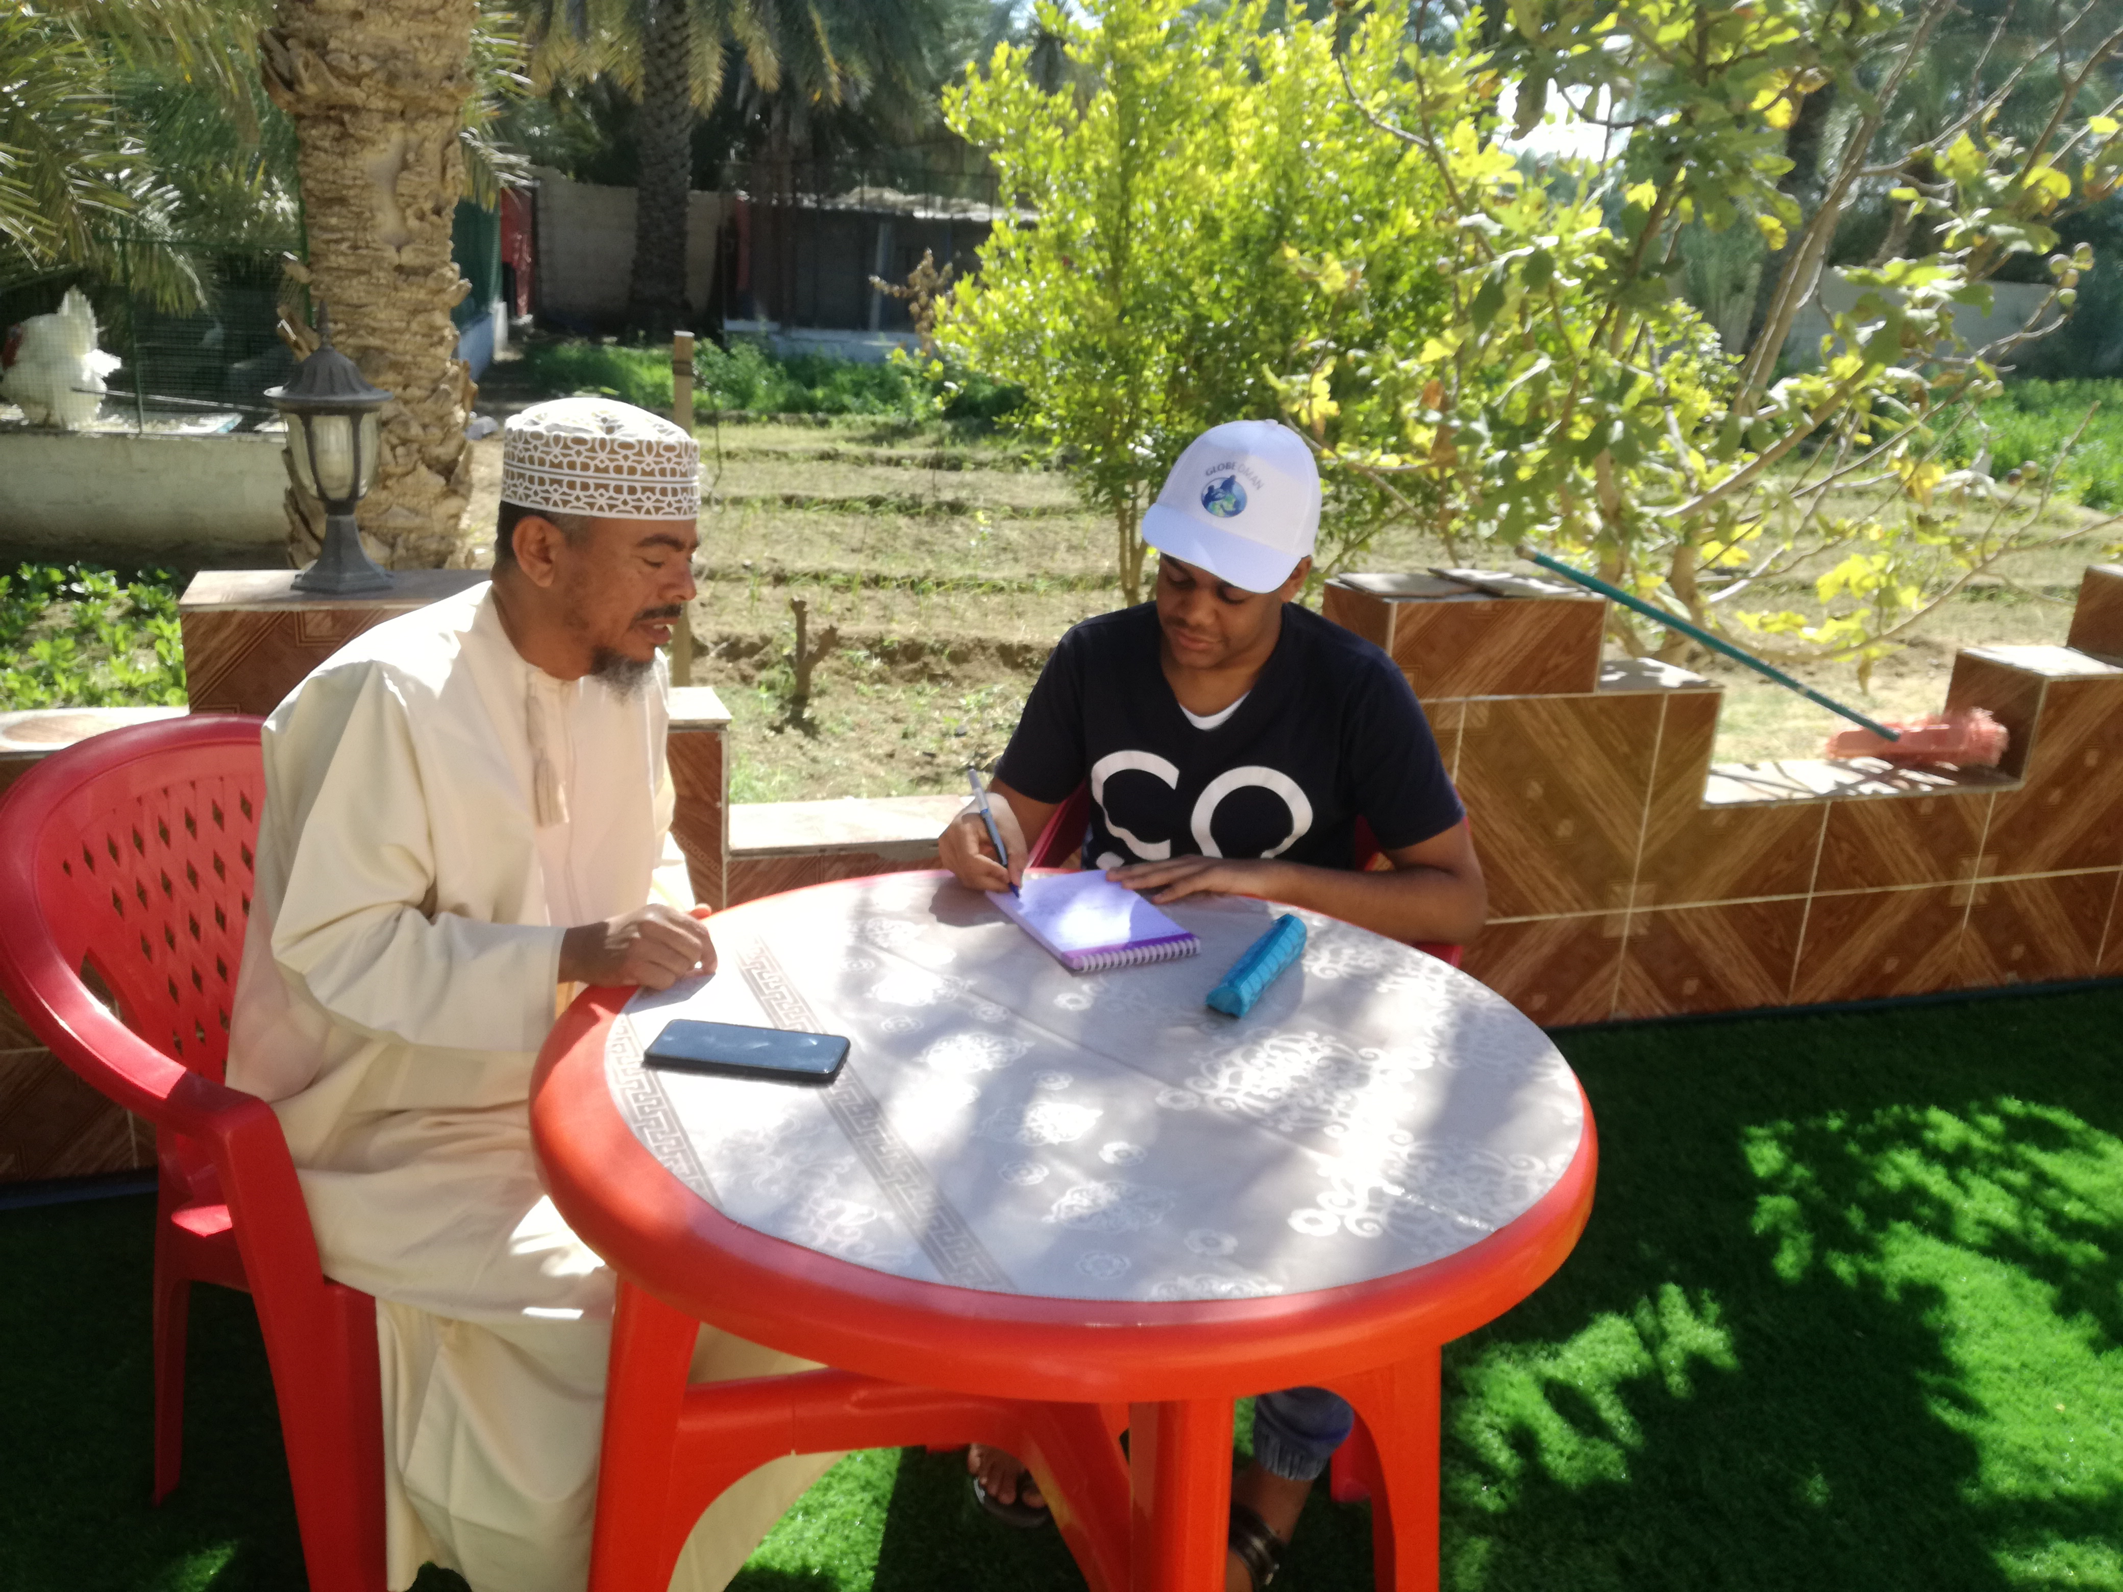
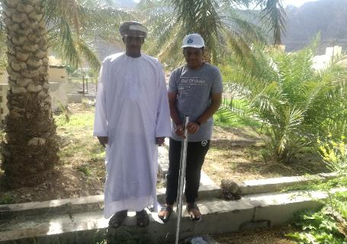

Our summary of the interview was that farm owners pay great attention to the palm tree by fertilizing it with water and combating diseases that may affect the palm tree, so that they can obtain the best fruits and benefit from its harvest in both research sites.
We also studied the properties of soil and water used in irrigation of palm trees, and applied the Soil + Water protocols at the two sites, where we obtained the following results:

Apply the soil protocol
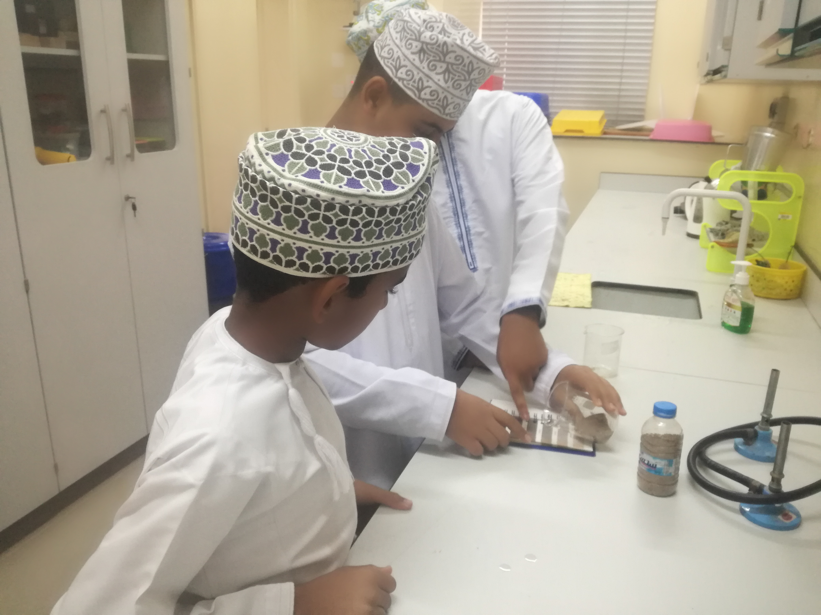
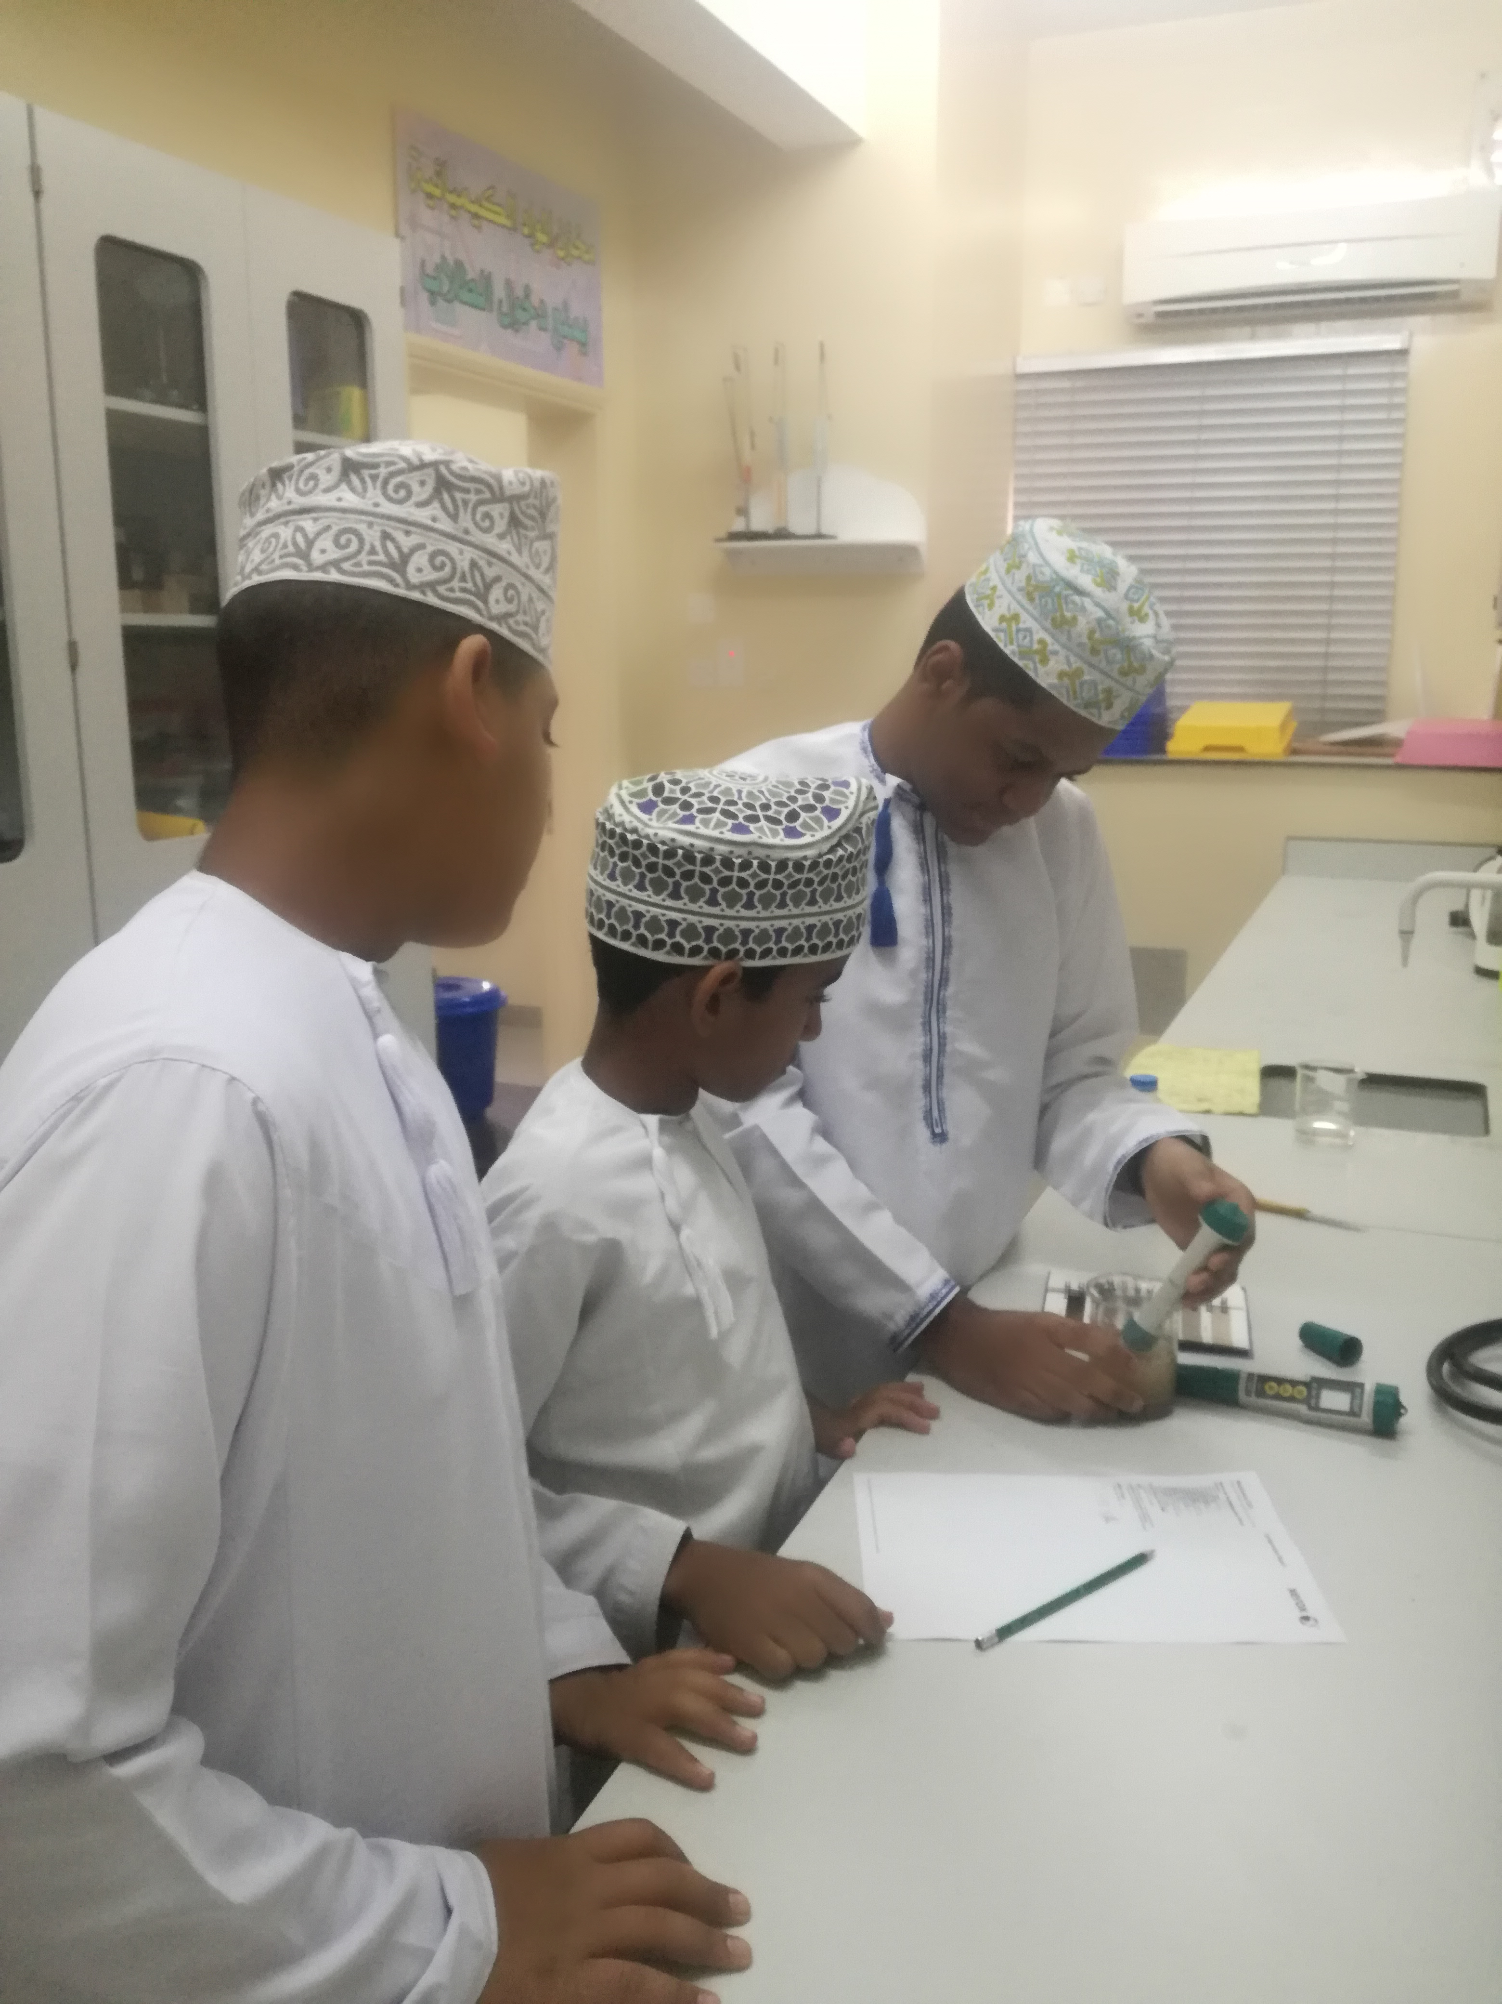

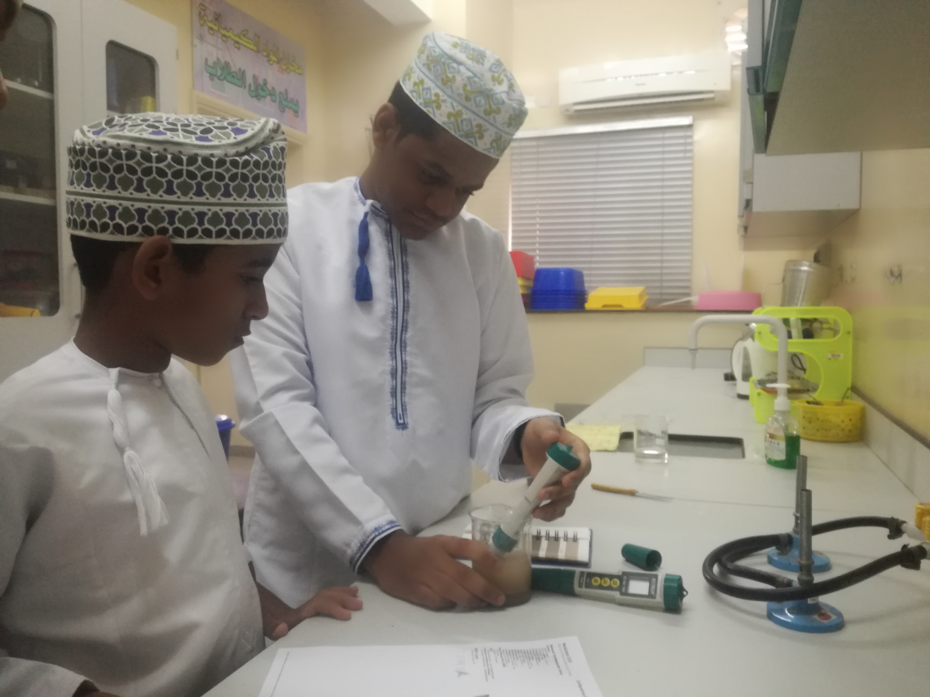

The following table shows the soil properties for the two sites.
And we came out with the following scientific observations:

The face of comparison |  | Soil village of Al-Bayd | Soil of Al-Fulaij village
Amount of rock |  | Low | Low
Amount of roots |  | Low | Low
The amount of calcium carbonate |  | Low | Medium
Acidity |  | 8.8 | 8.77
Consistency |  | Fragility | Fragility
Structure |  | grains | grains
Soil color | The main color | 7.5YR 6l3 | 7.5YR 6l4
Soil color | Secondary color | 7.5YR 5l3 | 7.5YR 5l4
Implementation of the water protocol
The face of comparison | Soil village of Al-Bayd | Soil of Al-Fulaij village
Transparency | High above 120 cm | High above 120 cm
temperature | 23 c | 22.7 c
Acidity | 9 | 8.17
Salinity | 335 | 455
conductivity | 680 | 820
Water used | Aflaj + the well | Aflaj + the well

Entering soil data in the program website (www.globe.gov)
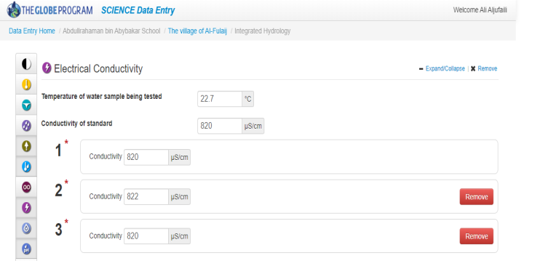
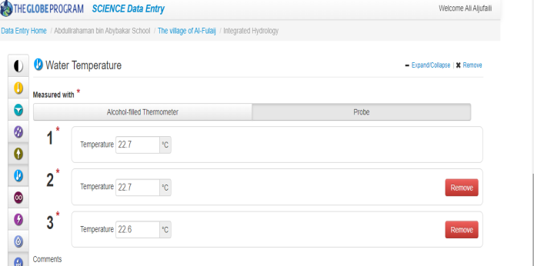
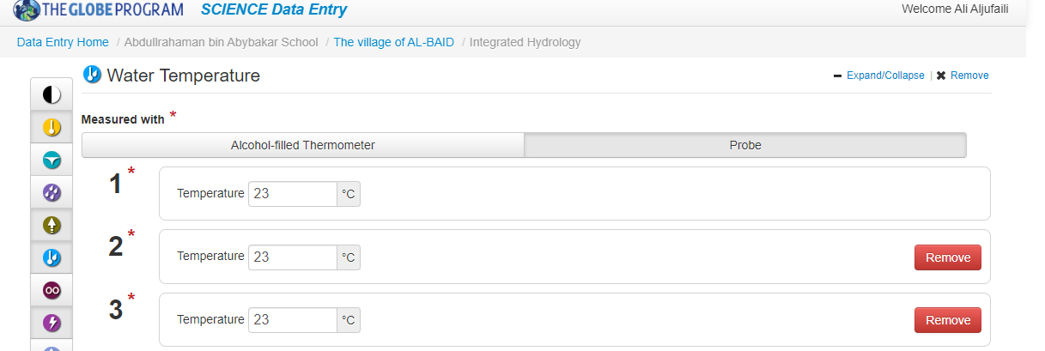
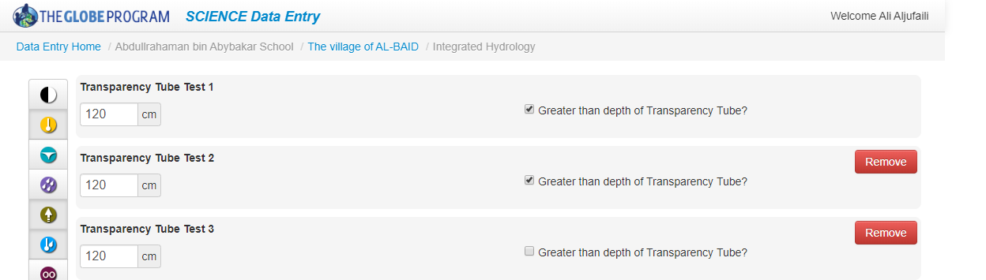
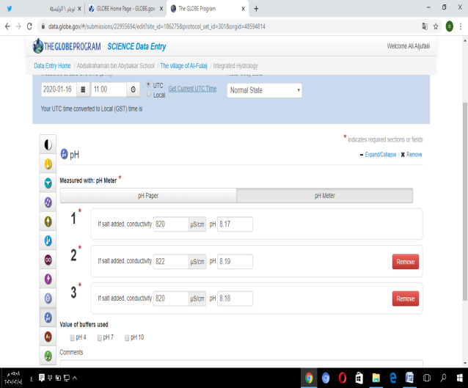

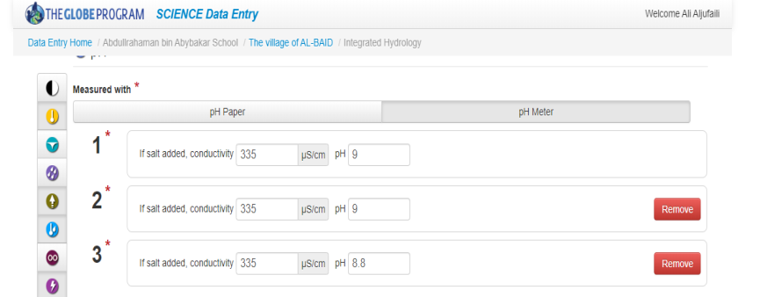
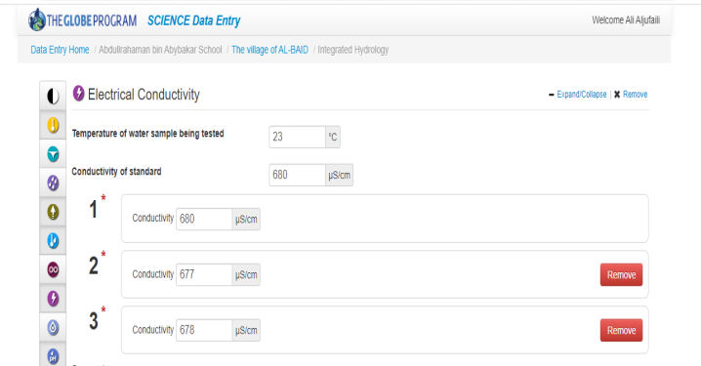
Presentation and discussion of the results:
To answer the first question in the paper:
After the procedure that we took, it became clear from the table of the average temperature of the two villages in the past three years, the rise in temperature in Al-Bayd village compared to the village of Al-Fulaij in the months before the ripening of the date palm trees, especially the months (March, April, May) and this rise in temperature It contributes to a great ripening speed of this fruit. This is consistent with the study (Diwan of Royal Court, 2019) and (Matar, 1991).

To answer the second question:
After our analysis of the percentage humidity recorded for the two villages in the past three years, it became clear to us that this percentage increased in Al-Fulaij village compared to Ibra and this appears in the months (March, April, May), where there is an inverse relationship between high humidity and temperature, when high humidity is accompanied by a decrease in The temperature and vice versa are correct. This proves that the decrease in humidity in the village of Al-Bayd is caused by the increase in temperature, because the air becomes able to carry a greater amount of water vapor and thus the relative humidity decreases.

To answer the third question:
After locating and visiting the two sites, we noticed the mountains surrounding the farms in the village of al-Bayd as well as the location chosen in this village, as these mountains contribute to maintaining the temperature and its rise for a long time in the confined area, and this is another reason that contributed to the high temperature.

To answer the fourth question:
After we conducted the interviews with the farmers, it became clear to us how similar the practices of the farmers in caring for the palm and caring for it.
Conclusion:
After we applied the study in the two sites and we collected the data that had to answer the research questions that determined the research plan, our results were as follows:
- The effect of high temperature in Al-Bayadh village, especially in the months of March and April, with a decrease in the relative humidity in this village compared to Al-Fulaij Village. It greatly contributed to the speed of wet ripening of palm trees. Palm tree.

- The geographical location of Al-Baid village contributed to maintaining the temperature for a long time, as the village was distinguished by its surrounding mountains, which work to store temperatures.

- The practice of farmers in the two villages was similar in caring for the palm in general and the palm tree in particular, so we consider these practices a constant variable.

After completing the research, we recommend reviewing the experience of the Diwan of the Royal Court project, in planting a million palm trees as an important project, which is one of the projects for food security, and knowing how the sites were chosen for the cultivation of these palms and its relationship to the nature of the environment and climate.

Acknowledgment:

We are pleased to extend our sincere thanks and appreciation and great gratitude to both:
1- To manage the school, its teachers and students' parents for their cooperation.
2- The reinforced team from our educational district.
3- The farmers (Khamis bin Obaid Al-Sabqi, Nasir bin Rashid al-Khalifin) who provided us with enriching information.
4- The General Directorate of Meteorology at the General Authority of Civil Aviation to provide us with information that helped us to complete our research.
- Abdullah bin Hamoud Al-Harthi, an employee in the e-learning department of the Ministry of Education, to help us complete the elements of our research.

References:

1- Ibrahim, Abdel Baset Odeh. (2008). Date palm tree of life. Dar Degla Publishers and Distributors.
2- Diwan of Royal Court. (2019). Climatic factors specific to palm cultivation. General Directorate of the project to plant a million palm trees.
3- Zayed, Abdel Wahab, Al-Jabouri, Hamid Jasim. (2006). Date palm cultivation and production technology. Cairo, FAO Regional Office for the Near East.
4- Matar, Abdul Amir. (1991). Palm cultivation and production. Basra. Albasrah university.
5- Al-Maamari, Ahmed. A wet bean with 7 riyals with blood and Al-Taei. Oman Newspaper. April 29, 2018. Retrieved from: https://www.omandaily.om/?p=587574
6- Al-Maamari, Ahmed. Moist bees sold by the pill in the blood and the Taoists. Oman Newspaper. May 5, 2017. Retrieved from: https://www.omandaily.om/?p=469599
7- The Ministry of Agriculture and Fisheries. 2015. At the beginning of the preaching of the spring, the Nakhalat of Nghal at 1350 riyals in the town of Sout with blood and the Ta’i. Retrieved from: https://www.maf.gov.om/MediaCenter/NewsDetails/6796

The appendices
Accessory (1)
Examples of meteorological readings for the two sites

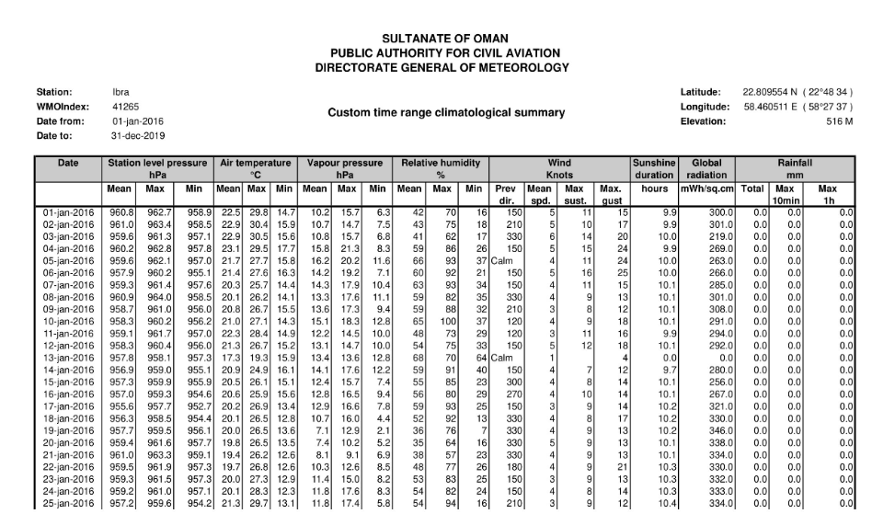
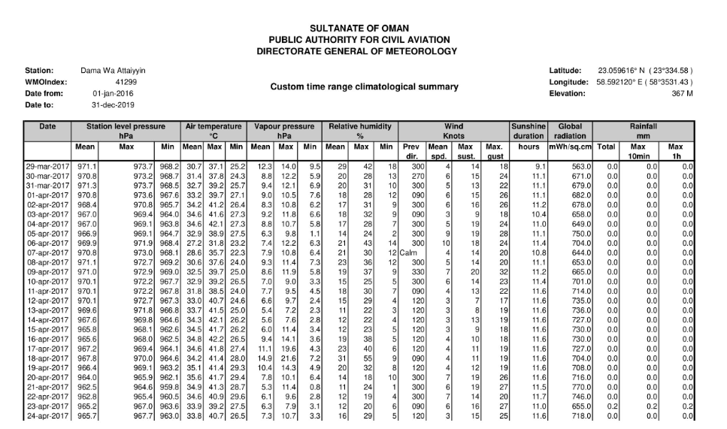

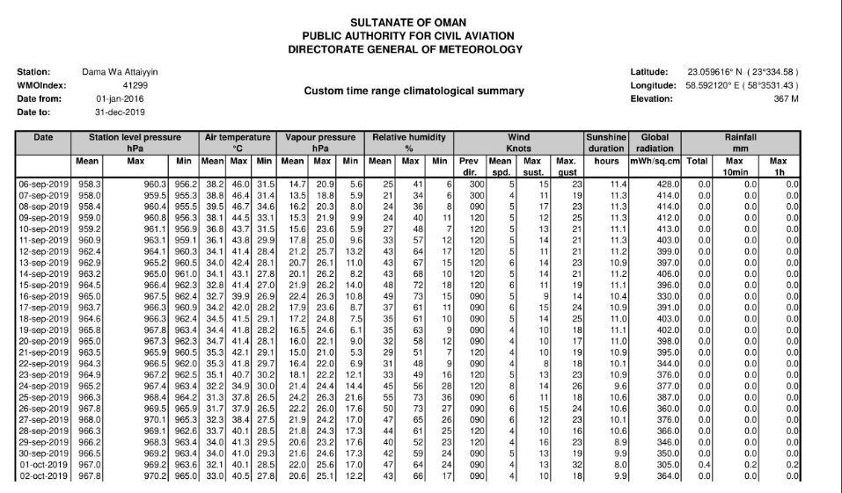

Accessory (2)
the interview

Interview questions for farmers:
1- In your opinion, why Palm Tree in the village of Al-Beid, Wilayat Dima and Al-Taaiyin, precedes Al-Fulaij in the Wilayat of Ibra in the formation of Al-Rutb?
2- In which month does the palm tree wet picking begin with you?
3- Is there a great interest of farmers in this palm tree, and how?
4- Are there other factors that contribute to the wet formation of this palm tree?

