Scientific research
Examine the effect of water type on the growth of lentils seeds

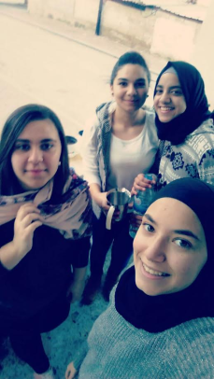
Students names :

Tasneem Saleem 212606800
Raghad Zeyadat 213028483
Jowan Saleem 213025646
Bara Ahmad 212601900

Ort Muqeible Junior High School

Ninth Grade 1

Subjects Teacher : Miriam Abdullah

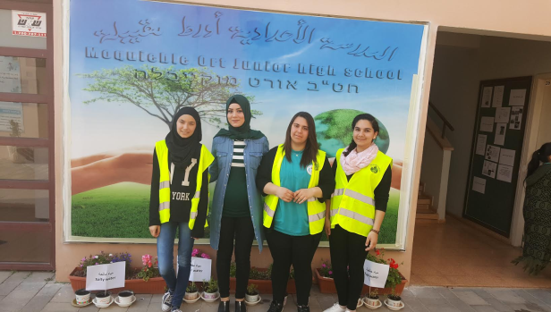

-1-
The contents
The subject page

The introduction …………………………………………………………2
Theoretical section
Water .....................................................................................................3-5
Lentils.....................................................................................................6-8
Practical section
Tools and methods of work..................................................................9-10
Search results by tables......................................................................11-14
Results by chart..................................................................................15-16
Conclusions.............................................................................................17
Pictures appendix....................................................................................18
The references…………………………………………………….……..19

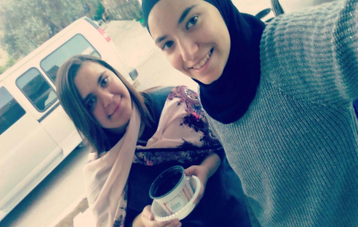

-2-
The introduction

We have been very curious about the effect of water on the growth rate of lentil seeds. After all the questions we decided to do a scientific research about this subject. So we brought 12 pots and the same kind of soil, we planted lentil seeds in every pot which contains 400 gm of soil and we have 4 types of water :
- washing water
- salt water
- distilled water
- tap water
At first we assumed that washing water and salt water will have negative effects on the growth of lentil seeds, but distilled water and tap water will affect on the growth of lentil seeds positively. But after we did the experiment and saw the results, we made sure that our hypothesis was wrong. We noticed that washing water, distilled water and tap water have positive effects, but salt water has a negative effect on the growth of lentil seeds. So we advice everyone who wants to plant lentils not to use salt water because of its negative effects.

-3-
Scientific background

Water :
Water is one of the basic elements of the earth, and it is one of the most available material on its surface and inside, it is also one of the elements that humans need in their daily life. All organisms need water to stay alive, all biological processes which occur in organisms depend on water starting from eating until waste disposal. Humans need water to stay alive in addition to using it in cooking, personal and household hygiene, manufacturing, agriculture and crops irrigation. Water is on the earth's surface in a continuous and repetitive movement. Water which is in seas, rivers and oceans evaporate because of the heat of the sun, arising as an invisible vapor then it goes back to earth like rain, snow and any form of water moisture. Most of this water fall directly on the oceans, rivers and seas , the other water fall on the surface of the earth. This cycle is continuous and repetitive without ending. The amount of water in nature remains constant because of this cycle
The types of water we used:
Distilled water
It is a type of treated water by distillation process where the water is boiled ( tap water or rainwater) the resulting steam is collected and condensed to get the distilled water. Through this process we get rid of

-4-
salts, suspended solids and mineral pollutants, but we can't get rid of mercury and volatile organic substances.
Gray water
It is the water of washing basins and bathtubs , it was named because of its gray color. There are no organic substances in this type of water, and it differs from the black water which is in toilets. There is no manure in gray water. Black water can only be used after treatment, but we can reuse gray water especially in agriculture by treating it in simple ways. In addition to gray water is less polluted than black water.

Features of gray water:
- it is about 60 of the total produced wastewater
- containing less pollutants than black water
- easy to process and reuse
- saving the amount of produced drinking water
- contains a high amount of fat

-5-
Types of gray water which we used
Salt water
It contains a lot of mineral salts especially Sodium Chloride Salt ( NaCl) Washing water It contains a certain amount of soap, it is polluted and no drinkable
The effect of using gray water on plants:
Gray water is used to irrigate crops so we must not throw harmful substances in gray water when we used it such as paints, resistant material and chemicals from photographic laboratories. Many gray water sources already contain harmful substances for plants. Many types of soap and cleaning materials consist of Sodium compounds which lead to burn plants leaves and lose their color, it also increases the basal rate in the soil. High amounts of Sodium in the soil is toxic to some plants and prevent calcium to reach the plants.
The effect of using gray water on soil:
The opinions about using gray water in irrigation are :
- increasing soil salinity and banality
- the ability of soil to conserve and absorb

-6-
Lentils seeds:
Lentils are legumes, the color of it's seeds is brown and tends to red, or gray or black .it's diameter is about 13 millimeters, it is used for food, it's green leaves are used as food for dairy cows , it is also used to fertilize poor land with organic substances by turning it into soil when it is in the process of being bloomed
Nutritional value and health benefits:
Lentils contain high amounts of proteins and fiber, Follett ,vitamin B1 and minerals. Red lentils contain less fiber than green lentils ( 11 instead of 33)
The health magazine chose lentils as one of the most five healthy food
Lentils temperature:
Lentils don't need high temperatures , it can't be planted in the frost so it should be grown in temperate climate with low humidity. Lentils are grown in many places: Levant, southern Europe, United States and Iran . It is used in many dishes. The age of lentil plant is between 100_145 days. The growth of lentils stopped in a temperature ranging from 4_5 , and affected by the maturity stage as a result we will have hard to cook grains. Lentils need yellow soil , medium fertility and contains enough lime.

-7-
Conditions of lentils :
Water:
It is one of the most important environmental factors for germination. Water contents control the growth of the plants. Plant doesn't grow if it's moisture content is less than 40_60 , when we plant dry seeds, they absorb water in the beginning, then the saturation and bloating occur . Seed's ability to absorb depends on many factors such as transmittance , environmental temperature, water ,which help the seeds to form roots, and form smaller radical bristles to absorb much water. The amount of water are absorbed by the plant during bloating will affect on seed's growth.
The heat:
It is one of the most important environmental factors for plant growth. At low temperature, plant growth decreased. And the growth increases at high temperature but the temperature shouldn't be too high.
The light :
It is one of the factors for plant growth, plants need another factors such as water and food . There are some plants need light and others need shade to grow.

-8-
Ph degree:

Hydrogen has a significant impact on plant growth. If it's value is seven, the soil is neutral. If it is less than seven, the soil is acidic. If it is more than seven, the soil is basicity
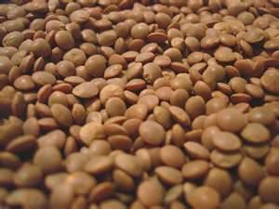

-9-
Tools and methods of work

Research's question:
What is the effect of water type on the growth of lentils?

:Research hypothesis

- we assume that the washing water and salt water affect negatively on the growth of lentils

- we assume that distilled water affect positively on the growth of lentils

***************************************************
Research tools:

- lentil seeds for pots 120
- inserted tube
- washing water bottle, distilled water bottle, salt water bottle, tap water bottle
- plastic plates

****************************************************

-10-

The method of work
In the beginning we put the same amount of soil in the pots , and put 10 lentil seeds in each pot ( every type of water has 3 pots) then we put 100 millimeters of

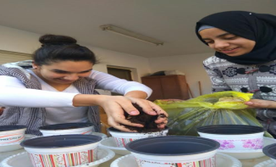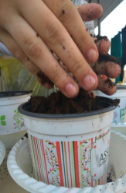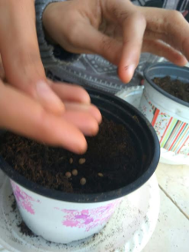:
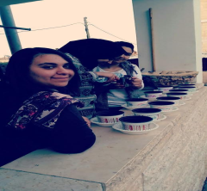

-11-

Results by tables

Washing water

The Date | length | Leaves number | color | Seeds number
18.1.2017 | 0 cm | 0 | ------------------ | 0/10
20.1.2017 | 0 cm | 0 | ------------------ | 0/10
22.1.2017 | 0 cm | 0 | ------------------ | 010
24.1.2017 | 1 cm | 2 | green | 6/10
26.1.2017 | 2 cm | 4 | green | 7/10
28.1.2017 | 3 cm | 4 | green | 8/10
30.1.2017 | 4 cm | 4 | Green+Brown | 8/10
1.2.2017 | 6 cm | 6 | Green+Brown | 8/10
3.2.2017 | 6.5 cm | 6 | Green+Brown | 8/10
5.2.2017 | 7 cm | 11 | Green+Brown | 8/10
7.2.2017 | 8 cm | 11 | Green+Brown | 8/10
9.2.2017 | 8.3 cm | 12 | Green+Brown | 8/10
11.2.2017 | 9.5 cm | 16 | Green+Brown | 9/10
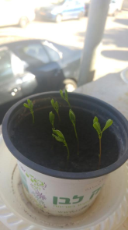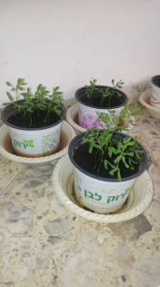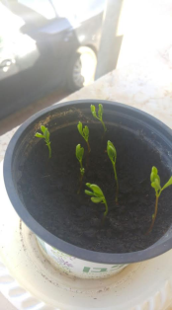
-12-
Distilled water:
The date | length | Leaves number | color | Seeds number
18.1.2017 | 0 cm | 0 | ------------------ | 0/10
20.1.2017 | 0 cm | 0 | ------------------ | 0/10
22.1.2017 | 0 cm | 0 | ------------------ | 0/10
24.1.2017 | 1.5 cm | 1 | green | 6/10
26.1.2017 | 3 cm | 3 | green | 9/10
28.1.2017 | 3.5 cm | 4 | green | 9/10
30.1.2017 | 4 cm | 4 | green | 9/10
1.2.2017 | 6 cm | 6 | Green+Brown | 9/10
3.2.2017 | 6.8 cm | 6 | Green+Brown | 10/10
5.2.2017 | 8 cm | 8 | Green+Brown | 10/10
7.2.2017 | 8.6 cm | 9 | Green+Brown | 10/10
9.2.2017 | 9 cm | 12 | Green+Brown | 10/10
11.2.2017 | 10.6 cm | 16 | Green+Brown | 10/10
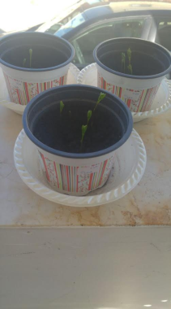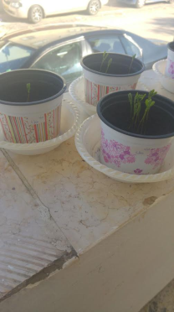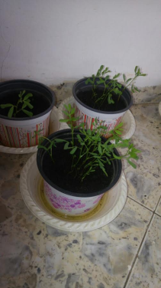

-13-
Salt water:

The date | length | Leaves number | color | Seeds number
18.1.2017 | 0 cm | 0 | ----------------- | 0/10
20.1.2017 | 0 cm | 0 | ----------------- | 0/10
22.1.2017 | 0 cm | 0 | ----------------- | 0/10
24.1.2017 | 0 cm | 0 | ----------------- | 0/10
26.1.2017 | 0 cm | 0 | ----------------- | 0/10
28.1.2017 | 0 cm | 0 | ----------------- | 0/10
30.1.2017 | 0 cm | 0 | ----------------- | 0/10
1.2.2017 | 0 cm | 0 | ----------------- | 0/10
3.2.2017 | 0 cm | 0 | ----------------- | 0/10
5.2.2017 | 0 cm | 0 | ----------------- | 0/10
7.2.2017 | 0 cm | 0 | ----------------- | 0/10
9.2.2017 | 0 cm | 0 | ----------------- | 0/10
11.2.2017 | 0 cm | 0 | ----------------- | 0/10
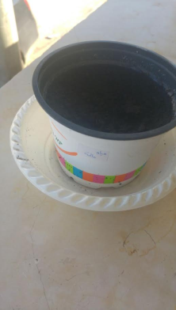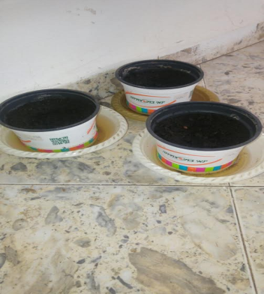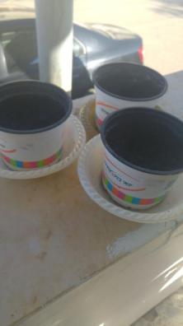

-14-
Tap water:

The date | legnth | Leaves number | color | Seeds number
18.1.2017 | 0 cm | 0 | ------------------ | 0/10
20.1.2017 | 0 cm | 0 | ------------------ | 0/10
22.1.2017 | 0 cm | 0 | ------------------ | 0/10
24.1.2017 | 1.4 cm | 1 | green | 3/10
26.1.2017 | 2.5 cm | 2 | green | 5/10
28.1.2017 | 2.7 cm | 3 | green | 6/10
30.1.2017 | 3 cm | 4 | green | 6/10
1.2.2017 | 5 cm | 4 | Green+Brown | 7/10
3.2.2017 | 6.5 cm | 6 | Green+Brown | 7/10
5.2.2017 | 8 cm | 6 | Green+Brown | 7/10
7.2.2017 | 8 cm | 8 | Green+Brown | 7/10
9.2.2017 | 9 cm | 10 | Green+Brown | 7/10
11.2.2017 | 10.5 cm | 15 | Green+Brown | 7/10
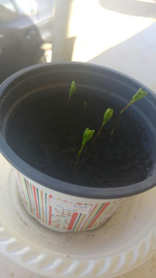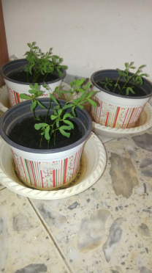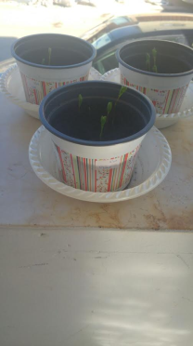

-15-
Results by charts:

Leaves number:
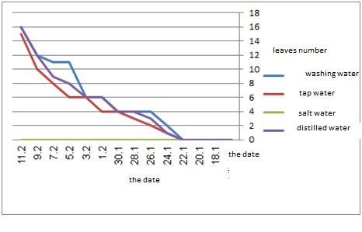

Number of seeds that grown (from10):

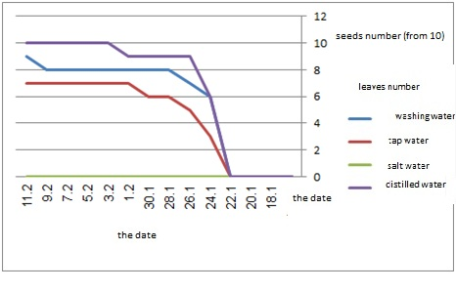

-16-
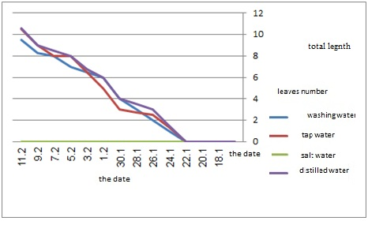
total legnth

-17-
Conclusions
Based on charts we made sure that distilled water is the best for seeds, it helps the plants to grow and increases their length and make their leaves grow more, all the seeds have grown when we used distilled water.
It followed by washing water and tap water but salt water is very bad for the growth of lentils. There is no growth when we used salt water because when soil salinity increases, soil deteriorates.

-18-
Picture appendix:
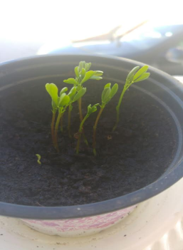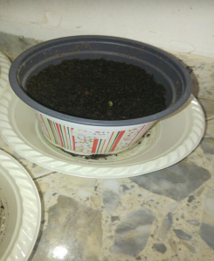
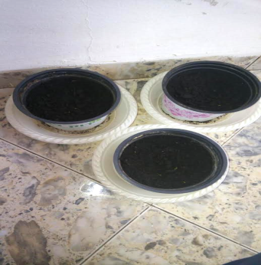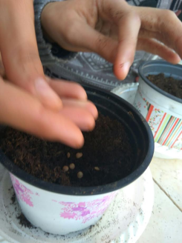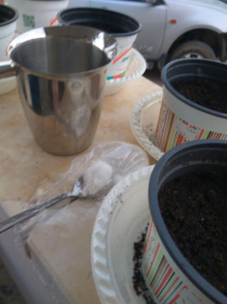
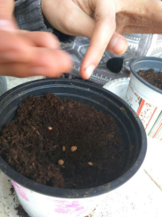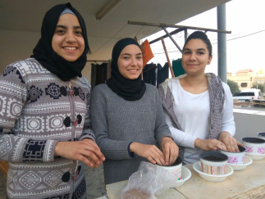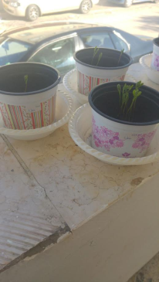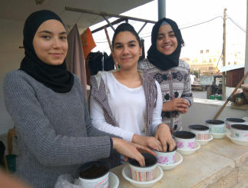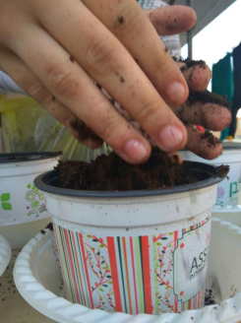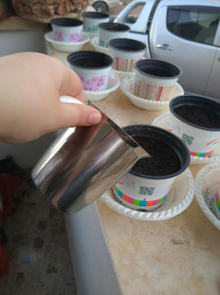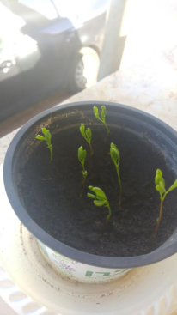

-19-
The references
Internet sites

- http://mawdoo3.com/%D8%AA%D8%B9%D8%B1%D9%8A%D9%81_%D8%A7%D9%84%D9%85%D8%A7%D8%A1

- https://arabian-chemistry.com/%D8%A7%D9%84%D9%81%D8%B1%D9%82-%D8%A8%D9%8A%D9%86-%D8%A7%D9%84%D9%85%D8%A7%D8%A1-%D9%85%D9%86%D8%B2%D9%88%D8%B9-%D8%A7%D9%84%D8%B4%D9%88%D8%A7%D8%B1%D8%AF-%D9%88%D8%A7%D9%84%D9%85%D8%A7%D8%A1-%D8%A7/
- https://ar.wikipedia.org/wiki/%D8%B9%D8%AF%D8%B3
- The books

- Contemporary scientific encyclopedia
- Book of physical and chemical pollution

