The Effect of Indoor and Outdoor Humidity on PM_{2.5}

Students: Su,Ching-Yi,Li,Pei-Jou,Chang,Chiun-Fang, Liu, Yu-Ming
Teacher: Liu, Cheng-Chueh
Advisor: Lin, Pay-Liam
Taichung Municipal Taichung Girl’s Senior High School
1 March 2018

Abstract
Nowadays, air pollution has become one of serious problems in Taiwan. Compared with outdoors, indoors due to relatively small in space, may contain higher concentration of particulate matters (PM). In addition to the size of space factor, the humidity of indoors and outdoors may also play an import role on the concentration of PM. Therefore, we conducted this research to analyze the effect of indoor and outdoor humidity on the concentration of PM. We calculated the difference between indoor and outdoor humidity, and converted it into a line graph with the concentration of indoor PM_{2.5.} And then we inferred that PM_{2.5} is definitely related to the difference between indoor and outdoor humidity and the concentration of indoor PM_{2.5.} As mentioned above, we can not only learn about the connection between water and PM_{2.5}, but also realize that water causes the deviation to the machine but it helps reduce PM_{2.5.}

Issues:
The effect of indoor and outdoor humidity on the concentration of PM.

Literature Review

1.The definition of PM_{2.5}
There are many pollutants in the air. Whatever floats in the air like dust particles is called ’’particulate matters, PM’’. (Environmental Protection Administration, 2018) Particulate matters vary in size: fine particles with a diameter of 2.5 micrometres or less in size are known as PM_{2.5}, also called aerosol. (Wang Zhi- Zhong, 王治中, 2017)
Different from PM₁₀, which is bigger particles, quickly taken down by gravity after emitted into the atmosphere, PM_{2.5} can stay longer in the atmosphere until being washed out by rain. (Environmental Protection Administration, 2018)

2.The cause of PM_{2.5}
(Environmental Protection Administration,2018)

PM_{2.5} can be either human-made or naturally-occurring.
Naturally-occurring: volcanic eruptions, crustal rocks, etc.
Human-made: the combustion of fossil fuels, the exhaust gas from factories, etc.

For example, in Taichung city, the target city of this research, the main pollution sources include stationary pollution, vehicles, and fugitive pollution.

Stationary pollution source: Stationary pollution source mainly comes from automobiles. Due to the great quantity of waste gas emissions from automobiles, automobiles have affected air quality to some degree. (Chen Bo-Cheng ,陳柏丞,2017)

Mobile pollution source: Mobile pollution source results from domestic major industrial zones, including electricity industry, steel industry,Taichung thermal power plant, etc. (Chen Bo-Cheng ,陳柏丞,2017)

Fugitive pollution source: Fugitive pollution source comes from industrial zones,
harbors, gravel yards, construction sites, etc.(Chinatimes,2017)

The above-mentioned are Taichung’s outdoor air pollution sources. However, since they have little to do with this study, we just made a brief introduction.

3.The origin of PM2.5

Indoor air quality is influenced by gas (such as Carbon monoxide, radon, or Volatile Organic Compounds), particulate matters, and microbes (such as Molds, bacteria). (Liu Yao-Kai ,劉耀凱,2016)Furthermore, outdoor air pollutants may be one of the factors that affects indoor air quality. They include exhaust emissions from mobiles and factories, and central air-conditioning system's filter which is not regularly cleaned and thus breed microorganisms.

Measurement methods

- Outdoor: monitored by Environmental Protection Agency
In Taiwan, outdoor air quality is mainly measured by manual monitoring and automatic monitoring. It takes about 20 days to carry out this mission by manual monitoring because it requires manual sampling, and samples are required to go through a variety of processes, including coordinate, measurement, quality control, and so on. (Environmental Protection Administration,2018)
Meanwhile, automatic monitoring utilize β-radiation-absorption-method to detect the relative concentration of particulate matters. (Hsu Chih-Hsiang,許志祥,2015)

- Indoor: According to measuring instruments

2.1 The definition of granules we measured
( Cai Xiao-shu, Su Min-gxu & Shen Jian-qi,2010)
Particles are tiny solid, gas, or liquid insplit state. In most cases, particle means solid molecule; droplet is liquid molecule, bubble signifies gas molecule. In fact, the size of particles is one of the most basic measurements.

2.2 We use a Begood detector, which is based on light scattering. It can measure the quantity of different particle size of particulate matters in the air by light-scattering. When the surface of particulate matters are irradiated by ray, it causes refractions and reflections. These effects vary with size, shape, the surface roughness, as well as wavelength. (anonymous,2017) The optoelectronic detector accepts light scattering signals of particles. After that, all the signals will be sent to a computational equipment to convert them into the concentration of PM2.5. (Cai Xiao-shu et al, 2010) In the environment with high humidity, such as Taiwan, when we use automatic particle sensing monitor to take the sampling to particle matters, if we don’t reduce humidity effectively, particles’ appearances and their sizes will change due to absorbing water. In that case, the data will be higher than they really are. Thus, it won’t be the correct concentration. (Environmental Protection Administration,2013)

Research methods

Observing site: A security office in Taichung Municipal Taichung Girls' Senior High School
Date:1/21~2/20 (For about one month.)
Time:10:00AM~12:00PM ( Measure for at least 20 minutes in this period of time)
Equipment: Begood detector - to measure the concentration of indoor particulate matters; Dry and wet bulb thermometer - to measure the indoor humidity.
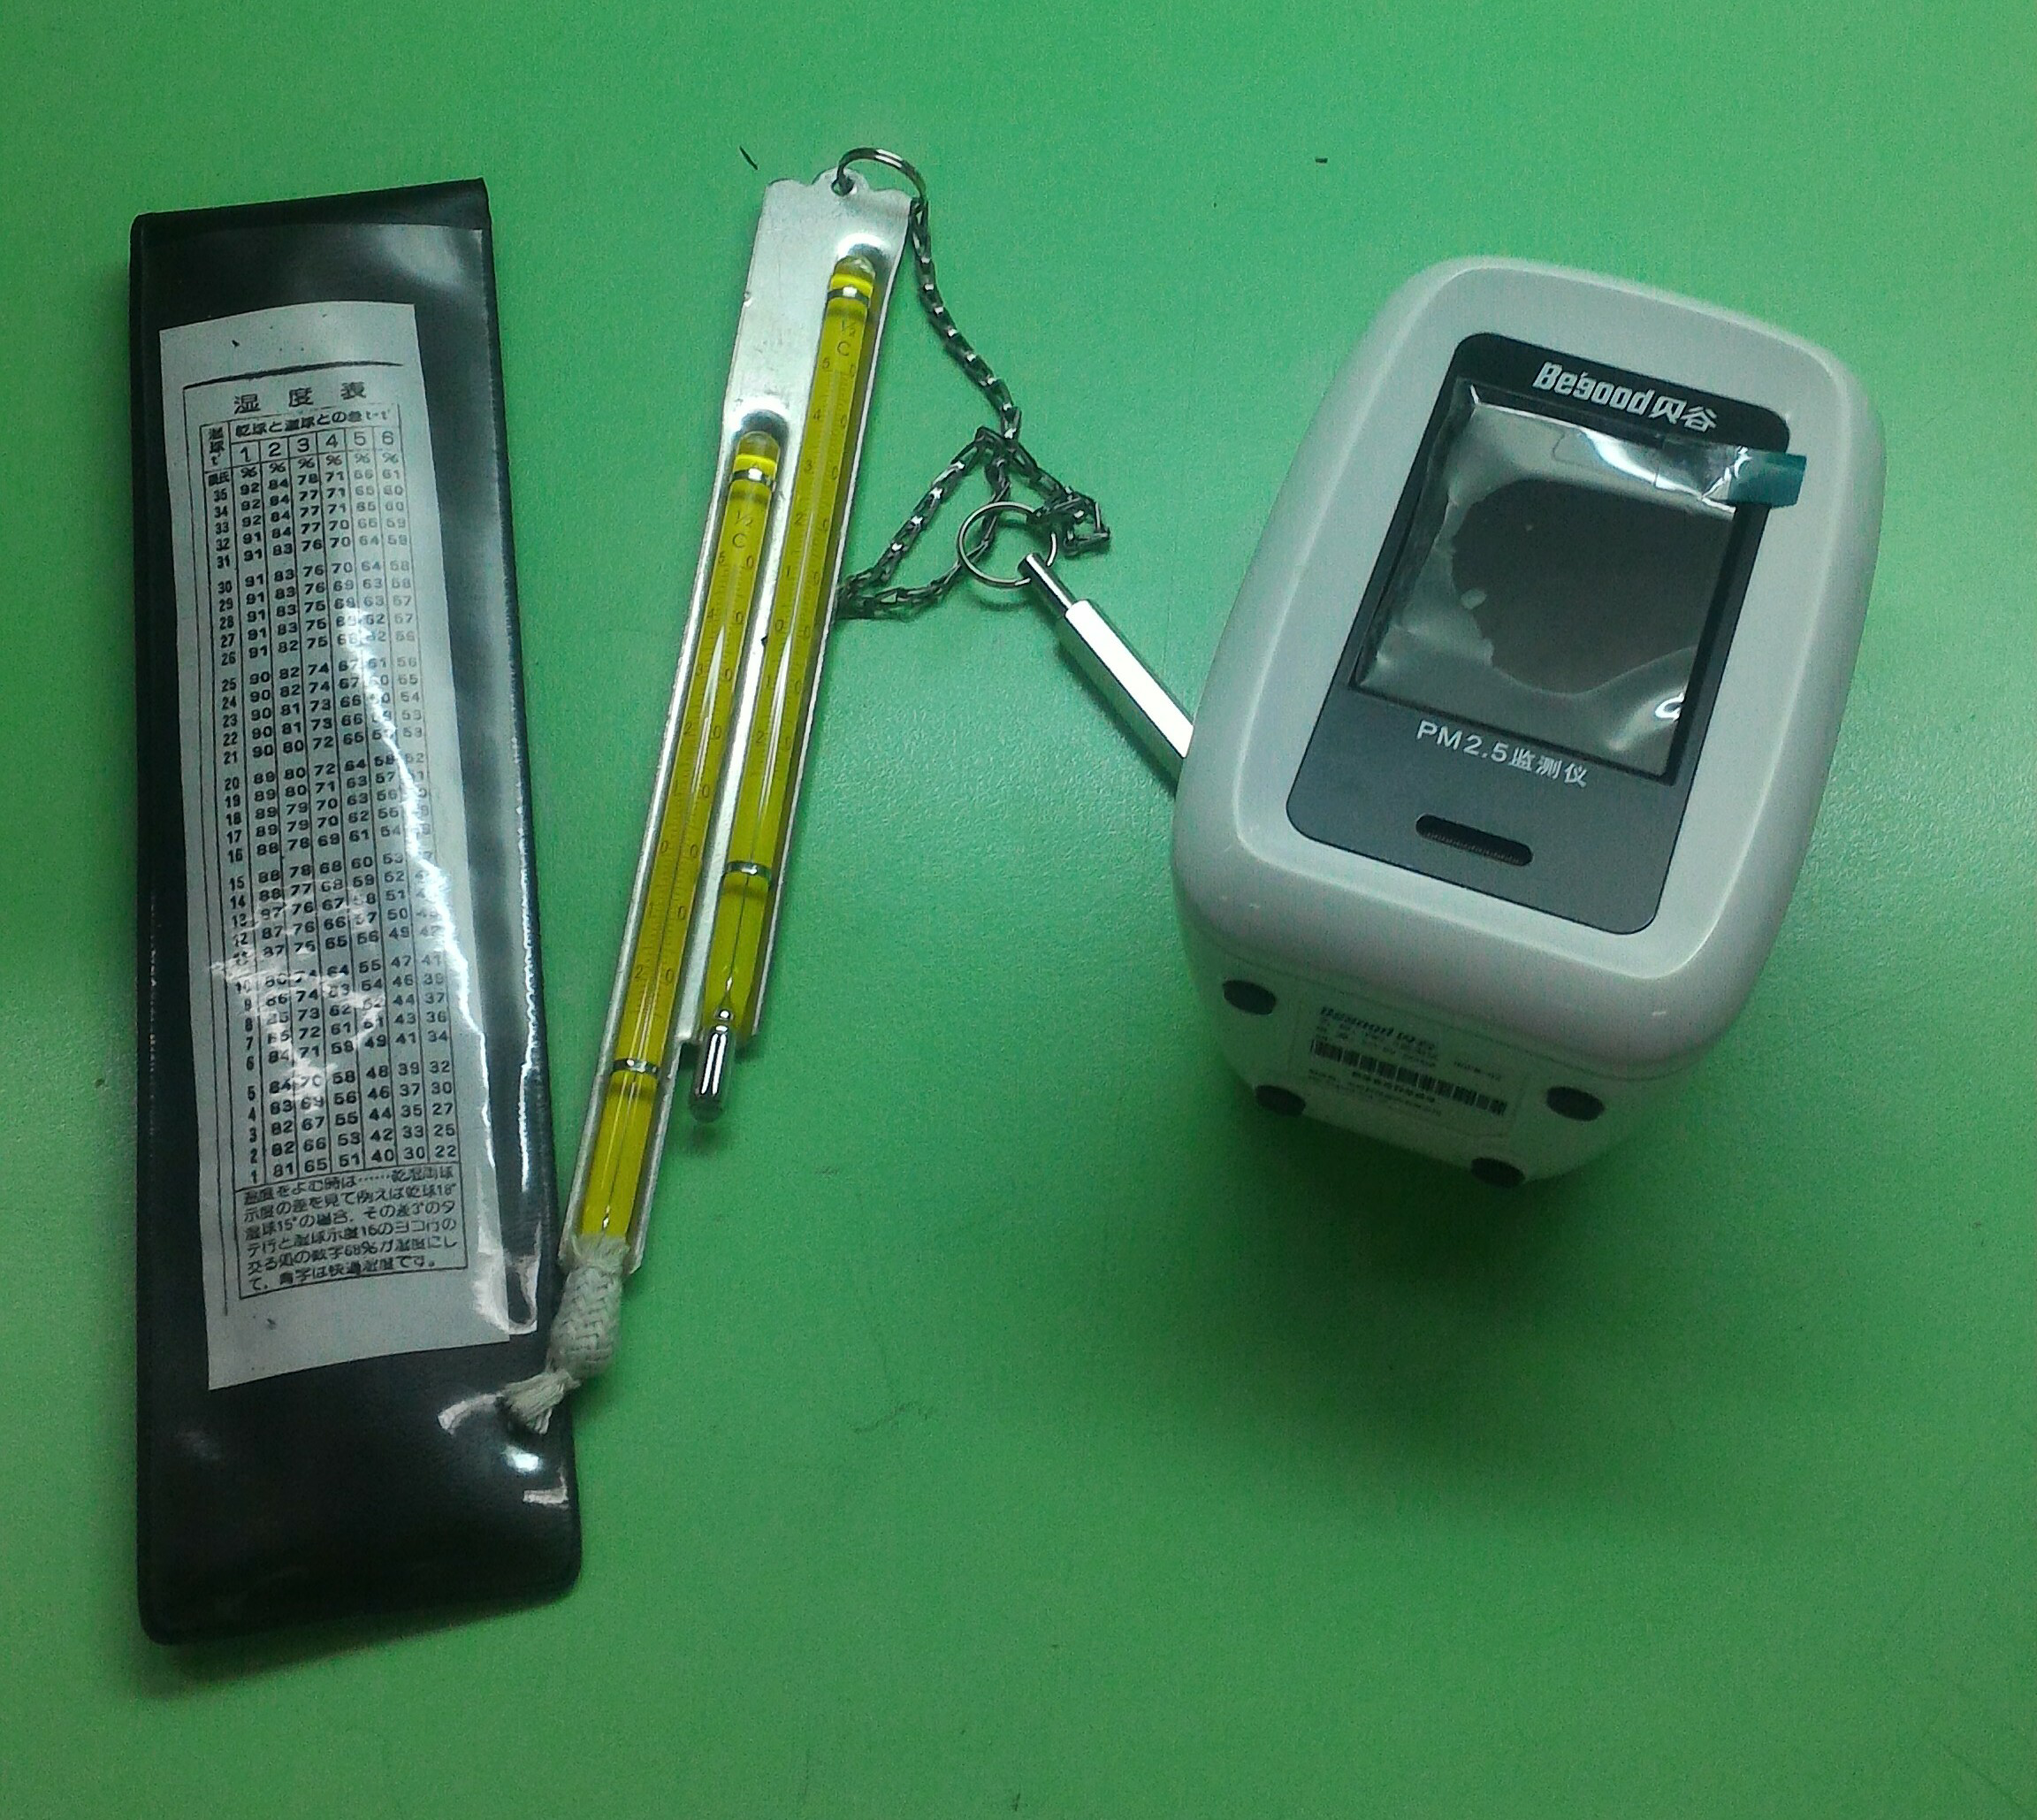
Outdoor humidity is taken from the station of the GLOBE program in school. We measure the humidity both indoor and outdoor, and compare the connection between the concentration of particulate matter and humidity we can conduct the study through analyzing these data.

Results and discussion
When the initial test was made, the numerical value suddenly soared when the instrument was lifted by hand. We recorded the values ​​before and after lifting it by hand and inquired about the observation principle of this instrument. Since the instrument takes air into it by using a similar internal fan structure, so if the instrument is suddenly moved during the process, the amount of air taken-in may increase or decrease, which leads to the change of value. Therefore, after discussion, we decided that the instrument’s fan should face upwards, placed still for 20 to 30 minutes to get more complete values. Besides, we should pay attention not to move the instrument, and record the values in the very beginning and after 20-30 minutes, along with the graphs of the changes in the values ​​during this period. When recording the data, we can not get close to the fan of the instrument to avoid carbon dioxide and fine particulates caused by speech and other factors. To ensure the accuracy of the value, nor can the instrument be moved at all.
With a month of measurement, we put these data into some charts and show them with line graphs. But the data of the concentration of indoor particulate matters on January 31 can’t be trusted because the guard burned a mosquito-repelling incense at that time. Thus,we removed the data of that day from the chart.
First,look at the data of indoor humidity and the concentration of indoor PM_{2.5}. As you can see, when the humidity increased,the concentration increased as well. It can be inferred that how much water is in the air may affect the concentration of PM_{2.5.}
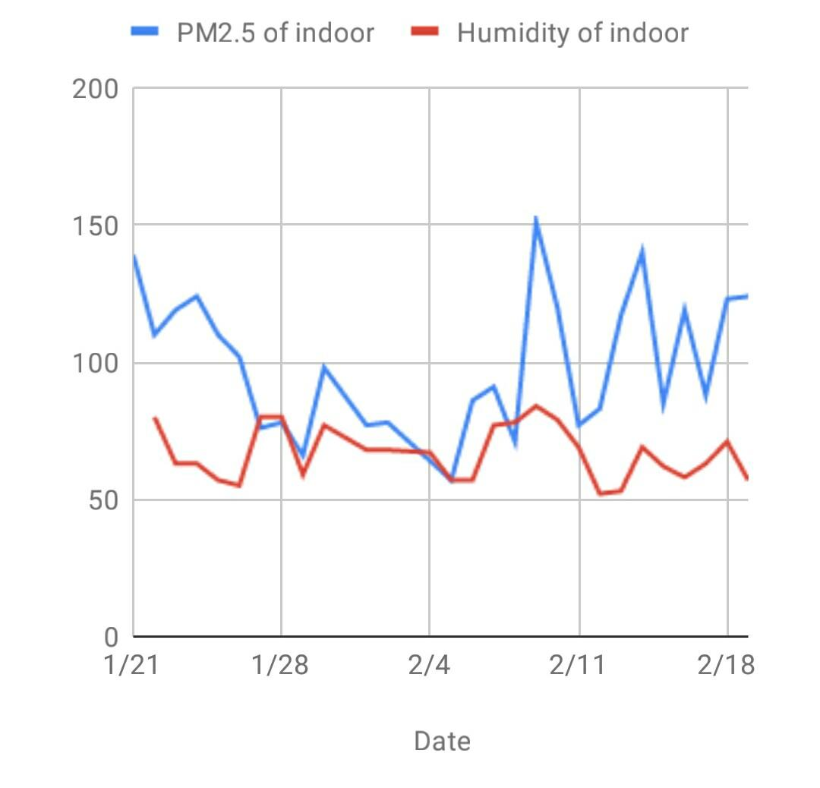
Next, compare the concentration of indoor PM_{2.5} with outdoor humidity. We can see that when the humidity increased, a part of concentration increased, but we can’t find out the direct connection between them. We inferred outdoor humidity doesn’t have a significant impact on the concentration of indoor PM_{2.5.,} because outdoor environment is different from indoor environment. Moreover, to realize why some humidity ascended, we analyzed the different humidity indoor and outdoor.
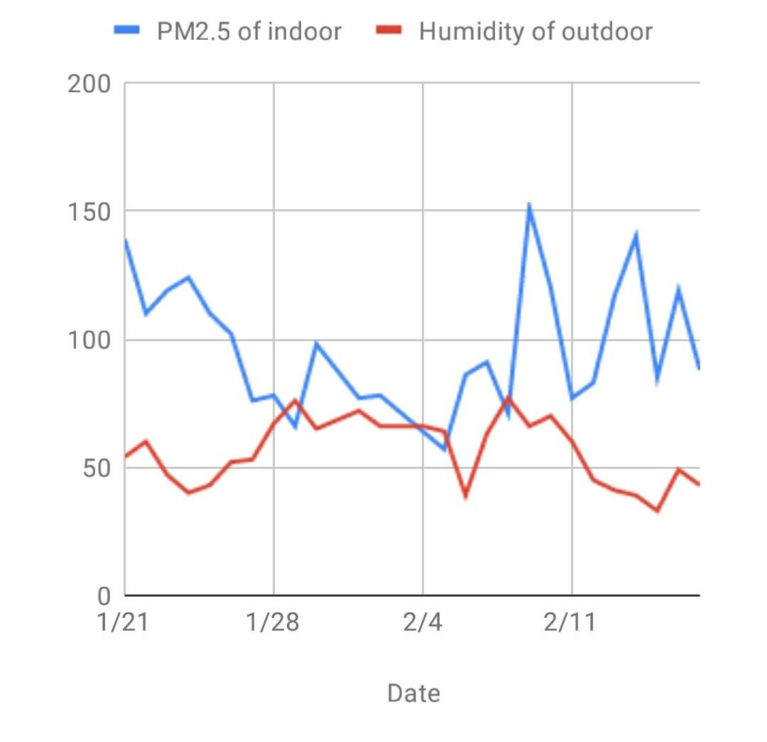

We calculated the difference between humidity indoor and outdoor,and converted it into a line graph with the concentration of indoor PM_{2.5.}.
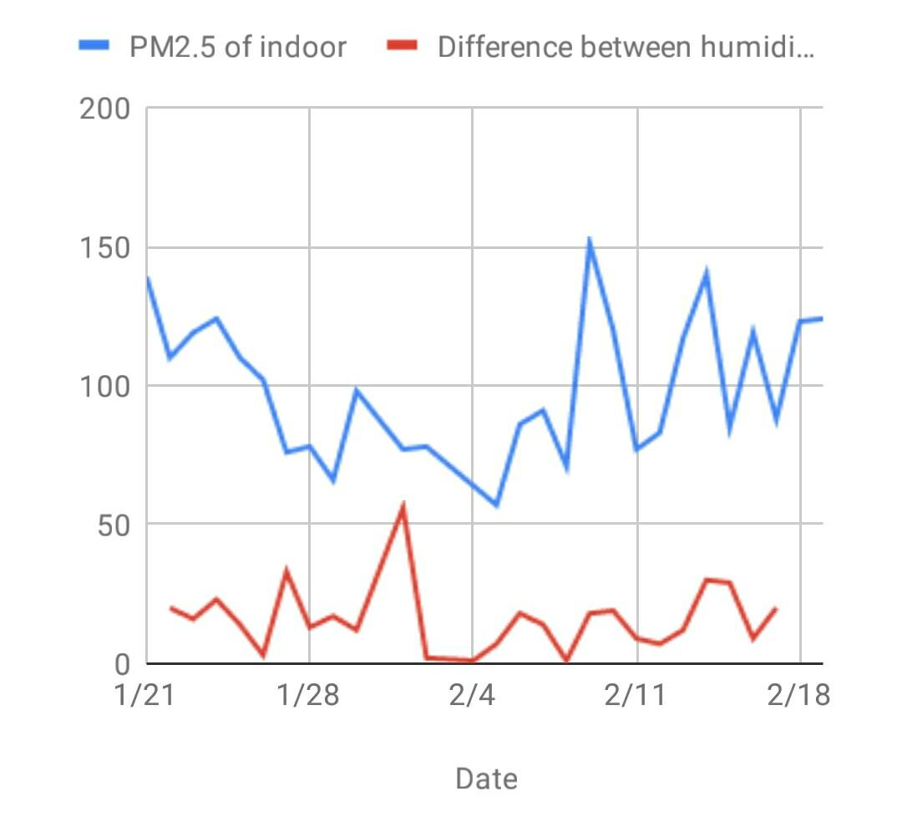

Roughly, when the difference between humidity indoor and outdoor increased, the concentration increased, too. Therefore, the difference of humidity has an influence on the concentration. Hence, we deducted the first explanation.
In the environment where the absolute value of humidity is greatly different, the consistency of PM_{2.5} will rise. This is because the value might include that of the hydrone as small as PM_{2.5}. According to the theory of the machine, it will launch a laser which interacts with the particles and produce light scattering, by which we can find the correct size of the particles corresponding to PM_{2.5} from diffused light. Those particles are accepted by the Photoelectric detector and then transformed into electrical signals. The machine will calculate the quality of the PM_{2.5} within the area. That is, if the size of hydrone is the same as the particles, the deviation will happen. Therefore, when the difference rises, the real concentration of PM_{2.5} doesn't increase but produce the wrong higher value. So, the difference of the humidity actually doesn't affect the concentration of PM_{2.5}.

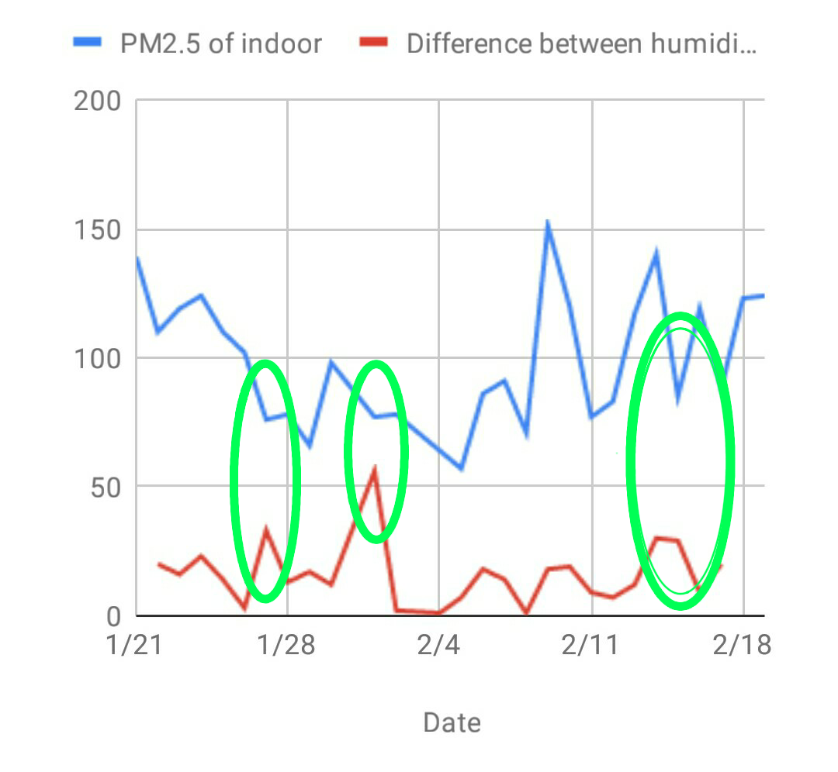
From the above picture, we also know that not all the values correspond with the first inference. Some values, even though the difference rises, the concentration still decreases. As a result, we infer the second explanation.
Since particulate matter provide hydrone with condensation nucleus which congeal the water droplets, when more and more hydrone gathers, it will turn into bigger water droplets, and there might be two conditions. One is because the particle is too large to be measured by the machine, in case that consumption of PM_{2.5} and the produced-water droplets can't be measured, the value will decrease. Another is that the water droplets still can be measured. The value stays the same under the consumption of PM_{2.5}, which the produced-water droplets still can be measured. Putting the two conditions with the deviation of the first inference together, the final value may rise and fall. Therefore, whatever values might be measured by the machine will go wrong. Literally, the concentration of PM_{2.5} will decline because of the water condensation. As a result, the humidity indoor and outdoor still has impact on the concentration of PM_{2.5.}
To sum up, the difference between two inferences lies in whether PM_{2.5} became condensation nuclei and condensed into drops of water or not. In the first one, condensation nuclei doesn’t take shape, while in the second one the condensation nuclei does take shape.
If we observe the picture above, we will find that the data is closer to the second inference. The data recorded for one month in a row have some differences with droplets condensing. As a result, the value of PM_{2.5} may vary greatly in a place where humidity rose and dropped, which became deviations.

Conclusion

From the research, we not only understand that the air pollution indoor is more serious than outdoor, but also find the reason why the deviation happened by observing fixed values, by studying the measurement methods and theories of the machine to infer why the phenomenon happened. Because of this, we have more insight into the machine and actual condition of scientific research. It also makes us realize how to apply science to our lives, which can help us improve air pollution indoor with moisture. During the process, the research also breaks our absolute trust in the value. We start to realize the importance of deviation. Understanding that we can’t simply absorb the knowledge without thinking, what we need to do is to challenge the fixed value. We think it is significant for students to think one thing from different aspects, and then we may have new discoveries, and that's why science develops so fast. After more observations in the research, we realize that life is always filled with surprising knowledge, and we have really benefited a lot from the research.

Reference

https://air.epa.gov.tw/Public/suspended_particles.aspx
Environmental Protection Administration 2018
Control of Fine Suspended Particulate

https://taqm.epa.gov.tw/pm25/tw/PM25A.aspx
Environmental Protection Administration 2018(The first three lines)

https://www.epa.gov.tw/public/Attachment/4312252816.pdf Environmental Protection Administration 空氣污染物自動連續測定儀各偵測原理之準確性評估 Accuracy Evaluation of Detection Principle of Air Pollution Automatic Continuous Measuring Instrument 2013

http://www.chinatimes.com/newspapers/20170908000469-260107
Chinatimes Chen Shi-zong 2017

http://www.hsjh.tn.edu.tw/modules/tad_web/news.php?WebID=10&NewsID=15 What is the principle of the sensor?(anonymous) 2017

蔡小舒、苏明旭、沈建琪 Cai Xiao-shu, Su Min-gxu & Shen Jian-qi 顆粒粒度測量技術及應用 Measurement Technology and Application of Particle Size,p 1,p 65 , 2010, First edition

許志祥 Hsu Chih-Hsiang https://ndltd.ncl.edu.tw/cgi-bin/gs32/gsweb.cgi/login?o=dnclcdr&s=id=%22103NPUS5615035%22.&searchmode=basic
2015 探討細懸浮微粒PM2.5自動與手動分析之相關性
The Investigation of Fine Suspended Particle PM2.5 Levels between Automatic and Manual Analysis(p.13~P.14)

劉耀凱 Liu Yao-Kai
https://ndltd.ncl.edu.tw/cgi-bin/gs32/gsweb.cgi/login?o=dnclcdr&s=id=%22104KSUT0515011%22.&searchmode=basic
2016 室內外不同環境PM2.5所含多溴聯苯醚特徵
Characteristics of Polybrominated Dipheny Ethers on PM2.5 in The Indoor and Outdoor Air of Different Public Sites(p.12~P.14)

陳柏丞 Chen Po-Cheng
https://ndltd.ncl.edu.tw/cgi-bin/gs32/gsweb.cgi/login?o=dnclcdr&s=id=%22105TNIO0653005%22.&searchmode=basic
2017 台中市PM2.5與其他空氣汙染物之關係
Relationship of PM2.5 and Other Air Pollutants in Taichung City(p.3~p.5)

王志中 Wang CHih-Chung
https://ndltd.ncl.edu.tw/cgi-bin/gs32/gsweb.cgi/ccd=xKFReX/result#result
2017 台灣西部細懸浮微粒(PM2.5)濃度分布與趨勢之探討
Distribution and Trend of Fine Particulate Matters (PM2.5) in Western of Taiwan(p.3)

