The Relation Between The Weather
and Various Sickness & Injury of The Student in Our School

By:
Ting-Yu lin
Zhi-Yi li
Marie Yonlien Tsotsolis
Teacher:
Ching-Yi Su
National Lo-Tung Senior High School
Taiwan
Index:
Abstract………………………………………………………….3
a. Concise
b. Context of research
c. Research questions
d. Objectives set
e. Brief methods description
f. Results
g. Conclusions
h. Recommendations for a way forward
i. Keywords that emphasize key ideas in the paper
Research Questions………………………………………….6
a. Why they are important
b. Main research question
c. Sub-questions:
Introduction and review of the literature…………7
a. Thorough
b. Description of the problem
Research Methods…………………………………….……9
Results………………………………………………………….10
Discussion……………………………………………………13
a. Excluded injuries
b. Weather factors
c. Special months
Conclusion……………………………………………………14
a. Menstrual pain
b.Old injuries
c.Headaches
d.Dizziness
e.Follow-on research/actions
Bibliography/citations……………………………………16

Abstract
a. Concise
There’s about 1200 students in our school. And most of us have experience of turning to the health center for help. We wonder what causes the injuries and sickness, and if we can predict the frequency of those illnesses.
In this report, we analysed the data of the injuries and illnesses of the students. Including menstrual pain, old injuries, headaches, dizziness.
We tried to find a pattern of the data, and use it to predict how season, weather is going to influence the health of the students in the future.
b. Context of research
Students in senior high get sick quite frequently, especially in winter, many of us would catch a cold or even a flu. An ounce of prevention is worth a pound of cure. We hope the pattern we find can help the school to prepare and prevent possible illnesses, and to help the student to be cured.
c. Research questions
Our main research question is: How does weather affect the health conditions of the students?
The sub-questions are:
- How does weather affect menstrual pain?
- What kind of weather causes old injuries to relapse?
- How does weather affect headache?
- How does weather affect dizziness?
d. Objectives set
The objective of this research is to find the pattern of the relation between the weather and the illnesses and injuries of the student in school. We want to conclude a simple but applicable theory to help the school better understand the health conditions and the trends of the various discomforts.
e. Brief methods description
In our school, the health center records the data of every case, including the date, symptoms, name, and the treatment. To protect the privacy of them, we made the data anonymous, then we started to analyse.
f. Results
We observed that when the temperature is lower, the frequency of menstrual pain increases.
When the temperature drops, the frequency of old injuries' discomfort rises in first place, then the tendency drops.
We observed that there's no direct relation between temperature and headache but has more to do with humidity. The frequency of students having headache increases with the increasing humidity.
And we observed that the frequency of dizziness is higher when the temperature drops.
g. Conclusions
We observed that when the temperature is lower, the frequency of menstrual pain increases. And it’s related to blood vessels and uterus.
We observed the relation between temperature and the frequency of old injuries' discomfort. It rises when the temperature drops in first place, then the tendency drops.
And we did found a relation between headache and humidity. The frequency of students having headache increases with the increasing humidity. This kind of phenomenon can be found in Chinese medicine, described as rheumatic headaches.

The frequency of dizziness is higher when the temperature drops. The temperature causes the poor blood circulation. And the following symptoms will causes imbalance that causes dizziness.
h. Recommendations for a way forward
Since we've only analysed the data of our school, we can only get limited information and cases. In the future, we can collect various data to make more completed theories.
i. Keywords that emphasize key ideas in the paper
- Weather
- Health
- School
- Illness

Research Questions
a. Why they are important:
It is important to maintain the average health state of the school. We need to prevent the spread of the illnesses, and prepare the treatments for the common illness during the infection period.
b. Main research question
Our main research question is: How does weather affect the health conditions of the students?
c. Sub-questions:
- How does weather affect menstrual pain?
- How many cases of menstrual pain happen every month?
- The students mainly suffer from menstrual pain in which season?
- What can be the reason for the phenomenon we observe?
- What kind of weather causes old injuries to relapse?
- How many cases of old injuries happen every month?
- The students mainly suffer from old injuries in which season?
- What can be the reason for the phenomenon we observe?
- How does Chinese medicine explain about this, and whether it’s the same as our conclusion.
- How does weather affect headache?
- How many cases of headache happen every month?
- The students mainly suffer from headaches in which season?
- What can be the reason for the phenomenon we observe?
- How does weather affect dizziness?
- How many cases of dizziness happen every month?
- The students mainly suffer from dizziness in which season?
- What can be the reason for the phenomenon we observe?
Introduction and review of the literature
a. Throughout
We wanted to find a pattern of the relation between the weather and the health condition of the student. Since we do globe observation in our school, we got some usable globe data.
And we asked the health center of our school for anonymous lists of illnesses and injuries. We searched for some articles and research about this topic, and made our hypothesis.
Then we combine globe data, official weather data from CWB, and the lists of illne-ss and injuries from the school health center. We found some of the data usable, for example, cut and slash definitely have nothing to do with the weather, we need to exclude those cases.
We observed that when the temperature is lower, the frequency of menstrual pain increases. And through biological knowledge, the blood vessels compress in
winters, which means a narrower pathway for blood flow. Due to constricted vessels, blood flow during periods can get interrupted. This leads to increased period pain in winter, which supports our hypothesis.
And we go on analysing the data of old injuries. It contains the most various
cases. We observed that when the temperature drops, the frequency of old injuries' discomfort rises in first place, then the tendency drops.
When the temperature drops, it may cause vasoconstriction, poor peripheral blood circulation, slower sympathetic nerves, and soft tissue characteristics may change, and the soft tissues of the joints will produce a similar inflammatory reaction, which will cause the pain symptoms to worsen.
We then looked for the relation between temperature and headache, but we didn’t find any relative phenomenon. There's no direct relation between them, but headache has more to do with humidity. The frequency of students having headache increases with the increasing humidity.
The frequency of dizziness is higher when the temperature drops.When the weather is cold, the blood vessels will shrink, and if the blood supply to the inner ear cells is insufficient, it will cause dizziness.One of the functions of the inner ear is to control the balance system, so damage to the inner ear cells can cause imbala-nce and dizziness.
b. Description of the problem
We wanted to find a pattern of the relation between the weather and the health condition of the student. But not all of the injuries are related to the weather. So after excluding the unrelatable ones, the symptoms we analysed are menstrual pain, headache, dizziness and old injuries.
It’s important to use the scientific data, instead of just “feeling cold or hot”, as we used to say about weather.
This research can help the school nurses better understand and predict an average state of the health condition in school. Since the school plays an important role in the community, the health condition of the school sure influences the nearby regi-on a lot.

Research Methods
We searched for some articles and research about this topic, and made our hypo- thesis.
Then we combine globe data, official weather data from CWB, and the lists of illne-sses and injuries from the school health center. We found some of the data usable, for example, cut and slash definitely have nothing to do with the weather, we need to exclude those cases.
We considered the temperature, RH, air pressure, and we analysed the data during September/2018 to June/2019, which is a school year. The winter break is January 21st-February 10th. The summer break is July 1st- August 29th. So we 9excluded January, February, July and August.
We used the data that we entries to Globe to make a line chart on excel, and com-pared them to our injuries and illnesses data, to find the relation, and to see if the result supposes our hypothesis.

Results
We observed that when the temperature is lower, the frequency of menstrual pain increases. As the following chart illustrates. We also analysed RH, but we couldn’t find any relation in both number and biological research.
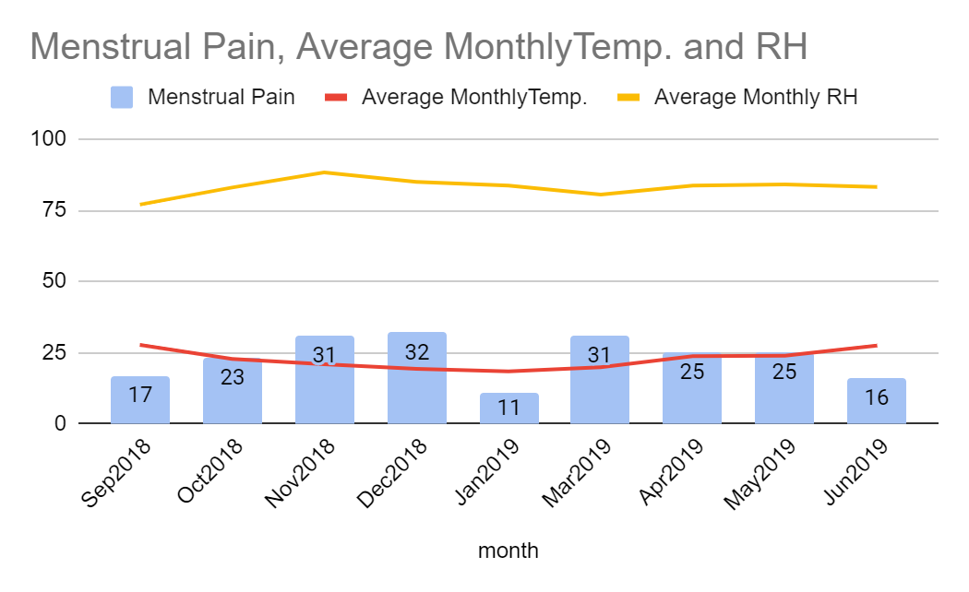
We observed that when the temperature drops, the frequency of old injuries' disc-omfort rises in first place, then the tendency drops. As the following chart illustrat-es. We also analysed RH, but the tendency of RH doesn't completely match in number.
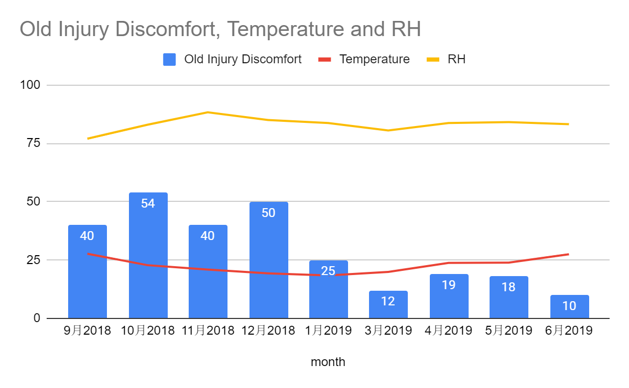
We observed that there's no direct relation between temperature and headache but has more to do with humidity. The frequency of students having headache increases with the increasing humidity.
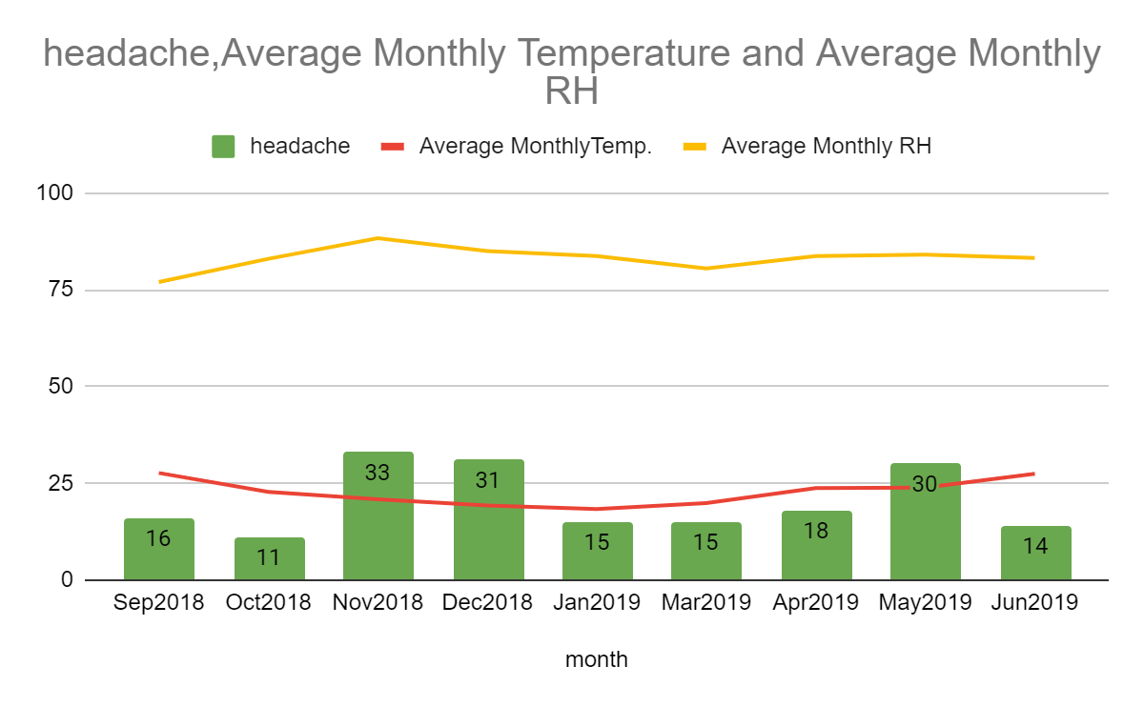

We observed that the frequency of dizziness is higher when the temperature drops. We also analysed RH, but the tendency of RH doesn't completely match in number.
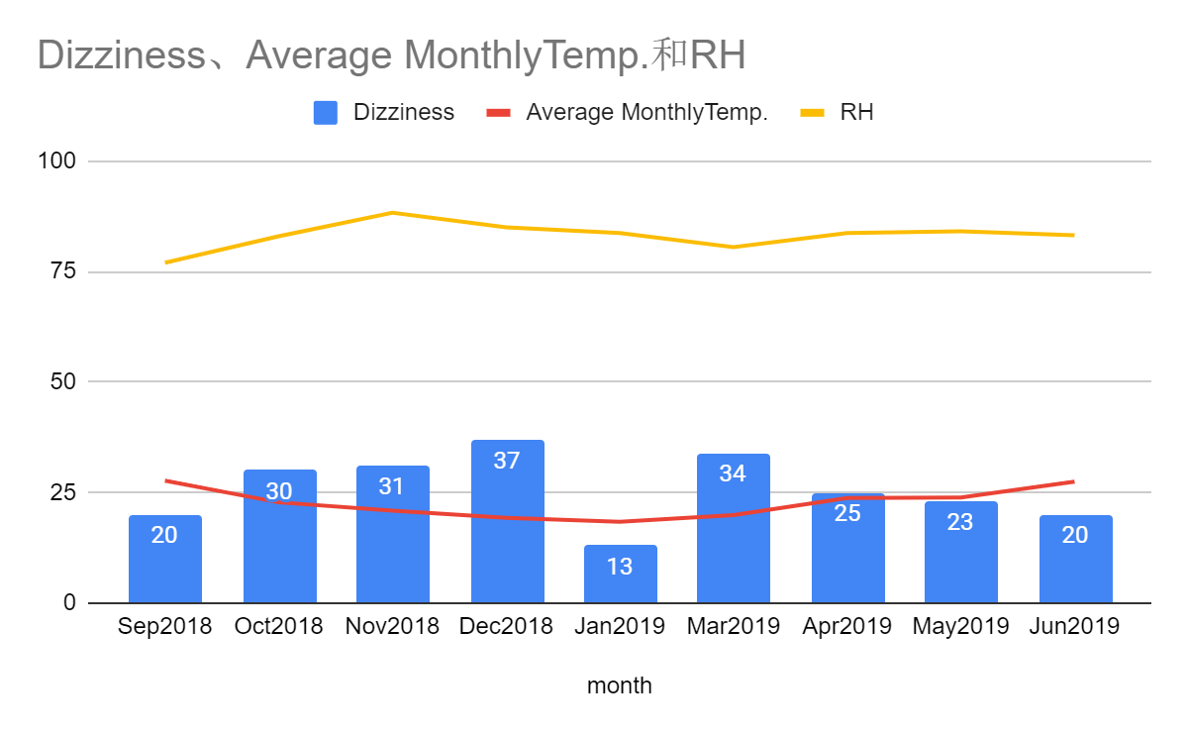

Discussion
a. Excluded Injuries
When we started to classificate the data of illnesses and injuries, we found some of them are obviously not related to the weather. Most of them are visible traumas, including slash, strain, cut, scald, stabbed, bitten by mosquitos. To help the progre-ss of our analysis, we decided to just exclude them.
b. Weather Factors
We analysed three weather factors: relative humidity, temperature, and air pressur-e. Not three of them are related to all the symptoms, so we needed to trade-off if the factor is unnecessary or our hypothesis was wrong.
Luckily, we can combine some biological knowledge to make sure if the problem is really about the unrelativity of the weather factors.
c. Special Months
The winter break is January 21st-February 10th.
The summer break is July 1st- August 29th. So January, February, July and August are the special months. We have thought of double the data, but then the number wouldn’t be accurate. And whether most of the students are in school is an import-ant part of the average health condition.
Therefore, we decided to exclude those months.

Conclusion
a.Menstrual pain
In our country, hot water is thought to be able to cure menstrual pain. So our hypothesis is menstrual pain has something to do with the temperature.
We observed that when the temperature is lower, the frequency of menstrual pain increases.
In winters the blood vessels compress, which means a narrower pathway for blood flow. Due to constricted vessels, blood flow during periods can get interrupted. This leads to increased period pain in winter.
And in Chinese medicine, menstrual pain is thought to be the consequense of “cold uterus”.
b.Old injuries
We observed the relation between temperature and the frequency of old injuries' discomfort. It rises when the temperature drops in first place, then the tendency drops.
The phenomenon matches our hypothesis. When the temperature drops, it may cause vasoconstriction, poor peripheral blood circulation, slower sympathetic ne-rves, and soft tissue characteristics may change, and the soft tissues of the joints will produce a similar inflammatory reaction, which will cause the pain symptoms to worsen.
c.Headaches
We observed that there's no direct relation between temperature and headache . But we did found a relation with humidity. The frequency of students having headache increases with the increasing humidity.
Our scalp is rich in micro blood vessels. When the humidity is too heavy, it will affect the blood circulation and metabolism of the scalp. The lack of oxygen on the scalp will cause tightness and tension, described as rheumatic headaches in Chinese medicine.
d.Dizziness
We think that dizziness might be caused by poor blood circulation of our head.
And we observed that the frequency of dizziness is higher when the temperature drops.
So we wonder if it’s the temperature that causes the poor blood circulation.
When the weather is cold, the blood vessels will shrink, and if the blood supply to the inner ear cells is insufficient, it will cause dizziness. One of the functions of the inner ear is to control the balance system, so damage to the inner ear cells can cause imbalance and dizziness.
e.Follow-on research/actions
Our research is available for the nurses to refer in our school.
We think we can analyse more data, and add more weather factors, to make our conclusion more complete and more applicable in different school,community.

Bibliography/citations
We’ve searched for some Chinese reports online that show how weather can influ-ence people’s health condition.
Especially Chinese medical science, so we can compare between the traditional explanation and scientific analysis .

Here are a list of the bibliography:
https://www.top1health.com/Article/56188
https://www.commonhealth.com.tw/article/article.action?nid=77592
https://health.businessweekly.com.tw/AArticle.aspx?id=ARTL000123597

