|  |
| --- |
| *cid:F5B093C2-056B-477B-A04C-D7297E9FB3D4* |

Saudi Arabia

Ministry of Education / Sabya Education Department

**search title**

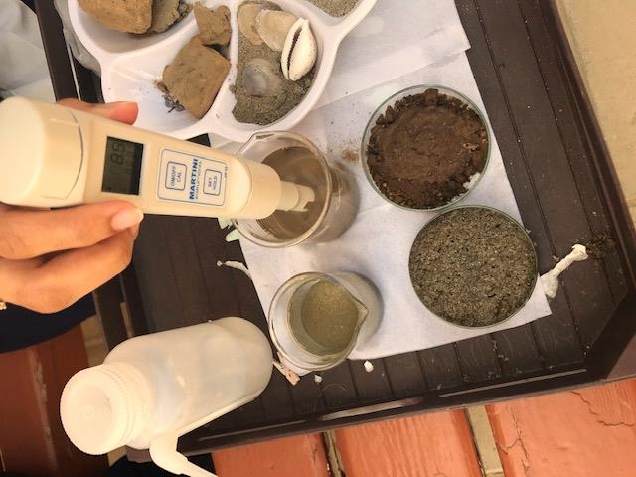**Comparison between the soil of Valley**

**Bish plains and the soil of Bish coasts and their impact on agriculture.**

**Students names**/ Raghad Ali Ibrahim Bahri-

Amassi Moussa Deghasi.

**School** / Al-Matan Intermediate and Secondary Girls School at Sabya

**Research Supervisor, Teacher** / Faizah Ibrahim Musa Bahry

**Date** / 2020 AD

**Abstract**

The study aims to compare the soil of Valley Bish plains and the soil of the Bish coasts and their impact on agriculture. Through the characterization of soils and our study of soil protocols, we began to suggest questions:

• What is the impact of soil on Valley Bish plains and the soil of the sea Bish coasts on agriculture?

• Is there a relationship between the acidity of the soil and the amount of bicarbonate on agriculture?

**Hypothesis:**

1- There is an impact of soil on agriculture on the plains of Valley Bish and the coasts of sea Bish.

2- There is no trace of soil on agriculture in the plains of Valley Bish and the coasts of sea Bish.

3- There is an inverse relationship between the acidity of the soil, the amount of bicarbonate, and the cultivation of land in Beach.

**Measures:**

Using the experimental approach, we brought two types of soil to the study area, measurements were made with Globe tools, to compare them with the suitability of each of them for cultivation.

**Conclusions:**

The relationship between acidity of the soil and the amount of bicarbonate in the soil and agriculture is inverse and varies according to location.

- This study helps to develop and improve the level of agriculture in the coast of Bish and stresses the importance of reducing acidity and alkalinity in the soil to obtain arable land.

**content list :**

Summary ................................................. .......................................... 2

Research questions and hypotheses ............................................... ..4

Introduction ................................................. ……………………............... 5

Steps of the experiment ............................................................ ...... 6

Analysis and results ................................................................... ....... 8

Discussion and conclusions ............................................................ ..10

Thanks and appreciation ..................................................... ............ 11

References ......................................................................... ............. 12

**Abstract :**

This study aims to compare the soils of Valley Bish Plain and the Soil of Baysh Coasts and their effect on agriculture. Through the characterization of the soil and our study of the protocols of acidity of the soil and the protocol of the amount of bicarbonate in it. And (alkalinity) in the soil and the color of the soil protocol and our observation of its impact on the cultivation of plants in which it grows, we began to suggest the following:

**Research questions and hypotheses:**

• What is the impact of the soil of Valley Bish Plains and the soil of the Bish Seashells on agriculture?

Is there a relationship between soil acidity and the amount of bicarbonate cultivated?

**Hypothesis:**

1- There is an impact of soil on agriculture on the plains of Valley Bish and the coasts of sea Bish.

2- There is no trace of soil on agriculture in the plains ofValley Bish and the coasts of sea Bish.

3- There is an inverse relationship between the acidity of the soil, the amount of bicarbonate, and the cultivation of land in Bish.

**Variables:**

Independent: soil.

Follower: Agriculture.

**research aims:**

Comparison between the soil of the Valley Bish Plains and the soil of the Bish Seashells and their impact on agriculture.

**research importance :**

Contributes to knowing the soil of the plains of Valley Bish and the soil of the coasts of the Bish.

**search limits :**

Objectivity: A comparison between the soil of the Valley Bish plains and the soil of the sea Bish coasts and their effect on agriculture.

Time: in the year 2020 AD

Spatial: middle and secondary stabbing girls for the city of Bish.

**Search terms:**

Plains: a large area of ​​low and flat land near the valleys.

Valley: A natural basin or depression on the surface of the earth, the place where water flows.

Coast: It is a land area adjacent to the sea.

Sea: A large pool of salt water that connects with the ocean or on salt lakes.

Soil: is a mixture of organic and inorganic materials covering the Earth's surface.

Soil acidity: It is a measure of the activity of hydrogen ions in the soil solution.

**Introduction:**

Bish Governorate faces the lack of vegetation and agricultural cover in the coastal areas of the Bish Sea, while agriculture flourishes significantly in the plains of Valley Baysh, which is considered one of the basic ingredients for economic exploitation to grow crops, and based on this matter we tried to find a comparison between the soil of the Plains of Valley Bish and the soil of the Bish coasts and their impact on Agriculture .

The acidity of the soil is a major variable because it affects many chemical processes and particularly affects the availability of plant nutrients. Soils with a high degree of alkalinity and have PH 8.5 or higher, or have a high content of carbonate and sodium bicarbonate have a significant impact on agriculture as they constitute an impediment to plant growth.

**Previous studies :**

- a. Dr. Habib. Al-Shammari (2012) Wasit University. College of Education. Geography Department mentioned in his study (spatial variation of fruit and citrus trees in Wasit Governorate)

That the soil represents a natural phenomenon that affects the spatial variation of the cultivation of fruit trees from one place to another, but one of the most important characteristics that distinguishes it from other other phenomena is that it is a variable element, as it is subject to change more than other natural phenomena as a result of the difference in the quality of the soil and the variation of its geographical distribution has led to a variation The geographical distribution of fruit trees.

- In a study in (2019) at the default Globe exhibition where the study measured the amount of acidity of the soil and its effect on the rate of plant growth and concluded that there is a relationship between the acidity of the soil and the amount of bicarbonate, as it shows the importance of these two vital factors and their impact on agriculture.

- In a report of the first secondary school in Arqa, Riyadh, entitled (Comparing acidity and the amount of alkalis in soil types and their effect on agriculture) was used to characterize soil types, as the study measured the amount of soil acidity and its impact on the rate of plant growth and concluded that there is a relationship between the acidity of the soil and the amount of bicarbonate.

Based on previous studies, we did a similar study and helps to improve the hypothesis which states that there is a relationship between acidity and bicarbonate in the soil and plant cultivation, the lower the acidity and the amount of bicarbonate in the soil, the higher the rate of plant growth.

**Materials and method (procedures):**

Tools: GLOBE devices (ph protocol device - soil color book) - vinegar - bowl - pen - paper - computer - 2 soil samples - water.

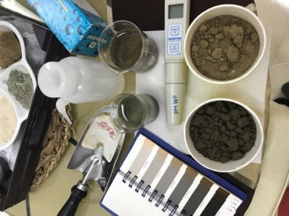

Tools used (Figure 1)

Steps to experiment: We used the experimental method

We brought two types of soil (soil No. 1), and soil from the coast of the Bish Sea (soil No. 2), located in the south of the Kingdom of Saudi Arabia.

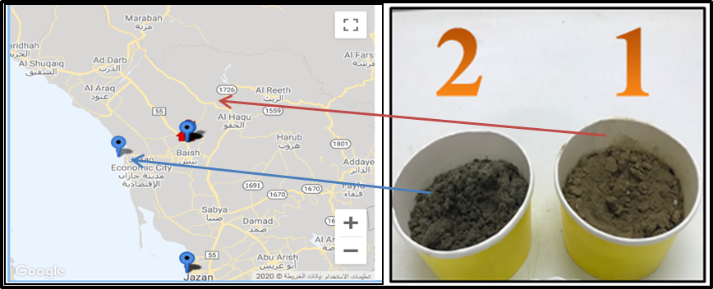

Soil types and their location on the map (Figure 2)

- To demonstrate the acidity of the soil, the amount of bicarbonate in it and its color and its effect on plant cultivation in the soil. We conducted soil characterization measurements in terms of soil pH using the pH protocol, structure and color using the Soil Color Book and added vinegar to them to identify the carbonate percentage on the soil types that we brought in and recorded the measurements.

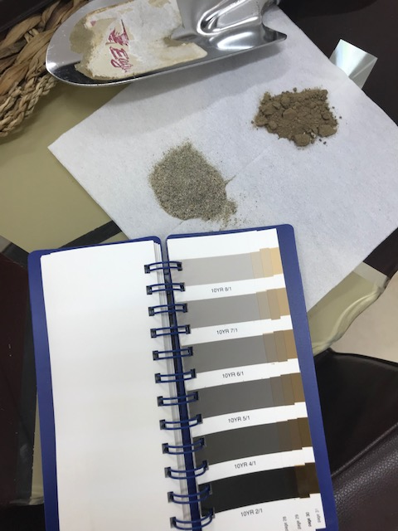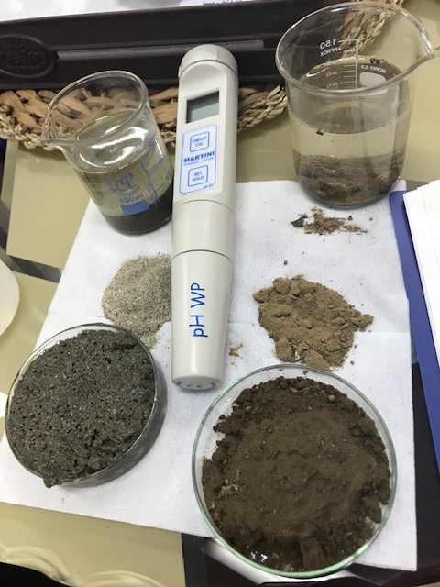

Soil pH measurement experiment (Figure 3) Soil color measurement (Figure 4)

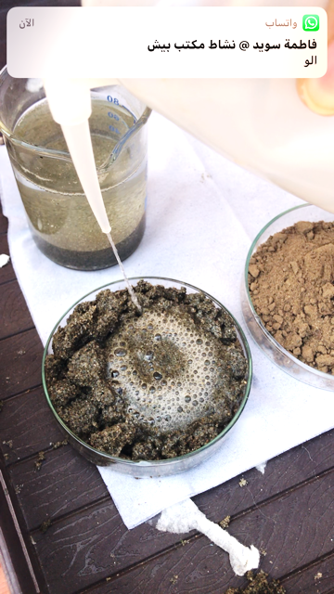

Vinegar experiment to measure the amount of bicarbonate in the soil (Figure 5).

- Seeds were planted in the soil, and we waited for a week.

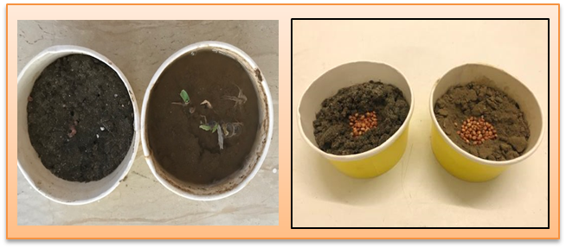

Soil cultivation experiment (Figure 6).

**Analysis and results:**

- By characterizing the soil in terms of the acidity of the soil using a device (pH protocol) and the structure and color using the soil color book and we added vinegar to it to know the percentage of carbonate we noticed the following:

Table No. (3) soil characterization in terms of acidity, color and bicarbonate

|  |  |  |  |
| --- | --- | --- | --- |
| Bicarbonate | Soil color | pH | Soil types |
| Not found | 10YR6/4 | 8.5 | Soil 1 |
| strong | 10YR6/2 | 8.1 | Soil 2 |

**Diagram No. (1) pH measurement**

**From charts and experiments, we conclude that:**

- From the experiment of Ph to measure the pH of soil No. (1) equals 8.5, while soil (2) recorded 8.1, and this indicates the alkalinity of the soil.

- From the experience of measuring the color of the soil, we noticed a difference in its color.

- From the experience of adding vinegar, we noticed soil No. (1) that has no bicarbonate. While soil No. (2) there is a large percentage of bicarbonate.

After a week of planting in the soil types, we noticed that they grew in (soil No. 1) and did not grow in the other type (soil No. 2).

- Therefore, the relationship between the acidity of the soil and the amount of bicarbonate in the soil and agriculture is inverse, because when the acidity in the soil rises and the amount of bicarbonate the soil is not suitable for cultivation and vice versa, and through the measurements resulting from experiments on soil samples from the Valley Bish plains and the coasts of the Bish Sea, we came to The plains of Valley Bish are suitable for cultivation because they are neutral soils, while the coasts of the Bish Beach are not suitable for cultivation due to the high acidity and the amount of bicarbonates, and for this coastal region is weak vegetation and difficult to live and not suitable for agriculture.

**Discussion and conclusions:**

There are many studies that prove the effect of the soil on agriculture in agreement with our current study, but the purpose of this study is to develop and improve cultivation in the region of Pech and other areas similar to the same conditions.

In this study, we reached the relationship between soil acidity and the amount of bicarbonate in the soil, which is (alkaline), and agriculture is an inverse relationship with soil and acidity, and how it differs in each region according to the location, and we conclude that the relationship is an inverse relationship between them.

 This study helps to develop and improve the level of agriculture in the coast of Bish and stresses the importance of reducing acidity and alkalinity in the soil to obtain arable land.

**Recommendations:**

- Conducting more advanced studies and experiments on soil types and their effect on agriculture.

Establishing centers for scientific research and monitoring environmental problems by the Ministry of Agriculture and the Ministry of Environment.

- Expanding innovative cultivation and afforestation operations on the coasts by adding fertilizers to the soil, fertilizing it and making underground lines from Baysh Valley to the coasts of the Baysh Beach.

Exploiting the lands of Valley Baysh plains and utilizing the water of the valley for irrigation in order to obtain a high-quality crop.

**Difficulties:** No previous soil measurements were available for the Globe study site.

**Acknowledgment:**

Thank you to my family that pushed me forward, and to my country, Teacher Ohood Bahari, Master of Chemistry, and Globe Environmental Teacher Faizah Ibrahim Bahry a geography specialist for mentoring me. Also English teachers Kamlah Muharraq and Faigah Mughani to translate research. And science teachers, Awali Attia, a biology specialist, Fatima Wafi Chemistry specialist, and laboratory preparer Hanan Khurmy for help and guidance. Also to my school that gave me support .Finally for the Globe Granting Supplies program.

**References:**

- The default exhibition for Globe 2019

<https://www.globe.gov/news-events/meetings_symposia/annual-meetings/23rd-annual-meeting>

Ali. Alaa. Last update: 7:14, March 25, 2018. Soil acidity measurement.

<https://mawdoo3.com/>

-a. Dr. Habib. Al-Shammari (2012) Wasit University. College of Education. Geography Department, Male (Spatial variation of fruit and citrus trees in Wasit Governorate)

<http://eduj.uowasit.edu.iq/index.php/eduj/article/view/435/391>

* - How to reduce soil pH<https://ar.wikihow.com>
* - <https://www.almaany.com> / -Glossary of meanings

|  |  |  |
| --- | --- | --- |
| **Communication between schools** | **Contact a stem specialist** | **Cooperate** |
| - Communicate with  The teacher, Idah Al-Rashdi, at the Nawan School in Makhwa, who was asked about some measurements.  Irqah Secondary School in Riyadh in terms of its research presented, which compares between the types of soils and the impact of each type on agriculture. | Teacher Ohood Bahari, Master of Chemistry, and Globe Environmental Teacher Faizah Ibrahim Bahry a geography specialist for mentoring me. Also English teachers Kamlah Muharraq and Faigah Mughani to translate research. And science teachers, Awali Attia, a biology specialist, Fatima Wafi Chemistry specialist, and laboratory preparer Hanan Khurmy for help and guidance. Also to my school that gave me support .Finally for the Globe Granting Supplies program. | Female students / Amasi Musa Daghassi - Raghad Ali Bahri.  1- The translation has been translated into English  Writing the research paragraphs.  3- Searching and reading about books that help in searching.  4- Conducting experiments that cause the impact of soil acidity and bicarbonate on agriculture. |

**Badges**

**poster**

<https://drive.google.com/open?id=1QUXtc_SBay0I1bpi5Srvd7Q3ie9Tpz6H>