“A Comparison of the Mean Temperature of Asphalt, Concrete and Grass as Measured At the Brazil Secondary School Compound
Between 2008 and 2014.”

Organization: Brazil Secondary School

Students: Dana Ali
Jessica Ali
Elysha Bailey
Jessica Isaac
Chanecia Pillgrim
Maya Ragbir
Shivnarine Ramlogan
Dariana Seeram

Grade Level: Ages 12 - 14 (Secondary School)

GLOBE Teacher: Mrs. Roshni Madoo

Contributors: Mr. K. Mohammed-Ali, Ms. D. Ramnath

Date Submitted: 11th March 2016

Table of Contents

Abstract 3
Introduction 4
Research Question and Hypothesis 7
Research Methods 8
Results and Analysis 12
Conclusion 17
Discussion 18
Bibliography 19
Appendix 20

Abstract:

The BSS GLOBE Club is investigating the differences in the surface temperature of (i) grass, (ii) concrete and (iii) pitch. This is of particular importance to the students of Brazil Village as there have been marked developments in this community over the last 15 years. There is a distinct trend away from the rural life and one towards urbanization. This has been supported by a gradual replacement of the natural vegetation of the community by infrastructural support for the rapidly developing community.
The data collected during the period 2008 to 2014 showed that there were increases in the ambient temperatures of both the concrete and the asphalt surface and a decrease in the ambient temperature of the grass field. The data also showed the ambient temperature of the asphalt was consistently higher than the other two surfaces and that of the grass field consistently lower. It was concluded that these differences in ambient temperature was primarily due to the moisture holding capacity of the surfaces and to some extent the dark coloration of the asphalt.
It was recommended that similar investigations be done at a different time of the year. It was also recommended that the exact moisture capacity of each surface be quantified and compared. Finally, a detailed description of the extent of urbanization in Brazil Village was suggested, to determine its effect on the microclimate of the community.

Introduction:

Brazil Secondary School is a small rural school located in Brazil Village, Trinidad and Tobago. It was built in 2000, to provide accessible secondary school education to students from surrounding communities, such as Las Lomas, Mundo Nuevo, Talparo and La Horquettta. To date, this is the only secondary school catering to these catchment areas.
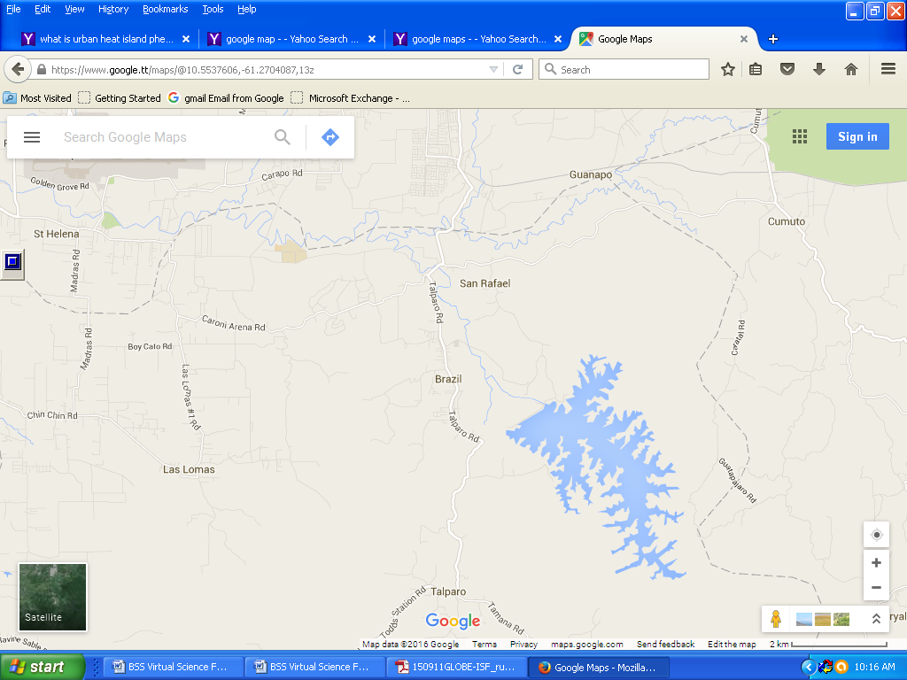
Figure 1: Location of Brazil Secondary School and catchment areas

Historically, Brazil Village has been predominantly a rural community; outputs include cocoa, coffee, short crops, poultry and pigs. The village itself is nestled amongst several lush forests, for example the Arena Forest.
However, during the last 15 years, the easy, slow paced lifestyle of the residents of this village has been rapidly changing. The apparent easy money of the urban lifestyle has pulled the younger generations of this community from the manual hardships of farming. This has resulted in a reduced work force for the agricultural sector of Brazil Village, which has culminated in its demise.
This transitioning from a rural to an urban community, has led to the gradual replacement of the natural vegetation by artificial surfaces, such has concrete and asphalt. This has become necessary to provide the infrastructural support for the burgeoning community. This infrastructural support includes the establishment of the secondary school, several housing developments, savannah with paved running tract and car park, groceries, factories, and the paving of many once dirt roads.
One effect of the replacement of natural vegetation by artificial surfaces is the increase in ambient temperature known as the urban heat island phenomenon.
In the urban heat island phenomenon, artificial surfaces absorb and store greater amounts of heat than the natural vegetation, such as grass and trees. This increases the ambient temperature. The increased heat retention of the urban areas is more noticeable in the afternoon, when there is less wind. As urbanization increases, the effects of the urban heat island rises. The effects of this
phenomenon, couple with that of global warming, has made the microclimate of Brazil Village extremely uncomfortable.

Figure 2: Showing a comparison of Brazil Village (from left to right) in 2016, 2006 and 2002

Research Questions and Hypothesis:

In 2015, classes at Brazil Secondary School had to be shortened to half the normal school day due to the unbearable heat experienced by students and teachers during the hours of 12 noon to 2:30p.m. This resulted in a reduction in the teacher / student contact time from 5 hours to 3 hours.
Faced with this situation, the students of the GLOBE club asked the following questions:

- Is there a marked difference in the surface temperatures of different surfaces found on the school’s compound?
The temperature in the classrooms has been increasingly unbearable, especially in the afternoon periods. Since this situation has made the classroom environment completely unfavorable to learning, the members of the GLOBE Club seek to establish if there is a difference in the ambient temperature throughout the school’s compound.

- Has there been an increase in the ambient temperature in the school’s compound from years gone by?
In light of the significant infrastructural changes observed in the community, the students would like to determine if there has been any correlation between the physical changes in their environment and the ambient temperatures experienced.

The students of the GLOBE club proposed the following hypothesis;

Our hypothesis states that an increase in urbanization and the replacement of natural vegetation by artificial surfaces has led to an increase in the ambient temperature in Brazil Secondary School, Brazil Village, Trinidad.

Research Methods

Brazil Secondary School (see Figure 3) has three main surfaces in which temperature was measured; two artificial surfaces (the concrete courtyard, the asphalt car park) and one natural surface (the grass covered field). All measurements were done within the school’s compound.

Figure 3: Showing the layout of Brazil Secondary School

By observing all GLOBE protocols, students used an Infra-Red thermometer to measure the surface temperature of asphalt, concrete and grass as seen in Figure 4.

Figure 4: Showing students of Brazil Secondary School measuring the temperature of two artificial surfaces and a natural grass surface using an Infra-Red thermometer

In each area, nine (9) readings were obtained and the mean temperature of the area was then found.
This was done over a period of five days.
Measurements were taken on the first five (5) days of December in each of the following years 2008, 2009, 2010, 2012 and 2014.
After which, the mean of the temperature of the five days was calculated and recorded as the reference temperature for that specific year.
Results were tabulated in Table 1 and used to prepare bar charts (as seen in Figures 5 to 9) for analysis.

Results and Analysis

Surface Materials | Mean Temperature per year
 | 2008 | 2009 | 2010 | 2012 | 2014
GRASS in field | 33.52 | 34.06 | 32.08 | 35.00 | 31.60
ASPHALT in car park | 38.86 | 42.00 | 37.68 | 48.20 | 47.20
CONCRETE in courtyard | 35.12 | 35.6 | 36.30 | 44.80 | 43.40

Figure 5: Showing a table of the mean temperatures over three surfaces (concrete, grass, asphalt) over Period 2008 to 2014
From Figure 4, it is evident that there was an increase in the mean temperature in two of the three surfaces being investigated in the 2008 to 2014. The temperature of the concrete surface increased by 8.28 ⁰C, while that of the asphalt surface increased by 8.34 ⁰C. It should be noted, that although these increases were comparable, the asphalt surface had a consistently higher temperature. For example in 2012 the mean temperature of the asphalt was 48.20⁰C, while that of the concrete was 44.80⁰C.

In comparison the mean temperature of the grass field showed a decrease in the temperature of 1.92 ⁰C. Although there was a net decrease in the surface temperature of the grass field during this period, the temperature did in fact fluctuate, reaching a high of 35.00⁰C in 2012.
In the period 2012 to 2014, all three surfaces showed a decrease in their respective mean temperatures; asphalt 1⁰C, concrete 1.4⁰C and the grass field 3.4⁰C.

Figure 6: A bar graph showing the mean temperatures over grass, asphalt and concrete over five (5) years

Figure7: Showing a line graph that compares the mean ambient temperature over each surface for five (5) years
As seen in figure 7, the surface temperature above the asphalt is always higher than that over grass or concrete. The surface temperature of the grass field was always the lowest.

Figure 8: Showing a bar graph of the change in the mean temperature of asphalt over five (5) years
From Fig. 8, it can be seen that there was a marked increase, of 8.340C in the surface temperature of the asphalt, during the period of investigation. The lowest temperature of 37.68⁰C was recorded in 2010, while the highest temperature of 48.20⁰ C was recorded in 2012.

Figure 9: Showing a bar graph of the mean surface temperature over concrete for five (5) years
As with the asphalt, there was an increase in the ambient temperature recorded in the concrete. This increase was 8.28 ⁰C between the years 2008 to 2014. The highest temperature recorded was 44.80 ⁰ C in 2012, while the lowest temperature recorded was 35.12 ⁰ C in 2008.

Figure 10: Showing a bar graph of the changes in the mean temperature over grass for five (5) years

As seen in Figure 10, there was a decrease of 1.92 ⁰ C in the surface temperature recorded for the grass field. The highest temperature of 35.00 ⁰ C was recorded in 2012, the lowest of 31.60 ⁰ C in 2014. In 2010, a comparably low temperature of 32.08 ⁰ C was recorded.
It should be noted that the fluctuations observed in the mean temperature of the grass field was far more significant than those observed for the ambient temperatures of the concrete and asphalt surfaces. Significant decrease in the surface temperature of 1.26 ⁰C and 3.4 ⁰ C, in 2010 and 2014 respectively were recorded for the grass field.

Conclusion
From the data collected in this investigation, it is clear that there is a marked difference in the surface temperature of concrete, asphalt and grass surfaces. In all the years investigated the asphalt surface had the highest temperature, the grass field the lowest and the concrete with a temperature between the two aforementioned surfaces.
The difference in the ambient temperatures of the three surfaces is due to capacity of the surface to absorb and retain heat energy. The artificial surfaces of concrete and asphalt have a greater capacity to do this. The asphalt absorbs and retains more heat than the other two surfaces as a result of its dark coloration. In comparison, the grass field loses heat faster than the other two surfaces. This could be due primarily to the moisture content of the grass and soil. As the water in the soil evaporates, the latent heat of evaporation lowers the ambient temperature. The more moisture in the surface the greater its ability to lose heat as the water evaporates. As this happens the microclimate above the surface cools. Concrete is more porous than asphalt, and therefore would have more moisture, although significantly less than the grass field. Asphalt is a petroleum product, and therefore retains very little moisture. This could explain its capacity to retain heat for a longer period of time. Further investigations into the exact water retention capacities of the three surfaces would also be useful in supporting this paper.
It can therefore be concluded that the increased urbanization of Brazil Village has definitely impacted on its ambient temperatures. The reduction of grass areas and the increased areas of concrete and asphalt is, at the very least, responsible for the increased temperatures experienced by the residents of the community.

Discussion of Measurement Limitations and Sources of Error

In this investigation the ambient temperatures of three surfaces were compared. However, the data used was collected during the first five days of the month of December. Before any definitive conclusions can be made, similar investigations should be carried out during different time periods in the year. Trinidad and Tobago experience two seasons: a dry season from January to June and a rainy season from July to December. A similar investigation should be carried out during the dry season. A comparison of the results from these two investigations could then be used to determine the impact of the moisture on the heat absorption and retention of the three surfaces.
From the observations of the investigators, it was concluded that there were many infrastructural developments in the Brazil Village. A more thorough investigation of exactly what changes were made in the community, in terms of how much natural vegetation was replaced by what area of asphalt and concrete would be instrumental in determining the impact of the increased urbanization of the area on the microclimate of Brazil Village. This could a useful parameter in the specifications of development allowed in rural areas.

Bibliography

The GLOBE Program: http://www.globe.gov/
Google maps: https://www.google.tt/maps?source=tldso

Appendix I – Surface Temperature Data Collected

