The impact of the exhaust of
the aircraft on the environment

Salim abdullrahman
Tendaha high school
Teacher : Mr.mohammed saad al habbab

The extracted
In this research will examine the impact of the exhaust of the aircraft on the environment and the multiplicity of it’s forms and it’s benefits and what is the most appropriate way to curb this problem or downplay it’s risk as much as possible

- Research questions and hypotheses
This research has been done to find out the impact of aircraft exhausts on the environment, and what are aircraft exhausts made of ? and why are they shown like that ? and is it differ from one plane to another ?
And is it possible to get rid of it or reduce it’s risk and why does it take a while to fade ? and is it useful or not?
With the outbreak of war in the world and the many airlines, certainly the amount of these exhausts will increase all over the world. it is supposed to be studied and also study all the probability of this problem.
After studying this problem it turned out to be a thin lines of clouds, formed behind planes flying at high altitudes. also called ,”plane effect or lines of charge or line waste “ (see figure 1 )

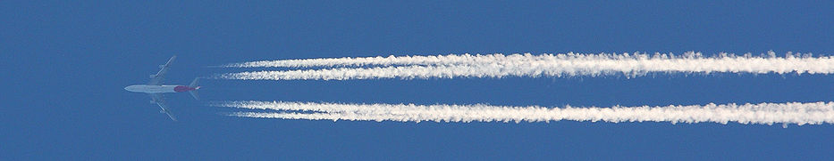

(figure 1) :Exhaust from the Boeing 747-400 in Australia

Another type of lines generated by aircraft is a whirlpool wing tip which is prouduced from tora lines the wing of the plane is sometimes semi-visible and is a result the consideration inside the vortex nucleus has a rotating air mass it’s pressure inside the centre of the vortex is low, and it is not as the condensation lines produced by aircraft engines “cloud plane” may last for a few seconds or minutes or hours, and that is what affects the weather

- Materials and method
These lines are generated from the plane in the sky and it is basically condensation of condensate water vapor resulting from engine exhaust when the gases cooled out of exhaust the plane in the surrounding air generated small drops of water , and if the air is cooler than it is generated small crystals of ice . condensation lines or plane clouds are usually formed on the height is higher than 800 meters at 40 degrees below zero , -40
These lines are made of :
to Exhaust engine exhaust contains carbon dioxide, carbon, sulfur and nitrogen oxides, some non-burning fuels, some tar
and two mineral molecules, as well as water vapor (see Figure2).
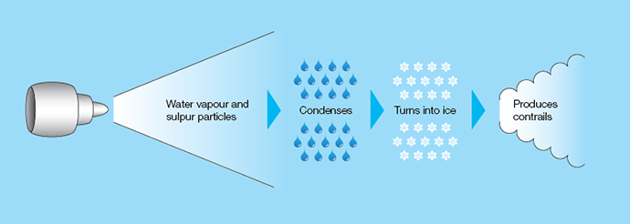
- Summary of data analysis
The problem is widespread worldwide and is a major problem because of its negative effects on its positives. According NASA, the most important drawbacks are: • Climate change On the ground, because they release their exhaust in the upper layers of the atmosphere, causing the work of the cover or so-called "phenomenon of the greenhouse," which cause constant high temperatures, threatening earth.

It has a significant effect in raising the temperature of the earth and reducing the temperature of the atmosphere • It affects the radiation balance on the surface of the earth There are two ways to form these lines are: • Smoke from the engine of the aircraft to the vapor contains water, which condenses when mixed with cold air around the plane, The jet line is longer and the cold air is so rare to see the aircraft take off or fall (this is the most frequent way). When the air moves through the air, the water vapor condenses into thin lines and appears on the wings and fan ends. Condensation occurs when the temperature drops
And and. With low pressure

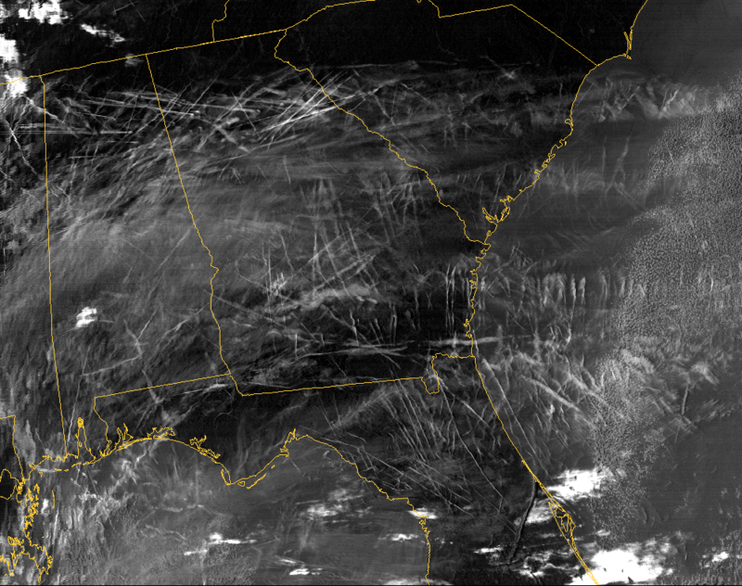
Image of condensate lines resulting from air traffic over the south of 2004 29 East of the United States in January This phenomenon is spread in most aircraft, including warplanes, reconnaissance aircraft and passenger
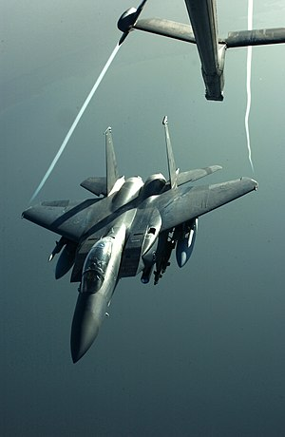
aircraft condensate water vapor in the center of Dama resulting from the wing F-15 10 Strike Eagle after refueling from the KC-Extender and its downsides is a major cause of disruptions:

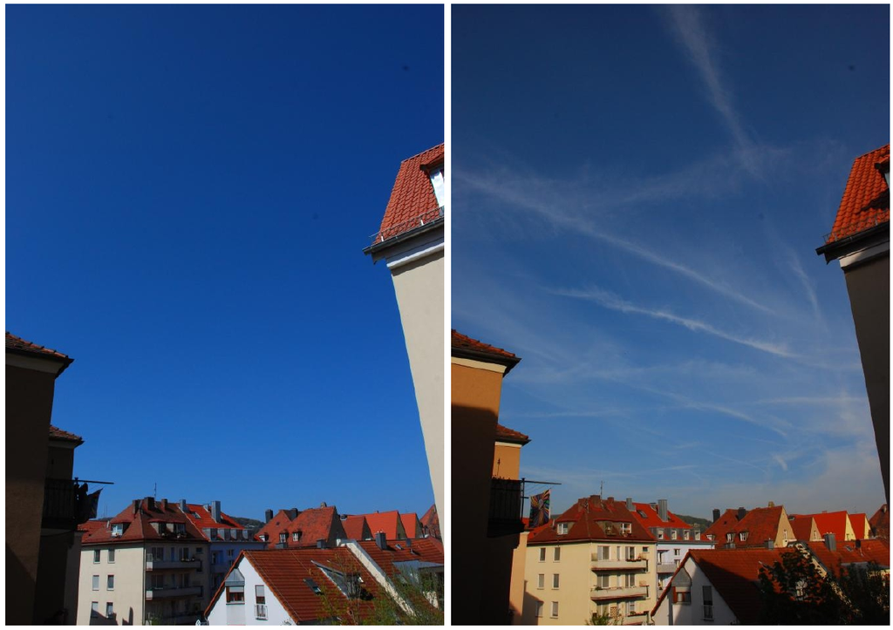
The picture on the left, showing the sky of the city of werzerg germany Without clouds after the general air embargo imposed Which in 2010 The usual And the picture on the right shows the sky at land speed 4. Conclusions, Conclusions and Discussion: " Based on the height of the plane over sea level Prevailing temperature and atmospheric humidity, The shapes and duration of white lines vary in The sky, hot steam output from the engine collides With cold atmosphere located at high altitudes in layers The upper atmosphere, turning into heavy vapor freezes in some Sometimes to form a white line Strangely enough, those lines are reliable To predict the weather, if the white lines are short
This indicates that the humidity is low, and a mark The weather is mild, but if it is thick and long They last for a long time, they are proof that the air humidity High, and may be indicative of fluctuations Gore This problem can be eliminated or minimized in the following ways: . . • The peaceful coexistence of the world to reduce the flight of warplanes Atmosphere • Manufacturing aircraft that do not leave the exhaust behind, or leave A simple effect is what the Globe Environmental Program aspires to 5. Acknowledgments: • All thanks and appreciation is connected to the management school Tindha Secondary education • All thanks and appreciation to : Mr. Mohammed saad al habbab.

References :
NASA
https://owl.english.purdue.edu/owl.section/2/

