**Our town under the stars: Do we sleep better after the change of the urban lighting?**

**Nika Sraka, Maja Hozjak i Katarina Hozjan**

**Valentina Pirc Mezga i Maja Labaš Horvat**

**Srednja škola Prelog, Prelog**

1. SUMMARY

A few years ago, we conducted a survey on light pollution in our region and we got more closely acquainted with the types of existing street lighting fixtures and their impact on the population. We decided to resume the previous project because in the meantime, most streets had their lighting replaced. We decided to conduct a survey at the school level and examine the students and their families about observing the differences after changing the lighting. The basic research questions we have asked were how does the lighting affect our dreams, driving and visibility of constellations. In this project, we used the „GLOBE at night“ database. Our project is of interest to company Energy + from Ludbreg, which is engaged in the production of LED lighting, and the association "Eco Lighting" from Zagreb. We conducted our research in the period from 6th January 2018 to 19th April 2018. The results have shown that the change of lighting is good for our dreams, for better driving and better visibility of the constellations. We conclude that people are sleeping better, the number of road accidents in rural and urban areas have decreased and the visibility of the constellations is greater.

2. RESEARCH QUESTIONS AND HYPOTHESES

Here are the questions that we have asked ourselves:

* What are the changes after the change of street lighting - can we see the stars better after the change in the town of Prelog and suburbs Otok and Čehovec?
* Does the change of lighting have a positive effect on the life of peopland their sleep?
* Was there a reduction in the number of traffic accidents caused by the reflection from street lighting?

We have done research into the visibility of Orion constellation in Prelog and its suburbs, Otok and Čehovec.

Our hypothesis was that the visibility of the star would be worse in the town's area and better in rural suburbs, regardless the lighting change. We have also assumed that most of the drivers had a problem with inadequate street lighting and that its change has led to positive changes. Our last assumption was connected to a smaller influence of new, cut off lighting, to people's sleeping habits.

3. RESEARCH METHODS

During our reasearch, we used „Globe at night“ app method in which we observed the Orion constellation. In 2100, during clear nights, the Orion constellation was located and with the assistance of GPS, the location coordinates were determined. The identical constellation was located on the street/square and the magnitude was determined – the photograph which shows the constellation as seen from the certain location (from the display where constellation isn't visible at all, up to magnitude 7, where Orion is completely visible). Orion constellation was observed during the January-April period, and during that period, two GLOBE at night campaigns lasted as well.

Collected data about the magnitudes of the Orion constellations were entered into the GLOBE at night database. With the assistance of the GLOBE at Night database, we were working on the comparison of the situation in Prelog before and after the lighting change, in order to notice eventual alterations and improvements.

On the first photo, data entering about constellation visibility via GLOBE at night app can be seen. This was done during the campaign in the Prelog area, and Čehovec and Otok, rural suburbs. Orion constellation was observed by total of 20 GLOBE group students, which also assisted us during various measurements.



Photo 1 – Data entering app (Source: Globe at Night )

The survey between the students of our school and their households was conducted as well. In the conducted survey, 140 inhabitants from Prelog and rural suburbs Otok and Čehovec were surveyed. Various questions were asked – what kind of lighting do they have in front of their homes, is the lighting replaced, does the lighting impair their sleep, do they see constellations when they are in front of their homes and have they ever been constricted by the reflection of the bad lighting on the road, if those surveyed were drivers. Observations and surveys were done in the period between 6th of January and 19th of April 2018 and were performed by GLOBE group students. During campaigns, data entering in the GLOBE at night app was performed as well. The second photo shows the light pollution survey, in which the questions were done in accordance with our hypothesis. The survey was done via Google Forms.



Image 2. Survey about the light pollution after the lighting change (Source: Google )

Observing the Orion constellation in the given period, we created our own database of the Orion constellation visibility. All of the GLOBE group students participated in the process.

4. DATA DISPLAY AND ANALYSIS

Orion constellation observation coordinates:

ČEHOVEC: latitude 46.359 N, longitude 16.620 E (rural area)

PRELOG: latitude 46.336 N, longitude 16.622 E (urban area)

OTOK: latitude 46.327 N, longitude 16.585 E (rural area)

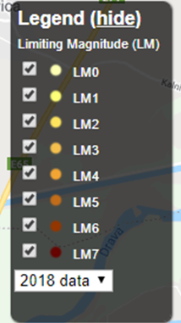 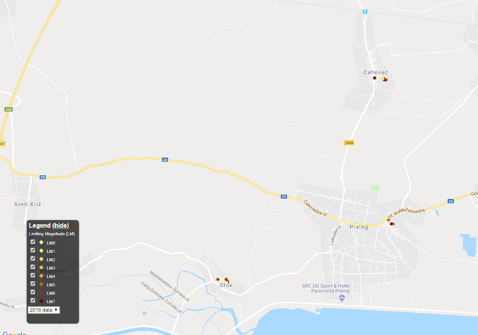

Image 3 – Magnitude display for Prelog, Otok and Čehovec (source: Globe at night)

Magnitudes during the Globe at Night campaign are shown on the map. Because of the low cloud amount, magnitudes in January ranged between 1 to 3. During clear nights, magnitudes reached 6 or 7, which means that the new „cut off“ lighting significantly impacted on the lessening of the light polution in those places that had it replaced acouple of years ago. In the graph, location, magnitude and the selected observation dates are shown. During the January GLOBE at night campaign, the cloud amount was low. Because of that, magnitudes in those places were extremely low, in some cases zero.



Graph 1. – visibility of the Orion constellation in the Prelog, Otok and Čakovec

From the Graph 1, it is visible that the constellation is much more visible than in urban area because lamp posts in rural areas are much more farther away than the urban ones. This was proven as well in our previous research, done in 2014.

After this year's research analysis, as well as the comparison with previous project, we conclude that the Orion visibility in given period is much higher, regardless whether the observation was done in the rural or urban area. The average magnitude for Prelog in 2014 was 4, while research conducted this year showed that the magnitude raised to 5. Rural areas had the average magnitude of 6, which remained the same in the present research.

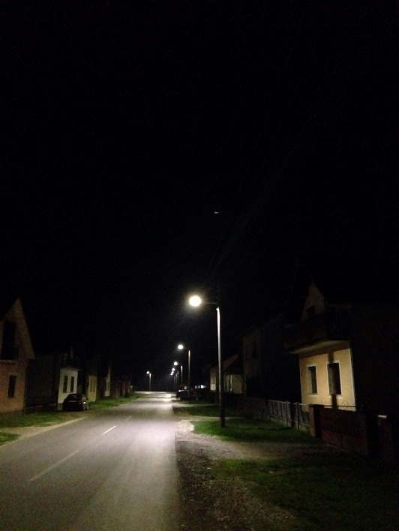

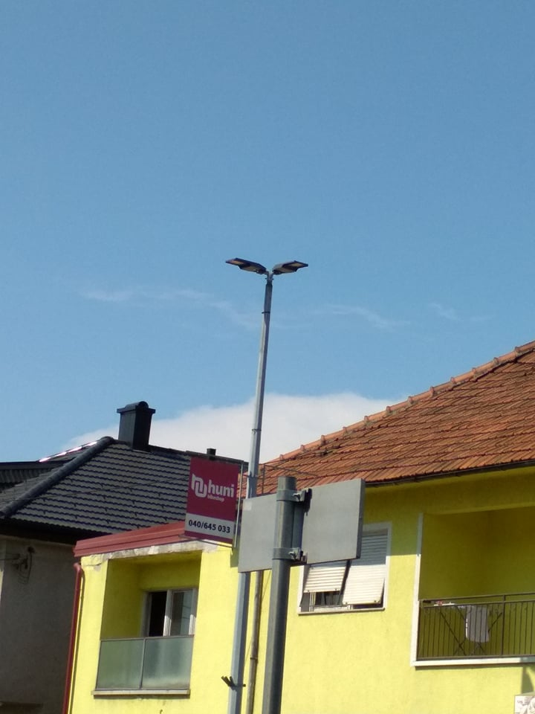

Image 4 – display of the „cut off“ lighting during daytime and at night

Image 4 shows new „cut off“ LED lamp posts which don't disperse light.

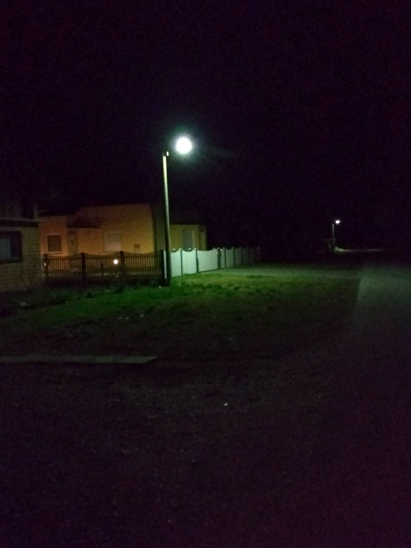 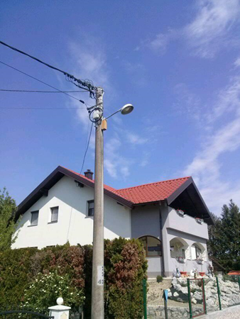

Photo 5 – daytime and nighttime photos of the old lighting

On the fifth photo, the inadequate lighting can be seen, which harmfully impacts birds' and bats' flight and endangers natural balance, which consequently impacts people's sleep.

The gathered surveys are displayed by pie chart, in which the answers of the surveyed population is visible.

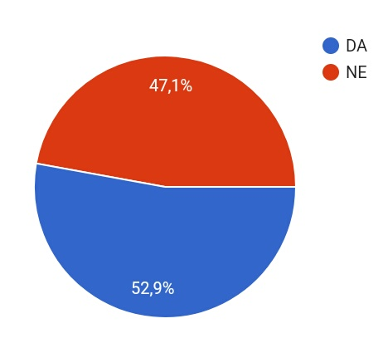

Graph 2 – Percentage of the subjects which noticed the lighting change after 2014

After the data analysis, it was shown that 52,9% of the subjects have noticed the lighting change, while 47,1% haven't noticed any change.

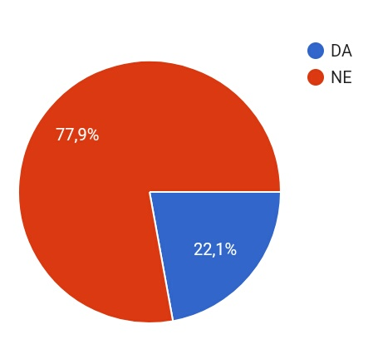

Graph 3 – Percentage of subjects who had sleeping problems before the change of lighting

After the data analysis, it was shown that 21,1% of the total of 140 inhabitants had sleeping problems before the change of lighting, while 77,9% didn't have any problems. We also asked the subjects whether they live in the urban area (Prelog) or rural area (Čehovec and Otok). Out of 140 inhabitants, 51,1% surveyed inhabitants live in rural area, while other 48,9% live in the urban area.

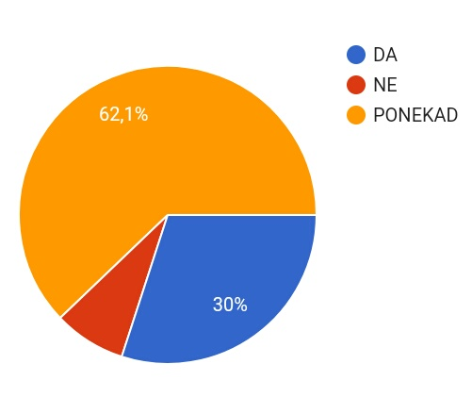

Graph 4 – Percentage of subjects (constellation observation)

After the data analysis, the results were that 62,1% of the subjects ocassionally observe stars, 30% of the subjects observe stars, and the other 7,9% aren't engaged in the star observation.

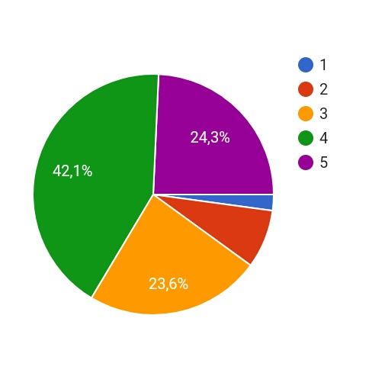

Graph 6 – Rated star visibility (1 – poor visibility, 5 – clear visibility)

The subjects were asked to rate the constellation visbility from their backyards. They had to mark the least visible stars with 1, and the most visibile stars with 5. From the pie chart, we can see that 23,9% of the subjects rated the star visibility with 5, 42,1% with 4, 24,3% with 3, 7,7% with 2, and 2% of the subjects with 1. Based on the results, we can see that results of the survey overlap with our observations of the Orion (magnitude indexes), since the larger part of the subjects live in rural areas.

The number of drivers between subjects was also researched. Out of 140 inhabitants, 47,9% of them drive. From the total amount of drivers, 74,3% of them said that they aren't constricted by the reflection, while 25,7% of drivers said that they are constricted by the reflection.

5. CONCLUSION:

With the replacement of the old lighting with „cut off“ lighting, it is concluded that light pollution improvement can be seen. Orion constellation is much more visible because the light doesn't reflect into space as much as it did before. We also conclude that constellations are still much more visible in rural areas than in urban areas. The reason for that lies in the distance of lamp posts in Otok and Čehovec. In the conversation with the mayor of Prelog, we learned that the cut off LED lighting was set on every second lamp post. The survey showed that as well – the surveyed subjects from the rural area said that the stars are very visible. With the change of the lighting, the lighting pollution decreased. The surveyed subjects had sleeping problems, which decreased with the cut off lighting. Although the vast majority of subjects answered that street lightning isn't disrupting their sleep, we think that the cause of such results is because in the pattern, the majority of the inhabitants were of younger age.

Lighting change positively affects the traffic as well. Cut off lighting doesn't disperse into the atmosphere as much. The following was confirmed by drivers which filled out the survey. The number of road accidents also dropped, according to the Prelog police station.

LITERATURE:

1. <https://www.globeatnight.org/> ( 5.1.2018.)
2. <http://www.energyplus.hr/> ( 15.1.2018)
3. <http://www.prelog.hr/> ( 15.1.2018.)
4. <http://www.pre-kom.hr/> ( 15.1.2018.)