The United Arab Emirates
The Ministry of Education
Ajman
Rashid bin Humaid Model School for Boys

Environment friendly air conditioning unit
(Within the Globe Project)

Students' implementation:
1- Ibrahim Ayoub Al-Awadhi
2- ziad Alrawdani
Supervision of the research: - Ziad Manasra

Environment friendly air conditioning unit
The main objective of the project:
Reducing the electricity consumption (reduce carbon footprint) used in the air cooling process by reducing the number of conventional refrigeration units used at home or any other facility.
This is done through the manufacture of secondary cooling units with low consumption of electricity, and these units are derived from the main unit used for cooling.

Project Idea:
The use of cold air that exits from the main air conditioning unit in cooling a network of copper pipes filled with water. The water, which will be cold, is pumped into another cooling unit made up of pipes a copper system, which is located in front of a fan pumping air, so the air will cool after contact with cold pipes that filled with the cold water coming from the base unit. So the air that comes out from the secondary unit of refrigeration, and again the water returns to Basic cooling unit via pump to complete the cycle.
More than one secondary refrigeration unit can be connected to the basic refrigeration unit.
In other words, if there were in a classroom or any hall or house 4 air conditioning units (for example). We can dispense 3 units of air conditioning. With 3 secondary air conditioning units running on cold water coming from the main unit. In this way, the electricity bill will be reduced almost to a quarter because the secondary air conditioning units consume a small amount of electricity because they are only composed of a fan witch it depends on cold water coming from the primary unit, unlike conventional air conditioning units. That consumes a large amount of power supply

How did the idea arise?
The idea arose because of the high electricity bill and the high carbon footprint resulting from air cooling using many traditional air conditioning units, which consume a large amount of electricity up to 90% of the monthly electricity bill, whether in homes or any other facilities. This in turn has financial loss and environmental pollution.

Related theories with the Project:
Thermal conductivity
The amount of heat per unit time per unit area that can be conducted through a plate of unit thickness of a given material, the faces of the plate differing by one unit of temperature.

Convection is the transfer of internal energy into or out of an object by the physical movement of a surrounding fluid that transfers the internal energy along with its mass. Although the heat is initially transferred between the object and the fluid by conduction, the bulk transfer of energy comes from the motion of the fluid. Convection can arise spontaneously (or naturally or freely) through the creation of convection cells or can be forced by propelling the fluid across the object or by the object through the fluid.

Hypothesis

Can we use a primary air-conditioning unit to make associated secondary air-conditioning units with low power consumption, so that the cost of air-conditioning and air-cooling will decrease significantly? Through the use of cold air from the main unit and transfer this cold to the secondary conditioning units do not consume a lot of electric current.

Hypothesis testing
We have designed an experiment to prove that if there is a cool body in front of a fan. Will make the air that emitted from the fan cool down after it collides with the cold body by passing heat from the air to the cold body, leading to a drop in the temperature of the air that comes out after colliding with the cold body.
Materials:-
Fan or (hood) - glassware - cold water - glass basin
Implementation mechanism
1. Operate the fan and measuring the air temperature emitted from the fan
2 - Put the glass container that contains cold water in front of the fan
3 - We measure the temperature of the air emitted from the fan after colliding with the glass vessel containing cold water
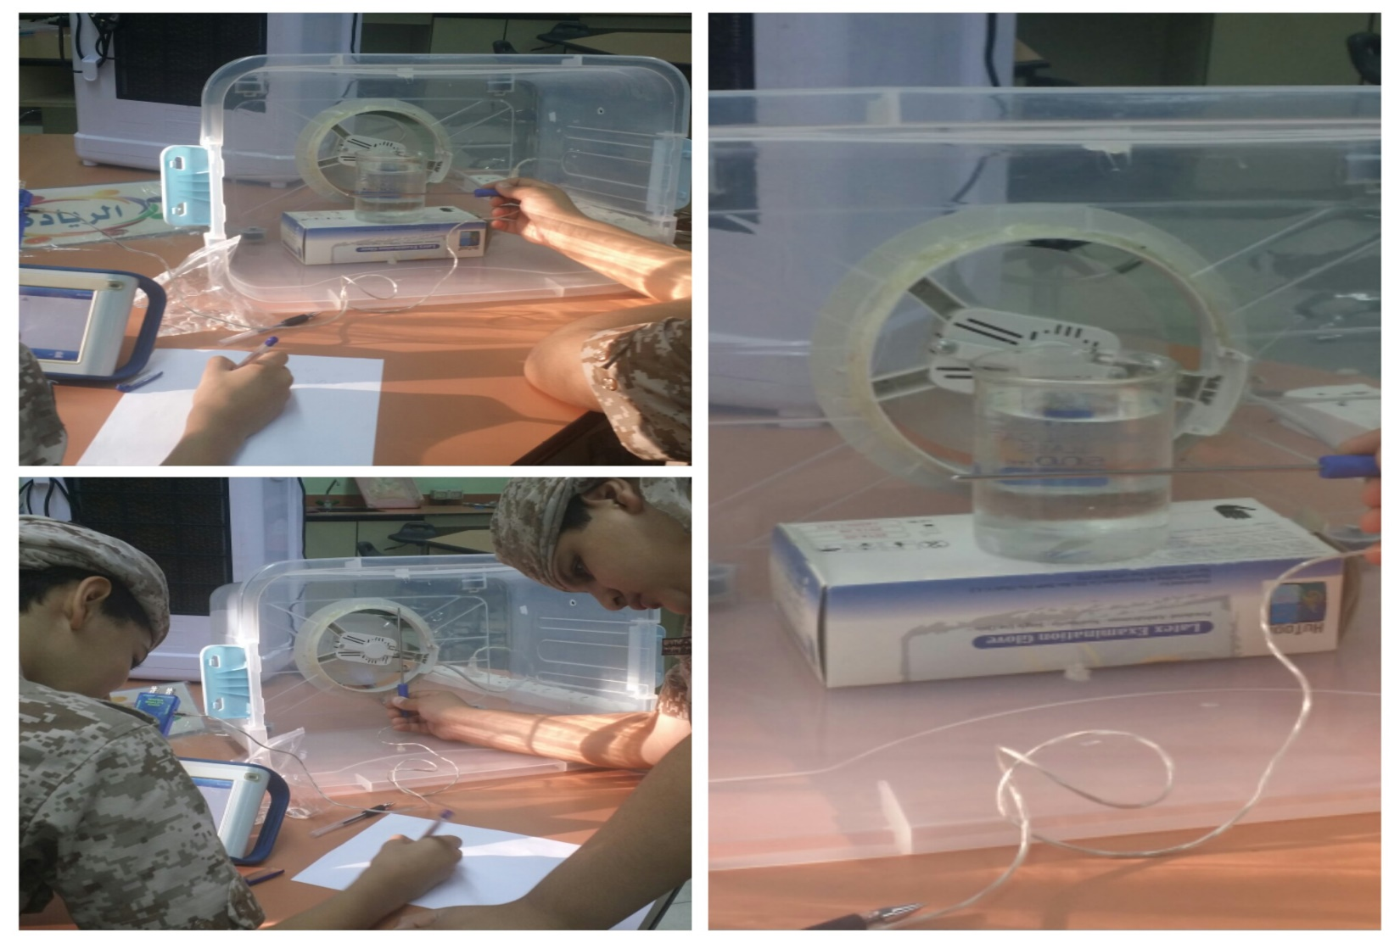

Observation:-
The air temperature emitted from the fan at first was 25 ° C. After the cold water glass was placed and collided with it, the emitted air temperature became 20 degrees Celsius

Temperature changing with time

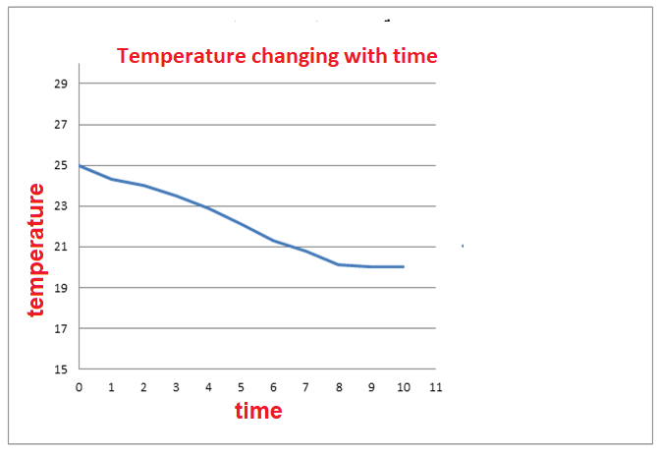

Conclusion
The air emitted from the fan its temperature has decreased due to the transfer of heat from the air to the vessel containing cold water. This confirms the validity of our hypothesis.

The second experiment
We have designed an experiment to prove that copper pipes are a good conductive material for heat and heat is transferred from the air to it, which leads to reduce the air temperature.

Materials:-
Cold air source (small mobile air conditioner) - copper pipes - thermometer

Implementation mechanism
1 - We install a spiral copper tube in front of the air conditioner opening (in order to increase the area of copper pipes that will be meet the cold air out of the conditioner

2 - We measure the temperature of the end of the copper tube (away from the air duct outside the air conditioner)
3 - We operate the air conditioner and then we measure the temperature of the tip of the copper pipe away from the air conditioner for 10 minutes. Then we record the temperature every minute of time.

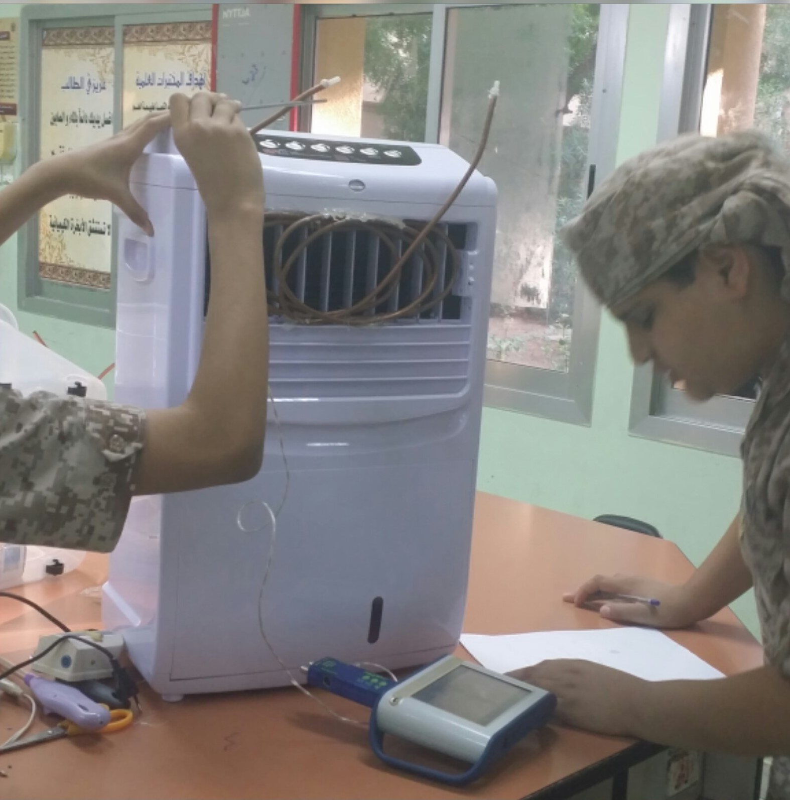

Observation
1. The temperature of the tip of the copper pipe before operating the air conditioner was 25 ° C
2. After operating the air conditioner and measuring the temperature of the end of the copper pipe. We noticed a gradual reduction in the temperature of the tip of the copper tube until it reached 20 ° C, the same as the temperature from the air conditioner
Conclusion:
Copper is a highly efficient material in conductivity and thermal transport. It can be used in the machine to make a secondary air conditioner depends on the cooling on the original air conditioner.

Steps in implementing the project
Tools
Copper pipes - Fan or air conditioner - Portable air conditioner (small size) - Plastic basin - Water pump - Heat wax - Thermal candle gun - Small plastic tubes - Thermal heat

A schematic diagram of the device agreed on to manufacture.
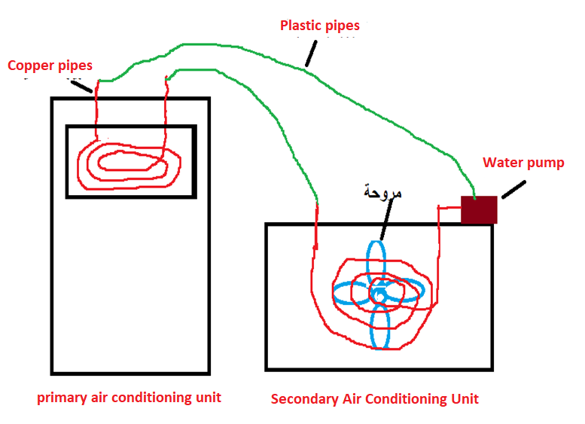

Implementation phases
First phase: - Equipping the main air conditioning unit
1 - We cut the appropriate length of copper pipes.
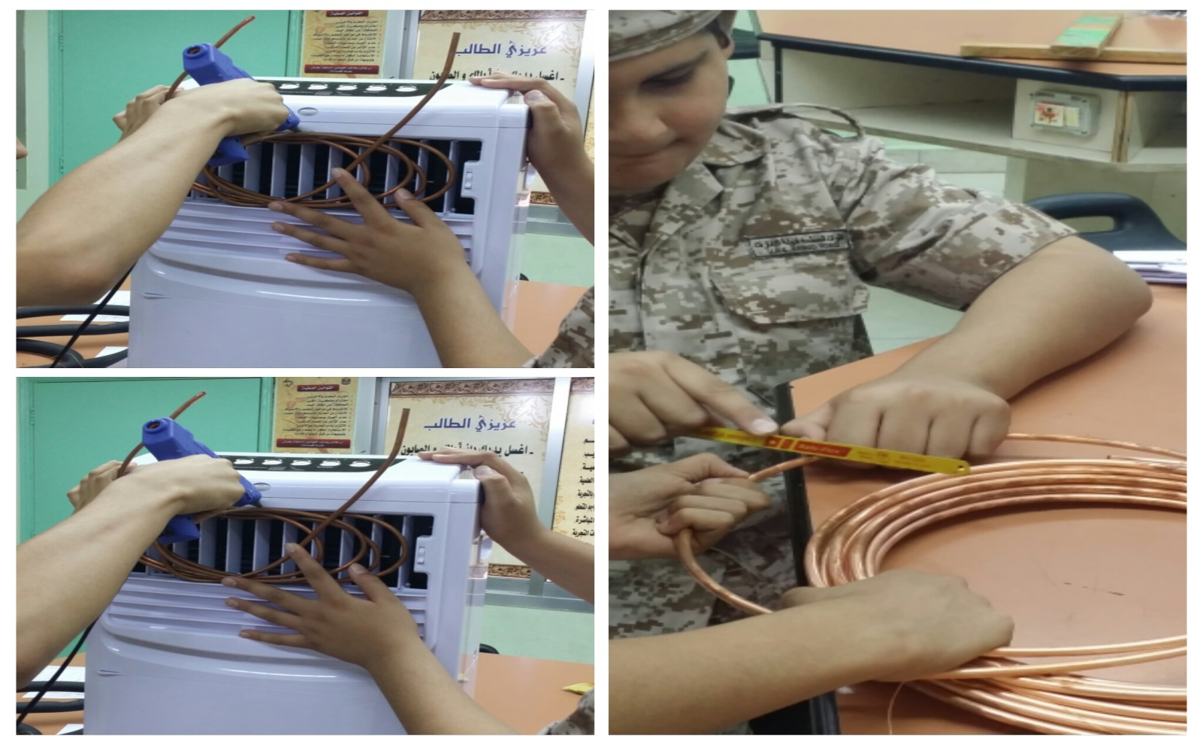
2 - We install the copper tube in the as a spiral in front of the exit of cold air from the air conditioner

Second phase: - Equipping the secondary air conditioning unit
1. We make a hole in the plastic container to install the fan (air suction), so that the air from the outside of the plastic container comes into the container
2 - We install the spiral copper tube in front of the air suction inside the plastic container, and we make the ends of the tube outside the plastic container by the made two small holes by the thermal welding tool.
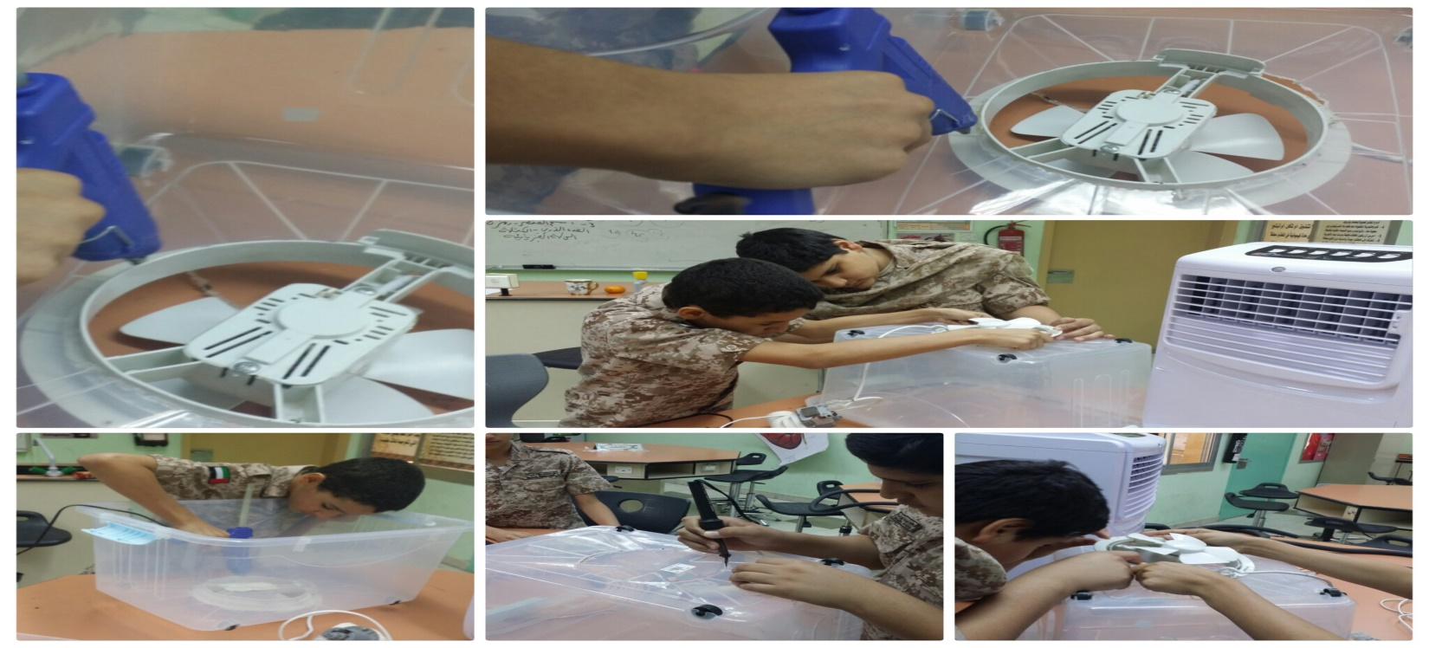
3. We install the water pump on the back of the plastic box
4 - Make holes in the lid of the plastic container. Then cover the container

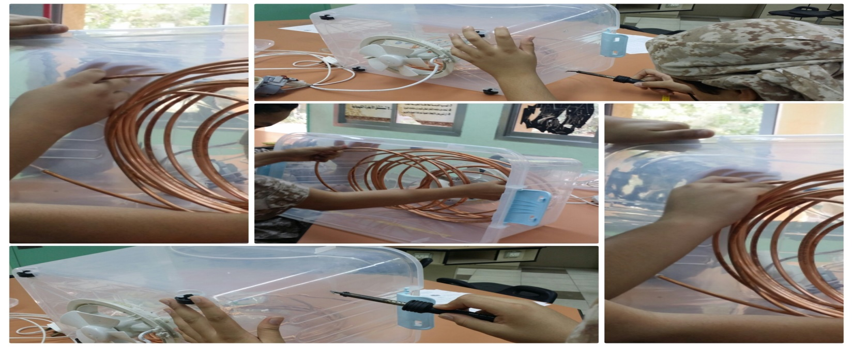

Phase 3: - Connecting the main air conditioning unit to the secondary air conditioning unit
1 - We connect the first section of the copper pipe located on the main air conditioning unit in the first section of the copper tube in the secondary air conditioning unit by a plastic tube (used in aquariums)
2. We connect the second branch of the copper pipe to the main air conditioning unit of the first part of the water pump
3 - We fill the copper tube with water
4 - We close the circuit by connecting the second end of the pump to the second end of the copper pipe in the secondary air conditioning unit by a plastic tube
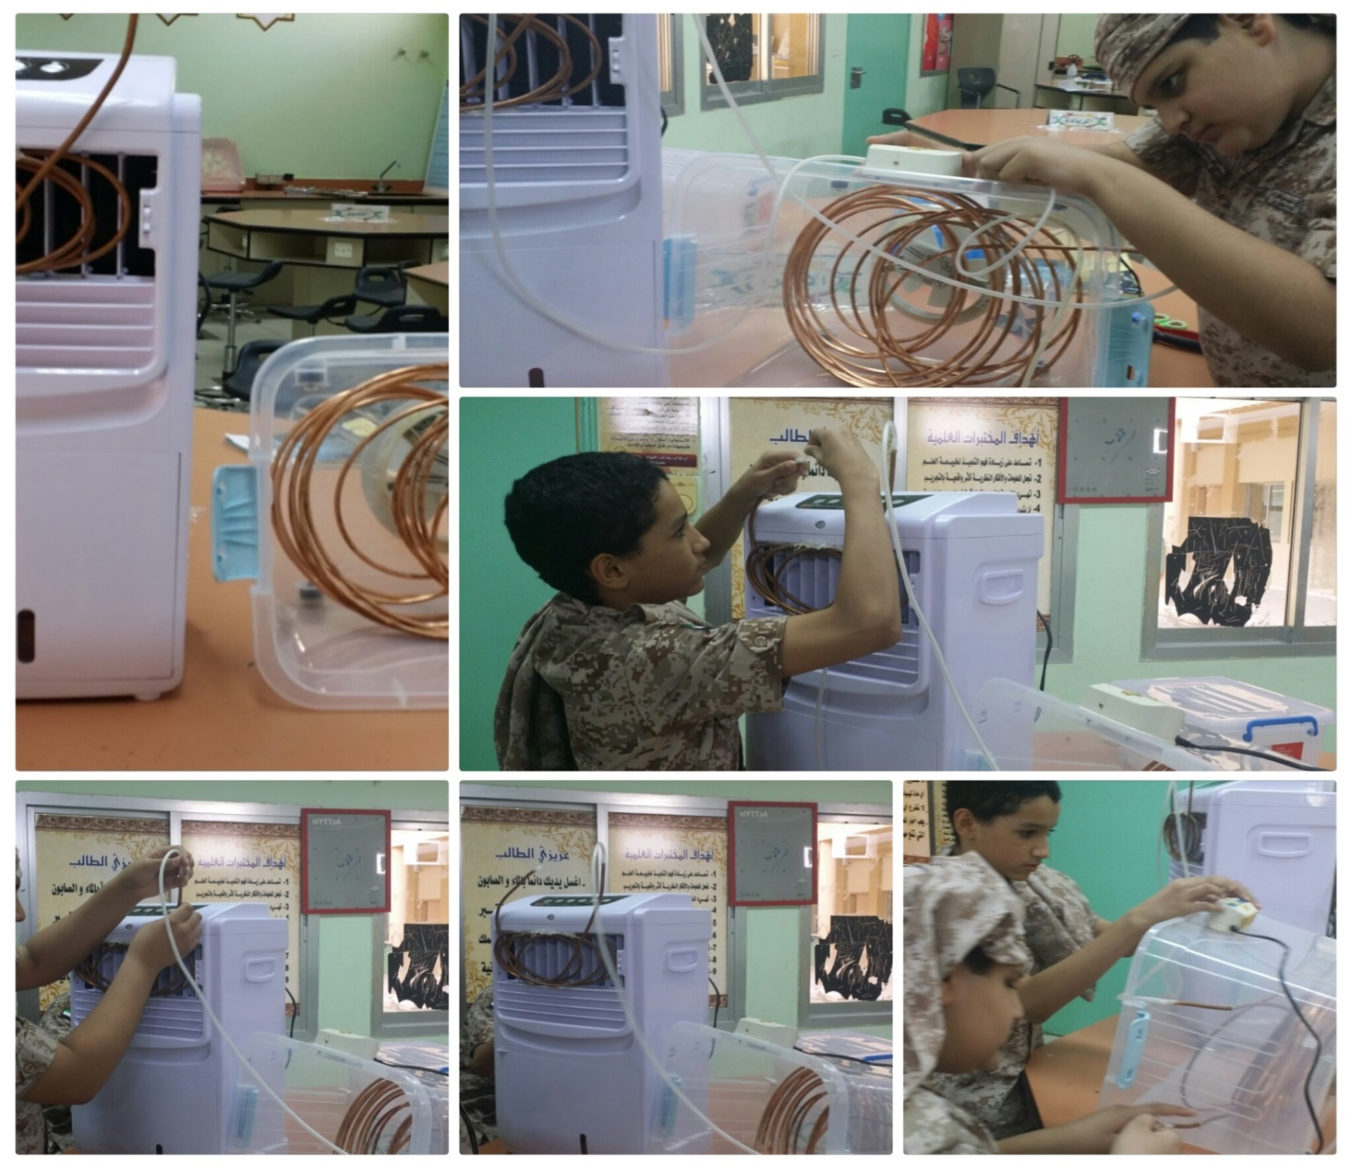

The most important results
At the starting, the main air conditioning the air temperature of the air coming out was 23 ° C. The air temperature of the secondary air conditioning unit was 28 ° C and as same room temperature.
After a few minutes, the air temperature from the secondary air conditioning unit began to gradually decrease until it became almost after 7 minutes, 23 degrees Celsius
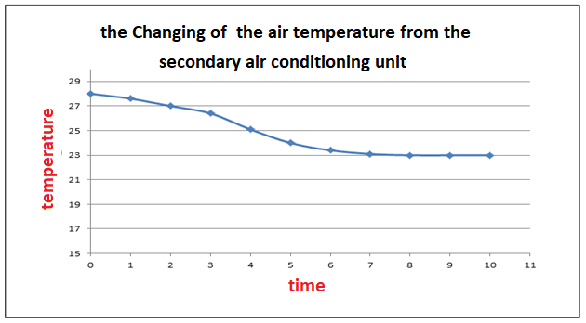

Changing the air temperature from the secondary air conditioning unit
Analysis of the results
We were able to get a secondary air conditioning unit from the main unit, so that the air conditioning unit produced air that it is temperature equivalent to the temperature of the main air conditioning unit depending on cold water that moved from the main air conditioning unit to the secondary air conditioning unit.
This proves the validity of the hypothesis developed at the beginning of the project

Conclusions and recommendations.
Our hypothesis was the possibility of getting air conditioning units from one main unit to reduce the amount of electric power consumption, by using water cooled by a basic air conditioning unit and transporting this cold water to a secondary air conditioning unit through copper tubes, and this unit only works on the fan.

To prove this hypothesis, we have designed experiments confirming the validity of the hypothesis. Having confirmed the results we have obtained and supporting the hypothesis. We drew a chart of the device we're going to make.
After finishing the design of the machine and test it and analyze the results. We actually found that we were able to get an eco-friendly air conditioning unit and managed to make cold air coming out of the main air conditioning unit to get a secondary air conditioning unit.

This air conditioning unit features these features
1 - It is an environmentally friendly air conditioning unit because it consumes much less than the electric power consumed by conventional air conditioning units depending on the compressor (Compressor)
2 - The adoption of the device on the fan only and the small amount of electricity consumed, it reduces the great waste in the amount of electricity consumed, which in turn reduces the amount of pollution from power plants, which consume a large amount of fossil fuels to generate electricity
3 - The reduction in the amount of electricity consumed from this air conditioning unit leads to the provision of a large amount of money that was paid through the use of traditional air conditioning units

Future plans for device development

1. Instead of making one secondary air conditioning unit with the main air conditioning unit. We will manufacture more than one secondary air conditioning unit connected to the main unit

2. The device can be developed by using the high latent heat of the water, which maintains in the cold for longer, the extension of secondary copper pipes placed behind the walls and connected to the main air conditioning unit, and in this way the room remains cool for a very long time even after the closure of main and secondary cooling units

Acknowledgments
We thank very much to the Manager of the school, Ms. Hind Youssef, who provided us with the support we need in all kinds. We also thank the director of the project, Ziad Manasra, who made a great effort to guide us and supervise us, and we do not forget the great support of our parents. We also thanks Ms. Bahia Shehab, the global program's supervisor, for her support and recommendations

References

https://mawdoo3.
http://www.phys4arab.net

