National Capital Region

Division of City Schools – Quezon City

**BATASAN HILLS NATIONAL HIGH SCHOOL**

IBP Road, Batasan Hills, Quezon City

**Assessment of Community Awareness and Responsiveness on the Health Hazard brought by Mosquito-borne Diseases**

**Aerish R. Ocomen**

**Mae Joy S. Bernales**

Researchers

**Ms. Joan B. Callope**

Research Coach

**March 2020**

Date

**ABSTRACT**

Quezon City is located in the Philippines and considered as the most populated city in the country, with nearly 2.9 million as indicated by the last national statistics. Numerous number of the dengue cases in Metro Manila for the year 2019 were recorded in Quezon City based on the recent report of Department of Health (DOH). The city had more than 3,000 instances of dengue This study was descriptive in nature, determining the relevance of health and barangay officials' responsiveness to the awareness of the residents from a particular barangay area. This study focused on the aspects on the perception and views of the selected participants regarding the mosquito-borne disease cases. Campus principal of Batasan Hills National High School and Health Sanitation Officer in-charged from the twenty selected barangays were then asked for their permission to formally conduct the study. Twenty barangays in Quezon City including Barangay Payatas**,** Commonwealth, Batasan Hills, Holy Spirit, San Agustin, Capri, Bagbag, NagkaisangNayon, East Kamias, Sikatuna Viilage, Quirino 3A, Quirino 2A, San Bartolome, Krus na Ligas, Pinyahan, Quirino 2B, Bagong Silangan, Sauyo, Talipapa and Tandang Sora possess a siginifcat health risk on mosquito-borne diseases as indicated positive on having such mosquito breeding sites.. There are preventive strategies being performed in each barangay. Unfortunately, due to the rising population, there are times that the needs are not being satisfied but the good thing about it is the commitment of barangay to serve its fellows through providing alternatives and other solutions to be able to meet the public health demand. To sum it all up, there are still factors that need to be addressed by the city Health Department, for the residents, allotting more self-discipline on their surroundings may reduce to reduce mosquito-borne diseases cases.

**TABLE OF CONTENTS**

**TITLE PAGE**…………………………………………………………………..... **1**

**ABSTRACT**.....................………………………………………………….…...... **2**

**TABLE OF CONTENTS**……………………………......................................... **3**

**RESEARCH QUESTIONS**………………………………………....................... **4-5**

**HYPOTHESIS**…………………………………………………........................... **5**

**INTRODUCTION**……………………………………………..…....................... **5-7**

**MATERIALS AND METHODS**……………………………............................. **7-11**

**RESULTS**……………………………………...................................................... **12-42**

**CONCLUSIONS**…………………………………………………........................ **43**

**DISCUSSION**……………………………………………………......................... **44**

**ACKNOWLEDGEMENTS**………………………………………...................... **45-46**

**REFERENCES/BIBLIOGRAPHY**…………………………………….............. **47-48**

**APPENDICES**................................................................................................... **49-59**

**RESEARCH QUESTIONS**

Generally, the sole purpose of this study is to seek infomation and provide knowledge development on the relevance between the barangays responsiveness and the residents awareness on mosquito-borne diseases. More specifically, it aims to answer the following questions:

1. What barangays in Quezon City possess a positive threat on mosquito-borne diseases? 2. What are the classifications of pupae/larvae found in breeding sites in terms of:

a. Density

b. Type

3. How does the barangay health officials respond to the needs of the residents when it comes to the following aspects:

a. Timely Manner

b. Facilities and Equipment

c. Communication

d. Medical Needs

4. What are the sources of information being utilized by the residents in each barangay enabling them to be aware of mosquito-borne diseases?

5. How aware are the residents in terms of:

a. Mosquito-borne Diseases

b. Disease Symptoms

c. Possible Breeding Sites

d. Prevention Mitigation and Adaptation Practices on Mosquito-borne Diseases

6. What are the suggestive coping mechanisms to be implemented by each barangays to improve and invent new possible preventive strategy to lessen diseases rates caused by mosquitoes?

**HYPOTHESIS**

The following are the possible outcomes of the study based on the researchers’ perspective:

*HO: The community awareness and responsiveness is higly efficient to deal with the threat of lethal mosquitoes*

*HA: The community awareness and responsiveness is not higly efficient to deal with the threat of lethal mosquitoes*

**INTRODUCTION AND REVIEW OF LITERATURE**

According to the World Population Review (2020), Quezon City is located in the Philippines and considered as the most populated city in the country, with nearly 2.9 million as indicated by the last national statistics. Quezon City was assigned as a city in 1939. After 40 years, it was assigned as a Highly Urbanized City. Quezon City has more than one million a bigger number of occupants than the national capital, Manila. Several programs were conducted to deal with the rising population of the City because this reality possesses a significant role to the well being of the community. Being populated city can cause many viral diseases and can grow many harmful organisms and mosquitoes. Recently, a thousand bull frogs were being released by Brgy. Old Balara, Quezon City in esteros in a bid to halt the widespread of lethal mosquitoes that has affected 188,562 people nationwide and killed 807 from January 1 to August 3. Local governments try to combat dengue through fumigation and by encouraging residents to clean their surroundings (Panela, 2019)

Numerous number of the dengue cases in Metro Manila for the year 2019 were recorded in Quezon City based on the recent report of Department of Health (DOH). The city had more than 3,000 instances of dengue. During a similar period in 2018, more than 4,000 dengue cases were accounted for in the zone. One of the factors that caught the attention of DOH is the immense rising population of Quezon City, including the fact that the city is an intently observing zones where dengue cases strike (Marchadesch, 2019).. In Taguig, the quantity of dengue cases was at that point over the pandemic edge, developing more than 100 percent from the report in 2018. Defogging and cleanup drives had the option to help diminish the frequency of dengue in the territory, as indicated by the report. The Philippine health service has asked nearby authorities to increase endeavors to fight against dengue fever after the loss of life from the scourge arrived at 1,021 (Fonbuena, 2019).

Realizing the huge dilemma and impacts caused by mosquito-borne diseases, it is, therefore, very important to seek for information to be able to formulate solution to deal with the threat od these lethal mosquitoes. This research study can be a promising strategy for long-standing concerns of different areas not only in Quezon City, but in the whole wide world. The improvement of issues realted to mosquitoes may lead future generation to have a better platforms in reducing the rates of diseases-causing mosquitoes as they go through the process of being professionals.

The dedication of the community in mosquito-control researches is one of the strategy to effectively disseminate information on different localities. Residents from different barangays should put more effort in commitment and should be more involved to strengthen community awareness and briefing the barangay and health center responsiveness to meet the needs of the community to fight against mosquito-related diseases.

**MATERIALS AND METHODS**

This section shows the thorough process of the whole research study including methodology and design, research site, purposeful sampling/population, preparation and of materials, data analysis procedures, statistical tool and the researchers’ role.

**Methodology and Design**

This study was descriptive in nature, determining the relevance of health and barangay officials' responsiveness to the awareness of the residents from a particular barangay area. This study focused on the aspects on the perception and views of the selected participants regarding the mosquito-borne disease cases. Campus principal of Batasan Hills National High School and Health Sanitation Officer in-charged from the twenty selected barangays were then asked for their permission to formally conduct the study. Barangay officials were also interviewed on their current ability to respond to the needs of the residents.

The survey questionnaires were distributed among the selected participantsfrom 20 barangays. The researchers only observed them and answered questions and clarifications of the selected participants. The survey questionnaires were collected after the participants have finished answering questions. NVivo qualitative data analysis software was used to show the non-numerical data that the researchers gathered from the views of the community through interviews.

**Research Site**

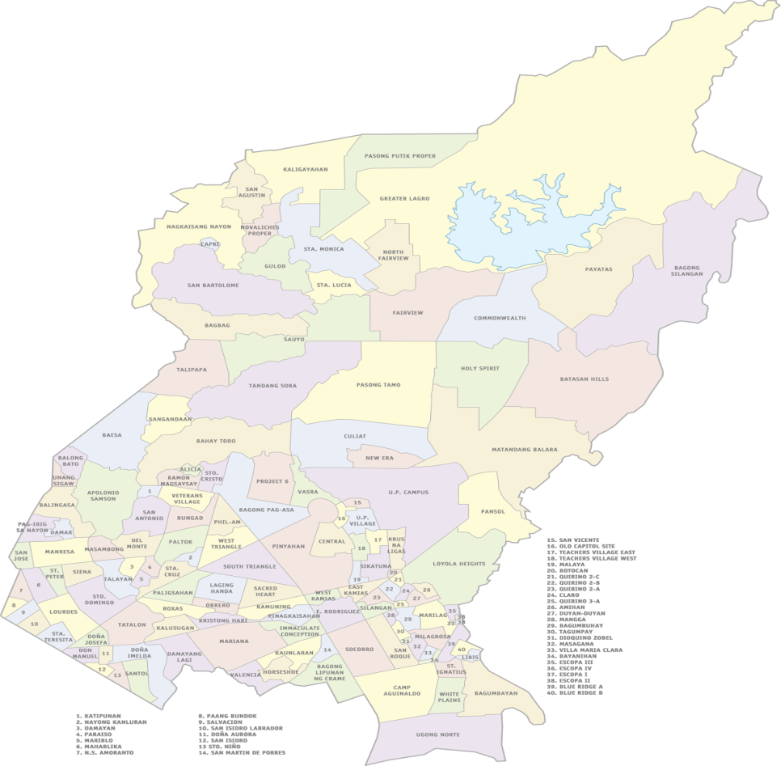**Figure 1. One Hundred Forty Two Barangays in Quezon City, Philippines**

### Photo Credits: The Metro Commuter, *QC Barangay Map for overlay*

**Table 1.Twenty Selected Barangays from Quezon City as Research Sites**

|  |  |
| --- | --- |
| No. of Barangay | Nmae of Barangay |
| B(1) | Payatas |
| B(2) | Commonwealth |
| B(3) | Batasan Hills |
| B(4) | Holy Spirit |
| B(5) | San Agustin |
| B(6) | Capri |
| B(7) | Bagbag |
| B(8) | NagkaisangNayon |
| B(9) | East Kamias |
| B(10) | SikatunaViilage |
| B(11) | Quirino 3A |
| B(12) | Quirino 2A |
| B(13) | San Bartolome |
| B(14) | KrusnaLigas |
| B(15) | Pinyahan |
| B(16) | Quirino 2B |
| B(17) | BagongSilangan |
| B(18) | Sauyo |
| B(19) | Talipapa |
| B(20) | TandangSora |

The study was held at the vicinity of Quezon City and particularly conducted it to 20 barangays as shown in Table 1. It includes Barangay Payatas**,** Commonwealth, Batasan Hills, Holy Spirit, San Agustin, Capri, Bagbag, NagkaisangNayon, East Kamias, Sikatuna Viilage, Quirino 3A, Quirino 2A, San Bartolome, Krus na Ligas, Pinyahan, Quirino 2B, Bagong Silangan, Sauyo, Talipapa and Tandang Sora.Various sites were observed by the researchers to seek knowledge on possible mosquito breeding sites, the type of mosquito and the level of the density present from a particular site.

**Purposeful Sampling/Population**

The participants of this study were selected from 20 barangays in Quezon City. Purposive sampling method was used to gather the samples required from the population. Ten residents from each barangay were selected to participate in the study on their views and perception on mosquito-borne diseases, diseases symptoms, source of mosquito information, time occurrence of mosquitoes and current preventive practices of the residents to cope up with this cases. Threeresidents were interviewed on their current commitment and relationship with the programs being implemented by their respective barangays. The participants were not subjected to any unethical behavior from the researchers during the course of the research process.

Survey questionnaires was utilized as the primary instrument for data collection and gathering in the study. Regarding the ethicality of the data gathering instrument, questions do not contain any sensitive topics and consist of mixed open-ended questions and checklist type of questionnaire targeted specifically towards the topic of the study. For the other ethical considerations, the respective barangay officer in-charged for the health sanitation of each barangaywere interviewed on their current capabilities to respond to the needs of the residents in terms of timely manner, communication, facilities, equipment and other medical needs.

**Preparation of Materials**

The researchers keep in mind the materials to be used in the study for collecting mosquito samples from breeding sites in the selected barangays. This materials includes white plate, gloves, mouth masks, permanent markers, macro lens, plastic containers and dropper. Also, utilization of long-sleeves shirt and maong pants were performed by the research to have a proper attire in gathering samples and for the avoidance of such incidents.

**Data Analysis Procedures**

The data gathered from the procedures were carefully analyzed by the researchers. The researchers ensured that no data gathered is omitted and included all the answers provided by the participants.

**Statistical Analysis**

Percentage frequency distribution was used as a statistical tool for the analyzation of the data to clearly shows the specification of large volume of the gathered data. On the other hand, Measures of Central Tendency was also utilized to showcase the mean, median and mode of the responses of the participants. It was used to merely determine the central point of various distribution that corresponds the majority responses of the participants.

**Researchers’ Role**

Researchers are the primary instrument for the initiation of the research process and data collection. The onesthat established good rapport with the participants and responsible enough for the analysis of relevant literature. Furthermore, after executing such actions, structuring of new concepts will be done by the researchers where inferences from their observation and evaluation of the data gathered. Lastly, having a more secured standards of research is one of the main role of the researchers to fulfill wherein biases and explicate beliefs were set aside.

**RESULT**

**Table 2. Frequency and Percentage of Study Participants based on Sex**

|  |  |  |  |  |
| --- | --- | --- | --- | --- |
| Barangay | No. of Male | Percentage | No. of Female | Percentage |
| **(n)** | **(%)** | **(n)** | **(%)** |
| B(1) | 3 | 30% | 7 | 70% |
| B(2) | 2 | 20% | 8 | 80% |
| B(3) | 4 | 40% | 6 | 60% |
| B(4) | 5 | 50% | 5 | 50% |
| B(5) | 2 | 20% | 8 | 80% |
| B(6) | 2 | 20% | 8 | 80% |
| B(7) | 3 | 30% | 7 | 70% |
| B(8) | 5 | 50% | 5 | 50% |
| B(9) | 6 | 60% | 4 | 40% |
| B(10) | 5 | 50% | 5 | 50% |
| B(11) | 3 | 30% | 7 | 70% |
| B(12) | 3 | 30% | 7 | 70% |
| B(13) | 3 | 30% | 7 | 70% |
| B(14) | 2 | 20% | 8 | 80% |
| B(15) | 6 | 60% | 4 | 40% |
| B(16) | 3 | 30% | 7 | 70% |
| B(17) | 5 | 50% | 5 | 50% |
| B(18) | 3 | 30% | 7 | 70% |
| B(19) | 6 | 60% | 4 | 40% |
| B(20) | 4 | 40% | 6 | 60% |
| Total | 75 | 37.50% | 125 | 62.50% |

As shown in the table above, there were 75 males having 37.50% and 125 females with 62.50% of the total percentage. All in all, the totality of study participants was 200 which came from 20 selected barangays in Quezon City.

**Figure 2.Percentage of Study Participants based on Sex**

Figure 2 shows the percentage of study participants according to their respective sex.There were 37.50% male sout of the 200 particpants. 125 females with 62.50% of the total percentage were involved in the study. The study participants came from twenty selected barangays in Quezon City.

**Table 3. Age Frequency and Percentage of Study Participants**

|  |  |  |  |  |  |  |  |
| --- | --- | --- | --- | --- | --- | --- | --- |
| Barangay | | Age | | | | | |
| 14-23 | 24-33 | 34-43 | 44-53 | 54-63 | 64 + |
| B(1) | | - | - | - | 10 | - | - |
| B(2) | | - | - | - | 9 | 1 | - |
| B(3) | | 9 | - | - | 1 | - | - |
| B(4) | | 7 | - | - | 2 | 1 | - |
| B(5) | | 6 | - | 1 | 2 | 1 | - |
| B(6) | | 3 | 3 | 2 | 1 | 1 | - |
| B(7) | | 3 | 2 | 2 | 1 | 2 | - |
| B(8) | | 8 | 1 | 1 | - | - | - |
| B(9) | | 5 | 1 | 3 | 1 | - | - |
| B(10) | | 7 | 2 | - | 1 | - | - |
| B(11) | | 3 | 2 | 3 | - | 2 | - |
| B(12) | | - | 1 | 1 | 5 | - | 3 |
| B(13) | | 3 | - | 3 | 3 | - | 1 |
| B(14) | | 1 | 6 | 3 | - | - | - |
| B(15) | | 5 | 3 | - | 2 | - | - |
| B(16) | | 5 | - | 2 | 3 | - | - |
| B(17) | | 5 | 3 | 2 | - | - | - |
| B(18) | | 10 | - | - | - | - | - |
| B(19) | | 1 | 3 | 3 | 1 | 2 | - |
| B(20) | | - | - | - | 1 | 8 | 1 |
| Total | (n) | 81 | 27 | 26 | 43 | 18 | 5 |
| (%) | 40.50 | 13.5 | 13 | 21.5 | 9 | 2.5 |

The table above indicates the detailed age frequency and percentage of the study participants involved. It implicates that most of the study participants came from the ages that is ranging from 14 years old to 23 years old that is 40.50% of the strudy participants. They are 81 individuals to be exact.

**Figure 3.Age Percentage of Study Participants**

As shown in Figure 3, most of the study participants have ages from 14 to 23 which is 40.50% of the total study participants. Followed by participants having ages of 44 to 53 which is 21.5%. The least number of participants involved in the study were found in the ages of 64 and above.

**Table4. Type and Density of Larvae found from 20 barangays**

|  |  |  |  |  |
| --- | --- | --- | --- | --- |
| Barangay | Sample | Density | Total | Type |
| B(1) | 1 | 15 | 48 | Aedes |
|  | 2 | 14 | Aedes |
|  | 3 | 19 | Aedes |
| B(2) | 1 | 13 | 31 | Aedes |
|  | 2 | 8 | Aedes |
|  | 3 | 10 | Aedes |
| B(3) | 1 | 5 | 18 | Aedes |
|  | 2 | 7 | Aedes |
|  | 3 | 6 | Aedes |
| B(4) | 1 | 4 | 20 | Aedes |
|  | 2 | 7 | Aedes |
|  | 3 | 9 | Aedes |
| B(5) | 1 | 0 | 4 | - |
|  | 2 | 3 | Aedes |
|  | 3 | 1 | Aedes |
| B(6) | 1 | 7 | 20 | Aedes |
|  | 2 | 5 | Aedes |
|  | 3 | 8 | Aedes |
| B(7) | 1 | 5 | 14 | Aedes |
|  | 2 | 3 | Aedes |
|  | 3 | 6 | Aedes |
| B(8) | 1 | 10 | 27 | Aedes |
|  | 2 | 6 | Aedes |
|  | 3 | 11 | Aedes |
| B(9) | 1 | 11 | 43 | Aedes |
|  | 2 | 12 | Aedes |
|  | 3 | 20 | Aedes |
| B(10) | 1 | 4 | 17 | Aedes |
|  | 2 | 6 | Aedes |
|  | 3 | 7 | Aedes |
| B(11) | 1 | 6 | 14 | Aedes |
|  | 2 | 3 | Aedes |
|  | 3 | 5 | Aedes |
| B(12) | 1 | 6 | 17 | Aedes |
|  | 2 | 5 | Aedes |
|  | 3 | 6 | Aedes |
| B(13) | 1 | 7 | 15 | Aedes |
|  | 2 | 5 | Aedes |
|  | 3 | 3 | Aedes |

|  |  |  |  |  |
| --- | --- | --- | --- | --- |
| B(14) | 1 | 12 | 23 | Aedes |
|  | 2 | 7 | Aedes |
|  | 3 | 4 | Aedes |
| B(15) | 1 | 11 | 25 | Aedes |
|  | 2 | 9 | Aedes |
|  | 3 | 5 | Aedes |
| B(16) | 1 | 2 | 6 | Aedes |
|  | 2 | 0 | - |
|  | 3 | 4 | Aedes |
| B(17) | 1 | 5 | 15 | Aedes |
|  | 2 | 7 | Aedes |
|  | 3 | 3 | Aedes |
| B(18) | 1 | 6 | 18 | Aedes |
|  | 2 | 4 | Aedes |
|  | 3 | 8 | Aedes |
| B(19) | 1 | 6 | 23 | Aedes |
|  | 2 | 9 | Aedes |
|  | 3 | 8 | Aedes |
| B(20) | 1 | 8 | 18 | Aedes |
|  | 2 | 6 | Aedes |
|  | 3 | 4 | Aedes |
|  |  |  |  |  |

The table above shows the larvae identification in each of barangay. The researchers prepared a 3 sample in each barangay and examined the water sample by identifying the type of larvae and the density. Moreover, the researcher determined the total numbers of larvae in each of barangay and all of the larvae type is Aedes.

**Figure 4. Density of Larvae/Pupae found from 20 barangays**

As shown in Figure 4, the graph of the density of larvaein each sample of Barangay showing the highest number of larvae is Barangay 1,followed by the Barangay 9 and the Barangay 5 being the least number of larvae.

FIG. 1.H

FIG. 1.G

|  |  |  |  |  |  |  |  |  |  |  |  |  |  |  |  |  |
| --- | --- | --- | --- | --- | --- | --- | --- | --- | --- | --- | --- | --- | --- | --- | --- | --- |
|  | Mosquito-borne diseases are caused by mosquito bites | | | | Mosquito-borne diseases can be prevented | | | | Mosquito-borne diseases are curable | | | | Mosquito-borne diseases can lead to death | | | |
|  | Yes | | No | | Yes | | No | | Yes | | No | | Yes | | No | |
| Barangay | (n) | (%) | (n) | (%) | (n) | (%) | (n) | (%) | (n) | (%) | (n) | (%) | (n) | (%) | (n) | (%) |
| B(1) | 10 | 100 | 0 | 0 | 10 | 100 | 0 | 0 | 10 | 100 | 0 | 0 | 10 | 100 | 0 | 0 |
| B(2) | 10 | 100 | 0 | 0 | 10 | 100 | 0 | 0 | 10 | 100 | 0 | 0 | 10 | 100 | 0 | 0 |
| B(3) | 10 | 100 | 0 | 0 | 10 | 100 | 0 | 0 | 9 | 90 | 1 | 10 | 10 | 100 | 0 | 0 |
| B(4) | 9 | 90 | 1 | 10 | 10 | 100 | 0 | 0 | 9 | 90 | 1 | 10 | 10 | 100 | 0 | 0 |
| B(5) | 10 | 100 | 0 | 0 | 10 | 100 | 0 | 0 | 9 | 90 | 1 | 10 | 10 | 100 | 0 | 0 |
| B(6) | 10 | 100 | 0 | 0 | 10 | 100 | 0 | 0 | 10 | 100 | 0 | 0 | 10 | 100 | 0 | 0 |
| B(7) | 9 | 90 | 1 | 10 | 9 | 90 | 1 | 10 | 8 | 80 | 2 | 20 | 9 | 90 | 1 | 10 |
| B(8) | 10 | 100 | 0 | 0 | 10 | 100 | 0 | 0 | 9 | 90 | 1 | 10 | 10 | 100 | 0 | 0 |
| B(9) | 10 | 100 | 0 | 0 | 10 | 100 | 0 | 0 | 10 | 100 | 0 | 0 | 10 | 100 | 0 | 0 |
| B(10) | 9 | 90 | 1 | 10 | 7 | 70 | 3 | 30 | 9 | 90 | 1 | 10 | 9 | 90 | 1 | 10 |
| B(11) | 10 | 100 | 0 | 0 | 9 | 90 | 1 | 10 | 10 | 100 | 0 | 0 | 10 | 100 | 0 | 0 |
| B(12) | 10 | 100 | 0 | 0 | 10 | 100 | 0 | 0 | 10 | 100 | 0 | 0 | 9 | 90 | 1 | 10 |
| B(13) | 10 | 100 | 0 | 0 | 10 | 100 | 0 | 0 | 9 | 90 | 1 | 10 | 9 | 90 | 1 | 10 |
| B(14) | 10 | 100 | 0 | 0 | 10 | 100 | 0 | 0 | 10 | 100 | 0 | 0 | 10 | 100 | 0 | 0 |
| B(15) | 10 | 100 | 0 | 0 | 9 | 90 | 1 | 10 | 9 | 90 | 1 | 10 | 10 | 100 | 0 | 0 |
| B(16) | 10 | 100 | 0 | 0 | 10 | 100 | 0 | 0 | 10 | 100 | 0 | 0 | 10 | 100 | 0 | 0 |
| B(17) | 10 | 100 | 0 | 0 | 10 | 100 | 0 | 0 | 10 | 100 | 0 | 0 | 9 | 90 | 1 | 10 |
| B(18) | 10 | 100 | 0 | 0 | 10 | 100 | 0 | 0 | 10 | 100 | 0 | 0 | 10 | 100 | 0 | 0 |
| B(19) | 10 | 100 | 0 | 0 | 7 | 70 | 3 | 30 | 10 | 100 | 0 | 0 | 10 | 100 | 0 | 0 |
| B(20) | 10 | 100 | 0 | 0 | 7 | 70 | 3 | 30 | 7 | 70 | 3 | 30 | 10 | 100 | 0 | 0 |
| Total | 197 | 98.5 | 3 | 1.5 | 188 | 94 | 12 | 6 | 188 | 94 | 12 | 6 | 195 | 97.5 | 5 | 2.5 |

**Table 5. Community Awareness on Mosquito-borne Diseases**

Table 5 indicates the awareness of the community on mosquito-borne diseases as to whether the diseases are caused by mosquito bites, these diseases can be prevented , curable and can even lead to death of an individual. The table implies that most of the residents are aware on this circumstances brought by mosquito-borne diseases. Also, there are still residents who are not aware of this information.

**Figure 5A. Frequency Percentage of Community Awareness ifMosquito-borne Diseases are caused by Mosquito Bites**

The figure shown above illustrates the frequency percentage of the responses of the participants on their knowledge if mosquito-borne diseases are primarily caused by mosquito bites. 98.5% of the participants believes that mosquito-borne diseases are caused by lethal mosquito bites. 3 out of 200 participants answered that they do not believe that these diseases are caused by mosquitoes through bites.

**Figure 5B. Frequency Percentage of Community Awareness if Mosquito-borne Diseases can be Prevented**

Figure 5B conveys the frequency percentage of the responses of the participants on their knowledge if mosquito-borne diseases can be prevented. 188 out of 200 study participants believes that the occurrence of these diseases brought by mosquitoes can be prevented which is 94% of the total percentage. The percentage of the participants who disbelieves that mosquito-borne diseases can be prevented is 6%.

**Figure 5C. Frequency Percentage of Community Awareness if Mosquito-borne Diseases areCurable**

The figure shown above shows the frequency percentage of the responses of the participants on their knowledge if mosquito-borne diseases are curable. 94% answered that it is curable and 6% of the study participants do not believe that this can be cured.

**Figure 5D. Frequency Percentage of Community Awareness if Mosquito-borne Diseases can lead to Death**

The figure shown above illustrates the frequency percentage of the responses of the participants on their knowledge if mosquito-borne diseases can lead to a death of an individual if they are found positive on mosquito-borne diseases. 195 individuals which is 97.5% of the study participants answered “yes” indicating that they believe mosquito-borne diseases can cause a death to a person. 5 participants do not believe that it cannot cause death to people having 2.5% of the total percentage.

**Table 6. Community Sources of Information regarding Mosquito-borne Diseases**

|  |  |  |  |  |  |  |  |  |  |  |
| --- | --- | --- | --- | --- | --- | --- | --- | --- | --- | --- |
| Barangay | TV/  Newspaper | | Friends/  Neighbor | | Health Care Worker/  Provider | | Government Hospital/  Health Facility | | Others | |
| (n) | (%) | (n) | (%) | (n) | (%) | (n) | (%) | (n) | (%) |
| B(1) | 9 | 45 | 3 | 15 | 4 | 20 | 4 | 20 | 0 | 0 |
| B(2) | 8 | 38.10 | 6 | 28.57 | 3 | 14.29 | 4 | 19.05 | 0 | 0.00 |
| B(3) | 9 | 47.37 | 4 | 21.05 | 4 | 21.05 | 2 | 10.53 | 0 | 0.00 |
| B(4) | 8 | 42.11 | 4 | 21.05 | 4 | 21.05 | 3 | 15.79 | 0 | 0.00 |
| B(5) | 6 | 31.58 | 5 | 26.32 | 4 | 21.05 | 4 | 21.05 | 0 | 0.00 |
| B(6) | 7 | 36.84 | 4 | 21.05 | 5 | 26.32 | 3 | 15.79 | 0 | 0.00 |
| B(7) | 9 | 47.37 | 3 | 15.79 | 4 | 21.05 | 3 | 15.79 | 0 | 0.00 |
| B(8) | 8 | 33.33 | 6 | 25.00 | 5 | 20.83 | 5 | 20.83 | 0 | 0.00 |
| B(9) | 6 | 30.00 | 5 | 25.00 | 4 | 20.00 | 4 | 20.00 | 1 | 5.00 |
| B(10) | 5 | 35.71 | 4 | 28.57 | 2 | 14.29 | 3 | 21.43 | 0 | 0.00 |
| B(11) | 5 | 33.33 | 1 | 6.67 | 3 | 20.00 | 5 | 33.33 | 1 | 6.67 |
| B(12) | 8 | 38.10 | 4 | 19.05 | 4 | 19.05 | 5 | 23.81 | 0 | 0.00 |
| B(13) | 9 | 34.62 | 5 | 19.23 | 6 | 23.08 | 3 | 11.54 | 3 | 11.54 |
| B(14) | 6 | 40.00 | 2 | 13.33 | 4 | 26.67 | 3 | 20.00 | 0 | 0.00 |
| B(15) | 10 | 40.00 | 3 | 12.00 | 5 | 20.00 | 6 | 24.00 | 1 | 4.00 |
| B(16) | 9 | 42.86 | 2 | 9.52 | 4 | 19.05 | 6 | 28.57 | 0 | 0.00 |
| B(17) | 10 | 62.50 | 1 | 6.25 | 3 | 18.75 | 2 | 12.50 | 0 | 0.00 |
| B(18) | 7 | 46.67 | 4 | 26.67 | 2 | 13.33 | 2 | 13.33 | 0 | 0.00 |
| B(19) | 9 | 47.37 | 2 | 10.53 | 3 | 15.79 | 5 | 26.32 | 0 | 0.00 |
| B(20) | 10 | 45.45 | 0 | 0.00 | 6 | 27.27 | 6 | 27.27 | 0 | 0.00 |
| Total | 158 | 40.62 | 68 | 17.48 | 79 | 20.31 | 78 | 20.05 | 6 | 1.54 |

As shown in Table 6, it illustrates the sources of information on mosquito-borne diseases that the participants utilized. 158 out of 200 participants uses television and newspapers as their sources of information about disease-causing mosquitoes. Followed by 20.31% of the participants which came from health care worker/provider. The other source of information that the participants uses are from radio, textbooks and display brochures.

**Figure 6. Frequency Percentage of Community Sources of Information regarding Mosquito-borne Diseases**

As shown in Figure 6, TV/Newspaper is the highest source of information of the respondents in each barangay regarding the mosquito-borne diseases, followed by the Friends/Neighbor and Health Care Worker/ Provider as the source of their information regarding the diseases. The Government Hospital/ Health Facility being

**Table 7. Community Awareness on Mosquito-borne Diseases Symptoms**

|  |  |  |  |  |  |  |  |  |  |  |
| --- | --- | --- | --- | --- | --- | --- | --- | --- | --- | --- |
| Barangay | Fever with shivering | | Loss of appetite | | Fever with sweats | | Body pains | | Others | |
| (n) | (%) | (n) | (%) | (n) | (%) | (n) | (%) | (n) | (%) |
| B(1) | 7 | 31.82 | 4 | 18.18 | 5 | 22.73 | 6 | 27.27 | 0 | 0.00 |
| B(2) | 8 | 36.36 | 3 | 13.64 | 4 | 18.18 | 7 | 31.82 | 0 | 0.00 |
| B(3) | 8 | 30.77 | 3 | 11.54 | 5 | 19.23 | 8 | 30.77 | 2 | 7.69 |
| B(4) | 8 | 32.00 | 4 | 16.00 | 3 | 12.00 | 9 | 36.00 | 1 | 4.00 |
| B(5) | 6 | 33.33 | 2 | 11.11 | 4 | 22.22 | 4 | 22.22 | 2 | 11.11 |
| B(6) | 5 | 35.71 | 3 | 21.43 | 3 | 21.43 | 3 | 21.43 | 0 | 0.00 |
| B(7) | 6 | 30.00 | 4 | 20.00 | 3 | 15.00 | 5 | 25.00 | 2 | 10.00 |
| B(8) | 5 | 31.25 | 3 | 18.75 | 2 | 12.50 | 6 | 37.50 | 0 | 0.00 |
| B(9) | 7 | 33.33 | 4 | 19.05 | 5 | 23.81 | 5 | 23.81 | 0 | 0.00 |
| B(10) | 7 | 35.00 | 4 | 20.00 | 6 | 30.00 | 3 | 15.00 | 0 | 0.00 |
| B(11) | 8 | 47.06 | 2 | 11.76 | 3 | 17.65 | 4 | 23.53 | 0 | 0.00 |
| B(12) | 6 | 31.58 | 4 | 21.05 | 5 | 26.32 | 4 | 21.05 | 0 | 0.00 |
| B(13) | 9 | 29.03 | 8 | 25.81 | 6 | 19.35 | 6 | 19.35 | 2 | 6.45 |
| B(14) | 6 | 31.58 | 4 | 21.05 | 5 | 26.32 | 4 | 21.05 | 0 | 0.00 |
| B(15) | 6 | 23.08 | 6 | 23.08 | 7 | 26.92 | 7 | 26.92 | 0 | 0.00 |
| B(16) | 8 | 44.44 | 2 | 11.11 | 5 | 27.78 | 3 | 16.67 | 0 | 0.00 |
| B(17) | 9 | 42.86 | 3 | 14.29 | 4 | 19.05 | 5 | 23.81 | 0 | 0.00 |
| B(18) | 7 | 31.82 | 4 | 18.18 | 6 | 27.27 | 5 | 22.73 | 0 | 0.00 |
| B(19) | 9 | 33.33 | 4 | 14.81 | 7 | 25.93 | 7 | 25.93 | 0 | 0.00 |
| B(20) | 8 | 28.57 | 6 | 21.43 | 8 | 28.57 | 6 | 21.43 | 0 | 0.00 |
| Total | 143 | 33.10 | 77 | 17.82 | 96 | 22.22 | 107 | 24.77 | 9 | 2.08 |

This table 7 shows the community awareness on mosquito-borne diseases symptomsin each barangay. Most of the respondents answered “Fever with shivering” which is common symptoms of mosquito-borne diseases and followed by the “Body Pains” next is the “Fever with sweating” and “Loss of appetite” being the last.

**Figure 7. Frequency Percentage of Community Awareness on Mosquito-borne Diseases Symptoms**

As shown in this Figure 7, it is the frequency percentage of community awareness on mosquito-borne disease symptoms. Most of the respondents in each barangay answered “Fever with shivering” being the highest in the community of most aware symptoms of mosquito-borne diseases.

**Table 8. Community Awareness on Time Occurrence of Mosquito Bites**

|  |  |  |  |  |  |  |
| --- | --- | --- | --- | --- | --- | --- |
| Barangay | Daytime | | At night | | Any time | |
| (n) | (%) | (n) | (%) | (n) | (%) |
| B(1) | 0 | 0 | 3 | 30 | 7 | 70 |
| B(2) | 3 | 30 | 3 | 30 | 4 | 40 |
| B(3) | 1 | 10 | 2 | 20 | 7 | 70 |
| B(4) | 1 | 30 | 4 | 40 | 5 | 50 |
| B(5) | 0 | 0 | 4 | 40 | 6 | 60 |
| B(6) | 2 | 20 | 4 | 40 | 4 | 40 |
| B(7) | 0 | 0 | 5 | 50 | 5 | 50 |
| B(8) | 1 | 10 | 2 | 20 | 7 | 70 |
| B(9) | 3 | 30 | 2 | 20 | 5 | 50 |
| B(10) | 2 | 20 | 2 | 20 | 6 | 60 |
| B(11) | 2 | 20 | 1 | 10 | 7 | 70 |
| B(12) | 1 | 10 | 1 | 10 | 8 | 80 |
| B(13) | 1 | 10 | 1 | 10 | 8 | 80 |
| B(14) | 2 | 20 | 2 | 20 | 6 | 60 |
| B(15) | 1 | 10 | 2 | 20 | 7 | 70 |
| B(16) | 0 | 0 | 0 | 0 | 10 | 100 |
| B(17) | 0 | 0 | 1 | 10 | 9 | 90 |
| B(18) | 0 | 0 | 4 | 40 | 6 | 60 |
| B(19) | 1 | 10 | 2 | 20 | 7 | 70 |
| B(20) | 2 | 20 | 3 | 30 | 5 | 50 |
| Total | 23 | 11.5 | 48 | 24 | 129 | 64.5 |

This Table 8 shows the community awareness regarding on time occurrence of the mosquito bite that leads to mosquito-borne diseases. Nearly all of the respondents answered “anytime” wherein the mosquito bites might occurred daytime and at night.

**Figure 8. Community Awareness on Time Occurrence of Mosquito Bites**

This Figure 8 graph shows the frequency percentage of community awareness regarding the mosquito bites. As a result, “anytime” is the highest percentage answer of the respondents in each barangay. Moreover, the mosquito bites might occur in daytime and at night.

**Table 9. Community Awareness on Possible Mosquito Breeding Sites**

|  |  |  |  |  |  |  |  |  |  |  |
| --- | --- | --- | --- | --- | --- | --- | --- | --- | --- | --- |
| Barangay | Dark places inside rooms | | Cattle sheds | | On edges of ponds/stagnant water | | Dirty areas | | Others | |
| (n) | (%) | (n) | (%) | (n) | (%) | (n) | (%) | (n) | (%) |
| B(1) | 7.00 | 36.84 | 2.00 | 10.53 | 5.00 | 26.32 | 5.00 | 26.32 | 0.00 | 0.00 |
| B(2) | 6.00 | 35.29 | 3.00 | 17.65 | 4.00 | 23.53 | 4.00 | 23.53 | 0.00 | 0.00 |
| B(3) | 7.00 | 36.84 | 3.00 | 15.79 | 6.00 | 31.58 | 3.00 | 15.79 | 0.00 | 0.00 |
| B(4) | 5.00 | 26.32 | 2.00 | 10.53 | 7.00 | 36.84 | 5.00 | 26.32 | 0.00 | 0.00 |
| B(5) | 5.00 | 33.33 | 1.00 | 6.67 | 5.00 | 33.33 | 4.00 | 26.67 | 0.00 | 0.00 |
| B(6) | 4.00 | 25.00 | 3.00 | 18.75 | 4.00 | 25.00 | 5.00 | 31.25 | 0.00 | 0.00 |
| B(7) | 7.00 | 35.00 | 2.00 | 10.00 | 5.00 | 25.00 | 6.00 | 30.00 | 0.00 | 0.00 |
| B(8) | 7.00 | 31.82 | 3.00 | 13.64 | 5.00 | 22.73 | 7.00 | 31.82 | 0.00 | 0.00 |
| B(9) | 7.00 | 41.18 | 2.00 | 11.76 | 4.00 | 23.53 | 4.00 | 23.53 | 0.00 | 0.00 |
| B(10) | 6.00 | 42.86 | 1.00 | 7.14 | 4.00 | 28.57 | 3.00 | 21.43 | 0.00 | 0.00 |
| B(11) | 6.00 | 35.29 | 1.00 | 5.88 | 5.00 | 29.41 | 5.00 | 29.41 | 0.00 | 0.00 |
| B(12) | 7.00 | 31.82 | 3.00 | 13.64 | 8.00 | 36.36 | 4.00 | 18.18 | 0.00 | 0.00 |
| B(13) | 4.00 | 23.53 | 0.00 | 0.00 | 8.00 | 47.06 | 5.00 | 29.41 | 0.00 | 0.00 |
| B(14) | 7.00 | 31.82 | 1.00 | 4.55 | 8.00 | 36.36 | 6.00 | 27.27 | 0.00 | 0.00 |
| B(15) | 7.00 | 35.00 | 0.00 | 0.00 | 8.00 | 40.00 | 5.00 | 25.00 | 0.00 | 0.00 |
| B(16) | 6.00 | 31.58 | 1.00 | 5.26 | 6.00 | 31.58 | 6.00 | 31.58 | 0.00 | 0.00 |
| B(17) | 7.00 | 31.82 | 2.00 | 9.09 | 8.00 | 36.36 | 5.00 | 22.73 | 0.00 | 0.00 |
| B(18) | 5.00 | 29.41 | 2.00 | 11.76 | 5.00 | 29.41 | 5.00 | 29.41 | 0.00 | 0.00 |
| B(19) | 6.00 | 31.58 | 1.00 | 5.26 | 8.00 | 42.11 | 4.00 | 21.05 | 0.00 | 0.00 |
| B(20) | 5.00 | 26.32 | 0.00 | 0.00 | 10.00 | 52.63 | 4.00 | 21.05 | 0.00 | 0.00 |
| Total | 121.00 | 32.53 | 33.00 | 8.87 | 123.00 | 33.06 | 95.00 | 25.54 | 0.00 | 0.00 |

This Table 9 shows the community awareness of mosquito breeding sites. As a result in the table above, the “on edges of ponds/ stagnant water” is the most answered in possible mosquito breeding sites and cattle sheds being the least.

**Figure 9. Frequency Percentage of Community Awareness on Possible Mosquito Breeding Sites**

This Figure 9 shows the possible breeding sites of mosquito. Thus, the most answered is the “on edges of ponds/stagnant water” and followed by the “dark places inside rooms” next is the “dirty areas” and the “cattle sheds” being the least.

**Table 10. Measures of Central Tendency for Prevention Practices of the Community on Mosquito Breeding**

|  |  |  |  |  |  |  |  |  |  |  |  |  |  |  |  |  |  |  |
| --- | --- | --- | --- | --- | --- | --- | --- | --- | --- | --- | --- | --- | --- | --- | --- | --- | --- | --- |
|  | Cover all water used for storing in or outside the house | | | Change stored water in flower vases, drip trays or pails | | | Put abate or chemical in water storage containers | | | Examine for mosquito larvae in containers for storing water | | | Clear out debris that may block water flow in drain or root gutter | | | Proper disposal of items that can collect rain water | | |
|  |
| Barangay | x̄ | x̃ | *Mo* | x̄ | x̃ | *Mo* | x̄ | x̃ | *Mo* | x̄ | x̃ | *Mo* | x̄ | x̃ | *Mo* | x̄ | x̃ | *Mo* |
| B(1) | 4.7 | 5 | 5 | 4.3 | 5 | 5 | 2.7 | 2 | 1 | 3.9 | 4.5 | 5 | 4.2 | 5 | 5 | 4.1 | 4.5 | 5 |
| B(2) | 4.5 | 5 | 5 | 3.7 | 4 | 4 | 2.9 | 3 | 3 | 3.5 | 3.5 | 3 | 4.1 | 4 | 5 | 4.6 | 5 | 5 |
| B(3) | 4.2 | 4 | 4 | 4.3 | 4.5 | 5 | 2.9 | 3.5 | 4 | 4.2 | 4 | 5 | 4.8 | 5 | 5 | 5 | 5 | 5 |
| B(4) | 4.1 | 4 | 5 | 4.1 | 4.5 | 5 | 3.5 | 3 | 3 | 4.1 | 4 | 4 | 4.5 | 5 | 5 | 4.5 | 5 | 5 |
| B(5) | 5 | 5 | 5 | 4.8 | 5 | 5 | 3.5 | 3.5 | 4 | 4.1 | 4 | 4 | 4.5 | 5 | 5 | 4.1 | 5 | 5 |
| B(6) | 4.5 | 5 | 5 | 3.8 | 4 | 4 | 3.6 | 4 | 4 | 3.7 | 4 | 5 | 3.3 | 3 | 3 | 3.6 | 3 | 3 |
| B(7) | 4 | 4.5 | 5 | 4.5 | 4.5 | 5 | 4.1 | 4 | 5 | 4 | 4 | 4 | 4.2 | 4.5 | 5 | 4.2 | 4.5 | 5 |
| B(8) | 3.8 | 4 | 5 | 4.1 | 4 | 5 | 3.3 | 3 | 5 | 3.8 | 4 | 4 | 4.1 | 4 | 5 | 4.2 | 4.5 | 5 |
| B(9) | 4.3 | 4.5 | 5 | 3.9 | 4 | 5 | 2.7 | 3 | 3 | 3.2 | 3 | 3 | 4.5 | 5 | 5 | 4.6 | 5 | 5 |
| B(10) | 4.4 | 5 | 5 | 3.2 | 3.5 | 4 | 2.1 | 2 | 2 | 3.4 | 3 | 5 | 3.9 | 4.5 | 5 | 4.2 | 4.5 | 5 |
| B(11) | 4.6 | 5 | 5 | 4.6 | 5 | 5 | 3.4 | 3 | 3 | 4.4 | 5 | 5 | 4.6 | 5 | 5 | 4.6 | 5 | 5 |
| B(12) | 4.6 | 5 | 5 | 4.1 | 4.5 | 5 | 3.2 | 3 | 5 | 3.9 | 4 | 5 | 4.4 | 4.5 | 5 | 4.3 | 4.5 | 5 |
| B(13) | 4.5 | 5 | 5 | 4.4 | 5 | 5 | 1.9 | 1 | 1 | 4.1 | 5 | 5 | 4.2 | 4.5 | 5 | 5 | 5 | 5 |
| B(14) | 4.7 | 5 | 5 | 4.3 | 5 | 5 | 2.8 | 3 | 3 | 3.9 | 4.5 | 5 | 4.4 | 4.5 | 5 | 4.6 | 5 | 5 |
| B(15) | 3.7 | 4 | 4 | 4.3 | 4.5 | 5 | 2.3 | 1.5 | 1 | 3.9 | 4 | 4 | 4.2 | 4.5 | 5 | 4.3 | 5 | 5 |
| B(16) | 4.4 | 4.5 | 5 | 4 | 5 | 5 | 3.3 | 3.5 | 4 | 4.4 | 4.5 | 5 | 4.3 | 5 | 5 | 5 | 5 | 5 |
| B(17) | 4.2 | 4 | 4 | 3.6 | 3.5 | 3 | 2.3 | 2.5 | 3 | 3.6 | 4 | 4 | 3.8 | 4 | 4 | 4.7 | 5 | 5 |
| B(18) | 4.7 | 5 | 5 | 4.6 | 5 | 5 | 2.6 | 2.5 | 1 | 3.8 | 3.5 | 3 | 4.5 | 5 | 5 | 4.6 | 5 | 5 |
| B(19) | 4.6 | 5 | 5 | 4.1 | 4.5 | 5 | 2.9 | 3 | 3 | 4.7 | 5 | 5 | 4.8 | 5 | 5 | 4.7 | 5 | 5 |
| B(20) | 4.4 | 5 | 5 | 4 | 4 | 4 | 3.4 | 3 | 3 | 3.9 | 4 | 5 | 3.8 | 4 | 4 | 4.7 | 5 | 5 |
| Total | 4.4 | 5 | 5 | 4.14 | 4.5 | 5 | 2.97 | 3 | 3 | 3.93 | 4 | 5 | 4.26 | 4.5 | 5 | 4.48 | 5 | 5 |

This Table 10 shows the summary of prevention and practices to avoid possible breeding sites in the community of mosquito and being aware on the mosquito-borne diseases.

**Figure 10.Responses Summary of Residents from 20 barangays on Mosquito Breeding Prevention Practices as shown using Measures of Central Tendency**

This Figure 10 shows the measures of central tendency of practices on mosquito breeding prevention. Almost all of the respondents cover all water used for storing in or outside the house and proper disposal of items that can collect rain water.

**Table 11. Measures of Central Tendency for Mitigation of the Community on Lethal Mosquitoes**

|  |  |  |  |  |  |  |  |  |  |
| --- | --- | --- | --- | --- | --- | --- | --- | --- | --- |
|  | Proper disposal of household garbages | | | Clean up house surrounding area | | | Take mosquito preventive measures before going on a long holiday | | |
|  |
| Barangay | x̄ | x̃ | *Mo* | x̄ | x̃ | *Mo* | x̄ | x̃ | *Mo* |
| B(1) | 4.8 | 5 | 5 | 4.6 | 5 | 5 | 3.9 | 4 | 5 |
| B(2) | 4.7 | 5 | 5 | 3.7 | 4 | 4 | 2.3 | 2.5 | 3 |
| B(3) | 4.7 | 5 | 5 | 4 | 4 | 5 | 3.9 | 4 | 5 |
| B(4) | 4.5 | 5 | 5 | 4.5 | 4.5 | 5 | 4 | 4 | 3 |
| B(5) | 5 | 5 | 5 | 4.8 | 5 | 5 | 3.4 | 4 | 4 |
| B(6) | 3.7 | 4 | 4 | 3.5 | 3.5 | 4 | 4 | 4 | 4 |
| B(7) | 4.4 | 4 | 4 | 4.3 | 4.5 | 5 | 4.6 | 5 | 5 |
| B(8) | 4.6 | 5 | 5 | 4.7 | 5 | 5 | 3.9 | 4 | 4 |
| B(9) | 4.7 | 5 | 5 | 4.5 | 5 | 5 | 4.2 | 4 | 4 |
| B(10) | 4.2 | 4 | 4 | 4.7 | 5 | 5 | 4.3 | 4.5 | 5 |
| B(11) | 5 | 5 | 5 | 4.7 | 5 | 5 | 3.8 | 4 | 5 |
| B(12) | 4.6 | 5 | 5 | 4.3 | 4.5 | 5 | 4.2 | 4.5 | 5 |
| B(13) | 4.1 | 5 | 5 | 4.6 | 5 | 5 | 3.3 | 3 | 5 |
| B(14) | 4.4 | 5 | 5 | 4.4 | 5 | 5 | 4.4 | 5 | 5 |
| B(15) | 4.5 | 5 | 5 | 4.8 | 5 | 5 | 4.1 | 5 | 5 |
| B(16) | 4.3 | 5 | 5 | 4.8 | 5 | 5 | 3.7 | 5 | 5 |
| B(17) | 4.3 | 5 | 5 | 4.7 | 5 | 5 | 4.2 | 5 | 5 |
| B(18) | 4.1 | 5 | 5 | 4.7 | 5 | 5 | 4.2 | 5 | 5 |
| B(19) | 4.6 | 5 | 5 | 4.9 | 5 | 5 | 4.1 | 5 | 5 |
| B(20) | 4.2 | 5 | 5 | 4.8 | 5 | 5 | 4.6 | 5 | 5 |
| Total | 4.47 | 5 | 5 | 4.5 | 5 | 5 | 4.5 | 4.25 | 5 |

This Table 11 shows the measures of central tendency for mitigation of community regarding the lethal mosquito. Nearly all of the respondents cleaning up in their surrounding take mosquito preventive.

**Figure 11. Summary of Responses for Community Mitigation on Lethal Mosquitoes using Measures of Central Tendency**

The Figure 11 shows the graph of mitigation regarding the lethal mosquitoes in the community. Moreover, the majority answers of the respondent are to clean up their house or surrounding and a proper disposal of household garbage.

**Table 12.Measures of Central Tendency for Adaptation Practices of the Community on Mosquito Bites**

|  |  |  |  |  |  |  |  |  |  |  |  |  |
| --- | --- | --- | --- | --- | --- | --- | --- | --- | --- | --- | --- | --- |
| Barangay | Clear out debris that may block water flow in drain or roSleep in mosquito net or have mosquito screens on windows | | | Use mosquito coil, electrical mosquito mat, liquid vaporizer | | | Use mosquito repellent on body | | | Avoid dark area in home where there is no light or no wind | | |
| x̄ | x̃ | *Mo* | x̄ | x̃ | *Mo* | x̄ | x̃ | *Mo* | x̄ | x̃ | *Mo* |
| B(1) | 3.70 | 3.50 | 5.00 | 3.50 | 3.00 | 3.00 | 3.40 | 3.00 | 3.00 | 3.50 | 4.00 | 4.00 |
| B(2) | 2.60 | 3.00 | 3.00 | 3.30 | 3.00 | 2.00 | 3.00 | 3.00 | 3.00 | 5.00 | 5.00 | 5.00 |
| B(3) | 4.00 | 4.00 | 3.00 | 3.70 | 3.00 | 3.00 | 4.00 | 4.00 | 4.00 | 4.50 | 5.00 | 5.00 |
| B(4) | 3.60 | 4.00 | 5.00 | 3.50 | 3.00 | 3.00 | 4.20 | 5.00 | 5.00 | 4.00 | 4.50 | 5.00 |
| B(5) | 3.10 | 3.00 | 3.00 | 3.50 | 3.50 | 4.00 | 3.90 | 4.00 | 4.00 | 3.90 | 4.00 | 4.00 |
| B(6) | 3.40 | 4.00 | 4.00 | 3.80 | 4.00 | 4.00 | 3.50 | 3.00 | 3.00 | 3.50 | 3.50 | 3.00 |
| B(7) | 4.10 | 4.00 | 5.00 | 4.00 | 4.00 | 4.00 | 3.40 | 3.00 | 3.00 | 3.50 | 3.50 | 4.00 |
| B(8) | 3.40 | 3.50 | 5.00 | 3.00 | 3.00 | 3.00 | 3.00 | 3.00 | 3.00 | 3.80 | 4.00 | 5.00 |
| B(9) | 3.70 | 4.50 | 5.00 | 4.20 | 4.00 | 4.00 | 3.70 | 4.00 | 4.00 | 3.90 | 4.00 | 3.00 |
| B(10) | 4.10 | 4.00 | 5.00 | 3.50 | 3.50 | 3.00 | 3.20 | 4.00 | 1.00 | 3.70 | 4.50 | 5.00 |
| B(11) | 3.50 | 4.00 | 4.00 | 3.10 | 3.50 | 4.00 | 3.40 | 4.00 | 4.00 | 3.30 | 3.00 | 3.00 |
| B(12) | 4.60 | 5.00 | 5.00 | 5.00 | 5.00 | 5.00 | 4.70 | 5.00 | 5.00 | 5.00 | 5.00 | 5.00 |
| B(13) | 4.00 | 5.00 | 5.00 | 4.10 | 4.50 | 5.00 | 4.40 | 5.00 | 5.00 | 4.40 | 5.00 | 5.00 |
| B(14) | 4.20 | 5.00 | 5.00 | 4.00 | 5.00 | 5.00 | 4.00 | 5.00 | 5.00 | 4.70 | 5.00 | 5.00 |
| B(15) | 4.40 | 5.00 | 5.00 | 3.90 | 4.50 | 5.00 | 4.30 | 5.00 | 5.00 | 4.70 | 5.00 | 5.00 |
| B(16) | 4.20 | 5.00 | 5.00 | 3.80 | 4.50 | 5.00 | 4.60 | 5.00 | 5.00 | 4.40 | 5.00 | 5.00 |
| B(17) | 4.60 | 5.00 | 5.00 | 4.60 | 5.00 | 5.00 | 4.20 | 5.00 | 5.00 | 4.90 | 5.00 | 5.00 |
| B(18) | 3.50 | 4.00 | 5.00 | 4.70 | 5.00 | 5.00 | 4.20 | 5.00 | 5.00 | 4.80 | 5.00 | 5.00 |
| B(19) | 4.20 | 5.00 | 5.00 | 4.70 | 5.00 | 5.00 | 4.50 | 5.00 | 5.00 | 3.80 | 4.50 | 5.00 |
| B(20) | 3.90 | 5.00 | 5.00 | 4.60 | 5.00 | 5.00 | 4.50 | 5.00 | 5.00 | 4.00 | 5.00 | 5.00 |
| Total | 3.84 | 4.00 | 5.00 | 3.93 | 4.05 | 5.00 | 3.91 | 4.25 | 5.00 | 4.17 | 4.48 | 5.00 |

This Table 12 shows the adaptation practices of community to avoid mosquito-borne diseases. However, the highest total mean is to use mosquito repellen on the body followed by avoid dark places in your house that is no light and wind.

**Figure 12. Summary of Responses for the Adaptation Practices of the Community on Mosquito Bites using Measures of Central Tendency**

This Figure 12 shows the graph of measure of central tendency egarding the adaptation of the community on mosquito bite. Therefore, the highest computed mean is to put mosquito repellent in your body and clear out debris that block rain water being the least.

**Figure 13.B Barangay Responsiveness on Timely Manner**



As seen on the word cloud above, it can be seen that most of the barangay officials said that they respond as soon as possible or immediately after they received a report. They said that whenever they received informations or reports, they immediately respond after the emergency call from the residents.

**Figure 13.A Views of the Residents on Barangay Responsiveness on Timely Manner**

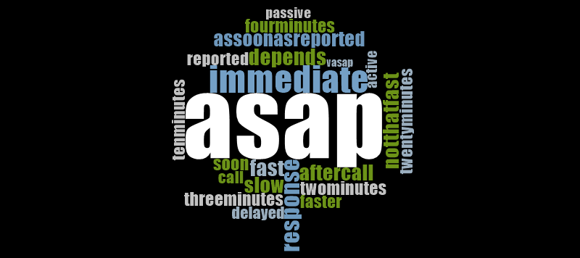

As you can see in the figure above, the most common response of the residents with regards to time of response of their barangay officials is ASAP ( as soon as possible). It implies that most of the barangay in Quezon City response as soon as they received a report. As per the places that answered slow, delayed and such, factors like vehicle, communication and road traffic affect greatly in their time response. To sum it all up, there might be some delays but according to the residents, local officials response as soon as they can.

**Figure 14.B Barangay Responsiveness on Facilities and Equipment Capabilities**



With regards to facilities and equipment, this word cloud illustrates that spraying machines, spray and chemicals are the common equipment being used by the officials. This type of equipment are essential in maintaining a safe community free from mosquito borne diseases. In addition to this, participants said that they lack machines to occupy the rest of the baranggay that is why for some instances some places did not experience this kind of safety measures.

**Figure 14.A Views of the Residents on Barangay Responsiveness on Facilities and Equipment Capabilities**



Figure 14.A indicates that most common respond of the residents with regards to facilities and equipments are protective gears. As per some that have been interviewed, they can clearly see staffs spraying without proper gears that’s why they want it to be addressed. As per the others, sprays and chemicals are the equipment they lack because of some places that does not regularly experience these kind of activities.

**Figure 15.B Barangay Responsiveness on Communitaion Reliability**



Based on the answers gathered from barangay officials that can clearly be seen in this word cloud. According to them, they are accessible to every person in the area through their public number and social media that are known to public. With the help of this, they can easily and immediately respond in every situation.

**Figure 15.A Views of the Residents on Barangay Responsiveness on Communitaion Reliability**



As you can see in the word cloud above, the best and easiest way that the residents can access to the barangay officials is through social media and public numbers. With that being said, residents can easily report and even ask for assistance from their local government. In addition to this, people of a certain place can easily be updated by their barangay officials without the need of conducting a meeting.

**Figure 16.B Barangay Responsiveness on Timely Manner**



Figure 16.B shows that most of the barangay lack doctor and medical staffs. Most of the barangay said that having a single doctor would not be enough for large barangay. As per the others that do not have a permanent health professional in their place, it is hard to respond in situations especially when there is no one who is expert on that field. In addition to this, most of the barangay need staffs for additional man power to occupy all of their residents.

**Figure 16.A Views of the Residents on Barangay Responsiveness on Timely Manner**



As shown in Figure 16.A, the most needed in terms of medical needs are doctors and medical related staffs. Residents from barangays within Quezon City said that there are now permanent doctors in there places for they need someone that will assist them in their medicines and will check them up. In addition to this, vaccines and other basic medicines also lack in some of the barangays that we have visited.

**Figure 17.B Barangay Responsiveness on Timely Manner**



Based on this word cloud shown above, we can infer that programs like the 3 o’clock habbit is very helpful for the residents of a barangay. Barangay officials also conduct enrichment activities to teach their residents especially the children about the precautionary and safety measures to avoid mosquito borne diseases. Programs like clean up drive, fumigation and awareness seminars means a lot to the residents. This can be helpful for them not only to be safe from disease but also prevent current mosquito borne diseases issues from affecting more people.

**Figure 17.A Views of the Residents on Barangay Responsiveness on Timely Manner**



As seen on the word cloud, the most suggestive way to cope up is the 3 o’clock habbit. Based from the answers of the residents, this habbit is very effective to reduce chances of having a mosquito borne disease in the community. Also, seminars that deals about informing residents within the area is an effective way to prevent this kind of diseases.

**DISCUSSION**

Gather data and information from the selected partipants showed the level of the community's knowledge on mosquito-borne diseases. It showed that there are circumstances where the health officials and residents' knowledge do not meet the needs to be correlated to one another. In addition, it reflects that some residents did not knowabout mosquito breeding sites. According to Sandoval (2016), one of mind-boggling issue face by the Philippines is the shortage of Doctorsor health workers in-charged to merely occupied the residents in need. It is stated by the Department of Health (DOH)'s Health Human Resource Development Bureau that there are 3.5 doctors for evey 10,000 population in the country, far beyond the ideal ratio of 1 to 1.5 for every 1,000 population. Tanggol and Chowdhury (2019), stated that 3 out of 10 health care facilities in the Philippines lack access to clean toilets. This simply implied that there is an insufficiency occuring in each barangay when it comes to facilities and equipment. Moreover, ten barangays in City were under strict-monitoring to provide platforms to lessen dengue cases. Fairview, Payatas, Commonwealth, Holy Spirit, Batasan, Pasong Tamo, Bagong Silangan, Bagbag, Tandang Sora and Tatalon are the ten barangays that possess high risk on mosquito-borne diseases, most especially the dengue cases (De Leon, 2019).

**CONCLUSION**

The researchers therefore concluded that the perception of the community about mosquito-borne diseases is somehow lacking due to matters being prioritized. Twenty barangays in Quezon City including Barangay Payatas**,** Commonwealth, Batasan Hills, Holy Spirit, San Agustin, Capri, Bagbag, NagkaisangNayon, East Kamias, Sikatuna Viilage, Quirino 3A, Quirino 2A, San Bartolome, Krus na Ligas, Pinyahan, Quirino 2B, Bagong Silangan, Sauyo, Talipapa and Tandang Sora possess a siginifcat health risk on mosquito-borne diseases as indicated positive on having such mosquito breeding sites. There are different specific type and density level of larvae and pupae that is found in the breeding sites of the community and it depends upon the location of the site. There are vital factors in the community that affects their well-being such as the insufficienct medical demand and communication between the officials and the residents and the range of its responsiveness towards these issues. There are preventive strategies being performed in each barangay, it is commanded by the City Health Department. Unfortunately, due to the rising population, there are times that the needs are not being satisfied but the good thing about it is the commitment of barangay to serve its fellows through providing alternatives and other solutions to be able to meet the public health demand. To sum it all up, there are still factors that needs to be addressed by the city Health Department, for the residents, alloting more self-discipline on their suroundings may reduce to reduce mosquito-borne diseases cases.

**ACKNOWLEDGEMENT**

This Research Study would not be feasible without the heartfelt, everlasting provision and help of theindividuals who were always there at our back throughout the success of this study. We would like to express our deepest appreciation and profound gratefulness to all those who provided us the possibility to complete this study. We are forever indebted to:

First and foremost, to **Almighty GOD** for His present throughout our research journey, for bestowing us guidance and the strength thaw we need to be able to finish the study. Lastly, for His endless love that no one can surpass.

To our beloved, **Ms. Joan B. Callope** that create a huge impact in conducting this study. With her presence, we are capable of gaining new knowledge for she shares her expertise on the study topic.

We want to acknowledge our Dear Prinicipal, **Dr. Proceso T. Lera** and **Mr. Rod Allan De Lara** for the approval of the study and for sharing their valuable thoughts towards the study.

We are thankful for **Ms. Jazi Yvonne M. Minimo** for imparting her knowledge on the topic. **Mr. Jermaine C. Crisostomo** for lending us his laptop to finish our study and for the moral support. **Mr. David Adrian R. Esperida** and **Ms. Felinah Marie Mendoza**who pushed us to continue what we’ve started in spite of many obstacles we encountered.

We are also grateful most especially to our **family**because of their relentless support for doing everything just to meet our needs and to fulfill all these study demand. Also, for their unending love, understanding and help morally, as well as financially.

We would like to appreciate the help and all the efforts that our colleague from Batasan Hills National High School and the scholars from Center for Research and Excellence (CENTREX) Leadership Program that gave us many reasons to continue and face this challenge. People who never failed to support us and always there for us possessing their never-ending help up to the extent of their abilities.

**ARO**

**MJSB**

**REFERENCES/BIBLIOGRAPHY**

CNN Philippines (2019). 1,000 frogs released in Quezon City barangay vs dengue. Retrieved from https://cnnphilippines.com/news/2019/8/25/frogs-mosquitoes-Quezon-City-Old-Balara.html

De Leon, S.G. (2019). 10 QC barangays under strict monitoring, intensified anti-dengue. Retrieved from https://pia.gov.ph/news/articles/1026153

Fonbuena, C. (2019). Hundreds of children die in Philippine dengue epidemic as local action urged. Retrieved from https://www.theguardian.com/global-development/2019/sep/12/hundreds-of-children-die-in-philippine-dengue-epidemic-as-local-action-urged

Geronimo, J.Y. (2014). Where are the health workers?. Retrieved from https://www.rappler.com/nation/50267-health-workforce-crisis

Lavrakas, P.J. (2008). Percentage Frequency Distribution. Retrieved from https://methods.sagepub.com/reference/encyclopedia-of-survey-research-methods/n372.xml

Marchadesch, B. (2019). QC has highest number of dengue cases in Metro Manila –

DOH. Retrieved from https://www.msn.com/en-ph/news/national/qc-has-highest-number-of-dengue-cases-in-metro-manila-—-doh/ar-AAFtuqu

Panela, S. (2019). Oops? QC barangay goofed in releasing cane toads to estero. Retrieved from https://www.rappler.com/science-nature/environment/238768-quezon-city-barangay-goofs-releasing-cane-toads-estero

Tanggol, F. & Chowdhury, Z.(2019). 3 out of 10 health care facilities in the Philippines lack access to clean toilets. Retrieved from https://www.unicef.org/philippines/press-releases/3-out-10-health-care-facilities-philippines-lack-access-clean-toilets

THE METRO COMMUTER (2013). QC Barangay Map for overlay. Retrieved from https://komyutero.blogspot.com/2013/10/qc-barangay-map-for-overlay.html

World Population Review (2020). Quezon City Population 2020. Retrieved from https://worldpopulationreview.com/world-cities/quezon-city-population/

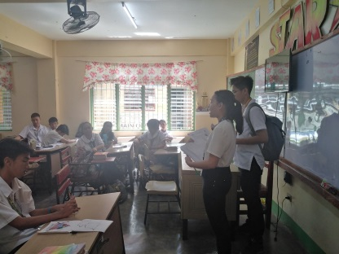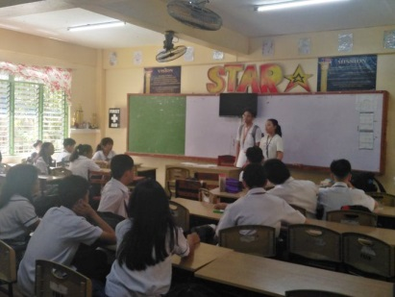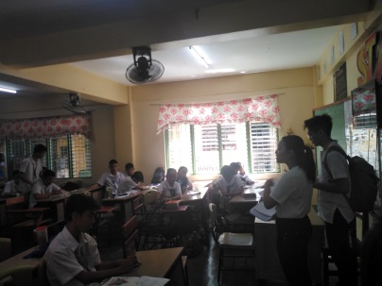**APPENDICES**

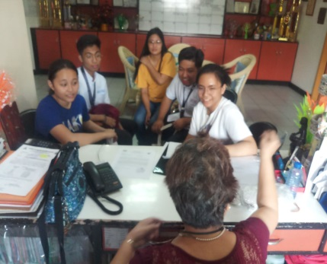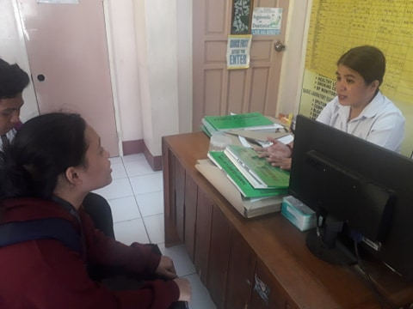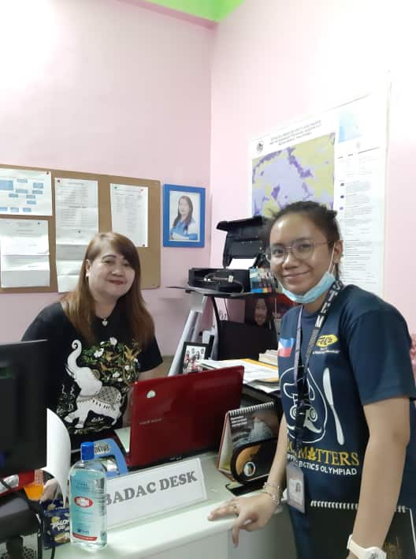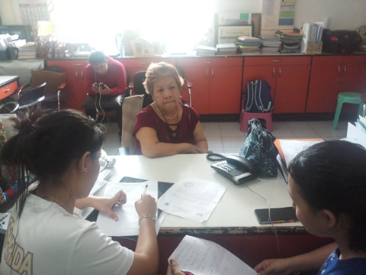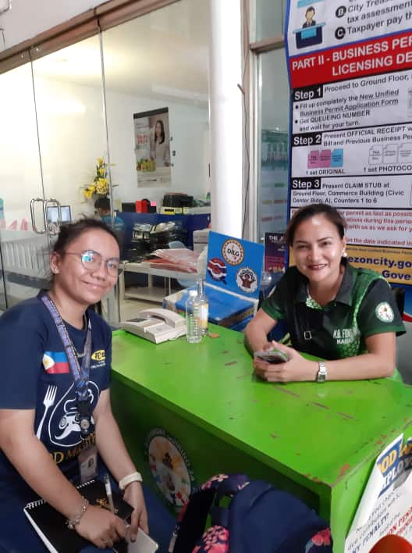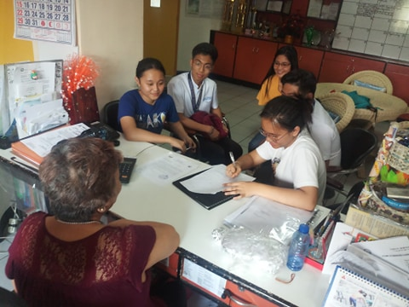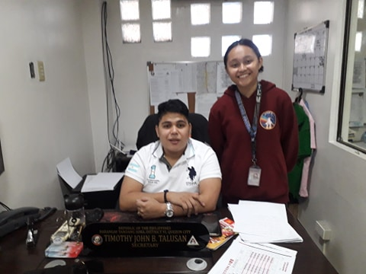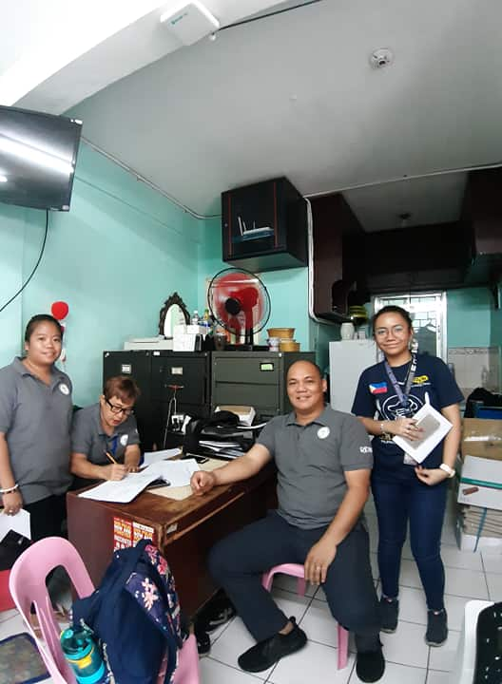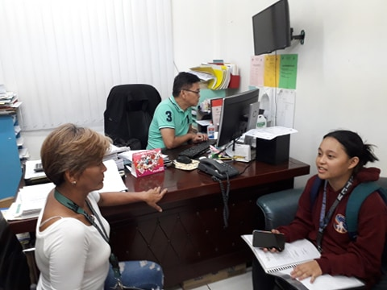

Information Dissemination about Mosquito-borne diseases

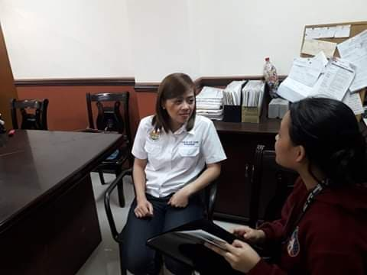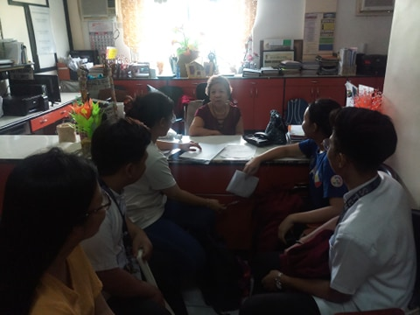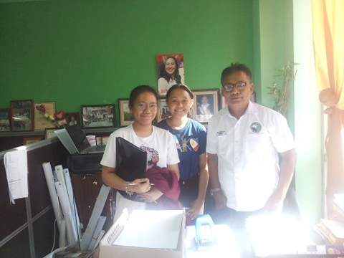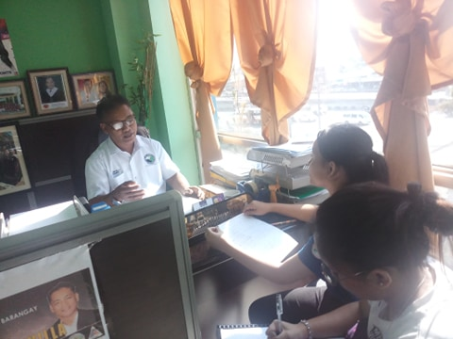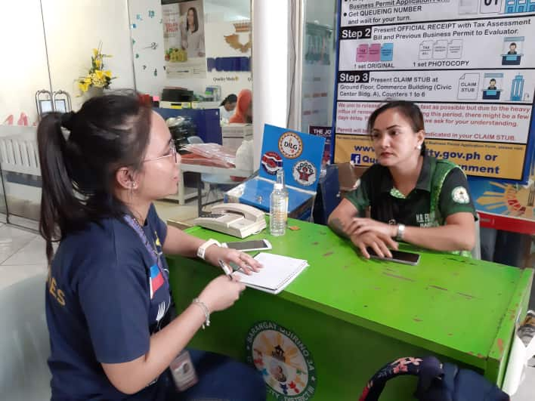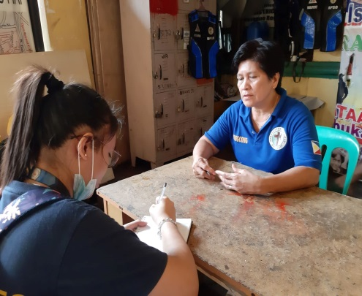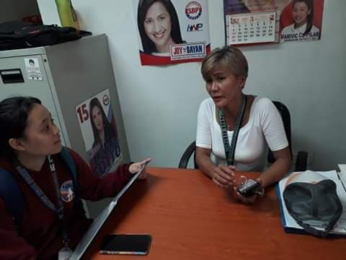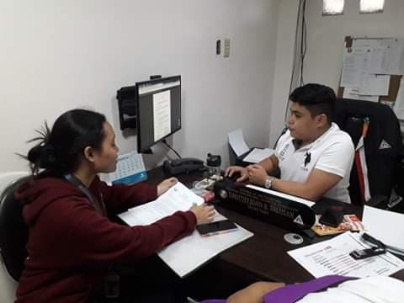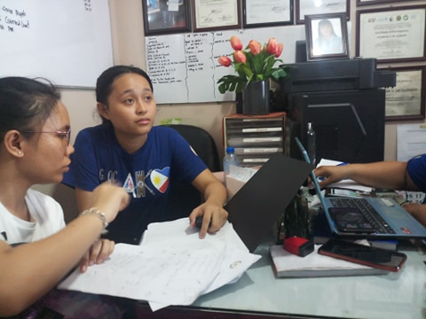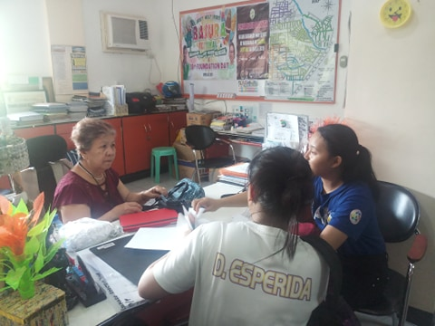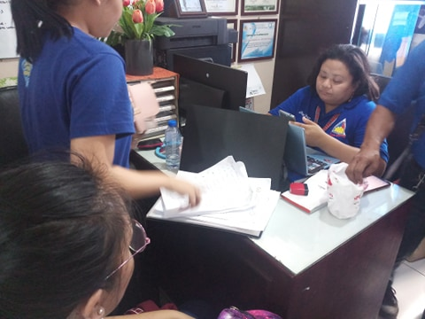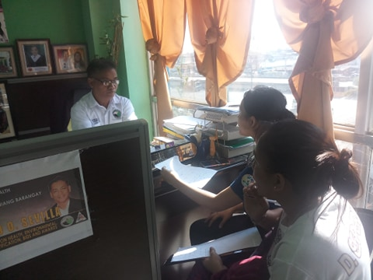

Conducting an interview in 20 barangays of Quezon City, Philippines

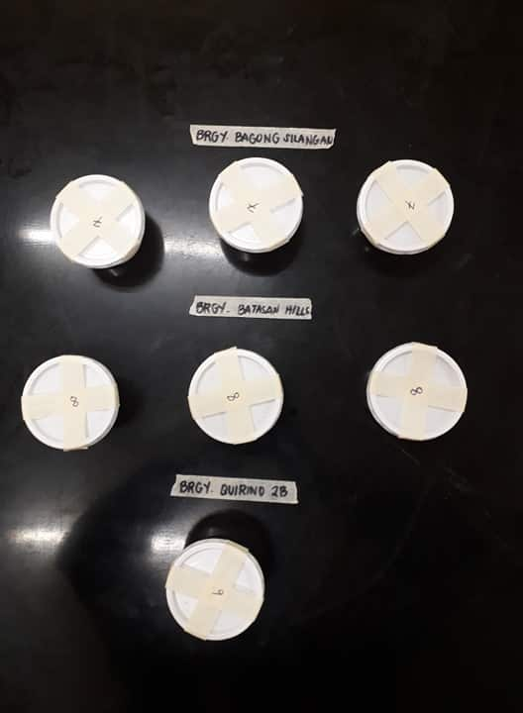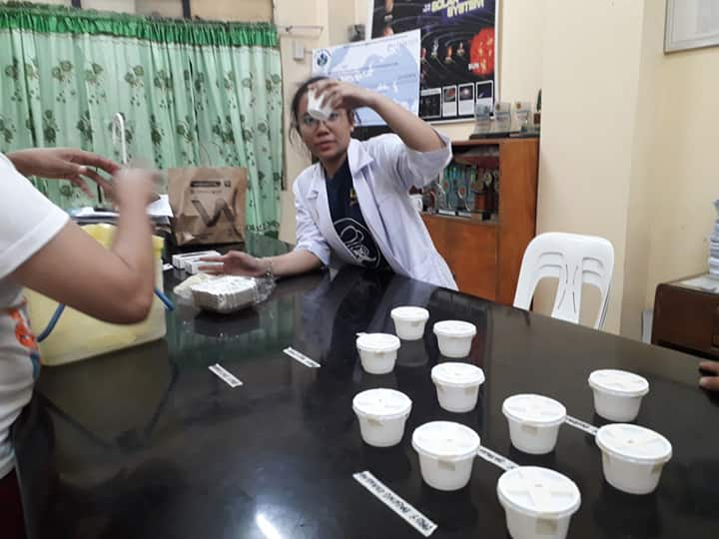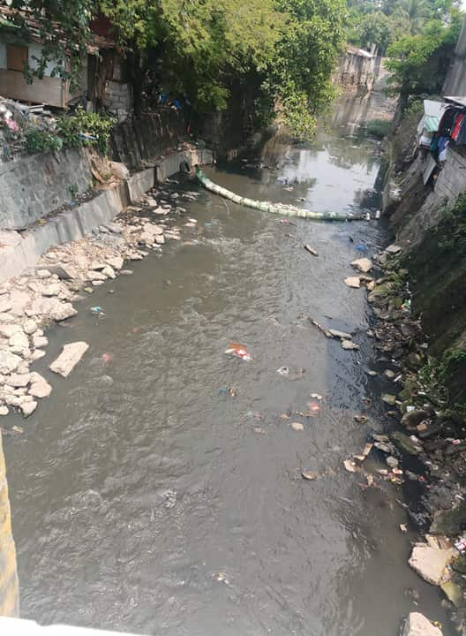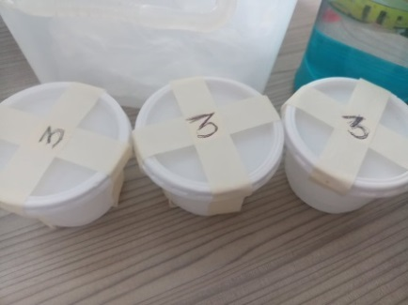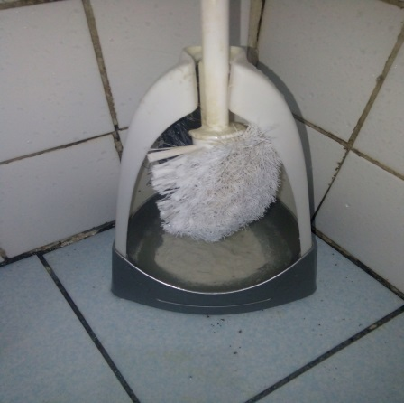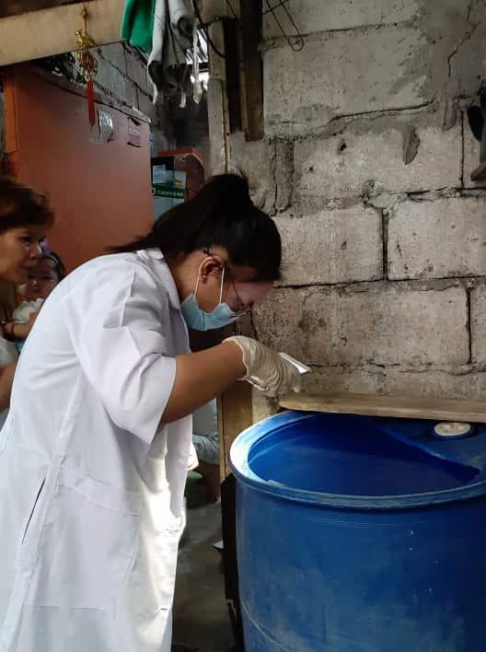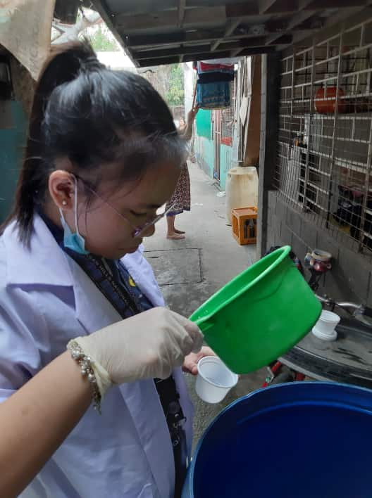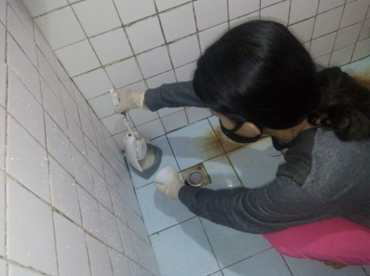

Collecting water sample at breeding areas of mosquito for *Larvae Identification*

Preparation of samples and set-ups for *Larvae Idetification*

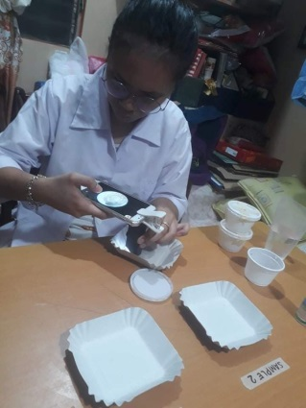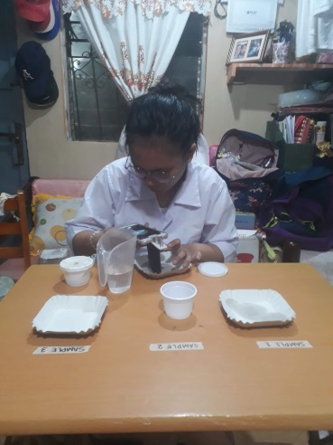

*Larvae Identification*

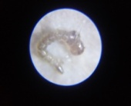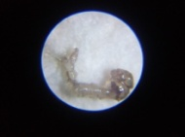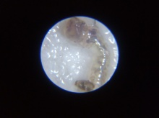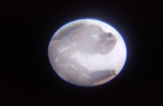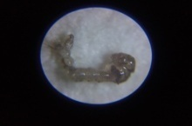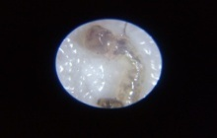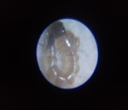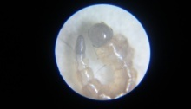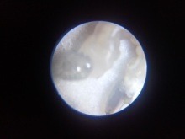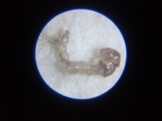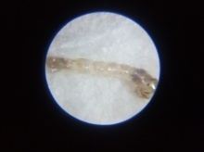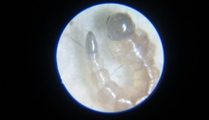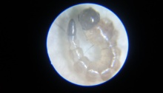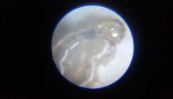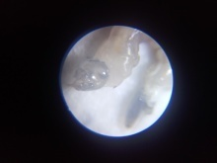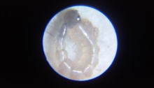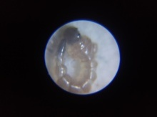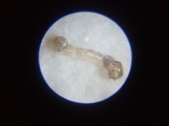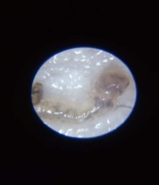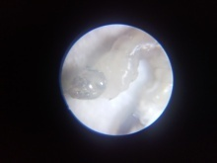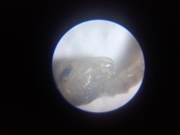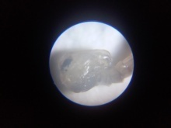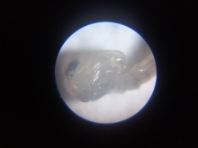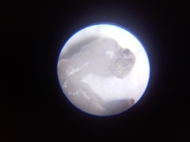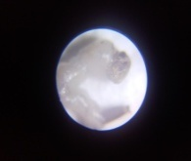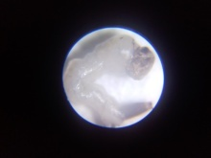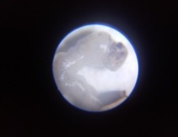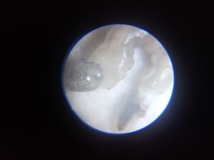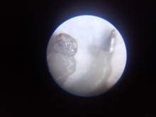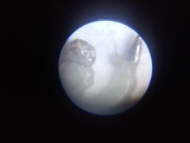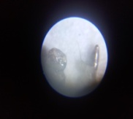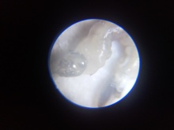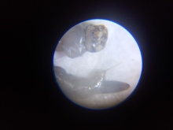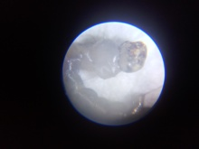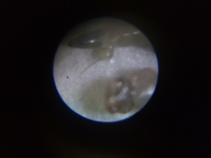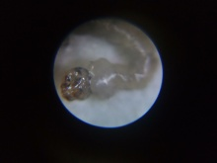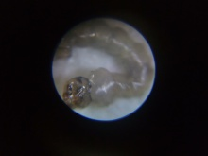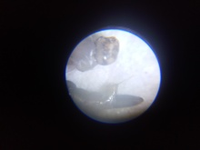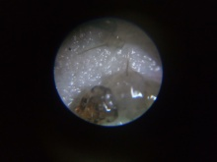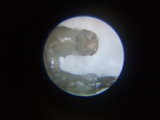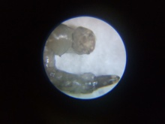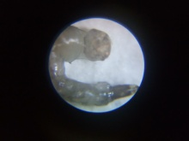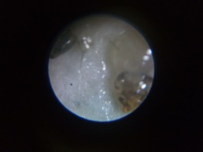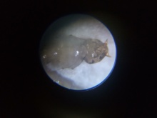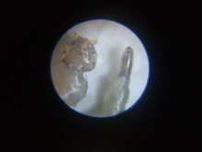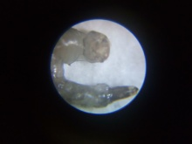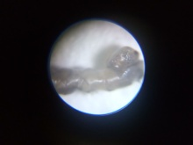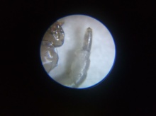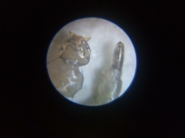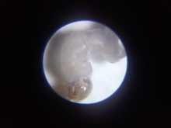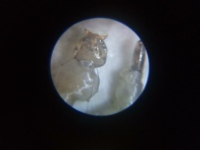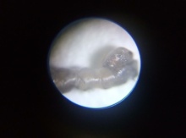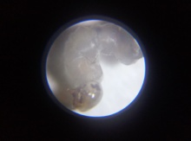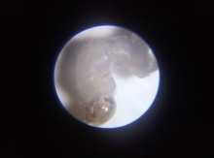

*Larvae Identification*

National Capital Region

Division of City Schools – Quezon City

**BATASAN HILLS NATIONAL HIGH SCHOOL**

IBP Road, Batasan Hills, Quezon City

***Assessment of Community Awareness and Responsiveness on the Health Hazard brought by Mosquito-borne Diseases***

Greetings of Peace!

We are the researchers from Grade 11 STEM Diophantus that are currently conducting a study regarding the community assessment on public health awareness on disease causing mosquitoes. This questionnaire will serve as an instrument for this study to gather the data needed in our research. Therefore, we look forward to your response to the following allegations in each item. Rest assured that the information you share will remain confidential.

Thank you very much and God bless!

***Name (Optional):***

***Address:***

***Sex:***

***Age:***

**Instruction:** Please complete this survey questionnaire form by filling in each item with your corresponding answers. Make sure you read the whole question carefully before you respond. Do not write any identifying marks on this form as participants are meant to be anonymous . All information will remain confidential. Your participation will greatly contribute to our study.

|  |  |  |
| --- | --- | --- |
| **Mosquito-borne diseases** | **Yes** | **No** |
| 1. Are you aware that mosquito-borne diseases such as west nile, dengue, malaria etc. are caused by mosquito bite? |  |  |
| 2. Can mosquito-borne diseases be prevented? |  |  |
| 3. Can mosquito-borne diseases be cured? |  |  |
| 4. Can mosquito-borne diseases cause death? |  |  |

**Source of information regarding mosquito-borne diseases**

TV/newspaper Health Care Worker/Provider

Friends/neighbor Government hospital/health facility

Others:

**Knowledge about mosquito-borne diseases symptoms**

Fever with shivering Fever with sweats

Loss of appetite Body pains

Others:

**Do you know when mosquito bites?**

Day time 06 2.02 At night 128 43.2 Any time 156 52.7

Others:

**Do you know resting places of mosquitoes?**

Dark places inside rooms On edges of ponds/stagnant water

Cattle sheds Dirty areas

Others:

**How often do you perform each of the following?**

|  |  |  |  |  |  |
| --- | --- | --- | --- | --- | --- |
| **Prevention of Mosquito Breeding** | **Always**  **(5)** | **Often**  **(4)** | **Sometimes**  **(3)** | **Seldom**  **(2)** | **Never**  **(1)** |
| 1. Cover all water used for storing in or outside the house. |  |  |  |  |  |
| 2. Change stored water in flower vases, drip tray or pails |  |  |  |  |  |
| 3. Put abate or chemical in water storage containers. |  |  |  |  |  |
| 4. Examine for mosquito larvae in containers for storing water. |  |  |  |  |  |
| 5. Clear out debris that may block water flow in drain or root gutters. |  |  |  |  |  |
| 6. Proper disposal of items that can collecyt water rain. |  |  |  |  |  |
| **Cue to Action** | **Always**  **(5)** | **Often**  **(4)** | **Sometimes**  **(3)** | **Seldom**  **(2)** | **Never**  **(1)** |
| 1. Proper disposal of household garbage. |  |  |  |  |  |
| 2. Clean up house surrounding area |  |  |  |  |  |
| 3. Take mosquito preventive measures before going on a long holiday |  |  |  |  |  |
| **Prevention on Mosquito Bites** | **Always**  **(5)** | **Often**  **(4)** | **Sometimes**  **(3)** | **Seldom**  **(2)** | **Never**  **(1)** |
| 1. Sleep in mosquito net or have mosquito screens on windows |  |  |  |  |  |
| 2. Use mosquito coil, electrical mosquito mat, liquid vaporizer |  |  |  |  |  |
| 4. Use mosquito repellent on body. |  |  |  |  |  |
| 5. Avoid dark areas in the home where there is no light and no wind |  |  |  |  |  |

**What are the preventive strategies you can suggest to be implemented by the barangay officials or the city health departmentwith regards to reducing the threat of lethal mosquitoes?**

National Capital Region

Division of City Schools – Quezon City

**BATASAN HILLS NATIONAL HIGH SCHOOL**

IBP Road, Batasan Hills, Quezon City

***Assessment of Community Awareness and Responsiveness on the Health Hazard brought by Mosquito-borne Diseases***

**Informed Consent Form**

|  |  |
| --- | --- |
| **Title of the Research Study** | **Underpinning Public Health Susceptibility in Selected Asian Countries against Mosquito-borne Diseases** |
| Principal Investigators | Aerish R. Ocomen & Mae Joy S. Bernales  Grade 11-STEM Diophantus  Senior High School  Batasan Hills National High School |
| **Research Coach** | Ms. Joan B. Callope  **IVSS Coordinator**  Batasan Hills National High School |

You are being asked to take part in a research study. Your participation is voluntary which means you can choose whether or not to participate. If you decide not to participate there will be no penalty or negative consequence. Before you make a decision you will need to know the purpose of the study, the possible risks and benefits of being in the study and what you will have to do if you decide to participate. The researcher is going to talk with you about the study and give you this document to read.

If you do not understand what you are reading, do not sign it. Please ask the researcher to explain anything you do not understand, including any language contained in this form. If you decide to participate, you will be asked to sign this form and a copy will be given to you. Keep this form as it has the contact information and answers to questions about the study. If you like, this form can be read to you.

**What is the purpose of the study?**

The purpose of the study is to create *Community Assessments* with regards to the susceptibility and awareness of Public Health against Mosquito-borne diseases. This serves as a tool to determine, develop and build up a better understanding about the status of communities’ awareness.

This study is being conducted for an entry to IVSS - International Virtual Science Symposium 2020 which is a way for primary undergraduate students from all GLOBE Countries to showcase their research and hard work.

**Why am I being asked to participate in the study?**

You are being asked to join this study because the topics related to the activities were Public Health Susceptibility which is you might be the ones who were sampled randomly or because of the commitance of related situations.

**What will I be asked to do?**

*Interviews*

You will be asked a series of questions relevant to the study. Interviews will also be made through a one-by-one manner.

*Questionnaires*

You will be asked to answer survey questionnaires that focus on your responses and impressions toward/s your awareness on implementations of city health programs to fight against lethal mosquitoes.

**How long will I be in the study?**

The study will take place over a period of 30-45 minutes.

**Where will the study take place?**

The study will just take place in your respective recidencies.

**Are there any risks and what are they?**

There are no foreseeable risks to you from using the materials and getting engage in the activities.

**What are the benefits of participating in the study?**

Your participation could help us understand the effectiveness and evaluate the current and existing implementation with regards to the school’s student discipline interventions

**What happens if I do not choose to join the research study? Can I stop or withdraw from the study even after it has started?**

You may choose to join the study or you may choose not to join the study. Your participation is voluntary. There is no penalty if you choose not to join the research study. You will not lose any benefits or advantages that you are now receiving or will receive in the future.

You can stop your participation in the research study or withdraw your data at any time even after it has started. There is no penalty or loss of benefits if you decide to do so.

**How will confidentiality be maintained and my privacy protected? Who will have access to my data?**

The information you provide is confidential. Your full name will not appear on any of the questionnaires, and information identifying you will not appear in any report or publication of this research. Only the principal investigators will know the identity associated with the information collected for this study, and they will not reveal it to anyone else.

There are instances in which information concerning your interview/data would have to be released without your consent. This would happen if you pose a serious danger to yourself or others, or if there is evidence to suggest child abuse or neglect.

**Will I have to pay for anything?**

No payment or any monetary amount will be collected neither compensation will be gained in this study

**Who can I call for questions about the study or if I’m concerned about my rights as a research participant?**

If you have questions or concerns regarding the study and your participation in it, contact the Principal Investigators listed on page 1 of this form. If a member of the research team cannot be reached or you want to talk to someone other than those working on the study, you may contact the Research Coach for any question, concern, or complaint about your rights as a research subject.

When you sign this document, you are agreeing to take part in this research study. If you have any questions or there is something you do not understand, please ask. You will receive a copy of this consent document.

Signature of Participant: _____________________________________

Printed Name of Participant: __________________________________

Date: ____________________________________________________