Gminne Gimnazjum im. Jana Pawła II w Wieliszewie
ul. Kościelna 27
05-135 Wieliszew

The GLOBE Program

Student research project
Virtual scientific conference 2017

The Narew River and its role for the local community

As a part of GLOBE Project, we carry out the research in the field in hydrology. This project contains the description of one of our research places – Narew river. We carry out the research of water temperature and pH level.
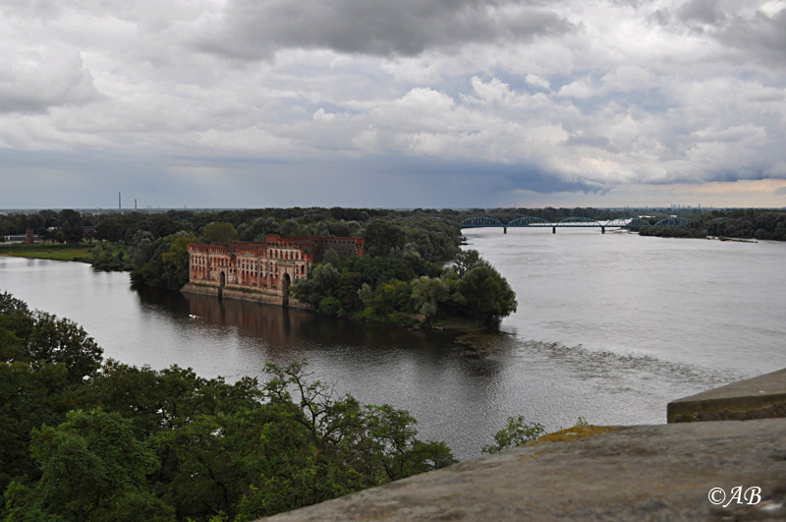
This picture aren’t took by our team. We „borrow” it from internet.

F
rom June 2016 to October 2016 the students of the Local Gymnasium in Wieliszew: Jakub Jaworski, Filip Piotrowski, Joanna Grzymkowska and Wiktoria Donarska together with their teacher Irena Rybak made the following hydrological measurements.
- Narew - Nowy Dwór Mazowiecki - mouth of the Narew River to the Vistula (toponymic name: Modlin Stary)
Narew is the right tributary of the Vistula and a river flowing through north-eastern Poland. It has a length of 484 km, and its greatest part is in Poland and the rest in Belarus. It represents the Polish-Belarusian border on the section of 1 km. In Poland, it splits into Siemianowski Lake, then falls into Lake Zegrzyński, where it connects with Bug. In Nowy Dwór Mazowiecki Narew goes to the Vistula River. Narew is a river forming swamps, mud and bogs. It is a lowland river that flows through a network of branched and connecting troughs. It is protected in Narew National Park.
The measurement site is located in the Mazovian lowland, in the city of Nowy Dwór Mazowiecki, in the Nowy Dwór district. Above the measuring site there is the railway bridge of the railway line No. 9. Slightly developed coastline. Visible few pollutants in the form of rubbish. The place is eagerly attended by fishermen. Nearby (about 200 meters) there is a wild bathing area. The shore is rocky, steep. In the immediate vicinity of the river the sandy shore. The bottom is visible within a radius of 10 meters. Water turbid, greenish.
Geographic coordinates: 52°26'19.1"N 20°41'52.4"E
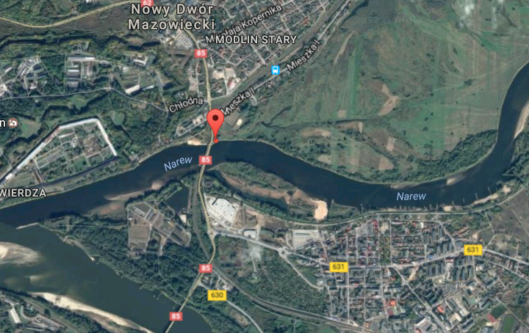

In the vicinity of the measurement site, the already mentioned railway bridge, parallel to the railway bridge, is located. This bridge is very important to the local community. There is noticeable traffic. On the north of the station there is "Modlin". In the south-east direction there are multi-family housing estates and detached houses. To the west, the Modlin Fortress is located along with the multi-family housing estate and service development surrounding it. To the north, about 4 km away there is the civilian Mazovian Airport Warsaw-Modlin, formerly a military port. Diagonal in the north-west direction there are the ruins of the granary. Buildings remember the times of the Swedish Flood.
No. | Date | Temperature | pH | Remarks
1 | 06.07.2016 h.13¹⁵ | 22,3 ºC | 9 | water turbid, greenish
2 | 15.07.2016  h. 14⁰⁰ | 21,1ºC | 8 | water greenish
3 | 25.07.2016  h. 13⁴⁵ | 25,1 ºC | 7 | water turbid

The recipient of the Narew River is the river Vistula - the longest river in Poland. It is here that Narew falls to the Vistula. Height above sea level is 67 m.
As part of the GLOBE program conducted in the Community’s Gymnasium of John Paul II in Wieliszew, we performed water tests in terms of temperature, pH, color and transparency.
Description of the shore: steep, rocky shore; Weakly developed coastline; The shore is moderately polluted, the place frequented by fishermen; Near the wild beach, above the place of measurements there is a railway bridge of railway line No. 9 (Warsaw East railway station – Gdańsk main railway station)
Conclusions: The presence of major transport routes as well as the functions of the local community have a great impact on the pollution and the occurrence of fauna and flora, which in the fields are virtually nonexistent. Historical conditions (such as the proximity of the Modlin Fortress) have undoubtedly also had, and they have a permanent influence on the present state of nature.
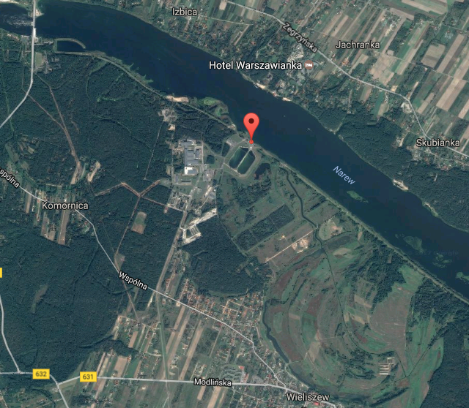
Others reasearchs:
Geographic coordinates:
- 52°28'36.8"N 20°57'35.0"E („In front of the dam”)

- 52°29'00.6"N 20°56'26.7"E (“Behind the dam”)
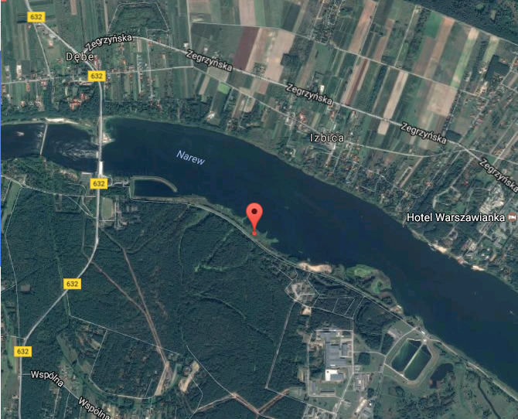
Results of reasearch:
- 24 VI In front of the dam: 29,9ºC 29,3ºC 28,9ºC Behind the dam 29,5ºC 28,8ºC 29,1ºC
- 9 VIII In front of the dam: 25,8ºC 25,9ºC 25,3ºC Behind the dam: 26,4ºC 25,3ºC 25,9ºC
- 26 VIII In front of the dam: 24,8ºC 24,2ºC 24,5ºC Behind the dam: 25,1ºC 24,9ºC 25,2ºC
- 2 IX 22ºC Behind and in the front of the dam |
pH always was 7

- Wisła Nowy Dwór Mazowiecki (Nowy Dwór Maz. Rezerwat przyrody Kępy Kazuńskie)
Geographic coordinaties: 52°25'40.8"N 20°41'34.8"E
The Vistula (Lat. Vistula) it is the longest river of Poland flowing into the Baltic Sea and sailing into the Gdańsk Bay. Length 1047 has a km. He has his source in the Sheep's Mountain in Silesian Beskid. For walking the Vistula escaping her was accepted with ditch between Świbno and Mikoszewo.
In the place of examinations a shoreline added variety is visible. The area is here wet. These are river heads, and along with their presence steep and rocky edge. The area is occasionally much frequented by fishermen, because area is unpolluted.

No. | Date | Temperature | pH | Remarks
1 | 06.07.2016 h. 15⁰⁰ | 23 ºC | 6 | Water transparent
2 | 15.07.2016 h. 14³⁰ | 22,1 ºC | 7 | Water transparent
3 | 25.07.2016 h. 15⁰⁰ | 25,6 ºC | 7 | water lightly muddy, greenish

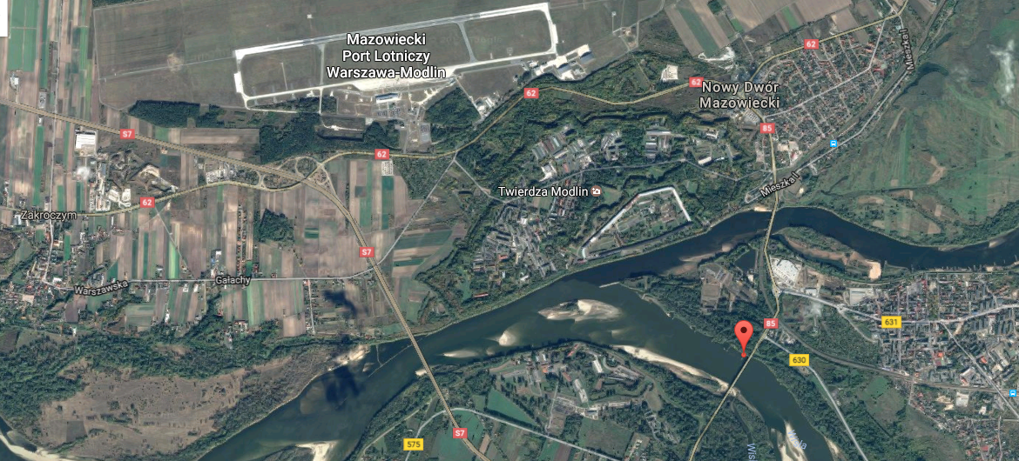
Incidental measurements:
- 52°26'42.0"N 20°44'45.6"E
Wkra goes to Narew

Description of the edge: area very hard to reach, boggy. Sandy-rocky edge, deficiency in any pollutants
No. | Date | Temperature | pH | Remarks
1 | 06.07.2016 h.13⁰⁰ | 22,3ºC | 7 | Water transparent

Thank you for your attention

