The Correlation Between Weather and Energy Consumption

Juniper Bunch
Homeschool
Kansas City, Missouri

3/26/19

ABSTRACT

Our house is small in comparison with other family homes. It is about 1000 square feet. We try to keep our energy usage low, but like many Americans, we are used to a certain level of comfort and convenience. We have decided to investigate how our family uses energy and if the outdoor temperatures influences how we consume energy. To keep things simple, we have decided to focus our research on our electric energy. This is how we cool our home in the summer and how we charge all of our electronic devices and light our house.

We are studying our electric bills and the average monthly temperature from the years 2017 and 2018. We will then create charts to help analyze and compare the data. We think this data can help inform us about our energy consumption as a family and be a guide to reduce our usage in the future. I am creating a blog that will document the steps that a typical American family can take to lower their electrical usage.

- Research Question and Hypothesis
This study was carried out to better understand how much the environment, specifically the weather, affects our energy use. Does our usage go up, when temperature goes up, and go down when temperature goes down? Is there a correlation between the two?

Understanding when we use most of our electricity, and what the temperatures are, will help us find ways to cut down on our usage. We have studied our electricity bills, which have information about the temperature and our energy use throughout February 2017 to February 2019. We have put this information on a chart that shows our usage (in kilowatts) and the temperature (in Fahrenheit).

Kansas City, Missouri (weatherspark.com)
Average High and Low Temperatures
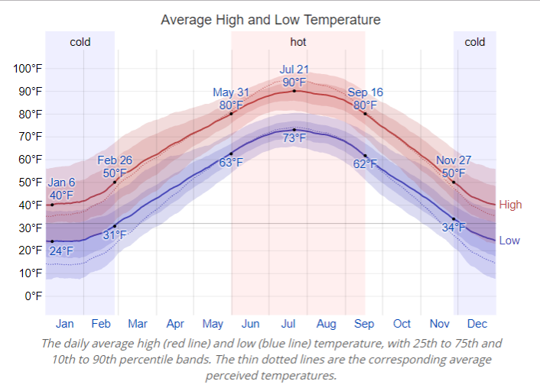
Figure 1. Kansas City, Missouri Temperatures

Kansas City, Missouri Geographic Location

Country: United States
State: Missouri
County: Jackson
City: Kansas City
Zip Code: 64116
Longitude: -94.7306
Latitude: 39.2972
Altitude - Elevation: 1004 feet

Our hypothesis is that when the temperatures go up, our electricity usage will increase, and when the temperatures go down, our electricity usage will go down as well. Our usage would go up in the summertime due to the fact that we use electricity for our air conditioning, and go down in colder weather because our heating is powered by natural gas.

As we look at our energy usage, we realize that we have many things that use electricity in our home. We have our devices, like two kindles, two laptops, four cell phones and two ipods. My brother Isaac has fish tanks, lights that we forget to turn off along with plant lights, and our appliances. I am also concerned about climate change and how weather conditions will affect the energy usage within our home. In an article titled Climate Impacts on Energy the EPA states, “Our production and use of energy (most of which comes from fossil fuels) also contributes to climate change, [2] accounting for more than 84% of U.S. greenhouse gas emissions.”[1]

In this same article the the U.S. Climate Change Science Program states, “In a warmer climate, Americans will use more electricity for air conditioning and less natural gas, oil, and wood for heating. If the nation's climate warms by 1.8°F, the demand for energy used for cooling is expected to increase by about 5-20%, while the demand for energy used for heating is expected to decrease by about 3-15%.” [3]

2. Materials and Research Methods
Our observations were made by use of the computer, from which we accessed our electricity bills. The KCPL (Kansas City Power & Light) website has a yearly or monthly viewing option, where you can click on a month, and see every day in that month, or you can see the monthly usage in a year. On the website, we can see a whole year, and looked at the average temperature and the electricity usage. From there we constructed our own charts, comparing and contrasting the data. We have looked at many websites, that offer suggestions on how to limit our energy usage.

3. Data Summary and Analysis - Results

Electric Usage and Average Temperatures for 2017
According to Kansas City Power & Light
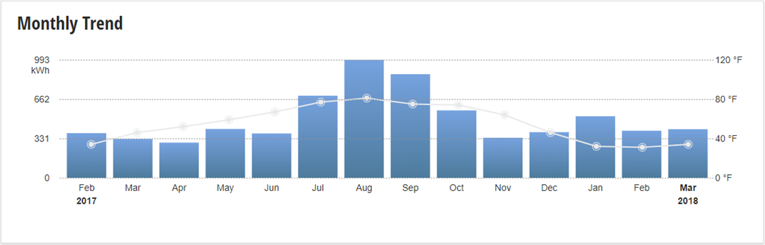
Figure 2.

Comparison Chart of Electric Usage and Average Temperatures
Month Avg. Temp kWh Energy Temp. + Usage
February | 34 | 376 | --
March | 46 | 326 | ↑↓
April | 52 | 296 | ↑↓
May | 59 | 411 | ↑↑
June | 67 | 373 | ↑↓
July | 77 | 691 | ↑↑
August | 81 | 992 | ↑↑
September | 75 | 872 | ↓↓
October | 74 | 567 | ↓↓
November | 64 | 337 | ↓↓
December | 46 | 384 | ↓↑
January | 32 | 518 | ↓↑
February | 31 | 396 | ↓↓
Figure 3.

Each month when we pay our bills the electric company provides a graph that shows the average temperature and our electric usage. In the graph from 2017 we noticed a severe spike in our usage in the summertime. Specifically in July, August and September. August was the hottest month, averaging 81 degrees Fahrenheit, which is the same average as the August of 2018. The hottest day recorded for that month was 88 F. according to Weather Underground [4]. Our usage for the month of August was 992 kWh, which is the highest temperature and energy usage of 2017.
The coldest month, according to this chart, figure 3, is February, but as we have no data for January, we cannot be sure it is the coldest month of the year. The average for February was 34 degrees Fahrenheit, but the coldest day was 12 F. on February 9th [4]. The kWh hours for that month was 376. The lowest usage of that year, was however, April, with a usage of 296 kilowatt hours.
In figure 3, the chart lists temperatures, kWh hours used, and compares the rise and fall of temperatures and usage by month. If the temperature goes up, there is an arrow that points upward, conversely if the temperature goes down, the arrow will point down. The kilowatt hours are represented the same way with arrows. An analysis of these arrows show that six months had arrows pointed in the same direction, meaning for six months the temperature and kilowatt usage either went up or down at the same time.

Electric Usage and Average Temperatures for 2018
According to Kansas City Power & Light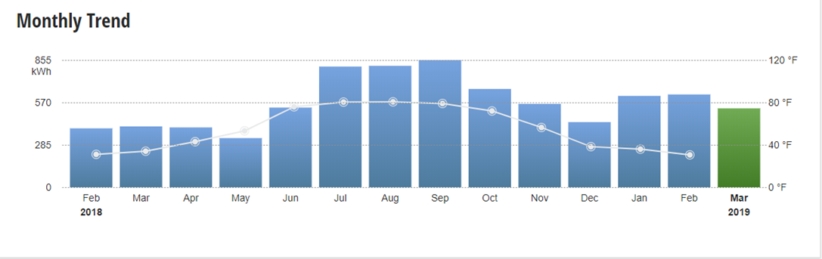
Figure 4.

Comparison Chart of Electric Usage and Average Temperatures
Month Avg. Temp kWh Energy Temp. + Usage
February | 31 | 396 | --
March | 34 | 449 | ↑↑
April | 43 | 402 | ↑↓
May | 53 | 330 | ↑↓
June | 76 | 535 | ↑↑
July | 80 | 811 | ↑↑
August | 81 | 816 | ↑↑
September | 79 | 854 | ↓↑
October | 72 | 661 | ↓↓
November | 56 | 560 | ↓↓
December | 38 | 438 | ↓↓
January | 38 | 614 | ↓↑
February | 31 | 624 | ↓↑
Figure 5.

In the graph from 2018, figure 4, we noticed the hottest months were August and September. The hottest day being August 5th, with a temperature of 97 degrees Fahrenheit [4]. The average temperature of August was 81 F. with an average usage of 816 kWh. September had an average of 854 kilowatt hours, with an average temperature of 79 F. For the month of September, the hottest temperature was 94 F, which happened on September 18th and 19th.

The month with the lowest average temperature in 2018 was February. The lowest recorded temperature was -2 degrees Fahrenheit on February 5th [4]. The usage in kilowatt hours was 396. The lowest average kWh hours recorded for 2018 was in May, with an average of 330. The average temperature for that month was 53 F.

Figure 5 compared the average temperatures and usage and found seven months in which the arrows corresponded. This means that the temperature either went up or down at the same time. In both years, 2017 and 2018, the months of July, August, October, and November have arrows that correspond.

3. Conclusion
According to our hypothesis, our energy usage would go up as the temperatures go up and down as the temperatures go down. That was right, and wrong. When we compared months we found that our theory was true about 50% of the time. For example, there were some irregularities like January in both years. The temperatures remained low but our usage took a huge spike!
We were shocked by this! And realized that our usage in these months must have comprised of things other than heating our home….like cell phone and computer charging and fish tank heaters and lights. This is what is encouraging me to work on lowering my families dependence on electricity and lessen our carbon footprint.

Here are my blog entries on how a typical american family can lower their usage:
Day 1!
Our family bought a solar charger and it arrived yesterday. It was $46.99 from amazon. It’s a Hiluckey 25000mAh solar charger that charges phones and tablets. It has four solar panels, so it charges faster, and a light for nighttime or emergencies. It is waterproof, shockproof and dust-proof (apparently) so it’s good for outdoor activities as well. You can hang it from your backpack to charge while you are hiking or biking. The only downside is that once you've used all of the battery, it takes 20 hours in the sun to recharge.
Today we’re going to buy:
1. Timer plug-ins
2. Timers (for fish tanks)
3. Energy-saving power strip

Day 2!
The second step we took was to unplug our television. T.V.s take A LOT of energy, because even when it’s off it’s sucking energy so when you turn it on, you don’t have to wait. Another thing that takes a lot of energy is the wifi! Did you know you actually can, and should unplug your wifi? It consumes a lot of energy if it is on all the time.
On a different note, our solar charger has stopped working. It has charged for hours and is still sucking power from devices. I hope we just need to charge it more and it’ll work.

Day 3!
The third step we took was to set a time for when we start turning off the lights before bedtime. We set an alarm to go off when we should start turning off all electronics. We also bought a timer plugin, where you can plug it in and set the time, so it doesn’t waste any more electricity when it’s fully charged. It has a 30 minute setting, a 3 hour setting and a 6 hour setting. You can use it for stuff from power tools to computers, basically anything.
Another thing we have been doing for a while is using energy efficient bulbs, like LEDs. These can save you a lot of energy and don’t cost too much.

FIGURES

Fig. 1 Weather Spark Average Weather in Kansas City:
(https://weatherspark.com/y/9847/Average-Weather-in-Kansas-City-Missouri-United-States-Year-Round)

Fig. 2 Electric Usage and Average Temperatures for 2017 According to Kansas City Power & Light

Fig. 3 Comparison Chart of Electric Usage and Average Temperatures (2017)

Fig. 4 Electric Usage and Average Temperatures for 2018 According to Kansas City Power & Light

Fig. 5 Comparison Chart of Electric Usage and Average Temperatures (2018)

REFERENCES
[1] EPA (2017). Climate Impacts on Energy

[2] EPA (2015). Inventory of U.S. Greenhouse Gas Emissions and Sinks: 1990-2013. U.S. Environmental Protection Agency (EPA).

[3] CCSP (2008). Effects of Climate Change on Energy Production and Use in the United States. A Report by the U.S. Climate Change Science Program and the subcommittee on Global change Research. Wilbanks, T.J., V. Bhatt, D.E. Bilello, S.R. Bull, J.Ekmann, W.C. Horak, Y.J. Huang, M.D. Levine, M.J. Sale, D.K. Schmalzer, and M.J. Scott. Department of Energy, Office of Biological & Environmental Research, Washington, DC, USA.

[4] weatherunderground.com/history/monthly/us/mo/kansas-city/KMCI/date/2017-2

