The name of work : characteristic of groundwater of analysis at Wu Yuan area

group：Earth and Planetary Science

keyword : groundwater、temperature、discharge

author：Yang Shi Kai、Lin Yan Ting、Yu Hsin Hsuan

mentor teacher：Ching Yi Su

February , 2018

Abstract
What the main research directions of us is map the distribution of groundwater wells containing natural gas in Wuyuan with the longitude and latitude in Google Earth. Next, we researched the difference between the groundwater in Wuyuan and the water in normal drainages. The conclusions of research results indicated that the pH and the water temperature of groundwater are higher than that of normal drainages.
Motivation of Research

Fire and water spring is not common in Taiwan, but it has easy access in some area at Wu Yuan. In the beginning, an idiom“oil and water don ' t get along”came across our mind ,if that is a case than the fire and water definitely could not get along . However, when we went to Wu Yuan to survey the quality of water last year, we found out that ground well here contains gas which can be dissolved in the water. The residents effectively use escaping gas, which is a great help to their life. We were curious about this phenomenon; therefore, we want to further study on the relation between the water quality of underground well and gas in Wu Yuan.

Purpose and Background
1.To find out the distribution out of the groundwater wells which contain natural gas at Wu Yuan area.
2.To analyze the difference between groundwater and water channels.

Tools and Materials
1.pH Meter(pH7 buffer solutions)
2.Thermo-Hygrometer
3.Beaker (50 ml)
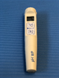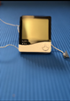
pH Meter Thermo-Hygrometer Beaker (50 ml)
Introduction of research area
< Wu Yuan village >
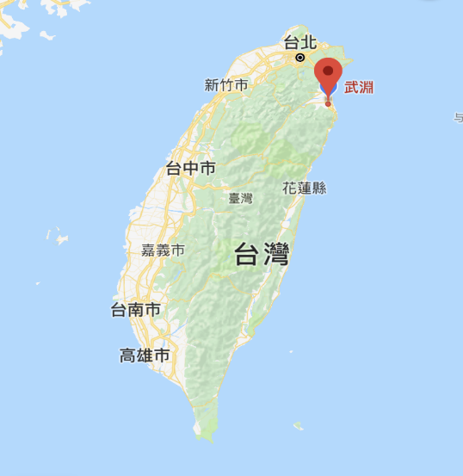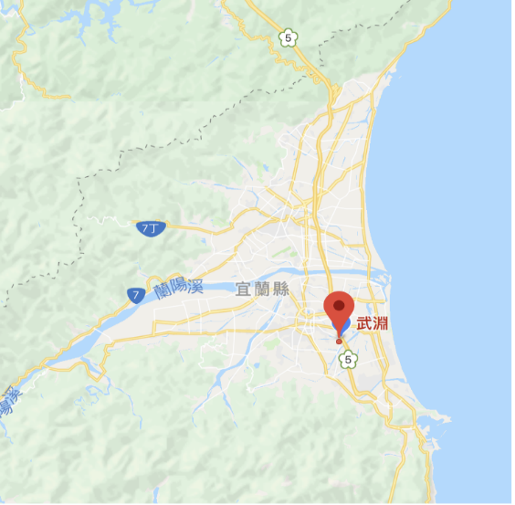
the location of Wu Yuan in Taiwan the location of Wu Yuan in Yilan

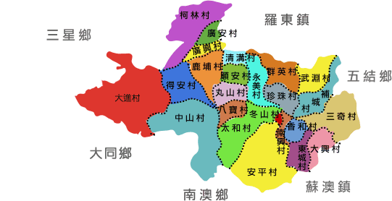
the administrative Region of Dongshan Township

Wuyuan is located at southeast of Yilan, it faces Wujie Township on the east, and Qunying Village on the west. It roughly lies in northeast of Dongshan Township.

The Water Quality of Wuyuan:
There is a great quantity of natural gas flows with natural fountain. The record of using the natural gas has been kept since 1922. The residents collect the natural gas by metal pails and then they use tubes to convey the gas. With the gift from Mother Nature, the locals save a little expense of fuel. In the meantime, they developed some special cultures, such as urn chicken and clothes dryer rooms.
In these years, the government started to use the special resource of Wuyuan and built a tourist attraction “fire and water spring” under the high speed rail. It not only draws tourists well but also makes people pay attention to the natural resource of Wuyuan.

Procedures
1.Investigate the distribution of dissolved gas in water in Wuyuan.
(1).Inspect the locations of groundwater wells in Wuyuan.
(2).Mark the longitude and latitude of the wells by Google Map
2..Analyze the difference between the wells (A site and B site) and the water channel (C site).
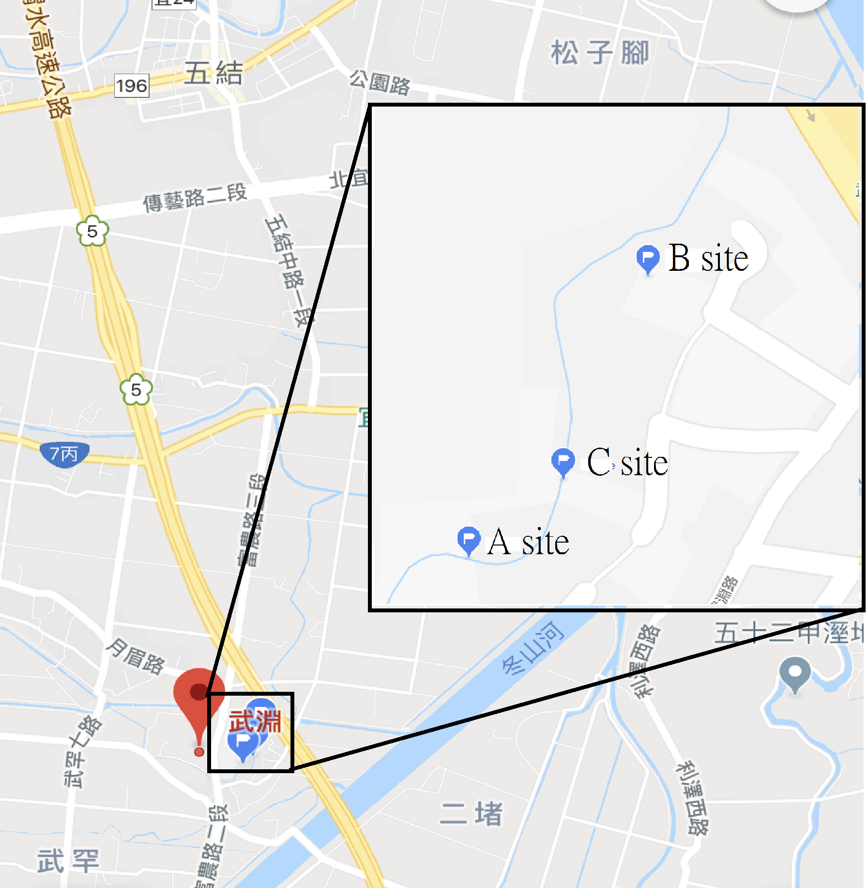
the located of distribution of A.B.C site

Table of the latitude and longitude and the relative direction of A and B and C
site | Locate | Latitude | Longitude
A | Site A is one hundred meter to the south east of the main entrance of Wu Yuan elementary school | 24.6609230 | 121.7988600
B | Site B is about one hundred and sixty meter to the east north east of Wu Yuan elementary school | 24.6617310 | 121.7994500
C | Site C is an water channel, which is located about one hundred and twenty meter to the east south east of Wu Yuan elementary school. | 24.6611610 | 121.7991890

Generally , our study areas are in three site (see figure 10). Site A and site B are the underground well with nature gas . Site A is one hundred meter to the south east of the main entrance of Wu Yuan elementary school. Site B is about one hundred and sixty meter to the east north east of Wu Yuan elementary school. Site C is an water channel, which is located about one hundred and twenty meter to the east south east of Wu Yuan elementary school.
The underground well in Site A and B site are closer to ordinary drains , compared to others well (see figure 18) , and measuring spot for ordinary drains are in between. Site A is about fifty meters to the south west of site C. Site B is about one hundred and fifty meter to the east north north of site C.

(1)the temperature of water:：
A. use timing measurement of thermometer to measure water temperature of well at 9 a.m. every Sunday
B. use thermometer to measure temperature and moisture at 9 a.m. every Sunday
C. set the timing measurement of thermometer to measure temperature and water temperature of A site and B site
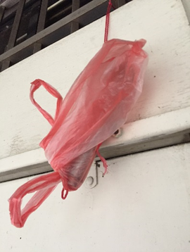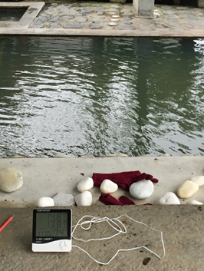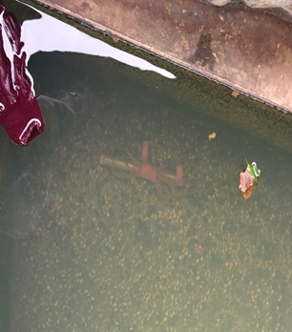
use timing measurement of use thermometer to measure use timing measurement of
thermometer to measure temperature and moisture thermometer to measure water
temperature temperature

(2)、the pH of water :
A. use pH meter to measure the pH of water at 9 a.m. every Sunday

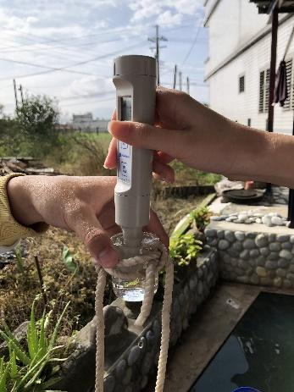 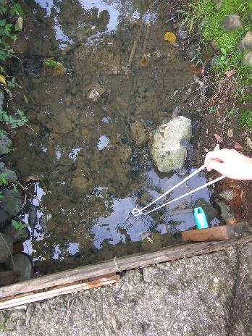 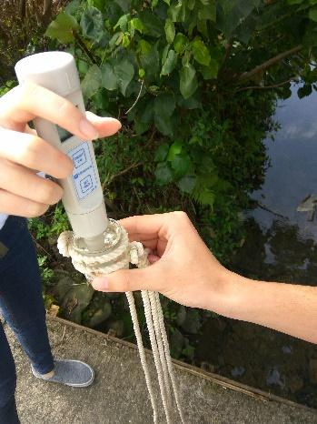use pH meter to measure the method of gaining use pH meter to measure
the pH of well C site sample pH of C site

Research Results
1
Investigation of Wuyuan groundwater well containing natural gas distribution:
Through door-to-door visits and the help of village heads and residents, we found nine groundwater wells containing natural gas. After that, we roughly depicting the wells distribution in Wuyuan, marking its own code name and their latitude and longitude of each well we investigated. Since some of the wells are located in the fields or on the roadside, we cannot find out the address of the well.We will continue to further visit nearby residents, and then conduct extensive surveys on well locations in Wuyuan.
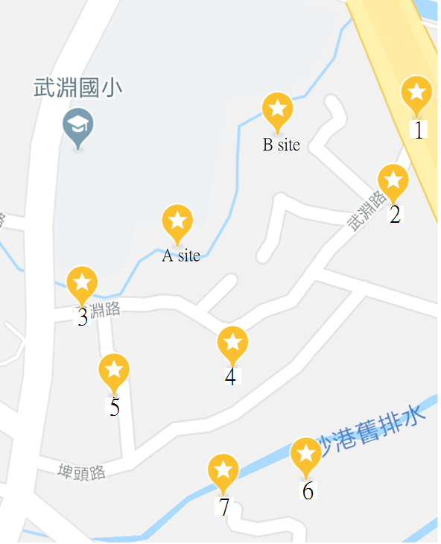

Investigation of Wuyuan groundwater well

Code name | Address | Latitude | Longitude
A | No.19, Wuyuan Rd., Dongshan Township, Yilan County 26966, Taiwan (R.O.C.) | 24.6609230 | 121.7988600
B | No.35, Ln. 91, Wuyuan Rd., Dongshan Township, Yilan County 26966, Taiwan (R.O.C.) | 24.6617310 | 121.7994500
1 | No.103, Wuyuan Rd., Dongshan Township, Yilan County 26966, Taiwan (R.O.C.) | 24.6619704 | 121.8004088
2 | No.97, Wuyuan Rd., Dongshan Township, Yilan County 26966, Taiwan (R.O.C.) | 24.6613890 | 121.8003880
3 | No.2, Wuyuan Rd., Dongshan Township, Yilan County 26966, Taiwan (R.O.C.) | 24.6604380 | 121.7982620
4 | No.50, Wuyuan Rd., Dongshan Township, Yilan County 26966, Taiwan (R.O.C.) | 24.6602049 | 121.7993836
5 | No.23, Pitou Rd., Dongshan Township, Yilan County 26966, Taiwan (R.O.C.) | 24.6599160 | 121.7985790
6 | No.52, Ln. 75, Jiadong Rd., Dongshan Township, Yilan County 26966, Taiwan (R.O.C.) | 24.6595696 | 121.8000166
7 | No.32-1, Ln. 75, Jiadong Rd., Dongshan Township, Yilan County 26966, Taiwan (R.O.C.) | 24.6593860 | 121.7994520
Table of well’s address,latitude and longitude
2
pH comparison:
Take site A of the three measuring points were "Inside the well"(blue), "The outlet of the well" (red), "Outside the pool of the well" (orange).After 4 months of measurement, the pH of the three measuring points at site A are maintained at 7.8 ~ 8.1, while the site C pH data are maintained at 7.3 to 7.6. Between the two can be clearly found that the water in groundwater wells is relatively alkaline in comparison of normal drainage. Last but not least, there is no obvious difference between the pH of the three measuring points at site A which indicates that the pH between them almost the same.
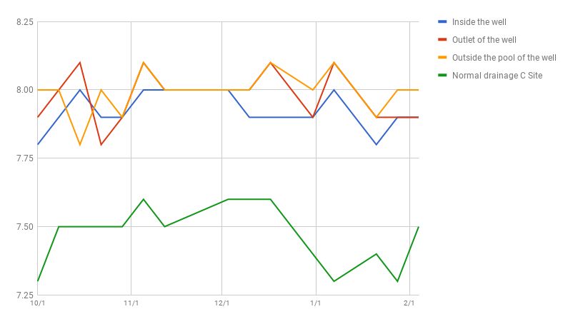
Line chart of pH value
(1)After many measurements, the measuring data of three measuring points of site A are nearly the same.They can be measured as a reference point in the future.
(2) The pH ​​of the three measuring points in the well are all higher than that in the normal drainage, so the former are more alkaline than the latter.

3Temperature:
The trend lines (dotted line in Figure) of the "inside the well"(green),"the outlet of the well"(orange) and"outside the pool of the well"(purple) indicate that the temperature of three measuring points of groundwater well A Site almost maintained constant temperature. The temperature of the water is about 29-30 ° C anytime. In contrast, the water temperature of the "control group" normal drainage C site (yellow) is about 28 ° C decline to about 15 ° C, which temperature relatively lower than that of groundwater wells, and the amount of temperature change is larger. Besides, the trend line of C site and the air temperature trend line (blue) have similar tendencies, and the temperature of the C site is also affected by the air temperature and straight down. It is obvious that the groundwater wells temperature is relatively constant, while the water temperature of the normal drainage is relatively easy to be affected by environment air temperature.
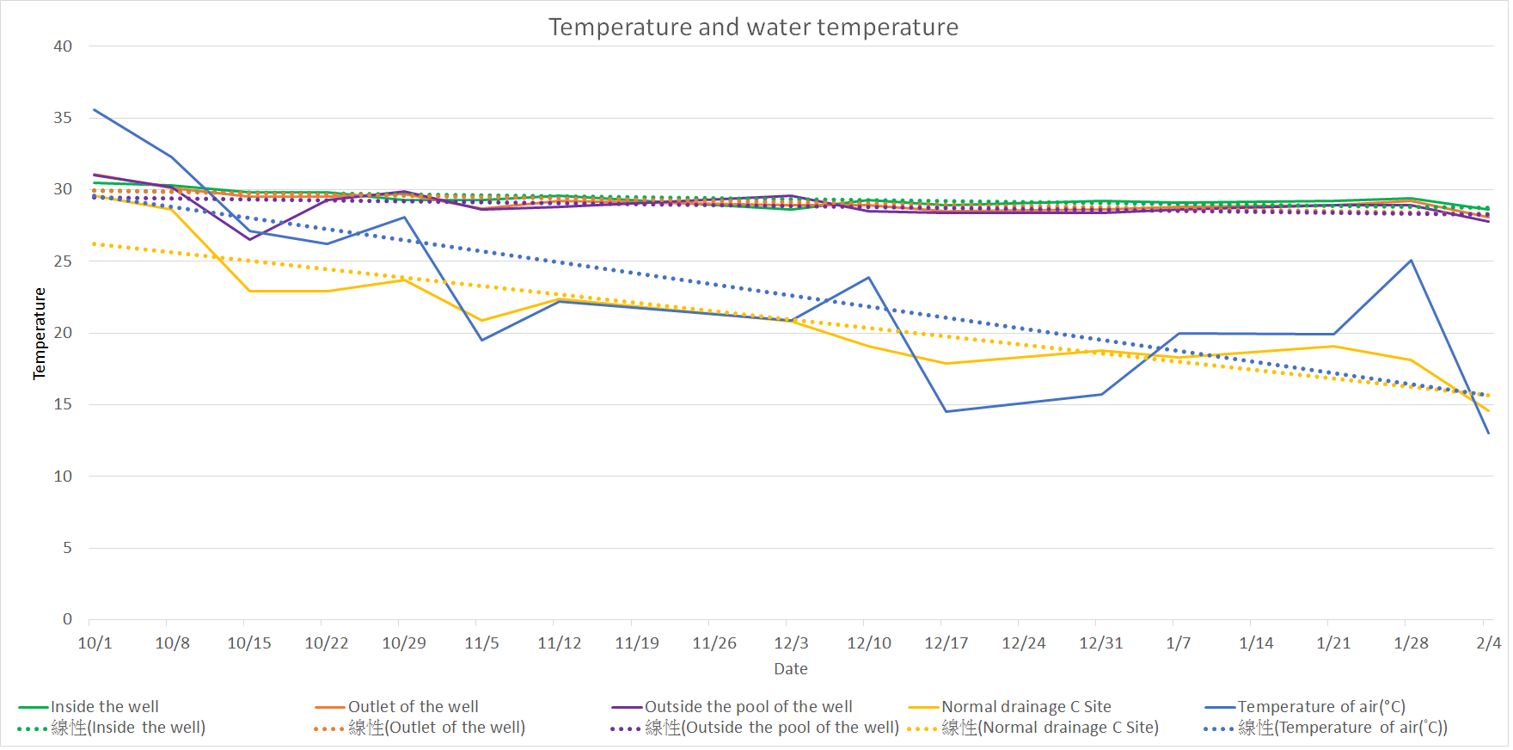
(1) The temperature of groundwater is almost constant and the temperature is higher than the water in normal drainages.
(2) The water temperature tendency of normal drainages is similar to that of the air temperature, and the temperature between the two are nearly the same.

Conclusion
After a few months of visit and investigation, we arranged the distribution of groundwater wells containing natural gas in Wuyuan, and also completed the scatter diagram. In the measurement of pH, we obtained the result of the pH in gruondwater is higher than that in normal drainage. Another aspect, the measurement of temperature, the results indicated that the temperature of groundwater containing natural gas tends to be constant anytime, and it is higher than that in normal drainage. Infering to the result of the tendency diagram, the temperature of normal drainage is affected by the air temperature. Both of them have the same tendency and similar temperature while the temperature in groundwater is hardly affected by air temperature.

