1: Title:
Aerosols
Effect of aerosols in multiple countries.

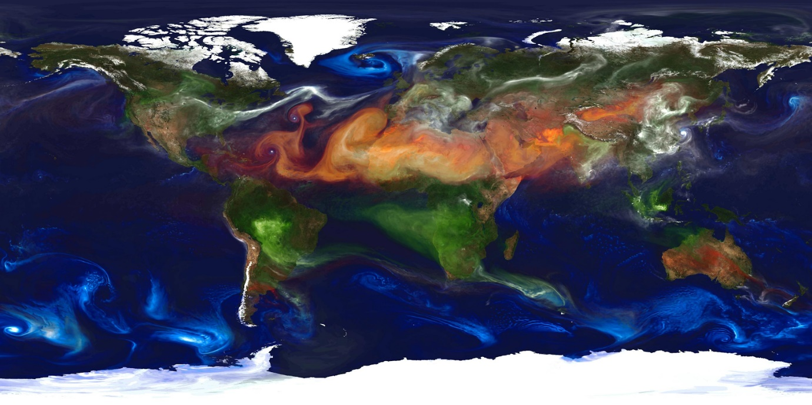
Tayyibe Uguz
Cedric Coronel
Romaissa Rakkani
Ardjumand Bual
Helen Parkhurst ASG

Contents
- Title…………………………………………………………… page 1
- Abstract……………………………………………………… page 3-4
a. Context of research…………………………………………………… page 3
b. Research questions…………………………………………………… page 3
c. Objectives...……………………………………………………………. page 3
d. Results...………………………………………………………………. page 3
e. Conclusion...…………………………………………………………. page 4
f. Recommendations...………………………………………………… page 4
- Research questions……………………………………… page 5
a. Research question...……………………………………………………. page 5
b. Sub-questions...……………………………………………………….... page 5
- Introduction…………………………………………………….. page 6-7
a. Problem...………………………………………………………………... page 6
b. Community relevance...………………………………………………... page 7
- Research methods……………………………………………. Page 8-9
a. Study site...……………………………………………………………… page 8
b. Data collection...………………………………………………………... page 8
c. Print-screen...…………………………………………………………… page 9
- Results…………………………………………………………… page 10-11
a. Tables and graphs...…………………………………………………… page 10-11

- Discussion………………………………………………………. Page 12
a. Interpretation of results...……………………………………………… page 12
b. Possible sources of error...…………………………………………… page 12
c. Comparison with similar studies...…………………………………… page 12
8. Conclusion……………………………………………………….. page13-14
a. Explanation...…………………………………………………………... page 13
b. Follow-on research...………………………………………………….. page 14
9. Bibliography/citations………………………………………….. page 13
a. Materials...……………………………………………………………… page 15
b. GLOBE materials...……………………………………………………. page 15
c. Sources...………………………………………………………………. page 15
10. Badges…………………………………………………………… page 16
a. B1. Collaboration……………………………………………………….. page 16
a. B2. Community impact………………………………………………… page 17

2. Abstract

2A - Context of Research:

In this project, we are going to do research on how much impact the Aerosols Optical Thickness (AOT) in the Netherlands have and how those impacts influence other countries such as The United States and Spain. Using the measurements we did, we can compare this with other countries. If our AOT is higher than the other countries, we can take a look at how their AOT is lower than ours. This gives us the opportunity to think about solutions to lower our AOT.

2B - Research questions:

Our main research question is:
“What is the Aerosol Optical Thickness in the Netherlands, is it high compared to countries like Spain and The United States (Ohio), and what are the explanations for the observed differences?”

To answer the main research question, we must answer these sub-questions:
- What causes high AOT?
- How can we prevent the AOT rising?
- Does climate influence the AOT?

2C - Objectives:

Our objective for this research is getting a clear understanding of our current situation in the Netherlands. To do this, we are going to compare our data with other countries, which is why we take measurements. With the results of this research, we should be able to analyse our current situation, search for a link between the AOT and other variables and maybe even look for a solution.

2D - Results:
(See 6A - Graphs and Tables)
Our results section show differences in AOT, temperature differences and barometric pressure. a Difference in temperature and AOT values is clearly seen between the three countries. Spain has the warmest climate and also the highest average AOT value. The Netherlands have the coldest climate and the lowest average AOT-value.
These results show a very obvious link between temperature and the AOT value.

2E - Conclusion:
While analysing our results, we observed a clear difference in climate between the Netherlands, the USA and Spain. The Netherlands is a relatively cold country and also the country with the lowest AOT-value of the three. According to our results,the cold climate might be a reason for the AOT to be lower in the Netherlands.
2F - Recommendations:
If we continue this project we also have to be strict with the variables. Think about the date and time. They have to be even in order to draw a proper conclusion.
This gives us options for further research. We can co-operate and stay in contact with schools in other countries to be sure the measurements are even. We could also go to other countries ourself so we can measure with our own devices. this will give us the ability to improve our research. Making sure all variables are the same is only possible if you make strict rules about how measurements are done.

3. Research questions

3A - Research question:

Our main research question is:
“Is the Aerosol Optical Thickness high in the Netherlands, compared to countries like Spain and The United States(Ohio), and what is the reason for it?”

3B - Sub-questions:

To answer the main research question, we must answer these sub-questions:
- What causes high AOT?
- How can we prevent the AOT rising?
- Does climate influence the AOT?

4. Introduction
4A - Problem:

Aerosols are small particles in the atmosphere that often cause cooling by reducing incoming sunlight. There are also some aerosols that cause warming up the atmosphere. Aerosols come from volcanoes, dust storms, fires, vegetation, sea spray, burning of fossil fuels and land use. Warming aerosols include black carbon and dark soot. Cooling aerosols include dust, sulfate particles and sea spray.

Aerosols can affect the climate in two ways, through direct or indirect processes.
A direct process is the immediate effect on radiation absorption. If the aerosol is light in color, it generally reflects solar radiation and causes cooling by reducing incoming energy. if the aerosol is dark, it absorbs solar radiation and directly affects the climate through warming. Some aerosols can also encourage the growth of clouds, if they have water-attracting properties.

Aerosols also have a negative effect on humans, the particles that affect our health the most are:
- Nitrous oxide (NO and NO2)
- Sulfur dioxide (SO2)
- Ozone (O3)

These small particles can enter our respiratory system, and can accumulate. Once they enter the alveoli, lung damage can occur.
This lung damage can result in various complaints, including:

- Heart conditions
- Coughing
- Tightness of the chest
- Asthma attack
- Worsened lung
- Irregular heartbeat

Due to the exposure of small particles being constant, most of the time the effects are chronical.

In this project, we are going to do research on how much impact the Aerosols Optical Thickness (AOT) in the Netherlands have and how those impacts influence other countries such as The United States and Spain. Using the measurements we did, we can compare this with other countries. If our AOT is higher than the other countries, we can take a look at how their AOT is lower than ours. This gives us the opportunity to think about solutions to lower our AOT.

4B - Community relevance:

Aerosols mostly affect the climate and agriculture. However aerosols also influence the health of people. Asthma and bronchitis patients for instance. The small particles in the air tend to have more effect on people with asthma and/or bronchitis. A study in germany showed how young campers with moderate to severe asthma were 40 percent more likely to have acute asthma episode on high pollution summer days than on days with average pollution levels. The small particles can pass through your nose and mouth and enter your lungs. This can irritate the airways and lungs and may trigger acute asthma episodes.

In Holland, we have a saying which roughly translates to “Prevention is better than recovery”.
We really agree with this saying and this is one of the reasons for exchanging data with a country in which there’s less pollution. We want to prevent turning the Netherlands into a country with a worse air pollution. This is why we decided to do measurements in the Netherlands, and exchange data with countries like Spain and the United States of America. This way we can gather information about how we’re currently dealing with aerosols and how we should deal with them.

5. Research methods
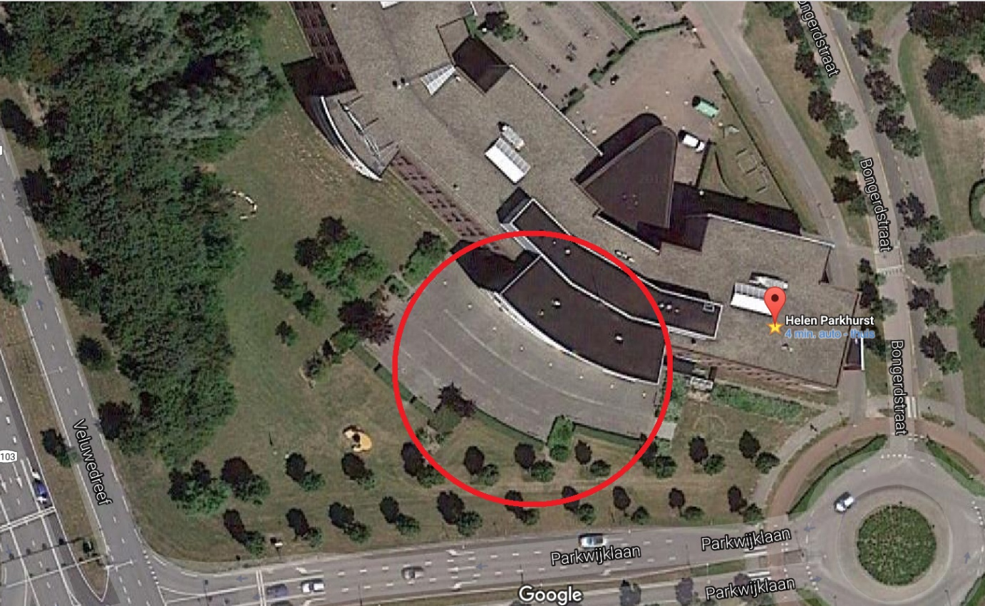
5A - Study-site:

The site where we measure aerosols is the backyard of our school, Helen Parkhurst in Almere. The climate of The Netherlands can be classified as CFB Climate; a warm temperated humid climate with the warmest month lower than 22°C over average and four or more months above 10°C over average.
The weather in the Netherlands at this time of the year is relatively cold, humid and cloudy.
The land in our backyard is covered by mainly grass, but we take measurements on a sidewalk.

5B - Data collection:
To see where our measurements were done, please see section 5A - Study Site.
We followed a strict research plan during our research in which was described in a very detailed way how we were supposed to do the measurements. You can find it at (https://drive.google.com/file/d/0B7eICVmkinfoNUg4ZEg2Q3hvck0/view, page 5, Globe Nederland)
We have measured almost on a daily basis, but decided to only use the dates that match the data of the schools we are comparing our results with. (see section 6A - Graphs and Tables)

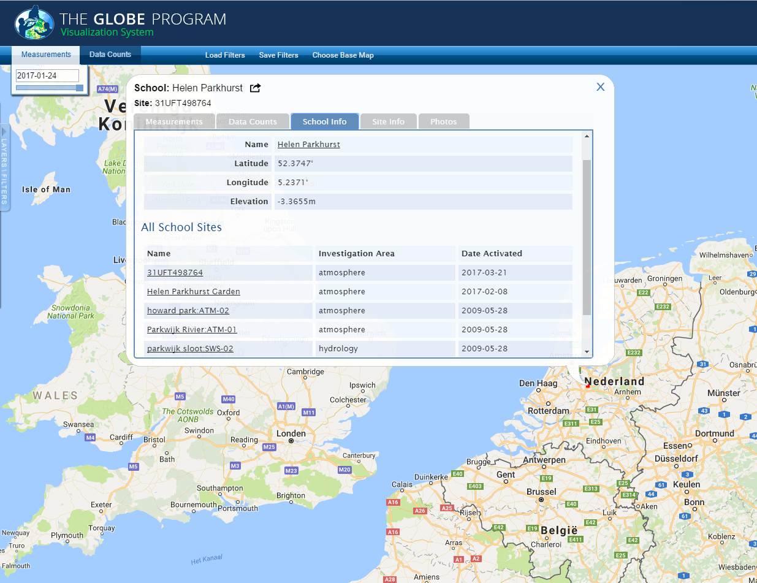
5C - Printscreen:

6. Results
6A - Graphs and Tables
Our measurements (Helen Parkhurst) in Almere, The Netherlands.
Date (dd/mm/yyyy) | Temperature (Celsius) | AOT
26/01/2017 | 0 | 0,738
27/01/2017 | 3 | 0,752
28/01/2017 | 3 | 0,748
02/02/2017 | 2 | 0,398
15/02/2017 | 9 | 0,336
United States (Crestwood High School) in Ohio, the USA:
Date (dd/mm/yyyy) | Temperature (Celsius) | AOT
25/01/2017 | 21 | 0,619
27/01/2017 | 8 | 0,770
03/02/2017 | 23 | 0,683
13/02/2017 | 32 | 0,540
15/02/2017 | 18 | 0,465
Spain (Christelijk Lyceum Veenendaal) in La Palma, Spain:
Date (dd/mm/yyyy) | Temperature (Celsius) | AOT
25/01/2017 | 27 | 0,505
27/01/2017 | 31 | 0,625
28/01/2017 | 17 | 0,635
29/01/2017 | 24 | 0,722
02/02/2017 | 30 | 1,324

Graph illustrating the temperature in degrees Celsius of the three countries we compared data with:
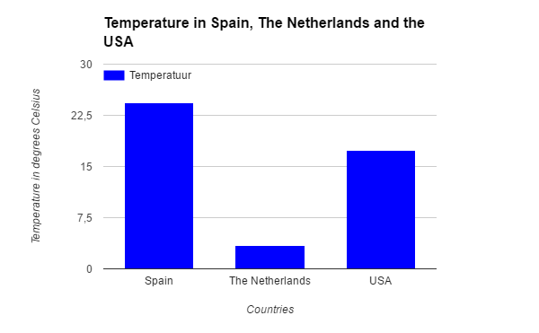

Graph illustrating the AOT of the three countries we compared data with:

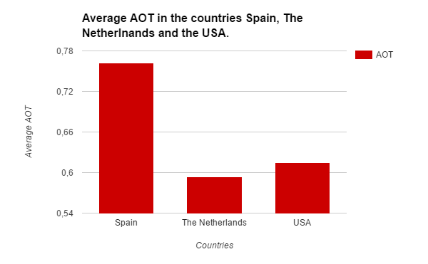

7. Discussion
7A - Interpretation of results
(See 6A - Graphs and Tables)
In our Results-section, you can clearly see a difference in temperature and AOT values between the three countries. Spain has the warmest climate and also the highest average AOT value. The Netherlands have the coldest climate and the lowest average AOT-value.
These results show a very obvious link between temperature and the AOT value.
7B - Possible sources of error
It is very common for a researcher to make mistakes and we also believe we could have made some errors. Luckily enough we haven’t encountered major problems.
One of the mistakes we made could be measurement errors, which are generated by the measurement process itself, and it represents the difference between information generated and the information wanted by the researcher.
There’s also without a doubt a case of random errors that occurred during the research. Random errors being unpredictable and are tiny variations in the measurements over which we had little, if any, control. Luckily they are small differences and don’t impact a large set of data because the data can be averaged. An example of a random error is measuring with a stopwatch which may be slightly shorter or longer than the actual time.

7C - Comparison with similar studies
Searching on the internet and on sites from the government results in finding researches about aerosols but not about comparing them with other countries and the effects on the AOT. We also make a connection between the AOT and industry and climate. A research like this has been done yet.

8. Conclusion
8A - Explanation
To get the results we wanted we had to take measurements every day for at least a month. With these measurements we were able to compare with the other countries. This gave us the option to conclude certain things.
This research should have given us sufficient information to answer the research questions:
- What causes high AOT?
A high AOT is caused by industry, but aerosols also come from volcanoes, dust storms, fires, vegetation, sea spray, burning of fossil fuels and land use.
Our research also shows a clear link between temperature/climate and the AOT.

- How can we prevent the AOT rising?
To decrease the amount of aerosols in the air, we would have to set strict rules and laws about industry. Industry and man-made aerosols seem to be the biggest threat. (see 9B - Sources)
Perhaps there should be a law that encourages the use of more environmentally cars, like electric cars.

- Does climate influence the AOT?
According to a research by Yoram Kaufman from NATURE (see 9B - Sources) and our own research, we are able to conclude that in colder climates, there are usually less aerosols. This is also a reason why the AOT is lower in the Netherlands compared to the USA and Spain (two relatively warm countries).
This is important because this makes it easier for a country like the Netherlands to prevent the AOT from rising.

Now we have to answer our main research question:
“Is the Aerosol Optical Thickness high in the Netherlands, compared to countries like Spain and The United States(state), and what is the reason for it?”
While analysing our results, we observed a clear difference in climate between the Netherlands, the USA and Spain. The Netherlands is a relatively cold country and also the country with the lowest AOT-value of the three. According to our results,the cold climate might be a reason for the AOT to be lower in the Netherlands.

8B - Follow-on research
With all of the measurements we have done, we are able to conclude several things. Compared to the other countries our AOT is pretty low. Our AOT can be influenced by temperature, season or the way the measurements are made. Maybe The United States and Spain have used other devices than we did.
If we continue this project we also have to be strict with the variables. Think about the date and time. They have to be even in order to draw a proper conclusion.
This gives us options for further research. We can co-operate and stay in contact with schools in other countries to be sure the measurements are even. We could also go to other countries ourself so we can measure with our own devices. this will give us the ability to improve our research. Making sure all variables are the same is only possible if you make strict rules about how measurements are done.
The impact our project mentors made is pretty big, there has been several occasions where we as a group weren’t sure how to continue further and that’s when our mentors helped us out and gave us helpful advice. Without project mentors, this research would have been much harder and more complicated.

9. Bibliography/citations
9A - Materials
The materials we used are:
- a pen
- clock (preferably digital)
- a notebook
- GLOBE data sheets
- a sun photometer from the KNMI in The Netherlands
- a Barometer
- a thermometer

9B - Sources
https://data.globe.gov/data#/entry The GLOBE Program, March 31, 2017.
https://www.globe.gov The GLOBE Program, March 31, 2017
https://www.knmi.nl/kennis-en-datacentrum/uitleg/aerosolen KNMI, February 15, 2017
https://www.globe.gov/documents/10157/21723051/161103GLOBE-IVSS+BADGES_6-8.pdf/26104574-8548-40ad-a56c-cedcc29915a3, The GLOBE Program, February 23, 2017
https://en.wikipedia.org/wiki/Aerosol, Wikipedia, February 23, 2017
https://www.nasa.gov/centers/langley/news/factsheets/Aerosols.html, Bob Allen: NASA, August 1, 1996
https://earthobservatory.nasa.gov/Features/Aerosols/, Adam Volland: NASA, November 2, 2010
http://projects.knmi.nl/earlinet/, Arnoud Apituley: KNMI, March 18, 2016
http://www.aafa.org/page/air-pollution-smog-asthma.aspx, October, 2015
10. Badges
10A - Badge B1: Collaboration
We were working in a group of four members. Each of us had a role in this project which supports one another to do this research. All team members are listed below with their contribution to this project. With all of the specialities we have had, we completed each other.
Ardjumand Bual: Ardjumand is the person who did the measurements. He is the one who knew everything about the photometer. The knowledge helped the group understand how we had to take the measurements properly. Another thing he knew a lot about is computer science. This gave us the opportunity to make a website for our sponsors and give them more information.
Cèdric Coronel: Cèdric also knew a lot about computer science. He worked together with Ardjumand. His knowledge helped us for example with entering the data and other things related to computers. Cedric also came with good ideas and proposals for the project. It helped us with making the project clear for ourselves and the people who are going to read it.
Tayyibe Uguz: Tayyibe was responsible for the measurements. During the measurements, she was the one who kept an eye on the time. She also helped with entering the data which is very important to enter properly. She also searched a lot for sponsors and professionals to ask questions about the project. This helped us to make the project clear.

Romaissa Rakkani: Romaissa noted the results during the measurements. She was mostly responsible for entering the data which also means she is responsible for the results and just like the rest of the group she helped with making this research report. She had contact with professionals from the KNMI especially to ask questions and helped to search for sponsors.

10B - Badge B2: Community Impact
Aerosols mostly affect the climate and agriculture. However aerosols also influence the health of people. Asthma and bronchitis patients for instance. The small particles in the air tend to have more effect on people with asthma and/or bronchitis. A study in germany showed how young campers with moderate to severe asthma were 40 percent more likely to have acute asthma episode on high pollution summer days than on days with average pollution levels. (http://www.aafa.org/page/air-pollution-smog-asthma.aspx, October 2015) The small particles can pass through your nose and mouth and enter your lungs. This can irritate the airways and lungs and may trigger acute asthma episodes. Around 50 thousand people die from lung diseases every year.
The effect of aerosols on the health isn’t only a local issue, but affects people around the globe. This is also one of our reasons for the research questions we thought of.

