GLOBAL SPACE CHALLENGE 2020

A RESEARCH PROJECT ABOUT ZIKA FEVER AND MALARIA PREVALENCE IN THE LAKE VICTORIA REGION-KENYA

GROUP NAME:EARTH SCIENTISTS
Members 1.Brian Oweka
2.Andrew Odhiambo
3.Wilfred Matengo
4.Silvester Ojwang
5.Edwin Onyango
6.Timothy
7.Oyoo Moses Nyangwecha
8.Odhiambo Robert Omondi
9.Edwin Onyango
10.Onyango Rolvince Onyango

TEACHER:WASHINGTON ADEDE OTIENO
HOMA BAY HIGH SCHOOL
KENYA
DATE:3RD MARCH 2020

TABLE OF CONTENTS

ABSTRACT………………………………………………………………..3
RESEARCH QUESTIONS
AND HYPOTHESIS………………………………………………………3

INTRODUCTION
AND LITERATURE REVIEW………………………………………….3

RESEARCH NETHODS AND MATERIALS………………………….4

RESULTS………………………………………………………………....5

DISCUSSION/ANALYSIS………………………………………………5
CONCLUSION…………………………………………………………..5

RECOMMENDATIONS………………………………………………..6

BIBLIOGRAPHY………………………………………………………7

ABSTRACT
There is need to understand the spread of Malaria and Zika Fever in the Kenya Lake region and globally.Both the two diseases are spread by mosquito though of different species i.e anopheles and aedes respectively.Practical research on mosquito species were done and outcomes further analysed.

RESEARCH QUESTIONS & HYPOTHESIS
This study was prompted by rising cases of Malaria and Zika fever in the tropical regions thus a need to know reasons for its prevalence.We specifically took a study around the Lake Victoria Region in Kenya,East African zone captured by the grid squares enclosed below.
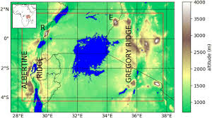
The East African Lake Region
Hypothesis.
1.Malaria is prevalent in the tropical regions due to female anopheles mosquitoes dorminant in the lake region.
2.Zika fever is prevalent in tropical regions with the aedes species present.

INTRODUCTION AND LITERATURE REVIEW
Mosquitoes are dangerous insects that have caused series of problems.Various ailments are associated with them I.e,Malaria,Zika Fever,Elepahantiasis,Chikungunya etc.However of great concern is Zika Fever and Malaria.
In this context and with reference to this research,our concern is Zika fever and malaria.While in the human body,the parasite multiply in the liver and then infect red bloods and if not treated disrupts the blood supply to the vital organs.
Zika fever is a disease caused by aedes species of mosquito.Species refer to the smallest unit of taxonomic classification.Taxonomy is a branch of science concerned with classification of libiong organisms.

RESEARCH METHODS AND MATERIALS
1.We carried out research study on larva identification in different water masses in our surrounding to check on the mosquito species by the machines that were availed to us by the Globe-centre—Kenya in various steps as some evidenced.
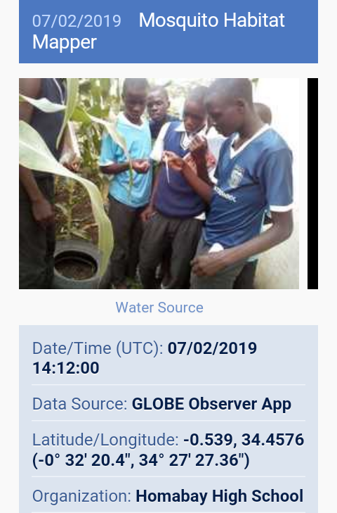
A sample research site
2.We also used data on Malaria and Zika fever collected from Homa Bay County Refferal Hospital and from Regional centre for Mapping of Resources for Development (RCMRD) to further obtain further studies on Malaria prevalence and occurrence in the given regions.
3.Mapping was done by the lens provided by the GLOBE and results obtained submitted in the globe observer app under the guidance of our teacher.
RESULTS
From our findings in the set of mosquito breeding sites,anopheles mosquito genera is dorminant.This is the main reason as to why Malaria cases were very high in these zones from 2017 and took the diminishing trends toward evidenced in the data below.Totality in figures were higher in some periods of the year indicating a strong correlation with the mosquito species and spread of Zika and Malaria fever.
2017 2018
Confirmed Malaria(positive cases) | Malaria in pregancy | Suspected  Malaria | Confirmed Malaria(positive cases) | Malaria in pregancy | Suspected  Malaria
48195 | 623 | 11572 | 44842 | 439 | 19981
35020 | 722 | 12316 | 33645 | 635 | 18551
32924 | 590 | 11232 | 23268 | 334 | 15505
32599 | 488 | 10834 | 14210 | 321 | 9397
52231 | 396 | 18573 | 21340 | 485 | 22088
31620 | 348 | 9168 | 18465 | 355 | 22803
25961 | 300 | 8193 | 19661 | 195 | 23315
17897 | 269 | 6660 | 13179 | 204 | 16302
20148 | 460 | 7961 | 12500 | 308 | 18296
17773 | 297 | 6715 | 10661 | 193 | 17942
30703 | 1977 | 13050 | 7423 | 303 | 14509
25341 | 310 | 13198 | 8948 | 154 | 11055

ANALYSIS
1.The most common species of mosquitoes we found in the Lake Region is the Anopheles type hence a reason behind the higher prevalence and occurrence of Malaria is this region.
2.Traces of zika fever were also experienced hence posing a danger to human life.

CONCLUSIONS
Malaria is a threat in the tropical regions especially in the tropical regions.Adversely,it affects both the young and the old in the society.A control measure must therefore be put in place.

RECOMMENDATIONS
1.The local and national government should carry out campaigms on Malaria prevalence.
2.Temporary mosquito breeding sites should be eliminated totally to bar the development of these species which in turn cause malaria.
3.Based on NDVI,bushy areas should be cleared to do away with the breeding sites which would otherwise be detrimental in terms of the spread of malaria.
4.For stability,proper medicare should be put into place to provide adequate drugs necessary for the treatment of this disease since the parasite responsible for the cause of Malaria has developed resistance to this disease.
5.Continous medical research should be done to take all the necessary precautions to help the citizens minimise effects of spread of malaria.

BIBLIOGRAPHY
1.Adaptation to Malaria:The Interaction of Biology and Culture.Lawrence S.Greene and Maria Enrica Danubio (Eds)1998.

2.Malaria:Parasite Biology,Pathogenesis and Protection –Irwin W.Sherman.

3.Insect Man.The Fight Against Malaria in Africa by Alec Smith.

4.www.google.com

5.An Illustrated History of Malaria by Charles M.Poser and G.W Bruyun.

6.Molecular Immunological Considerations in Malaria Vaccine Development by Michael F.Good and Allan J.Saul.

