مدرسة أسماء بنت عميس للتعليم الأساسي ( 1- 10 )
GLOBE OMAN

WATER RESOURCES IN DHAHIR AL-FAWARIS VILLAGE AND THEIR SUITABILITY FOR DRINKING

PREPARED BY STUDENTS:
1. Ruwaa Abdullah Ali Al-Farsi
2. Timaa Ali Salim Al-Farsi
3. Wi’aam Dawood Al-Farsi

SUPERVISED BY TEACHER:
Hidaya Sulieman Said Al-Farsi

ASMAA BIN OMAIS BASIC SCHOOL (01-10)

March 2017

PAGE No. | CONTENTS
2 | Acknowledgement
3 | abstract
4 | Research Question
4 | Proposition
4 | Research Scope
5 | Research Method
5 | Data
6 | Data Analysis
7 | Results
7 | Recommendations
8 | Conclusion
9 | References
10 | Exhibits

ACKNOWLEDGEMENT
We would like to extend our sincere thanks and appreciations to our school principal for her continuous cooperation and constant support to GLOBE team. Our thanks and appreciations are also extended to our teacher Sumaya Al-Farsi for her role in sample collection and Yangul and Ibri laboratories for their cooperation in providing the necessary information and conducting the water testing and analysis. We are also indebted to our teacher Hidaya Al-Farsi for giving the opportunity us to conduct this research.

Abstract

WATER RESOURCES IN DHAHIR AL-FAWARIS VILLAGE AND THEIR POTABILITY
PREPARED BY STUDENTS:
1. Rawaa Abdullah Ali Al-Farsi
2. Timaa Ali Salim Al-Farsi
3. Wi’aam Dawood Al-Farsi

SUPERVISED BY TEACHER:
Hidaya Sulieman Said Al-Farsi

ASMAA BIN OMAIS BASIC SCHOOL (01-10)

Our research aims to determine the suitability of of water resources available in Dhahir Al-Fawaris Village for drinking and whether they conform to international standards for drinking water as World Health Organization (WHO) sets the guidelines for drinking water that the ideal PH (potential of hydrogen) level of drinking water is between (6.5- 8.5) and acidity should be between (300-1500 ppm) and to be free to bacteria and pathogenic organisms by comparing the village three water resources including the Falaj water, Al-Masarrat reservoir and artisan wells dug by the government using water protocol (acidity and alkalinity). We also sent water samples to Ibri laboratory for the measurement of acidity and bacteriological testing.
It is found that two of the three water resources are perfectly good for drinking [artisan wells – PH = 8.01, acidity = 592 ppt and Al-Masarrat reservoir – PH = 8.10 and acidity = 1101 ppm] while the third water resource [Falaj water its PH = 8.92 and acidity = 398] which is slightly higher than the average acidity level and it contains two types of bacterial pathogens which render it bacteriologically unsuitable for drinking.
Therefore, we advise GLOBE students to cooperate with the Ministry of Health and regional municipalities and water resources to conduct studies in order to investigate the causes of increased acidity in Falaj water and the presence of bacterial pathogens. We also advise the local population to keep their water resources as clean as possible and boil water before drinking it.

RESEARCH PROBLEM
The primacy concern of this research is to find out if the water resources in Dhahir Al-Fawaris Village located in Walayat Ibri, Al-Dhahira Governorate are safe for drinking because after the application of Water Protocol that we notice that the Falaj water, which is one of the main drinking water resources in the village, contain a high acid concentration. We also noticed the formation of salt crystals on the school water coolers faucets and clearly accelerated corrosion on them noting that these dispensers are fed from Al-Masarrat water reservoir. Based on the above observations, we decided to conduct a study to examine all water resources in the village – Falaj water, Al-Masarrat water reservoir and government artisan well and determine if they are suitable for human applications.
RESEARCH QUESTION
To what extent water resources in Dhahir Al-Fawaris Village are suitable for drinking?
Hypothesis
Falaj water is more suitable for drinking due to its low acidic content while the water of Al-Masarrat reservoir is less suitable for drinking because of its excessive acidity.

RESEARCH SCOPE
We conducted the research to investigate the drinking water resources in Dhahir Al-Fawaris Village, Wilayat Ibri – Al-Dhahira Governorate during February 2016.
RESEARCH PLAN
1. To identity the water resources in the village.
2. To visit the sites covered by the research.
3. To collect the data and information from different sources for the research subject.
4. To set a timeframe for the implementation of the research plan.
5. To assign the roles of the research team.
6. To use Water Protocol to determine water properties in each resource (acidity, alkalinity and conductivity).
7. To cooperate with Yangul and Ibri to determine the level of dissolved salts in water and conduct bacteriological testing.
8. To held a comparison between the three water resources in terms of acidity, alkalinity and conductivity.

RESEARCH METHOD
- Materials and Devices:

  - pH measurement device.
  - Acidity and conductivity scale.
  - Turbidity tube.
  - (3) Cups.
  - Bottles for collection of water samples.

- Materials and Devices:

  - Calibration of measurement devices.
  - Taking Samples from Water Resources in the village including:

    - Sample 1 from government well.
    - Sample 2 from Al-Masarrat reservoir.
    - Sample 3 from Falaj water.
    - Measurement of turbidity, acidity, salinity and conductivity.
    - Collection of samples from the three water resources in special bottles and dispatch them to the municipal laboratory for chemical analysis.
DATA
1. After data collection, they are inserted and classified in a table for the purpose of comparison as follows:
Properties | Sample 1 (Well Water) | Sample 2 (Al-Masarrat Reservoir | Sample 3 (Falaj Water)
Temperature ( ̊C) | 23 | 24 | 21
transparency | 120 | 120 | 120
Acidity pH | 8.01 | 8.10 | 8.92
Salinity ppm | 592 | 1101 | 389
Conductivity µc/cm | 830 | 1561 | 540

2. Exhibit 1 – Salinity and bacteriological testing for the three samples at Ibri laboratory
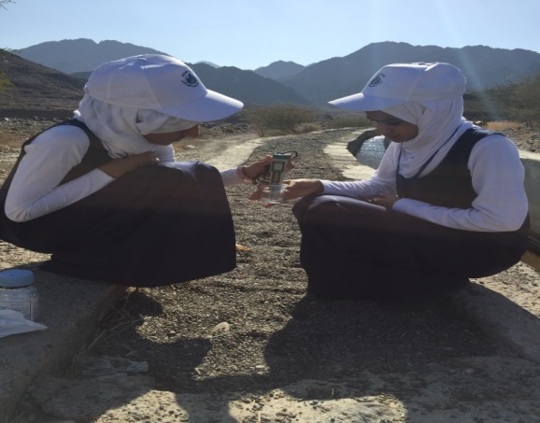
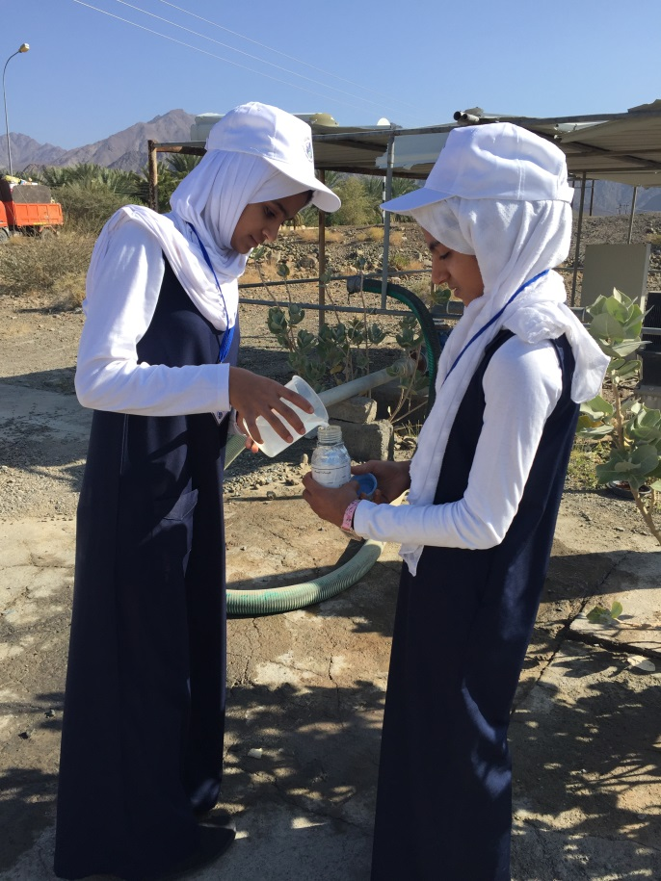

Students conducting measurements
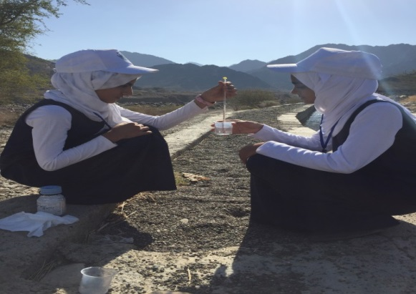

Students collecting water samples

DATA ANALYSIS
Based on the collected data and chemical analysis conducted at specialized labs as well as international standards and World Health Organization (WHO) reports about safe drinking water standards and guidelines, we conclude that:
- The acidity of well water and Al-Masarrat water lies within the permissible internatinal levels (6.5-8.5) while the Falaj water has elevated level of acidity (8.92).
- It noted from the table that the level of salinty in the three water resources is within the permissible international limits for safe drinking water as determined WHO (300-1500 ppm).
- Al-Masarrat reservoir has increased water salinity (1101 ppm) yet it is considered within universally permissible limits.
- Water sample 3 was found to be bacteriologically contaminated with Coliform and E. Coli baceria.

Results
- Considering acidity, Al-Masarrat reservoir and artisan wells water is considered the best among all three water resources because acidity is still within internationally permissible ranges decided by WHO (8.5-6.5) while Fajal water is not suitable for drinking because its acidic content is higher than internationally permissible standards. Since GLOBE team applies Water Protocol to investigate water properties in this resource, we referred to the data we recorded last year about the acidity of Falaj water and it was, in fact, higher than the permissible limit as it recorded (9.2) on 29/04/2015.
- The salinity level of Al-Masarrat reservoir was as high as (1101 ppm) according to the readings of salinity scale used by GLOBE program and as high as (756 ppm) as per the analysis conducted in Ibri laboratory. Despite the increased level of salinity, it is still within internationally permissible limits (300-1500 ppm). However, increased concentration of salt in water will definitely inhibit plant growth and result in the corrosion of water pipes and faucets and that is exactly what we saw when we visited several houses that use Al-Masarrat water reservoir for drinking and irrigation.
- Falaj water is bacteriologically unsafe for drinking because it contains Coliform and E Coli bacteria.
RECOMMENDATINS
1. We draw the attention of the Ministry of Municipalities and Water Resources to the importance of conducting a study to investigate the reasons for the increased acidity of Falaj water compared to other water resources.
2. Educate the village community about the necessity to keep their water resources clean and safe by not dumping dirt and waste materials into the water bodies.
3. Raise public awareness about the need to boil before drinking it to get rid of pathogenic bacteria.
4. We request the Ministry of Health to provide a chemical laboratory in each governorate for water analysis and testing.
5. We advise the community members to install water filtering devices for water purification and to avoid using multistage filtering as it removes much of the salt content from the water. This process may result in liver disorders in the long run.
6. We urge the Ministry of Municipalities and Water Resources in collaboration with the Ministry of Information to launch awareness programs about water conservation and sensitize the local population to conduct regular testing for the quality of drinking water.

CONCLUSION
Praised be to Allah for the strengths and His blessing in completing this research. We will definitely use the findings to conduct a further study in collaboration with the Ministry of Municipalities and Water Resources to investigate the rising acidity of Falaj water deploying the protocols of GLOBE Progam.

REFERECES
1. Shawahin, Khair (2009), Geoscience and Ecology for Amateurs (2nd Edition), Dar Al-Masira.
2. WHO Drinking Water Standards, Faculty of Science (29th April 2012), retrieved on 08/02/2015 from:
https://ar-ar.facebook.com/faculty.science.aleppo/.../396398910383527
3. Miscellaneous educational booklets issued by Ministry of Municipalities and Water Resour Exhibit 2 -

