Date: 25th of March 2017
Subject: The interaction between Air Pollution and Temperature Inversion
- Abstract: We want to find out whether the air pollution and inversion phenomenon is related, so we find some data before a factory explosion event in Taichung and after the explosion from different station, after analyzing we found that the two may be related. Therefore, we conducted the following experiments to explore the relationship between the two, also find out the reason that they affect each other.
- Research Question:
- How dose air pollution affect temperature inversion?
Hypothesis: Floating In the air to stop the sun caused the lower air cannot
be sunshine.
- What is the relationship between air pollution and temperature inversion?
Hypothesis: Air pollution and temperature inversion are positive correlation.
- Introduction and review of the literature
1) Definition of temperature inversion: Under normal condition the temperature will rise as the height reduces. When the temperature increases as the height increases, this phenomenon is called temperature inversion.
2) The classification of the temperature inversion:
Category name | Factor
Radiation Inversion | The rapid cooling of the surface generates the phenomenon. When the warm air floes to the cold ground, the air near the surface cool faster which cause the upper air temperature is higher than the lower air. Usually occurs in night time and Polar zone.
Subsidence Inversion | The whole layer of air from the upper atmosphere subsidence. In the sinking process, the adiabatic warming air block sink and volume compression, so the temperature drops, which causes the phenomenon.
Frontal Inversion | Frontal surface is the transition zone of warm and cold air mass. In this transition zone, the warm air group goes above the cold air group, which causes the inversion phenomenon.
Mixing Inversion | When the wind are strong, it will make the ground layer of the atmosphere mixed together, so that the lower water vapor is reduced and the upper layer of water vapor is increased. When the amount of water in the upper part reaches enough to condense into cloud, which releases heat out, and causes the phenomenon.
3) The report of the exploration in Taichung 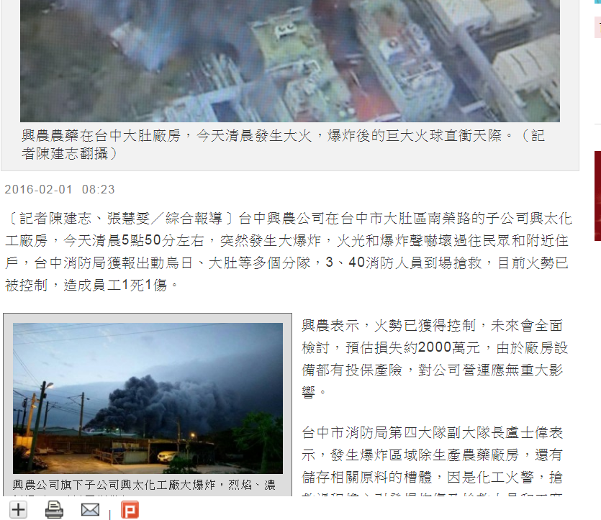
The big exploration happened in the Taichung factory.
4) The data before an explosion, the day the explosion happened, and after the explosion from different station. (The blue part is from our GLOBE project.)
2016/1/31 | A Taichung | B Fengyuan | C Zhongzhulin | D Xinshe
Altitude | 84 | 230 | 425 | 525
6 o'clock | 14.4 | 13.7 | 13.5 | 11.8
7 o'clock | 14 | 13.7 | 13.4 | 11.4
8 o'clock | 15.5 | 14.9 | 13.9 | 12.6
9 o'clock | 17.9 | 16.4 | 15.9 | 13.6
10 o'clock | 19.1 | 17.9 | 16.6 | 17
11 o'clock | 20.6 | 20.2 | 19.8 | 19.8
12 o'clock | 21.5 | 20.9 | 19.6 | 20.7

Height
2016/2/1 | A Taichung | B Fengyuan | C Zhongzhulin | D Xinshe
Altitude | 84 | 230 | 425 | 525
6 o'clock | 15.6 | 14.2 | 14.4 | 13
7 o'clock | 15.5 | 14 | 14.2 | 12.8
8 o'clock | 15.8 | 14 | 14.6 | 12.4
9 o'clock | 15.5 | 13.6 | 15.3 | 12.9
10 o'clock | 16.3 | 13.5 | 16.3 | 12.9
11 o'clock | 17.6 | 14.4 | 17.6 | 13
12 o'clock | 18 | 15.2 | 18.6 | 14.8

Temperature
Height

2016/2/2 | A Taichung | B Fengyuan | C Zhongzhulin | D Xinshe
Altitude | 84 | 230 | 425 | 525
6 o'clock | 12.5 | 11 | 10.7 | 9.2
7 o'clock | 12 | 10.6 | 10.5 | 9.4
8 o'clock | 12.4 | 10.9 | 10.7 | 9.2
9 o'clock | 14 | 11.7 | 11.8 | 9.9
10 o'clock | 13.4 | 11.5 | 11.6 | 10.4
11 o'clock | 13.8 | 11.4 | 12.4 | 10.6
12 o'clock | 14.4 | 12.4 | 13.3 | 10.8
Temperature
Height
- Research Methods
We did two experiences, using the smoke of incense to simulate air pollution, light bulb to simulate the sun, hope to found out that the two really do show positive correlation.
1) In the first experiment we made 2 layers of space, one full with air pollution, one below it empty, which we expected to see the light was blocked because of the air pollution.
2) The second experiment we control the time of the burning line incense to simulate different level of air pollution, want to find out the relationship between air pollution concentration and inversion.
- Result
- Result of the first experience
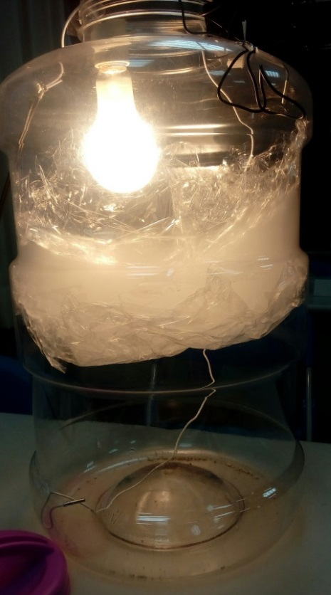
The air pollution block the sun light, and the heat.
- Result of the second experience (2 min light each time)
No incense(only 2 min light)
 | Up(℃) | down(℃) | difference(℃)
No light | 26.6 | 26.1 | 0.5
Light | 30.2 | 28.5 | 1.7

1 min incense
 | Up(℃) | down(℃) | difference(℃)
No light / no incense | 26.8 | 26.3 | 0.5
No light / incense | 27.2 | 26.2 | 1.0
Light / incense | 35.2 | 27.0 | 8.2

2 min incense
 | Up(℃) | down(℃) | difference(℃)
No light / no incense | 26.8 | 26.3 | 0.5
No light / incense | 30.1 | 26.4 | 3.7
Light / incense | 36.2 | 27.4 | 8.8

3 min incense
 | Up(℃) | down(℃) | difference(℃)
No light / no incense | 28.0 | 27.5 | 0.5
No light / incense | 30.7 | 27.5 | 3.2
Light / incense | 39.0 | 28.5 | 10.5

4 min incense
 | Up(℃) | down(℃) | difference(℃)
No light / no incense | 26.5 | 25.9 | 0.6
No light / incense | 29.2 | 26.6 | 2.6
Light / incense | 37.5 | 27.9 | 9.6

5 min incense
 | Up(℃) | down(℃) | difference(℃)
No light / no incense | 24.4 | 23.9 | 0.5
No light / incense | 27.8 | 24.2 | 3.6
Light / incense | 36.5 | 25.3 | 11.2
The numbers with red in the table are different with our study.

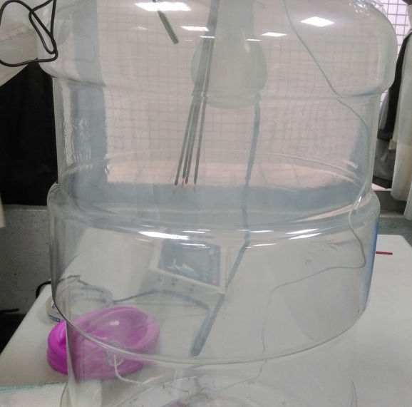
The pictures of the second experience
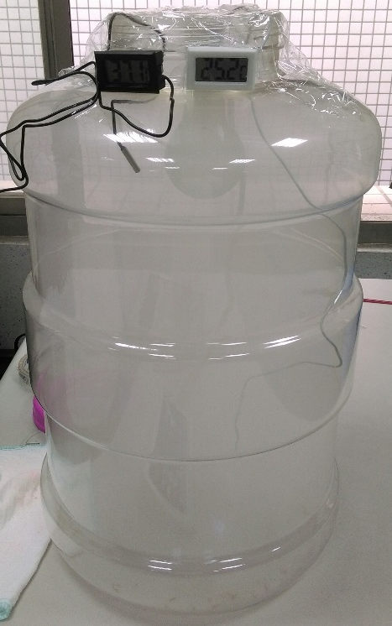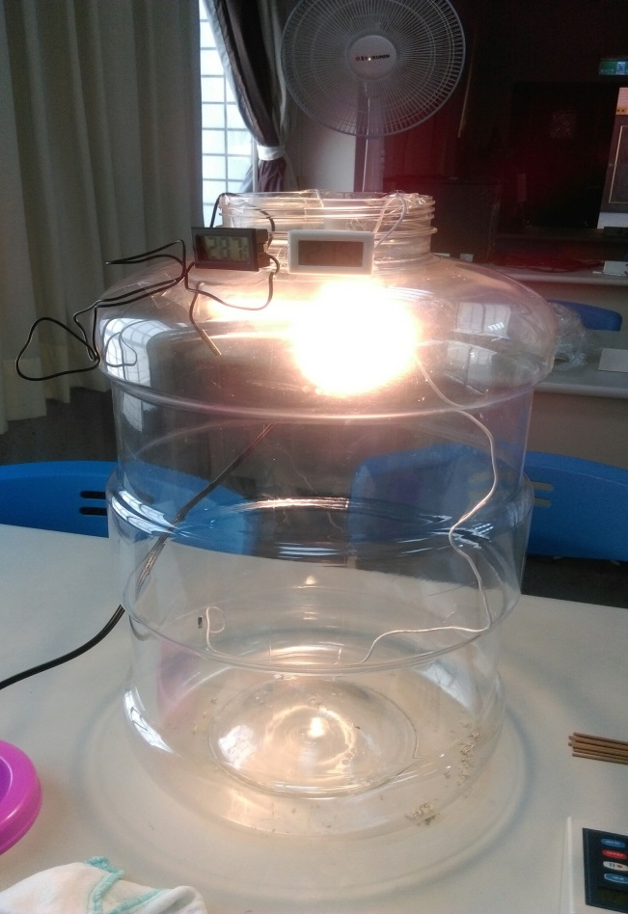

The difference in different air pollution concentration (light)
The difference in different air pollution concentration (no light)
- Discussion
The following is our answer to our first question “How does air pollution affect temperature inversion?” From our experience, we found out that the light is blocked by smoke, so the lower layer’s temperature drops, leaving the upper temperature high, resulting in inversion phenomenon. As for the second question “What is the relationship between air pollution and temperature inversion?” , it can be seen from the experience that the air pollution makes the inversion temperature more obvious, the temperature difference between the upper and lower air will increase with the concentration of smoke. However, our result of the experience is not completely equal to what we expect, (the red part) the picture we draw about the difference in different air pollution concentration are not absolutely positive correlation, especially the 4 min one. We think the reason of it might be the length of the incense, for we used the same incense repeatedly, which caused the incense we burned in the 4 min row almost finished burning at last. Also, we think it is different to burn the different part of the incense.
- Conclusion
Many cities in the world have air pollution problems; according to our study, air pollution is more serious with inversion phenomenon. Inverse temperature is like a layer of cover will block the upper and lower air circulation, so the situation is more serious with air pollution, that’s why many cities often face the threat of the Air Pollution Index being in the very unhealthy level, the purple level. In our experiments we simulate the real environment by incense. However, in the real air pollution ingredients, there are many other substances, and we hope someday we can find the most influencing elements of inversion, control the use of the material, so that the temperature inversion phenomenon, which leads to more serious air pollution, will not be more serious.
- Bibliography
These were the bibliography that were used:
- Data: http://e-service.cwb.gov.tw/HistoryDataQuery/index.jsp

- Report: http://news.ltn.com.tw/news/society/breakingnews/1590914
- Paper:
http://www.shs.edu.tw/works/essay/2012/04/2012040323424681.pdf
- Book: <應用氣候手冊> by 朱瑞兆
<普通氣象學> by戚啓勳
<氣象分析原理> repeat from : 譚繼純 薛繼勳
<大氣科學> repeat from : 薛繼勳

