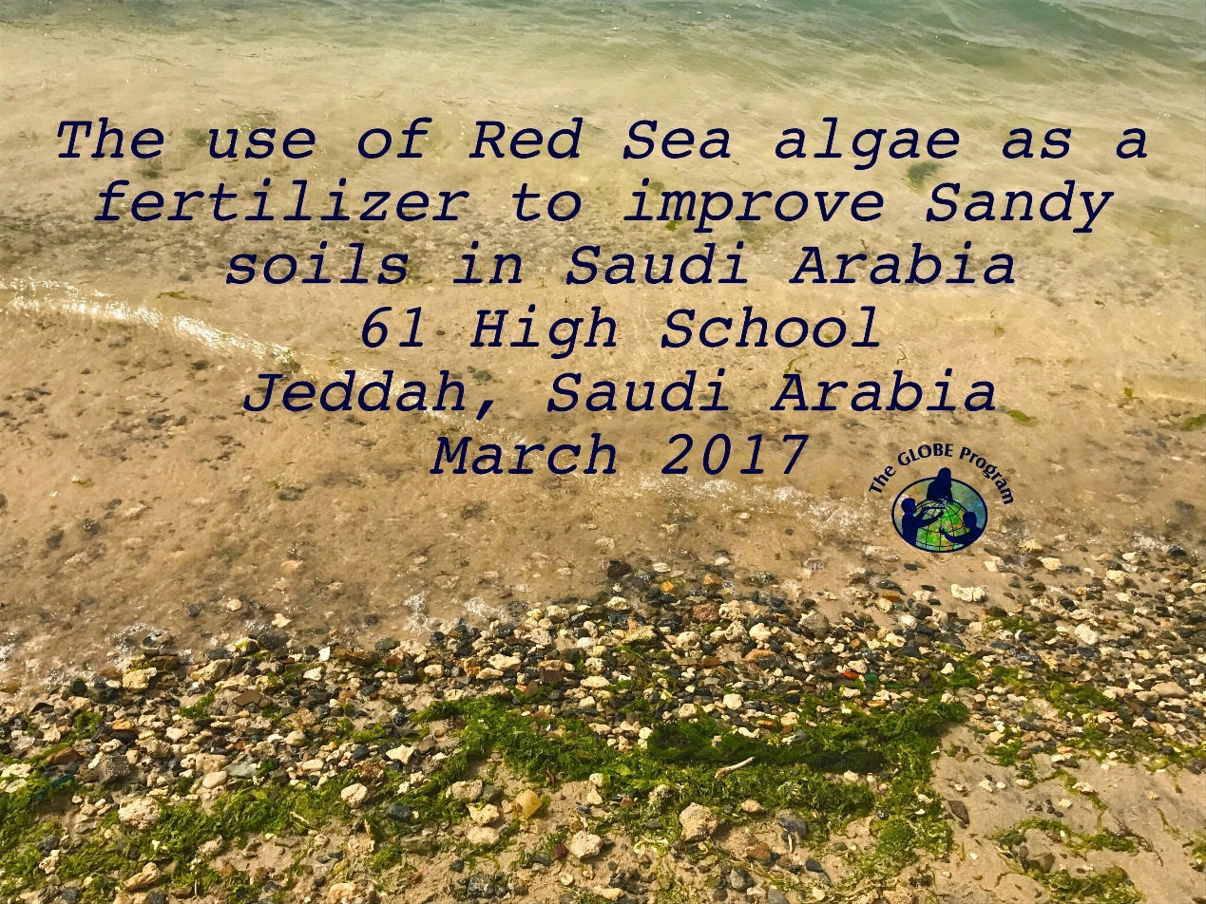

The use of Red Sea algae as a fertilizer to improve Sandy soilsin Saudi Arabia
Written by: Sara Kashgari, Basma Alsanieand ShahadAlshehri
61 High School
Jeddah, Saudi Arabia
Teacher: HussaAlsaheel
March 2017

ABSTRACT
Since the Kingdom of Saudi Arabia is one of the largest sand deserts in the world and one of the algae producing countries, this research focused on how to use the Red Sea algae as a fertilizer and toimprovethe quality ofsandy soil.In this research, we suggest that algae can be really helpful to improve the sandy soil for cultivation.

- Research question and hypothesis
This research was encouraged by the surprising amount of the Red Sea algae especially in Jeddah. The purpose of this research is tousethis specific type of algae forsandy soil so it can't be used for cultivation. Therefore, this study used algae as a fertilizer for sandy soil.The hypothesis was: Is it possible to use Red Sea algae to improve sandy soils for cultivation?
The sandy soil unfit for cultivation
''…… Sandy soil has large particles and those particles are solid and have no pockets where water and nutrients can hold to it,and because sandy soil lacks both water and nutrients, many plants have a difficult time surviving in this kind of soil''( Rhoades, 2016).
The aim of this research is to improve the agricultural crops in Jeddah, Saudi Arabia.We are trying to look for a solution that is not expensive. In reviewing the recent literature, we found that algae are one of the best solutions to fertilize sandy soil(alzwawi, 2015).
To what extent do algae effects on sandy soil?
Algae contain high proportion of plant hormones which are missing in sandy soil such as (Auxin and cytokinins).These hormones are important factors and vital for plant growth. Thus, algae have large amounts of calcium, sodium and potassium which are also important factors for plant growth.Algae act as a fertilizer that leads to an increase in growth and quality of vegetables and fruits as well as improves the soil nitrogen (Rubio et al., 2009).
Along with algae, high numbers of active microorganisms in the soil improves the efficiency of absorption, urge plant to continue growth, increase storage entrance in the process of aging, and contains steroids and growth incentives such as ( mannitil and alalginik acid) that helps to have high numbers of active microorganisms in the soil (Bhardwaj et al., 2014).
A scientific team of Egyptian researchers has managed to produce a vital fertilizer from Blue–Green algae and other fertilizers from brown algae and red algae, these fertilizers were improved sandy soil productivity over by %20(alzwawi, 2015 )

- Materials and methods
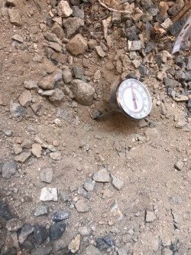
The basis of the data collection was by taking samples of sandy soil from (61 Secondary School) Al nahdah, Jeddah, Saudi Arabia. 5/3/2017
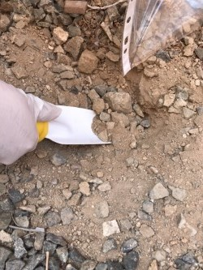
https://goo.gl/maps/9JQ8mCkoD3G2

Figure 1 the left picture shows the sample was taken by shovel. The right picture shows the tool for measuring the soil temperature.

‏In this location, the soil temperature was ( 26degree centigrade ) degree and the air temperature was ( 28.4) (Figure 1). The weight of the sample was(40g), this sample was taken by using a manual shovel (Figure 1). After that, we put the sample in a crock plate in order to heat it in the oven at (176degree centigrade) for 24 hours. The soil temperature was measured by soil testing meters device. Then, we took the soil out of the oven the measurements of the organic matter was (37g). The reason of this experiment was to prepare the sandy soil to become suitable soil for agriculture.

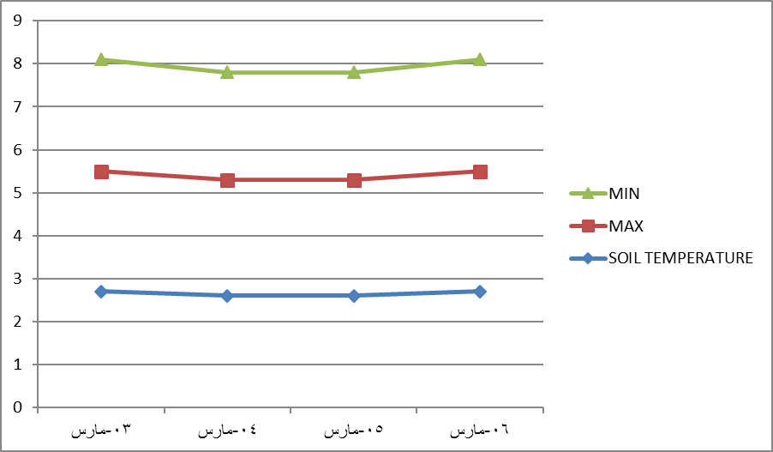
6march 5march 4march 3march
Figure 2 showsthedatathatwasenteredintheglobeprogramwebsite
The algae was taken from the (red sea, Jeddah, Saudi Arabia) https://goo.gl/maps/gNDjQLv2QEM2 4/3/2017 by using a tongs and keep it in a plastic box (Figure 2). In this experiment, we divide the soil into 3 samples, sample 1 we are going to grind the algae and put it in the soil, sample 2 we are going to cut the algae into small pieces and put it in the soil, and lastly sample 3 we are going to put the algae as it in the soil.

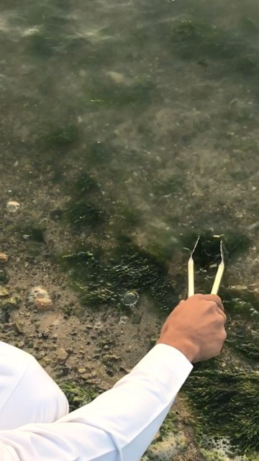
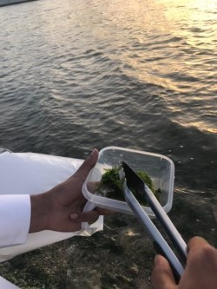

Figure 2 Collecting and put the algae in a plastic box
- Data summary and analysis
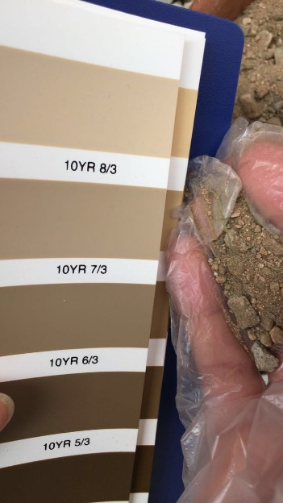
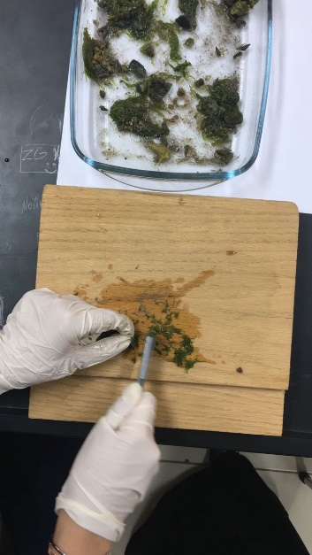
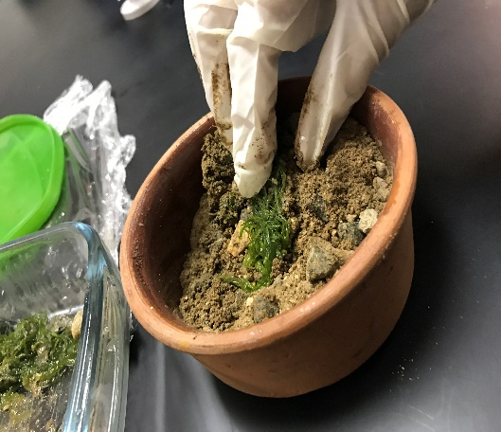
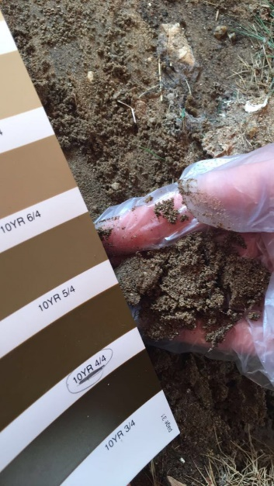
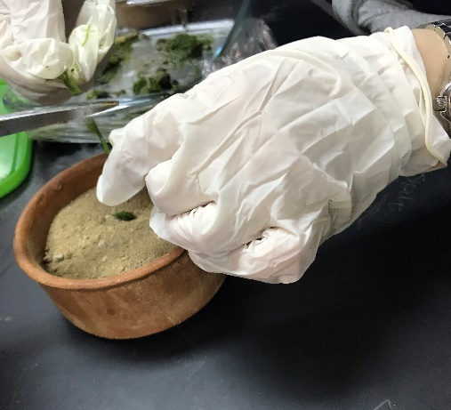
Thebar chart illustrates the carbon level in sandy and agricultural soil, before and after entering the oven (Figure 3). Before entering the samples in the oven, the weights for both samples were the same 40g. It can be seen that the carbon level in both samples were decreased after drying soils in an oven, but the sandy soil was less. This indicates the richness of agricultural soil than the sandy soil. It shows clearly that sandy soils are poor in water retention and lack of macro- and micronutrients (Weber et al., 2007). For this reason we need to improve the sandy soil to be suitable for cultivation by adding algae as a solution. Since the sandy soil has large particles that can not hold the nutrients, algae will help the sandy soils to absorb all the nutrient for a long time. This benefit will make the sandy soils ready for cultivation.

Figure 3 mixing the algae with the sandy soil, and the color of the sandy soil and the agricultural soil.

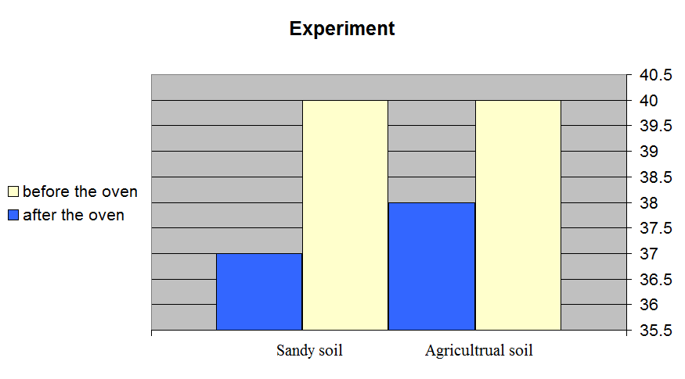
Figure 4the sandy and agricultural soils measurement before and after drying the soil in an oven.

- Results, Conclusions, and discussion
The main reason of this experiment is to solve the problem of sandy soil that could not be suitable for agriculture in Saudi Arabia, and also to consume the large amounts of algae in the Red Sea.
When we looked for an experiment similar to the one we did we found that an Egyptian scientific team produced a vital fertilizer from algae there researches and experiments were close to this research but we did not depend on it because there were some differences.
And there will be some amendments on this research that could be detailed about how to incorporate algae with sandy soil in better ways and clearer and more useful by doing more experiments and taking more accurate data and statistics .

Acknowledgments:I wishtoacknowledgepro/ ftounalsaig, T / sarahalhowish, forshowingushowtowrite a properresearchinallthewhy's,guidedusalongtheway, andhowtorephrase a documentproperly.jT/ hussaalsaheel, forencouragingustoworkhard.j

Reference
Bhardwaj, D., Ansari, M. W., Sahoo, R. K., &Tuteja, N. (2014). Biofertilizers function as key player in sustainable agriculture by improving soil fertility, plant tolerance and crop productivity. Microbial cell factories, 13(1), 66.
‏
Rhoades, H. (2016). Sandy Soil Amendments: How To Do Sandy Soil Improvements. gardening know how. Retrieved from https://www.gardeningknowhow.com/garden-how-to/soil-fertilizers/amending-sandy-soil.htm

Rubio, V., Bustos, R., Irigoyen, M. L., Cardona-López, X., Rojas-Triana, M., & Paz-Ares, J. (2009). Plant hormones and nutrient signaling. Plant molecular biology, 69(4), 361.
‏
Weber, J., Karczewska, A., Drozd, J., Licznar, M., Licznar, S., Jamroz, E., &Kocowicz, A. (2007). Agricultural and ecological aspects of a sandy soil as affected by the application of municipal solid waste composts. Soil Biology and Biochemistry, 39(6), 1294-1302.
‏

