NO₂ Levels and Traffic
Air Quality Campaign Ireland
Larkin Community College, Dublin 1

Abstract
The combustion of fossil and solid fuels leads to the release of products, which are harmful to the biosphere. These include Carbon, Sulphur and Nitrogen oxides, Ozone and Particular matter PM_{2.5} and PM₁₀. Long term exposure to the products of combustion can also pose a significant threat to plant, animal and human health. The World Health Organisation (WHO) states that air pollution is a major environmental risk to health. In 2016, 91% of the world population was living in places where the WHO air quality guidelines levels were not met. The current WHO guideline value of 40 µg/m³ (annual mean) was set to protect the public from the negative health effects of continual exposure to NO₂. In 2016 in both cities and rural areas 4.2 million premature deaths worldwide were attributed to exposure to the products of fossil and solid fuel combustion where the levels exceeded the WHO guidelines. In Ireland the Environmental Protection Agency (EPA) states that premature deaths attributed by air pollution is estimates at 1510 per annum.
This report investigates Nitrogen dioxide (NO₂) levels at different rural and urban schools in Ireland over a period from February 2019 to October 2019 and presents conclusions about the levels and behaviour of this gas from the patterns presented in the data. NO₂ passive diffusion tubes were placed at three locations at each school campus (busy-road, drop-off and sheltered zone). Data from February 2019 offered an opportunity to compare rural to urban schools while subsequent data from October 2019 made it possible to compare data between the two sampling periods and gather an insight into the levels and behaviour of NO₂ at the same sampling location. At Larkin Community college (LCC) NO₂ levels of 38.76 and 45.54µg/m³ for February and October 2019 were recorded for the busy-road zone on Cathal Brugha Street, Dublin 1. These values are close to or exceed the European Union air quality standards of 40µg/m³ as an annual mean. Continual real-time monitoring of air pollution levels assisted by quick-release of data through phone and desk-top applications can offer a valuable service to public health monitoring where people can readily access information about ambient air quality for specific locations.
Keywords
Nitrogen dioxide, air pollution, ambient air quality, sampling zones, passive diffusion tubes.

Research Questions
Recording and reporting ambient air quality data offers an opportunity to engage members of the public in citizen science programmes of continual real-time monitoring. The Irish EPA has established an Air Quality Index for Health (AQIH). The AQIH map updates every two to five minutes with the most up-to-date recordings of air pollution for each station. The AQIH gives information on the short-term effects of exposure to air pollution and offers health advise for each of the ambient air quality categories from very good (level1-3) to very poor (level 10).
EPA Air Quality Index for Health
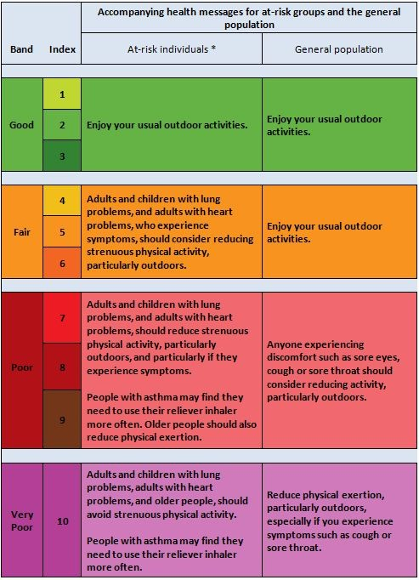

Research questions for this project were centered on comparing NO₂ levels from February 2019 to October 2019 within the three traffic zones of busy-road, drop-off and sheltered.
This data was analysed as follows:
- LCC and rural schools February 2019.
- LCC February 2019 and LCC October 2019.
- LCC and Central Model Senior School (CMSS) in the same city center location.
- LCC and EPA Pearse Street station October 2019.
- Evaluation of the potential use of citizen science participation in monitoring environmental NO₂ levels and commentary on the EPA AQIH.
- Evaluate the potential to raise public awareness for the AQIH and investigate the development of a mobile phone or desk-top application to report real-time air quality data.
- Consider the current response practices when ambient air quality levels are breached on national and european platforms.

Introduction
Larkin Community College (LCC) is a co-education college situated on Cathal Brugha Street in Dublin 1. The School has nearly 400 students and 40 staff. The school curriculum has an abundance of curricular and extra curricular activities taking place across all the different subjects including Arts, Sports, Music, Languages and Sciences. College staff have always been very supportive of students activities in all of these different areas including all the environmental activities that take place every year in junior and senior cycles of study.
The environmental projects currently underway include:
- An Taisce Air Quality Campaign, NO₂ Levels.
- Biodiversity Green Flag Application in March 2020.
- Outdoor classroom for Science Classroom Based Assessments (CBAs), Ecology Fieldwork Studies.
- Pollinator refuge with wildflower planting, supported by Dublin City Council Local Agenda 21 Funding.
Participating in the An Taisce Air Quality Campaign has offered students an opportunity to take part in a continual and long-term environmental monitoring project that links to other national and international programs and schools. It stimulates students to translate their interests in environmental responsibility and stewardship into real time monitoring, analysis and reporting of environmental data that supports the work of government and non-governmental agencies.
This project is part of a continual program monitoring atmospheric NO₂ levels by students in both rural and urban settings throughout Ireland. NO₂ levels were recorded in February and October 2019 and again in February 2020. The analysis of data evolved into the following categories:
February 2019:
- This data compared urban and rural schools for the three collection zones of busy-road, drop-off and sheltered.
October 2019:
- This data compared two sets for Larkin Community College (LCC) and analyse for patterns.
- LCC data compared to Central Model Senior School (CMSS) for the three selected zones.
- The school data compared with Environmental Protection Agency (EPA) data Pearse Street, D2.
February 2020:
- This third set of data is due before summer 2020, offers more opportunity to look for patterns between the three zones at the same schools in urban and rural areas for the 3 collection periods.

Research Methods
The map below shows the location of Larkin Community College and Central Model primary school north of the river Liffey in Dublin 1. The Environmental Protection Agency (EPA) Pearse Street station is located south of the river Liffey in Dublin 2. NO₂ levels (µg/m3) were recorded using the passive diffusion tubes shown in the pictures below for February and October 2019. These tubes were attached ca. 3.5m to flag poles for the busy-road and drop-off zone and to a high fence for the sheltered zone and sent to a laboratory in Whales for analysis after an exposure period of ca. 2-4 weeks.
The urban design of the streets appears to have an influence on the pocketing of NO₂ in areas where prevailing winds are less active than in other areas, e.g.
The duration and type of traffic is also of significance between the collection zones.
NO₂ Collection Zone | Description
Busy-Road | Cathal Brugha Street
Drop-off | Champions’ Avenue
Sheltered | Gym Building Rear

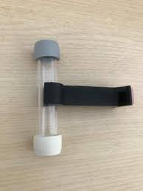
NO₂ Passive Diffusion Tube External
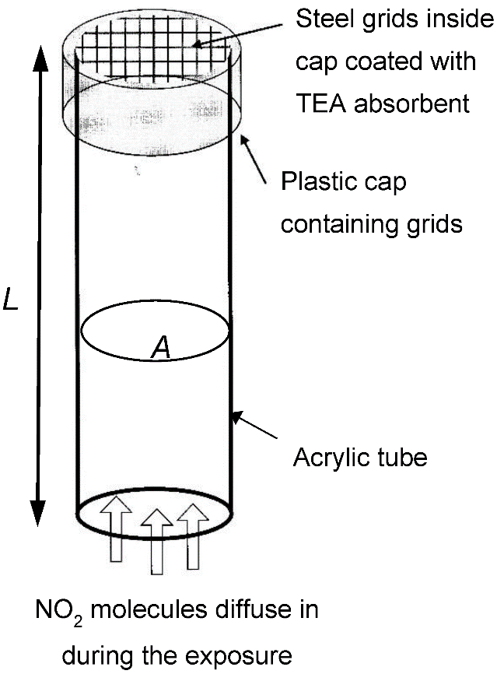
NO₂ Passive Diffusion Tube Internal

Larkin community College, Central Model Senior School, Dublin 1
Pearse Street, Dublin 2
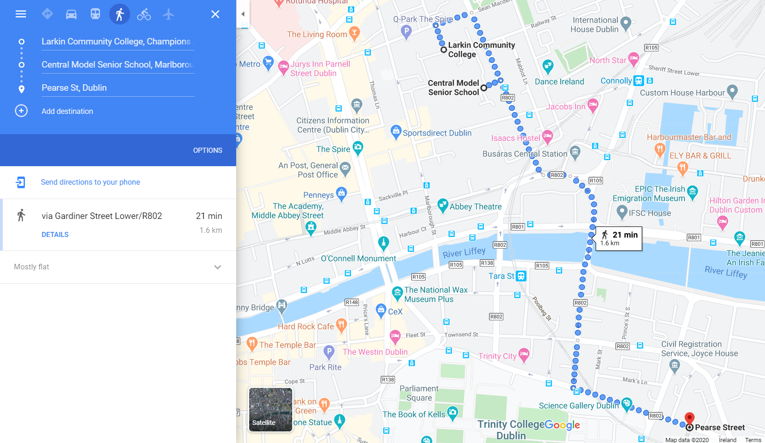

Results
February 2019 data indicates that increased levels of traffic caused an increase in levels of NO2 recorded. Schools reported an incremental rise in NO2 levels from the sheltered to drop-off to busy-road zones. This pattern was more pronounced for rural schools than for urban schools possibly due to the cleaner air in areas with less traffic and central heating sytems. Urban schools report higher levels of NO2 when compared to rural schools, notably so at city or town centres.
February and October 2019 data indicates an increase in NO₂ levels at busy-road and drop-off zones compared to sheltered zones for both urban and rural schools sampling periods. Increased traffic in bigger towns and cities may become a significant cause for concern and have serious implications for public health with particular concern for vulnerable groups such as the young and old or people with health issues such as asthma, COPD or other respiratory and cardiovascular conditions. This impacts on the transport and town planning sectors.
Unusual patterns include Larkin Community College reporting a higher NO₂ level at the sheltered zone than the drop-off zone and Central Model Senior School with a higher NO₂ level at the drop-off zone compared to the busy-road zone. The urban design features of a street may facilitate the pocketing of NO₂ as a heavier gas than oxygen in areas that do not readily allow it to disperse.

Rural School February 2019
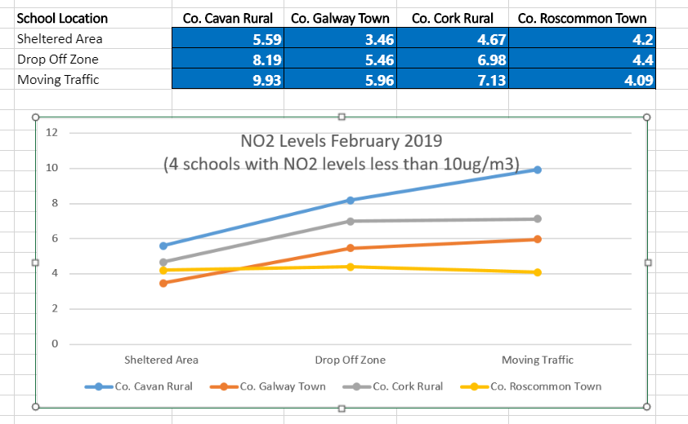

Urban School February 2019
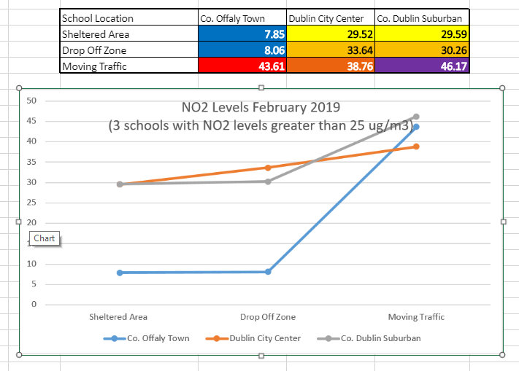
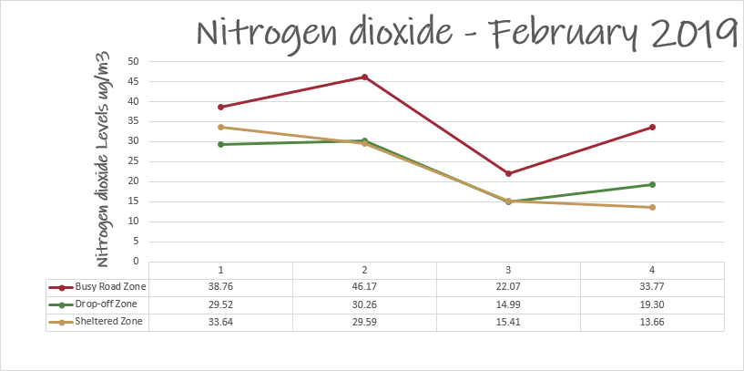
 | School Name | School Location
1 | Larkin Community College | Cathal Brugha Street, D1
2 | The Kings Hospital | Old Lucan Road, D20
3 | Christ King Secondary School | South Douglas Road, Cork
4 | Monaghan Model School | Monaghan Town

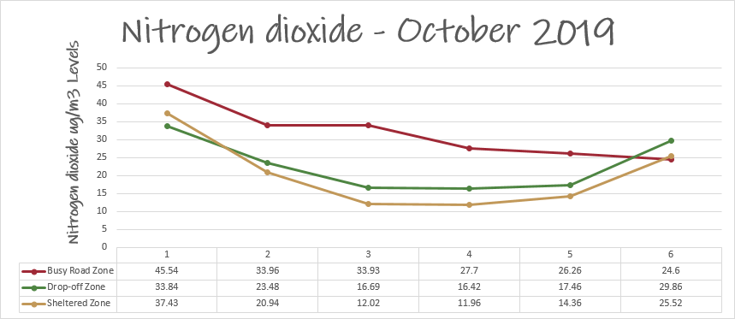

 | School Name | School Location
1 | Larkin Community College | Cathal Brugha Street, D1
2 | The Kings Hospital | Old Lucan Road, D20
3 | Christ King Secondary School | South Douglas Road, Cork
4 | Monaghan Model School | Monaghan Town
5 | Balbriggan Educate Together | Balbrigan, Co. Dublin
6 | Central Model | Marlboro Street, D1

Weather data relating to air temperature, precipitation and sunshine hours is shown below from MET Éireann Weather Statements.
Monthly Mean Weather Conditions Dublin Airport
 | Rainfall (mm) | Air Temperature (ºC) | Sunshine (hrs)
February 2019 | 30.5 | 7.0 | 112
October 2019 | 77.2 | 9.1 | 113

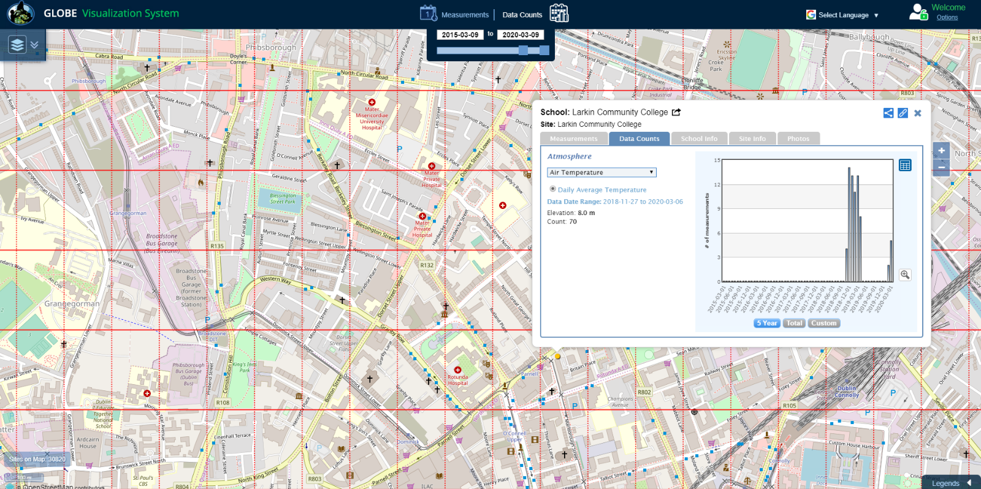
Weather data was also recorded and uploaded to GLOBE Visualization Tool.

Discussion
The EU air quality directive (2008/EC/50) has set two limit values for NO₂ for the protection of human health: the NO₂ hourly mean value may not exceed 200µg/m3 more than 18 times in a year and the NO₂ annual mean value may not exceed 40µg/m³. The Irish National Clean Air Strategy 2019 identifies the principle sources of NO2 and Particulate matter 2.5 air pollution from diesel engine transport, the combustion of domestic solid fuels and industrial, agricultural and shipping emissions.
As part of the Ambient Air Quality Monitoring Programme (AAMP) 2017 the Environmental Protection Agency in Ireland promotes public use of an Air Quality Index for Health (AQIH). This is a guide giving information about the health implications of different levels of air pollutants. A reading of 10 means the air quality is very poor and a reading of one to three means that the air quality is good. It is calculated hourly and readings are available at from the EPA on the AQIH map.
At Larkin Community College levels of NO2 were recorded at 38.76 and 45.54µg/m³ for February and October 2019 on Cathal Brugha Street, Dublin 1. These values are close to or exceed the EU guidelines for annual mean values. With the continued use of solid fuel to heat homes and diesel/petrol to power transport, NO₂ levels may continue to rise and pose significant threat to human and environmental health. Monitoring ambient air quality is important to inform government and policy makers on the best strategies to manage the causes of air pollution and implement solutions. It also allows people to make informed choices regarding their work and leisure activities, which is essential for those with underlying health considerations.
Citizen science is another way of gathering evidence. The GLOBE schools programme provides an opportunity for students and teachers to take part in the monitoring of ambient air quality and become invested citizens in the care and management of the Irish and global environment.
In response to high levels of NO2 in Dublin due to traffic the EPA plan to facilitate a citizen science programme like that which has been in operation in Antwerp, Belgium since May 2018. CurieuzeNeuzen Vlaanderen is a citizen science project in which 20.000 citizens measure the air quality near their own house during May 2018. The aim is to acquire a detailed map of air quality in Flanders (the northern region of Belgium), both in cities as well as in the countryside¹².
CurieuzeNeuzen Scale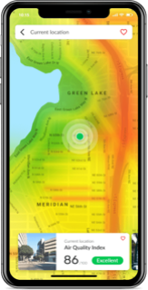Breezometer Ltd.

Active engagement of the public in citizen science programmes can be enhanced with the availability of user-friendly reporting systems such as a mobile phone application similar to that provided by Breezometer Ltd., which is a private company since 2012 that provides real-time ambient air quality information for pollen levels in addition to the principal pollutants from the combustion of solid and fossil fuels namely Nitrogen dioxide, Sulphur dioxide, Carbon monoxide, Ozone, Particulate Matter 2.5 and Particulate Matter 10.

Conclusion
Ambient air quality NO₂ levels were breached for the busy-road zone for LCC at 45.54 µg/m3, denoted as 'Very Bad' category of the CurieuzeNeuzen Scale. Sustained breaches of WHO guidelines and corresponding EU and national air quality standards can pose a significant risk to public health and result in many premature deaths.
Recommendations includes continued monitoring at the same locations coupled with further considerations about the urban design of the zones and the flow behaviour of traffic-based NO2 . We would like to investigate the development of a phone app that reports real-time colour-coded air pollutant zones for immediate and easy public use similar to the service offered by Breezometer Ltd.
The GLOBE programme in collaboration with national environmental agencies such as An Taisce offers students and teachers an opportunity to participate in environmental monitoring for the principal Earth spheres of atmosphere, hydrosphere, pedosphere, biosphere and Earth as a system.
Bibliography
www.airquality.epa.ie
https://www.epa.ie/irelandsenvironment/air/
https://www.epa.ie/air/quality/data/
http://www.epa.ie/air/quality/reports/no2/
https://www.epa.ie/air/quality/index/
https://www.epa.ie/pubs/reports/indicators/epa_factsheet_air_v2.pdf
https://www.epa.ie/pubs/reports/air/quality/Urban_Environmental_Indicators_2019.pdf
https://greennews.ie/an-taisce-and-epa-launch-new-citizen-science-project/
https://www.met.ie/
​
https://www.tcd.ie/transport-research/research/projects-current/NO2-Health.php
https://www.tcd.ie/civileng/air-pollution-webinar-series/

https://www.dccae.gov.ie/documents/Climate%20Plan%20Infographic_full.pdf
https://www.dccae.gov.ie/en-ie/environment/topics/air-quality/national-clean-air-strategy/Pages/default.aspx
https://www.dccae.gov.ie/en-ie/environment/topics/air-quality/pages/air-quality-overview.aspx
https://www.dccae.gov.ie/en-ie/environment/topics/air-quality/national-clean-air-strategy/Pages/default.aspx

https://environmentalpillar.ie/who-we-are/
https://www.google.ie/maps/dir/Larkin+Community+College,+Champions+Avenue,+Dublin,+Dublin+City/Central+Model+Senior+School,+Marlborough+Street,+Dublin/Pearse+Street,+Dublin+2

https://vis.globe.gov/GLOBE/
https://www.globe.gov/do-globe
https://www.globe.gov/do-globe/globe-spheres

https://eur-lex.europa.eu/eli/dir/2008/50/oj
https://breezometer.com/company
https://www.who.int/news-room/fact-sheets/detail/ambient-(outdoor)-air-quality-and-health
https://unfccc.int/process-and-meetings/the-paris-agreement/the-paris-agreement
https://www.eea.europa.eu/data-and-maps/figures/nitrogen-dioxide-annual-limit-values-for-the-protection-of-human-health
https://towardsdatascience.com/sensing-the-air-quality-5ed5320f7a56
https://energydesk.carto.com/me
https://www.unenvironment.org/news-and-stories/story/unep-implementing-principle-10-rio-declaration
https://curieuzeneuzen.be/in-english/
https://www.quora.com/Is-nitrous-oxide-heavier-than-air
https://www.sciencedirect.com/topics/earth-and-planetary-sciences/nitrogen-dioxide

