Investigating the Effect of Trees on Indoor Environment Conditions: A Case Study of The University Basic School, Legon

Student Name(s)
Kadmiel Armah, Audrey Lomotey, Caitlyn Akusah, Nana Kwame Oppong-Duah, Kwaku Osei Fredua-Agyemang, Dzifa Samelia Awuye

Teachers: Shadrack Kwaku Agyiri, Enoch Lamptey

University Basic School, Legon
Ghana

March 3, 2020

Abstract:

It is not clear whether the benefits of improving outdoor environmental conditions in urban areas apply to building indoor environment when trees are integrated in building environments. This research seeks to investigate and also clarify whether building environments covered by plants have effects on indoor environmental quality, and building occupants' health and comfort. The review exercise revealed that building envelopes covered by plants can (1) improve indoor thermal conditions (2) compromise indoor light level. Evidences addressing the impact on indoor air quality (chemical, physical, and biological pollutants) is lacking in this research due to lack of requisite tools and expertise. There are however no evidences in this research addressing the impact of improved IEQ conditions, as a result of integrating trees in the building environment, on building occupants' health and comfort. This research is relevant to promoting afforestation and maintaining green spaces in urban buildings.

Research Questions:
This research seeks to answer the following questions;
- Have trees any effect on the on the Indoor environment conditions in a building?
- To what extent would the atmospheric conditions of the outdoor environment impact on the comfort of the inhabitants.

Introduction:
The University Basic School is located on the beautiful campus of the University of Ghana, Legon. It is situated at longitude 0.188166 and latitude 5.665796. Situated on an altitude of 91meters above sea level, shares similar characteristics with tropical climate of Accra.
The atmospheric temperature of the school and its environs usually gets hot during the day especially on harmattan days. During hot sunny days, the atmospheric temperature of our school and its environs becomes so hot that it sometimes takes affects the indoor environmental conditions in the classrooms.
Thanks to mother nature, our school is blessed with a lot of trees that we always run to when the need be. During moments when the atmospheric temperature gets so unbearable, some lessons are held under the trees so as to mitigate the effects of the unbearable conditions encountered in the classroom. These unbearable conditions are experienced in only a few classrooms whiles others remain airy and relatively comfortable all year round.
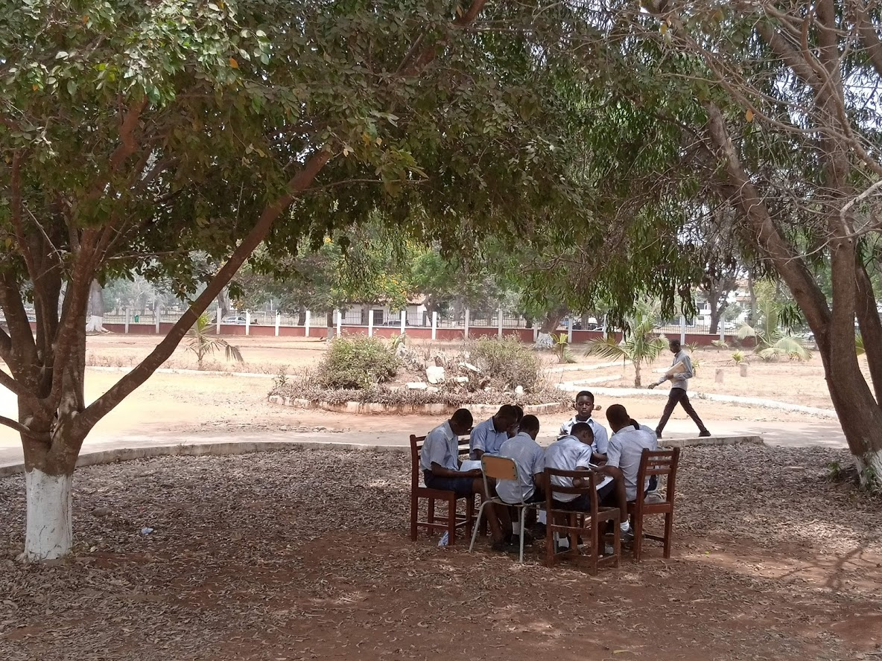
Figure 1: A Group of Students studying Under trees during a hot sunny day

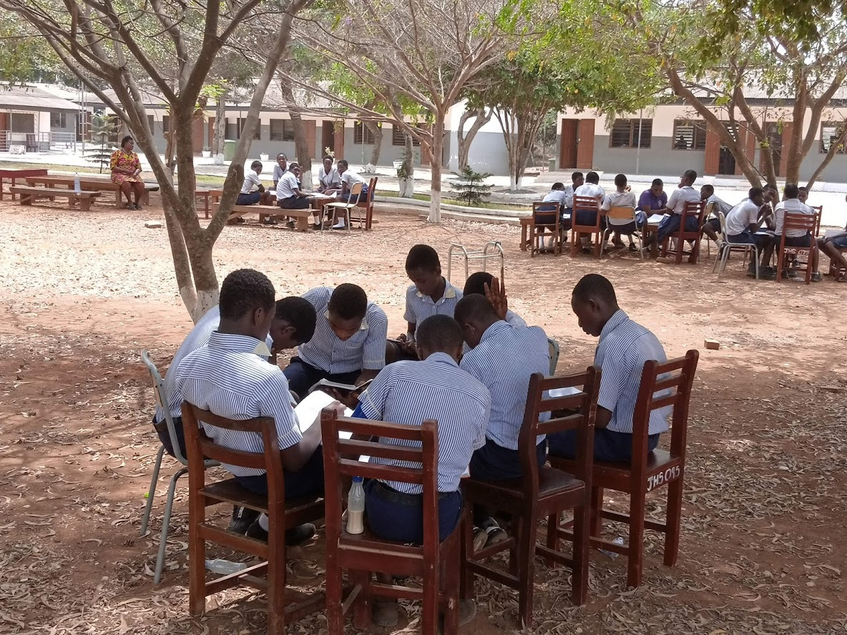
Figure 2: Students undertaking Group Discussion under the trees

Research Methods:

The study covered in this research included the following experimental components:
Indoor comfort levels were monitored in a purposefully selected sample of classroom
buildings mainly located in the University Basic school campus. All the buildings are free running and relying on natural light and ventilation.

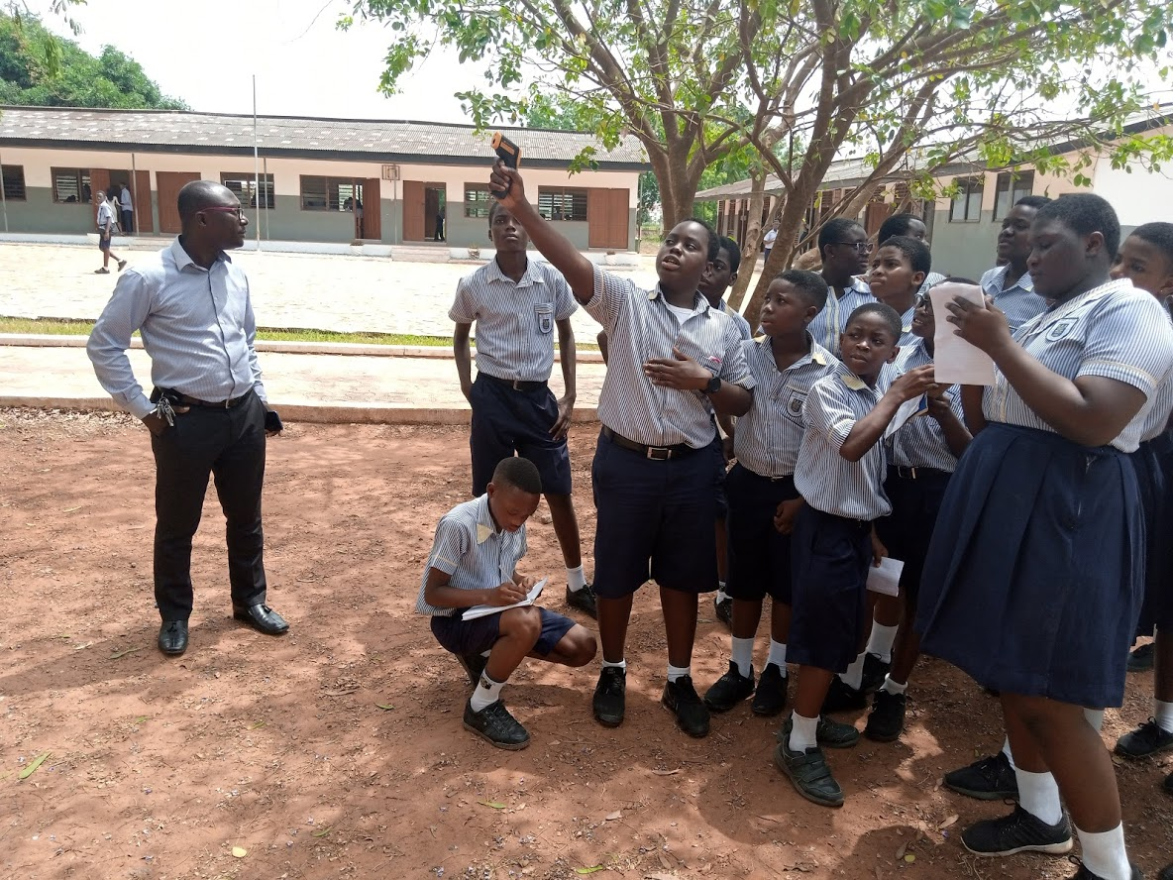
Figure 3: Students taking and recording some atmospheric conditions

Two classrooms were selected based on these two criteria;
- They must be of the same dimensions and also have similar orientation and features such as window size, etc.
- They should be such that one of the two classrooms should be surrounded by trees and the other should have no trees.
For the purposes of this report, these two selected classrooms would be referred to as Classrooms A and B respectively.

The two Classrooms were both monitored simultaneously for a five (5) days continuously. The instrument used for recording the atmospheric temperature was the Lasergrip 774 infrared thermometer by Etekcity.

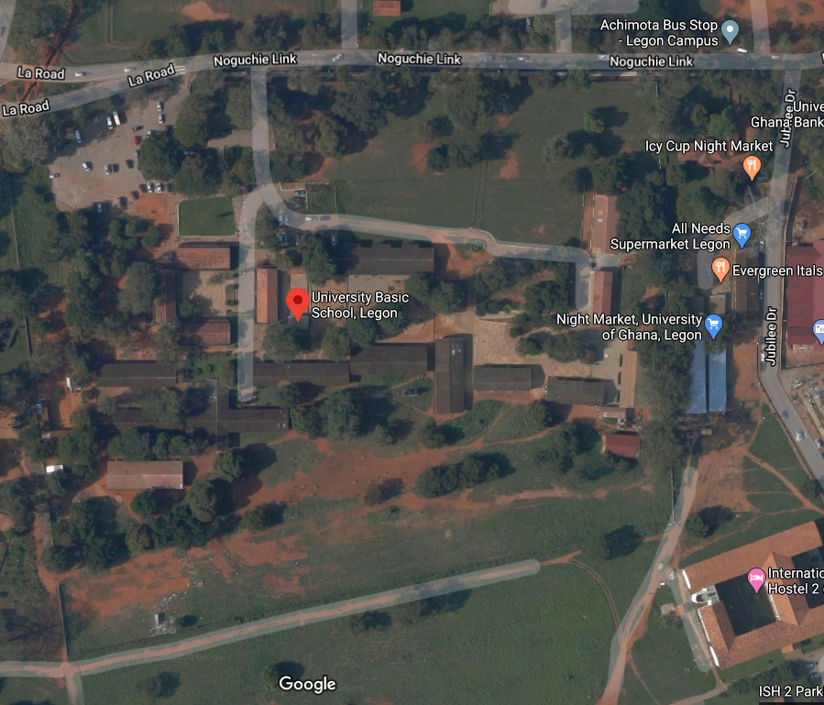
A
B
Figure 4: A Google Satellite image of the school showing the location of the two classrooms

Measurements

This study was mainly focused on the indoor environment condition in terms of indoor temperature, relative humidity and wind speed. Planning aspects of the buildings
such as area of openings, locations of openings, orientation were also observed.

Interviews were conducted among the occupants of the classrooms in the sample space considered in the case study in order to investigate whether they
have any problems related to the prevailing indoor environment?

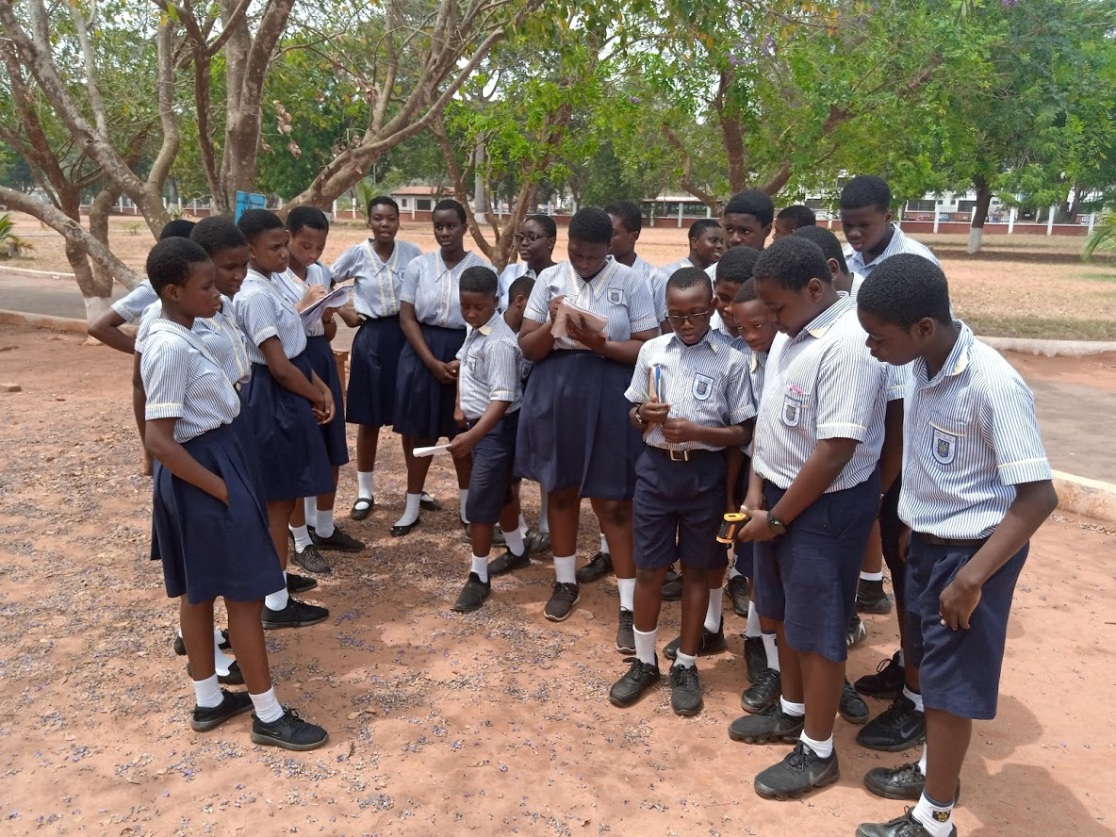
Figure 5: Students Measuring surface temperature of the outdoors

For each location, spot measurements were taken for all the parameters and temperature monitor, temperature and humidity using a laser grip 774 infrared thermometer.
Measurements were taken by keeping the windows open and closed positions for free
running residential buildings.
The condition of microclimate was judged as poor or good by observation and not by measurement of coverage of trees, due to practical limitations of the study.
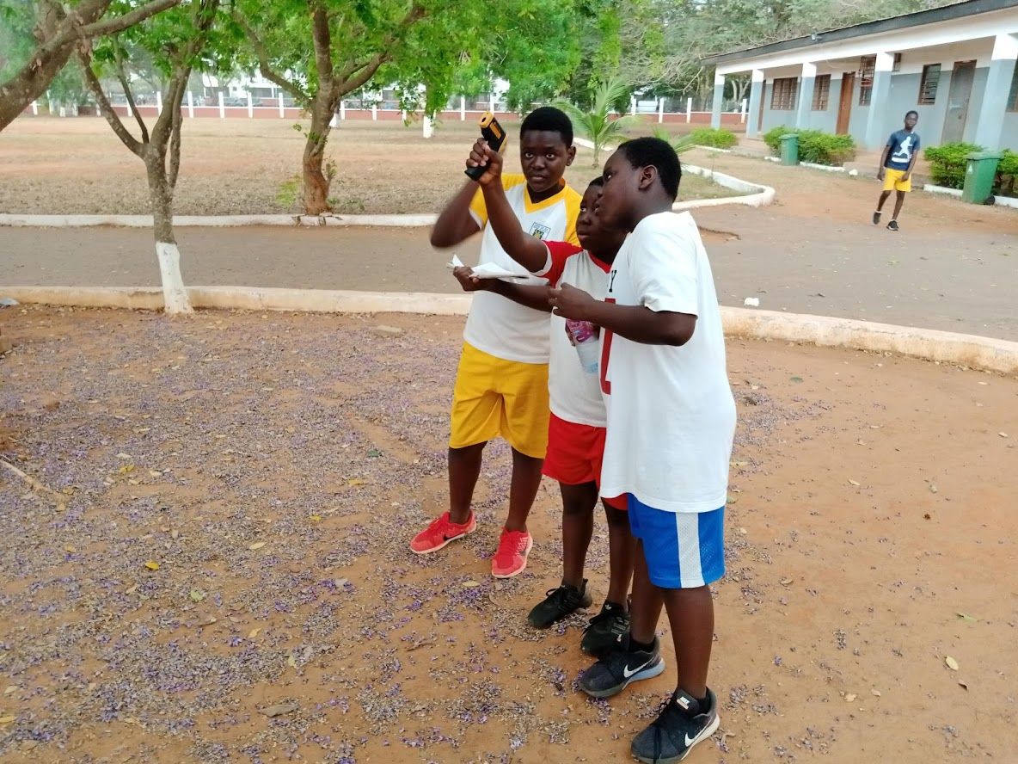
Figure 6:Students measuring ambient temperature

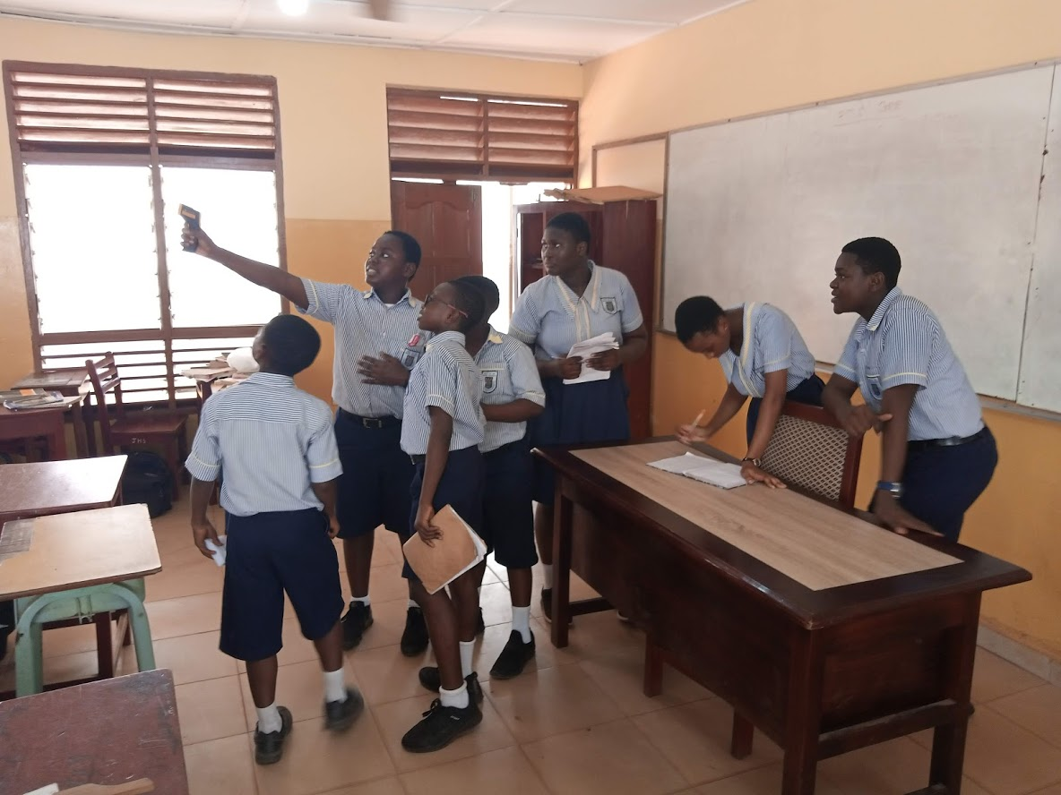
Figure 7: Students measuring ambient temperature in Classroom B
Results:
From the table below, it could be seen that the temperature of Classroom A ranges from 30°C and 35°C, for both Ground Temperature and the Ambient Temperature.

Table 1: Temperatures for Classroom A
Day | 1 | 2 | 3 | 4 | 5
Ground Temp | 32.4 | 32.3 | 30.9 | 31 | 31.9
Ambient Temp. | 34.5 | 34.3 | 31 | 30.9 | 32.1

Table 2: Temperatures for Classroom B
Day | 1 | 2 | 3 | 4 | 5
Ground Temp | 32.5 | 32.4 | 31.2 | 31.1 | 32.1
Ambient Temp. | 36.7 | 36.5 | 32.6 | 31.7 | 35.6

Table 3: Outdoor Temperatures
Day | 1 | 2 | 3 | 4 | 5
Ground Temp | 29.5 | 29.7 | 32.9 | 33 | 33.5
Ambient Temp. | 27.6 | 29.4 | 25.9 | 25.6 | 30.6

Table 4: Comparing Surface Temperature
Day | 1 | 2 | 3 | 4 | 5
Room A | 32.4 | 32.3 | 30.9 | 31 | 31.9
Room B | 32.5 | 32.4 | 31.2 | 31.1 | 32.1
Outside | 29.5 | 29.7 | 32.9 | 33 | 33.5

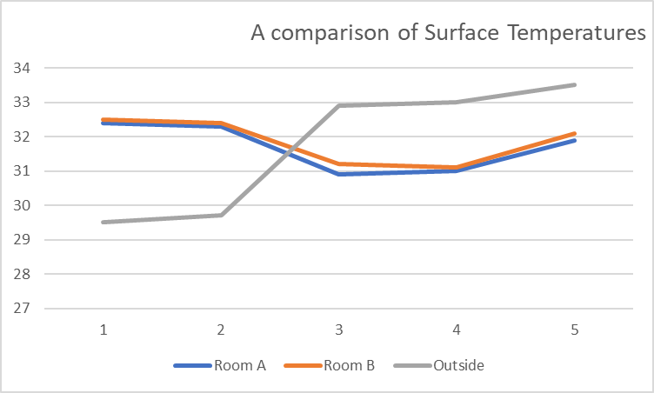
Graph 1: A graph comparing the Surface temperatures of Classrooms A and B and the Outdoor Temperature

Table 5: Comparing Ambient Temperatures for Classrooms A and B
Day | 1 | 2 | 3 | 4 | 5
Room A | 34.5 | 34.3 | 31 | 30.9 | 32.1
Room B | 36.7 | 36.5 | 32.6 | 31.7 | 35.6
Outside | 27.6 | 29.4 | 25.9 | 25.6 | 30.6

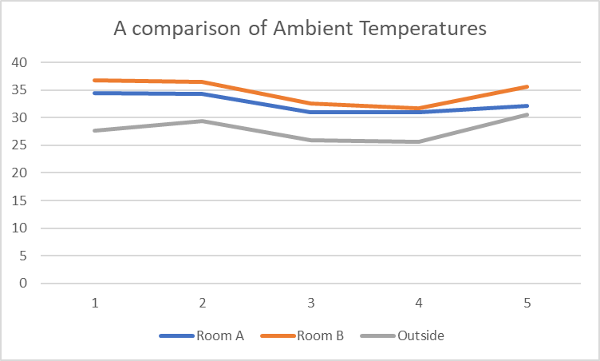

Discussion:
From the above graphs, it could be gathered that the rate the atmospheric conditions in the two classrooms i.e. A and B differ. Classroom A recorded a slightly lower temperature that Classroom B during all the days under observation. The surrounding outdoor environment recorded relatively lower surface and Ambient temperatures than Classrooms A and B.

Conclusion:
From the forgone, it could be concluded that the Outdoor environment has some effect on the indoor environmental conditions in a building.
Thus, it could be said that the fact that the trees surrounding Classroom A contributes significantly to the indoor environmental condition and comfort of its occupants hence a strong case can be made here for afforestation.
We hereby recommend that more trees should be planted on our school compound and also the existing trees should also be maintained to enable them contribute to the ecosystem.

Bibliography

- Jayasinghe, Chintha. (2010). Effect Of Building Ventilation On Indoor Environment. 10.13140/RG.2.1.4393.4806.
- Heidari, S., (2005) “Effect of air movement in Building”, International conference
“Passive and low energy cooling for the Built Environment”, May 2005, Santorini, Greece
- Saxena, M.,“Microclimate Modification: calculating the effect of trees on air temperature”, Heschong Mahone Group. www.sbse.org/awards/docs/
- Olawale, Moshood. (2013). Literature review of a relationship between indoor environmental quality (IEQ) and building envelopes covered by plants. International Journal of Environment and Sustainable Development. 12. 361-378. 10.1504/IJESD.2013.056340.

