Globe Science Fair research report:

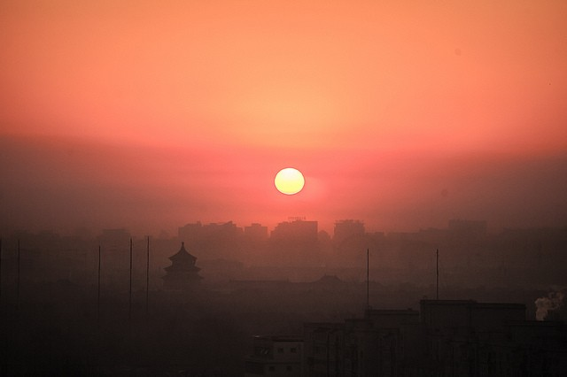
The effect of smog on (sun)light

Kandinsky College Malderburchtstraat (V4)
By: Luuk Hahn, Jim Hiddink, Pim Hom and Charles Cahigas

Table of contents

Introduction 3
Cause of investigation 3
Research question 4
Background information 4
Hypothesis 4
Setup experiment (short) 4
Expectation 4
Work plan 5
Materials 5
Setup of the experiment 5
Method 7
Results 9
Conclusion & Discussion 10
Sources 12

Introduction

Cause of investigation
When our teacher told us about the Globe Science Fair, we were very interested. Doing experiments in chemistry and physics classes are always fun, so this is a great way to take it to another level. We are more independent, free to make and perform an experiment where we can combine the subjects, which is exactly what we did.
We know that smog is bad to breath, but we wondered if it also blocked sunlight. When there were videos on the news about smog, you could see that it was darker than usual. We wanted to investigate this further. We wanted to know if smog blocked sunlight, but also how much it would block. In the future, this data could be used. If the sunlight would be measured when there is smog in the air, they will know how much smog there is in the air, and they could warn people if there is too much smog in the air to breath normally. So, our research is about the amount of sunlight that is being blocked by a certain amount of smog in the atmosphere. This experiment would give us the opportunity to use chemistry and physics: make smog and work with sensors. Of course, this would also tackle a problem that occurs around the globe, which the Globe Science Fair is all about.

Research question
To what extent can concentrations of smog affect light?

Background information
There are two different types of smog. One type is reducing smog, and it mainly consists out of sulfur dioxide and particulates, small particles in the atmosphere. The cause of the high concentrations of sulfur dioxide and soot, which also occurs in reducing smog, is the burning of fossil fuels such as coal. That is why nowadays fossil fuels are not burned in the middle of a big city. When it is inhaled, you could become ill and even die. The other type is photochemical or oxidizing smog, which mainly consists out of ozone and other oxidants. It is formed when large amounts of nitric oxide and hydrocarbons get into the atmosphere. After photochemical reactions, other gases are formed, mainly oxidants like ozone. Oxidizing smog causes irritation and damage to membranes in the respiratory system and eyes, but it isn’t deadly. (1)
There are some factors affecting the concentration of smog. Some factors are environmental conditions and sunlight. If the sunlight intensity is higher, more ozone will be produced. If there is more wind speed, the smog concentration will be lower. The wind will transport the smog to other areas. (2)

Hypothesis
When the concentration of smog is high, more light is blocked than with low concentrations of smog.

Setup experiment (short)
Put sodium thiosulfate in a glass beaker and dilute it with water. Add hydrochloric acid to it and stir it. Do this with different dilutions of sodium thiosulfate. This looks a lot like smog. Put a lamp on a table and a light sensor in front. Put the beaker with ‘smog’ between the lamp and sensor and measure the amount of light with the sensor, and connect it to Coach 7. Make sure no other light will interfere, so put a box over the setup. Measure the amount of light for each different dilution of ‘smog’.

Expectation
If more light is blocked with high concentrations of smog than with low concentrations, then the beakers with ‘smog’ that are least diluted will let less light through than ‘smog’ which is more diluted.

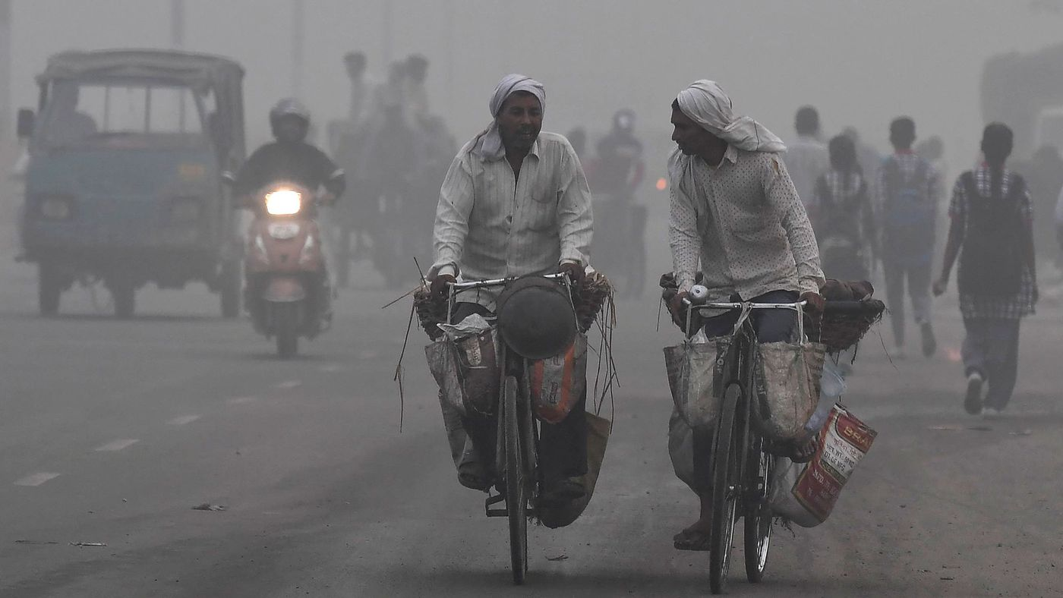
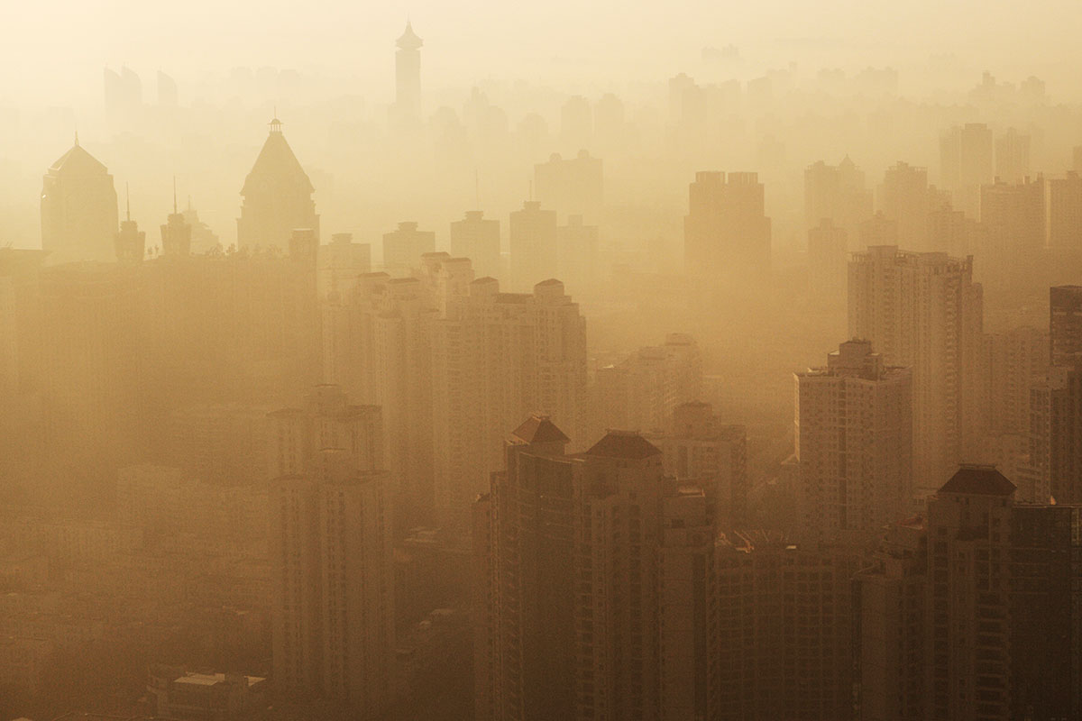

Figure 2: Indian commuters ride amid heavy smog in New Delhi.
Figure 1: Smog above New York City, USA

Work plan

Materials
Creating smog:
- Natrium thiosulfate (0.1 mol/L)
- Hydrochloric acid (1 mol/L)
- Beakers
- Demi-water
- Magnetic stirrer
- Magnets
Measuring:
- Eurolab
- Light sensor
- Laptop with Coach 7
- Tape
- Pencil
- Box
- Lamp

Setup of the experiment
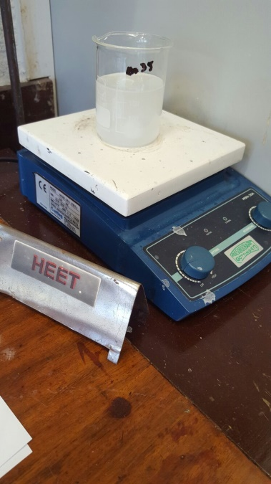
The experiment was done in two stages. The first stage was the reconstruction of smog through a reaction of the two chemicals. The reaction was expedited through the help of a magnetic stirrer, which could also heat up the beaker at the surface.

Figure 3: Magnetic stirrer stirring liquid in the beaker with a magnet
The second stage was the measuring with the program Coach 7. The set up looked the following:
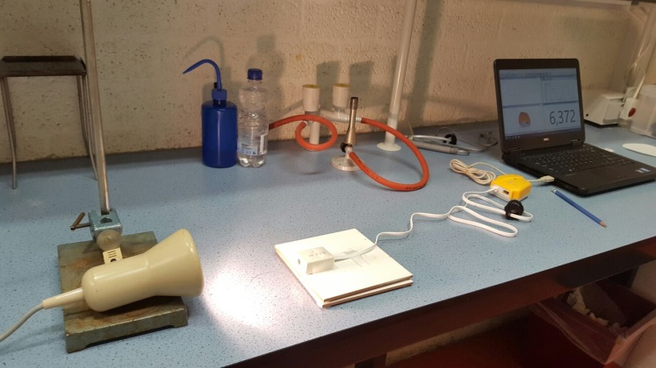
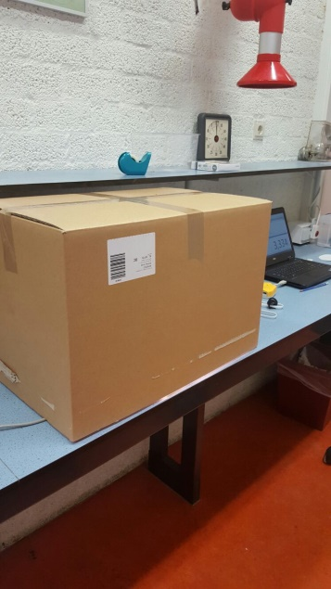

Figure 4: Measuring step-up (open)

Figure 5: Measuring set-up (covered)

Method
To reconstruct smog we used two chemicals which would react with one another. The chemical sodium thiosulfate was also diluted with demi-water to complete the reconstruction of smog, which would cause for cloudiness in the demi-water.
Creating Smog:
1. A specific amount of sodium thiosulfate was put in a beaker.
2. Specific amount of demi-water would then be added to be able to dilute to a specific concentration.
3. The hydrochloric acid is added to begin the reaction with the sodium thiosulfate.
4. A magnet is put in the beaker, which would stir the liquid inside with the help of a magnetic stirrer to facilitate the reaction.
5. After a while of stirring, the beaker would be transported to be measured.
Measuring:
6. On a table, place a lamp horizontally facing a light sensor. Make sure to leave room in between to place the beaker with the chemicals.

7. Use tape to make sure that the lamp and sensor will not move.

8. Draw a small line with the help of a pencil on the table between the lamp and sensor. Use this is as a reference where to put the beaker every time.

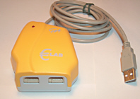
9. Put a box over the whole set up (lamp, beaker and light sensor) so any other light source will not interfere.

10. Connect the sensor to the Eurolab.
Figure 6: Eurolab
11. Connect the Eurolab to a laptop and start the program Coach 7.

12. Measure with a graph with one measurement a second. Measure for about a minute.

13. Calculate the average of the measurements and use it for the results.

The specific amounts of chemicals and demi-water added can vary for each experiment. So there are therefore many different dilutions you can make, causing the smog to intensify or weaken. In our experiment, there have been 7 measurements done, so 7 different dilutions:
Beaker 1: Regular demi-water
Beaker 2: 10x diluted sodium thiosulfate
20 mL hydrochloric acid + 20 mL sodium thiosulfate + 160 mL demi-water
Beaker 3: 20x diluted sodium thiosulfate
10 mL sodium thiosulfate + 10 mL hydrochloric acid + 180 mL demi-water
Beaker 4: 40x diluted sodium thiosulfate
5 mL sodium thiosulfate + 5 mL hydrochloric acid + 190 mL demi-water
Beaker 5: 30x diluted sodium thiosulfate
80 mL of liquid in beaker 2 + 160 mL demi-water
Beaker 6: 25x diluted sodium thiosulfate
70 mL of liquid in beaker 2 + 105 mL demi-water
Beaker 7: 35x diluted sodium thiosulfate
100 mL of liquid of beaker 3 + 75 mL demi-water

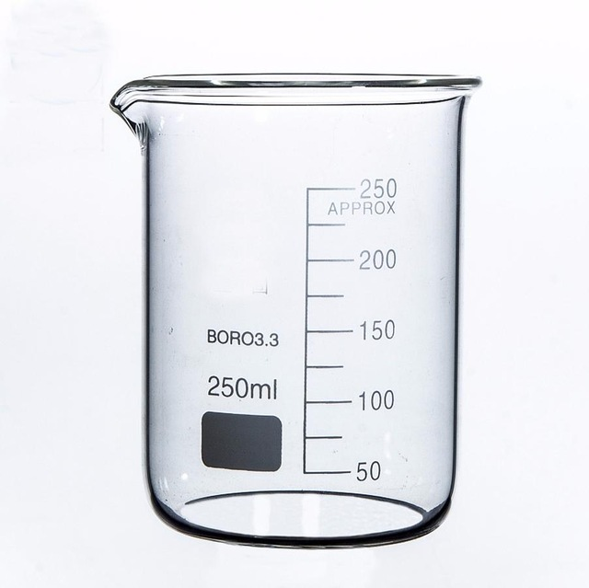

Figure 7: Beaker

Results
The results of the experiment were visible on Coach 7, and we collected the data we needed. For every dilution and for water the program put the results in a graph. The sensor measured the amount of light that came through the beaker with the (diluted) liquid. The amount of light is measured in kilolux (klx), which is 1 lumen/m². The 30x-diluted sodium thiosulfate was measured twice, and of those two averages there was a new average. The average amount of light for every dilution and water is shown in the chart below.
Dilution | Average amount of light (klx)
10x | 1,0
20x | 2,2
25x | 4,7
30x | 3,8
35x | 3,1
40x | 4,4
Demi-Water | 10,0

Chart 1: Average amount of light for each dilution.
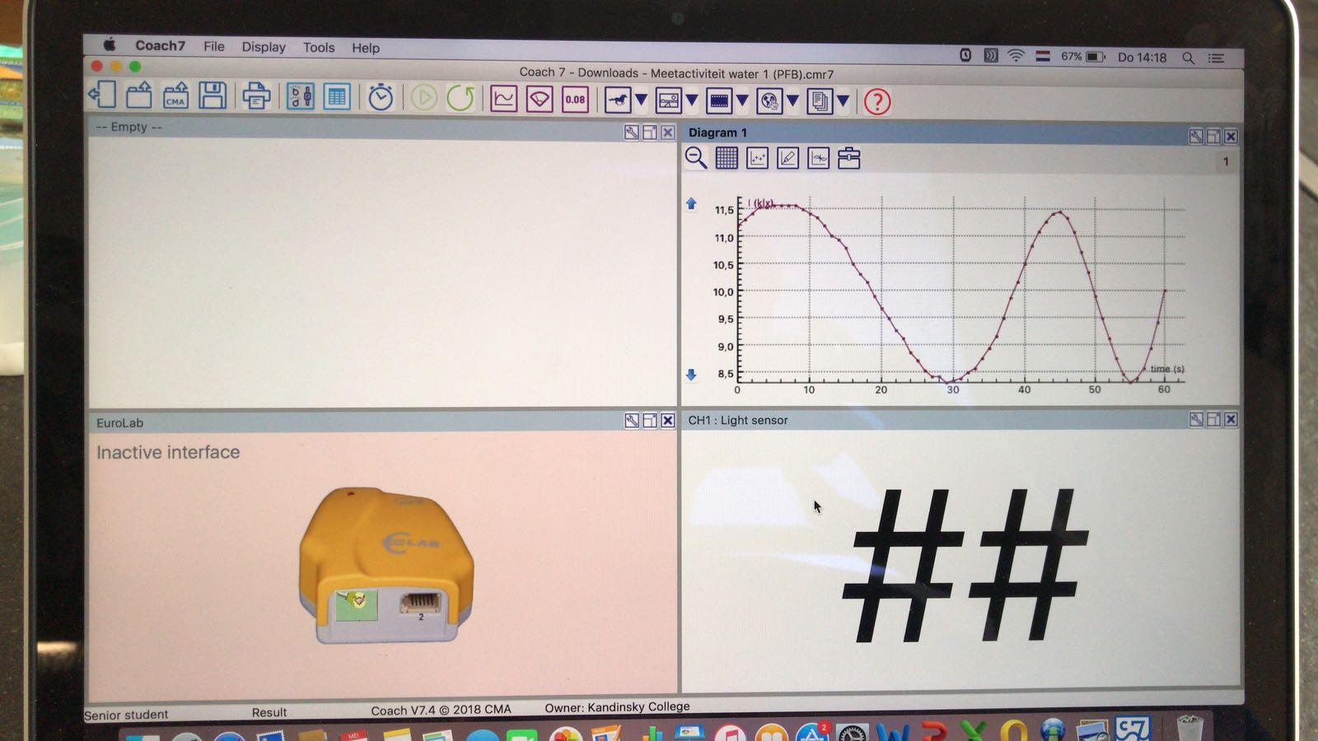

Figure 8: Coach 7 program

Conclusion & Discussion
Our expectations for the experiment matches more or less with our results. The more diluted one (40x) lets more light pass. The less diluted ones (10x and 20x) let’s in the least light. Ofcourse the beaker with only water lets the most light through, considering no ‘’smog’’ is present yet. The last three measurements of the dilutions do not follow our expectation. But a highly probable error was made with the stirring time, so not all of the chemicals could react in the beakers. Looking at the 10x diution and 40x dilution, you can see the increase of light that passes through. This can also be seen with the first three measurements. Our expectation is more or less right.
As our expectations, our hypothesis matches more or less with our results. Because a low dilution means a higher concentration, less light is passed through. The higher the dilutions are, the less concentration is present and therefore more light is let passed. As for our expectations, the last three do not follow our hypothesis. But this has to do with an error with the stirring, as mentioned before. But the difference in amount of light passed is clearly seen, when looking at our lowest dilution and highest dilution. This can be also seen in our first three measurements. So as our hypothesis states; when the concentration of smog is high, more light is blocked than with low concentrations of smog.

Feedback on execution: It went really well and everything was done according to the work method. It took some time to use Coach 7, but in the end it was manageable. There are some deviations like the measuring of the liquids, which were to be added. Also, a crucial deviation was the stirring time of each beaker. It therefore influenced our results and as a result the validity and reliability of the research as well.

Validity and reliability of this research is not a hundred percent right. The research question was to see how smog can affect light. Considering real smog, which is composed out of nitrogen dioxide, sulfur dioxide, ozone and micro dust, is quite toxic and difficult to recreate, an alternative was needed. This alternative had to be able to recreate the behavior of smog, which was also safe to do an experiment on. So, we used the reaction of natrium thiosulfate with hydrochloric acid and added demi-water. This created the cloudy look of smog in the water. The smog may not be completely real, but it gives a good idea in how real smog would affect light, considering that smog we created gave a similar cloudiness that affects the light. There was also a problem with measuring the liquids. Considering we used beakers, sometimes the added liquids were a little off from the planned amount to add. Lastly, the beakers were not all stirred the same amount of time. Some took longer and some shorter, so it was not known when all the natrium thiosulfate and all of the hydrochloric acid would be done with their reaction.

So an improvement that can be done to this experiment is to use real smog, but it will be quite difficult to measure it in the air. The smog will then have to be trapped in a glass container, where light can pass through. The right chemicals for smog will have to be present. Another improvement is to accurately measure the liquids, using a more precise measuring instrument. Ofcourse, the stirring should be improved. A higher dilution needs more times with the stirring. So enough time should be given for the reaction.
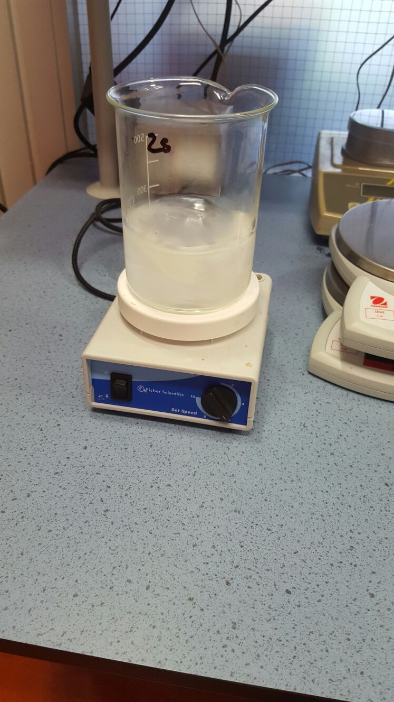
Aside from that, the experiment was done neatly and accurately. For example, in the experiment we used new beakers for each measurement, so we didn’t recycle. Also, the spot where the lamp, beakers and sensor has to be was marked, so the distance would be the same for all measurements. Furthermore, a box was placed over the whole measuring set-up to block off all light from other light sources. This way, only the lamp will emit light. It is also quite viable for the reason that we used the average lux in the sixty seconds that we measured.

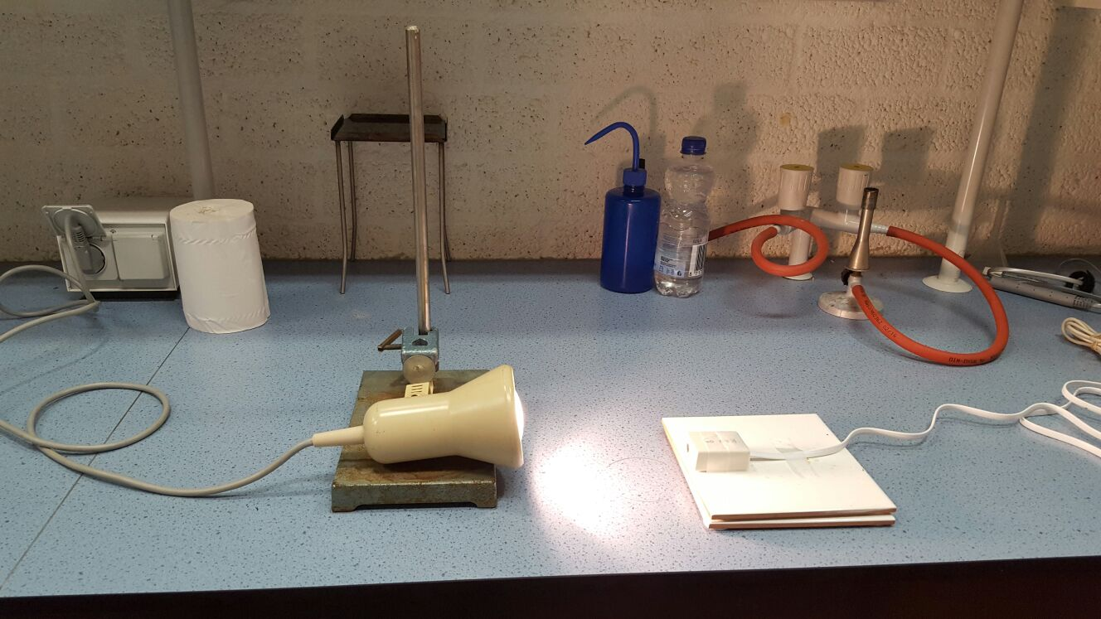

Figure 10: Measuring set-up (lamp and light sensor)
Figure 9: Beaker getting stirred by a magnetic stirrer

Sources
(1): Author: World of Earth Science (2003), Smog
https://www.encyclopedia.com/science-and-technology/biology-and-genetics/environmental-studies/smog

(2): Author: unknown, Factors affecting smog concentration
http://apollo.lsc.vsc.edu/classes/met130/notes/chapter18/smog_var.html

(3): Author: The Editors of Encyclopedia Britannica, Smog atmosphere https://www.britannica.com/science/smog

(4): Author: Christine Labelle, Main components of smog
http://publications.gc.ca/Collection-R/LoPBdP/modules/prb98-4-smog/maincomponents-e.htm

