Interactions Between Surface Temperature and
Select Winter Weather Parameters

Student Researchers:
Itidal Bazzi, Jelal Muflahi, and Cristian Sanchez

School:
Crestwood High School, Dearborn Heights, MI 48127

High School Science Teacher:
Mrs. Diana Johns

Date:
12 April 2019

Table of Contents:

Abstract……………………………………………………………………………………………3
Initial Research Questions………………………………………………………………………...4
Hypothesis………………………………………………………………………………………...4
Null Hypothesis…………………………………………………………………………………...4
Research Implications…………………………………………………………………………….5
Investigation Plan………………………………………………………………………………....6
Introduction and review of the literature………………………………………………………….8
Research Methods………………….…………………………………………………...…………9
Results…………………………………………………………………………………………....11
Discussion………………………………………………………………………………………..14
Conclusion……………………………………………………………………………………….16
Bibliography………………………………………………………………………………….….18
Badges……………………………………………………………………………………………18
Acknowledgements………………………………………………………………………………19

Abstract:
Daily surface temperature measurements are a significant and essential variable to consider while implementing strategies on working to develop a more complete understanding of how larger weather conditions, events, and patterns affect more local and microclimate sites. This research project was conducted at Crestwood High School in Dearborn Heights, Michigan; a suburban area approximately 18 miles away from the urban center of Detroit. A variety of daily atmospheric data was collected from January 10th, 2019 to February 10th, 2019. This research sought to investigate how surface temperature measurements either coincide in a directly proportional form, inversely related form, or lagged behind other atmospheric variables measured. An additional research goal was sought to determine the most significant factors affecting surface temperature fluctuations during select winter months. With Michigan’s unpredictable winter weather patterns, there were several varying weather conditions (wet, dry, sunny, windy, snow, etc.) throughout the study period. After analyzing the other select atmospheric weather parameters, we have come to a conclusion that there is a steady correlation between surface temperature and the three parameters: air temperature, relative humidity, and barometric pressure, also adding that later, percent cloud cover has an indirect correlation with surface temperature. Further research should be done to observe how atmospheric parameters affect the weather conditions at different latitudes, elevations, surface covers, and surface albedo including the effects of atmospheric disturbances locally and globally.

Research Questions:
-Initial Research Questions:
To what extent does surface temperature correlate with air temperature, relative humidity, surface cover, snow/no snow, wet/dry, and barometric pressure? How do instrumentation differences affect the results we obtained? Are the instruments we’re using affecting our accuracy and precision, if so, how? Do the regular fluctuations of surface temperatures affect the lag time between the following: air temperature, relative temperature, and barometric pressure? Did any atmospheric disturbances occur to vary our results? These questions were implemented into our research to lead our exploration of surface temperature and select winter weather parameters. These questions also will help us better understand our research and understanding of the parameters.

-Hypothesis:
Surface Temperature is affected by future air masses moving in causing barometric pressure to increase or decrease.
Uses of two different Infrared Thermometers does affect surface temperature measurements.
Extremely cold temperatures can cause many defects in our results and instruments used.
Areas that are shaded versus not shaded had significant differences in temperature readings.

-Null Hypothesis:
- There is no relationship between surface temperature and air temperature.
- There is no correlation between relative humidity and surface temperature.
- There is no significant correlation between barometric pressure and surface temperature.
- There is no difference in the presence of accuracy or precision between the Fluke 62 Max Infrared Thermometer and the Raytek AutoPro ST25 Automotive Non-Contact Infrared Thermometer.

-Why this is important / Research Implications:
- Data from NASA satellites on the deniers of climate change are typically inaccurate and only give us an idea of what's going on in the world because they only have sensors that cover large areas. So, by taking our own measurements, we are able to confirm our findings allowing for others to come with conclusions over any topic or climate concerns they have.
- We currently have endangered species, such as the Ash Tree and the Chimney Swift (an endangered bird), in Crestwood High School's local area. Allowing us to measure surface temperature and other atmospheric parameters will allow us to keep track of them and their behaviors weather that'll be through eating habits or growth in tree ring sizes.
- Local atmospheric parameters in our area can also affect one of the greatest things Crestwood is known for, our sports. Measuring the cloud cover and the other parameters we can also gather predictions to whether or not we would have to cancel a game whether it was soccer or track due to a thunderstorm or any occurs weather fluctuations.

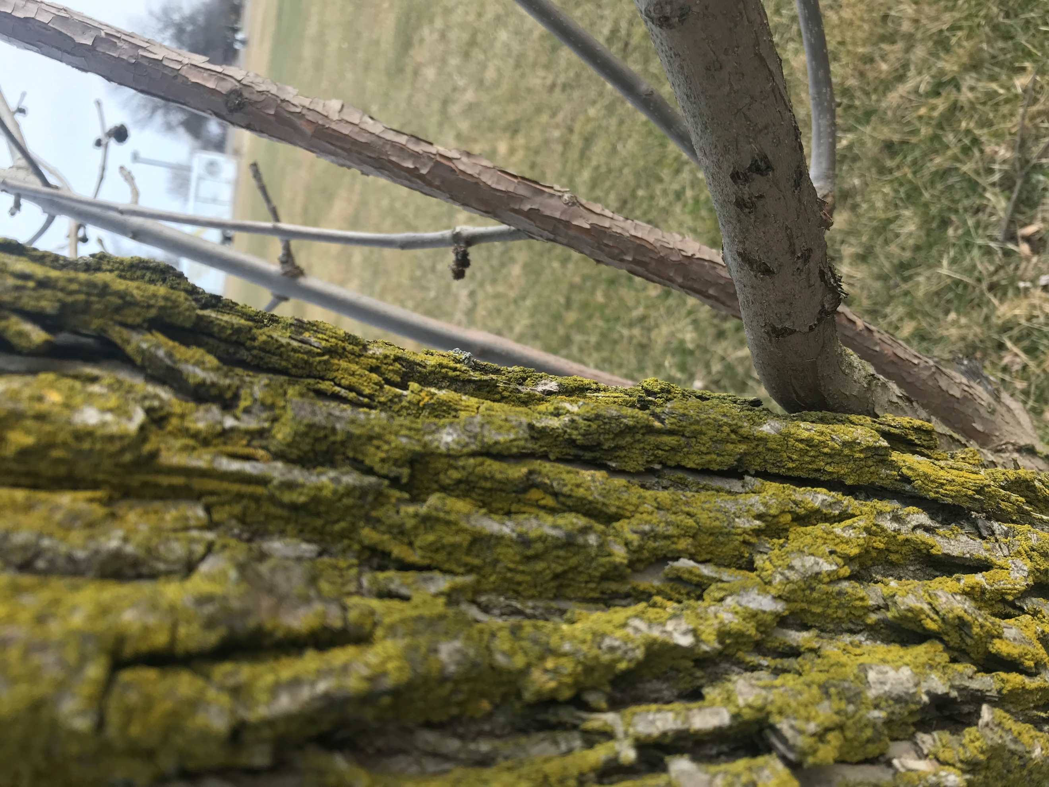
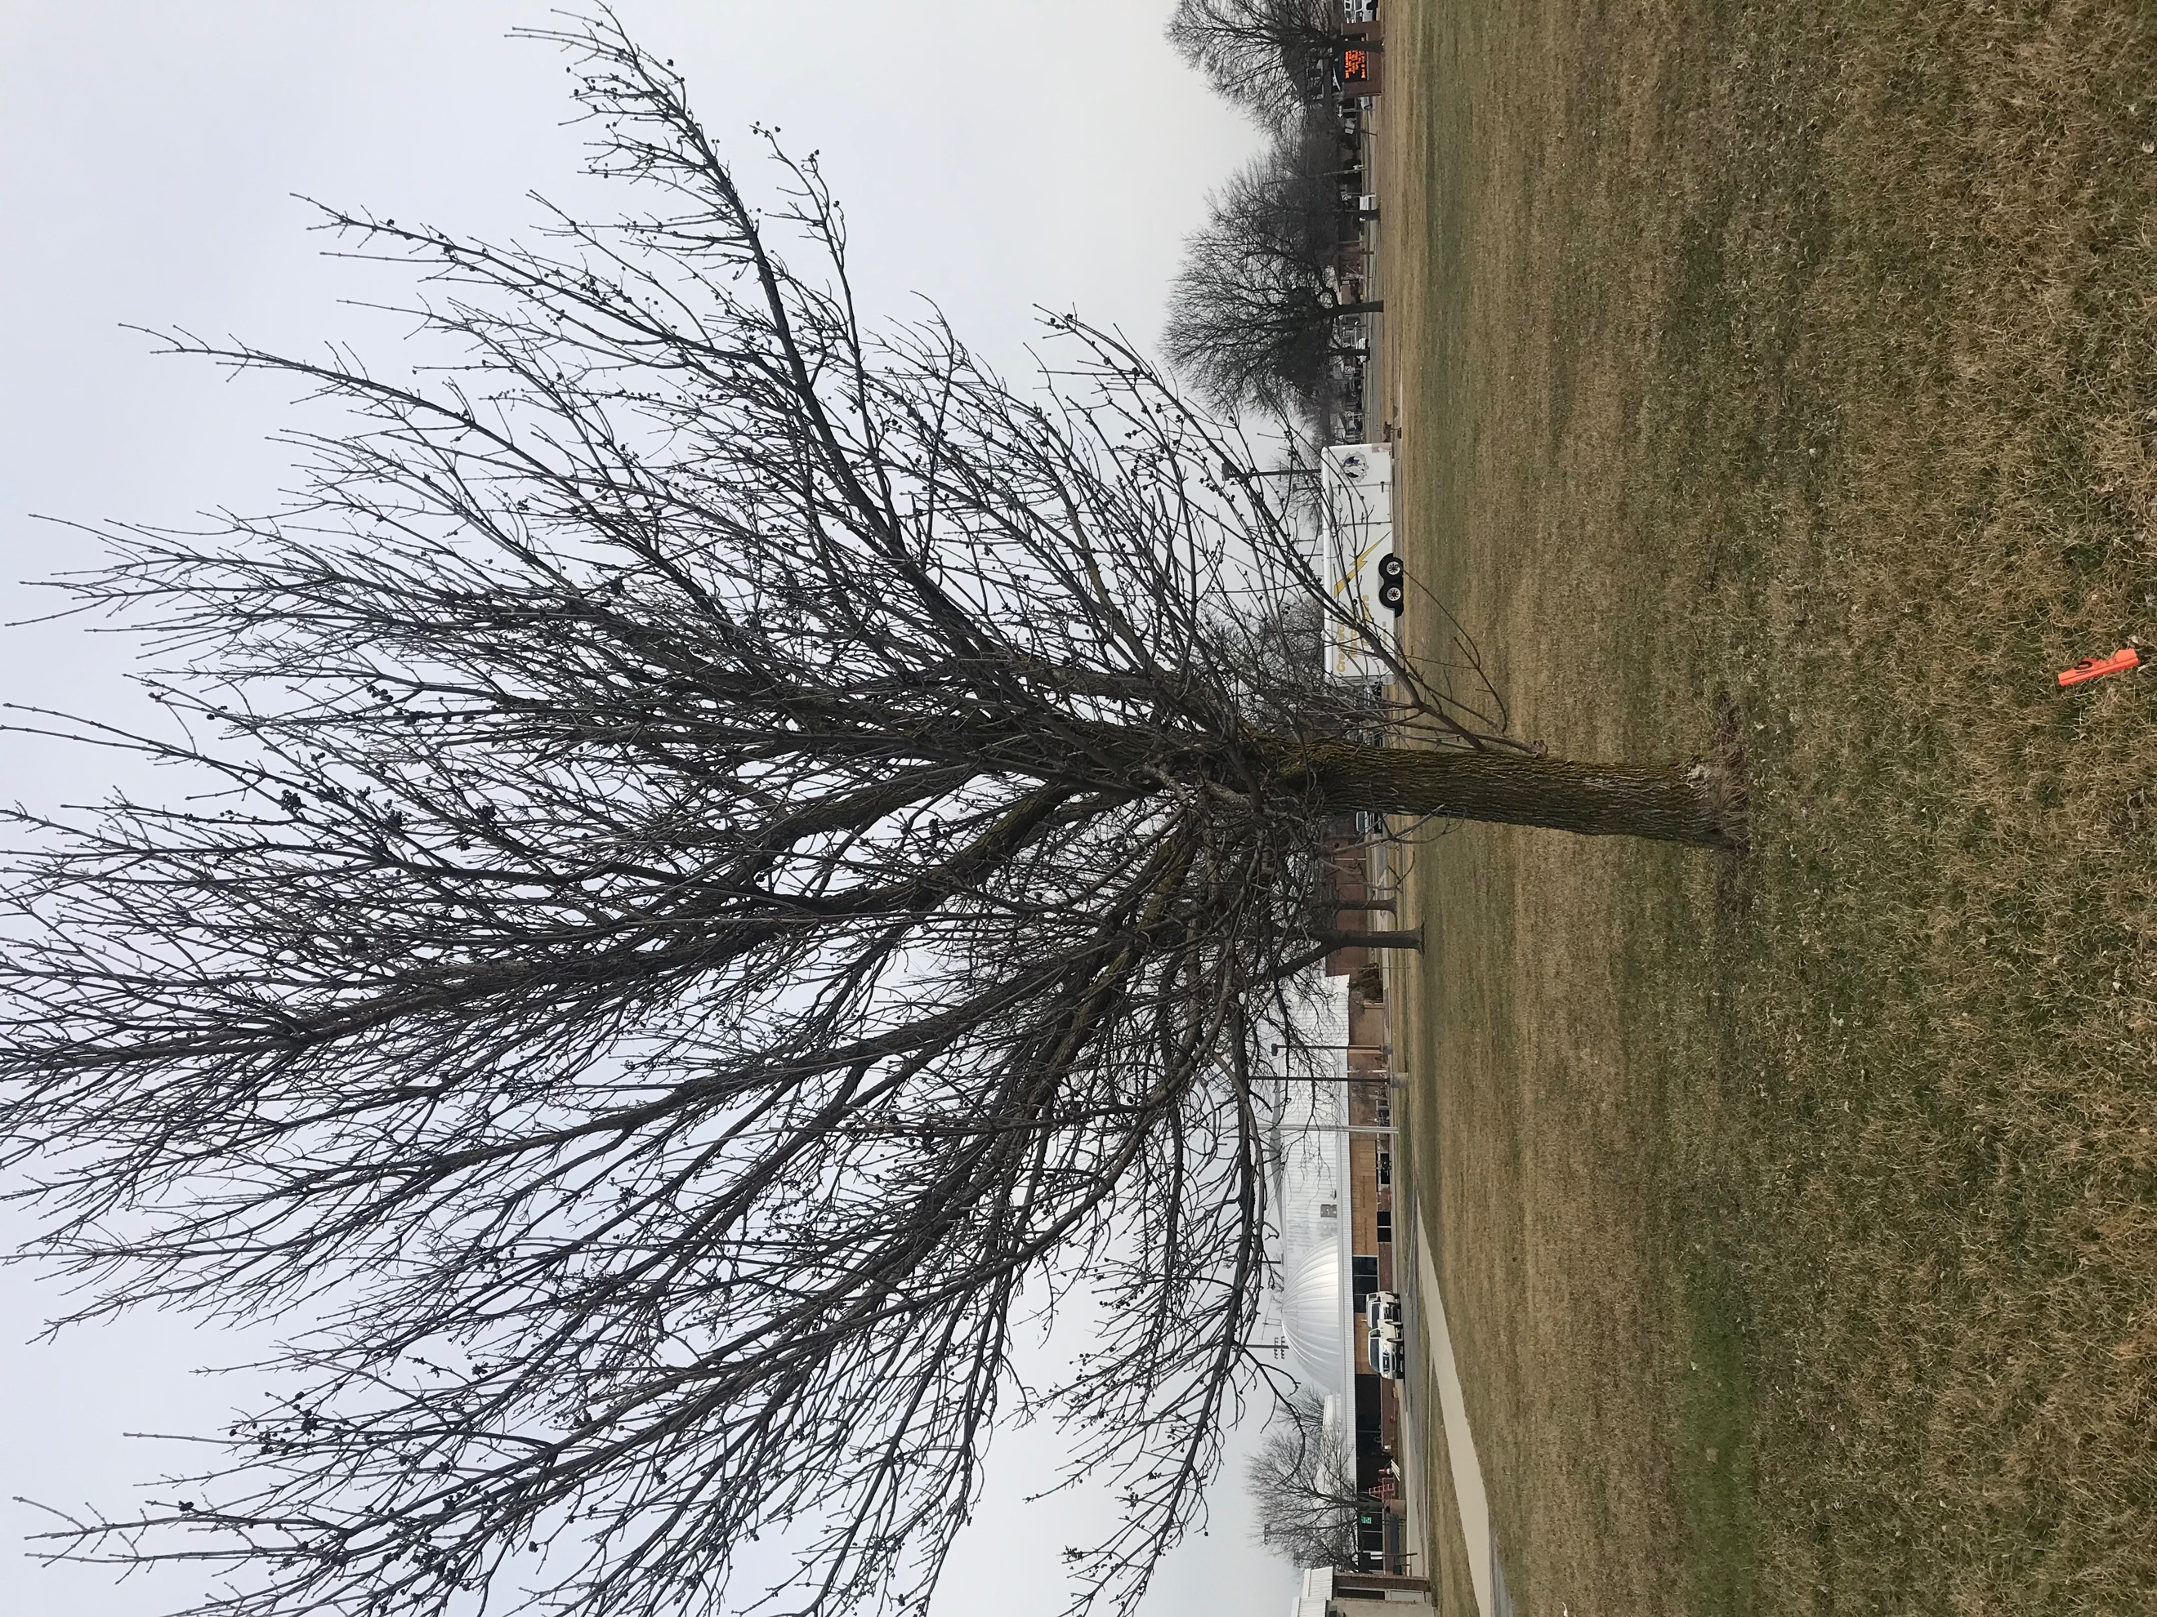

Figure 1-2: Figure 1 and 2 represents an Ash Tree in front of Crestwood High School where efforts have been put in to protect the endangered species.
-Investigation Plan:
A team of three (3) student researchers took measurements on surface temperature, air temperature, relative humidity, barometric pressure, and cloud cover percent daily for the past eight months of 2018 - 2019. Surface temperature was measured manually using infrared thermometers, the Fluke 62 Max Infrared Thermometer and the Raytek AutoPro ST25 Automotive Non-Contact Infrared Thermometer, data was collected as often as three (3) times a day, taking around 15 minutes for each recording. Data was taken in the morning typically around 8:00 A.M to 8:45 A.M varying 10 to 15 minutes depending if the students had academic interferences or atmospheric delays. Solar noon’s and any time after school ranging from 2:30 P.M to 3:15 P.M relying on whether or not Mrs. Johns was occupied was the organized way we collected data.

Figure 3: Figure 3 is an example off the GLOBE webpage of data recorded from January 2019- February 2019. Three (3) times a day was the minimum we tried to record data to provide the best accuracy.

Our research specifically focused on the select months of January 2019 through February 2019, this is especially important considering the irregular dips in surface and air temperature throughout the period, extremely low wind chills had also contributed to the selection of these two months as this is an unusual and rare phenomenon to experience in Michigan. Air temperature, relative humidity, and barometric pressure were taken every 15 minutes, automatically, with the WeatherBug Automated Station. Cloud cover percent was given for use by a NASA data specialist, Dr. Tina Rogerson, with many tables of data and continuous information but to receive a more local and precise data of cloud cover near Dearborn Heights satellite images were collected and studied. The site selected was an out of use football/soccer field behind Crestwood High School which was used for the surface temperature research. Nine areas were selected, all which are not covered by any shadows or shading of trees or school walls. Area six (6) was about five (5) ft. away the formation of a shadow caused by a tree; causing us to have to have measured that area including its shadow on some days. Data from the WeatherBug device was uploaded in the GLOBE database and as for the surface temperature, we have entered the data into a spreadsheet to organize the data which was then later entered into the GLOBE database.

-Introduction and review of the literature:

Surface temperature can have different issues causing unexpected outcomes. Micro climates are a great example of an issue because Crestwood High School is known for sports and temperatures can affect these activities. Different altitudes can also cause problems when trying to compare with different schools. Stated by, Effect of altitude and latitude on surface air temperature across the Qinghai-Tibet Plateau, Temperatures are affected by altitudes “The results show that temperature variations not only depend on altitude but also latitude, and there is a gradual decrease in temperature with the increasing altitude and latitude” (Keli Wang,Jia Sun, Guodong Cheng, Hao Jiang). At higher altitudes pressure decreases, due to the fact that the air molecules spread out, there for decreases the temperature. Changes in Surface temperature can affect the air temperature above and also other parameters. Changes in surface temperature can heat or cool the air above, an effect of these changes is air movement or wind. Surface temperature is an important parameter because it can affect and be affected by Air temperature, Barometric pressure, relative humidity, and cloud cover. Surface temperature can also measure net radiation and is important to agriculture. According to, climate impacts on Agriculture and food supply surface temperature can cause increases and decreases in productivity, “projected increases in temperatures, changes in precipitation patterns, changes in extreme weather events, and reductions in water availability may all result in reduced agricultural productivity” (Climate impacts on agriculture). Many farmers use surface temperature to monitor crops and vegetation. Surface temperature is important in our community because of the rare ash tree. Most of the ash trees in our community were wiped out because of the emerald ash borer. Emerald ash borers have adapted to survive in low temperature. According to, Effects of climate on emerald ash borer mortality and the potential for ash survival in North America, cold temperatures can kill EABs also known as emerald ash borers, “We found that between 1945 and 2012, while some Canadian locations experienced temperatures potentially cold enough to kill all EAB, very few locations in the United States experienced such temperatures” (DeSantis, Moser, Gormanson, Bartlett, and Vermont). During the January 30, 2019 to February 1, 2019, extreme temperatures occurred due to the polar vortex. This event has caused many of the Emerald ash borers to die off.

Research Methods:
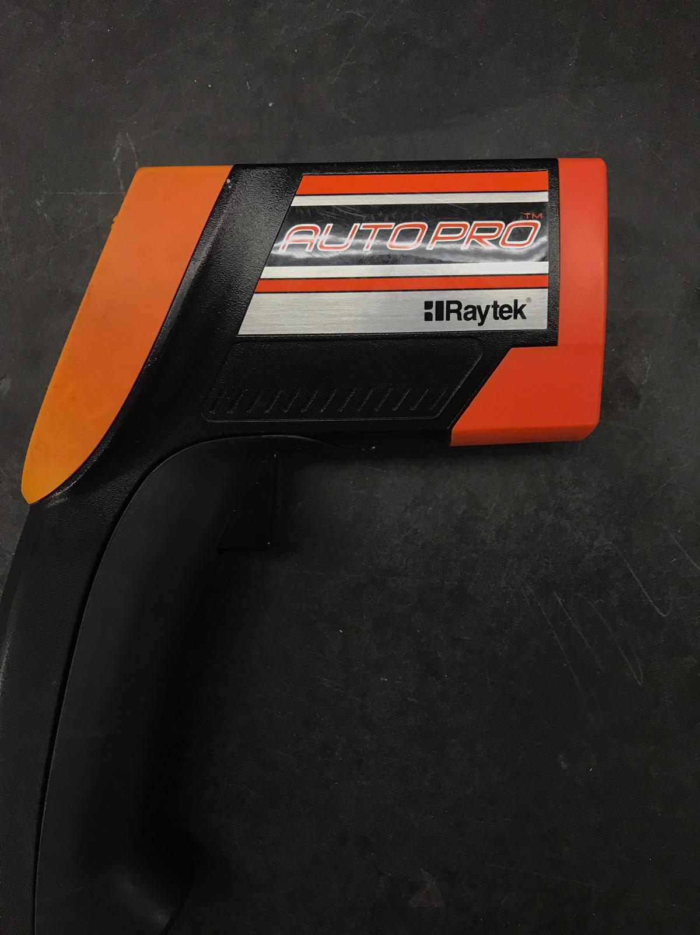
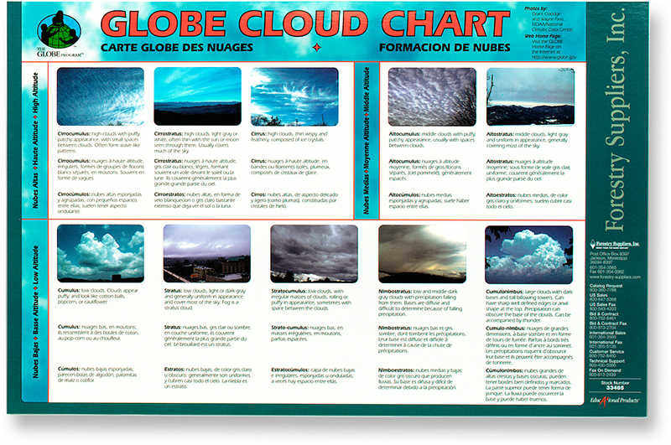
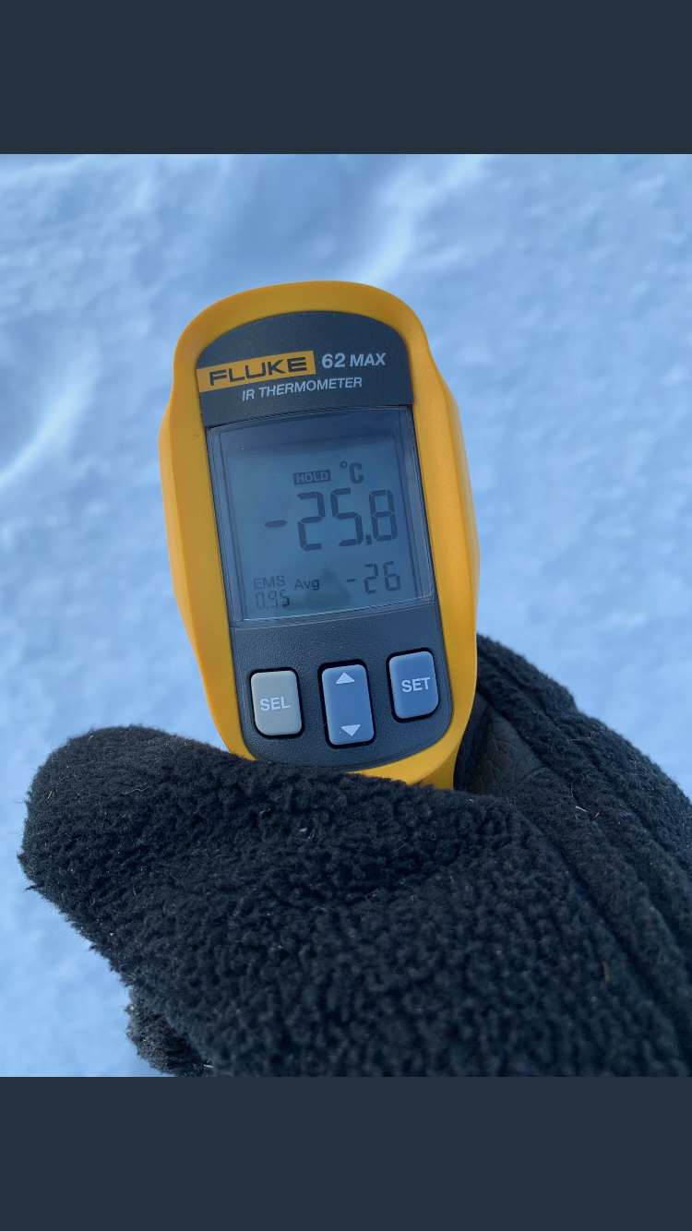
The soccer/football practice field is approximately 35 meters away from the backside of Crestwood High School’s right science wing near the staff parking lot (Precise Location: 42º19’16.07” N 83º17’40.50” W), this is where data was recorded manually by our Infrared Thermometers and our WeatherBug Automated Station. Nine sites were distinctly marked for research and data to collect surface temperature and one location for other select parameters. Manual readings for surface temperature were only accessible during school days and missed calculations and data occur from limitations to school grounds and the proper equipment needed to collect data. Data was collected as often as three (3) times a day for surface temperature, mostly aimed for collection near or during solar noon’s, but collection before or after school were also recorded. Surface temperature was collected manually by the AutoPro ST25- Automotive Non-Contact Infrared Thermometer and the Fluke 62 MAX Infrared Thermometer, both of which have a reading temperature limit of -30 °C.

Figures 4-6: Figures 4, 5 and 6 show the instruments that were used to take daily surface temperature readings, percent cloud cover, and cloud identification. Figure 2 and 4 are the two Infrared Thermometers (Fluke 62 max IR thermometer and Auto Pro Raytek) that were used throughout the research study to manually record surface temperature. Figure 3 determined the percent of cloud cover in the sky and the proper identification of cloud types and what atmospheric events may occur.

The Surface temperature protocol was a method that determined if the infrared thermometers needed to be replaced or were not calibrated. This protocol assisted us on answering our research questions whether or not there is a difference in accuracy or precision between the two infrared thermometers. Other select parameters that were chosen had been automatically recorded every 15 minutes or so by our WeatherBug Automated Station.

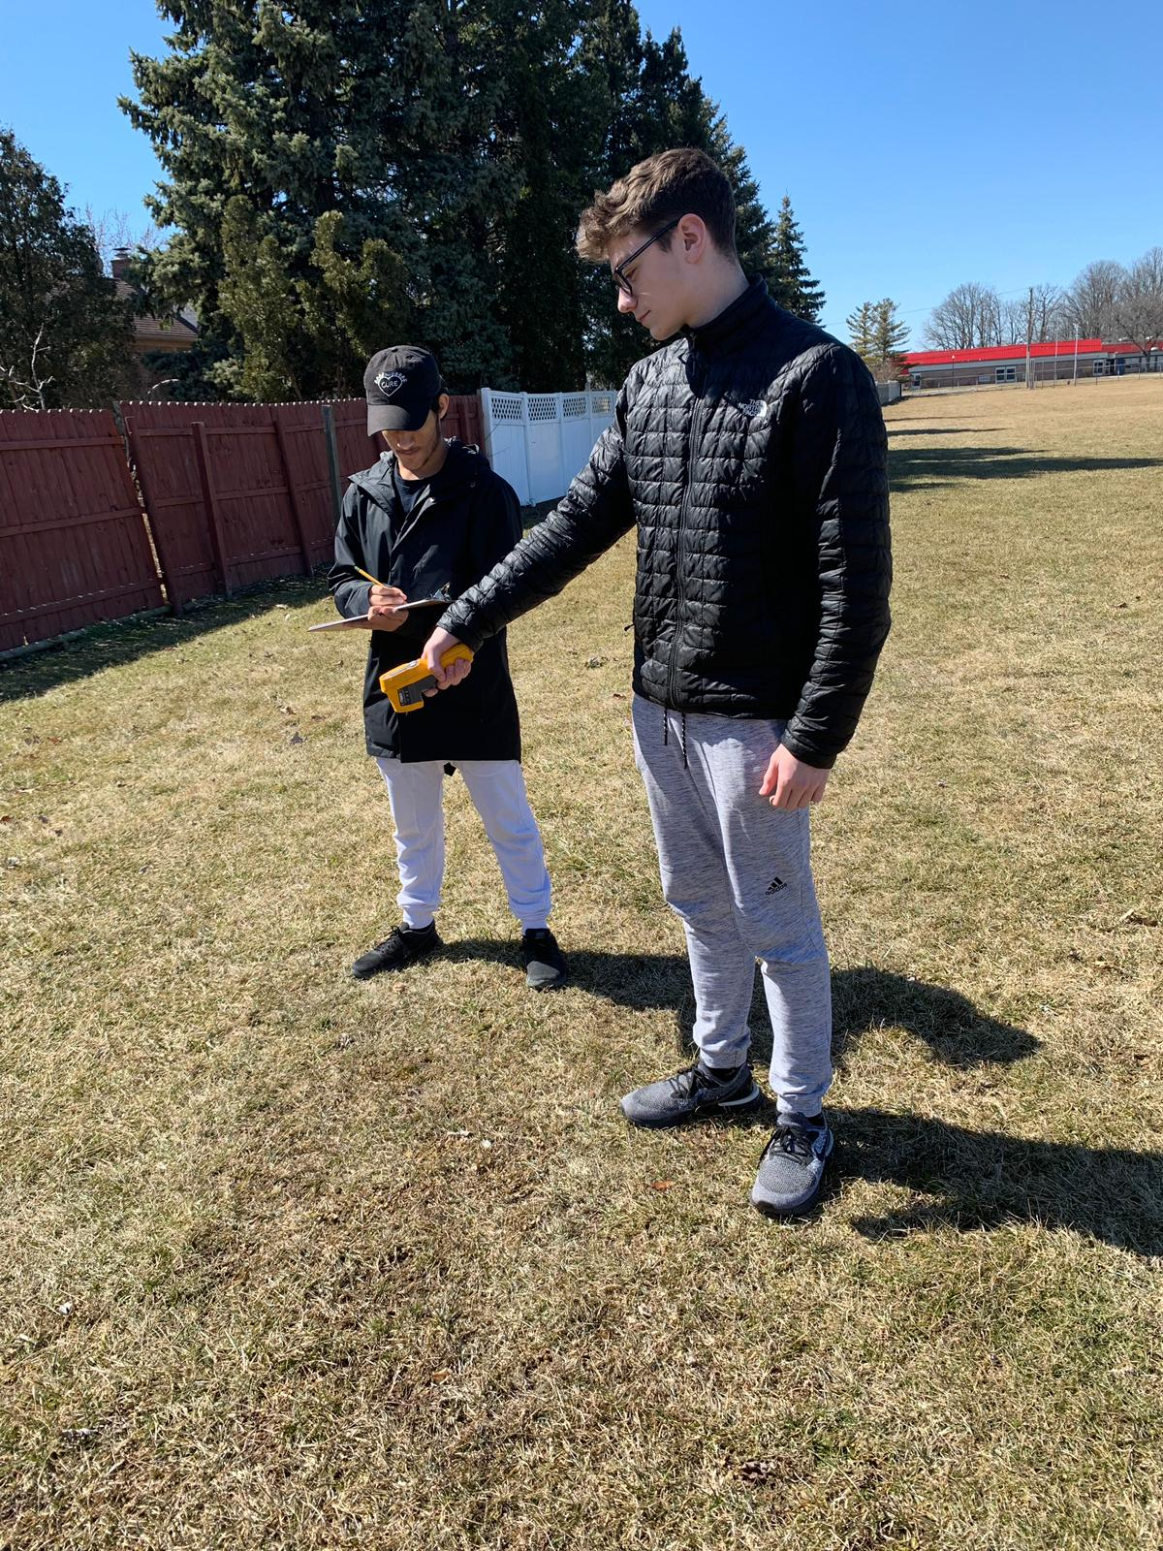

Figure 7-8: Figure 7 is a live demonstration of Cristian Sanchez and Jelal Muflahi taking our daily surface temperature readings. Figure 8 shows our WeatherBug Automated Station approximately projected 9 meters off the ground where current surface temperature is taken. The WeatherBug Station records air temperature, relative humidity, and barometric pressure every 15 minutes, daily.
-Results:

Figure 9: Figure 9 includes the comparison of Surface Temperature Vs. Air Temperature Vs. Relative Humidity this is comparing surface temperature data that was collected from the Fluke 62 IR Thermometer and other weather parameters from the WeatherBug device. The graph shows a correlation between relative humidity, surface temperature, and air temperature. But due to a thermal inversion from January 26th to February 1st showing an inverse correlation between surface temperature/relative humidity and air temperature.

Figure 10: Figure 10 shows the correlation between surface temperature and relative humidity. there was an inverse correlation between the two. As surface temperature rises the relative humidity decreases, this will always happen unless certain circumstances. This is due to the fact that warmer air moisture contains more moisture then cooler air causing relative humidity to be inversely related.

Figure 11: Figure 11 demonstrates a graph on the correlation between barometric pressure and surface temperature. Typically surface temperature and barometric pressure have a correlation between the two being directly proportional, however, when surface temperature is warm enough it’ll cause the barometric pressure to not correlate and possibly become inversed. This is the main effect of a Thermal Inversion.

Figure 12: Figure 12 exemplifies that surface temperature and air temperature have a significant correlation with each other but then around January 26th - February 1st there is a flip and it becomes an inverse correlation between the two. This is also around the time of the Polar Vortex, therefore the possibility of it being a cause is highly probable.

Figure 13: Figure 13 shows a graph on surface temperature and cloud cover percent. There is no correlation between the two. The percent cloud cover is mainly affected by the atmospheric masses moving through rather than surface temperature.

Figure 14: Figure 14 is the first table of data recorded for surface temperature, three (3) times a day, for at least 15 minutes, at nine (9) sites.

-Discussion:
The results concluded that only air temperature and relative humidity have a directly proportional correlation to surface temperature, while barometric pressure and cloud cover have little to no direct correlation to surface temperature. Air temperature had a direct correlation to surface temperature until January 31, 2019. From January 31, 2019 to February 1, 2019 there was a missing day in all the graphs do to the incoming polar vortex and also the creation of an inverse correlation. Recent studies implied that since surface temperature levels were so low that stored heat below the surface rises to keep living organisms alive causing a warm layer above the surface as well with the existing cold layer above causing a thermal inversion. Relative humidity had an inverse correlation with surface temperature. As surface temperature rises the relative humidity decreases, however around the time of the vortex the temperatures became directly proportional to the rest of the graph, switching once again. Barometric pressure is also directly proportional to surface temperature throughout the graph, the polar vortex is also responsible for this switch. With students also focusing on their academics a normal school day consists of interruptions and reasons why data can and cannot be collected. Being off from school also caused for a delay for a record six (6) days during our study period and restrictions on school grounds. Mrs. Johns had offered to collect the data for the days we were prohibited on school grounds. Even leaving class could be a hassle to take readings because of tests, group activities, thunderstorms, etc. Another source of error during January 30, 2019 - February 1, 2019 data was not recorded by our WeatherBug Automated Weather Station. Coming to the belief that the extreme wind chill and cold temperatures led to temporary malfunctions in our instrument. Extremely low temperatures also appear to affect the proper functioning of our battery operated infrared thermometers. Typically, the use of a thermal mitt isn't recommended but instead let the instrument acclimate to the outdoor temperatures for an hour as indicated in the GLOBE protocols. This made it unmanageable to get accurate readings on some days (comparisons) Our hypothesis on accuracy between the two infrared thermometers, Fluke 62 max IR thermometer and Auto Pro Raytek, stated that there would be a difference in temperature. In our results, there was a defect in all the graphs due to extreme weather. The unpredicted atmospheric conditions were too severe for the infrared thermometers and for the WeatherBug instrument to take. The max reading temperature is 30°C for the Fluke 62 max IR thermometer and the temperature from January 30, 2019 - February 1, 2019 exceed the temperature limit for the thermometer causing a blank spot in our graph, it also caused the probes and the anemometer of the WeatherBug machine to have malfunctions in the data.
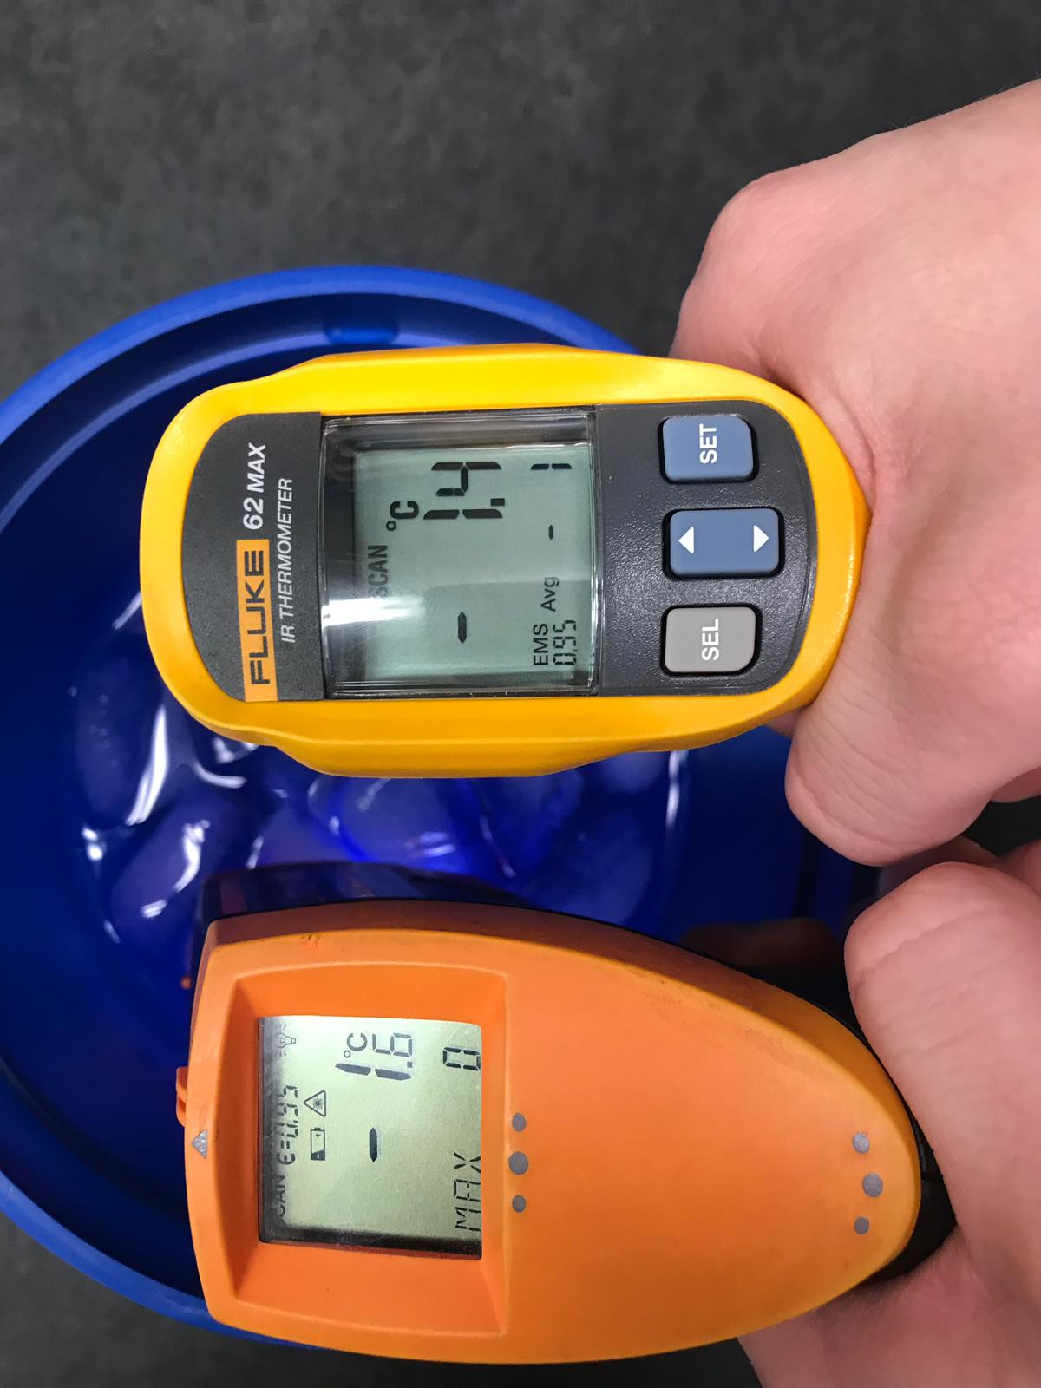

Figure 15-16: Figure 15 shows the water ice bath solution on how to properly calibrate our Infrared Thermometers, meeting the requirement of -2°C to 2°C. While figure 16 is Itidal Bazzi and Cristian Sanchez testing the precession and accuracy of the Infrared Thermometer.

-Conclusion:
After gathering measurements on surface temperature, air temperature, relative humidity, barometric pressure, and percent cloud cover observations brought to light new incidences. Among one of those incidences is the significant correlations between surface temperature, air temperature, and relative humidity. Although, surface temperature has very little correlation with percent cloud cover, it is still existent. Also, there seems to be an inverse correlation between surface temperature and barometric pressure, however, there is a short delay in barometric pressure showing a correlation but on a lagged time difference. The Fluke 62 Max Infrared Thermometer seems to give better precision to provide useful data than the Raytek AutoPro ST25 Automotive Non-Contact Infrared Thermometer which was only 13% accurate against the opposing 21%. Our research provides us with many important information. Such as atmospheric conditions that can occur, they tell us whether or not we should cancel our school events, they let us know about endangered species, such as the ash tree and chimney swift, and finally we gather better and more accurate data on our local environment and temperature rather than the satellite images NASA gives us which is typically inaccurate because they cover a large area and are a medium of them. There are room for improvements within our methods. We believe we should have more times where other students also take measurements also to have students already doing surface temperature to make sure they are collecting correct data. We also believe we can improve in the IR thermometer we are currently using to get more accurate readings in our data. In the future, we would like to see if our graphs and research trends continue. We would also like to see how our results compare and differ at different elevations and at different latitudes. For instance, we would like to compare our data with others locally and globally i.e. Croatia, Taiwan, Wayne State University, etc. Also for altitudes we might use various different types of kites and balloons and at different locations around Crestwood. We would love to see how our data this winter compares to the next especially because we have had a interesting winter with this year’s Polar Vortex. Lastly we would like to see how surface temperature correlates with the other research projects students at Crestwood are working on. For example, there is a research group working on how light pollution correlates with Photinus pyralises, fireflies, and we would like to see if there is any correlation between surface temperature and light pollution and if there is if there is between surface temperature and Photinus pyralises. Working with former researchers such as Leanne Alawieh, Jordan Horton, and Dr. Kevin Czajkowski (Mission Earth-University of Toledo) was very beneficial and interesting. Leanne helped us greatly with the graphs and how to create them. Jordan Horton gave us a lot of input and topics with things that correlate with surface temperature. Dr. Kevin C. provided us with the surface temperature protocols and really intriguing us in this project.

-Bibliography:
Davies, R. & Waggoner, P. E. Climate. Encyclopædia Britannica (2019). Available at: https://www.britannica.com/science/climate-meteorology/Relation-between-temperature-and-humidity. (Accessed: 1st April 2019)
Relations between Surface Temperature and Air Temperature on a Local Scale during Winter Nights. Relations between Surface Temperature and Air Temperature on a Local Scale during Winter Nights: Journal of Applied Meteorology: Vol 39, No 9 Available at: https://journals.ametsoc.org/doi/10.1175/1520
-0450(2000)039<1570:RBSTAA>2.0.CO;2. (Accessed: 1st April 2019)
Brennan, J. What Happens to Relative Humidity as Air Temperature Rises? Sciencing (2019). Available at: https://sciencing.com/happens-relative-humidity-air-temperature-rises-22563.html. (Accessed: 1st April 2019)
The materials included in the research project are the Fluke 62 max IR infrared thermometer, the Raytek Autopro ST25, Globe cloud chart, and the WeatherBug instrument. Sources that were provided beyond Globe were previous Globe participants. Previous globe participants, Jordan Horton, assisted us with input on topics and questions regarding surface temperature.

Badges:
Data Scientists: Daily we would take measurements of surface temperature, cloud cover, snow depth, etc. These were all major contributions to our answering our research questions and all hypotheses we have had during testing. We have uploaded all our data recorded into the Globe database and then we have analyzed that from charts and graphs we have made from the Globe’s visualization system.

Collaborator: To make sure we have had sufficient data we have trained and worked a lot with students from the same school. It has played a big role in allowing us to have got all the data we needed throughout the day and it was always good to have a second eye on your paper or results. Also, the understanding how to properly access data or analyze data with these students proved they were a key to completing this research. Lastly working with others has made this research very fun and competitive in a good way which has always kept us going and wanting to keep pursuing this.

Acknowledgements:
We would like to give a special thanks to:
- Mr. David Bydlowski and Dr. Kevin Czajkowski for providing the free transportation and housing to the Iowa trip and helping pay the expenses of our research equipment.
- Mrs. Johns for introducing us to GLOBE and giving us the chance show ourselves worthy of this research. We will also like to thank her for giving up her weekends and time after and before school to help us and answer any questions we have had.
- NASA data specialist, Tina Rogerson, for giving us correct data on cloud cover.
- Ali Eter and Sara Komaiha for guiding us with their ideas and thoughts on our research.
- Leanne Alawieh away for assisting us on our graph making and the logistics of the research.
- Nathan Johns for recommending how we should have our poster laid out and correcting any mistakes.

