Date: 15th of March 2016
Subject: Hydrology report made by students of Dalton Den Haag
1. Introduction
A few months ago, there was word of a remarkable pond that would instantaneously catch anyone’s attention. Contrary to other ponds in the area, this pond was half-covered with red stuff floating on top of it. There was no detectable form of life in the pond, even though it is located on the edge of a forest! Since the cause of these conditions was yet unknown, a research project dedicated to this river would be of great benefit and has therefore become its aim.
2. Research question and hypothesis
With remark to the introduction, there were two main questions/reasons to investigate this area, listed accordingly:
1) What is the red stuff that floated in the pond?
Hypothesis: the red stuff is most likely algae, indication that the pond is probably rich of, for instance, phosphorus and nitrogen, but the red stuff could also be iron.
2) Why is there no detectable form of live in the pond?
Hypothesis: if the red stuff were to be algae, than the algae is probably already far enough in its circle of killing every organism in the pond. If it were to be iron, than the nearby construction site or industry is probably causing a lot of trouble for Mother Nature.
3. Investigation plan
In order to conclude something about the situation in the ‘lifeless’ pond (pond 1), it will be compared to a ‘normal’ pond (pond 2). Pond 2 has a weak current. These are the coordinates:
Pond 1: 52.037312, 4.225583
Pond 2: 52.067024, 4.239039
Plan pond 1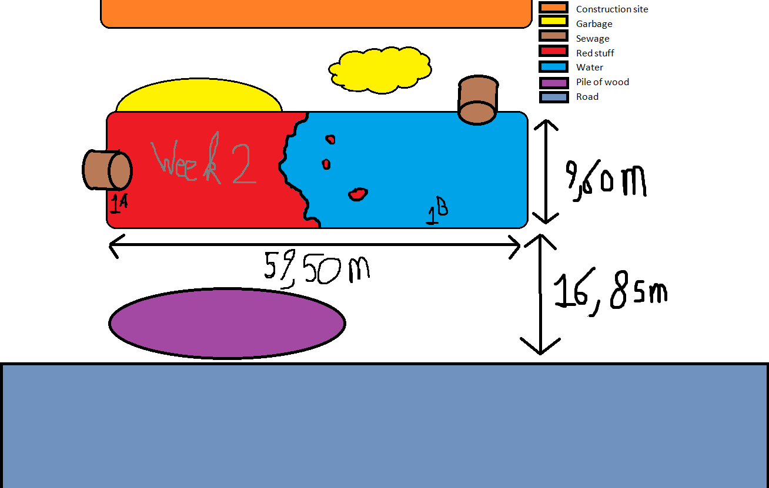
Plan pond 2 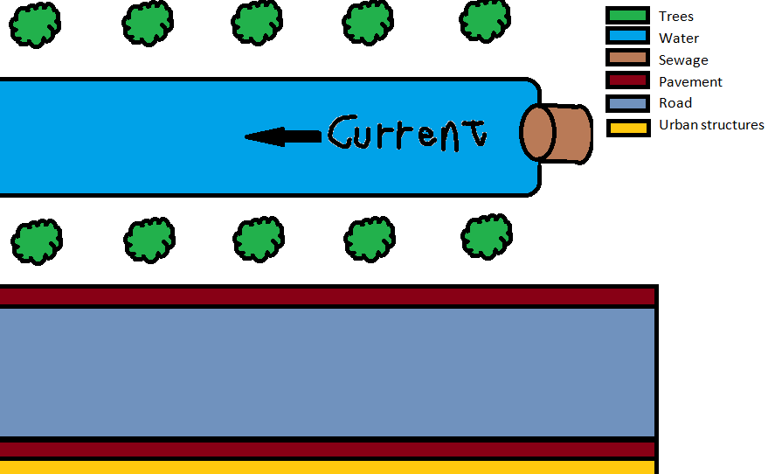
Four measurements would be taken in four consecutive weeks. On the first research day (Thursday 17 march), the water was only tested after 20 hours since the incubation. Therefore second research day was moved to Friday (25 march) to ensure that the water would be tested within 2,5 hours of incubation. The third and fourth measurements were also taken on a Friday, respectively on Friday the 1st and 8th of April. To give a quick overview:
The 1st week lasted from the 14th of March till the 20th of March.
The 2nd week lasted from the 21st of March till the 27th of March.
The 3rd week lasted from the 28th of March till the 3rd of April.
The 4th week lasted from the 4th of April till the 10th of April.
In the next chapter is a list of the investigated matters.
4. Research method
The means which were provided by school allowed the project to investigate the level of oxygen, nitrogen, phosphorus and the pH value of the water. The testing of these characteristics were all condemned with research kits of the brand Hach, the model was Visocolor. In order to test the water, the kit required that a certain liquid would be added to the water. By comparing the darkness of the colour to prescribed values, an estimate could be made of the present amount of that substance in the water. All the testing has been done in the school laboratory. On top of that, a record was made of the weather, wind direction and penetration of the light.
Note: in the first week, there was no access to an oxygen test nor was the water of pond 2 tested.
At the end of the report, there will be some pictures of pond 1.
Oxygen (mg/l) | Week1 | Week 2 | Week 3 | Week 4
1ª | - | 7 | 10 | 7
1^{b} | - | 10 | 10 | 10
2 | - | 10 | 10 | 10

NO3 (mg/l) | Week 1 | Week 2 | Week 3 | Week 4
1ª | 5 | 10 | 3 | 7
1^{b} | 6 | 10 | 6 | 6
2 | - | 3 | 2 | 2,5

PO4 (mg/l) | Week 1 | Week 2 | Week 3 | Week 4
1ª | 1,7 | 1,0 | 1,2 | 2,5
1^{b} | 0,9 | 1,0 | 1,0 | 2,5
2 | - | 0,05 | 0 | 0,9

pH | Week 1 | Week 2 | Week 3 | Week 4
1ª | 7,5 | 7,5 | 8 | 8
1^{b} | 7,5 | 7,5 | 8 | 8
2 | - | 6,5 | 8 | 8

Furthermore, with help of a secchi disc, the discovery was made that the light was clearly able to reach the bottom of both ponds.
In pond one, the light was able to reach the 34 cm deep bottom.
In pond two, the light was able to reach the 42 cm deep bottom.
Additionally, with the wind records, it was uncovered that the wind direction was the deciding factor for the location of the algae.
Weather | Week 1 | Week 2 | Week 3 | Week 4
Average measurement day temperature | 6,9°C | 7,1°C | 8,7°C | 8,2°C
Average week temperature | 6,2°C | 8,4°C | 10,0°C | 10,1°C
Wind direction (pond 1) | East | West | East | West
Location of the algae  (looking from the roadside, pond 1 only) | East | West | East | West
Note: the wind direction was empirically tested and is therefore, although it was each time conducted by a pair, only a general direction. Sadly enough, there was no access to wind-determining equipment.
5. Found data (compared)
The data was compared to the data of a river with quite similar characteristics. Although it is not unique to pond 1, it was the most identical river found with measurements not older than 5 years. The river’s ID number is 8725 and the Pasvalys P. Vileisis Gymnasium has conducted the measurements. The measurements start in 2008 but, in order to have a more accurate comparison, there was decided to only compare these measurements with the measurements of the other school that have been made after 2011-04-07.
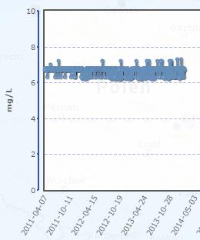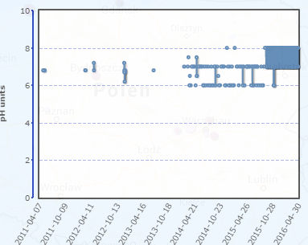
As the data shows, the consecutive measurements remained quite constant with, of course, a few little exceptions. However, what is most worrisome about pond 1 is that in week four, the oxygen level suddenly dropped with a difference that the 1023 counts of the other school have never experienced before. This is a good indication that there are actually algae in pond 1 and that they are already at the stage where they ‘remove all the oxygen from the water’. The difference between week two and three can be explained by the fact that the algae were in the ‘phase’ where they reproduce a lot and create a lot of oxygen. ^{A}
6. Data analysis
Oxygen
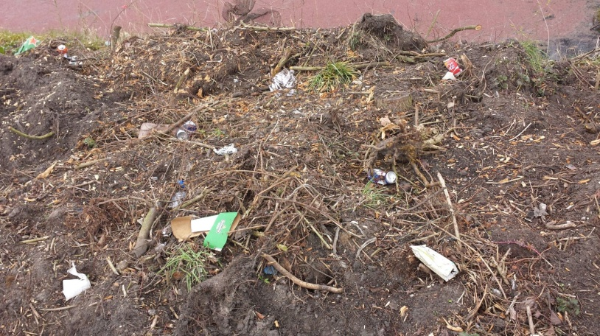
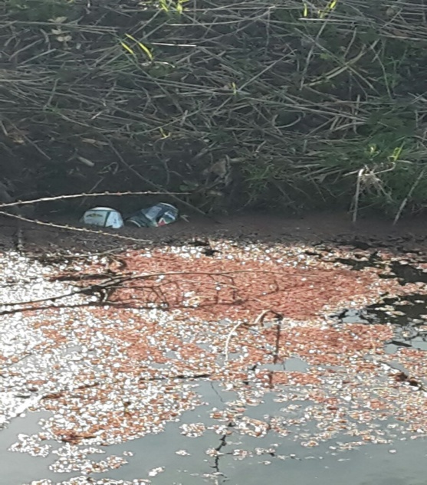
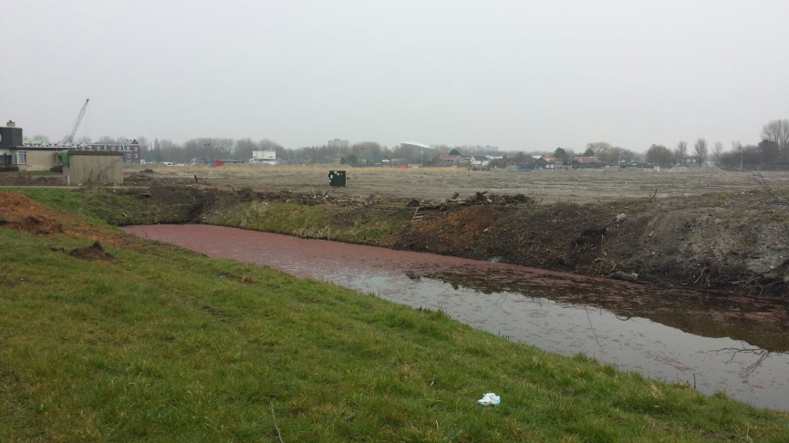
From the results can be concluded that the pH and oxygen levels are almost completely the same in both ponds, so these are likely not the reason why there is life in one pond and none in the other. However, we also see that the pond with the algae (samples 1ª and 1^{b}) have higher amounts of NO3 and PO4. These are both important nutrients for the algae to grow. The algae blocks a lot of light from coming to the bottom of the pond, and the pond itself is very shallow. The light can only reach the surface. Because there is no access to light for other river-dedicated forms of life, it is quite difficult for a circle of life to be created there.
7. Conclusion
Concerning research question 1: the ‘red stuff’ floating on the surface of the water is algae. Due to the wind, it moved to a different side of the pond every week. Because of the high amounts of NO3 and PO4, the algae grew in almost perfect conditions. Pond 2 on the other hand had less NO3 and PO4, therefore there is a smaller chance of algae-growth occurring.
Concerning research question 2: living organism such as fish (actually almost everything but algae) are rarely found in ponds with a large amount of algae on the surface. This would partially be caused by an insufficient amount of sunlight breaking through the surface, due to the algae acting as some sort of barrier. Also there can be concluded that living organisms are not found in the pond 1 because it is near a construction site and an industrial area, meaning that it can easily be polluted. Combined with the fact that the water is very shallow, this pond is incapable of ‘housing’ fish. This also explains why the other pond did have fish living in there: there was more nature (trees, grass, flowers) surrounding the area and no industry or constructions sites. Therefore, it is less struck by pollution.
8. Discussion
After a re-evaluation of the condemned research, one will notice that the research report would actually benefit if a search for living organisms would be supported by tools that enable one to look beyond the restrictions of the human eye to eliminate the possibility of doubts arising. On top of that, it was discovered, during the fourth time of analyzing the measurements that a mistake might have been made with measuring the PO4, which is one of the possible explanations for the deviating results. Furthermore is the week one research result a bit off since the water was only tested after 20 hours since incubation. At last, it would be wise for the next group to have access to wind-determining instruments to get a more accurate result. Therefore, it would be wise to set up a second research operation to, for instance, re-check the PO4 values and to use more tools to find living organisms. Additionally, a second set of oxygen measurements is critical either to make the algae theory incontestable or to erase all the discussion by proving that the week four measurement was just off.
9. Bibliography
http://www.ecy.wa.gov/programs/wq/plants/algae/lakes/AlgaeInformation.html - algae information
http://www.hetweeractueel.nl/weer/den-haag-wateringse-veld/historie/2016/03/ - weather reports
https://www.google.nl/maps/ - coordinates of the ponds
http://vis.globe.gov/GLOBE/# - data comparison site
10. Pictures of pond 1
Direction: Downward
Direction: East
Take note of all the garbage.
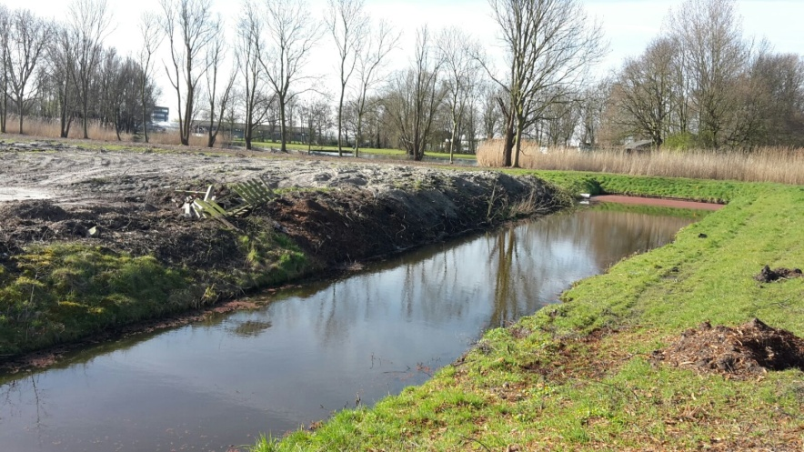
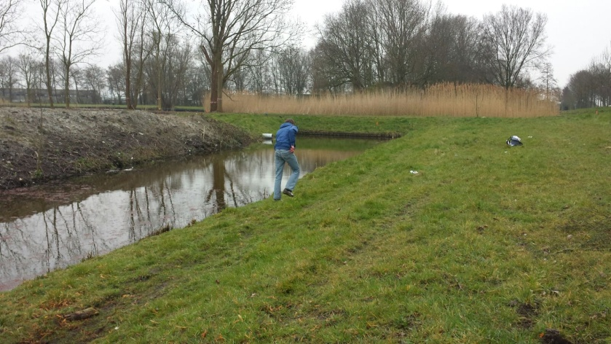
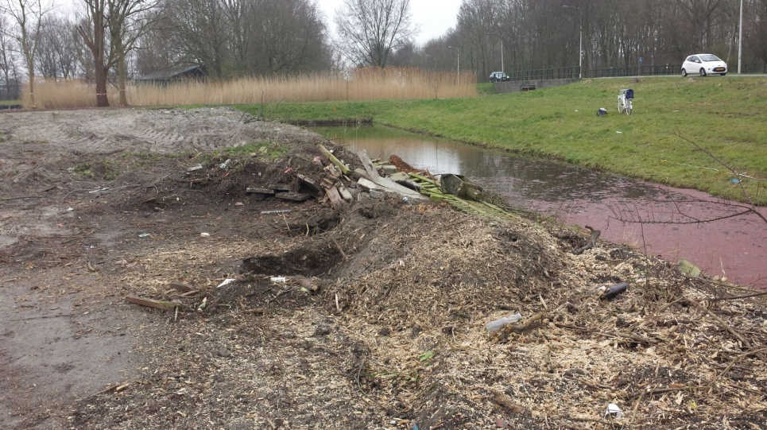
Direction: West
Direction: South
Direction: South
Take note of the garbage
Action photo

