The Effect of Climate Change on Our White Christmas

Student Name(s): Jeong hayun, Kim soyul

Teacher Name: Kim bumhak

Hyunhwa Elementary School
(in Pyeongtaek)
Republic of Korea

2020.03.01.

Summary

The problem

At the end of 2019, it gathered questions from the 2020 IVSS research. Among the various opinions, the theme that gained the sympathy of many friends was "Why? White Christmas doesn't come?"

Hasn't it ever been a real white Christmas? If white Christmas does not happen often, why? Are these phenomena related to the global environment? If so, what efforts should be made to make us and our descendants see 'White Christmas'?

Research Questions

How many times has it snowed in our village this winter?

Have you ever had snow on Christmas in our country?

(Global issues)Doesn't it snow on Christmas in other countries, too?

Objectives set

Perform GLOBE Protocol and use data from Data Entry to identify the state of the atmosphere and find records of snowing in Korea and other countries.

The results of the study can be found by referring to the national meteorological agency observations, news and newspaper articles.

White Christmas can be seen again by presenting and implementing climate change response measures.

Conclusions

In order to make it snow again at Christmas, we all need to practice climate change response. GHG emissions and energy use should be reduced. Practice pulling unused socket-outlets, turning off unused lights, and not using disposable products at home. We're going to get everyone to do it together through our campaign activities. So We suggest a few things.

First, let's take part in a time campaign for Earth. On Saturday, March 28, 2020, at 20:30 p.m., let's all get together and turn off everything that uses electricity, and have a warm time with candles.

Second, I will do GLOBE activities with my school friends for 'climate change response behavior Let's be concerned about the global environment, and let's be protective.

Third, I will do environmental exhibition and campaign activities at flea market in our village. From children to adults, we will ask for efforts to protect the environment and protect the Earth.

We hope that children like us and their descendants will be able to breathe and play freely. Let's all be together.

Research Questions

How many times has it snowed in our village this winter?

Have you ever had snow on Christmas in our country?

(Global issues)Doesn't it snow on Christmas in other countries, too?

Introduction

Our school's GLOBE students collect data about the atmosphere. It mainly measures cloud observation, temperature and humidity, and air pressure. At the end of 2019, it gathered questions from the 2020 IVSS research. Among the various opinions, the theme that gained the sympathy of many friends was "Why? White Christmas doesn't come?"

Hasn't it ever been a real white Christmas? If white Christmas does not happen often, why? Are these phenomena related to the global environment? If so, what efforts should be made to make us and our descendants see 'White Christmas'?

We wondered about all these things. The number of snow in our town has really decreased dramatically, and it hasn't come a few times this year.

Research Methods

Study sites setting

Study Site

Our School location: Hyunhwa Elementary School(80, Anhyeon-ro seo 7-gil, Anjung-eup, Pyeongtaek-si, Gyeonggi-do, Republic of Korea)

A major area: The Korean Peninsula, Pyeongtaek, Seoul, Suwon, Cheonan, Seosan

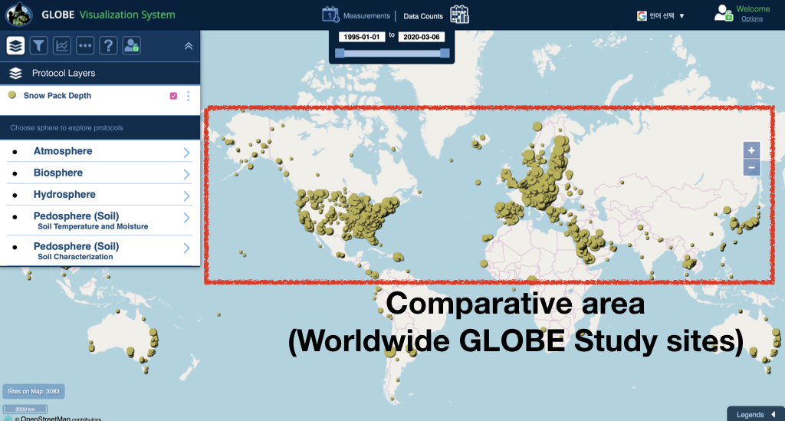
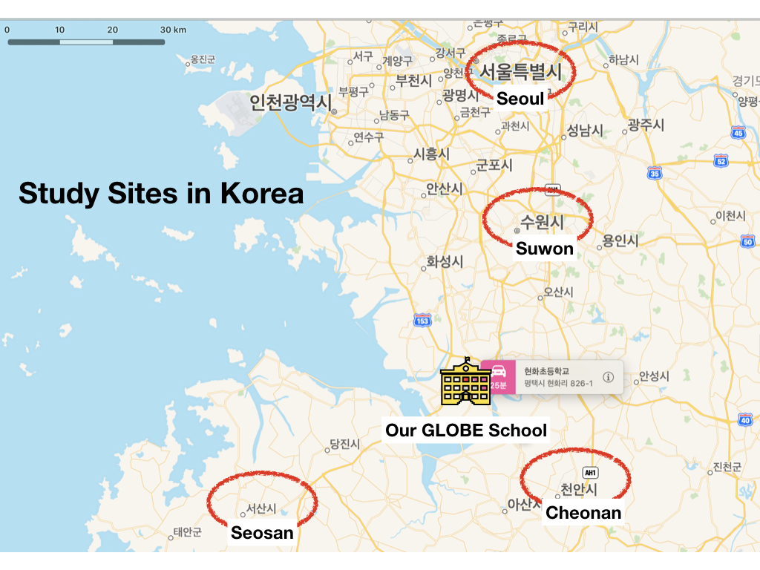
Comparative area: Worldwide GLOBE Study Sites

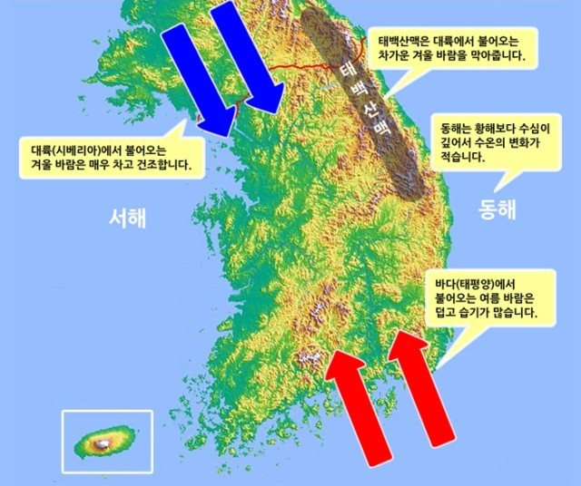
The Climate Characteristics and Land Surface Condition of the Korean Peninsula
The Korean Peninsula is located in the mid - latitudes of the Northern Hemisphere, with distinct seasons, mild climates, hot and rainy in summer, cold and dry in winter. Spring(March~May), Summer(June~August), Fall(September~November), Winter(December ~ February).
Average annual average temperature is 13.2 degrees Celsius. Most of the annual precipitation is concentrated in summer. Most people live in the plains, and most of the observation points in GLOBE schools are on the plains.

Data Collection method

Perform GLOBE Protocol and use Data Entry

Atmosphere_Cloud protocol

Atmosphere_Temperature protocol

Atmosphere_Precipitation protocol

Atmosphere_Relative Humidity protocol

Atmosphere_Surface Temperature protocol

Use data of the national meteorological agency

News and newspaper articles

The relationship between data and research questions
Research Questions | Data Set
Q1. How many times has it snowed in our village this winter? | GLOBE_Precipitation protocol  Use data of the national meteorological agency
Q2. Have you ever had snow on Christmas in our country? | Use data of the national meteorological agency  News and newspaper articles
Q3. Doesn't it snow on Christmas in other countries, too? | GLOBE_Cloud protocol  GLOBE_Precipitation protocol  GLOBE_Surface Temperature protocol

Results

Q1. How many times has it snowed in our village this winter?

Snow fell six times in our village from November 2019 to February 2020. Unfortunately, there was no Christmas among them. Adults say it's 'dry winter.' Snow falls less frequently than before(Source: Past Observations for Integrated Atmosphere (1-Day))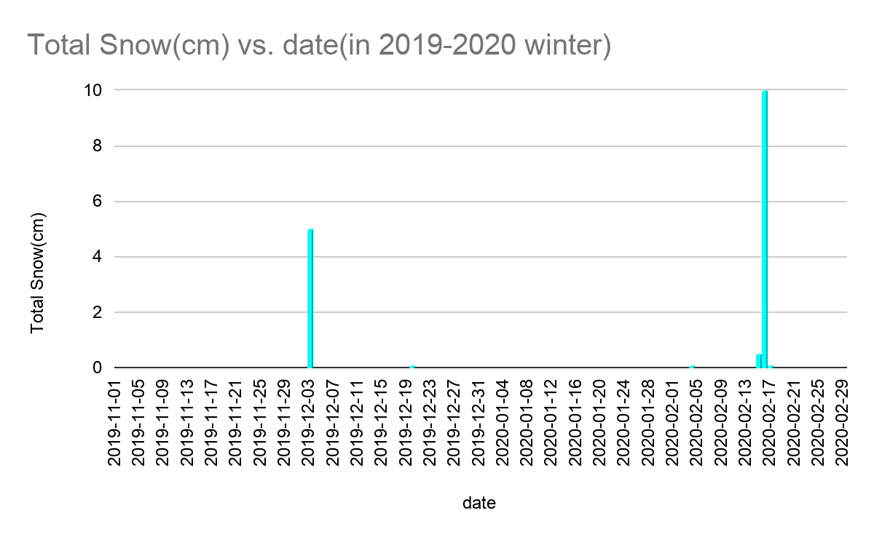

Using data from the National Weather Service, we compared the snowy days from winter 2013 to winter 2019. As we see, the number of snow falls has decreased. There is a change every year, and we expect it to continue.
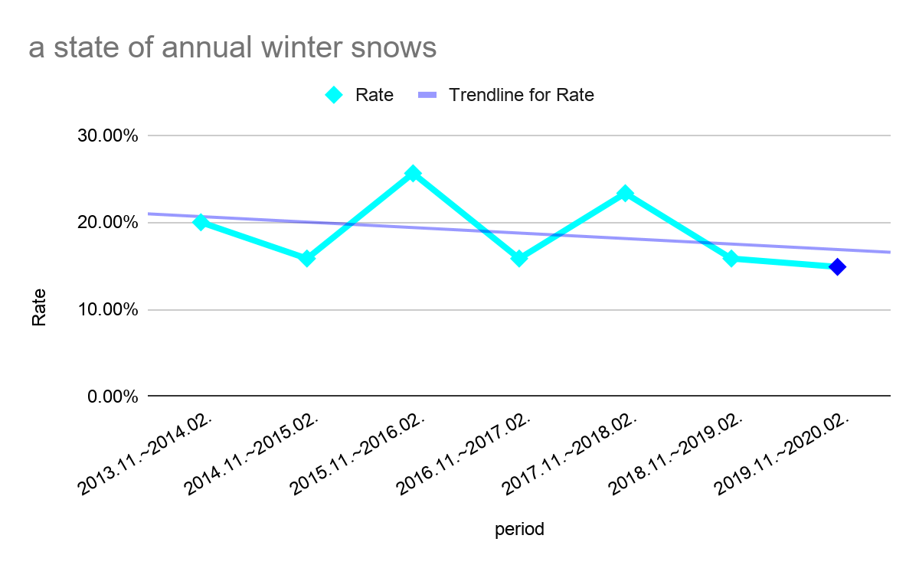

Q2. Have you ever had snow on Christmas in our country?

We looked into the records of Christmas snow in our country. National meteorological agency data and news articles were utilized. In the 40 years from 1980 to 2019, there were 13 Christmas snows in Seoul, the capital of Korea. On average, it was white Christmas about three times a decade. The latest white Christmas was snowing at midnight in 2015.

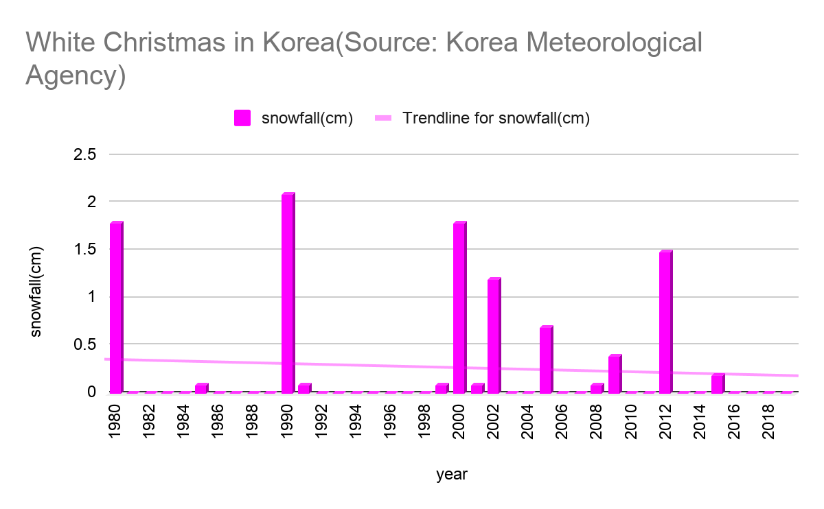

Q3. Doesn't it snow on Christmas in other countries, too?

We wondered if it was our country's own or global problem that no snow was coming at Christmas. So we used GLOBE data to explore the situation in other countries. From 2015 to 2019, data from GLOBE schools, which measure snowfall, were collected.
Measurement of Christmas snow in other countries (Source: GLOBE data)
Year | Date,Time | Snow Depth(mm) | Cloud cover | Cloud type | Country(State) | GLOBE School | Site_id
2019 | 12.25.11:55 | -9 | Overcast | Stratus | Lithuania | Zemynos pro-gimnazium | 33425
2019 | 12.25.02:36 | -9 | Overcast | - | Saudi Arabia | The 2nd Secondary Girls School at Makkah Al-Mukarramah | 33736
2019 | 12.25.12:36 | 0.5 | None | - | Saudi Arabia | Bin Baz Secondary Scool At-Riyadh | 147583
2019 | 12.25.12:22 | 0.5 | None | - | Saudi Arabia | Rowad AL-Omaraa secondery Scool At Riyadh | 144858
2019 | 12.25.12:06 | 0.5 | None | - | Saudi Arabia | Yamama Secondary School at Riyadh | 13092
2018 | 12.25.11:38 | 0.5 | None | - | Saudi Arabia | The 19th Secondary Girls School at Al-Madinah Al-Monawarah | 101090
2018 | 12.25.12:06 | 0.5 | Clear | Cirrus | Saudi Arabia | Yamama Secondary School at Riyadh | 13092
2018 | 12.25.04:29 | 94 | Overcast | Stratus | Lithuania | Akmenes gimnazija | 8633
2018 | 12.25.11:55 | 150 | Overcast | Stratus | Lithuania | Zemynos pro-gimnazium | 34998
2018 | 12.25.11:29 | 40 | Overcast | Stratus | Latvia | Dundaga Secondary School | 8828
2018 | 12.25.11:59 | 100 | Overcast | AltoStratus | Estonia | Kilingi-Nomme Gymnasium | 3363
2018 | 12.25.11:45 | 200 | Overcast | StratoCumulus | Estonia | Palupera Primary School | 3415
2018 | 12.25.12:05 | 50 | None | - | Croatia | OS Eugena Kumicica | 6183
2017 | 12.25.12:08 | -9 | Overcast | Cirrus,CirroStratus,AltoCumulus | Saudi Arabia | The 19th Secondary Girls School at Al-Madinah Al-Monawarah | 101090
2017 | 12.25.11:38 | -9 | None | - | Saudi Arabia | The 25th Secondary Girls School at Al-Madinah Al-Monawarah | 12509
2017 | 12.25.12:06 | 0.5 | Clear | Cirrus | Saudi Arabia | Yamama Secondary School at Riyadh | 13092
2017 | 12.25.12:28 | 43 | Overcast | CirroStratus,AltoStratus | Estonia | Kaapa Comprehensive School | 3462
2017 | 12.25.11:59 | 7 | Broken | AltoStratus | Estonia | Kilingi-Nomme Gymnasium | 3363
2017 | 12.25.11:45 | 53 | Clear | CirroStratus | Estonia | Palupera Primary School | 3415
2017 | 12.25.11:55 | -9 | Overcast | Stratus | Lithuania | Zemynos pro-gimnazium | 34998
2017 | 12.25.11:50 | 104 | - | - | USA(Michigan) | Shumate Middle School | 102676
2017 | 12.25.11:43 | 76 | - | - | USA(NewYork) | State University of New York at Fredonia | 104611
2017 | 12.25.11:45 | -9 | Overcast | AltoStratus | Finland | Utajarven Ylaaste | 4594
2016 | 12.25.11:59 | 7 | Overcast | Stratus,NimboStratus | Poland | Complex of Secondary Schools no 1 Jana Pawła II in Przysucha | 10470
2016 | 12.25.11:57 | 89 | Broken | StratoCumulus | Poland | Stanislaw Dambski Primary School in Rudna Wielka | 11215
2016 | 12.25.11:15 | -9 | None | - | Saudi Arabia | Moamar Bin Rashed Intermediate School at Riyadh | 33549
2016 | 12.25.11:37 | -9 | Broken | Cumulus | Saudi Arabia | The 25th Secondary Girls School at Al-Madinah Al-Monawarah | 12509
2016 | 12.25.12:06 | 0.5 | Clear | Cirrus | Saudi Arabia | Yamama Secondary School at Riyadh | 13092
2016 | 12.25.11:55 | -9 | Overcast | Stratus | Lithuania | Zemynos pro-gimnazium | 34998
2015 | 12.25.12:20 | -9 | Clear | Cumulus | Saudi Arabia | Al-Khaleej Secondary School at Dammam | 12809
2015 | 12.25.12:06 | 0.5 | Overcast | Stratus | Saudi Arabia | Yamama Secondary School at Riyadh | 13092
2015 | 12.25.12:09 | -9 | None | - | Croatia | Gimnazija Petra Preradovica | 6208
2015 | 12.25.12:38 | -9 | Scattered | Stratus | Poland | XI Liceum St. Konarskiego in Wrocław | 11646
2015 | 12.25.11:55 | -9 | Overcast | Stratus | Lithuania | Zemynos pro-gimnazium | 34998
2015 | 12.25.11:36 | -9 | Overcast | Stratus | Germany | Alexander von Humboldt Gymnasium | 2329

What we learned from the research is that many GLOBE schools are measuring snow levels. They also say that Saudi Arabia suffered an untimely snowfall this winter (January 15, 2020), and that in 2018, heavy snow and heat waves in various parts of the world put many people in a difficult situation.

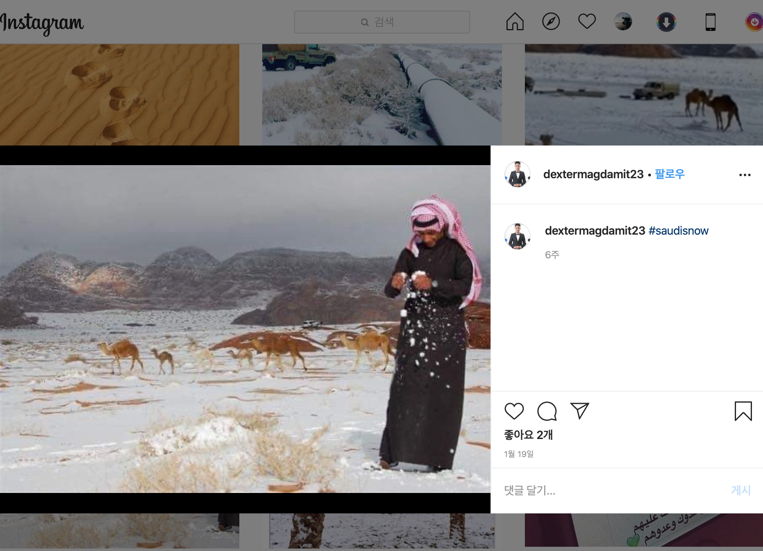

Conclusion

Is no snow on Christmas related to global warming and climate change?

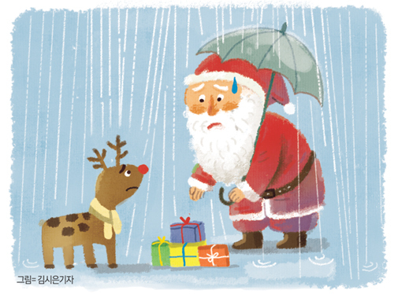
The reason why we can't see white Christmas is because of El Nino. According to the National Oceanic and Atmospheric Administration's announcement, the El Nino phenomenon causes abnormal weather conditions on Earth and is difficult to predict. The thermal equilibrium of the earth has collapsed. According to an interview with Professor Jeon Jong-gap of Seoul National University, if carbon dioxide continues to increase, the Korean Peninsula will become even hotter in 100 years and be in a terrible state.

Not only Our Country, but also the global Santa village has lost winter snow due to global warming. Some Santa villages suffer from floods, and reindeer can't run around in the snow. As a result, many countries around the world are taking action against climate change.

What efforts should be put into practice to have snow on Christmas?

We must take 'climate change response' to have a happy Christmas with friends from all over the world. Efforts to reduce greenhouse gas emissions and energy use should be implemented.

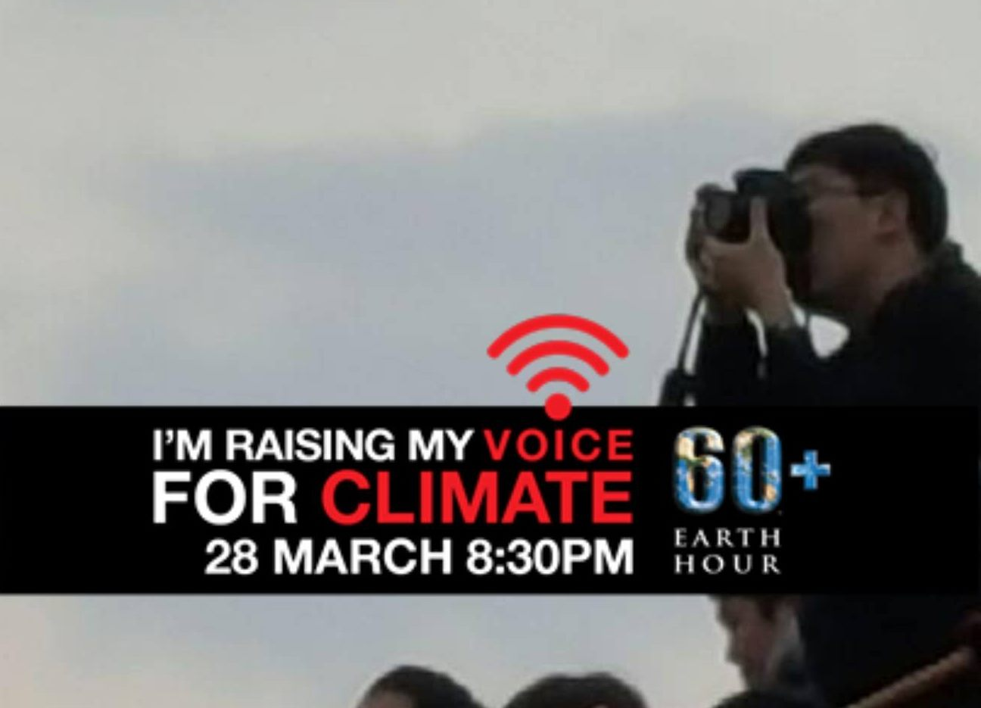
The use of fossil fuels should be reduced, such as pulling out unused socket-outlets, turning off unused lights, and reducing the use of disposable products at home. The country should come up with policies to reduce carbon dioxide emissions. And we all have to practice 'climate change response'. We ask you to join us from the March 28, 2020 'Earth Hour' campaign.

(Planning later) Study how to predict 'White Christmas' by observing the clouds on Christmas Day.

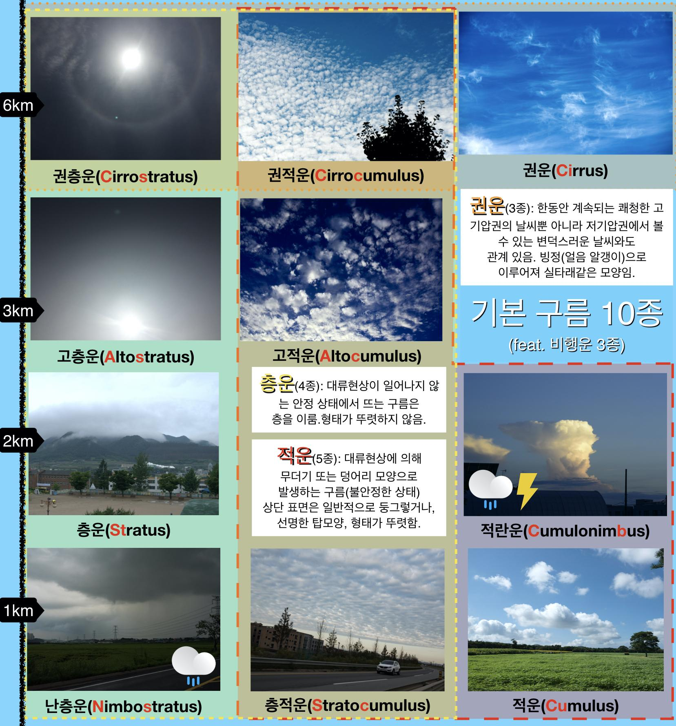
It would be a 'white Christmas' if our efforts brought the Earth back to normal. When you look at the clouds in the morning of December 25, you can predict whether they are 'white Christmas' or not. Looking at the GLOBE data, the snow-falling clouds were "Cumulonimbus", "Nimbostratus", "StratoCumulus" and "Stratus". Among them, it will definitely be a "white Christmas" if you see "Cumulonimbus", "NimboStratus" and "StratoCumulus" which contain a lot of water vapor.

Our club will carry out a project to use AI (machine learning) to identify clouds. I want to make it easy for anyone to sort clouds. I want to share the joy of Christmas with people.

References/Bibliography

List of GLOBE data used

Clouds Noons protocol(2015-12-24~2019-12-25)

Clouds protocol(2015-12-24~2019-12-25)

Precipitation protocol(Snow pack)(2015-12-24~2019-12-25)

Surface Temperature Noons protocol(2015-12-24~2019-12-25)

Surface Temperature protocol(2015-12-24~2019-12-25)

GLOBE Materials listed

Cloud Chart(Korean Ver.3)

Digital thermometer

Snowboard

Handheld Infrared Thermometer(IRT)

The Meteorological Administration Observation Data

기상청 날씨누리: http://www.weather.go.kr/weather/main.jsp

기상청 기상자료개방포털: https://data.kma.go.kr/cmmn/main.do

Article

climate change response : http://kfem.or.kr/?p=203803

El Nino: http://www.sjournal.kr/news/articleView.html?idxno=401

Lost Christmas: http://www.segye.com/newsView/20181225001454?fbclid=IwAR2nZZnoWRvdvxDSxc0Sc_xHa6FZtBww7aNwwQOWeQfmlaKrxUJmKzLsn1Q

Instagram

#Saudisnow: https://www.instagram.com/p/B7eE0YiHx-M/

Interview

Professor Jeon Jong-gap: http://gmcl.pusan.ac.kr/?ca=board&page=notice_view&auto_idx=213&page_num=5

(Optional) Badge Descriptions/Justifications:

Be a Collaborator

Student | GLOBE Protocol | Role in IVSS
Kim Soyul | Cloud, Precipitation, AirTemp, RelativeHumidity, SurfaceTemp | Article Collector, To review the conclusions, Plan our campaign
Jeong hayun | Cloud, Precipitation, AirTemp, RelativeHumidity, Aerosol | Data Collector, To analyze the results, Ai-Programming

Be a data Scientist

Type | Content(period) | the number of cases
GLOBE Data | Precipitation(2019-11-01~2020-02-29) | 6
 | Precipitation_SnowDepth(2015-12-25~2019-12-25) | 35
 | Cloud_Photo(2016~2020) | 100
The Meteorological Administration Observation Data | Snowfall(2013-11-01~2020-02-29) | 158
 | White Christma(1980~2019) | 13
SNS(Instagram) | #Saudisnow | 16
Article | White Christmas, Heavy Snow(in 2018), Climate change, Global warming, Climate Change Response Action | 15

Make a Impact
  - Participating in “Earth Hour” Campaign(2020-03-28, 20:30)
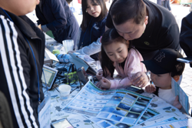
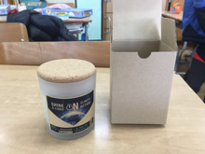
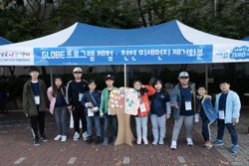
  - Join GLOBE activities with friends to respond to climate change(in 2020)
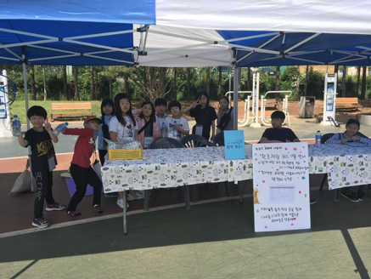
  - Environmental Exhibition and Campaign in the Village flea Market
(Link to Regional Sustainable Development Committee)

