2020
Jurjen, Damian, Tibbe and Maximo
Helenparkhurst
9-3-2020

What causes particulate matter concentrations in our region?
Inhoudsopgave
Concise: 2
Context of research: 2
Research questions: 2
Methods description: 2
Results: 3
Day of March 3
Results Almere Buiten 3
Results Tussen de vaarten 3
Discussion: 3
Conclusion: 3

Concise:
For this project we are going to assemble a particulate matter sensor by using Arduino. We will use the particulate matter sensor in several places, after we have obtained all the required results we will compare them and investigate the possible causes. From this we will be determining the main causes and draw a conclusion.

Context of research:
When we made our team, we all already knew that we wanted to do something with the air, but we did not exactly know what we wanted to do. When thinking about the air we instantly thought about CO2 and O2. What some neglect is particulate matter, and the effects it might have. From that point onwards we decided to research particulate matter. We wanted to know if there was a disproportionate amount of particulate matter in the air around our neighbourhood. That is why we chose to measure the particulate matter in our own environment.

Research questions:
Main question:
What causes particulate matter concentrations in our area?
Side questions:
What day has the highest concentrations of particulate matter?
Which neighbourhood generally has the highest concentration of particulate matter?
These questions are important for multiple reasons. Generally, measurements are done on a large scale. This can lead to imprecise results in certain areas. From these results it is harder to list possible factors of particulate matter. For example, an area with a lot of industrial terrain might get a small amount of sensors allocated to it. When this happens, one might not be able to precisely list the factors that lead to the measured particulate matter, as it isn’t clear where the sources of particulate matter are, and the smaller sources might output so little that it might be attributed to larger sources. If you take measurements with the focus on how much different sources output, you can explain how the larger scale measurements are formed.
Methods description:
1: Building a particulate matter sensor with Arduino
2: Install the particulate matter sensor in different locations throughout our city and note the results. This happens in a time span of 1 week.
3: Comparing the results and calculating the differences.
4: Investigating the potential causes of the differences between the results by comparing multiple factors that can have influence on the amount of particulate matter.
5: Determining the cause.
6: Drawing a conclusion about what the cause of the particulate matter in our region is.
Results:
Day of March | Results Almere Buiten  (PM2.5, μg/m3) | Results Tussen de vaarten  (PM2.5, μg/m3)
Monday 2 | 2 | 2
Tuesday 3 | 2 | 2
Wednesday 4 | 4 | 3
Thursday 5 | 6 | 4
Friday 6 | 8 | 3
Saturday 7 | 4 | 3
Sunday 8 | 3 | 3

Discussion:
This research has a lot of factors that can influence the results.
The 2 main problems are the weather and the Arduino. If it is a windy day, the weather might affect your results by spreading the particulate matter in a wider area. The amount you may have measured can come from different sources. This means that your results have a chance of being lower or higher than the actual amount of particulate matter that has been “created” in your area.
The Arduino can be really challenging to work with because, you may be able to get all the parts working but they won't immediately work together. This might create a delay in our research. The sensor of the assembly might also need to be calibrated due to humidity.
Conclusion:
We can see in the results that there is not much of a difference of PM2.5 concentrations, except for Thursday, Friday and Saturday. Looking at past weather measurements, we can see that there were strong winds coming from the west at that point in time. These speeds reaching up to 58 km/h. To the west of Almere, there are multiple factors that might lead to this increase. Schiphol is a major output for particulate matter, and can impact these results. Amsterdam also lies west of Almere, and its high traffic and tourism might affect particulate matter in our city.

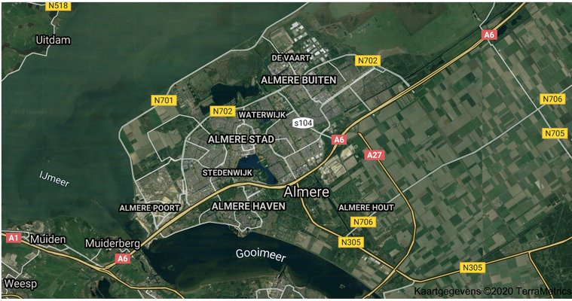

Here we have the link to our powerpoint presentation:
https://asgvo-my.sharepoint.com/:p:/g/personal/425918_hp_asgleerling_nl/EXBN8JYKrYxFpRImxRFgTVABBkHVDZSApk8uM-w7cKOLXA?e=mAkgPZ

