**Search rain and climate**

**Students:** Mohanad Othman Awadhallah & Mahmood Ahmed Aldhaher

**Research Hypothesis:**

**Warming of the atmosphere of the reasons leading to the lack of rain.**

**Data collection and analysis:**

**Factors influencing the climate**

**A range of factors influence and control over the quality of climate, weather and have all the change happening on the climate was whether local, regional or continental back.**

**1 _almstahat water (oceans, seas, lakes and rivers)**

**Water bodies play an important and influential role in the Earth's climate and covers about 71% of the surface of the Earth's surface and interact directly with the atmosphere (71% of the atmosphere located above these water bodies). The high degree of bodies of water temperature to increase the speed of the blocks and air currents and wind also increases the speed of evaporation of water, bringing the water vapor ratio in the atmosphere, which in turn leads to increased precipitation on the surface of the globe, especially in the vicinity of the oceans and seas. Because of the vast areas of water bodies, they represent a great reservoirs solar thermal, to its unique ability to absorb solar radiation due to the high permeability of the rays.**

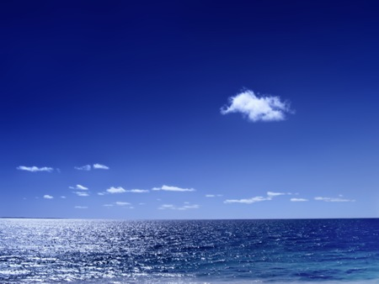

**Data collection and analysis continued**

**heights (mountains and hills)2**

**Characterized by mountainous highlands tastefully climate, it often rises from the sea surface and is known that levels higher you go above sea level, the temperature dropped and atmospheric pressure. At the same time, the closer to the high mountain peaks of the closer the temperature to zero percentile or lower for this rate. Atmospheric pressure decreases higher you go, because the air layers and less pressure on our bodies. The mountains serve as bumpers air currents emanating from the oceans and seas, and this is what helps to rainfall and reduce the effects of these air currents on the domestic and continental areas. And prevail humid and sub-humid lands in the mountainous areas of confrontation water bodies, while the opposite areas of the mountains and the interior prevail semi-arid climate and desert. Often covers the tops of elevated areas (in particular, the Himalayas and the Alps and the Qandil mountains, etc. ..) snow and this is what helps to lower the temperature in the mountains and nearby areas including climate Viatdl there.**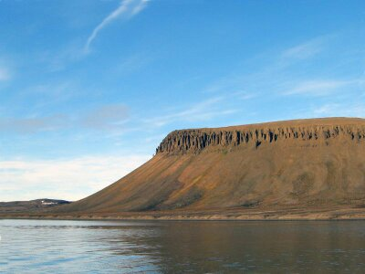

**Data collection and analysis continued**

**3-climate change**

**Climate change can be defined as any change or breach of a long-term climate gets in the case of a result of the change made in the energy and balance into force and be effective in environmental and natural systems. And climate change also refers to the continuous change in the Earth's climate caused by cosmic reasons or natural or human negative impact on the biosphere and lead to the occurrence of devastating natural disasters explanations about how to get climate change vary.**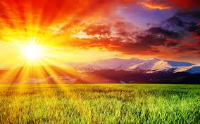

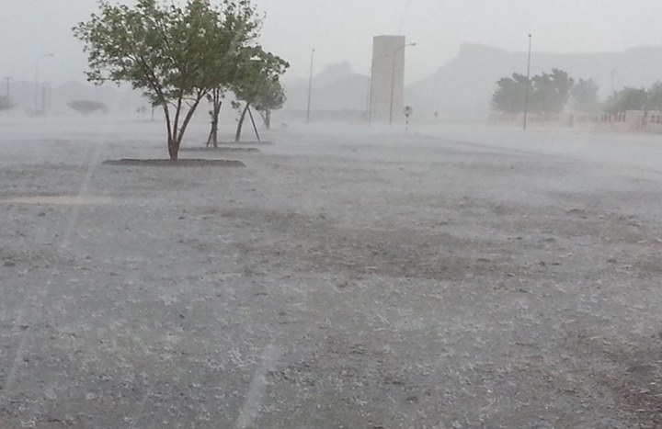

**Data collection and analysis continued**

**Rain water vapor created in the atmosphere, water vapor is formed when causing the sun's heat in the evaporation of water from the oceans and other bodies of water, the air warm wet Viberd when it rises, and less than the amount of steam that can carry, called a temperature that can not air then, that accommodate the additional amount of moisture dew point, and if the temperature dropped to below the dew point, the water vapor condenses in the form of spray, forming clouds. Water vapor condenses in the form of micro-particles in micro-called condensation nuclei. These consist nuclei of dust and salts of the seas and oceans, and some emitted from factories and car exhaust chemicals, when water vapor condensation off the heat, make hot clouds, and this helps the heating to push the clouds to the top, and thus become more cooler.**