Title:
THE SPREAD AND BIODIVERSITY OF MOSQUITOES IN SPUSSA COMMUNITY, AKURE, ONDO STATE, NIGERIA
Grade Level: Secondary School (grades 9 -12, ages 14-18)
Report Type: International Virtual Science Symposium Report

Student Names:
- Paul Eke
- Kemisola Akomolafe
- Temitope Akinsunmade

GLOBE Teacher Name
Olawunmi Fasakin

School Name
St. Peter’s Unity Secondary School, Akure (SPUSSA)
Country
Nigeria

Date
9th March, 2020

Principal of School: Mrs. F. I. Busari (GLOBE Certified)
Country Coordinator: Mrs. Aminulai Modupe Salamotu (GLOBE Certified)

Table of Content

- Abstract ………………………………………………………………………….2
- Research Questions ……………………………………………………………2
- Introduction and Literature Review ……………………………………………2
- Research Methods and Materials ……………………………………………..4
- Results ……………...…………………………………………………………..13
- Discussion ………………………………………………………………………16
- Conclusion ………………………………………………………………………17
- Recommendation ………………………………………………………………17
- Limitation ………………………………………………………………………..17
- Bibliography/Citations ………………………………………………………….18
- Acknowledgments ……………………………………………………...………19

Abstract:
The sufferings and pains caused by mosquitoes in our communities and societies cannot be overlooked. These insects propagate their diseases by infecting the host through pathogens. The project was aimed at observing the spread and bio-diversity of mosquitoes in St. Peter’s Unity Secondary School, Akure (SPUSSA) community, Ondo State, Nigeria. The objectives are to identify potential habitats of mosquito larvae, identify different species found in the study area and evaluate the physico-chemical properties of the environmental habitat. The study was conducted within three months. Two mosquito habitat sites were investigated in two locations (hydrosphere sites A and B). Samples of mosquito larvae from the sites were taken to the School’s science laboratory. They were placed in Petri dishes after they were sieved in which the larvae were counted. Macro clip on lens was used to count the mosquito larvae. The environmentally favorable parameters that support the breeding of mosquitoes in the area of study include air temperature range of 32ºC – 39ºC, water temperature range of 26ºC – 35ºC, relative humidity range of 10% - 42% and pH range of 3.5 – 8.0. Hydrosphere site A has less mosquito larvae than site B. The genera found in site A are Anopheles (58) and Aedes (19) while that found in site B are Aedes (112) and Anopheles (12). There is need to develop control strategies that will target the vector species.

Keywords: Mosquito larvae, Anopheles, Aedes, SPUSSA, Hydrosphere sites

Research Question and Hypothesis:

The following research questions were put forward.
- Where are the typical breeding habitats of mosquito larva in SPUSSA community?
- What are the different genera of mosquitoes found in SPUSSA community?
- What are physico-chemical properties that are favorable for breeding mosquito larvae in the study area?
- What is the spread/distribution of biodiversity of mosquitoes in SPUSSA community?

Introduction and Review of Literature:

In the Africa continent, Nigeria has shown the highest number of malaria cases. Malaria is one of the most severe global public health challenges facing humanity on planet Earth (World Health Organization, 2014). Nearly half of the world’s population is at risk of malaria sickness; in 2015, there were about 212 million malaria cases and an estimated 429,000 malaria deaths. Nigeria suffers the world’s greatest malaria burden, with approximately 51 million cases and 207,000 deaths reported annually while 97% of the total population is at risk of malaria infection (World Health Organization, 2014).

Zika virus, basically transmitted through mosquito bites, was first discovered in 1947 and is named after the Zika Forest in Uganda. The first human cases of Zika were detected in 1952 and since then, outbreaks of Zika infection have been reported in tropical Africa, Southeast Asia, and the Pacific Islands. Zika outbreaks have probably occurred in many regions and locality. Before 2007, at least 14 cases of Zika had been documented, although other cases were likely to have occurred and were not reported. Because the symptoms of Zika are similar to those of many other diseases, many cases may not have been recognized (CDC, 2019). Zika is spread mostly by the bite of an infected Aedes species mosquito (Ae. aegypti and Ae. albopictus). These mosquitoes bite during the day and night. It can also be passed through sex from a person who has Zika and from a pregnant woman to her fetus (CDC, 2019). We should prevent Zika by avoiding mosquito bites. The most common symptoms of Zika virus include fever, muscular pain, headache, joint pain and red eyes.

Previous researches in Nigeria have shown the abundance of various mosquito species to include the genera Anopheles, Culex, Aedes and Eretmapodites (Nwoke et al., 1993).

The diverse aquatic habitats for mosquito breeding always make them occur in adequate population to constitute unpleasant biting effects or vectors of disease-causing organisms (Adebote et al., 2008). An aquatic habitat for oviposition is required by all mosquito species for larval and pupal development. Mosquito larvae are known to show greater preference to water with suitable pH, optimum temperature, dissolved oxygen, concentration of ammonia, and nitrate (Afolabi et al., 2013). It has been observed that there are strong correlations between certain physico-chemical parameters and larval abundance which confirm the influence of these parameters on the distribution and abundance of mosquito larvae in their breeding habitats and also indicate the possibility of mosquito larval control through the manipulations of such parameters (Olayemi et al., 2010).

Akure metropolitan city consists of areas that are densely populated due to her rapid urbanization growth. St. Peter’s Unity Secondary School, Akure (SPUSSA) is a mixed coeducational institution with a population of about 1, 300 people including some teachers and their families living on the school’s compound. Therefore, the rate of domestic and human activities is on the high side. This will generate water drains, peridomestic runoffs, and pools of standing water. In addition, there are portions of land for farming activities. These domestic wastes, water run-offs and cultivated farm lands, within the school compound, are possibly places for breeding common mosquitoes such as Anopheles species and Aedes species. This informed the study to identify the different species of mosquitoes found in the SPUSSA community, with the aim to determine the relative spread and bio-diversity of mosquitoes in the area of investigation. Also, the study seeks to assess the physico-chemical attributes of the aquatic habitat to determine the distribution of the mosquito larvae species in certain hydrosphere sites within the school premises.

Research Methods and Materials (Including GLOBE Data!):
The materials used in this study to obtain our data are as follows:
- Digital Hygro-thermometer (Figure 1)  - Clip-on Macro Lens (Figure 2)  - Digital soil meter (pH) (Figure 3)  - Hand gloves (Figure 4)  - Plastic bucket (Figure 5)  - Plastic containers for scooping (Figure 6) | - Petri dishes (Figure 7)  - GLOBE Mosquito Habitat Mapper App (Figure 8)  - Camera (Phone camera) (Figure 9)  - Net (Figure 10)
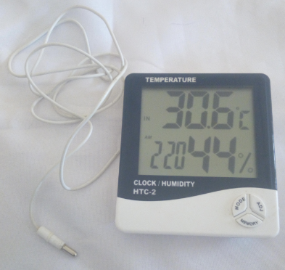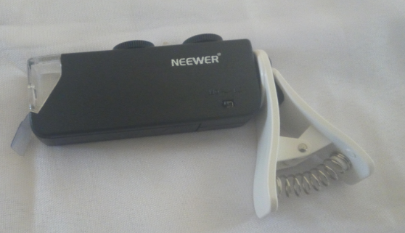
Figure 2: Clip-on Macro Lens (100x version). Used for Mosquito identification.
Figure 1: Digital Hygro-thermometer. Measures both Relative Humidity and Air Temperature.

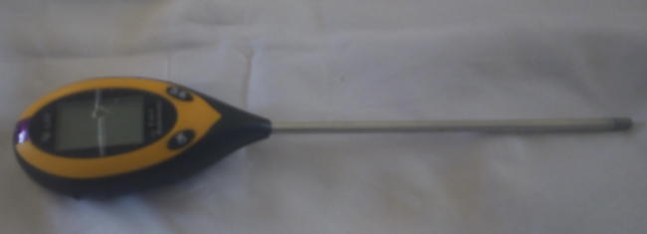
Figure 3: Digital Soil Meter. Used for measuring water alkalinity (pH) and water temperature.

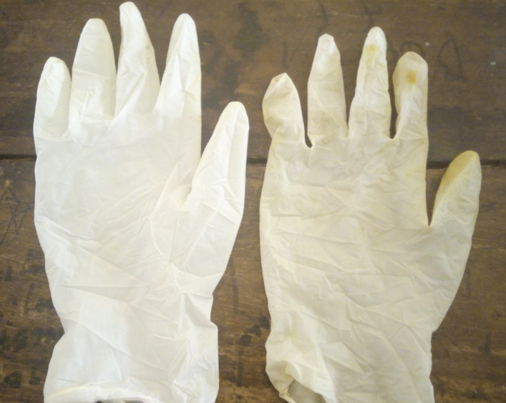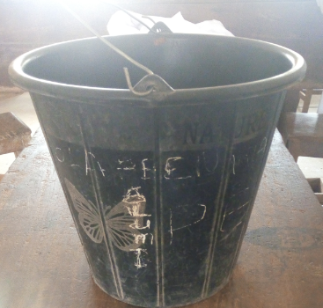
Figure 5: Plastic Bucket
Figure 4: White Hand gloves

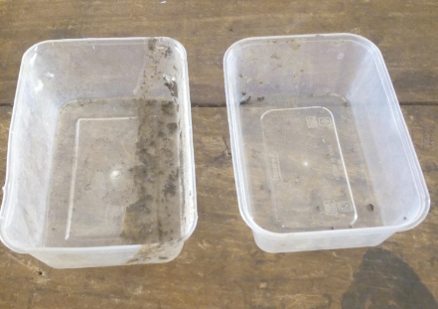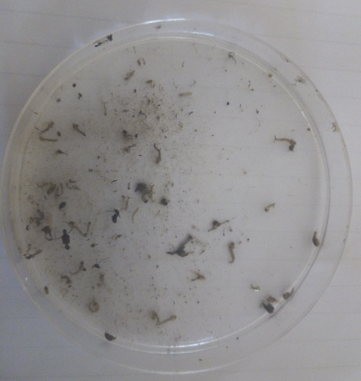
Figure 6: Plastic containers
Figure 7: Petri dish with Mosquito Larvae.

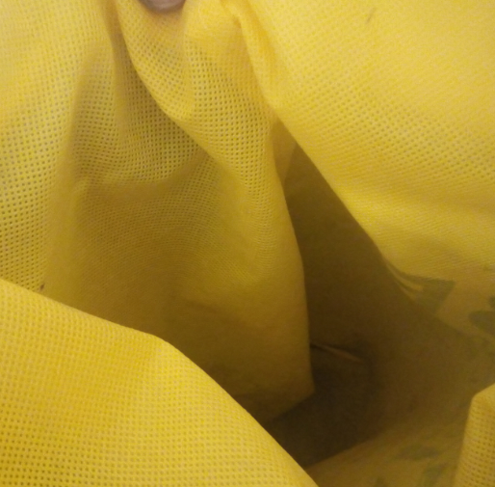
Figure 10: Net
Figure 9: Camera (Phone Camera)
Figure 8: GLOBE Mosquito Habitat Mapper App

The GLOBE protocols used in this study are:
- GLOBE Hydrology Protocols
- Water temperature
- Water pH
- GLOBE Atmosphere Protocols
- Air temperature
- Relative Humidity
Sample Collection
Mosquito larvae were collected from hydrosphere breeding sites (Hydrosites A and B) which are shallow temporary peridomestic run-off and gutters using the scooping method during the day. Larvae were collected for seven weeks (within January – March 2020) during the day between 10 am and 1 pm. All samples were carefully taken to the science laboratory of St. Peter’s Unity Secondary School, Akure for identification of larval specimens. In the laboratory, the mosquito larvae collected were identified to species and counted. Figure 11 shows SPUUSA students collecting mosquito larvae from hydrosphere site B (a gutter with standing water) while Figure 12 represents students scooping water with mosquito larvae from Hydrosphere site A (a shallow pool of flowing water with bushy environment).
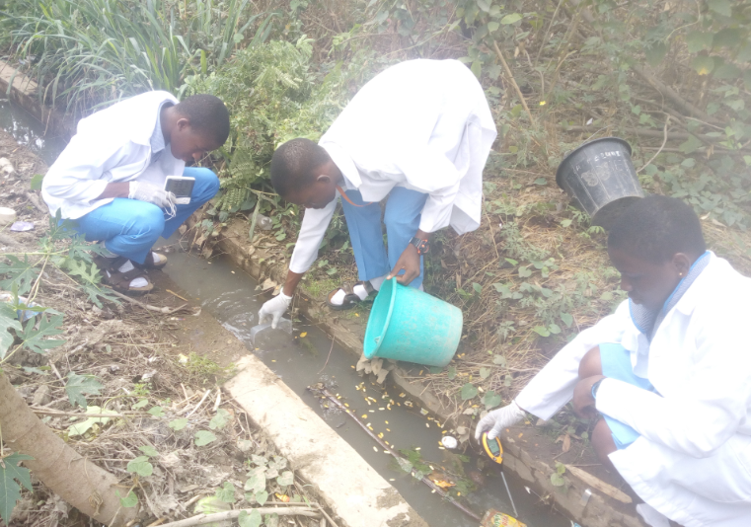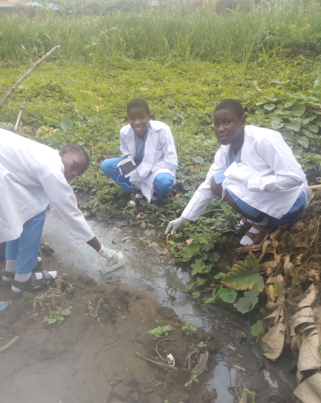
Figure 12: Students collecting Mosquito Larvae and physico-chemical properties from Hydrosphere Site A.
Figure 11: Students collecting Mosquito Larvae and physico-chemical properties from Hydrosphere Site B.

Physical and Chemical Parameters
Water samples from the selected sites (A and B) within SPUSSA community were analyzed for physico-chemical properties such as pH and temperature. The water pH and water temperature were measured using the digital soil meter and digital hygro-thermometer respectively. Figure 13 and 14 present SPUSSA students identifying and observing larvae.
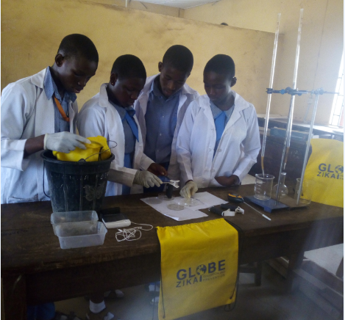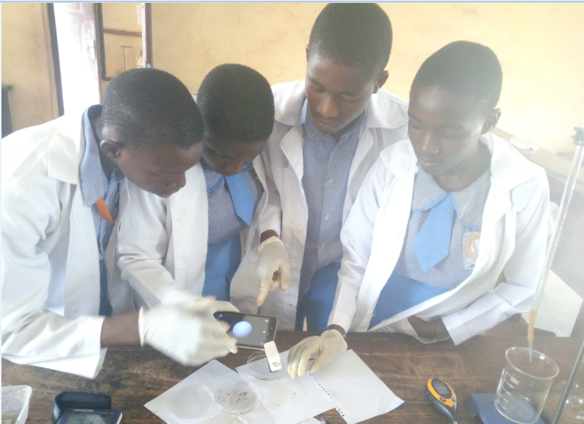
Figure 14: Identification of genera of Mosquito Larvae using Clip-on Micro Lens in the science lab.
Figure 13: Students observing types of Mosquito Larvae using Clip-on Micro Lens.

Precautions taken when conducting the Hydrosphere protocols
We put on protective gloves when handling water samples to avoid splashes. We also wore the laboratory coat to protect us from exposure to mosquito bites.
Geographical Location of the Study Area
Akure is a city in south-western Nigeria, and is the largest city and capital of Ondo State. The city had a population of 484,798 as at the 2006 population census. Akure lies about 7°25’ north of the equator and 5°19’ east of the Meridian (Figure 15). It is about 700 km Southwest of Abuja and 311 km north of Lagos State. Residential districts are of varying density, some areas such as Arakale, Ayedun Quarters, Ijoka, and Oja-Oba consist of over 200 persons per hectare, while areas such as Ijapo Estate, Alagbaka Estate and Idofin have between 60-100 people per hectare. The town is situated in the tropic rainforest zone in Nigeria (Ayeni, 2011).
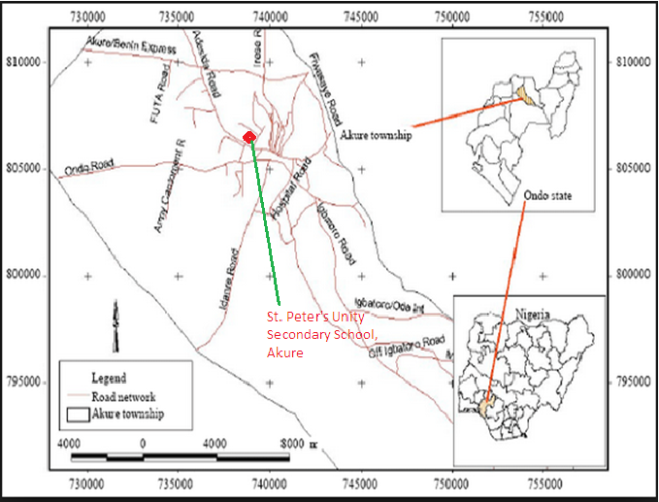
Figure 15: Map of Akure Township in Ondo State, Nigeria showing St. Peter’s Unity Secondary school, Akure Compound (After Ayeni, 2011).

Figures 16 and 17 illustrate the map and satellite image of SPUSSA compound, Akure.
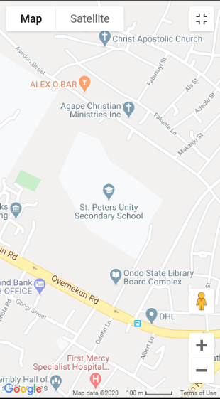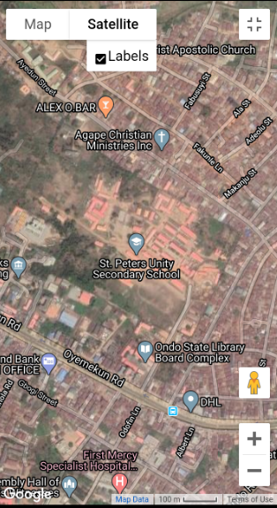
Figure 16: The Map and Location of St. Peter’s Unity Secondary School, Akure, Ondo State, Nigeria (from Google Map).
Figure 17: The Satellite Image Map and Location of St. Peter’s Unity Secondary School, Akure, Ondo State, Nigeria (from Google Map).

Average Weather Conditions in Akure
Temperature: In Akure, the wet season is warm, oppressive, and overcast and the dry season is hot, muggy, and partly cloudy. During the year, the temperature normally varies from 18°C to 31°C and is rarely below 14°C or above 34°C (Weatherspak.com, 2020). The weather-related data on Figure 18 were taken entirely from National Aeronautics and Space Administration’s (NASA's) MERRA-2 satellite-era reanalysis (Weatherspak.com, 2020). The hot season lasts for 2 months, from January 22 to March 22, with an average daily high temperature above 30°C. The cool season lasts for about 5 months, from June to October, with an average daily high temperature below 28°C. The coldest day of the year is January 1, with an average low of 18°C and high of 29°C (Weatherspak.com, 2020).
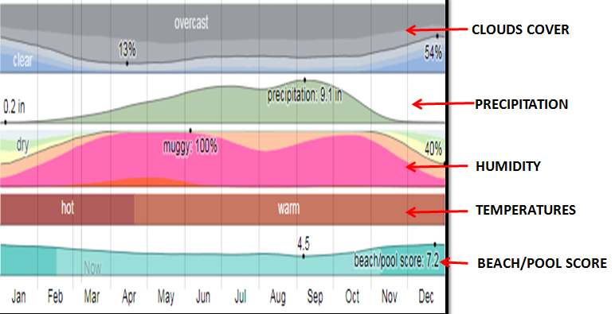
Figure 18: Climate Summary of Akure City, Ondo State, Nigeria (Courtesy Weathwerspak.com, 2020 obtained from NASA's MERRA-2 satellite-era reanalysis).

Humidity: Akure metropolis experiences extreme seasonal variation in the perceived humidity. Unlike temperature, which varies significantly between night and day, dew point tends to change more slowly, so while the temperature may decrease at night, a muggy day is typically followed by a muggy night. The muggiest day of the year is June 5, with muggy conditions 100% of the time (Figure 18). The least muggy day of the year is December 31, with muggy conditions 40% of the time (Weatherspak.com, 2020).
Precipitation: A wet day is one with at least 0.04 inches of liquid or liquid-equivalent precipitation. The chance of wet days in Akure varies very significantly throughout the year. The wetter season lasts about 7 months, from April to October, with a greater than 43% chance of a given day being a wet day (Figure 18). The drier season lasts about 5 months, from November to April (Weatherspak.com, 2020).
Clouds Cover: Akure city experiences an average percentage of the sky covered by clouds and shows significant seasonal variation over the course of the year. The clearer part of the year in Akure begins around November 14 and lasts for 3 months, ending around February 12 (Figure 18). On December 25, the clearest day of the year, the sky is clear, mostly clear, or partly cloudy 54% of the time, and overcast or mostly cloudy 47% of the time (Weatherspak.com, 2020).
Beach/Pool Score: The beach/pool score favors clear, rainless days with perceived temperatures between 24°C and 32°C (Figure 18). Based on this score, the best time of year to visit Akure for hot-weather activities is from early November to mid February, with a peak score in the third week of December (Weatherspak.com, 2020).

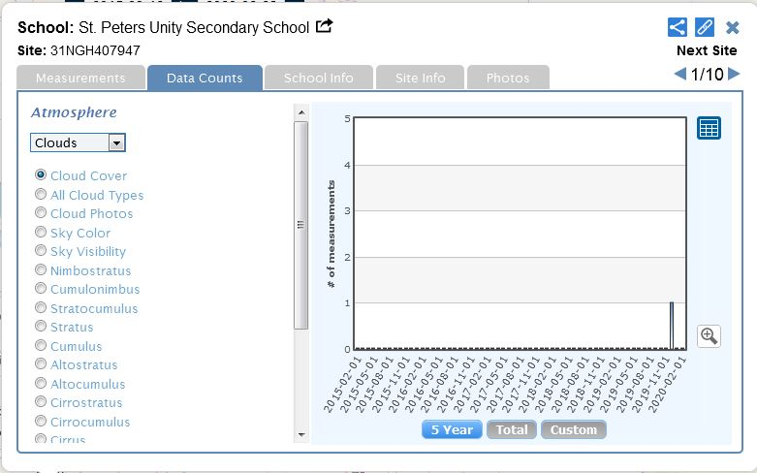
Figure 19: GLOBE Data – Atmosphere Clouds Cover 1

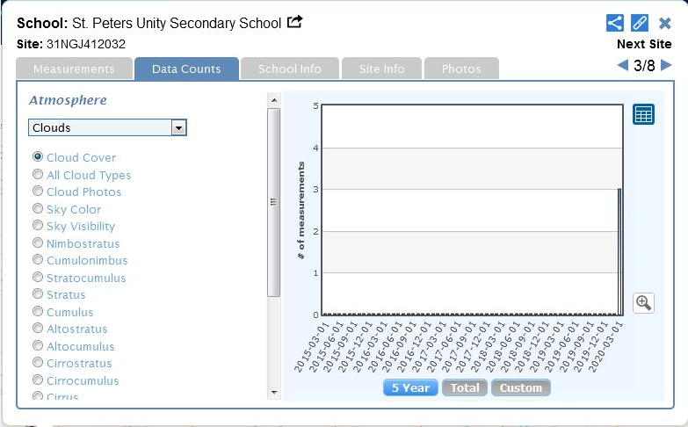
Figure 20: GLOBE Data – Atmosphere Protocol Clouds Cover 2

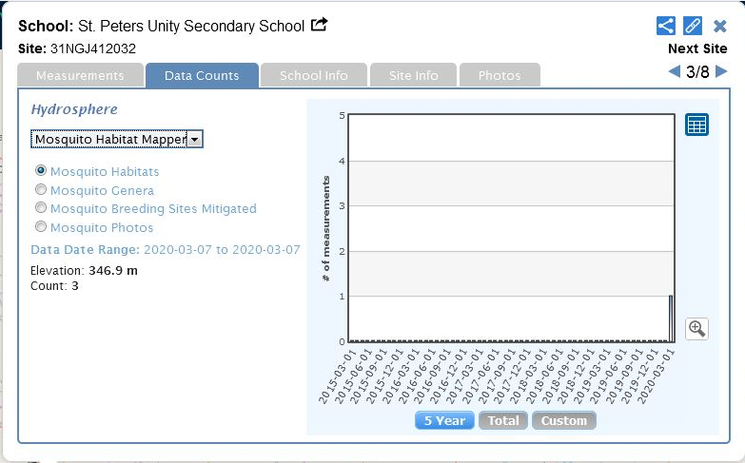
Figure 21: GLOBE Data – Hydrosphere Protocol Mosquito Habitat Mapper

Figures 19 – 21 illustrates the GLOBE data atmosphere protocol clouds cover 1, atmosphere clouds cover 2 and hydrosphere protocol Mosquito Habitat Mapper respectively over St. Peter’s Unity Secondary School, Akure.

Results:

SPUSSA community is predominantly academic environment which consists of various classrooms, administrative buildings, staff offices, staff quarters, junior and senior dining halls, science laboratories, school hall, student hostels, football field, uncultivated plots of lands, kitchen complex, dunghill and agricultural farm lands. This location (SPUSSA) contains lots of peridomestic containers such as paper wastes, can, plastic, kitchen wastes, bottles, gutters with stagnant water, puddles and runoff which encourage populations of mosquito developing stages.
- Identification of potential habitats of mosquito larvae
Figures 22 – 25 show the potential breeding habitats of mosquitoes in SPUSSA community.
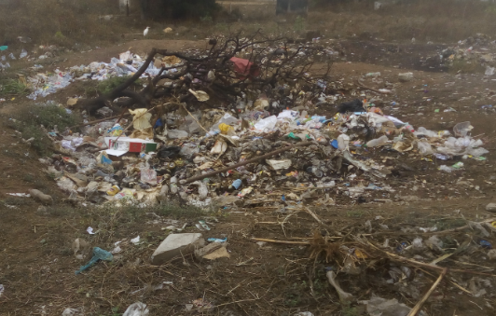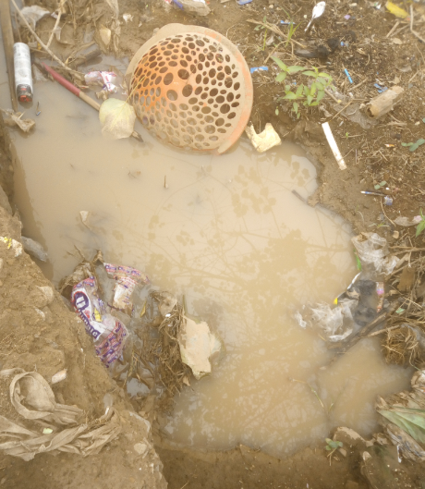
Figure 22: Dunghill consisting majorly of paper and nylon wastes.
Figure 23: Stagnant Pool of water.

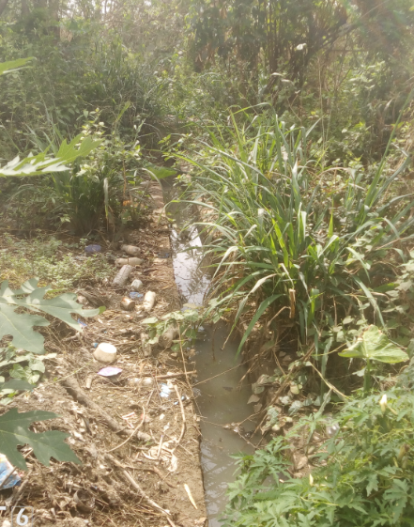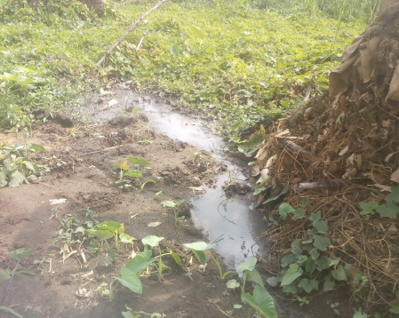
Figure 25: Hydrosphere site A. Shallow pool of water.
Figure 24: Gutter with standing water in Hydrosphere site B surrounded by farm land.

- Identifying different species or genera found in the study area
The diagrams below are samples of Anopheles and Aedes mosquito larvae as seen by the clip-on macro lens from the investigated hydro-sites A and B.
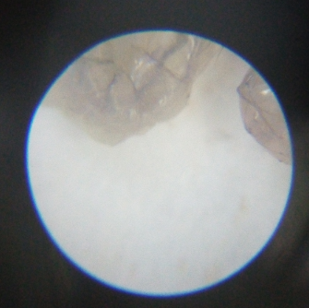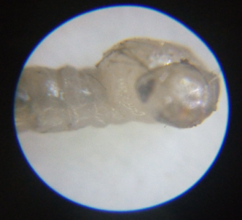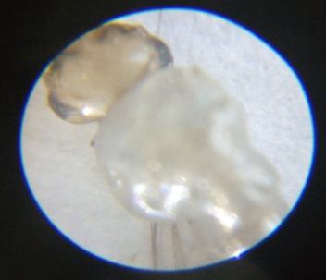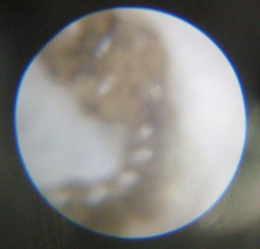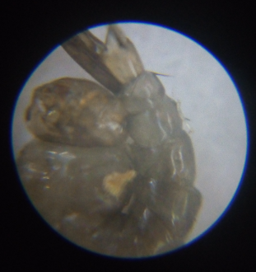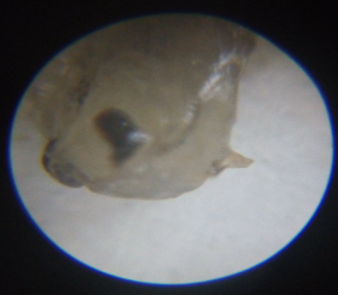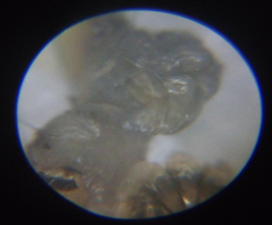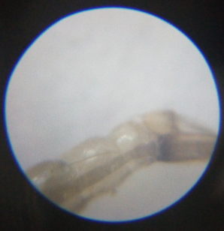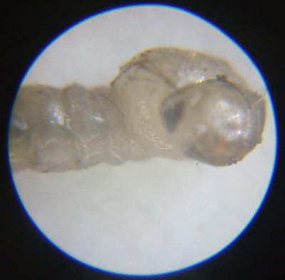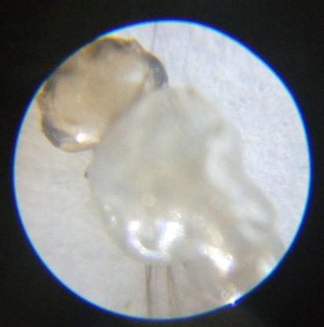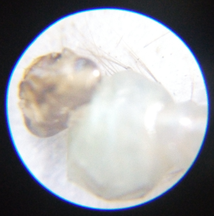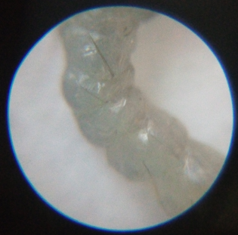

- Evaluate the physico-chemical properties of the hydrosphere or environmental habitat.
Tables 1 and 2 display the physico-chemical values and types of mosquito larvae obtained from investigated hydrosphere sites A and B respectively.

Table 1: SPUSSA HYDROSPHERE SITE A
 | Atmospheric Temperature  (°C) | Water Temperature  (°C) | Relative Humidity  (%) | pH | No. of Aedes Larvae | No. of Anopheles Larvae
Week 1 | 39 | 34 | 10 | 6.0 | 3 | 7
Week 2 | 37 | 32 | 11 | 6.5 | 5 | 7
Week 3 | 38 | 35 | 13 | 5.5 | 2 | 12
Week 4 | 36 | 31 | 16 | 6.0 | 0 | 13
Week 5 | 35 | 31 | 22 | 4.5 | 2 | 10
Week 6 | 33 | 28 | 34 | 3.5 | 4 | 5
Week 7 | 32 | 27 | 42 | 4.0 | 3 | 4

Table 2: SPUSSA HYDROSPHERE SITE B
 | Atmospheric Temperature  (°C) | Water Temperature  (°C) | Relative Humidity  (%) | pH | No. of Aedes Larvae | No. of Anopheles Larvae
Week 1 | 38 | 29 | 10 | 8.0 | 20 | 1
Week 2 | 37 | 30 | 12 | 7.5 | 23 | 4
Week 3 | 35 | 28 | 12 | 6.5 | 14 | 2
Week 4 | 34 | 26 | 17 | 6.0 | 12 | 0
Week 5 | 35 | 26 | 21 | 5.0 | 16 | 1
Week 6 | 32 | 31 | 35 | 5.5 | 8 | 3
Week 7 | 33 | 28 | 39 | 4.0 | 19 | 1

The physico-chemical parameters of the breeding sites as presented in the two tables (Tables 1 and 2) reveal that the atmospheric temperature ranges between 32 – 39°C , water temperature ranges between 26 – 35°C, relative humidity ranges between 10 – 42% and a pH range of 3.5 – 8.0.
- determine distribution of mosquito larvae
The study has revealed that the number of anopheles genera is abundant in hydrosphere site A compared to hydrosphere site B

Discussion:

The abundance of Anopheles species in hydrosphere site A is due to human activities like, pool of stagnant water, domestic runoffs, disposal of household and kitchen wastes which provide numerous breeding sites. The study has revealed that the number of anopheles genera is abundant in hydrosphere site A compared to hydrosphere site B. All species of mosquitoes reported in this study have also been reported by different researchers elsewhere in Nigeria (Adeleke, 2010; Bunza et al., 2010; Afolabi et al., 2013, Yayock et al., 2014). This confirms the wide range of geographical distribution of the anophilines. In SPUSSA community, the Anopheles genera and Aedes genera are the most common species in the study area and are listed among the most effective and efficient dominant vector species of human malaria. The anthropophagy of these two competent vectors has been well documented by (Awolola et al., 2005). It was further observed that physico-chemical parameters of the mosquito habitat determine mosquito oviposition and abundance. The optimal pH recorded in this study has also been reported by other authors (Adebote et al., 2006). The authors reported that pH range of 6.8–7.2 and 7.0–7.4 were suitable for the weakening of the mosquito egg shells for the emergence of its first larvae and that pH less than 5.0 and higher than 7.4 have fatal effects on survival of mosquito species. Optimal temperature suitable for breeding (28.6 °C) in Akure metropolis also concurred with the reports of Clement (1992).

In this study the temperatures observed are keen factors which affect the abundance and distribution of mosquito in the identified habitats. A research study conducted by Afolabi and Aladesanmi (2018) also shows that the optimal temperature that favored breeding in Akure is 28 °C while mosquito breeding is not likely to be found in temperature below 25 °C.

Conclusion:
The result of this study revealed the abundance of Anopheline mosquito species in the study area. The abundance and distribution of the mosquito species in the study area may be related to the availability of breeding sites. The Anopheles genera and Aedes genera encountered in the study are potential vectors of malaria. Lack of good drainage could be contributing to the abundance of mosquitoes in the study area. Pathogens spread by mosquitos kill more than a million people a year across the world, mostly in tropical regions. Increasing temperature and rainfall are potentially providing suitable conditions and habitats for mosquitos to spread pathogens, however, climate alone is not enough.

Recommendation:
It is good to educate the population, especially learners, about good practices to limit and destroy mosquito nests. These mosquitoes are probably vectors of the transmission of several serious diseases (malaria, Zika). There is need to develop control strategies that will target the vector species. Therefore, effective vector control programmes and public enlightenment especially on human activities that encourage mosquito breeding are recommended.
Limitation:
Only immature stages of mosquitoes were collected, while indoor resting mosquitoes were not examined. Further research should examine more environmental factors such as analysis of water contents and the ecology of the mosquito species. That is, using of more GLOBE protocols like turbidity, salinity, dissolved oxygen, rainfall and rain pH.

Bibliography/Citations:

- Adebote, D.A., Oniye, S.J., Ndams, I.S. & Nache, K.M. (2006). The Breeding of
Mosquitoes (Diptera: Culicidae) In Peridomestic Containers and Implication in Yellow Fever Transmission in Villages around Zaria, Northern Nigeria. Journal of Entomology, 3, 180–188.
- Adebote, D.A., Abolude, D.S., Oniye, S.J., & Wayas, O.S. (2008). Studies on
Some Physiochemical Factors Affecting the Breeding and Abundance of Mosquitoes (Diptera: Culicidae) In Phytotelmata On Delonix Regia (Leguminosa: Caesalpinoidea). Journal of Biological Sciences, 8, 1304–1309.
- Adeleke, M.A. (2010). Population Dynamics of Indoor Sampled Mosquitoes and
their Implication in Disease Transmission in Abeokuta, South-Western Nigeria. Journal of Vector Borne Diseases, 47, 33–38.
- Afolabi, O.J. & Aladesanmi, C.O. (2018). Seasonal Variation in Distribution and
Abundance of Mosquitoes (Diptera: Culidae) in Akure North Local Government Area, Ondo State, Nigeria. Uttar Pradesh Journal of Zoology, 38, 149–159.
- Afolabi, O.J., Simon-Oke, I.A. & Osomo, B.O. (2013). Distribution,
Abundance and Diversity of Mosquitoes in Akure, Ondo State, Nigeria. Journal of Parasitology & Vector Biology, 5, 132–136.
- Ayeni, A., (2011). Malaria Morbidity in Akure, Southwest, Nigeria. A Temporary
Observation in a Climate Change Scenario, Trends in Applied Sciences Research, 6, 488 – 494.
- Awolola, T.S, Oyewole, I.O., Amajoh, C.N., Idowu, E.T., Ajayi, M.B. & Oduola,
A. (2005). Distribution of the Molecular forms of Anopheles Gambiae and Pyrethroid knock down Resistance Gene in Nigeria. Acta tropica, 95, 204 – 209.
- Bunza, M. D. A., Suleiman, A. A., Yusuf, A. M. & Bala, A.Y. (2010). Relative
Abundance of Mosquito Species in Katsina Metropolis, Katsina State, Nigeria. Nigerian Journal of Parasitology, 31, 73-78.
- Centers for Disease Control and Prevention CDC (2019). Zika Virus.
https://www.cdc.gov/zika/about/overview.html 01/03/2020
- Clement, A.N. (1992). Development, Nutrition and Reproduction of Mosquitoes. In
The biology of mosquitoes, London: Chapman and Hall.
- Dawn, H.G., Kirk, A.S., Carl, O. & Paul, B. (2001). Cooperative Extension.
College of Agriculture and Life Sciences, The University of Arizona, 26, 307–367.
- Nwoke, B.E.B., Nduka, F.O., Okereke, O.M. & Ehighibe, O.C. (1993).
Sustainable Urban Development and Human Health Septic Tanks as a Major Breeding Habitat of Mosquito Vectors of Human Disease in South Eastern Nigeria. Appl. Parasitol. 34, 1-10.
- Olayemi, I.K., Omalu, I.C.J., Famotele, O.I., Shegna, S.P. & Idris, B. (2010).
Distribution of Mosquito Larvae in Relation to Physico-Chemical Characteristics of Breeding Habitats in Minna, North Central, Nigeria. Reviews of Infectious Diseases, 1, 49–53.
- Weatherspak.com (2020). Average Weather in Akure
https://weatherspark.com/y/51445/Average-Weather-in-Akure-Nigeria-Year-Round#Sections-BestTime
- WHO (2014). World Malaria Report 2014. Geneva: World Health Organization

- Yayock, H.C., Ndams, I.S., Kogi, E., Ahmed A.B. & Vagime, C.G. (2014).
Distribution of Mosquito Species in Kaduna Metropolis, Kaduna State, Northern Nigeria. Nigerian Journal of Entomology, 31, 15 – 21.

(Optional) Badge Descriptions/Justifications:
- Be a Collaborator
- Be a Data Scientist
- Make An Impact

Acknowledgments

Our gratitude and appreciation go to Mrs. F.I. Busari, Principal of St. Peter’s Unity Secondary School, Akure (SPUSSA), Ondo State, Nigeria for her support, encouragement and assistance during the study. She possesses the GLOBE Teacher Certification.
Phone Number: +234-8033502141

We are grateful to Mrs. Aminulai Modupe Salamotu, the Country Coordinator, for her strong commitment to the implementation of GLOBE in all primary and secondary schools in Ondo State, Nigeria. We salute your courage. She is GLOBE Certified.

Phone Number: +234-8035984500
Email: step13@yahoo.com

