Globe Sciencefaire: Aerosols
4-4-2017
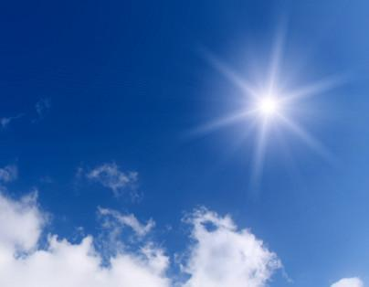
Yannick Hoegee, Bram Swaanen and Djimo de Rooij

Content
Introduction/abstract 3
Research question 4
Hypothesis 5
Materials 6
Method 7
Results 8-11
Analysis 12
Conclusion/discussion/new question 13
Report interview with scientists 14-17

Research Report - Aerosols in urban and non-urban areas
Introduction
The atmosphere of the earth doesn’t only exist out of gas molecules like oxygen and nitrogen. However it also exist of small solid and liquid particles flying through the air called aerosols. Where do these molecules come from? They form by natural and human ways. For natural ways we mostly speak about the condensing and freezing of water vapours, volcanic eruptions, salt sprayed by breaking waves, a wildfire and dust storms which causes aerosols to form. For human ways it is mostly caused by burning wood, leaves, industrial processes and even the vehicle emissions will cause aerosols. The kinds of aerosols are split up over five categories, which are: dust, soot, sulphate, sea salt and organic aerosols. The length of time aerosols spend in the atmosphere before being removed is called the `residence time'. Typical residence times are days or weeks. In comparison, greenhouse gases can have residence times of many years. This is significant because any major change in aerosol emissions would have a much more immediate effect than a corresponding change in greenhouse gases.
Processes that remove aerosols from the atmosphere are divided into two categories - wet and dry deposition. Dry deposition is the removal of particles by gravitational settling, and is more important for larger particles. Smaller aerosols tend to undergo wet deposition, which involves the incorporation of aerosols into clouds, and transport to the ground by precipitation. Furthermore an urban area is an area where many people live and work close together. The population density is higher than in the surrounding area. It is where buildings are close together. Urban is the opposite of rural, where farm lands and nature are. Urban areas are usually cities and towns. However it depends on the country you live in. And a non-urban area is situated outside town or city. Less people live and work close together in a non-urban area.
Abstract
Our research question was: what is the difference in aerosol optical thickness between Leerdam Centrum (urban) and Schoonrewoerd (non-urban) on monday the 27th of march between 1pm and 5pm. Doing this we will find out whether there is a link between aerosol optical thickness and the areas aerosols occur.This is important to find a possible solution for problems like global warming, knowing aerosols have a lot to do with temperature and the weather. This might also help to make weather forecasts more precise and reliable. Furthermore we will use our sub-questions like: what are aerosols, what kinds of aerosols are there, what is an urban area and what is a non-urban area. This is for the sake to understand the subject better and for better understanding of our results of the testing.
To conclude we have compared the results from Leerdam with these from Schoonrewoerd, and remarkable is that there is hardly a difference in Light intensity and so also in AOT. This refutes our hypothesis because we thought there would be a generally big difference.

Research Question
What is the difference in aerosol optical thickness between Leerdam Centrum (urban) and Schoonrewoerd (non-urban) on Monday the 27th of march between 2pm and 5pm?

Doing this we will find out whether there is a link between aerosol optical thickness and the areas aerosols occur. This is important to find a possible solution for problems like global warming, knowing aerosols have a lot to do with temperature and the weather. This might also help to make weather forecasts more precise and reliable.

Hypothesis
The optical thickness is higher in urban regions (Leerdam) than in non-urban regions (Schoonrewoerd).

The reason for this is the presence of more vehicles and industrial activity in urban regions than in non-urban regions. These activities cause the emission of soot particles which increase the aerosol optical thickness.
Testability/measurability
This hypothesis can be tested by measuring the optical thickness in urban regions and in non-urban regions on a local scale level and on a global scale level. The measurements on a local scale level could, for example, be done in Leerdam and in Schoonrewoerd. Leerdam will be the urban area and Schoonrewoerd will be the non-urban area. The measurements on global scale could be done in a sparsely populated area in Canada and in the Ruhr area in Germany. Here, the Ruhr area will be the urban region and the sparsely populated area in Canada will be the non-urban region. After that the outcome of the measurements on the same scale level should be compared.

Materials
- Sun photometer
- Hygrometer
- Thermometer
- Cloud map
- Barometer
- clock/mobile phone

Method
We decided to take one day to do measurements and cycle back and forth between Leerdam (more urban) and Schoonrewoerd (non-urban). For the measurements we firstly measure the temperature of the sunphotometer. Write down the time of measuring and face the sunphotometer towards the sun, exactly so the sunlight passes the circle and falls on the blue dot. Write down the outcome on the paper, do this for green and red. Measure both at least four times. Also do not forget to do black measurements, without light entering the sunphotometer. After you have filled in every box on the paper for the measurements you start looking at the environment. Fill in which clouds are present and how they could influence the measurements. Measure the air temperature, air pressure and humidity, also write those down. Now cycle down to the next place and measure there.

These are the two places where we chose to do measurement:
- In the city centre of Leerdam
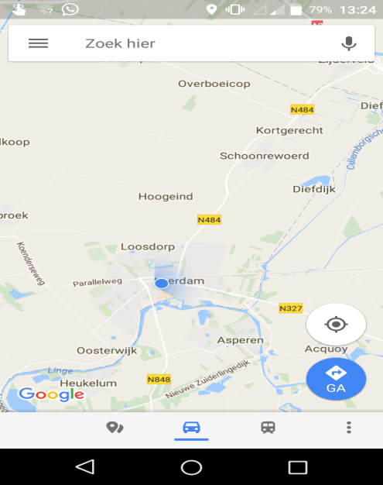
- In the village of Schoonrewoerd
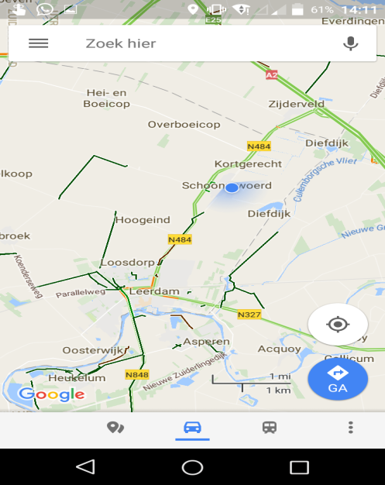

Results
Results voltage sunlight for different colours of light
Where | Date | Time* | Maximum voltage sunlight (V)** | Average (V)**
Leerdam city centre | 27-03-2017 | 11.30.45  11.31.30  11.32.15  11.33.00  11.33.15  11.33.30  11.33.45  11.34.00  11.34.15  11.34.45 | 0,958  1,298  0,919  1,299  0,950  1,303  0,963  1,277  0,961  1,315 | 0,950  1,298
Schoonrewoerd | 27-03-2017 | 12.03.45  12.04.15  12.04.45  12.05.00  12.05.30  12.05.45  12.06.00  12.06.15  12.06.30  12.06.45 | 0,974  1,309  0,937  1,333  0,957  1,194  0,947  1,330  1,007  1,219 | 0,964  1,277
Leerdam city centre | 27-03-2017 | 12.34.15  12.34.30  12.34.45  12.35.00  12.35.15  12.35.30  12.35.45  12.36.00  12.36.15  12.36.30 | 1,001  1,334  1,005  1,345  1,003  1,350  0,992  1,354  0,999  1,354 | 1,000  1,347
Schoonrewoerd | 27-03-2017 | 13.04.00  13.04.30  13.04.45  13.05.00  13.05.15  13.05.30  13.05.45  13.06.00  13.06.15  13.06.30 | 1,006  1,357  0,987  1,370  1,001  1,374  1,017  1,278  1,012  1,371 | 1,000  1,350
Leerdam city centre | 27-03-2017 | 14.17.00  14.17.45  14.18.00  14.18.15  14.18.45  14.19.15  14.19.30  14.19.45  14.20.00  14.20.15 | 0,810  1,267  0,669  1,271  0,904  1,275  0,914  1,265  0,860  1,226 | 0,831  1,261
Schoonrewoerd | 27-02-2017 | 14.44.00  14.44.30  14.44.45  14.45.15  14.45.45  14.46.15  14.46.45  14.47.00  14.47.15  14.47.30 | 0,832  1,155  0,846  1,037  0,857  1,212  0,796  1,203  0,833  1,199 | 0,833  1,161
*The time displayed is the UT = universal time (wintertime in the timezone of Greenwich)(when winter in the Netherlands: current time - 1; when summertime: current time -2)
**Green coloured number: average measurement for green light intensity; Red coloured number: average measurement for red light intensity)
Sun Covered by Clouds per Place per Time
Place | Time* | Sun covered by clouds (%)
Leerdam city centre | 11:27 | 0-10
Leerdam city centre | 12:32 | 0
Leerdam city centre | 14:15 | 0-10
Schoonrewoerd | 12:03 | 0
Schoonrewoerd | 13:02 | 0
Schoonrewoerd | 14:42 | 0-10
*The time displayed is the UT = universal time (wintertime in the timezone of Greenwich)(when winter in the Netherlands: current time - 1; when summertime: current time -2).
All measurements were done on the same day: 27-03-2017

Relative Humidity per Place per Time
Place | Time* | Relative humidity (%)
Leerdam city centre | 11:27 | 33
Leerdam city centre | 12:02 | 28
Leerdam city centre | 14:15 | 31
Schoonrewoerd | 12:03 | 32
Schoonrewoerd | 13:02 | 27
Schoonrewoerd | 14:42 | 28
*The time displayed is the UT = universal time (wintertime in the timezone of Greenwich)(when winter in the Netherlands: current time - 1; when summertime: current time -2).
All measurements were done on the same day: 27-03-2017
Air Pressure per Place per Time
Place | Time* | Airpressure (Mbar)
Leerdam city centre | 11:27 | 1053
Leerdam city centre | 12:02 | 1053
Leerdam city centre | 14:15 | 1052
Schoonrewoerd | 12:03 | 1053
Schoonrewoerd | 13:02 | 1054
Schoonrewoerd | 14:42 | 1052
*The time displayed is the UT = universal time (wintertime in the timezone of Greenwich)(when winter in the Netherlands: current time - 1; when summertime: current time -2).
All measurements were done on the same day: 27-03-2017
Sun Covered by Contrails per Place per Time
Place | Time* | Sun covered by contrails (%)
Leerdam city centre | 11:27 | 0
Leerdam city centre | 12:02 | 0
Leerdam city centre | 14:15 | 0-10
Schoonrewoerd | 12:03 | 0
Schoonrewoerd | 13:02 | 0-10
Schoonrewoerd | 14:42 | 0

Analysis
To compare the two places we can leave the humidity etcetera aside because there is hardly any difference so they won’t influence the measurements a lot.

The graph shows the results of the measurements.

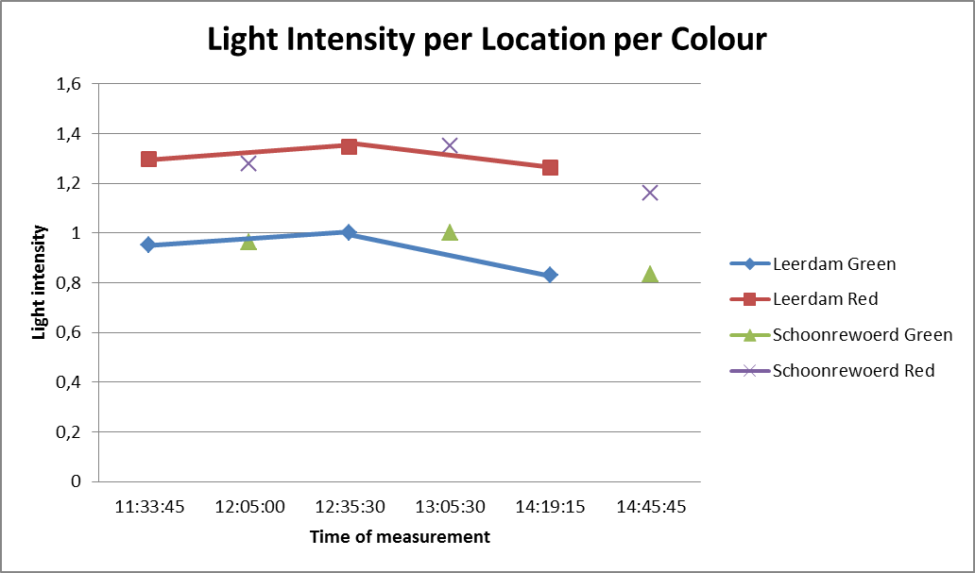

Conclusion
Comparing the results from Leerdam with these from Schoonrewoerd, there is hardly a difference in Light intensity and so also in AOT. This refutes our hypothesis because we thought there would be a generally big difference.
Discussion
It was pretty difficult to do measurements because conditions change very quickly and there are lots of factors which can influence the measurements. It would have been handy to have two sunphotometers so we could do the measurements at the same time in two different places for more accurate results. Further on it was pretty fun to do these measurements, only all the cycling was a bit waste of time. For the next time it would be handy to make sure there are two sunphotometers.
We did pretty much extra work for this project, like visiting TU Delft for a conversation with a scientist.
We started a bit late because we had difficulties with formulating a right research question which was answerable by our own measurements and was specific enough. This made the last three weeks a bit stressful because of all the work that still had to be done. We should do that better next time.

New questions
How would the data be like when we measured at two place at the same time?
What will the difference be between an area where there are winter conditions the whole year and for an area where are summer conditions the whole year?
Can we use the aerosols in one way or another? So make an advantage of it.

Report Interview with Scientist
Introduction
Monday 27 February, we visited Herman Russchenberg, Professor Atmospheric Remote Sensing, at the Technical University of Delft. With him we talked about our research into the difference in aerosol optical thickness in urban and non-urban areas.

On the forehand we had thought up several questions:
- How can we draw reliable conclusions from our measuring results? After all there are very many variables that have to be taken into account when analyzing the data.
- In which climate do most aerosols arise?
- Can clear differences in aerosol optical thickness be discovered on a local scale or should one really look at national or international scale level?
- Which place is the best to do measurements? And at which moment?
- Which of the factors mentioned on our datasheet has the biggest influences the measurements by the sunphotometer the most? Which factor contributes most to the inaccuracy of our measurements?
- Are there aerosols in space?
- Do you think our research question “what is the difference in aerosol optical thickness in urban and non-urban areas?” is a good question or should we make it more specific?

The answers professor Russchenberg gave us were really helpful to extended our understanding of the matter and it also helped us improve our method and research question. Furthermore doing this interview we learned something about the mindset one should have when researching something.

In this report a summary will be given of Professor Russchenberg’s answers to the questions mentioned above. After this the significance of this answer will be described under the heading significance. The interview was in Dutch so the Professor’s answers have been translated into English. (A complete recording of the interview can be found in the attachments)
Answers
How can we draw reliable conclusions from our measuring results? After all there are very many variables that have to be taken into account when analyzing the data.
The best way to draw reliable conclusions from the measuring results is to make sure that you can compare measurements during which factors different that the light intensity are the same. Do measurements in both place at the same day for example. In this way the moist in the air won’t vary much. This means one factor less to take into account.

It’s also wise to measure when there are no clouds. Clouds decrease the accuracy of your results, because they absorb and reflect sunlight, while you actually only want you observe the reflection and absorption of sunlight by aerosols.

Furthermore it’s important to keep the temperature of the sunphotometer constant, since temperature influences the measurements done with the device.

Last of all, it’s useful to put the alternative data, such as humidity, air pressure and air temperature in a graph. In this way you get an easy overview of the situation during every particular measurement. This enables you to easily identify two measurements during which the circumstances were approximately the same.

Significance
This helped us think up a good research method. And it also helped us with analysing the data we collected.

In which climate do most aerosols arise?
Before you can answer that question you need to know something about in which ways aerosols arise. Aerosols can arise from human sources such as car emissions and aerosols can arise from natural sources such as the sea (sea salt can form aerosols) and deserts (sand and dust are aerosols).

But if your question is in which climate most natural aerosols arise this will be in the tropic and subtropics. This where you find most deserts and where water from seas evaporates the fastest.

Significance
/

Can clear differences in aerosol optical thickness be discovered on a local scale or should one really look at national or international scale level?
Both is possible. It depends on over what time scale you look. Local differences can for example be very big if you do measurements during one day. However, when you start to look at the average aerosol thickness over a longer period of time you see that local differences start to disappear. This is because all the aerosols in the atmosphere mix a bit over time making the amount of aerosols in the air for two close by areas approximately the same.

Significance
This made us aware of the fact that our research did not have to include measurements from large distances apart. We did not have to use measurements from other countries or even other continents. We could just use the data we collected nearby.

Which place is the best to do measurements? And at which moment?
This depends on what you want to know. It depends on what the goal of the research is. Furthermore you should know why you want to do measurements. Those are all kinds of things you have to keep in mind when doing a research, because in the end you want to achieve something with your measurements.

One condition that is necessary for doing measurements, of course, is that you should be able to look directly at sun. There should not be any clouds in front of it.

Significance
This showed us that while doing a research you should never forget that you are doing this research because you want to find out something; you should take this into account in every decision you make.

Which of the factors mentioned on our datasheet has the biggest influence on the measurements done with the sun photometer? Which factor other than the light intensity contributes most to the inaccuracy of our measurements?
There isn’t really one factor that make the measurements the least accurate. However, there are ways to find out whether a certain factor will have a big or a smaller influence on the measurements done with your sunphotometer.

For example, low clouds often let through less sunlight than higher clouds. You can easily see this because low clouds appear darker than high clouds. This means that measurements done when there are dark clouds will come out lower than they would in ideal circumstances.

Furthermore a white sky indicates that there is much water vapour in the air. This also reduces the accuracy of your measurement, because the water vapour reflects light. So, if the sky is bright blue the measurements you do will be more accurate than when the sky appears white.

Significance
In this way we can take into account that when we have measurements which were done while there were dark clouds or a milky sky, the values we measure will be lower than it would be in ideal conditions.

Are there aerosols in space?
The higher you get in the atmosphere the less aerosols you will encounter. When you eventually leave the atmosphere and you really enter space you won’t find any aerosols anymore. You do have something similar to aerosols in space which we call cosmic radiation. This is, however, not the same as aerosols; cosmic radiation is smaller.

Significance
This answer is not really significant for our research.

Do you think our research question “what is the difference in aerosol optical thickness in urban and non-urban areas?” is a good question or should we make it more specific?
This question is pretty general and you cannot measure it exactly. Because you cannot measure the average aerosol optical thickness in urban and non-urban areas. You can only measure the aerosol optical thickness in a certain place at certain time or during a certain timeframe.

So, I’d make it more specific. In the research question I would mention the date and the timeframe in which you did measurements.

If you make it more specific you’ll also be able to deduce a research method from the research question more easily. But if you keep it as general as this, you can do anything with your research method.

Significance
This answers helped us to formulate a better research question; we made our research question more specific. In this way we were also able to think up a good research method.

This answer is also very useful in next researches we will do, because Professor Russchenberg clearly shows a connection can be found between a research question and the research method.

Professor Russchenberg also made some comments that are not explicitly linked to our questions during the interview. A summary of these comments will be given here.
- Aerosols are very much influenced by meteorology; this determines for example where aerosols are transported to or whether certain chemical reactions from which aerosols arise can occur.

Significance
/
- What I’d do to measure differences between urban and non-urban areas is to choose two places - one in an urban area and one in a non-urban area - and take one day to do several measurements in both places. It’s best to measure at the same time. In this way you are sure that the other factors influencing your measurement are approximately the same.

Significance
This made us decide to do measurements during one afternoon in both places.

Unfortunately this method was not completely possible for us, because in order to measure in both places at the same time we would need two sun photometers and there wasn’t a second we could borrow from Globe. Furthermore could we only manage to do measurements for half a day.

