Does global warming have an effect on the water temperature of the river Drava?
Nika Sraka, Maja Hozjak i Katarina Hozjan
Maja Labaš Horvat i Valentina Pirc Mezga
Srednja škola Prelog, Prelog

Summary

Since the early ages, people have tried to change the environmnet and adjust it to their needs. However, after the industrial revolution, this influence has increased in such a way that it started to affect Earth as a whole, which can especially be seen on the example of climate. The temperatures are rising and there are drastic changes in climate. Our research has been invoked by the influence of the global warming or constant warming of the Earth's surface and the lowest layers of atmosphere due to greenhouse effect, which leads to the change in climate. Our main research questions are connected to the trend of global warming and they are: does water temperature increase together with air temperature and what was the average water temperature in the past 7 years. Then we also wanted to know whether the water level had an influence on the increase/decrease of water temperature. For the sake of this research, we have gathered data on air temperature, water temperature and water levels of the river Drava in water accumulation in Prelog.We have measured air temperature and water temperature and have used GLOBE hidrology protocols. Water level data has been found on DHMZ web pages, where we have also found graphs with data on water levels. We have used data from the past seven years.

Research questions and hypothesis

- We have asked ourselves these questions: Has the water temperature at our station increased at the same rate as the air temperature and what has been the average increase in water temperature in the last 7 years?

- Did changes in the water level of Drava affect the change in water temperature?

We have been measuring water and air temperature on Marina Drava for the past 7 years.

We know from physics class that „specific heat capacity of water is much higher than specific heat capacity of air“(1). The repercussion of the high specific heat capacity of water is that much more energy is required to heat the water than to heat the soil. Our assumption is that the water temperature will change at a slower rate, but will still follow the rise in air temperature. We also assumed that a lower water level would have a higher water temperature because a lower volume will heat up sooner than a higher one, and therefore water with a higher water level has a lower temperature. Regarding the average water temperature over the past 7 years, we assume that this average will be higher every year because of the increase of global warming each year.

Research methods
For this research, data on air, water and water temperatures were collected from the Drava River in
the Prelog reservoir area. We measured air temperature and water temperature using the GLOBE
water protocol (Matoničkin Kepčija, 2008). We found the water level data on the website of the State
Hydrometeorological Institute (in the sector of hydrology DHMZ 2019). On DHMZ page we found
graphs with data for water levels and red data from graphs. We entered the water data once a week,
the data for the atmosphere (air temperature) every day, and the water level data are cleared via the
automatic measuring station on the DHMZ website once a week, at the same day day when we also
entered the water data so that we can better establish the data . We got the average water
temperatures over the past 7 by calculating the average water temperature every month of the year,
and then the average monthly temperatures are summed and divided by months in a year. We
repeated the same process for all 7 years and summed average annual temperatures, and divided it
by the number of years. We used Excel for calculation of the average temperature. We have collected
and studied the information over a 7 year period. When drafting the project we consulted with the
doctor Ivan Čanjevec, from the Department of Physical Geography, Faculty of Science, Zagreb.
Review and data analysis

Coordinates of Marina Drava measuring station (picture 1):
latitude 46.3234 N, longitude 16.6044 E

Figure 1. Measuring station Drava

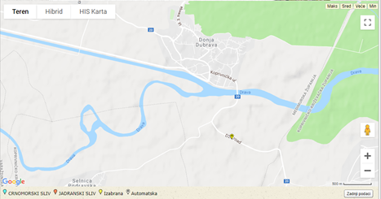
Figure 2. Measuring station DHMZ

From the average annual temperatures shown in Table 1, it is not possible to determine the trend of the increase or decrease of average water temperature, but it is visible that the average water temperature circles around 9 degrees. Also, looking at the table, we can see that 2012 was the warmest year and the average temperature was 11.6 ° C, while the average total temperature was 9.63 ° C, which is a difference of 1.97 ° C. The lowest average temperature was in 2014, and that year was the coldest. The difference between the average temperature in total and the average water temperature in the coldest year was 0.63 ° C.

Table 1. Average water temperature in the past seven years

YEAR | 2012. | 2013. | 2014. | 2015. | 2016. | 2017. | 2018.
AVERAGE WATER TEMPERATURE(°C) | 11,6 | 9,63 | 9 | 9,16 | 9,35 | 9,29 | 9,37
TOTAL (°C) | 9,63

Table 2. shows that the average temperature is the highest in August (18, 18 °C) and the lowest in December (2,06 °C). Average temperature in 2013. was 9,63 °C.
Table 2. Average water temperature in 2013
2013. MARINA PRELOG
DATE | WATER TEMPERATURE(°C) | AVERAGE WATER TEMPERATURE(°C) | AVERAGE TEMPERATURE IN 2013.
31.01. | 3 | 3,4 | 9,63
3.1 | 3,5
10.1. | 3
24.1. | 3,8
17.1. | 3,5
21.2 | 3 | 3,25
7.2 | 7
14.2 | 3
28.2 | 5
7.3 | 6,7 | 4,45
21.3 | 4
28.3 | 4,1
14.3 | 3
4.4 | 7,3 | 8,43
18.4 | 9
11.4 | 7,5
25.4 | 9,9
30.5 | 14,7 | 13,04
9.5 | 11,5
2.5 | 10,9
16.5 | 13,5
23.5 | 14,6
27.6 | 16,1 | 15,93
13.6 | 15,8
6.6 | 15,6
20.6 | 16,2
4.7 | 16,7 | 16,95
25.7 | 17
18.7 | 17,4
11.7 | 16,7
15.8 | 17,7 | 18,18
8.8 | 17,9
22.8 | 18,6
1.8 | 17,7
29.8 | 19
26.9 | 12,7 | 15,78
12.9 | 17
19.9 | 15,4
5.9 | 18
3.10 | 10,7 | 8,9
24.10 | 7,7
17.10 | 9
31.10 | 6,8
10.10 | 10,3
21.11 | 5 | 5,23
14.11 | 5,6
28.11 | 4,1
7.11 | 6,2
12.12 | 3,8 | 2,06
26.12 | 1,3
5.12 | 2
31.12 | 1,5
19.12 | 1,7

The highest water level of the Drava River in 2013 was in December and the lowest in early September.
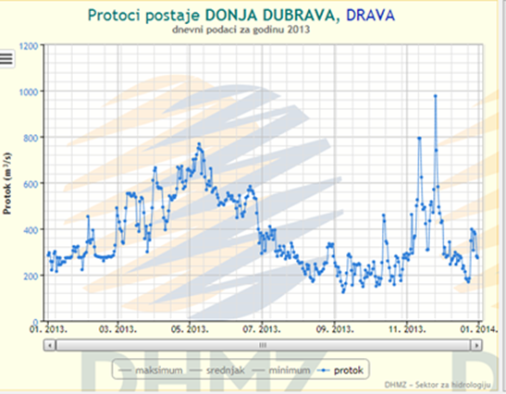
Figure 3. Water level of the river Drava in 2013
Source : DHMZ page
Comparing data from Figure 4 and Figure 5, it can be seen that the water temperature increases in parallel with the air temperature, i.e. the air temperatures are lowest in winter months and water temperature is the lowest in those months as well. Air and water temperatures are the highest in summer.
Observing Figure 3. and Figure 5., it can be seen that the water level is highest when the water temperature is lowest and when the water temperature rises, the water level decreases. Water temperature and water level are inversely proportional.
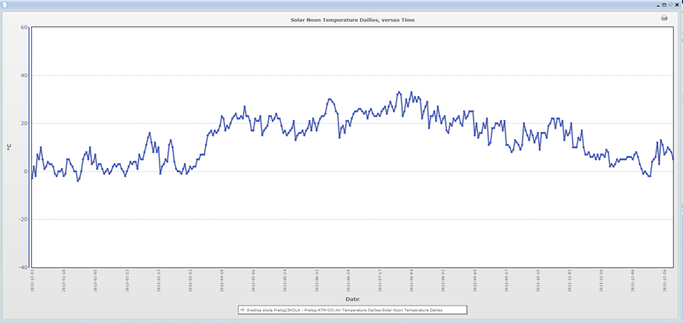
Figure 4. Air temperature in 2013
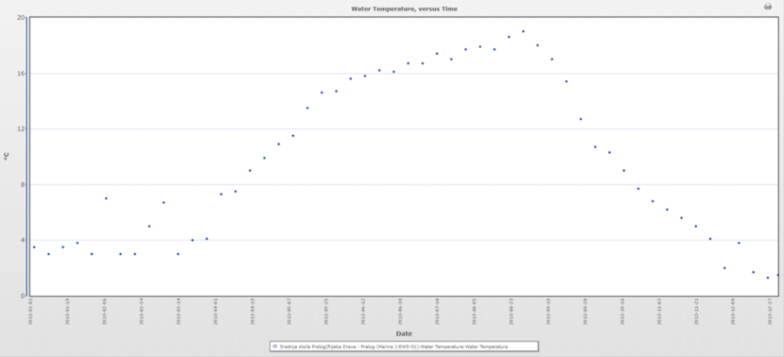
Figure 5. Water temperature in 2013

Table 3 shows that the average temperature in August is highest (18 ° C) and lowest in December (1,1° C). The average temperature in 2014 is 9.03 ° C
Table 3. Average water temperature in 2014
2014. MARINA PRELOG
DATE | WATER TEMPERATURE(°C) | AVERAGE WATER TEMPERATURE(°C) | AVERAGE TEMPERATURE IN 2014.
2.1. | 1,3 | 1,25 | 9,03
16.1. | 1,2
23.1. | 1,1
30.1. | 1,4
6.2. | 1,3 | 2,6
13.2. | 2,1
20.2. | 3,2
27.2. | 3,8
6.3. | 4,6 | 4,9
13.3. | 4
20.3. | 6
27.3. | 5
3.4. | 7 | 8
10.4. | 7
17.4. | 8
24.4. | 10
1.5. | 12 | 12,5
8.5. | 12
15.5. | 14
29.5. | 12
5.6. | 17 | 16,25
12.6. | 17
19.6. | 16
26.6. | 15
3.7. | 16 | 17
10.7. | 17
17.7. | 18
24.7. | 17
7.8. | 17 | 18
14.8. | 18
18.8. | 19
21.8. | 18
4.9. | 16 | 14,5
11.9. | 16
18.9. | 15
25.9. | 11
2.10. | 9 | 7,8
9.10. | 8
16.10. | 9
23.10. | 7
30.10. | 6
6.11. | 5 | 4,5
13.11. | 4
20.11. | 5
27.11. | 4
4.12. | 1 | 1,1
11.12. | 1
18.12. | 1
25.12. | 1
31.12. | 1,5

The highest water level of the Drava River in 2014 was in September and the lowest in early
November.
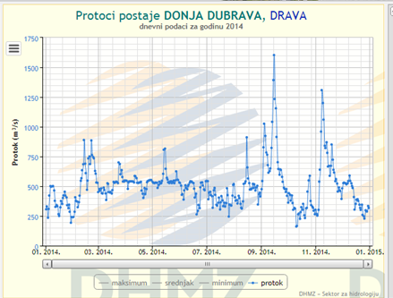
Figure 6. Water level of the river Drava in 2014
Source: DHMZ page

Comparing the data in Figure 7 and Figure 8, we see that the water temperature rises in parallel with the air temperature. Air and water temperatures are highest in summer.
Observing Figure 6 and Figure 8, it can be seen that the water level is highest when the water
temperature is also highest. Comparing this with graph 5, we can see that the highest water level was
during heavy rainfall (in September).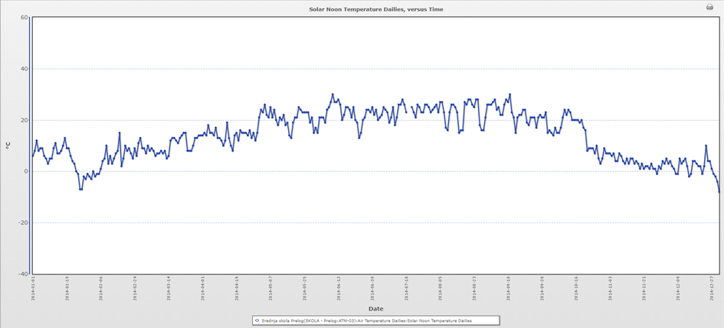
Figure 7. Air temperature in 2014

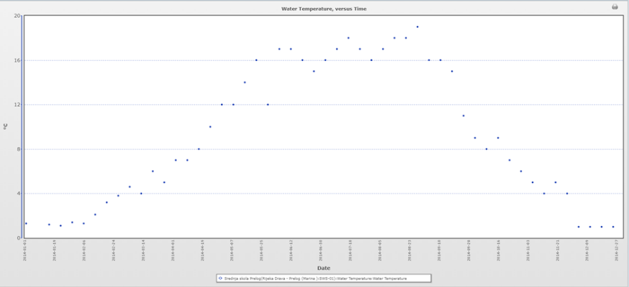
Figure 8. Water temperature in 2014

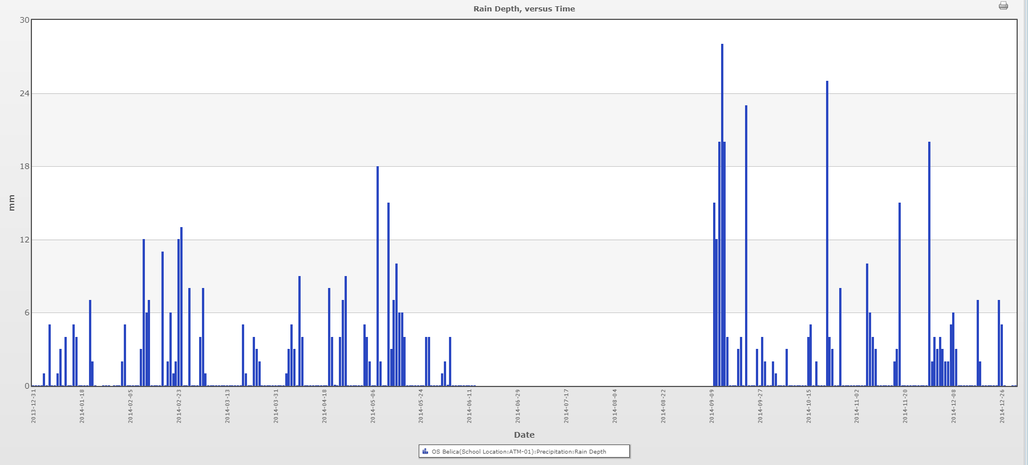
Figure 9. Rainfall in 2014

Table 4. Average water temperature in 2015
DATE | WATER TEMPERATURE(°C) | AVERAGE WATER TEMPERATURE(°C) | AVERAGE TEMPERATURE IN 2015.
15.1. | 1 | 1,50 | 9,35
1.1. | 2
22.1. | 2
29.1. | 1
5.2. | 1 | 2,25
12.2. | 3
26.2. | 3
19.2. | 2
19.3. | 4 | 3,78
5.3. | 4
12.3. | 3
26.3. | 4,1
30.4. | 10,9 | 8,92
9.4. | 7,5
16.4. | 9
23.4. | 9,9
2.4. | 7,3
28.5. | 14,7 | 13,83
14.5. | 14,5
21.5. | 14,6
7.5. | 11,5
4.6. | 15,6 | 15,93
25.6. | 16,1
18.6. | 16,2
11.6. | 15,8
9.7. | 16,7 | 17,13
30.7. | 17,7
16.7. | 17,4
2.7. | 16,7
20.8. | 18,6 | 18,33
27.8. | 19
13.8. | 17,8
6.8. | 17,9
24.9. | 12,7 | 15,78
10.9. | 17
3.9. | 18
17.9. | 15,4
15.10. | 9 | 8,13
29.10. | 6
1.10. | 10,7
22.10. | 6,8
5.11. | 6 | 5,15
19.11. | 5
26.11. | 4
12.11. | 5,6
24.12. | 1,5 | 1,50
10.12. | 1,7
31.12. | 1,5
17.12. | 1,3

Table 4 shows that the average temperature in August is the highest (18.33 ° C) and the lowest in December (1.5 ° C). The average temperature in 2015 is 9.35 ° C.
The highest water level of the Drava River in 2015 is in early April and mid-October, and the lowest in
January.
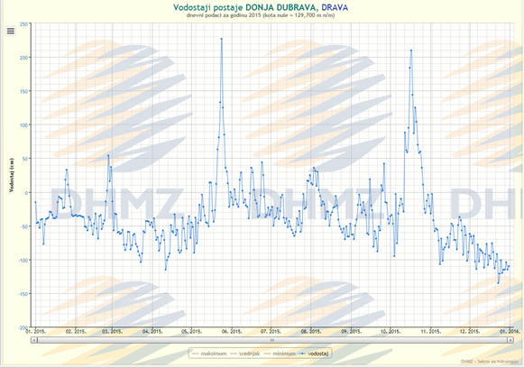
Figure10. Water level of the river Drava in 2015

Comparing the data in Figure 11 of Figure 12. we can see that the water temperature increases in
parallel with the air temperature. Air and water temperatures are lowest in the winter months.
Looking at Figure 10 and Figure 12, we can see that generally water levels are lowest when the
temperature is highest in summer.
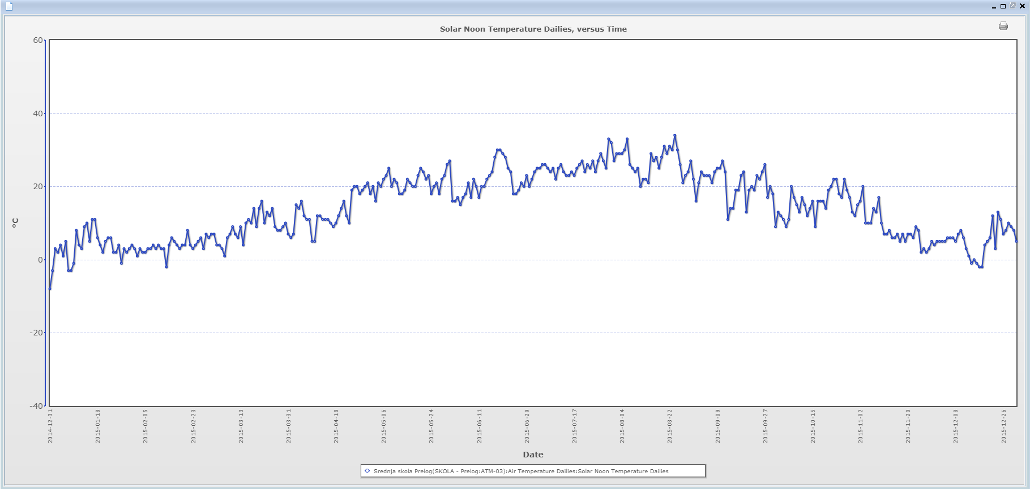
Figure11. Air temperature in 2015

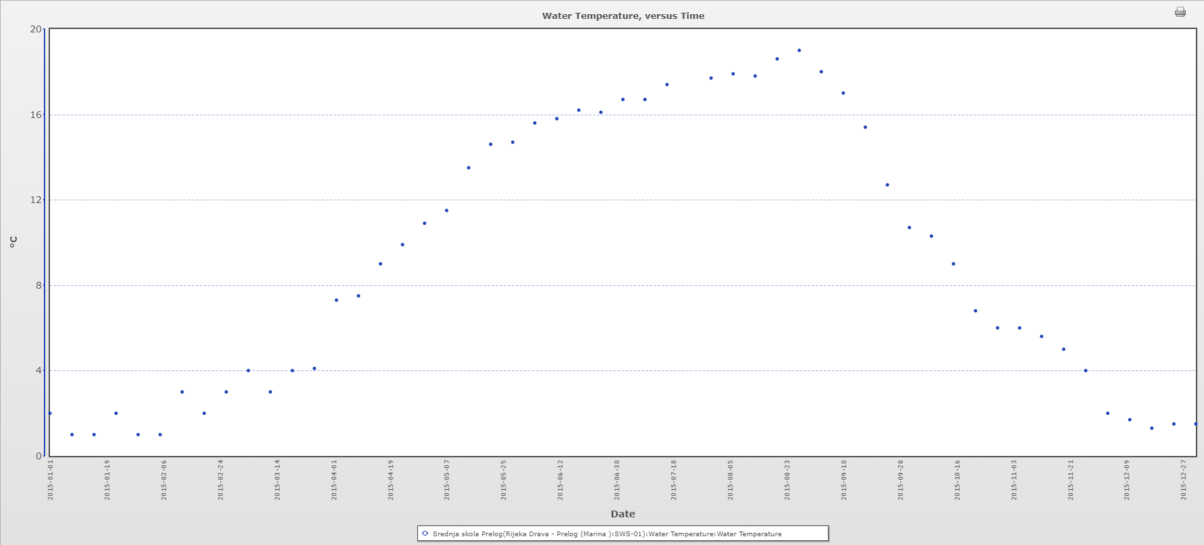

Figure 12. Water temperature in 2015

Table 5 shows that the average temperature in August is the highest (18.33 ° C) and the lowest in
January (1.17 ° C). The average temperature in 2017 is 9.29 ° C.

Table 5. Average water temperature in 2017

2017. MARINA PRELOG
DATE | WATER TEMPERATURE(°C) | AVERAGE WATER TEMPERATURE(°C) | AVERAGE TEMPERATURE IN 2017.
14.1. | 1,1 | 1,17 | 9,29
21.1. | 1
28.1. | 1,4
4.2. | 1 | 2,5
11.2. | 3
18.2. | 3
25.2. | 3
4.3. | 4 | 3,78
11.3. | 3
18.3. | 4
25.3. | 4,1
1.4. | 7,3 | 9,4
8.4. | 8,
15.4. | 9
22.4. | 9,9
29.4. | 12,7
6.5. | 11,5 | 13,58
13.5. | 13,5
20.5. | 14,6
27.5. | 14,7
3.6. | 15,6 | 15,93
10.6. | 15,8
17.6. | 16,2
24.6. | 16,1
1.7. | 16,7 | 17,04
8.7. | 16,7
15.7. | 17,4
22.7. | 17
29.7. | 17,7
5.8. | 17,9 | 18,33
12.8. | 17,8
19.8. | 18,6
26.8. | 19
2.9. | 18 | 15,02
9.9. | 17
16.9. | 15,4
23.9. | 12,7
30.9. | 12
7.10. | 10,3 | 8,03
14.10. | 9
21.10. | 6,8
28.10. | 6
4.11. | 6 | 5,15
11.11. | 5,6
18.11. | 5
25.11. | 4
2.12. | 2 | 1,6
9.12. | 1,7
16.12. | 1,3
23.12. | 1,5
30.12. | 1,5

The highest water level of the Drava River is in October and the lowest in January and February.
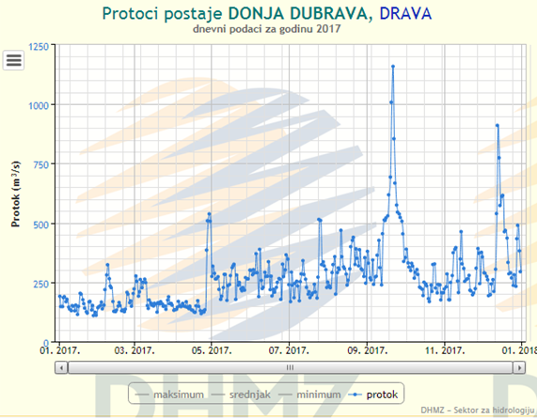

Figure13. Water level of the river Drava in 2017
Source: DHMZ page

Comparing the data in Figure 14 and Figure 15, we can see that the water temperature increased in parallel with the air temperature.

Looking at Figure 13 and Figure 15. we can see that the highest water level was in 2017 was when the water temperature started to decrease.
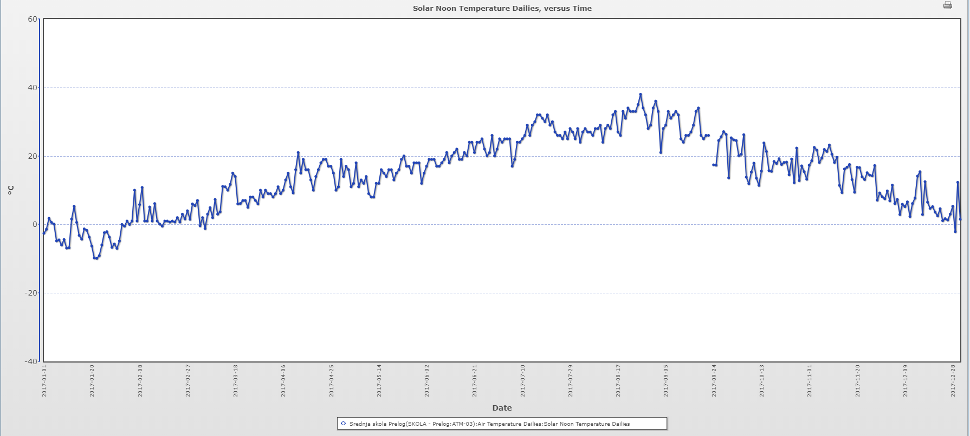

Figure 14. Air temperature in 2017

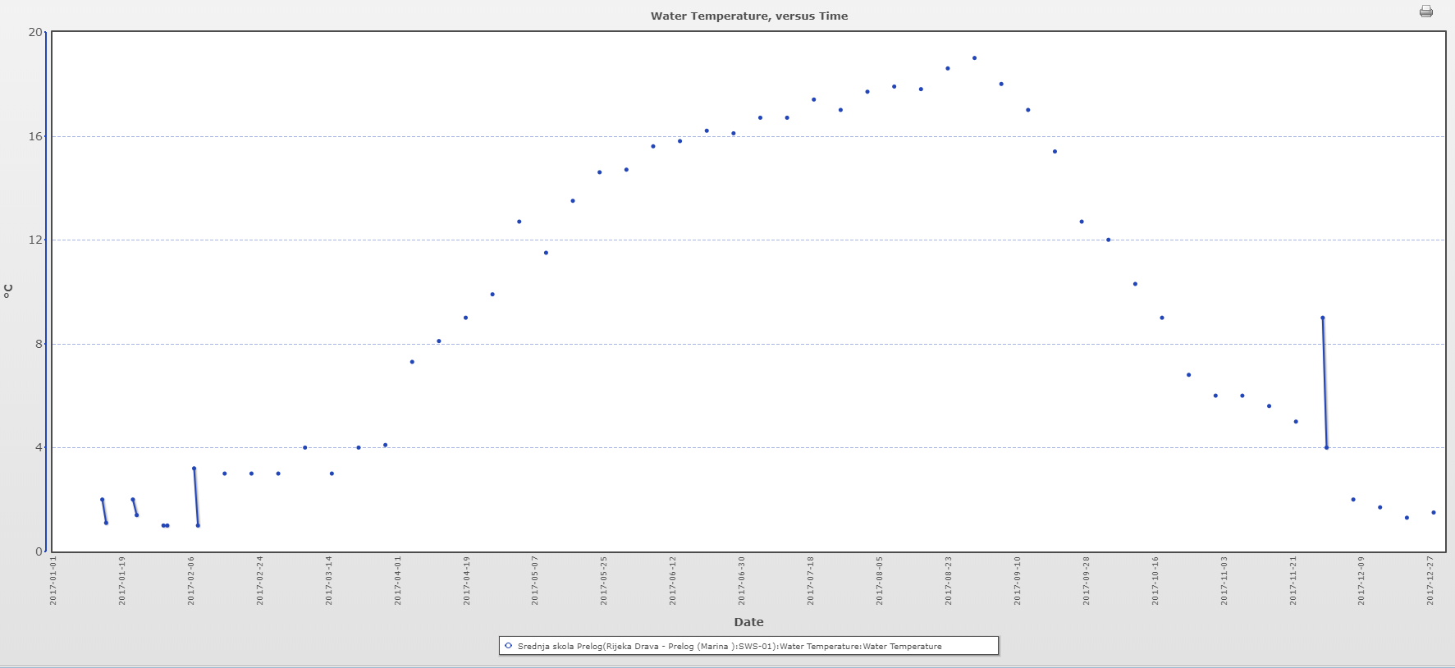

Figure 15. Water temperature in 2017

Comparing the data in Table 6, we note that in spring the highest average water temperature was recorded in 2015 (11.98 ° C) and the lowest in 2014 and 2017 (11.77 ° C). In the fall the highest average the water temperature was recorded in 2015 (7.02 ° C) and the lowest in 2014 (5.46 ° C). The highest average water temperature in summer was 2015 (17.47 ° C) and the lowest in 2014 (16.77 ° C). Then, at 3.64 ° C, 2013 reached the highest average water temperature, while in 2015 and 2017, they reached their lowest average water temperature with 2.29°C.

Table 6. Average temperature according to seasons

AVERAGE WATER TEMPERATURE(°C)
SEASON
YEAR | SPRING | SUMMER | FALL | WINTER
2013. | 11,89 | 17,32 | 6,58 | 3,64
2014. | 11,77 | 16,77 | 5,46 | 2,58
2015. | 11,98 | 17,47 | 7,02 | 2,29
2017. | 11,77 | 16,98 | 5,81 | 2,29
AVERAGE TEMPEERATURE (°C) | 11,85 | 17,14 | 6,22 | 2,70

Discussion and conclusions

In 2014, we can see that the water level is highest when the water temperature is also highest. We think that the reason is that there were excessive rainfall (precipitation) in the summer. We used precipitation data from Belica Elementary School because in 2014 we did not enter precipitation amounts.
We conclude that our assumption of a change in water temperature considering air temperature is correct, that is, that the water temperature will change more slowly, but that it will still accompany an increase in air temperature. This is confirmed by our graphs. We have proved our assumption about water level, where we assumed that the water level would be higher when the temperature was lower, and this can be seen in the graphs shown.
Due to insufficient data and too few measurements, we were unable to prove the last hypothesis and rejected it. From Table 1 we can only conclude that the average temperature over the past 7 years has been around 9 degrees.
From the tables of average temperatures by seasons, we conclude that 2015 was the warmest year and 2014 was the coldest.

Thanks
We were assisted by Ph.D. Ivan Čanjevac from the Department of Physical Geography, Faculty of Science, University of Zagreb.

Literature sources
Šegota T., Filipčić A. 1996. Klimatologija za geografe, Školska knjiga Zagreb
Matoničkin Kepčija R. 2002., Istraživanje vode, Program GLOBE – Priručnik za mjerenja
http://globe.pomsk.hr/prirucnik/voda.
https://www.globe.gov/do-globe/globe-teachers-guide/hydrosphere
https://www.globe.gov/
(pristup stranicama 13.1.2019.,20.2.2019., 28.3.2019.,7.3.2019.,13.3.2019.,29.3.2019.,6.4.2019.,13.4.2019.)
DHMZ 2019. Hidrološke postaje - sektor za hidrologiju
(pristup stranici 15.1.2019.,23.2.2019.,9.3.2019.,19.3.2019.,30.3.2019.,9.4.2019.,13.4.2019.)
https://hidro.dhz.hr/
(1) Udžbenik iz fizike- Fizika 2 pojmovi i koncepti, A- inačica, Dubravko Horvat, Dario Hrupec (drugo izdanje, Zagreb 2015.)

