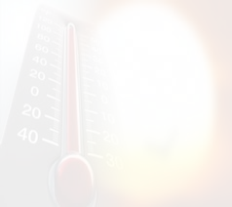

Temperature and its Impact on the Relative Humidity in the Last Quarter of 2015 in Jeddah

Prepared by the student :
Abdullah Hameduddin
Hamza Bin Abdul-Motaleb
Supervised by the teacher:
Mohammed Saleh Al-Garni
22/2/2016

Table of contents
Page No. | Subject
3 | ABSTRACT
4 | Research questions and hypothesis
5 | Definition of a body temperature
6 | Factors affecting the temperature
7 | Types of humidity
8 | Data brief
10 | Results discussion
11 | references

ABSTRACT
The main objective of this research is to know the effect of temperature on the relative humidity in the city of Jeddah, during the time period specified by the use of observed data in the environmental GLOBE Program has developed hypotheses that are looking for the impact of heat on the humidity as well as what are the other factors affecting the humidity is heat the results showed the existence of a clear impact of heat on humidity moisture will rise as temperatures rise and fall with the fall, but he nevertheless there are cases with low temperatures and rising humidity, and this shows us that there are other factors affecting the humidity is the heat factor which is the movement of wind and atmospheric pressure.

Research questions and hypothesis
Q1. Does the temperature affect the relative humidity?
Q 2.Is there relation between temperature and relative humidity?
Hypothesis:
First hypothesis: there is a relation between the temperature and relative humidity
Second hypothesis: there are factors affecting the relative humidity degree

Definition of a body temperature is:
Thermal energy that the body stores and an indication to the movement of atoms, where it is possible mathematically to find an equation connecting between the kinetic energy of the molecules or atoms of an object and its temperature. There are many units for measuring temperature, such as kelvin and celsius. Temperature is a scale to measure the object heating or coldness, and the tool determining the direction of heat transfer automatically, but it is possible to follow certain way to transfer the same in the opposite direction
Introduction:-
temperature:
a body temperature is a scale used to recognize its heating, it is measured using thermometers that are calibrated to show different values of temperature. The two scales that are internationally approved are the absolute one and celsius one
Explanation:
• Some definitions of temperature:
Fixed point:
it is the temperature at which major changes occur (under certain conditions), then it should be provided with a value against which other temperatures can be measured. Examples: freezing point (the temperature at which pure ice melts) and steam point (steam temperature over boiling water under atmospheric pressure), this is together with using two points to calibrate the thermometer (minimum and maximum fixed point). And the distance between these two points represent the main range.
Temperature gauges Absolute temperature or Thermodynamics scale: -
standard scale to measure the temperature that is using a unit called Kelvin.
Zero value is given for the lowest temperature theoretically attainable, and this is called the absolute zero. The lowest temperature is inaccessible, as it would require a negative volume, which is impossible.

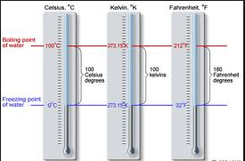

Celsius scale:
standard scale of temperature, similar to absolute temperature scale, but highlights the zero for in case of freezing point and the percent in case of steam.
Fahrenheit scale:
An ancient scale in which 32 represents the freezing point and 212 represents the steam point
this is rarely used for the scientific purposes.
• Methods of heat transfer:
Thermal conductivity or transfer:
The way in which heat travels in solids (as well as in liquids, gases, on a smaller scale). Energy is transmitted through carriers quickly, and that happens mainly by the movement of free electrons, as well as the vibration of the atoms.
Load:
A way by which energy is transmitted in liquids and gases. If gas or liquid is heated, it expands and accordingly its density decreases and then it rises, at the same time, cool gas or liquid decreases, to occupy its place, and accordingly, the load current arises
Radiation:
it is a way to transfer energy from a cold to hot place , without any role by the medium. Moreover, this can take place in the space, unlike transfer and load. The term (radiation) is mostly used to refer to the thermal energy (which otherwise called the radiated thermal energy). Radiation highlights as a form of electromagnetic waves, especially infrared radiation.

Factors affecting the earth temperature:
1. Factors affecting the temperature
Location: sun rays gradient and to which extent it is near or far from the equator
Atmospheric pressure
Wind direction
land and water distribution, that the temperature decreases near the areas of water
The rise over or fall under the sea level, that the temperature decreases at a rate of 1% against each 15 meters
Vegetation
Relationship between temperature and relative humidity:
indeed there is an adverse relationship between high relative humidity and temperature, that relative humidity rises early in the morning, where temperature is low and the air is unable to carry the water vapor, and as the air cools under specific pressure degree and a permanent amount of water vapor, it shall reaches a temperature against which it becomes saturated, which is called the dew point, but it temperature decreases, the water vapor begins to condense and clouds, fog or dew will be formed.
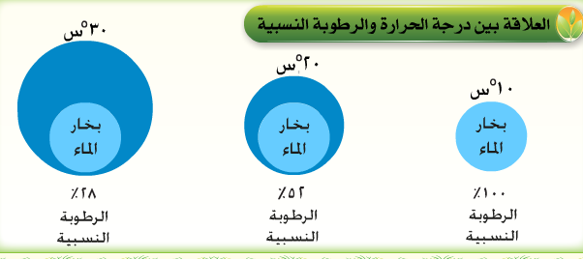
Relationship between temperature and relative humidity:

30 c
20 c
10 c

Water vapor
Water vapor
Water vapor

Relative humidity 100%
Relative humidity 52%
Relative humidity 28%

Relative humidity:
Air humidity is the water vapor amount existent in the air, particularly in the layer Alto and the Sphere (the lower layer of the atmosphere). Humidity varies depending on the temperature and air pressure, and whenever the air is warmer, there will be an increase in the water vapor it carries, and when air contains the maximum amount of water vapor, it can carry the same under a certain temperature and pressure, then air is said to be saturated with water vapor.
Types of humidity
1. Absolute humidity
it is the water vapor mass existent in a given volume of air, but this way is non-conservative (non conservative); i.e. .its quantity changes by change of the air intensity and / or temperature; nevertheless, the control its size; that the increase in humidity lead to decrease in air density; the increasing the volume of air in terms of unit mass. In addition, the temperature change leads a change in air density and size, relative to the unit mass. When the temperature increases, air expands, and specific mass size increases, and density decreases. If a cubic meter of air contains one gram of water in a form of vapor, its absolute humidity will be 1 g / m3, but If the air temperature raises, it will expands as much as heating, to become of a size larger than a cubic meter, it means 1.1 cubic meter. For the amount of water loaded by it in the form of steam, it will not change, the matter reducing the absolute humidity, which is becoming 1 gram / 1.1 cubic meter, or 0.91 g / m3.
2. Specific humidity
4. Expresses the mass of water vapor, existent in a given mass of air, containing dry air and water vapor, the unit of which is the g/ kg. Specific humidity is one of the conservative ways, to express air humidity, that is, it is not influenced by the temperature change, and its products including stretching or shrinkage, that affects the air density.
5. Radiating relative humidity is known as water vapor mass, that is carried by certain air mass, at a given temperature and air pressure
3. Relative humidity
it is represented by the ratio of water vapor carried by air, at the same temperature, and same atmospheric pressure. It is calculated by the actual specific humidity, radiating specific humidity, or through saturation water vapor pressure, actual water vapor pressure, as follows:
• The actual water vapor pressure × 100

Materials and method:
During the last quarter of 2015, We use the data that have been investigated about the temperature and relative humidity, with focus on October, November and December, through which we can accurately recognize the effect of temperature on the relative humidity in Jeddah city. The above-mentioned will take place using a graph to illustrate the relationship between temperature and relative humidity during the said period.

Data brief:

Results discussion:
From the graph covering the data included in the GLOBE Program, it is obviously that there is the impact of temperature on the relative humidity and it is proven that high temperature leads to increasing humidity, under increase of evaporation of water from the surface of the sea and in turn humidity rises, but in rare cases we have adverse result, where under low temperature we find that is humidity is high, this means that there are factors affecting humidity other than temperature, one of which is the movement of wind and atmospheric pressure. In addition, rising may be as a result of mistakes in taking measurements, therefore we recommend conducting a long-term study together with using all the appropriate factors, which in turn affect the relative humidity.

REFERENCES http://geo2all.mam9.com/t7243-topic https://ar.wikipedia.org/wiki/%D8%B1%D8%B7%D9%88%D8%A8%D8%A
Walter Wittenberger: Chemische Laboratoriumstechnik, Springer-Verlag, Wien, New York, 7. Auflage, 1973, S. 139, ISBN 3-211-81116-8

