Substrate evaluation for horticultural use in arid zones of the Patagonia region, Argentina

Abstract:
In April of 2015 the volcano Calbuco, erupted depositing volcanic ashes over the region. In the Patagonian steppe, the availability of water decreases in the summer period, when it is most necessary for crops irrigation. The objective of this work was to test volcanic ash and yerba mate as substrate, for the growth of radishes. The water retention and the growth of radish in the orchard were compared in the open air and in the greenhouse using the following substrates: volcanic ash, volcanic ash and soil mixture, vermicompost, yerba mate (discarded after infusion) and control soil.
Physical-chemical analyzes of the substrates were performed. The water content of the soil was determined before irrigation. Radish growth was determined by the total weight of the plants, the length of the longest leaf, the wet and dry weight of the leaves and the weight of the radish.
The volcanic ash is poor in nutrients, has greater water retention than the control soil, when mixed with organic substrates as the vermicompost improves this aspect. There were no significant differences in the growth of radish with the mixture of ash and vermicompost of the vermicompost alone, the quality was similar. The growth of the radish in the mixture of grass and soil was smaller. It is concluded that it is more favorable to use volcanic ash mixed with organic substrates. It is recommended to carry out tests with other horticultural, floral and tree species, as well as to try other mixtures of substrates.

Key words: Water retention. Ashes volcanic. Yerba mate. Calbuco Volcano. Organic substrates. Growth of radish.

Substrate evaluation for horticultural use in arid zones of the Patagonia region Argentina

Aliaga, Félix Alejandro; Arce, Patricio Martín and Porma Favre, Jeremías Lihuen
CEI San Ignacio
Junín de los Andes, Argentina

Teachers: Prieto, Ana Beatriz and Hick, Christian
February 2018

Table of Contents:
Abstract: 1
Substrate evaluation for horticultural use in arid zones of the Patagonia region 2
Research Questions and Hypothesis: 3
Materials and Method: 6
Data Summary: 8
Analysis and Results: 11
Conclusions: 12
Discussion: 13
Acknowledgements: 13
References/Bibliography: 13

Research Questions and Hypothesis:
Our school is located in the San Cabao Valley, approximately 10 km. of Junín de los Andes (39º 54 '6.5874" S - 71º 8' 14.0856" W) and for its property passes the river Chimehuín, from where we extract water for human consumption, and for agricultural production: irrigation, poultry, sheep, cattle and llamas. We also have the farm industry where we use water to process our production. In addition to water from the river, we also extract well water for our daily activities. (Fig. 1)

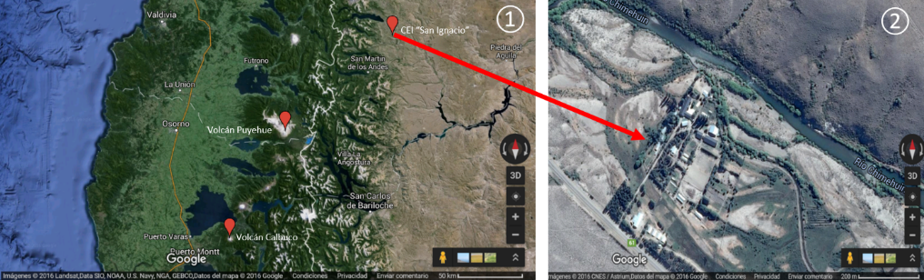
Figure 1. Location of the Puyehue and Calbuco volcanoes in relation to the CEI "San Ignacio"①. View of the building of the CEI "San Ignacio"②.

The climate is cold and windy with a dry season during the summer and early fall. The prevailing winds are of the West that discharge their humidity in the Mountain range of the Andes and pass like dry winds. Rains and snowfall decrease from west to east. There is no frost-free period. Matteucci, S.D. 2012. The rains have great inter-annual variability (Russián, G. F., et al., 2010).
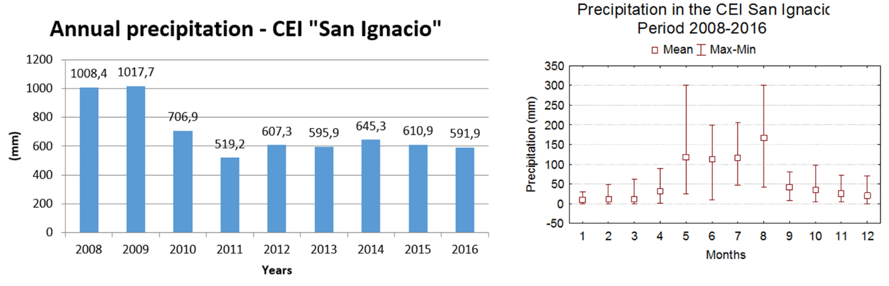
Figure 2. Annual and monthly rains in the CEI “San Ignacio”.

The data from the school's meteorological station show years with abundant rainfall (1000 mm), while in others rainfall only reached half, also the seasonality in which they occur (Fig. 2). The intensity is higher during winter and spring. Most of the rains are of few millimeters per day, only in the winter months there are 2 or 3 days with rains greater than 20 mm. (Fig. 3)

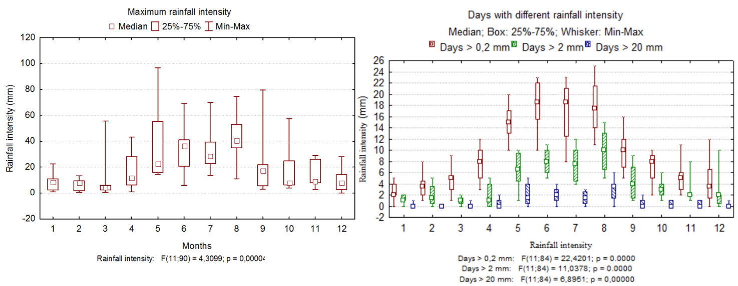
Figure 3. Maximum rainfall intensity per month and days with different rainfall intensities.

The Chimehuín river, like the rivers of the North of Patagonia has a regime of floods in winter by the rains and at the beginning of the spring by the thaw (Compagnucci, RH, & Araneo, D., 2007), in some years during the Flooding has occurred (Bruno Cubero, C., 2001). The average flow of the Chimehuín River, from 2001 to 2010 was 68.7 m³/s with a minimum of 10.5 m³/s (March 2009) and a maximum of 220.4 m³/s (July 2006). (AIC, 2010). During the summer and early autumn, the availability of water is complex for both agricultural production and for human consumption. The natural vegetation dries a lot and the number of fires increases, in particular in the periods of the "La Niña" phenomenon. (Prieto, A. et al., 2009). In addition, climate change forecasts for the region indicate rising temperatures (with the consequence of glacial ice loss) and reduced rainfall. Both factors influence the reduction of river flow, especially at the end of summer and early autumn, affecting the availability of water. (Loustau, MR, 2002; Torcuato Di Tella Foundation and Torcuato Di Tella Institute, 2006; Sadoff, C., & Muller, M., 2010; Costa, AJ et al., 2013; Nadal, GH, 2013; Stocker, TF (Ed) IPCC, 2014).
With respect to temperatures in the CEI San Ignacio, they are high in summer, with average maximum temperatures of 18°C (with absolute maximum 38°C on 7/2/2013) and evaporation occurs more quickly. In winter, the temperatures are low, with minimum averages close to 0°C (absolute minimum -13°C on 07/22/2013) without frost-free period, which makes it difficult for the development of vegetables. The thermal amplitude is 30°C (considering absolute maxima and minima).
On April 22 and 23, 2015, our region was affected by the eruption of the Calbuco Volcano with an important rain of ash. (Romero, J. E. et al., 2016). The ash affected health, agricultural production, roads, transportation, communications, water sources, infrastructure, etc. To return to daily activities had to remove as much ash as possible, but a large number remain in the hills and currently on windy days continues to reduce visibility. (Fig. 4). Previously, in 2011, Puyehue volcano (Craig, H. et al., 2016; Mulena, C. et al., 2012) erupted with more ash and dispersion than the eruption of the Calbuco volcano; but our area was not as affected on that occasion as it was in Bariloche, Villa La Angostura, Piedra del Águila and the entire southern line of the Province of Río Negro with the city of Ingeniero Jacobacci among the most affected. (Wilson, T. et al., 2013).

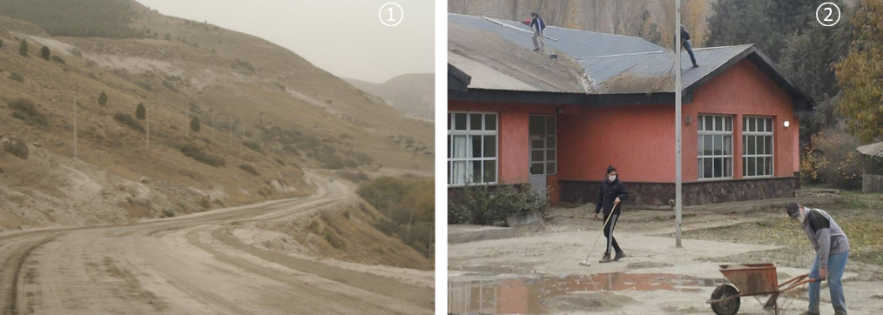
Figure 4. Path in the Valley of San Cabao, towards the school, covered with ashes of the Calbuco Volcano ①. Cleaning of volcanic ash in the CEI "San Ignacio" ②

Many authors have reported negative impacts of ash fall from both volcanoes, but some have also highlighted its positive aspect as insecticide (Buteler, M., et al., 2011) and soil moisture retention. (Barbaro, L.A., et al., 2014; Aliaga, et al., 2016). In this region, the retention of humidity is very important since most of the agricultural production is supported only with irrigation. Also due to the low temperatures, the production period is spring summer, which coincides with the period of less water availability. The wetlands known locally as "mallines" are areas where aquifers are closer to the ground and provide moisture; therefore, they are used for agricultural production and in some cases show signs of degradation (Gaitán, J. J. et al., 2015).
Last year we tested radish production using volcanic ash as a substrate (Aliaga, et al., 2016), but although it retains water it lacks nutrients, so this year we decided to incorporate a mixture of volcanic ash and vermicompost. Also considering the volume of waste yerba mate used for the popular infusion "mate" in our school, we decided to try it as a substrate. While yerba occurs in the northeastern region, it is consumed throughout the country. Annual per capita consumption in Argentina was 7 kg in 2010 (Gómez Lende, 2016).
Considering the problems of availability of water during the summer for production, coupled with the abundance of volcanic ash (almost 2 years of ash rain) and also of yerba mate, we asked the following research questions:
- Does volcanic ash mixed with other organic substrates and yerba mate can be useful in horticulture to retain soil moisture and favor the development of plants?
- How much water do they retain compared to other substrates known as vermicompost and the control soil?
- Will there be differences in moisture retention in different substrates in the orchard and in the greenhouse?
- Are there differences in fertility in the different substrates in the orchard and in the greenhouse? Is the effect of the substrates on the production of radishes both in the orchard and in the greenhouse?
To answer them, we propose the following hypotheses.
H₁: Yerba mate and mix (volcanic ash and soil) provide nutrients to the soil.
H₂: Volcanic ash and yerba mate retain moisture in the soil making it available for plants in the garden and in the greenhouse.
H₃: The growth of radish is different in different substrates, both in orchard and in greenhouse.

Materials and Method:
An experiment was carried out to test the water retention in different substrates: 1) volcanic ash (deposited by the Calbuco Volcano), 2) vermicompost (which is prepared from the school worm and normally used in the orchard), 3) A mixture composed of volcanic ash 50% compost 25% and vermicompost 25%), 4) control soil (taken from an uncultivated area of the school premises, classified as Molisoles, subgroups typical Argixeroles and Argixeroles typical Cruzate, GA, et. 2006) and 5) Yerba mate (Yerba mate (50%) mixed with control soil (50%). Radishes Raphanus sativus were planted on all substrates, located in: a) orchard in the open air and b) greenhouse, to test the effect of the substrates on the growth of the plants.
The test was developed in the summer of 2017. The test and repetition were performed at the same time with a duration of 35 days. Period from 27/02 to 03/26/2017. The sowing method was applied to the chorrillo and in the second week, in each period, a thinning was done leaving the best plants. (Method commonly used in the school for this crop).
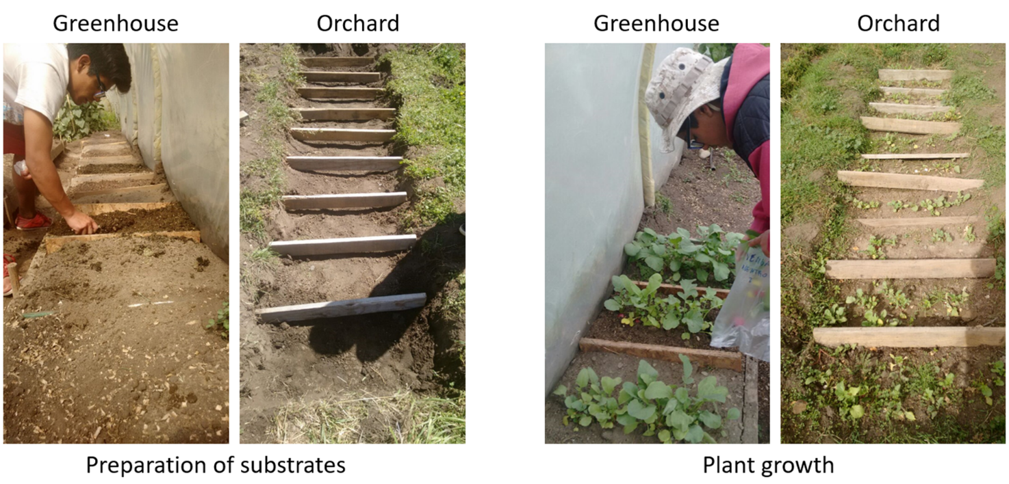
Figure 5. Preparation of the test and growth of the radish.

To determine the initial fertility of the substrates, nitrogen, phosphorus and potassium (NPK) contents were analyzed using NPK Soil Test Kit (Code: 3-5880). The procedures of the GLOBE Program (The GLOBE Program, 2005) for the analysis of texture, structure and fertility were followed, as well as to determine the water content of the different substrates. The soil water content was determined using the following formula.

$$Soil water content\frac{(wet mass-dry mass)}{(dry mass-container mass)}$$

When harvesting the radishes, the following measurements were taken: 1) Total weight of the plant, 2) Weight of radish, 3) Weight of leaves and 4) Longest leaf length and 5) Dry matter of leaves.
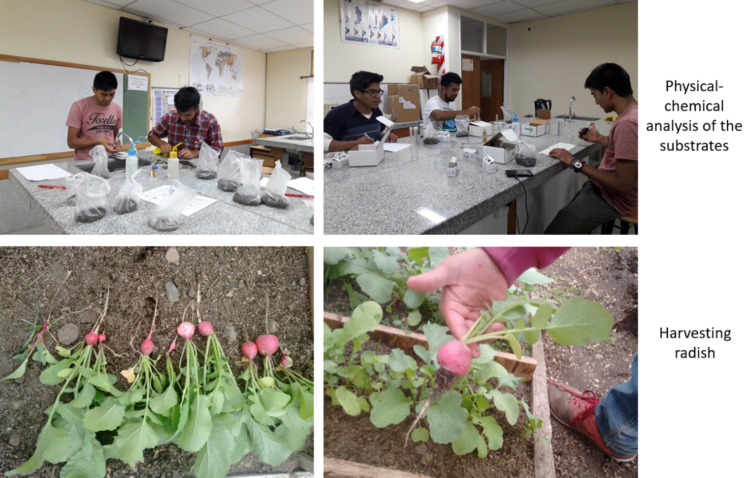
Figure 6. Images of different stages of the tests.

Table 1. Weather variations during the test period. Data from the CEI weather station.
Period | Average temperature (°C) | Maximum temperature (°C) | Minimum temperature (°C) | Rainfall (mm) | Average Wind Speed  (km/h) | Maximum bursts (km/h) | Wind Direction
27/2/2017 to 26/3/2017 | 16,0 | 23 | 4 | 21,4 | 5,0 | 45 | West

Statistical analysis was performed with STATISTICA software. (StatSoft, Inc., 2007). To test for normality, we used the tests (Shapiro-Wilk, Kolmogorov-Smirnov, Lilliefors), then the analysis of variance (ANOVA) was applied, homogeneity of the variance was checked with the Levene test and comparison of means was performed by applying The LSD Test.

Data Summary:

Table 2. Analysis of the substrates.
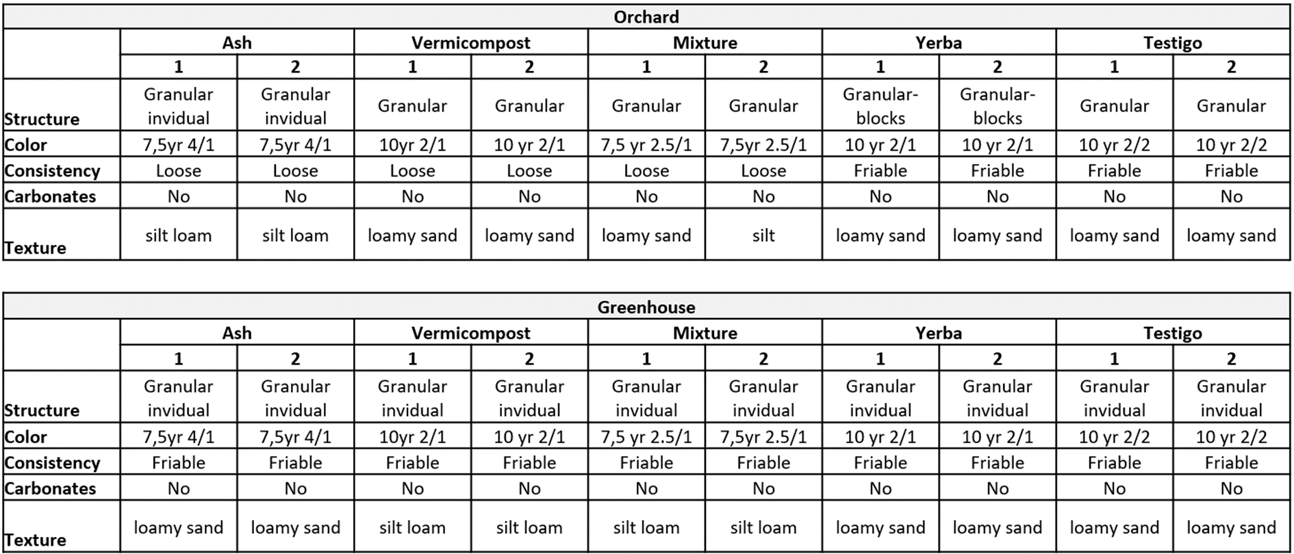
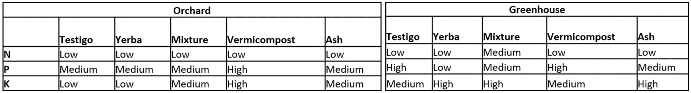

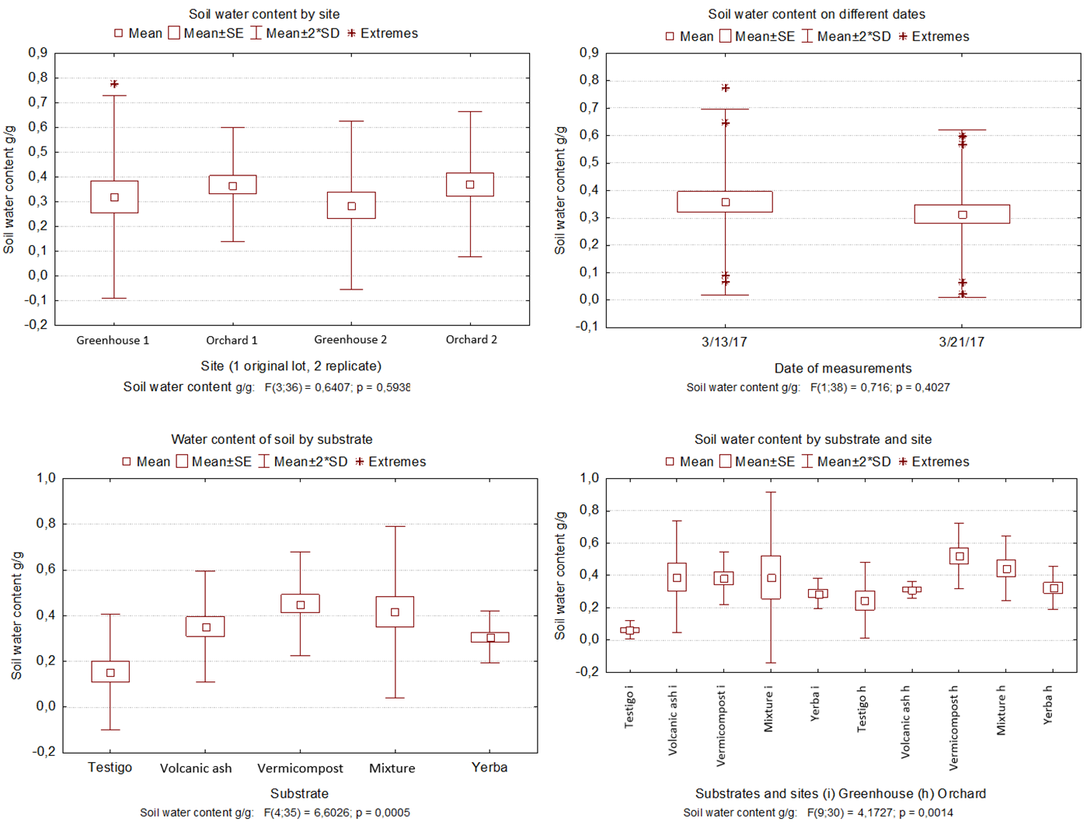
Figure 7. Results of the water content of the soil in the different substrates, places and dates.
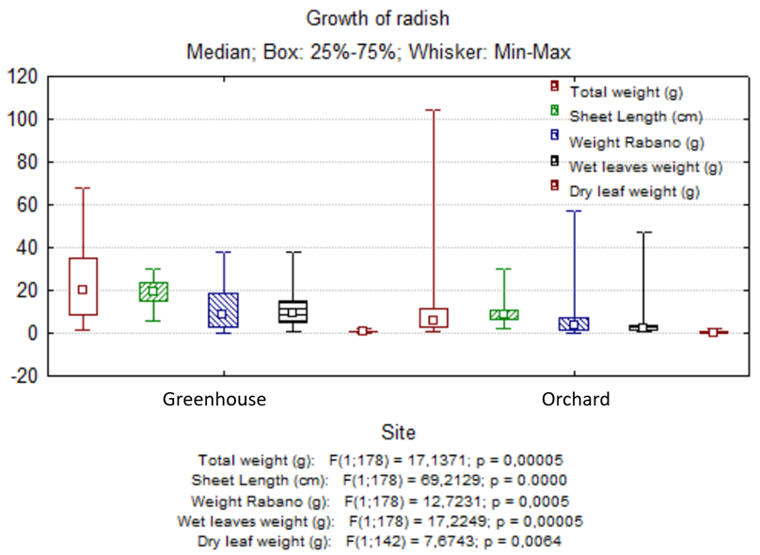
Figure 8. Growth of radishes according to harvest date and place.

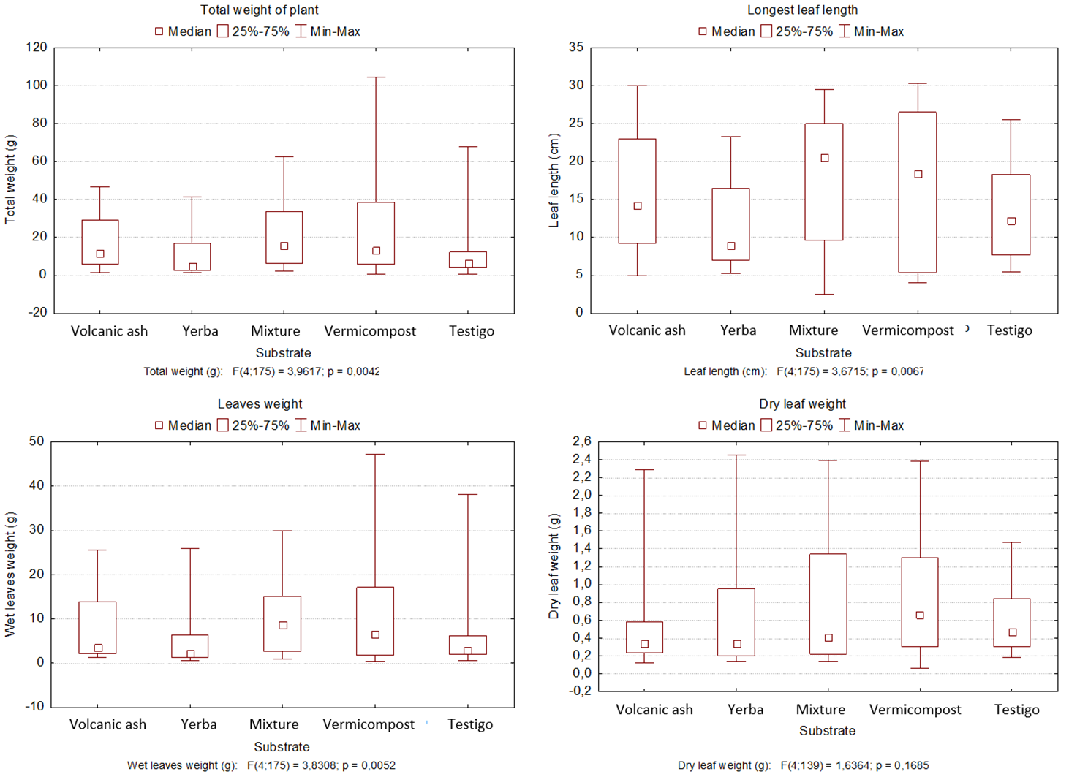
Figure 9. Growth of radish according to the substrate. Total weight of the plant, length of the longest leaves, wet and dry weight of the leaves.
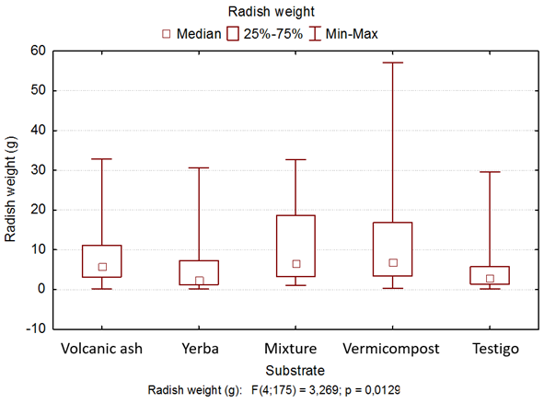
Figure 10. Growth of radish according to radish weight.

Analysis and Results:
The substrates are similar in structure. They vary in color, consistency and texture. The greatest variation is observed in the NPK content. (Table 2). Both volcanic ash, such as mixing and yerba are poor in NPK and provides few nutrients to the soil. H₁ is therefore rejected.
In the normality test and in the homogeneity of the variance, all analyzed variables related to water content in the soil were very significant (p <0.01).
The analysis of variance ANOVA does not show significant differences for soil water content between greenhouse and orchard nor between the dates of measurements. In contrast the differences are very significant (p <0.01) when considering the water content that the substrates retain. (Fig. 7)
The LSD test establishes soil control differences with the rest of the substrates because they contain less water. Volcanic ash also has significant differences with all substrates containing more water than the control soil and grass but less than the vermicompost and the mixture. Vermicompost and mix have higher water content and have no differences between them. Yerba has significant differences with the control soil and the vermicompost. It is the substrate that shows less variability. Therefore, H2 is not rejected because although the vermicompost retains more moisture volcanic ash, the mixture and the yerba mate contain more water than the control soil.
Considering the growth of the radish plants (Raphanus sativus), in the normality test and the homogeneity of the variance, all variables analyzed were very significant (p <0.01).
The analysis of the variance shows very significant differences in the variables related to the growth of radish according to the date of harvest and according to the place. (Fig. 8). The LSD test also shows very significant differences in the same variables for place and substrates.
As for radish growth (variables: total plant weight, radish weight, leaf length, wet and dry leaf weight), there are significant differences between orchard and greenhouse, with the highest growth in greenhouse. H₃ is therefore not rejected.
The substrates where it grew best is in the mixture of ash and vermicompost, and in vermicomposite with significant differences with respect to the control soil and the yerba. The growth in yerba mixed with soil was lower than in the mentioned substrates.
In relation to the uncertainties and possible sources of error, we do not test other crops; therefore, the results are only applicable to radishes.
Due to lack of equipment, we do not measure the humidity that may be influencing the soil moisture.

Conclusions:
The volcanic ash released by the Calbuco volcano is good for the growth of rabanitos (Raphanus sativus) as well as other sutrates, for use in orchards in the open air or in greenhouse. In yerba, they also grew but their results are smaller. The Calbuco volcano has a long history of eruptions. (Global Volcanism Program, 2013). In the eruption of 1893, its ash was analyzed and recommended as a substrate for plants (Beutel, A., 1893).
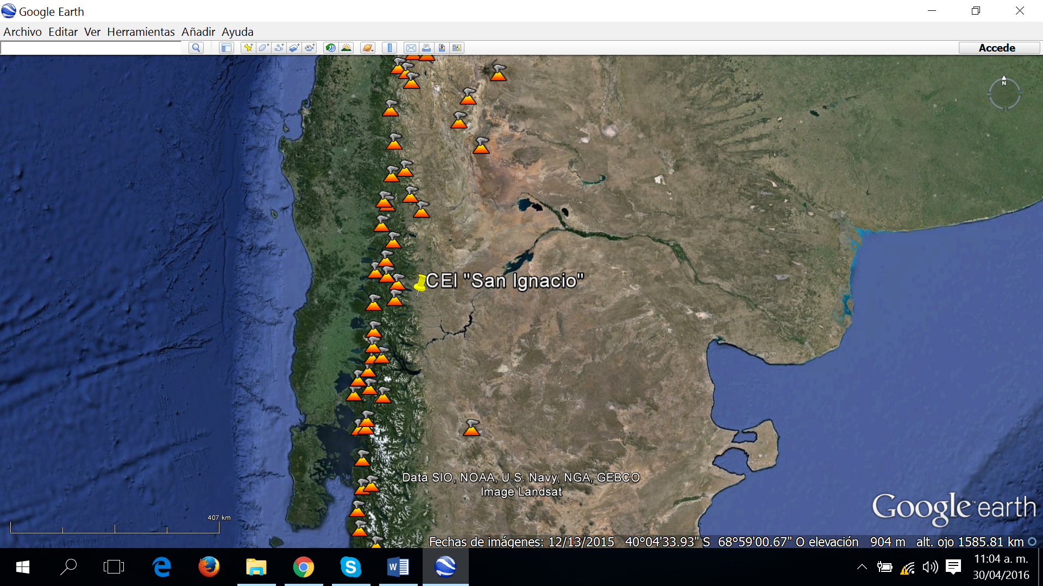
Figure 10. Location of the CEI "San Ignacio" and nearby volcanoes.
Other authors have also recommended the use of volcanic ash in crops, including Cremona, V., et al., 2011 indicates that much of the soils of the Andes mountain range region have been formed with volcanic ash and that these provide high water retention as good aeration and permeability. Barbaro, L.A et al recommends the use of volcanic ash from the Puyehue volcano as a substrate for plants.
Considering the large number of nearby volcanoes and the high probability of eruptions, it is recommended:
- Carry out more tests of this type with different horticultural, floral and tree species.
- Test different ash mixtures with other organic and soil substrates to observe the behavior of water retention and its effect on plant growth.
- Compare the behavior of the ash over time, once it is introduced into the ground by the effect of rainfall.

Discussion:
With the abundance of volcanic ash, even after 2 years of decline, and the scarcity of water during the period of growth of the plants, it is important to know their behavior in terms of the water retention capacity that can contribute when mixing with others substrates. Yerba mixed with soil has not been as efficient as ash in water retention and radish weight was also lower.
Ashes provide few nutrients but retain moisture and mixed with vermicompost similar results were obtained in water retention and radish growth so it should be mixed with this type of organic substrate to improve this aspect or fertilize.

Acknowledgements:
We would like to thank the school, CEI San Ignacio, for providing the laboratory, the greenhouse and the orchard to design and carry out the research. Also to the National University of Comahue, especially to the masters of the Master in Science Teaching for guiding us in this research and finally to the General Head of Practical Teaching of the CEI, Christian Hick for his help.

References/Bibliography:
AIC. (2010). Estadísticas climáticas e hidrológicas. Período 2001 – 2010. Cuencas de los ríos Limay, Neuquén y Negro. [Climatic and hydrological statistics. Period 2001 - 2010. Basins of the rivers Limay, Neuquén and Negro]. AIC. Cipolletti, Río Negro. 254 pp.
Aliaga, F.; Arce, M. y Porma Favre, J. (2016) Viabilidad del uso de ceniza proveniente del volcan Calbuco en horticultura. [Feasibility of using ash from the volcano Calbuco in horticulture]. Feria de Ciencias de Google. Finalistas regionales. [online] Available at: https://goo.gl/giQkQP [Accessed 17 Feb. 2018].
Barbaro, L. A., Mazzoni, A., Karlanian, M. A., Fernández, M. N., & Morisigue, D. E. (2014). Cenizas del volcán Puyehue como sustrato para plantas. [Ashes of the volcano Puyehue as substrate for plants]. In Congreso Argentino de Horticultura. 37. Encuentro de Docentes de Horticultura. 7. Jornadas de Floricultura. 15. Jornada de Semillas Hortícolas. Jornada de Fruticultura de Precisión. 2014 09 23-26, 23 a 26 de setiembre de 2014. Mendoza. AR. [online] Available at: https://goo.gl/vJz5pZ [Accessed 17 Feb. 2018].
Bermudez, A., & Delpino, D. (2011). La actividad el volcán Puyehue y su impacto sobre el territorio de la República Argentina. [The activity of the Puyehue volcano and its impact on the territory of the Argentine Republic]. Primer Informe, Neuquén, 14. [online] Available at: https://goo.gl/Yyyw9J [Accessed 17 Feb. 2018].
Beutell, A. (1893). Composición química de la ceniza arrojada por el volcán Calbuco. [Chemical composition of ash thrown by the Calbuco volcano]. In Anales de la Universidad de Chile (pp. Pág-863). [online] Available at: https://goo.gl/t9USTh [Accessed 17 Feb. 2018].
Bruno Cubero, C. (2001). Cuenca del río Chimehuín estudio de las inundaciones en la localidad de Junín de los Andes. [Chimehuín river basin study of the floods in the town of Junín de los Andes]. Secretaria de planificación y desarrollo. AIC. Cipolletti, Río Negro. 103 pp.
Buteler, M., Stadler, T., López García, G. P., Lassa, M. S., Trombotto Liaudat, D., D'Adamo, P., & Fernandez-Arhe, V. (2011). Propiedades insecticidas de la ceniza del complejo volcánico Puyehue-Cordón Caulle y su posible impacto ambiental. [Insecticidal properties of the ash of the Puyehue-Cordón Caulle volcanic complex and its possible environmental impact]. Revista de la Sociedad Entomológica Argentina, 70(3-4), 149-156. [online] Available at: https://goo.gl/dnpBXM [Accessed 17 Feb. 2018].
Compagnucci, R. H., & Araneo, D. (2007). Alcances de El Niño como predictor del caudal de los ríos andinos argentinos. [El Niño reaches as a predictor of the flow of Argentine Andean Rivers]. Ingeniería hidráulica en México, 22(3), 23-35.
Costa, A. J., González, M. H., & Núñez, M. N. (2013). Cambios esperados en la disponibilidad hídrica del suelo en Argentina. [Expected changes in soil water availability in Argentina]. Meteorologica, 38(1), 41-51. [online] Available at: https://goo.gl/nRpPob [Accessed 17 Feb. 2018].
Craig, H., Wilson, T., Stewart, C., Outes, V., Villarosa, G., & Baxter, P. (2016). Impacts to agriculture and critical infrastructure in Argentina after ashfall from the 2011 eruption of the Cordón Caulle volcanic complex: an assessment of published damage and function thresholds. Journal of Applied Volcanology, 5(1), 1. [online] Available at: https://goo.gl/eXME77 [Accessed 17 Feb. 2018].
Cremona, V., Ferrari, J., & López, S. (2011). Las cenizas volcánicas y los suelos de la región. [The volcanic ash and soils of the region]. Revista Presencia, (57), 8-11. [online] Available at: https://goo.gl/G4tDqo [Accessed 17 Feb. 2018].
Cruzate, G. A., López, C., Ayesa, J., & Panigatti, J. L. (2006). Suelos y Ambientes, Neuquén-Argentina. [Soils and Environments, Neuquén-Argentina]. Argentina: INTA-50 años. [online] Available at: https://goo.gl/J6ACZp [Accessed 17 Feb. 2018].
Fundación Torcuato Di Tella & Instituto Torcuato Di Tella. (2006). Comunicación nacional de cambio climático: vulnerabilidad de la Patagonia y sur de las provincias de Buenos Aires y La Pampa. [National communication on climate change: vulnerability of Patagonia and southern provinces of Buenos Aires and La Pampa]. Informe final. 369 pp.
Gaitán, J. J., Bran, D., Raffo, F., Ayesa, J., & Umaña, F. (2015) Evaluación y cartografía de mallines de la zona de Junín de los Andes, provincia del Neuquén. [Evaluation and mapping of mallins in the Junín de los Andes area, province of Neuquén]. INTA. Comunicaciones Técnicas. ISSN 1667-4006. [online] Available at: https://goo.gl/Vg3vxf [Accessed 17 Feb. 2018].
Global Volcanism Program, 2013. Calbuco (358020) in Volcanoes of the World, v. 4.4.3. Venzke, E (ed.). Smithsonian Institution. [online] Available at: https://goo.gl/cht3iP [Accessed 17 Feb. 2018].
Gómez Lende, S. (2016). Agricultura, agroindustria y territorio: crisis y reestructuración del circuito de la yerba-mate en la provincia de Misiones (Argentina) 1990-2014. [Agriculture, agro-industry and territory: crisis and restructuring of the yerba-mate circuit in the province of Misiones (Argentina) 1990-2014]. Cuadernos de Geografía-Revista Colombiana de Geografía, 25(1), 45-63.
Loustau, M. R. (2002). Influencia del cambio climático global sobre la producción agropecuaria argentina. [Influence of global climate change on Argentine agricultural production]. Revista de Ciencias Agrarias y Tecnología de los Alimentos, 20, 15-28. [online] Available at: http://200.16.86.38/uca/common/grupo5/files/vol20_3.pdf [Accessed 17 Feb. 2018].
Matteucci, S.D. 2012. Capítulo 15: Ecorregión Estepa Patagónica. [Chapter 15: Patagonian Steppe Ecoregion]. Pp: 549-654 En: J. Morello, S.D. Matteucci, A.F. Rodríguez y M. Silva. Ecorregiones y Complejos Ecosistémicos Argentinos, Orientación Gráfica Editora S.R.L., Buenos Aires. 719 pp. [online] Available at: https://goo.gl/NVnQyq [Accessed 17 Feb. 2018].
Mulena, C., Allende, D., Puliafito, E., & Lakkis, G. (2012). Estudio de la dispersión de cenizas volcánicas del Puyehue: simulaciones y validación. [Estudio de la dispersión de cenizas volcánicas del Puyehue: simulaciones y validación]. Av. Energías Renov. Medio Ambiente, 16, 7-14.
Nadal, G. H., Bravo, G., Girardin, L. O., & Gortari, S. (2013). Can renewable energy technologies improve the management of stressed water resources threatened by climate change? Argentine drylands case study. Environment, development and sustainability, 15(4), 1079-1097. [online] Available at: https://goo.gl/Fm4rZB [Accessed 17 Feb. 2018].
Pablo D. González, P. D., Ison, J. I. y Suárez, R. J. (2015). Análisis petrográfico preliminar de las cenizas volcánicas caídas en Roca (Rio Negro), entre el 23 y 24 de abril de 2015. [Preliminary petrographic analysis of the fallen volcanic ash in Roca (Rio Negro), between April 23 and 24, 2015]. Instituto de Investigación en Paleobiología y Geología. Universidad Nacional de Río Negro. [online] Available at: https://goo.gl/nCiguQ [Accessed 17 Feb. 2018].
Romero, J. E., Morgavi, D., Arzilli, F., Daga, R., Caselli, A., Reckziegel, F. & Perugini, D. (2016). Eruption dynamics of the 22–23 April 2015 Calbuco volcano (Southern Chile): Analyses of tephra fall deposits. Journal of Volcanology and Geothermal Research, 317, 15-29. [online] Available at: https://goo.gl/7pevap [Accessed 17 Feb. 2018].
Russián, G. F., Agosta, E. A., & Compagnucci, R. H. (2010). Variabilidad interanual a interdecádica de la precipitación en Patagonia Norte. Geoacta, 35(2), 27-43. [online] Available at: https://goo.gl/zcNVG2 [Accessed 17 Feb. 2018].
StatSoft, Inc. (2007). STATISTICA (data analysis software system), version 8.0 [online] Available at: http://www.statsoft.com/Textbook [Accessed 17 Feb. 2018].
Stocker, T., Qin, D., Plattner, G., Tignor, M., Allen, S., Boschung, J., Nauels, A., Xia, Y., Bex, V. and Midgley, P. (2013). Climate change 2013: the physical science basis. Cambridge: Cambridge University Press.
The GLOBE Program. (2005) Soil Protocols. En: GLOBE Teacher's Guide. Washington, WA. [online] Available at: www.globe.gov [Accessed 17 Feb. 2018].
Wilson, T., Stewart, C., Bickerton, H., Baxter, P., Outes, V., Villarosa, G., & Rovere, E. (2013). Impacts of the June 2011 Puyehue-Cordón Caulle volcanic complex eruption on urban infrastructure, agriculture and public health. GNS Science Report 2012/20. 88 p [online] Available at: https://goo.gl/2UYtcc [Accessed 17 Feb. 2018].

