Sultanate of Oman
Ministry of Education
Um Hani School/ Al Dakhalyah Governorate

The effect of irrigation with sulfur water on soil, land cover, and adaptation of some living organisms

Done by : Maryam Bader Al Qasmi
Bayan Soud Al Nadabi
Manar Khalid Al Syabi

Supervised by: T. Nawar Mohammed Al Rawahi

February 2020

List of Content

 | Page
Abstract | 3
Definition of terms | 4
Research questions | 4
Introduction and Literature Review | 5
Procedures | 6
Study Site | 7
Data Collection  Data Analysis | 8  11
Discussing Results | 17
Summary  Acknowledgment | 21  22
References | 23

Abstract
The effect of irrigation with sulfur water on soil, land cover, and adaptation of some living organisms

Done by: Maryam Al Qasmi, Bayan Al Nadabi, & Manar Al Syabi
Um Hani School (5-10) – Sultanate of Oman/ Al Dakhalyah
Supervised by: T. Nawar Mohammed Al Rawahi

The purpose of this study was to investigate the effect of irrigation with sulfur water on the chemical and physical properties of soil, land cover, and adaptation of some living organisms. This study was set out to answer the following research questions:
- What are the hydrological characteristics of sulfur water in Saya Spring, in Samail?
- What are the chemical & physical properties of the soil over which sulfur water flows?
- What is the nature of the land cover irrigated with sulfur water?
- What classes of organisms have shown their adaptation to sulfur water?
The research was applied to the sulfur- spring site in the town of Saiya in Samail. The water protocol was applied to sulfur water, and an analysis of minerals and materials was done on water samples. Soil protocol was also applied to samples from four sites of topsoil (5-20 cm) over which sulfur water flows. In addition, the land cover protocol was also applied to crops irrigated with sulfur water.
The results of the research indicate a medium-risk salinity of sulfuric spring water. The results also show that it contains a percentage of potassium and nitrate, and this would increase soil fertility. The soil through which the sulfur spring water flows was characterized as a simple alkaline (pH = 8.3) and its easy-to-crush granular structure with clayey clay tissue, during which many roots and a high percentage of carbonate appeared indicating the effect of the use of sulfur water on chemical and physical changes in the soil. The soil fertility is indicated by a high percentage (92%) of tree density in the area. It has also noted the presence of small ponds (repelling) swimming in these water. Thus, the researchers recommend the possibility of using sulfur spring water for irrigation if its properties are studied and evaluated.

Definition of terms
Sulfur water: Sulfur water is a condition where running water contains a high amount of hydrogen sulfide gas that is emitted into the air, and a distinct smell is produced from it, such as the smell of rotten eggs. (https://ar.m.wikipedia.org, 1/24)
Soil chemical properties: soil pH, soil salinity, amount of free carbonate. (Soil Protocol Research Guide)
Soil physical properties: soil structure, soil color, soil consistency, soil texture. (Soil Protocol Research Guide)

Research Questions

1. What are the hydrological characteristics of sulfur water in Saiya Spring, in Samail?
2. What are the chemical properties of the soil over which sulfur water flows?
3. What are the physical properties of soil over which sulfur water flows?
4. What is the nature of the ground cover irrigated with sulfur water?
5. What classes of organisms have shown their adaptation to sulfur water?

Introduction and Literature Review
Sultanate of Oman is famous for freshwater springs that spread in many areas from the far north to the far south. Such springs are one of the important tourism sites besides attractive nature, valleys and other cultural aspects. These springs range between hot and cold, fresh drinkable water, and salty alkaline water. Moreover, there are varying proportions of mineral salts that are considered suitable for medication as Omani people have believed.
Saiya Spring in the Wilayat of Sumail is considered as one of the sulfur water spring in the Sultanate. Its water is cold in the summer and very hot from which steam rises in the winter. Therefore, many people go to the spring site to treat many diseases that affect humans since ancient times. The spring originates from a cave that was excavated by local efforts of the townspeople for a distance of ten meters. (shabiba.com/article, 1/24)
Previous literature indicated an attempt to use sulfur water to irrigate crops due to lack of awareness among citizens. An example of such attempt is that Yemeni farmers used the pool of sulfur grasshoppers in Arhab to irrigate crops. However, engineers expressed concern about this, as sulfur alkali affects plants and the soil. (althawrah.ye/archives, 2014).
On the other hand, Al-Jurdi and Wert (2010) indicated in a study that the use of sulfur water led to chemical, physical, and fertility changes in the soil. It also led to the formation of sulfur salts in the soil, which are harmless. The researcher emphasized that the soil properties are affected by the quality of irrigation water, such as the structure of the soil and the stability of its grains. As a result, the quality and salinity of irrigation water as well as the concentration of sodium should be determined to ensure positive impact on the fragmentation of the soil.
Thus, this study was set out to investigate the impact of irrigation with sulfur water on the chemical and physical properties of soil, land cover, and find out the types of organisms that have adapted to live in it.

Research Procedures
Time | Work plan
November – December /2019 | Stating the research problem and deciding on the research instruments
January/ 2020 | Visit study sites, collecting and analyzing data
February/2020 | Discussing the results, writing the paper and submitting it to the local committee
March/2020 | Translating the paper into English and participating in the international virtual exhibition
1.Setting a timetable for the research plan.
Table (1) Study plan schedule

- Distributing the roles among the research team.
Table (2) the roles of the study team
Role | Students
Application of water protocol to samples | Bayan & Manar
Ground cover protocol application | Manar & Maryam
Collecting soil samples and studying their properties | Bayan, Manar & Maryam
Observing and photographing the species of living things in the Al Ain environment | Bayan
Data analysis and research writing under the supervision of the teacher | Bayan, Manar & Maryam

- Identifying and reviewing the related literature of the research topic and document them.
- Selecting the study site to start collecting data. (Saiya Spring, Saiya town, Samail State)
- Determining the appropriate protocols for collecting research data which include: water protocol, soil protocol, and land cover protocol.
- Determining the appropriate devices and tools to be used in the application of the protocols and select the necessary data. These devices include thermometer, transparency tube, conductivity meter, pH meter, dissolved oxygen meter, GPS, cups, water, paper, pen, smart phone, sample collection boxes, sieve, sensitive balance, stir bar, Metric tape, compass, tree density meter and soil color index).
- Implementing the prescribed protocols to samples taken from the specified sites.
- Interviewing some residents of the town of Saiya to collect information about the types of crops irrigated with sulfur water.
- Coordinating with the Soil and Water Laboratory in Muscat to examine the in the selected water samples from the research site.
- Collecting data and organizing it into tables.
- Inserting the data at the program site. (www.GLOBE.gov)
- Analyzing the collected data.
- Discussing the results and the recommendations.
- Identifying protocols that are appropriate for the data collection.
Study Site
This study was implemented in the town of Saiya, in the wilayat of Sumail, in Dakhiliya Governorate. (Sultanate of Oman, Al-Dakhiliya Governorate, Sumail, January / 2020) The weather is moderate. All the specified protocols including water and soil protocols and land cover have been implemented.)

The following table indicates the location coordinates data.

Table3; the location coordinates data
Village | Saiya, Sumail
Location coordinates by GPS | 23.16.49 N  58.02.17 E

The maps below show this geographical area.
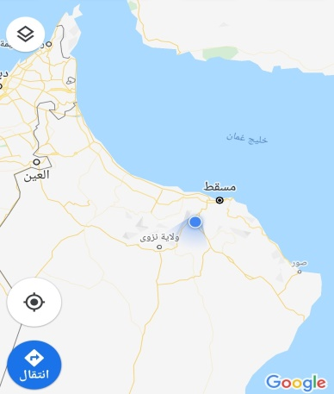
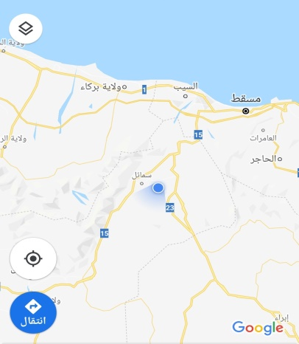
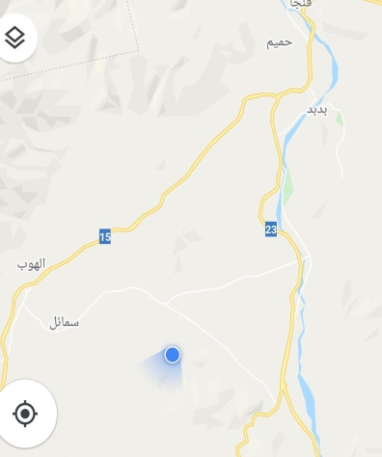

Photos (1) shows the geographical areas for the study site

Data Collection and Analysis
To address the first question, data were collected by measuring the transparency of water, temperature, conductivity, acidity, salinity, the amount of dissolved oxygen. These were applied to two samples of water: a sample of sulfur spring water and a sample of sulfur water after mixing it with the flowing water in the area. The samples were also sent to the Soil and Water Laboratory in Muscat to find out the minerals and materials contained therein.
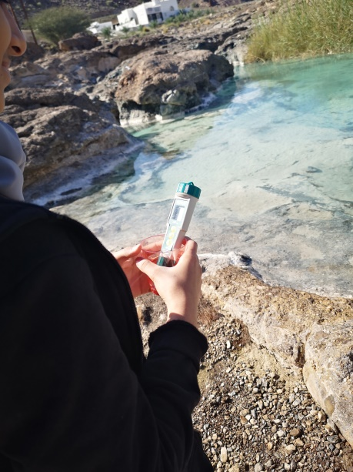
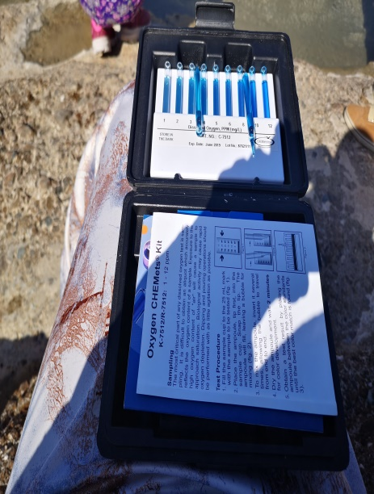

Photos (2) show applying the water protocol
To answer the second research question, data were collected by applying the soil protocol (acidity and carbonate presence). Four samples were taken from the soil from four different sites along the flow path of the sulfur spring water from the surface layer (5-20 cm) of the soil.
To address the third research question, the soil protocol (soil structure, soil color, soil consistency and cohesion, soil texture, presence of roots, and the presence of rocks) were applied to the samples from the four selected sites.
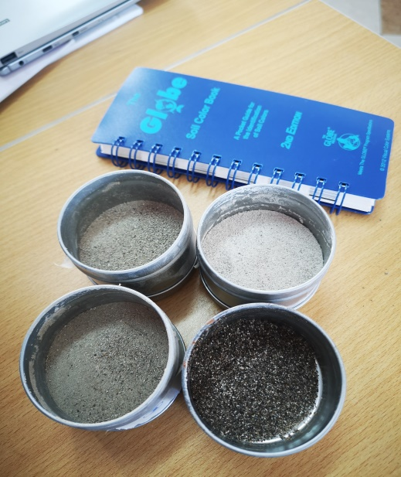
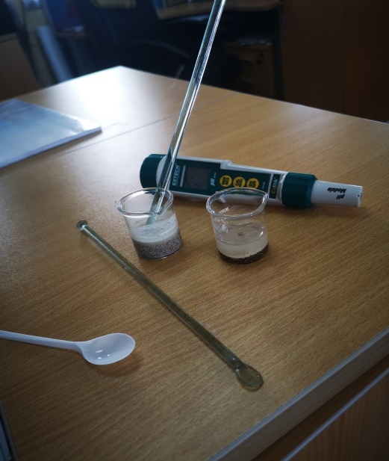

Photos (3) show applying the soil protocol

To answer the fourth question of the research, the land cover protocol was applied to a part of the land where crops irrigated with the sulfur water. The density of the trees and the land cover were measured over an estimated area of (15 * 15) m 2.
To address the fifth research question, observation and interview were used to collect information about the types of living organisms including both aquatic organisms and plants that are able to live and adapt in the flowing waters. These items were photographed. In addition, interviews with some people were conducted in order to identify the types of crops irrigated with the spring water.

Data Analysis
To answer the first research question:
Table (4) shows the hydrological characteristics of the water collected from the study site using the tools of the GLOBE program (Date January, 16th, 2020 at 10:00 am)
Table (4) Water samples data
Dissolved oxygen | Acidity (pH) | Salinity )ppm( | Electrical Conductivity (µs( | Temperature ˚C | Transparency | The Sample
4 | 10.51 | 854 | 1179 | 30 | 120 | Sulfur spring water
8 | 8.89 | 514 | 753 | 23 | 120 | Water collected with sulfur water used for irrigation
8 | 8.2 | 441 | 646 | 21 | 120 | Water from a fresh source near the spring

Table (5) illustrates the results of the analysis of sulfur water components and the sample of water collected with the spring water.
Table (5) data of some minerals and substances that were detected in water samples
Water collected with the spring water | Sulfur spring water | Substances g/L
488 | 702 | The total of dissolved substances
16.2 | 28.1 | Alkaline carbonate
195.2 | 43.9 | Alkaline bicarbonate
.38 | 0.89 | Ammonia
145 | 343 | Chlorine
8.4 | 25.3 | Nitrates
79.5 | 285 | Sodium
7.9 | 13.2 | Potassium
9.1 | 24.3 | Calcium
6.9 | 18.2 | Magnesium
45.3 | 85.6 | Sulfate
<0.1 | <0.1 | Boron

To address the second research question:
The following table indicates the results of the application of the soil acidity protocol and some chemical properties of the soil over which sulfur water flows. Four samples were collected from different sites near the spring. (pH was 7.1 for the used water)

Table (6) Chemical properties of soil samples
30 meters away | 20 meters away | 10 meters away | At spring source | Soil Sample
many | many | many | little | The presence of carbonates
8.3 | 8.3 | 8.3 | 8.5 | Soil Acidity

To answer the third research question:
The following table illustrates the physical properties obtained from the soil samples that were taken from different locations.

Table (7) Physical properties of soil samples
30 meters away | 20 meters away | 10 meters away | At spring source | Soil Sample
few | few | medium | many | Rocks
many | many | Not many | none | Roots
granular | granular | granular | blocky | Soil structure
7.5 YR 6/4 | 7.5 YR 5/3 | 7.5 YR 7/3 | 10 YR 3/4 | Soil colour
friable | friable | friable | firm | Soil consistency
clayey | clayey | clayey | sandy | Soil texture

To address the fourth research question:
The land cover protocol has been applied to an area (15 * 15 m 2) where the crops are irrigated with sulfur water. The following table indicates the data obtained.

Table (8) Land cover protocol data
Land cover classification | Land cover  G - green  B - brown  - nothing | E- evergreen  D- Falling leaves  Sky | The plant scientific name | Tree cover | No.
North
 | - | E | Phoenex | + | 1
 | - |  |  | + | 2
 | - |  |  | + | 3
 | - |  |  | + | 4
 | - |  |  | + | 5
 | - |  |  | + | 6
East
 | - | E | Phoenex | + | 7
 | - |  |  | + | 8
 | - |  |  | + | 9
 | - |  |  | - | 10
 | - |  |  | - | 11
 | - |  |  | - | 12
 | - |  |  | + | 13
 | - |  |  | + | 14
 | - |  |  | + | 15
 | - |  |  | + | 16
South
 | - | E | Phoenex | + | 17
 | - |  |  | + | 18
 | - |  |  | + | 19
 | - |  |  | + | 20
 | - |  |  | + | 21
 | - |  |  | + | 22
 | - |  |  | + | 21
 | - |  |  | + | 24
 | - |  |  | + | 25
West
 | - | E | Phoenex | + | 26
 | - |  |  | + | 27
 | - |  |  | + | 28
 | - |  |  | + | 29
 | - |  |  | + | 30
 | - |  |  | + | 31
 | - |  |  | + | 32
GD | + |  |  | + | 33
 | - |  |  | + | 34
 | - |  |  | + | 35
 | - |  |  | + | 36
 | - |  |  | + | 37
 | - 36 |  |  | 34 + | Total

To answer the fifth research question:
The observations indicated the presence of small pond fish in the waters that collect with sulfur-spring water in addition to a quantity of herbs, shrubs, and palm trees. The interview that was conducted with some people in Saiya revealed that they have relied on the spring water for irrigation since ancient times, and a number of crops are able to grow and adapt to this water source, such as palm trees, quince, lemon, mango and others.
The following images refer to some classes of living things near the spring.

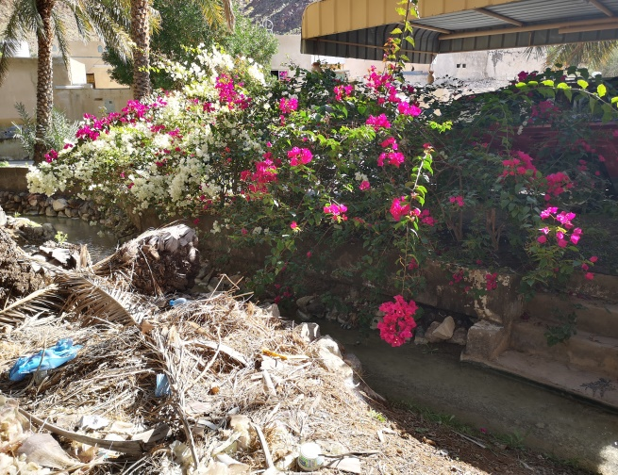
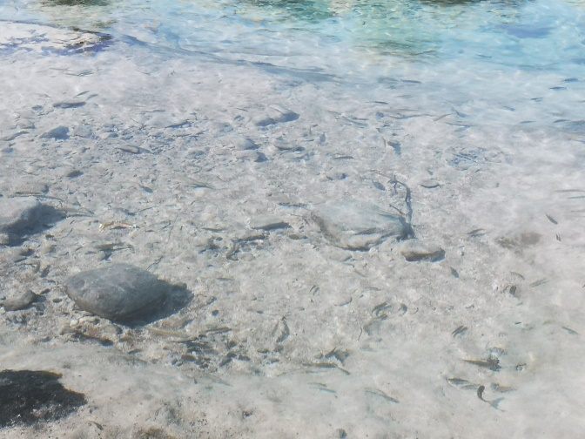

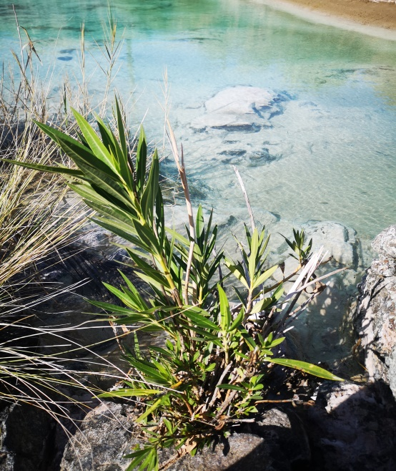
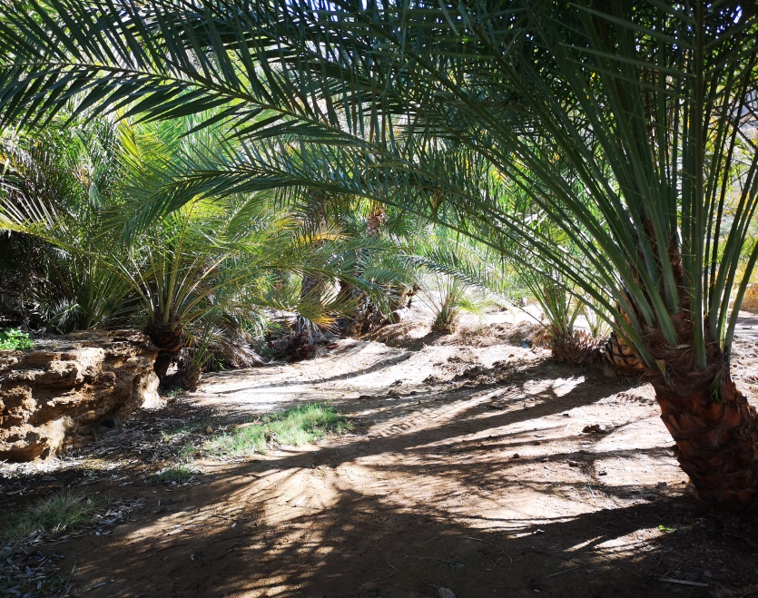

Photos (4) of some species of living organisms near Sulfur water spring

The collected data were inserted and sent to the program website ( www.GLOBE.gov) via the application (DATA ENTRY), where a new work site was added and the collected data were inserted within it.
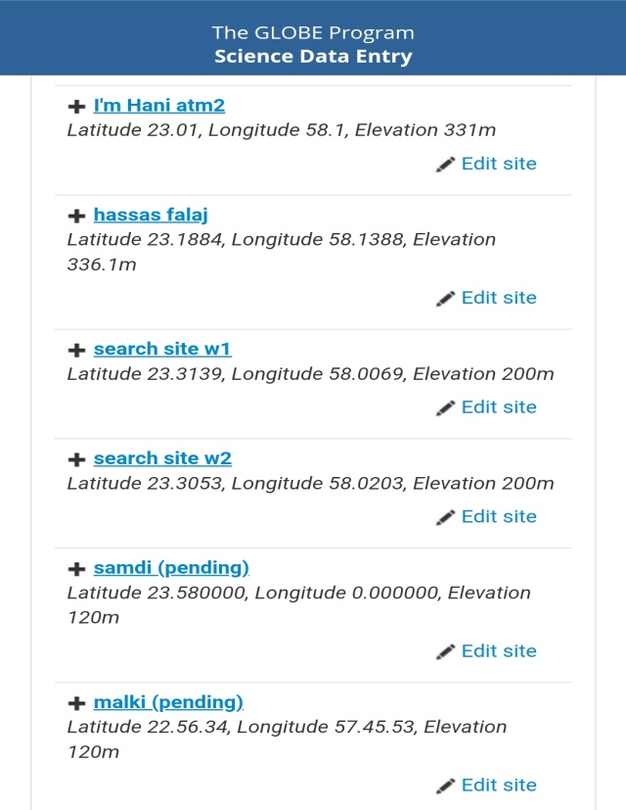
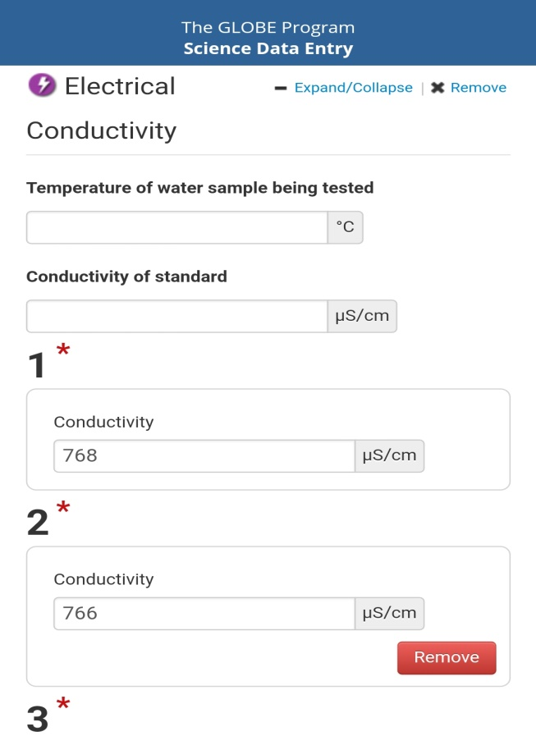

Photos (5) Data entry in GLOBE website

Discussing Results
Research Question One
Table (4) shows the sulfur spring water properties at the source and the properties of the spring water after mixing it with flowing water in the same location by applying the water protocol to the two samples. The table illustrates the temperatures, transparency, acidity, conductivity, salinity and the amount of dissolved oxygen.
The data shows a clear difference in temperature between the two samples. The sulfur spring water is naturally hot. Moreover, sulfur spring water recorded higher values ​​of conductivity, salinity and acidity, while the amount of dissolved oxygen was lower.
The quality of irrigation water is one of the most important factors affecting the production of agricultural crops especially in dry land conditions where water resources have decreased due to the fluctuation of rains in recent years. The salinity of irrigation water increases the salinity of the soil. The following table indicates how to classify irrigation water based on total dissolved salts (criteria for evaluating the suitability of water for irrigation).
Table (10) Irrigation Water Salinity Index
The seriousness of salinity | Electrical conductivity micrometers / cm at 25 ˚C | Salinity index
little | <750 | A
medium | 750 – 1500 | B
high | 1500 – 3000 | C
very high | 3000< | D

Whereas, the measured conductivity of the sulfur spring water and the water mixed with it are (1179, 753) µs, respectively. It could be classified as an average level regarding the severity of salinity.
Table (5) also shows an analysis of the minerals and materials present in the sulfur-spring water sample and the spring-water sample after mixing with other water sources in the same area.
The most prominent data shows a high level of 285 g / L of sodium for sulfur spring water, while after mixing with the water flowing in the site the quantity of sodium drops to 79.5 g / L.
An article in the website (www.startimes.com) indicated that one of the most important measures of water quality after water salinity is the relative concentration of sodium or sodality. It is stated that irrigation water with a high sodium content turns the land into a land with a high level of sodium and such lands have shallow surface crust that is badly dried and its colloidal material is greatly dispersed. This leads to a decrease in water permeability, which reduces the rate of drainage required to get rid of incoming salts with irrigation water and accumulated by evaporation.
Accordingly, a good irrigation and drainage system are required in this case. Solutions to these threads could be paying attention to continuous tillage or adding sand to the soil in order to ward off the risk from soil and crops (El-Wakeel, 2013).
According to the results of analyzing water samples, the availability of potassium and nitrate in this water will cause chemical and physical changes and increase soil fertility. As indicated by (Jasim, 2011) potassium, It is considered one of the main ions that the plant needs, because it has a great impact on the productivity and growth of agricultural crops.
Data analysis of water samples also indicates the presence of sulfates, naturally as long as the source is sulfur water. This can lead to the formation of sulfur salts in the soil, which are, as explained (Al-Jurdi, Tart, 2010), not harmful salts.
Besides, the boron rate is less than 0.1, and according to the irrigation water quality standards, does not represent any risk.
Research Question Two
Table (6) indicates the chemical properties of the soil. The acidity of the soil ranges between (8.3 - 8.5), which indicates that the soil is not acidic. Carbonate is also abundant in soil samples collected from the site at various distances along the sulfur-spring water flow line.
The presence of carbonate in the soil indicates a dry climate or a kind of calcium-rich parent material such as limestone (a general introduction to soil research). There is no doubt that the soil has obtained calcium from the water flowing over it, as shown in Table (5). The white calcareous layer was clear on the surface of the soil studied at the site.
These data reveal that the soil may suffer from drought, and thus it is necessary to take care of it and supply it with needed amount of water regularly.

Research Question Three
Table (7) demonstrates the physical properties of the soil. The soil through which the sulfur spring water flows is characterized by an easy-to-crush granular structure in which there are many fine roots, and with clayey clay tissue.
It is known that it is difficult for the roots of plants to grow in a solid consistency soil compared to the soil that has a fragile consistency. Moreover, many roots in the soil provide an indication of the porosity of the soil. (General introduction to soil research)
The data also indicates the examined soil sample has clayey tissue with high sodium. Therefore, good water drainage system is required in this soil in order not to accumulate salts and cause a layer that prevents water from reaching the roots. This was confirmed by what is stated in the science book for the seventh grade (2019), that the clay soil is poorly drained. Perhaps the people in the town of Saiya have taken care of the soil by mixing it with sand to provide a good drainage of water as the growing can be noticed in the study site. Consequently, it is possible to contribute to soil drainage through continuous tillage and mixing clay soil with sand to increase porosity and ease of drainage.
Research Question Four
Based on the data in Table (8) regarding land cover, general observations can be summarized through the following table:
Table (12) summary of land cover data
Land cover type | Land cover |  | Tree cover calssification | Tree cover |  | Protocol
GD | 36_ | 1+ | Phoenex | 34+ | 3- | Total
 | 37 |  |  | 37

The density of the trees is very high at 92%, as there are a large number of palm trees based on irrigation with sulfur water. The research team did not expect this percentage of tree density to be dependent on irrigation on the sulfur water source as it was believed that this water could not be used for irrigation. Perhaps this result is an indication of the contributions of the use of sulfur water for irrigation, including chemical, physical, and fertile changes in the soil. As a result of which many crops are planted in the area, and the most prominent and most widespread of which was palm trees.
Research Question Five
By observing and interviewing some of the residents of the town of Saiya, varieties of organisms are found and they have shown their adaptation to sulfur water over the years. Like small pond fish is observed in the sulfuric spring water pool area with flowing water. In terms of crops, there are many trees such as palm trees of all varieties, lemon, quince, mango and Sidr, in addition to vegetable crops such as radish, lettuce, tomato, eggplant, and others, as well as crops such as clover, and some flowering plants such as rose and bougainvillea.

Summary
The aim of the current study was to explore the properties of sulfur water in Saiya Spring in the state of Sumail. The spring water is characterized as alkaline water with a group of substances that have been gained by this alkalinity, such as carbonates and alkaline bicarbonates. It is also characterized by high soda, which makes the classification of its salinity to (medium) and the severity of salinity ranges (1179 µs- 753 µS). Based on these findings, good drainage system is required when using the spring water for irrigation.
Regarding the soil, the results show that it has an easily fragmented granular structure and it is rich in roots and carbonates, forming clayey clay tissue. The presence of roots in the soil and the high percentage of tree cover at the study site (92%) indicate the fertility of the soil. It is clear from the analysis of samples that there is availability of potassium and nitrates in sulfur water.
Although the prevailing belief shows that sulfur water is not valid for irrigation, the conclusions of the current study reveal that it is possible to use sulfur water in irrigation especially if there is an opportunity to mix it with a source of fresh water. However, it is important to mention here that in the case with Saiya Spring, it is important to use good drainage system, through the continuous tillage of the soil and the possibility of mixing sand with it.
A similar study can be applied by selecting different sites for other sulfur springs, in order to expand data and compare with the current study. It is also possible to study the nature of the chemical and physical properties of the soil and the land cover of a site that is irrigated with fresh water and compared with the current study. We also recommend studying the effect of adding sulfur to the growth of some crops, and clearly stating their impact on the ground cover.

Acknowledgment

Praise be to Allah and prayer and peace be upon His Messenger.
We would like to express our sincere gratitude to our research supervisor Teacher. Nawar Al-Rawahia, our school principal Ms. Badria Al-Siyabi and her assistants Zamzam Al-Bakriya and Badria Al-Baroumia, for their guidance, assistance and supervision during the application of this study. We would also like to thank the people of Saiya for their cooperation and for welcoming us at the study site. Thanks also go to people in the Soil and Water Laboratory in Muscat for helping us to examine the study samples. Not to forget to thank the team of the GLOBE program and the program's supervisors in the Dakhiliyah Governoratefor encouraging us to participate and guiding us throughout this study.

References

Recommendations for land improvement and utilization. Retrieved on 10/2/2020 from www.startimes.com
Jassim, Adnan. (2011).The role of sulfur and the quality of irrigation water in some characteristics of limestone and wheat growth. Diyala Journal of Agricultural Sciences.
Al-Jurdi, Ahmed and Wartat, Muhammad. (2010.) The relationship of irrigation with salty sulfur water and some physical and chemical properties of soil in potassium readiness for the soils of Jabal Al-Hoss / Aleppo. Tishreen University Journal for Research and Scientific Studies.
Appointed as. Retrieved on 1/24/2020 from shabiba.com/article/9242
Springs in Oman. Retrieved on 1/24/2020 from elaph.com/reports/2004
Criteria for assessing water suitability for irrigation. Retrieved on 1/24/2020 from https://www.google.com/url
GLOBE Environmental Technical Office, (2012). Field Study of Soil Research Environmental GLOBE Program
GLOBE Environmental Technical Office, (2012). GLOBE Teacher Guide
GLOBE Environmental Technical Office, (2012). General introduction to the Soil Research Environmental GLOBE Program
Sulfur water. Retrieved on 1/24/2020 from https://ar.m.wikipedia.org
Ministry of Education (2019). Science for the seventh grade. First edition
Al-Wakeel, Mohamed (2013) Quality of Irrigation Water. Retrieved on 10/2/2020 from www.mwakil.net

