The Relation between Harmful Radiation UV (ultraviolet) , Ozone and between The Different Location of The Sun in Daylight Hours at The Beginning of Spring ( Industrial YANBU )

Prepared by : Maria Rozy

Saudi Arabia

Second - High School ( Industrial YANBU ).

Supervised by : Eman Elghamdy / Mona Elghamdy

March 2019

2) The Contents :

Page number | Content | Numbering
2 | Contents | 2
3 | Abstract | 3
4 | Introduction | 4
5 | Research problem | 5
6 | Research Importance | 6
6 | Research Hypothesis | 7
7 | Literature Review | 8
7 | Materials and Method | 9
9 | Data Analysis | 10
16 | Deduction | 11
16 | Discussion | 12
17 | Clonclusion and Acknowledgment | 13
18 | References | 14

3) Abstract :

Because the UV (ultraviolet) touches a big part of our life which may lead to defect in some organs of the human body, the researcher offered some questions, As
-When do the UV indicators reach their peak ? Answer is needed to avoid it as much as possible.
Also, Proving or denying the hypothesis is needed, especially, knowing that the harmful radiation concentrates on the region of the tropical latitude circle and then the regions near to it. Depending on that, the research aims to determine the latitude circles that the UV radiation is focused on at the rush hours in '' Industrial YANBU " and " MAKKAH AL MOKARAMA" at the beginning of the spring .
The researcher collects all these data :
(Location of the sun – Indicators of the harmful radiation – The difference in the ozone layer – The temperature) .
The Results that the researcher found :
- The Location of the sun in the sky is one of the factors that affect on the indicators of the UV even if the change is simple .
- There is a relation between the location of the sun in the sky and the UV. That relation was determined at beginning of the spring in 'YANBU' industrial city, and the hypothesis of the research was proved. Harmful radiation concentrates on the region of the tropical latitude circle and other regions that comes after it. This is shown in the following picture:

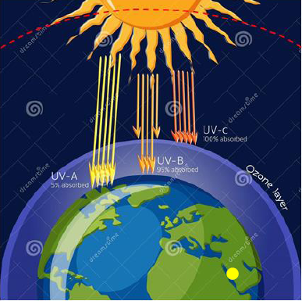
A picture which contains all the elements found on the research topic.

4) Introduction:

Sun is considered the most important reasons of life - God willing – on the earth. It provides the earth with the required energy, either thermal or light energy so that the creatures live in peace. However, sun has some negative aspects, which lead, it return, to the harm of the living organisms or cause death to them. Among these aspects are: the solar disorders , krona holes and the mass flow that affects the earth even beyond a distance of 150 million km .
we will focus in this research on the ultraviolet and its symbol is UV , because the radiation affects our daily life and that may cause a lot of diseases and cancers that affect the organs of the human body as eyes and skin. That leads to a deficit in the body functions which, in turn, will affect the practical life. Hence, it is important to determine the indicators, the predictions, and the peak of the UV.

5) Research Problem :

Away from the research, when the researcher was using the application of Start Chart and studying the movements of the planets and stars, she noticed that the path of the sun varies according to the change of the seasons of the year.
Here comes the second question : Is there any relation between the harmful radiation (ultraviolet), and the location of the sun depending on the change of times and seasons of the year ?
(look Fig.1 to notice obviously )

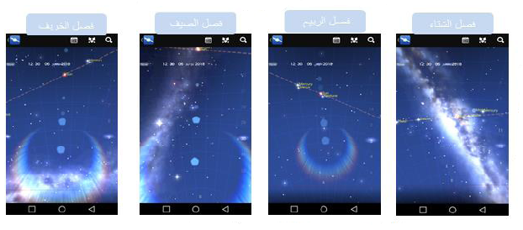
The dotted line refers to the path of the sun in the sky

The red line refers to the line of sight , what is above can be seen but what is below can't.

(Fig.1)
You can notice the change in path of the sun with the change of the seasons regarding "industrial YANBU" (North to the equator line ). This pictures was taken from the application of Start Chart at 12:30AM at the beginning of each season, notice the change the path of the sun from the line of view.

Because Ozone obscures around half from the ultraviolet (observation ozone from NASA ), then what will happen for our bodies and eyes if the ozone layer was lower than the normal rate (observation ozone from NASA ) in industrial YANBU ?
If we understand this relation well, it will save us - God willing – from exposure to the harmful radiation at the peak of the daylight. As a result, we will get better health. The researcher chose this topic especially in the spring for two reasons. Firstly, it touches big part of our life. Secondly, because the Ozone hole completes every year in the spring above the south frozen continent. So, that may affect the indicators of the harmful radiation on the rest of the regions in the earth.
In this research, the researcher focuses in each of the following points:
- Determining the times that the UV (ultraviolet) will be at its highest point in the "Industrial YANBOU" at the beginning of the spring .
- Determining the latitude circle that the ultraviolet will be concentrated on in case the researcher's assumption was wrong.
- The scientific assumption of the reasons why UV radiation are not rising in many regions located on different distances from the latitude .

6) Research Importance :

The importance of the research comes from the negative effects of the UV on the humans body. UV is one of the main reasons that cause skin cancer with it's different types as : ( Squamous cancer , Basal Cell Carcinoma ), and cause harm for the eye cornea and retina (cataract , chalazae , swelling ).
Look at the Fig.2 . Also, it's one of the major cases that are linked to Ozone layer.

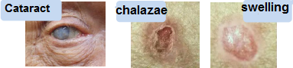
Pictures show types of eye diseases and skin cancers, resulting from the harmful radiation UV .

7 ) Research hypothesis :

Based on the simulation of the movement of the Earth around the sun made by the researcher, "Fig3" she assumes :
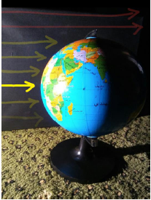

the normal movement of Earth around the sun From the northern side assume that the earth revolve in a way that is opposite to Clockwise around the sun , so the researcher emulates it clearly :
- the right direction of the earth axis (in front or behind )
- The direction in which the researcher took the stimulation photo, and to be parallel to the source of the light
- The yellow arrows shows the researcher's estimation to the radiation concentration. The less the color is transparent , the more the concentration is. However, the red arrows is a normal and real radiation but it's not a concerning point to the researcher.

FIG.3

The researcher assumes that the concentration of the sun rays in the spring is near to the tropical latitude , so the levels of the ultraviolet radiations are higher in the regions lied on the equator , and the regions near to it .

8) Literature Review :

Also called the harmful radiation or UV radiation. it is an electromagnetic waves, and its wavelength is shorter than the visible spectrum . Divided into types as UV-C, UV-B, UV-A. | The Ultraviolet
IT is the Triple oxygen gas, and the ozone, in its gas statues, is very harmful for the creatures' life if inhaled or touched by the skin.  But when it is in the air at distance of 10 k – 50 k from the surface of the sea, it protects the earth from the harmful radiation. | Ozone
The way through which the sun moves in the sky where the sun appears as it is revolving around the earth . | Path of the sun
It is numbers used to measure the range of levels of ultraviolet radiation. This indicator maybe at its highest level in the sunny days rather than the others. From 1-2, it's low and It's color is green, from 3-5, it's moderate and it's color is orange, from 6-10 it's high and it's color is red , >11 it's very high, and it's color is purple. | Indicator of the Ultraviolet
It is an estimated Lines and circles, and they were put to describe the geographical coordinates on the earth .The longitude is like an imaginary semi-circles surrounded by the earth and connects between the north pole and the south pole , they are 360 lines .  The Latitude is as an vertical circles on the longitude and they are 180 . | latitude and longitude
It is the region that located in the middle of the sky at night or in daytime . | The sky meditation
It's a line in the sky that separates between the part that can be seen and the part that cannot be seen because it's behind the earth .Look Fig.1 | The Line of Sight

9) Materials and Methods :

After noticing the research problem, the researcher collected the data for each of : Ozone , indicators of ultraviolet radiation, the temperature and the cloud cover. Some of the data collected were numbers and some were graphs and figures due to the lack of some devices.
So, the data is done according to the indicator from application that is specialized in collecting data and numbers, the data of the cloud cover was collected from the school with group of students of Global program , the temperature degrees were collected also by group of students of Global program (Fig.4) and all of them are in the region of "Industrial YANBU" which is far from the sea by 1km-3km, and higher than it between 0-20 M maximum.
The researcher was careful to collect each of : Ozone O3, indicators of the harmful radiation UV and the cloud cover. The lower the thickness of the
Ozone layer is (03), the more change in the harmful radiation occurs. That, will lead the earth to more of harmful radiation UV and vice versa .
Because the clear sky allows 100% of the ultraviolet to pass ,the scattered clouds allow 89%, the broken clouds allow 73%, and the overcast sky allows 31%. it was important to take in consideration the percentage of the cloud cover in "Industrial YANBU"
Figure -5- shows The different in types of the clouds :
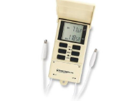
A device to measure the temperature of the air and the soil, having the mark of Globe environmental program .

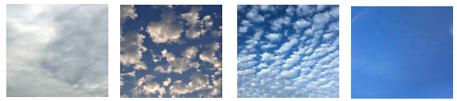
Types of the clouds from the left to right (overcast sky - scattered clouds – broken clouds – clean sky)
The height of the industrial city "YANBU" from the earth's surface and it's cloud cover are some of the influences of the indicator of the UV. However, it's height is very low and the percentage of the cloud cover during the collection of the data did not pass 10%, so the researcher did not have to change the indicator of the UV radiation .
However, the temperature is not considered from the factors that affect the indicators of the harmful radiation .
The "Industrial YANBU" Located at north latitude of 24 , south longitude 38 , Fig.6

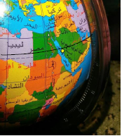
Fig.6

10) Data analysis :
Here is the Data :
Note : The Data was recorded at +3:00 Greenwich Time.
Indicators for the ultraviolet UV at "Industrial YANBU" at 9-10 March 2018 (Table 1)

12:00 AM | 11:00 AM | 10:00 AM | 9:00 AM | 8:00 AM | 7:00 AM | 6:00 AM | Data | Date
10 | 7.8 | 5.3 | 2.3 | 0.3 | 0 | 0 | UV indicator  Ozone | 9-March
288 | 288 | 288 | 286 | 286 | 286 | 286
10 | 8.1 | 5.1 | 2.5 | 0.7 | 0.1 | 0 | UV indicator  Ozone | 10-March
289 | 289 | 289 | 289 | 289 | 289 | 289
7:00 PM | 6:00 PM | 5:00 PM | 4:00 PM | 3:00 PM | 2:00 PM | 1:00 PM
0 | 0.1 | 0.9 | 2.9 | 5.7 | 8.1 | 10 | UV indicator  Ozone | 9-March
288 | 288 | 288 | 288 | 288 | 288 | 288
0 | 0.1 | 1 | 3.1 | 5.9-7.5-? |  | 10.2 | UV indicator  Ozone | 10-March
289 | 289 | 289 | 289 | 289 | 289 | 289

The ozone is measured by Dobson unit DU
The maximum value of the ultraviolet indicator in "YANBU" industrial city did not exceed 10.2 , Which indicated that it don't reach the high limit.
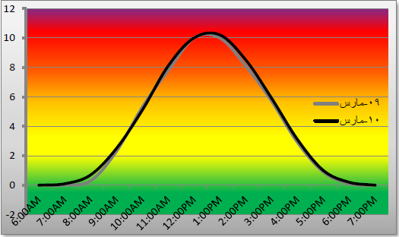
A graph for the ultraviolet radiation UV in "Industrial YANBU" by 9-1- march 2018 (Graph 1 ) :

Color Guide

Green – Low
Orange – Moderate
Red – High
Purple - Very High

A graph for the amount of the ozone layer in "Industrial YANBU" by 9-10 March 2018 (Graph 2 ) :

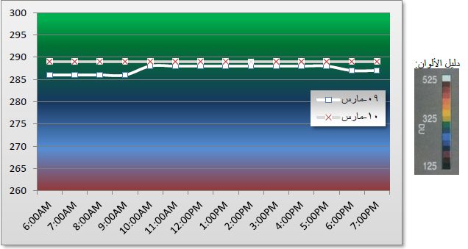
The ozone is measured by Dobson unit DU

Table of Data for cloud cover (Table 2 ), and a picture taken for the cloud cover in "Industrial YANBU" from the school ( Table 2 ) :
Table .2
8:00 PM | 6:00 PM | 4:00 PM | 2:00 PM | 12:00 PM | 10:00 AM | 8:00 AM | 6:00 AM | 9-March  10- March
0% | 0% | 0% | 0% | 0% | 0% | 0% | 0%
0% | 0% | 0% | 9% | 0% | 10% | 9% | 10%

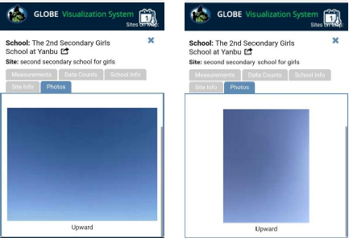
Fig.7

Picture of the cloud cover from website of Globe program for "Industrial YANBU"

Location of the sun path's from YANBU on 9-10 March at sunrise at 12:00 pm and at sunset (Fig.8):
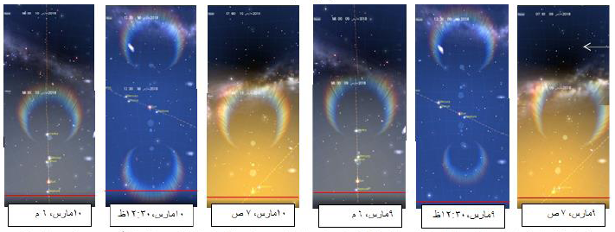

Concentration of the Ultraviolet radiation (FIG.13) :

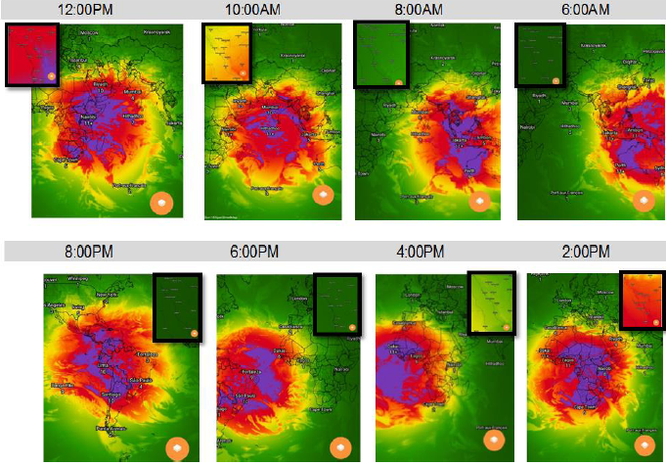
Concentration of the Ultraviolet radiation :Dark green zero – Green low – Yellow moderate – Red high – Purple Very high
The small square determines the data of concentrated ultraviolet radiation for "Industrial YANBU"' and ' MAKKAH '

11) Deduction :

The researcher noticed that the ultraviolet radiation in "Industrial YANBU" never reaches the high limit in both registered days 9-10 March 2018 (Table 1) , (Chart 1 ) , Even though , the cloud cover doesn’t reach 10% (Table 2 ), (chart 7 ) . In contrary, the ultraviolet radiation UV reaches the high limit in both registered days 9-10 March 2018 in MAKKAH AL-MOKARAMA (Table 3 ), (chart 4 ) at 12 pm -1 pm o'clock , knowing that the cloud cover doesn’t reach 4% ( Table 4 ) .
When checking the angle of the sunrise for a line of sight in "Industrial YANBU" (FIG.8) , and "MAKKAH AL-MOKARAMA" (FIG.12) , we notice the difference between the angle of the sunrise and the sunset by small amount , this related to the line of sight ,but it leads to relatively large change for the indicator of the harmful radiation UV .. and also for the path checking of the sun for both cities at 12:30 PM ( FIG 2,8 ) ,
Slight variation between the sun path and the mediating zone in the sky is noticed , and that leads to relatively large defect in the indicator of the UV despite of the change in the latitude circle between the two cities which does not exceed two latitude circle by (FIG 2,10 ). The researcher concludes that the research hypothesis is correct, by noticing the different of concentration in the ultraviolet UV (FIG 13) .
The concentration relatively at its high levels on the attitude circle is between north 22 and south 22 at the equator line . Lands or states that fall below this area are not exposed at the beginning of the spring to high ultraviolet radiation. For example, the United States of America and at the center of southern Argentina . As the time of peak can be noticed from the graph of (Graph 1 ) , for "Industrial YANBU" , and from graph (Graph 4 ) For "MAKKAH AL MOKARAMA" , the peak time is 12:00 PM – 1:00 PM for both cities , and that for time of +3:00 at Greenwich line .
Because there is no relationship between temperature and UV indicator, temperature is never considered as a measurement, which is a belief that people should correct to avoid health problems and radiation. Harms can be avoided by putting protection creams ,eyeglasses, hats and others.

12) Discussion :

The data can be collected in different seasons (summer – winter – spring) , and different times in one season ( beginning of season – middle of season – end of season ) in order to determine the relation with high accuracy or to measure the indicators of the harmful radiation with its different types (UV-A, UV-B, UV-C) , when the ozone layer reach the lower levels .
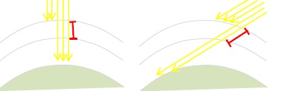
The ultraviolet is not high in some regions as : ( Regions below 22 north and 22 south of the equator ). That may be because the sun rays breakthrough wide layers from the atmosphere, so it exposes to the ozone layer that leads to bodice Ultraviolet from types of A , B (look FIG.14 to understand the pic. )

the number of the rays indicates the harmful radiation that reaches the earth , and the red line indicates difference between the distance traveled depends of the angle of fall (position of the sun in the sky)

the researcher calls for inquiry in this question .

13) Conclusion and Acknowledgment :

Finally, I thank the coordinators of these programs 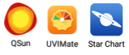 which gave me important information to complete the research .I would like to thank the unique teacher EMAN Al-GHAMDI who supported me in the formulation of my scientific research from its beginning to the end .I thank the unique teacher Mona Al-GHAMDI and BATOUL KARZON , and I am very grateful to them .

14) References :

- https:/www.webteb.com/cancer/disease/skincancer
https://www-spof.gsfc.nasa.gov/stargaze/Secliptc.htm -
https://ozonewatch.gsfc.nasa.gov/facts/SH.html-
https://en.wikipedia.org/wiki/Ultraviolet_index-
https://science.nasa.gov/ems/10_ultravioletwaves-

