In searching of the secrets of water

School
Escuela Primaria Particular Incorporada N° 1345 “Nuestra Señora del Carmen”
9 de Julio 860 C.P. S2122 Pujato (Pcia: Santa Fe) – Argentina
Phone:+54 3464 494552 email: prim1345_pujato@santafe.edu.ar

SCHOOL DIRECTOR: Romagnolli Alejandra Mónica

GLOBE TEACHER: Manginelli Guadalupe guadalupemanginelli57@hotmail.com

STUDENTS

Aranda, Diego
Barzanti, Tobías
Carreras, Federico
Córdoba, Santino
Fiori, Tiziano
Marelli Ramiro Fernando
Ponce, Ulises Santiago
Quiroga, Francisco Gabriel
Raschini, Santiago

Tarquini, Paolo
Valenzuela, Lucas

Leporatti, Julieta

English teacher: Grosso, Natalia

INDEX

Content | Pages
INDEX | 2
SUMMARY | 3
INTRODUCTION  - Pose Questions  - Hypothesis  - Objectives  - Background  - Theoretical framework | 3  4  4  4  4  5
DEVELOPMENT | 7
- Activities | 8
I.- Before Field Trip | 8
II.- During the Field Trip. Study Site | 15
III.- After Field Trip: in the classroom | 17
IV.- Field Trip with a small group | 18
Logo DESIGN | 18
RESULTS | 19
DISCUSSION | 20
CONCLUSION  BIBLIOGRAPHY | 20  21

SUMMARY

This work is being carried out by fifth graders School Nº 1345 "Nuestra Señora del Carmen" Pujato. It aims to describe the surrounding area of the canal-ditch located northwest of the town, a place where students often fish and play. Within the environmental characteristics, water quality is being especially studied.
Activities: reading and interpretation of the story "A Waterproof Case"; organisation of a field trip; localization of the place under study; preparation of materials and tools for work; field visits with observations and measurements to describe the ecosystem, wildlife, and state of time. The aquatic environment will be characterized by determining turbidity and water temperature, presence of aquatic plants, fish, insects; sampling of water so as to experiment and determine other properties -pH and DO-; performing bioassay to assess toxicity and finally to determine quality.
As a complement a logo is designed.

INTRODUCTION

Water is one of the most abundant and important substances on Earth; sustains plant and animal life, plays an important role in shaping climate, it helps to shape the planet's surface through erosion and other processes; it covers approximately seventy percent of the surface of the earth.
Simple organisms can survive without air, but none can survive without water. Water is essential for all living beings; its quality can affect the life of plants, animals and humans, because all of them depend on water for their survival.
Water quality varies from place to place, with the season, and the soil type by which is advancing, since it drags many things in its path. They are mostly natural causes which affect the quality of the water. Although not only the influence of nature affects the its quality but also the activities of human beings throughout the world. If we add things into the water, it becomes unhealthy for people, plants or animals consequently, it is said that water is being polluted.
This work is related to hydrology, especially with a watercourse in Pujato, a canal-side ditch located in the northwest area of the town, near the boundary between urban and rural areas.
In natural sciences curriculum of fifth grade appear some items linked to water, these had been worked at the time of initiating this study and then they were deepened with its development as follows:
- In connection with the earth, the universe and its changes.
- The description of the main characteristics of the hydrosphere, its relations with other terrestrial subsystems; water properties and water cycle characteristics.
- In relation to living beings: diversity, unity, relationships and changes.
- The characterization of aquatic environments and transition, relationships with air-ground environments, and the classification of groups of organisms.
- The recognition of man as modifying agent in the environment and its importance in preservation.
Once developed some of these contents, students say that, often, they play and go fishing in a ditch located on a dirt road, near the boundaries of the urban area with the field.
Reflecting on the properties of water, its importance in the ecosystem and recognition of man within the environment, concern arises in the group to meet the environmental conditions of the site where they usually go play, especially the water quality in that channel.

Pose questions
Questions that will guide the research: Where does the water come? In which condition is the water? Do people in the area throw things? Is it dangerous to play or go fishing? How could the characteristics of the water be studied? Will be there fish? What kind of species are there? There are many questions that arise, all of them attempting to define and limit the study that will mobilize school research: How is water quality during the month of August in 2015? An answer to the problem is being sought to define the hypothesis that will guide this investigation:
"The water quality in the canal-ditch located in the lateral northwest of Pujato, where fifth graders from School 1345 can play and go fishing, is good during the month of August as seen in fish and plants".
This statement is based on the fact that, at first glance the water is transparent, has some movement, and there are fish and vegetation on the shore. For that reason the category good is chosen. The investigation will attempt to test this hypothesis.

General purpose:
Describe the canal-ditch located on the northwest side of Pujato area where fifth graders School Nº 1345 can play and go fishing, especially to determine water quality.

Specific objectives:
• Itemize the environmental conditions where the channel-gutter is situated.
• Characterize the physical and chemical water properties of the water-ditch channel; in particular its temperature, turbidity, hydrogen potential, dissolved oxygen and toxicity.

Background:
As a background to this research, it is mentioned that other students of this school, in 2012, made some simple experiments related to water quality of this channel ("Canal de las Truchas"). These activities were part of a program in which the School Nº1345 participates: Challenge for World Water Monitoring. At that time, for monitoring the quality of water, were determined temperature, turbidity, potential of hydrogen and dissolved oxygen in the watercourse.

Theoretical framework:
Main concepts that have been looked up for the research:
Canal-ditch: An artificial open waterway constructed to transport water, to irrigate or drain land, to connect two or more bodies of water.
Environment: are the physical and biological factors along with their chemical interactions that affect an organism or a group of organisms.
Ecosystem: is a community of living organisms called producers, consumers, and decomposers. These biotic and abiotic components are regarded as linked together through nutrient cycles and energy flows.
Contaminant: something that makes a place or a substance (such as water, air, or food) no longer suitable for use, something that contaminates a place or substance.
Water pollution: Water pollution is the contamination of water bodies (e.g. lakes, rivers, oceans, aquifers and groundwater). This form of environmental degradation occurs when pollutants are directly or indirectly discharged into water bodies without adequate treatment to remove harmful compounds.
Bioassay: is a type of scientific experiment. A bioassay involves the use of live animal or plant (in vivo) or tissue or cell (in vitro) to determine the biological activity of a substance, such as a hormone or drug. Bioassays are typically conducted to measure the effects of a substance on a living organism and are essential in the development of new drugs and in monitoring environmental pollutants. Both are procedures by which the potency or the nature of a substance is estimated by studying its effects on living matter. A bioassay can also be used to determine the concentration of a particular constitution of a mixture that may cause harmful effects on organisms or the environment.
Toxicity: is the degree to which a substance can damage an organism. Toxicity can refer to the effect on a whole organism, such as an animal, bacterium, or plant, as well as the effect on a substructure of the organism, such as a cell (cytotoxicity) or an organ such as the liver (hepatotoxicity).
Water quality: refers to the chemical, physical, biological, and radiological characteristics of water. It is a measure of the condition of water relative to the requirements of one or more biotic species and or to any human need or purpose. It is most frequently used by reference to a set of standards against which compliance can be assessed. The most common standards used to assess water quality relate to health of ecosystems, safety of human contact and drinking water
Transparency or Turbidity: transparency relates to the depth that light will penetrate water. The transmission of light into a body of water is extremely important since the sun is the primary source of energy for all biological phenomena.
Turbidity is the cloudiness or haziness of a fluid caused by large numbers of individual particles that are generally invisible to the naked eye, similar to smoke in air. The measurement of turbidity is a key test of water quality.
Temperature: is a physical property expressing how hot or cold water is. As hot and cold are both arbitrary terms, temperature can further be defined as a measurement of the average thermal energy of a substance. Thermal energy is the kinetic energy of atoms and molecules, so temperature in turn measures the average kinetic energy of the atoms and molecules. This energy can be transferred between substances as the flow of heat. Heat transfer, whether from the air, sunlight, another water source or thermal pollution can change the temperature of water.
Dissolved oxygen (DO): the amount of oxygen dissolved in a body of water as an indication of the degree of health of the water and its ability to support a balanced aquatic ecosystem; also, the amount of free (not chemically combined) oxygen dissolved in water, wastewater, or other liquid, usually expressed in milligrams per liter, parts per million, or percent of saturation.
Potential of hydrogen pH: is a numeric scale used to specify the acidity or basicity (alkalinity) of an aqueous solution. It is roughly the negative of the logarithm to base 10 of the concentration, measured in units of moles per liter, of hydrogen ions. More precisely it is the negative of the logarithm to base 10 of the activity of the hydrogen ion. Solutions with a pH less than 7 are acidic and solutions with a pH greater than 7 are basic. Pure water is neutral, being neither an acid nor a base. Contrary to popular belief, the pH value can be less than 0 or greater than 14 for very strong acids and bases respectively.
Standard or quality parameters: is a value, generally defined by regulation, which specifies the maximum permissible concentration of a potentially hazardous chemical in an environmental sample, generally of air or water.
There are standards or parameters of water quality that allows classify it according to the level of dissolved oxygen and pH level. Two tables extracted from the World Challenge Program for Water Monitoring will be taken into account in this work.

Dissolved Oxygen Level | Water Quality
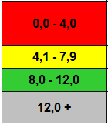 | Poor  Acceptable  Good  Repeat the test
pH Scale | Water Quality
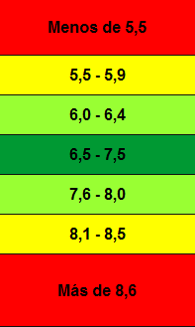 | Poor  Acceptable  Good  Excellent  Good  Acceptable  Poor

There are also parameters that allow us to appreciate the quality of water depending on its use, then it is added an extracted table Escarré (2000) to be used in this study.
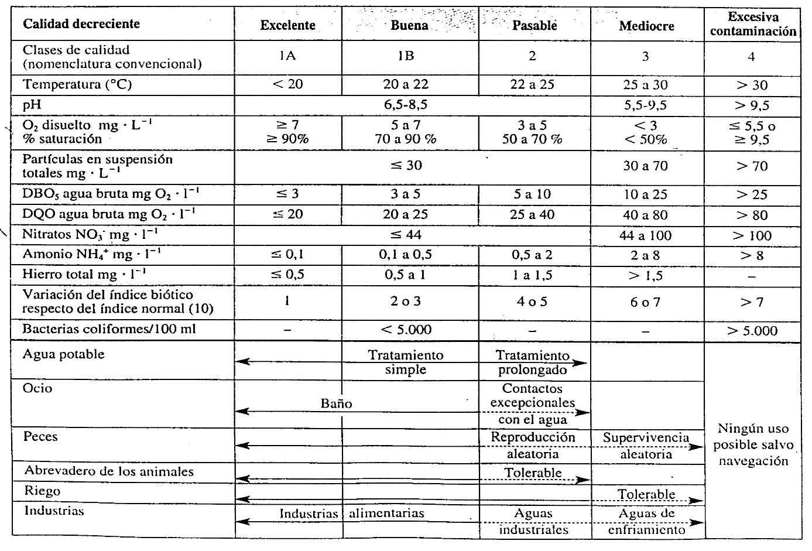

DEVELOPMENT

After being proposed the research problem and intended to corroborate the hypothesis different actions are proposed.
The main activity is a field trip with all investigators students. It is clear that in order to analyze the water quality would be important to repeat the activity several times during the month of August. Since this is not possible, a main output is organized and then another, with a small group to collect water samples and to conduct two quality tests.
The field trip includes a variety of activities: designed experiments, we proceed to the choice of instruments and techniques of data collection: direct observation, simple tests and recording measurements. These techniques are applied at different times of data collection either during previous activities in the study site or after the fieldwork.

Activities:
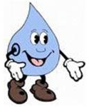
- BEFORE FIELD TRIP

Read and interpret a story.
As a motivating activity the story: "A Waterproof Case" is read, interpreted and it is represented through drawings as part of the program mentioned: Global Challenge Program for Water Monitoring.
In the story, the necessary elements are presented for the investigation of water quality in a surface course.

Santa Fe province and Pujato located in maps and plans.

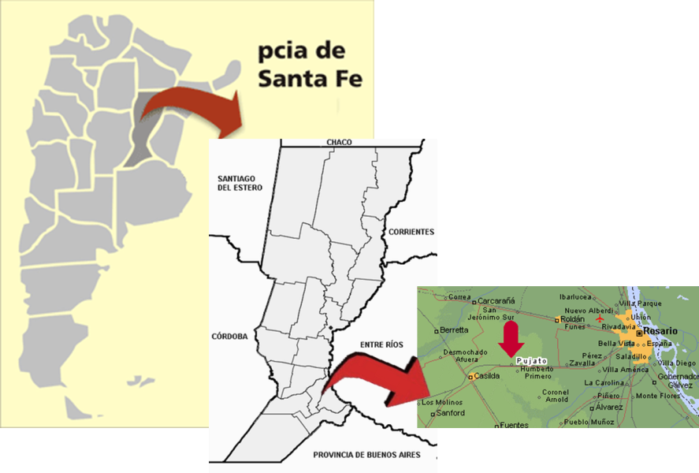

Specific places hydrological measurements are made.
It was decided to perform the work near the canal ditch where students often play and go fishing. The place becomes the study site where the school will carry out this investigation.

The site location is studied through a photograph and a satellite image.
In the aerial photograph you can see the blocks that constitute Pujato, the study site is indicated by an arrow.
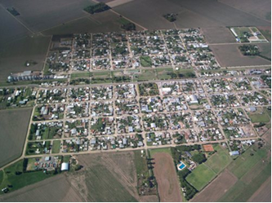

The study site, indicated by the arrow, appears in the image of Google Earth satellite

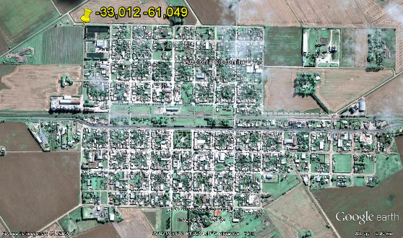

Road to go to the study site.
The journey goes from School Nº1345 to the study site which is drawn on the plane of Pujato.
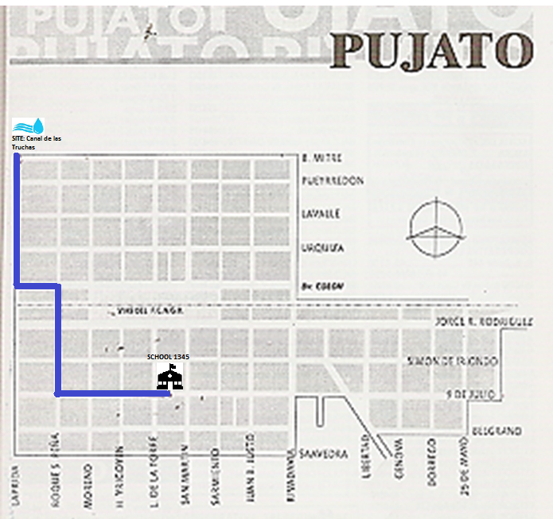



Information about the environment visited.
The study site is located in Pujato, this location is within the geographic region known as rolling pampas. The relief is gently undulating cut by ravines, streams and rivers. The urban part of the town is not traversed by any watercourse. There is a network of surface runoff, comprising, among other elements, channels-ditches that collect water from urban storm water runoff and constitute the surface watercourses of the place. In rural areas appear some channels and small streams. Both rural and urban area of Pujato, slopes, in general, are hardly noticeable, the terrain appears almost completely flat.
The climate of the area: temperate humid, with average temperatures of 15 ° C. Rainfall from 900 to 950 mm per year, with the highest in the warmer months. Winds from the South Atlantic, local winds: sudestada, pampero and north wind.
And the wildlife corresponds to the Pampas region. The natural plant community is the prairie grassland with wildlife associated with it. These have been modified by human activities and the current aspect corresponds to the fields and only remnants of the flora along in small streams trickling (coastal and floating plants) on the railway embankment and along the roads, under fences that delimit the fields.
The water canal-ditch you are visiting comes from groundwater and are pumped by grain storing Argentinean Farmers, the same water is used in the trout farm installed in the neighbourhoods, urban storm water runoff and discharges household.

Elements and tools used during the field trip.
• Compass for orientation on the site.
• Camera for photography oriented to the four cardinal points.
• GPS with which the exact position of where the water samples will be collected.
• Bucket, rope, bottles and containers with lids: elements for collecting water samples.
• Thermometer: To measure the water temperature can be used traditonal immersion glass thermometers or reversible thermal sensors, adhesive and sensitive to temperature which can be adhered to the containers with which water samples are taken.
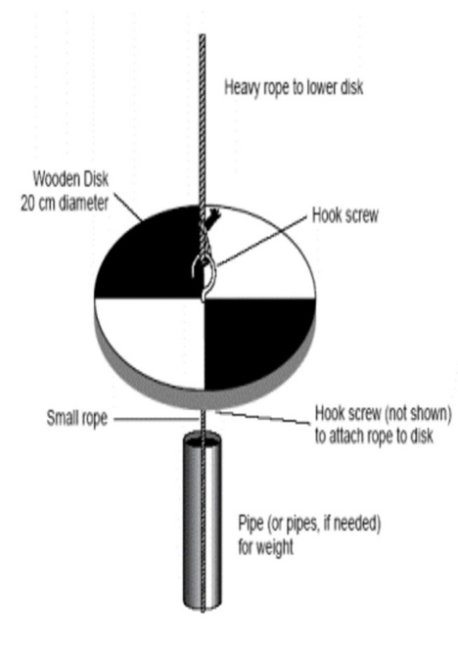
• Turbidity: To measure the transparency or the degree of light penetration in the water can be used two methods; in both cases instruments are constructed: Secchi disk and turbidity tube.

Secchi disk: Materials: Wooden platter (20 cm diameter) piece of string (the length will depend on the depth of the water body), white and black paint, black permanent marker, tape measure, screw hooks (2-3 cm), tube or lead to counter-piece and piece of string (about 50 cm-1 m) for the sinker.

INSTRUCTIONS:
  - Divide the 20 cm acrylic disk into quadrants using masking tape. Spray paint alternating quadrants black and white, so that you have a disk that is similar to that pictured below. Let the paint dry. Apply a second coat of paint if necessary.
  - Drill a hole of 3/8’ through the centre of the acrylic disk and the galvanized steel disk.
  - Assemble disks with eyebolt (5/16” in diameter). Use flat washers between disk and nut, and between steel plate and locking washer. Use 5/16” nuts at the top of the eyebolt and to bolt the steel plate on the underside of the acrylic disk.
  - Attach a brass chain or rope calibrated by 0.5 meter increments to the secchi-disk to use in the lake.
  - If rope is used, avoid using cotton rope or clothesline since it stretches when it is wet. Use non-stretching white plastic coated wire-core clothesline. Make sure to bend and straighten the line before you buy it to make sure that it will lie straight. Calibrate the rope at 0.5 meter increments using permanent pen, or by tying knots at each 0.5 meter interval.
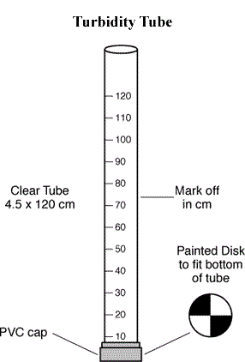
Turbidity Tube
Materials:
1 clear 4 ft long fluorescent light sleeve
Silicone adhesive sealant
Small Square of plexiglass (for base)
Meter stick
Masking tape and permanent marker
Small Secchi Disk diagram

Instructions
- Obtain a 4 ft long fluorescent light sleeve (available at home improvement stores). Use the tube as a template to trace a circle in the centre of the small square of plexiglass base. Draw or glue a diagram of a Secchi Disk that fits inside the circle on the base.
- Mount the plastic tube to the base with silicone adhesive so that you can see the Secchi Disk diagram when you peer down the tube.
- Use your meter stick to mark off 1cm measurements along the length of your tube (or mark the 1 com measurements on a piece of masking tape and then attach along the side of the tube).

Techniques for use of the instruments:

• Technique for collecting water samples
The elements necessary for the collection of water samples were already mentioned: bucket, rope, bottles and containers with lids.
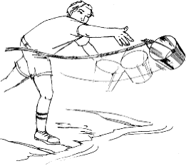
What should be clear prior to the field trip is how to use these elements to take water samples.

- If the place allows, the bucket which will be tied with a rope is thrown. It will seek to collect water that it comes from the surface and not from the background. It is rinsed, and then it is emptied and collected, and bottled for the remaining tests.

- If the channel is not deep and there is no danger to approach the shore, water extraction can be done directly with the bucket. In the same case the container can be used with a cover kit that provides the program "World Challenge for Water Monitoring”.

The technique in this case is as follows:

The elements should be clean. In the case of bottles and containers with lids they can be reused, washed with soap and rinsed thoroughly with boiled water. It is also suggested to use clean rags and papers to support the elements.

A general rule:
Begin with clean containers and then rinse them with water from the source you are going to take the sample. Finally take the sample, seal the container, and label it.

• Technique for temperature recording
If the glass thermometer is used it is placed 10cm under water for 1 minute, then the temperature is measured.
For sensitive sensors you must observe where a different colour appears on the temperature scale.

• Technique for determining turbidity
In the case of Secchi disk, depth is measured when the disk disappears while descending into the water and then when it is raised.
With the turbidity tube, water is poured and the water depth is recorded in the tube when the Secchi disk pattern disappears from view.

• Technique for determining the level ofDOand pH using the kit Program "Challenge for World Water Monitoring"
For practice, tests ofDOand pH are performed using ordinary tap water obtained from the tap of the school laboratory.
All materials required for the test are used as well as the colour table that provides the kit.

- Procedures for conducting the test Dissolved Oxygen:

DO test is completed by searching the percent saturation of DO in water on the table. It should relate the value of DO with the water temperature. The following table is annexed to determine saturation:

- Procedures for conducting the pH test

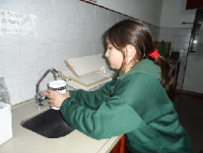
Before leaving, in the classroom, and with the running water network, practical tests are performed using the corresponding elements to determine the quality and then with the water from the water-gutter.

II. - DURING THE FIELD TRIP. STUDY SITE
The field trip, with all members of the group, is organized on August 13th, 2015.
Arrival at the study site is at 17.10
The site is located with a GPS: 33 ° 0 '42.8 "S 61 ° 2' 56.3" O
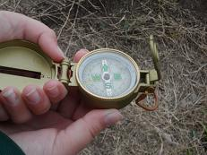
They are located on the site according to the cardinal points and photographs around the site are obtained.

Study site surroundings: NORTH; SOUTH; EAST; WEST
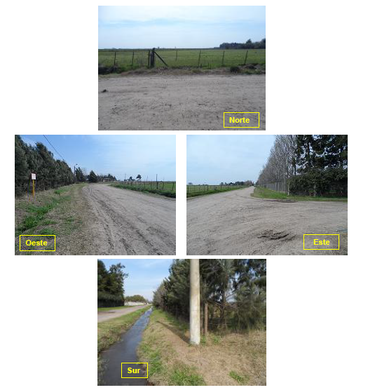

Ditch channel photographs are taken where you can see the water level, transparency and the overall look of the site. There is vegetation at the edges. Near the canal there is a barrier of trees and a road.

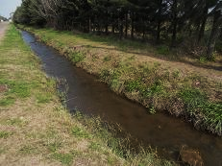
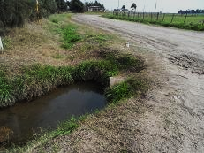

The study site is recognized and water samples are taken.
Since rains did not begin late in August, the gutter channel depth is small; about 20 cm. the elements in it can be perfectly observed. Therefore appropriate techniques and instruments are selected in relation with the gutter conditions.
When taking water samples, the container is introduced where water sample is collected.

Measurements related to physical indicators of water quality are performed: Temperature and turbidity or transparency.
Given the gutter conditions the appropriate instruments are: the reversible thermal sensor for measuring the water temperature and the turbidity tube to determine transparency.

With the water samples and the items from the "Challenge for World Water Monitoring", dissolved oxygen level and pH tests for determining chemical indicators of water quality are performed in the study site.
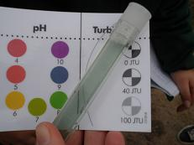
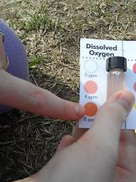

During the field trip, students visit the Pujato trout hatchery, which uses the water that then trickles into the gutter channel under study.
The owner of the place, Mr. Alberto Crognoletti said that water studies are performed, and its quality is good for that reason it is re-used since it leaves the ground water without doing any specific treatment. Each pool has a turbine that oxygenates the water.

III AFTER FIELD TRIP: IN THE CLASSROOM.
• Evaluation of water toxicity by bioassay.
The Water is collected and stored at 4 ° C, in the refrigerator; two bioassays take place in the classroom to assess the toxicity of the water ditch. The test is performed using onion bulbs.

BIOASSAY
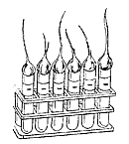
The presence of chemicals in ecosystems is a potential risk to the health of living beings. To assess the risk a pollutant to the aquatic environment it is not enough just to know its concentration, it is necessary to consider the effects that are capable of producing, which are estimated by evaluating toxicity, through a bioassay.
In this study onion bulbs are used, specifically to determine whether water toxicity affects the development of these bulbs. Through the experiment it is observed, measured and compared the length of the young roots and / or shoots in a non-toxic environment -water distilled and / or current-water (normal control), in a toxic environment saturated with current -water Sal (positive control) and a sample of water whose quality is not known. The test procedure is designed to provide the onions with the maximum amount of water consumed in its natural environment, as much as water as needed. This assay can be used to evaluate different types of water sources, in this case the gutter channel.
As a record some pictures of the first test are shown:

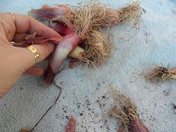
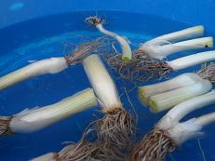
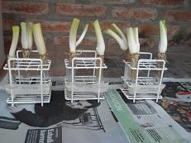
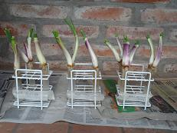
Preparation of onions
Water washing
The onions are placed in test tubes
Days later: Onions in test tubes.

IV.- FIELD TRIP WITH A SMALL GROUP.
The activity is carried out on 21st August 2015 at 16:45.
The main activity is to describe the environment, to collect water samples and to test temperature, turbidity, pH and OD. Then, in the classroom, the bioassay is repeated to assess toxicity.

LOGO DESIGN
A logo will represent not only the work done but also a reminder referred to the World Water Day.

RESULTS
Main findings:
• During the first visit is seen, at first glance, an environment in good condition.
You can see lots of vegetation at the edges, around and in the water. The water is so clear, that you can see fish. The sky is covered with clouds. The room temperature is 15.4 °C.
Regardless water testing we can say that the gutter appears to be a suitable area for recreation.
• During the second visit to the canal ditch, the place is also presented as an environment in good condition. The main difference is related to climatic factors. Days before the second visit it rained (82mm), which caused the channel to look deeper. Despite the different weather conditions, the sky is clear, and there are few clouds. The temperature is 18,5 °C, higher than during the first visit, consequently, the water temperature has increased.

Results obtained:

Water Quality | Results
Water Quality | 13/08/2015 | 21/08/2015
PHYSICAL
Temperature | 18°C | 20°C
Turbidity | >1m | >1m
CHEMICAL
Dissolved Oxygen | 8 ppm | 8 ppm
Percentage of saturation | 84% | 88%
pH | 8 | 8

To compare growth, outbreaks are measured. The following table shows how each of the samples has grown

BIOASSAY | Shoot growth  Water Sample
BIOASSAY | 13-08-2015 | 21-08-2015
Non-toxic environment  - Distilled water  - Water | 2 cm  2 cm | 1,5 cm  2 cm
Toxic environment  - Saturated salt water | 1cm | 0,5 cm
Field of study  - Canal water gutter | 2,5 cm | 2,5 cm
Regarding toxicity, in both bioassays it was found that growth of sprouts onions in water gutter were equally or even better, than in distilled water and tap water; so there is no toxicity in the water.

Finally, after presenting various designs, a logo is chosen with the message to protect the environment, especially water. They choose a drop of water and within it a magnifying glass, indicating that its properties are sought to determine the quality, and a round of children, to leave as a message that everyone, must take care of the environment.
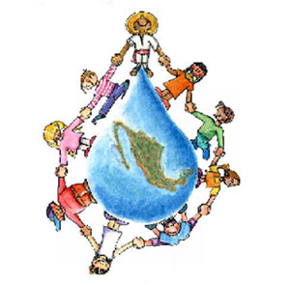
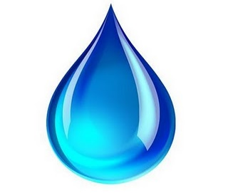


DISCUSSION
To interpret the results, we take into account the water quality standards that were annexed in the theoretical framework. When comparing the values obtained in both visits, we can say that:
- Regarding turbidity, the water is transparent, and there are no suspended solid substances in the water. The temperature is close to that observed in the trout farm, which suggests the existence of aquatic life. Arguably, the quality is GOOD.
- As regards dissolved oxygen and pH, the water presents a GOOD quality.
Depending on its use and taking into account the table shown Escarré (2000) can say that water quality is good.
- The water could be useful through simple treatment.
- For leisure, it could be used for bathing.
- It is suitable for fish growth.
- It can be used for irrigation.
- It could be used in food industries.
Regarding the evaluation of toxicity by bioassay, it was found that the growth of onions is not affected by water quality, indicating a very low probability of toxic chemicals in the water channel ditch. The water has a good quality in terms of toxicity.

CONCLUSION
Taking into consideration the description, analysis and interpretation of the results obtained through observations and tests made in the canal ditch located in the lateral northwest of Pujato, where fifth graders from School 1345 go to play and go fishing, it can be said that water quality during the month of August 2015, is GOOD.
It means that the hypothesis has been corroborated through the various activities carried out, since indicators of water quality and toxicity assessment are reflected.
The limitations in time and the difficulties in conducting the field trips have conditioned the conclusions obtained since we have to take into consideration only two sampling visits to the canal water.
The projection that has been thought is related to the search for temporal and spatial fluctuations in water quality through seasonal analysis. A possible analysis during the rainy season, because flow is related to it, like the effect which temperature causes on this watercourse. It can be said that there is a close connection between the water quality of the ditch channel with the seasons and weather conditions.
A deeper analysis for economic reasons and the age level of the participants were not performed, although there is a possibility for a future research.
It should be noted the importance that the subject has had, the reflections on the need to protect the environment, the development of skills related to the preservation of the local ecosystem and the ideas that were emerging about the need for joint action, especially water care. All this has been revealed in the design of the logo.

BIBLIOGRAPHY
Aquatox 2000. Red escolar internacional sobre la toxicidad del agua. http://archive.idrc.ca/aquatox/aquagifs/home_title_s.gif recuperado el 15 de mayo de 2015.
Biblioteca Virtual d e la Empresa Nicaragüense de Acueductos y Alcantarillados Sanitarios (ENACAL) Enacal. recuperado” el día 4 de agosto de 2015 del sitio http://biblioteca.enacal.com.ni/labiblioteca.html
Decenio Internacional para la Acción "El agua fuente de vida" 2005-2015. Departamento de Asuntos Económicos y Sociales de Naciones Unidas. Recuperado el 5 de agosto de 2015 del sitio http://www.un.org/spanish/waterforlifedecade/quality.shtml
Escarré, Antonio. Equipo Oikos. Ambiente y Sociedad, Buenos Aires. Editorial Santillana, 2000.
Integrantes del Club de Ciencias 136 “Dr. Bernardo A, Houssay” de Pujato (2008) Agua que no has de beber… (2008). Recuperado del sitio web del Programa GLOBE Argentina, http://www.uces.edu.ar/programaglobe/archivos/agua_que_no_has_de_beber.pdf el 12 de agosto de 2015.
Ministerio de Educación de la Nación. Consejo Federal de Educación. (2005). Núcleos de Aprendizajes Prioritarios para el Segundo Ciclo del Nivel Primario.
Ministerio de Salud de Perú. Dirección General de Ecología y Protección del Ambiente (s.f.) Estándares de calidad ambiental del agua. Recuperado del sitio web http://www.digesa.sld.pe/DEPA/informes_tecnicos/GRUPO DE USO3.pdf el 18 de agosto de 2015.
Pica Granado, Y. (Ct.) Serie Autodidáctica de Medición de la calidad del agua, segunda parte. Análisis de toxicidad en el agua. Recuperado del sitio web de CONAGUA Comisión Nacional del Agua del Gobierno Federal de México el 12 de agosto de 2015 http://www.conagua.gob.mx/CONAGUA07/Noticias/AnalisisDeToxicidad.pdf
Programa GLOBE. Guías de Investigación de Hidrología. 2005. Recuperado del sitio web http://www.globe.gov/documents/10157/381040/hydro_chap_es.pdf el 23 de julio de 2015.
Programa Reto Mundial para la Vigilancia del Agua http://www.worldwatermonitoringday.org/
Rodney, D. "Un caso pasado por agua" (2008). Estados Unidos: Federación del Medio Acuático. Recuperado del sitio web del Programa Reto Mundial para la Vigilancia del Agua www.worldwatermonitorday.org/Waterproof_Case_sp-aspx el 24 de agosto de 2015.
Wikipedia. Enciclopedia libre recuperado del sitio http://es.wikipedia.org/wiki/Medio_ambiente el día 4 de agosto de 2015.

When deciding to conduct this study, the terms used to characterize water quality and several classifications are: poor, fair, good and excellent. In another: excessive pollution, poor, fair, good and excellent. Therefore good is used.
Given the school organization, all teachers are in charge of students, no auxiliary. Therefore for the field trip, the group is accompanied by the Director and a substitute teacher. That's why the chances of another field trip is difficult with the whole group by the lack of accompanying teachers.
The next field trip with a smaller group will be on August 22nd, 2015.

