Effect of rust in water
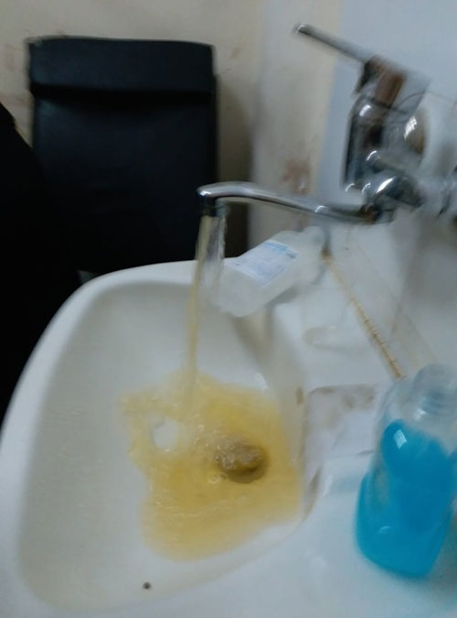

The names of the students: Shawq Alhazmi, Rowena Harbi
Supervised by: Tr. Amina Ahmadi
School leader: Tr. Ihsan Bazumh
School: 24th High School in Makkah
1440- - 2091

Research Summary
It was noticed when opening the water faucet from the pot of water heater in the house change the color of water. Questions were asked about why the color of the water and whether this variable water suitable for human! . Therefore, research was conducted to determine the validity of the use of water affected by rust-colored Water is a natural resource that exists in nature in limited quantities. Its distribution is linked to various factors such as climate, the extent of the earth's storage capacity, the natural resource availability and its irregular distribution in space and time makes it a natural heritage.
The importance of water is due to its association with human civilizations throughout history; Most of the Kingdom's cities rely on renewable surface, deep groundwater and seawater desalination plan
compare (for pure water, rust - colored water, for water that has been nominated) in terms of several faces when proven temperature and volume
The tests have shown that rust has changed the color of the water . Rust will not harm our health if it is in small quantities but If it is in large quantities and at intervals of time spaced, it may lead to kidney problems may reach kidney failure, stomach problems, colic severe pain, facial pallor and circulatory problems which is one of the leading causes of cancer may become part of the water coming to our homes, and can enter iron into drinking water by pipe wells.
Rust-stained water is often contaminated because water pollution is any changememt of natural qualities in the water by adding any strange substances that cause it to be disturbed or to gain color, smell or taste
Therefore, it is recommended to do periodic maintenance of the heater to remove the sediment and put the filter device and adjust the heat of the heater.

Keywords: water, rust, heater

Research questions | 1
Introduction and Hypothesis | 2,3,4
Materials and Methods of Notes | 5
Analysis, Conclusion and Discussion | 6
Thanks and Appreciation | 7
References | 8
Table of contents

Research Questions
- Is water contaminated when there is rust?
- What is the normal amount of rust in our water ?
- What is the difference between rust-colored water before and after filtration ?

Introduction
Water is one of the most important elements on which the planet is based, accounting for 71% of the Earth's surface area. It is a chemical compound composed of two atoms of hydrogen and one atom of oxygen, and it is liquid, tasteless, color and odor. Water has three cases: liquid in the form of oceans, rivers, seas, lakes, springs, and rain, the most common condition on the surface of the earth as the liquid state is responsible for biological processes within living organisms. Solid state in the form of snow and ice sheets. Gaseous state such as the water vapor present in the atmosphere whch causes the phenomenon of convection
It is a natural resource that exists in nature in limited quantities, and its distribution is linked to various factors: climate, the extent of the earth's storage capacity, the natural resource and its irregular distribution in place and time makes it a natural natural heritage;
The importance of water is related to the human civilizations throughout history; the presence of water sources. The story of the well of Zamzam, which contributed to the influx of tribes and their settlement in a non-planted valley in Makkah. Water sources are a major factor in the establishment of national and peoples' citizens on the surface of the earth. It is an indispensable prerequisite for any comprehensive development. Most of the Kingdom's cities rely on renewable surface, deep groundwater and seawater desalination plants. It was noticed when opening the water faucet from the pot of water heater in the house change the color of water, questions were asked about why the color of the water and whether this variable water color suitable for human! . Therefore, research was conducted to determine the validity of the use of water affected by rust (rust-colored) Rust is defined as a red substance that is brownish on the surface of a solid iron when exposed to wet air. The oxygen gas present in the water acts to react with iron and to form iron oxide or rust.

Hypothesis
When there is rust with water, is the water contaminated or not?
Experiment Method
Tools 1-
Cup - Spherical flask - Suppression - Filter paper
2-Devices:
Electrical conductivity measuring device - pH measurement device and temperature - Oxygen and nitrate concentration tubes
Steps of the experiment
Sample (1)
Place the pure water in the cup
Taking measurements: pH (temperature) - temperature - electrical conductivity concentration of nitrates - concentration of oxygen
Sample (2)
- The colored water is rusted in the cup
- Taking measurements: pH (temperature) - temperature - electrical conductivity - concentration of nitrates - concentration of oxygen
Sample(3)
- Fold the filter paper properly and place it in the funnel.
- Place the funnel inside the ball beake.
- Stained water is rusted by 600 ml.
- Wait 30 minutes for filter paper to be filtered .
- Taking filter water measurements (PH - temperature electrical
conductivity-concentration of nitrates concentration of oxygen.

Sample (4)
The comparison between pure water, water stained with rust, water that was nominated in terms of several faces when proven temperature and size and the results were as follows:
Comparisons | Pure water | Stained water | Water is nominated
transparency | transparent | non transparent | Transparent
Commission degree | 8.9 | 8.9 | 8.6
Electrical conductivity | 155 | 184 | 188
Concentration of oxygen | 6 | 6 | 4
Concentration of nitrates | 0 | 0 | 0
4

Comparison of rust water and water without rust

1-1 measure (PH) 1-2 Measurement of electrical conductivity 1-3 Nitrate measurement

1-4 Oxygen measurement 1-5 filter the rust of water

Analysis and discussion
It was found that the rust is a heterogeneous solution and that when the temperature and volume were confirmed, the effect of rust on the water in a number of changes, including color change, oxygen ratio and electrical conductivity. When filtering the rusted water, we found that the rust ratio was 77% through equation (2.88-2.11 = 0.77, 0.77 × 100 = 77%} This ratio is large .
Conclusion
After testing and researching , we found that the rust caused the water color change, rust will not harm our health if in small quantities either in large quantities and at intervals of time spaced, may lead to kidney problems may reach kidney failure, stomach problems, colic severe pain, facial pallor, circulatory problems which is one of the leading causes of cancer, may become part of the water coming to our homes, and can enter iron into drinking water by eating iron or pipe wells
Rust-stained water is often contaminated because water pollution is any change of natural qualities in the water by adding any strange substances that cause it to be disturbed or to gain color, smell or taste
Therefore, it is necessary to maintain periodic circulation of the heater to remove the sediment and put the filter device and adjust the heater temperature

Thanks and appreciation
Finally, we would like to thank everyone who helped us to reach this successful stage of our lives. Thank you very much to our families and friends, Hadeel Dabwan , Professor Maryam Bawazeer and Environmental Globe Professor Amina Al Ahmadi. Special thanks to the leader of this educational edifice, Ms. Ihsan Bazoumh

References

1- The book of the Arab World Encyclopedia, 10, letter Y, page number: 77
http://libback.uqu.edu.sa/hipres/futxt/16799.pdf 2-
http://scifun.chem.wisc.edu/homeexpts/TARNISH.html 3-
https://www.thoughtco.com/how-rust-works-608461 4-

