Project Title: SPOT THE STARS TO PROTECT THE DARK SKIES
Topic in which the entry is submitted: Light pollution and using constellations to measure it

Team Name: Astrophiles
Abstract

The light pollution is ecological (it influences the biodiversity), energetic, economical, astronomical problem. The light pollution is wrongly directed or abused light which is generally a result of the inappropriate use of the external lighting. Through history people looked at the stars trying to understand the events around them, but today it is a real privilege to see the Milky Way. The ecological effects on the biodiversity causes fast disappearing of the ecosystems and species extinction.
With Globe at night program (GaN) we have opportunity to get to know not only the light pollution, but also it’s measuring in a relatively simple way using constellations. GaN is part of the GLOBE project which is a worldwide scientific and educational project, which coordinates the work of students, teachers and scientists to study and understand the global environment .
Under this project, we have carried out measurements of light pollution by measuring the brightness of the sky in an urban environment (Prilep) and rural (rural settlement Novo Selo). These two areas differ in the number of residents, in altitude and climate. By comparing the measurements we extracted conclusions presented in this paper.
We have estimated the light pollution by measuring the limiting magnitude of stars from the constellation Orion and Perseus and additionally we have used the Sky Quality Meter to map a city and village at different locations with intention to identify dark sky oases.
With these activities we want to turn attention to the problem of light pollution which at first glance does not seem so, but in fact is a very serious problem. The solution is in all of us, or the more people know about the harmful effects of light pollution overall fauna and flora, and humans, so it would be better for all. I.e. all together we can change things for better.

Key Concept of the project

The man found various artificial light sources and thus today we have big advantages at night for learning, fun, freedom of movement and so on. But are all light sources properly positioned and whether they are intended for rational lighting? The answer is no. And, because of that we all are faced with the problem of light pollution. But what is it?
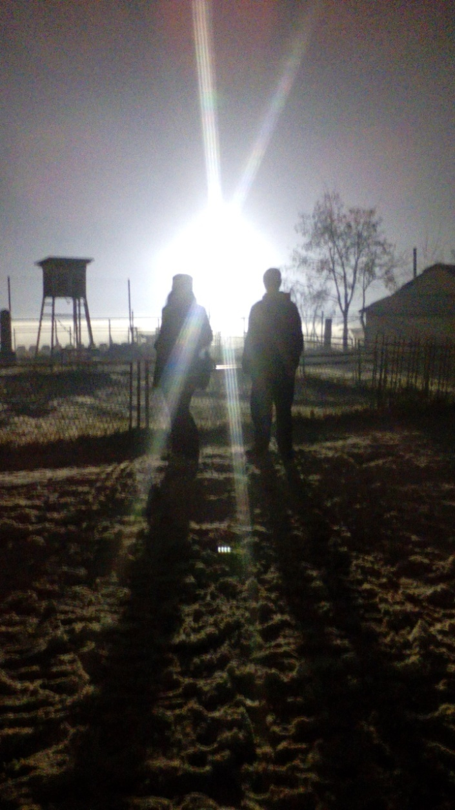
Light pollution is the illumination of the night sky caused by artificial light sources on the ground (streetlights, billboards, etc.). And how light can truly pollute? Someone rightly might think it sounds strange!? But what is the truth? Light pollution actually is a side effect of industrial civilization.The amount of outdoor lighting increases as a result of the increasing of the population. Using lights at night can be helpful, but there are unanticipated effects. Furthermore, light pollution can bring to a negative effect to the total plant and animal life, as well as the human.
Actually there are three main types of light pollution glare, light trespass and skyglow (in addition to over-illumination and clutter). Glare light scattering in the eye causes loss of contrast, sometimes blinds you temporarly and leads to unsafe driving conditions, for instance. Glare - when there is a lot of light in the background. Can you see clearly the faces of the people who stand in front of the reflector that is too illuminated (Fig. 1)?

Fig. 1

Light trespass occurs when unwanted light enters one’s property, for example, by shining unwanted light into a bedroom window of a person trying to sleep. (Fig.2)

Sky glow refers to the glow effect that can be seen over populated areas. Sky glow is the combination of all the reflected light and upward-directed (unshielded) light escaping up into the sky (and for the most part, unused). …Shielding lights significantly reduces all three of these types of light pollution. The phenomenon sky glow, as a type of light pollution, appears when all the public city lights are directed toward the sky where the rays of light in the atmosphere scatter and reflect from the aerosols back toward the ground. (Fig. 3) [10]
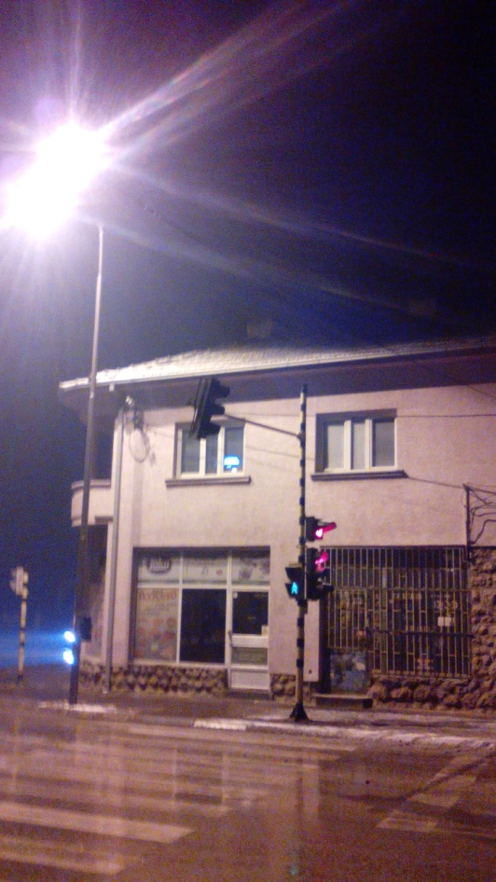

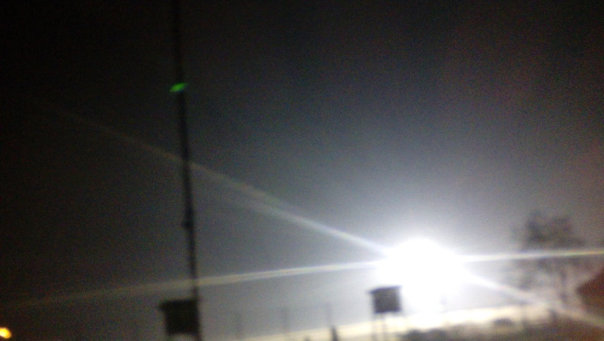
Fig: 3

So the biggest problem astronomers have precisely with this type of light pollution, because simply the stars are not visible. They/We all can’t see the stars. I.e., that is a big problem.

Fig: 2
Too much light pollution has consequences: it washes out starlight in the night sky, interferes with astronomical research, disrupts ecosystems, has adverse health effects and wastes energy. Men have artificially lit up everything that has come their way. As a result, today it is practically impossible for us to see the stars. We have been taken away our right of the stars, of nature. The “Milky Way” for us only exists in the fairy tales, because we cannot see it.
But there is a solution. By participating in the citizen-science campaign, Globe at Night (GaN), and taking as many measurements as we/you can do from different locations, we may promoting awareness and helping to monitor light pollution levels locally. And exactly we do that. The worldwide database is used to compare trends over years and with other data sets (like on animals) to see what effects light pollution has on them. If we know to ,”read” or spot the stars (in the constellation Orion for instance), they can tell us a lot about light pollution. These are actually very interesting activities and in the same time very useful and very important for environment. We fight to bring back the dark skies. Light at night - yes, but where we need and when needed.

Methodology for implementation

The Globe at Night program is an international citizen-science campaign to raise public awareness of the impact of light pollution by inviting citizen-scientists to measure their night sky brightness and submit their observations to a website from a computer or a smart phone. The citizen scientists in 102 countries participated in GaN in 2014. And they submitted their data in 22 different languages. What actually we need to do? There are 5 or 6 easy steps to “catch” the stars:

- Finding our constellation in the night sky;
- Finding the latitude and longitude of the location where we are making the observation;
- Going outside more than an hour after sunset (8-10 pm local time);
- Matching our observation to one of 7 magnitude charts and note the amount of cloud cover;
- Using the sky quality meter (SQM) to measure sky brightness;
- Sending data.

We have used constellation Orion in the campaign which was held from 1st to 10th of January 2016th. On the web site of GaN project and we learnt interactive how to find the constellation Orion but previously of the resources on the same web page we learned about the constellation Orion.
Orion resembles a person. First of all we saw the belt of Orion, formed of three bright stars set in a straight line. One of the “legs” of Orion is the bright star Rigel, one of the brightest stars in the night sky. Bellatrix and Betelgeuse are “the shoulders of Orion”. Betelgeuse serves as “the right shoulder” of Orion and it is the eighth brightest star in the night sky, it is a red star which can be seen with a naked eye. This constellation is remarkable and very easy to spot. Very helpful was activity Orion at your fingertips from Dark Skies Rangers program that provides ways to visualize the problem of light pollution etc. [1, 6]
Also we have used constellation Perseus in December (from 2nd to 11th) 2015th to spot the stars.
Perseus the slayer of Cetus is most easily seen rising in the East in the winter. The constellation is most easily identifiable as what almost appears to be a wishbone of brightest stars, with the brightest being the center and chest of Perseus. The legs of Perseus are pointing southward and are the forked part of the wishbone and the body and head are the straight line leading up northward. It is easy to find Perseus by either looking southward from Cassiopeia or just to the left of Taurus the Bull. [2]
For finding the latitude and longitude, we have used also web site of GaN project and smart phone.[3]
The observations take place outdoors, in the evening, and after sunset (from 8p.m. to 10p.m.). The night sky should be clear before the Moon is set too high, and the sunset occurred at least one hour ago. Otherwise, the glare from the Sun and the Moon will affect the observation.
We made our measurements at the specified time, so that we measured at two locations: 1. - in the city of Prilep (urban environment) and 2. - in the village of Novo Selo [near town of Strumica], (rural environment) away from Prilep 150 km in our country Macedonia. At both locations by us have been made more measurements in different places, and we compared all the results.
From GaN’s web site we have used magnitude charts of Orion and Perseus , which has be seen in the Fig. 4 and Fig. 5, bellow.[4, 5]

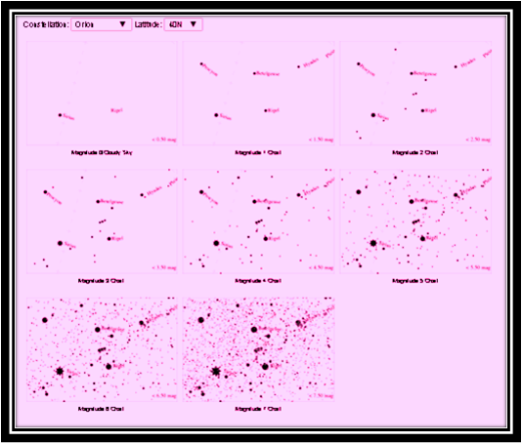

Fig. 4. (Magnitude charts of Orion)

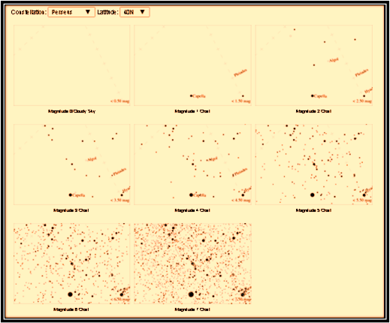

Fig. 5. (Magnitude charts of Perseus)

The measurements conducted using the SQM (Fig. 6) bring to a new prospective in the Globe at night program - the participants in the Globe at night program gain scientific experience, as well as the measurements are more precise.
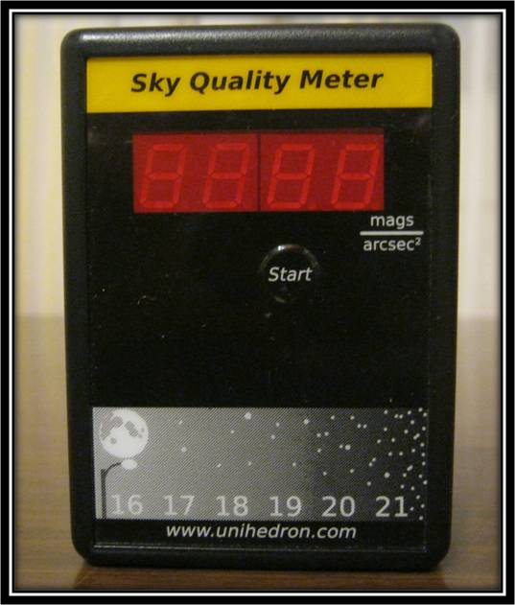
The SQM is influenced by the outdoor’s temperature, thus it is better to leave it outdoors at least for 5 minutes to adjust to the temperature and then to continue with the observation. The SQM should be held above the head pointed towards the zenith, so that the shadow or the reflection of the observer would not influence the observation. Also the instrument should be held firmly, without moving or shaking. The button should be pressed only once in order to start the observation. The SQM will beep every second while collecting the photons. The observation is finished after the last beep, and then the display should be read. [9]
Fig. 6
Under the urban sky (in urban areas) the result is shown almost immediately. When the sky is very dark the results appear after a minute or more. Also, the constellation Orion should be observed without an instrument in order to distinguish the magnitude (according to the magnitude graph).
To complete the procedure the serial number of the instrument is required; it will appear if the start button is pressed for one second. Firstly the temperature appears in ºC and ºF, secondly the result from the observation, and thirdly the serial number of the instrument. [9]
To sum up, the following data is required for the observation to be complete : date of the observation, local time, longitude and latitude, the result shown on the SQM’s display, the SQM’s serial number, comment on the location, comment on the sky quality etc. Multiple observations can be conducted varying in dates and locations. And our observations and measurements last all year long. With our continuous observation we hope that we would contribute to the campaign against light pollution.

Within this project we did an experiment:
The light pollution can be successfully demonstrated by a cardboard box that has holes and a flashlight. The demonstration is conducted indoors (in a room with low ceiling, but not necessarily). The lights in the room should be turned off and the stars should be projected from the cardboard on the ceiling, using only one flashlight. Then we can see the “stars”, their visibility and their brightness. (Fig. 7)
The second flashlight is used as a street lamp set on the desk in front of the landscape. After we turn this second flashlight on, we observe the stars again. Can you notice any difference? Is the number of the stars the same? When the second flashlight is turned on number of “stars" of the ceiling will be reduced due light pollution. (Fig. 8)
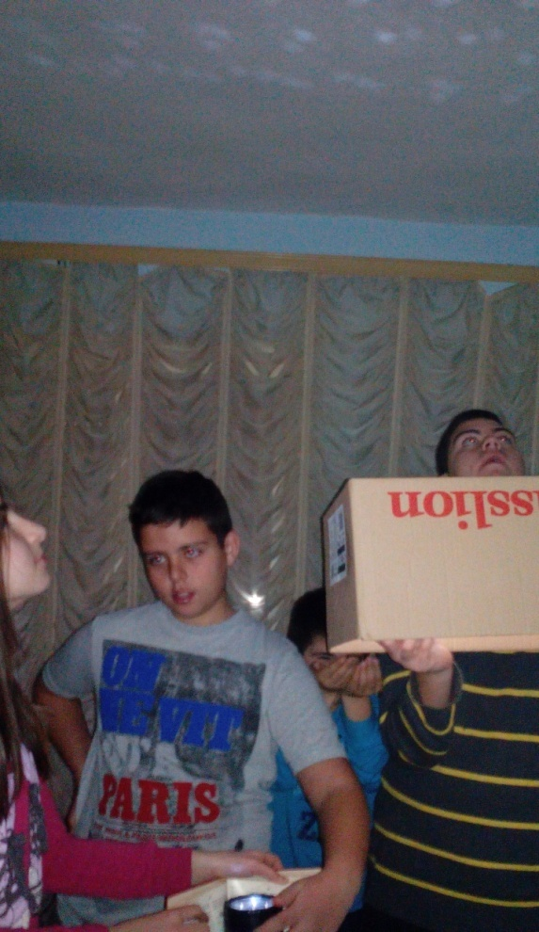

(Fig. 7) and (Fig. 8)
Social Relevance

The struggle with the problem of light pollution includes different types of experts and researchers, but they emphasize that necessary is a global solution and help from many people.
The light pollution destroys the view to the sky in which the man has enjoyed ever since the beginning of his existence. We are obligated to give away the night sky as a cultural heritage to the next generations. The light pollution is a threat to humanity, because it is connected to some serious diseases and disorder in ecological balance. The light pollution spends amazing amounts of natural resources so that it pollutes the air we breathe with the unnecessary production of electrical energy which uses fossil fuels. The air pollution is a serious problem which has negative impact on a big number of people. Because of that many countries in the world undertake many measures to save the night sky and to treat this problem. The world-famous scientists who research this problem use the results of our measurements.
In some countries in the world already has a law on the protection of the night sky. Unfortunately our country is not among them. With our measurements we are calling attention to this problem and we can do a lot. And we are aware that we need to think globally but act locally. If for example we get international recognition for our work then we can turn our attention to the competent, first in our municipality, and then in our country. On the sky there aren’t limits. We are all citizens of the world and deserve a dignified place to live and healthy environment.

Sustainability

Pollution is the process of making land, water, air or other parts of the environment dirty and unsafe or unsuitable to use. This can be done through the introduction of a contaminant into a natural environment, but the contaminant doesn't need to be tangible. Things as simple as light, sound and temperature can be considered pollutants when introduced artificially into an environment [7].
Most people can't imagine living without the modern convenience of electric lights. For the natural world, though, lights have changed the way that days and nights work. Some consequences of light pollution are:
- Some birds sing at unnatural hours in the presence of artificial light.
- Scientists have determined that long artificial days can affect migration schedules, as they allow for longer feeding times.
- Streetlights can confuse newly hatched sea turtles that rely on starlight reflecting off the waves to guide them from the beach to the ocean. They often head in the wrong direction.
- Light pollution, called sky glow, also makes it difficult for astronomers, both professional and amateur, to properly see the stars.
- Plant's flowering and developmental patterns can be entirely disrupted by artificial light.
- According to a study by the American Geophysical Union, light pollution could also be making smog worse by destroying nitrate radicals that helps the dispersion of smog.
Turning on so many lights may not be necessary. Research published by International Journal of Science and Research estimates that over-illumination wastes about 2 million barrels of oil per day and lighting is responsible for one-fourth of all energy consumption worldwide. [7, 8]
We hope that we will present our results to the public to show ways to dealing with light pollution. Because the more people know about this problem - so it would be better for all. And we will have great contribution to a healthy environment.

Findings and conclusions

Produced data from observations and measurements are presented below in tables and images from the maps with marked points.

Table 1 (Data from measurements done in December 2015)
N⁰ | Date | Local time | Longitude | Latitude | Magnitude/Constellation | SQM-L value (mag/arc sec²) | Comment on location | Comment on the sky and cloud coverage
1 | 02/12/2015 | 21:30 | 21.5611 | 41.3446 | 3/Perseus | 16.79 | Urban location | Cloud cover: > 50%
2 | 04/12/2015 | 20:10 | 21.5555 | 41.3348 | 3/Perseus | 18.17 | Urban location (Prilep brewery) | Clear sky
3 | 04/12/2015 | 21:31 | 21.567 | 41.3515 | 4/Perseus | 18.56 | Urban location. There were three lights on distance about 80 m away from my location. | Some clouds on the sky, but constellation Perseus is visible.
4 | 05/12/2015 | 20:10 | 21.5631 | 41.3461 | 4/Perseus | 17.89 | Streetlights on distance about 50 m. | Cloud cover: 25%. Perseus is visible but I can see very few stars on the south
5 | 05/12/2015 | 20:50 | 21.5478 | 41.3433 | 1/Perseus | 18.32 | Urban location. There are 2 street lights 50 m away. | Cloud cover: 50%.  Clouds and Haze. But constellation Perseus is visible.
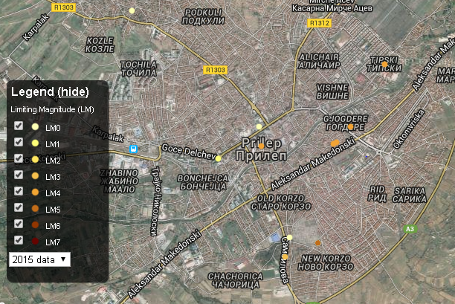
Fig. 9. (Map with measurements done in December 2015 with constellation Perseus)

Table 2 (Data from measurements done in January 2016 with constellation Orion in Prilep)
N⁰ | Date | Local time | Longitude | Latitude | Magnitude/Constellation | SQM-L value (mag/arc sec²) | Comment on location | Comment on the sky and cloud coverage
1 | 01/03/2016 | 21:04 | 21,534963 | 41,348867 | 1/Orion | 18,35 | Near High School Riste Risteski Richko. There are lights from the buildings that are close in the opposite site of the school. Also here is snow cover about 4cm. | Cloud cover:50%.  Clouds types:cumulonimbus, altostratus.
2 | 01/03/2016 | 21:14 | 21,536272 | 41,350872 | 2/Orion | 18,45 | Our location is near the Elementary School Blazhe Koneski in Prilep. This is relatively dark location. | Cloud cover is about 25%. Some cloud from south-west, but we can see the stars on the sky.
3 | 01/04/2016 | 21:10 | 21,558201 | 41,343655 | 0/Orion | 16,68 | We are near the Church Holly Metamorphosis in Prilep. There are few lighs, but they are on distance 80m. | Tonight is raining and we can’t see the stars.  Cloud cover is >50%.
4 | 01/04/2016 | 21:50 | 21,561677 | 41,341005 | 0/Orion | 16,11 | Near the playground for children.Thereare streetlights on distance 30m, and faint lights from the nearby houses. | Rain and clouds-we can’t see the stars.  Cloud cover is >50%.
5 | 01/05/2016 | 21:30 | 21,554790 | 41,343502 | 0/Orion | / | Urban location-near the city river. | It is raining. The sky is fully covered with clouds.  Cloud cover is >50%.
6 | 01/07/2016 | 21:20 | 21,552837 | 41,345838 | 3/Orion | / | Urban location near the park in Varosh that is part of city of Prilep. | Cloud cover is 25%.
7 | 01/10/2016 | 21:30 | 21,565904 | 41,334351 | 4/Orion | / | Urban location | Cloud cover is 25%.

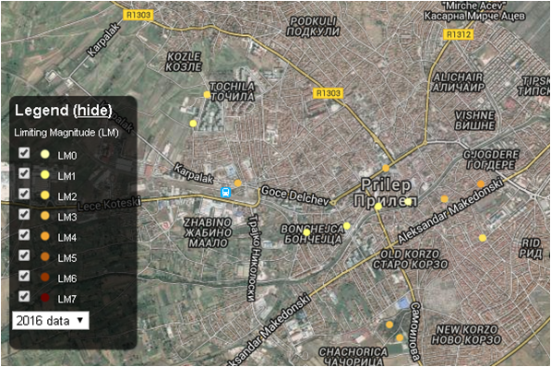
Fig. 10. (Map with measurements done in January 2016 with constellation Orion in Prilep)

Table 3 (Data from measurements done in January 2016 with constellation Orion in Novo Selo)
N⁰ | Date | Local time | Longitude | Latitude | Magnitude/Constellation | SQM-L value (mag/arc sec²) | Comment on location | Comment on the sky and cloud coverage
1 | 06/01/2016 | 21:30 | 22,881131 | 41,411627 | 0/Orion | 16,69 | Rural location-in the village of Novo Selo at Market place. | Cloud cover.50%.Raining.
2 | 07/01/2016 | 21:58 | 22,881793 | 41,412379 | 4/Orion | 17,81 | Rural location. There are a few faint lights on distance 50m. | The sky is clear and orion is visible.
3 | 07/01/2016 | 20:51 | 22,883470 | 41,416100 | 4/Orion | 18,01 | Rural location, near the Church in village Novo Selo. | Clear sky.
4 | 07/01/2016 | 20:35 | 22,876453 | 41,415167 | 3/Orion | 17,74 | Some streetlights on distance 50 to 60m. Our location is near the Petrol station i.e. on the opposite site of it. | Clear sky. Orion is visible.
5 | 08/01/2016 | 21:50 | 22,881228 | 41,412166 | 5/Orion | 20,16 | Rural location near the Market place in Novo Selo. | Clear sky. Orion is visible.
6 | 08/01/2016 | 22:00 | 22,881726 | 41,412340 | 4/Orion | 17,86 | Rural location near the Primary School Kliment Ohridski.There are many streetlights near here. | Clear sky.
7 | 08/01/2016 | 21:39 | 22,881346 | 41,411176 | 4/Orion | 17,62 | In the central area of the village of Novo Selo. There are many lights (streeear’s lights) | Clear sky
8 | 08/01/2016 | 21:22 | 22,881067 | 41,415597 | 5/Orion | 19,44 | Rural location.Here are one streetlight on distance 40m from us. | Clear sky. Orion is clearly visible.
9 | 08/01/2016 | 22:10 | 22,885476 | 41,410613 | 7/Orion | 20,62 | Rural location | Clear sky full with stars and magnificent view. Simple beautiful.
10 | 09/01/2016 | 21:35 | 22,881244 | 41,412017 | 6/Orion | 19,79 | Rural environment | Clear sky. Many stars on the sky
11 | 09/01/2016 | 20:40 | 22,880858 | 41,415279 | 7/Orion | 20,34 | Rural location. No lights near here. | Clear sky
12 | 10/01/2016 | 20:25 | 22,884350 | 41,416271 | 7/Orion | 20,21 | Rural location. We are in dark area. | Clear sky-full with stars.

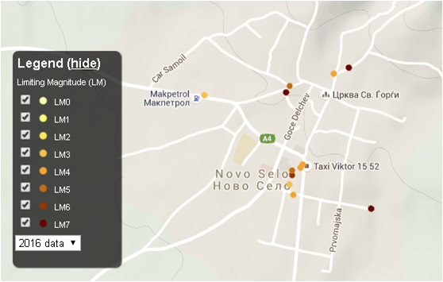

Fig. 11. (Map with measurements done in January 2016 with constellation Orion in Novo Selo)

The marked points on the map represent the observation of the illuminated night sky, the lighter the point the lighter the sky is, the darker the point the darker the sky. The lightest point (magnitude 1) can be seen over the major cities. There, only a few stars are visible in the night sky. The darkest point (magnitude 7) can be seen over a national park for example, where there aren’t any city lights. Then, there are a lot of stars (14 000) and it is difficult to tell the constellations apart.
From the produced data we concluded that light pollution in the city of Prilep is present, as well as three types of light pollution. Judging by magnitudes in Prilep we can’t measure higher value of 4, and this situation is very rare. It mostly means the city has too many bulbs that are improperly placed and vainly wasted energy, and probably has harmful consequences for animal and plant life. As a result of our research we can say that in the city of Prilep Skyglow phenomenon is present and we can’t enjoy watching the stars because they are in small numbers and poorly visible. Also and the other two types of light pollution (glare and light trespass) are not seldom.
But, from our measurement taken at the village Novo Selo we can conclude that situation is opposite because predominantly are represented magnitudes 4, 5, 6 and even 7 mainly on the periphery of this rural environment. From the results of the measurements remarkable is that the values of SQM the luminosity of the night sky in Novo Selo are higher than those measured in Prilep, and it means that in rural environment light pollution is very low. Even we can say that rural areas haven’t concerning level of light pollution. There are breathtaking views.
So if in the city of Prilep upper limit of magnitude is 4, in the village of Novo Selo it is the lower limit.
Now, from our experience we can conclude that protection of night sky can be done if:
- all external lighting use fully shielded fixtures that minimize impact on nocturnal environments;
- exterior lights on homes haven't glare into public view or neighbouring property;
- we use low-energy bulbs, low-light, three-watt LEDs that run on solar power;
- we use “downlighting” instead of “uplighting” - both inside and out;
- we minimize light loss at home by closing the curtains or blinds;
- we contribute to turning a park or public land into a Dark Sky Preserve. These specially designated areas raise awareness about light pollution and create protected space for science, education and the nocturnal cycles of nature and animals.

References

[1].http://www.globeatnight.org/resources/GaN2015_ActivityGuides_English_N/GaN2015_ActivityGuide_Orion_N.pdf

[2].http://www.globeatnight.org/resources/GaN2015_ActivityGuides_English_N/GaN2015_ActivityGuide_Perseus.pdf
[3].http://www.globeatnight.org/lat-long.php
[4].http://www.globeatnight.org/magcharts/perseus
[5].http://www.globeatnight.org/magcharts
[6].http://www.globeatnight.org/dsr/dsee/Dark%20Skies%20Activities/Constellation%20at%20Your%20Fingertips%20Activity/Constellation_at_Your_Fingertips-Orion.pdf
[7].http://www.livescience.com/22728-pollution-facts.html
[8].http://www.ijsr.net/?gclid=CJvs--jZncoCFVQaGwods_oBKw
[9].http://www.globeatnight.org/fsl/pdf/GaN/GaN_using_the_SQM.pdf
[10]. http://www.globeatnight.org/light-pollution.php

