Water Dispenser Kit Mimic the rain

Researcher Mr. Adisak Chantachai, Miss Jeeranan prommee
Level upper secondary
Teacher Mr. Chumpon Chareesaen,
Donchanwittayakom school kalasin Thailand
abstract
If number of bottles increased moisture in soil will increased. But compared to the information provided That said, the soil moisture level is beneficial to plants.34% found that providing 4 bottles of water. Soil moisture is close to the water requirement of plants.So the researchers used 4 bottles of water. When measuring soil properties grown from different experiments. Found at 4 weeks Soil properties from ground cover with coffee residue.At 15 grams, soil properties are most suitable for horticulture.The pH value was 5.8. Medium nitrogen, medium phosphorus and medium potassium.The ratio is then used in the kit to mimic the rain.Give water plants in different ways. Use of gardening equipment to imitate rain. Less water is used than watering. It can save water up to 1,260 cubic centimeters. 60%
When measuring soil moisture from watering plants in different ways. Irrigation with garden irrigation equipment imitates precipitation. The soil moisture is close to. Watering using a watering can Soil moisture content was only 15.07 ± 1.37. When giving water in different ways. Irrigation with garden irrigation equipment imitates precipitation. And watering by using a watering lotus. Tomato growth is similar. If we do not give water, tomato plants can not live.Use of gardening equipment to imitate rain. Can be used for gardening. It is based on the principle of rain together with the mulching of coffee grounds. Water is less than watering using a watering can. And can save water up to 1,260 cubic centimeters. 60% of soil moisture content. It is close to watering by using a common watering can. To give water to the tomatoes at the age of one month, the height and width of the sheath is similar.

Introduction
In Donchan District’s area face drought problem. The soil can’t absorb moisture,and farmer always grow plant which use a lot of water.Wateringof farmer will made waterevaporate from soil,it's a waste of water.In school and community, people have been buying bottles of drinking water. Then they will leave or burn them,that became pollution. From observation. The bottles that still have a little of water and take a heat, water will evaporate and condense become water again and happens again. Farmer in this area will cover soil with straw, dried leaves. From observation. In this area there are a lot of rain tree leafs. The leaf sessential soil nutrients for plants. From researching, bringing bottles to invent equipmentfor water plant. When the bottles take high temperature the particle of them have shrunk. Moreover, it also save water and useful from using rain tree leafssheet to cover soil, the sheet can increasedthe soil nutrients, and reduce using chemical fertilizer.
Objective.
- Invent equipment for water plant like raining.
- Research quality of equipment for water plant like raining.
Hypothesis.
Equipment for water plant like raining can save water more than watering of farmer.
Variables in researching.
Part 1. Research for quantity of moisture from equipment which has different quantity of bottles
First variablequantity of watering bottles
Second variablesoil moisture
Controlling variables bottles size and surrounding
Part 2. Invent cover soil sheet for use with the equipment.
First variable quantity of coffee ground
Second variable soil property
Controlling variables soil quantity, water and surrounding
Past 3. Testing quality of equipment for watering plants like raining.
First variable watering form
Second variables water quantity, soil moisture and plants grown
Controlling variables plants type, growing location and surrounding
In researching of equipment for water plant like raining have divided experiment for 3 steps as follows
Part 1. Research for quantity of moisture from equipment which has different quantity of bottles
Step to invent
- Cut bottle’s bottom that size 1.5 liter, then drill bottle at aside two hole with cutter which is different point and far from soil for 10 cm. . Cut inside bottle to be quadrate size 5x5 cm. .
- Drill black cup that high 15 cm. to be far from soil for 5cm. .
- Cut rubber tube for 15 cm. , then assemble it with cup and stick by glue for keep out leakage.
- Insert rubber tube which has already assemble into the bottle, then pull it out as picture.
- Assemble like last step for 3 form as 2, 4 ,6 and 8 bottles. Then connect to float system.
- Measure moisture in soil each experiment. Compare moisture in soil for conform to information of Ka-samsriSubson (1998), who said ‘ properlymoisture level for pants is 34% to use in next experiment.
Part 2. Invent cover soil sheet for use with the equipment.
Instrument to make cover soil sheet.
- Thoroughly grind rain tree leafs, then space out to dry. Mix grind leaf for 150 g. with coffee ground andcooked doughwhichin ratio
5 g. : 150 ml. : flour 10 g. , stir and fill into plate size width x long x high as 25 x 25 x 0.9 cm. then space out.
- Make again but change quantity of coffee ground from 5 g. to 10, 15 and 20 g.
- Cut cover soil sheet to circle and take to test affecting to soil.

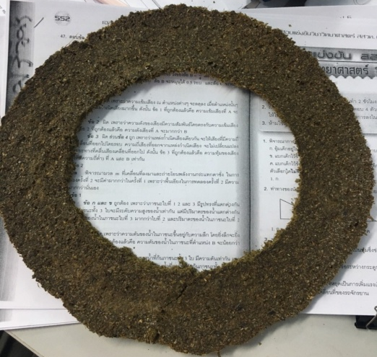

Testing cover soil sheet.
- Put soil for 5 Kg. in pot that has already measure property for 15 pot. Then string for 3 row by drawing lots and mark under pot.
- Water plants for 500 cm³ daily for 4 week. Measure nutrient in soil as nitrogen, phosphorus, potassium and pH value , record result and choose an appropriate experiment for plants touse with Equipment for water plant like raining

Step to test Equipment for water plant like raining
- Assemble part 1‘s equipment with cover soil sheet then test quality.
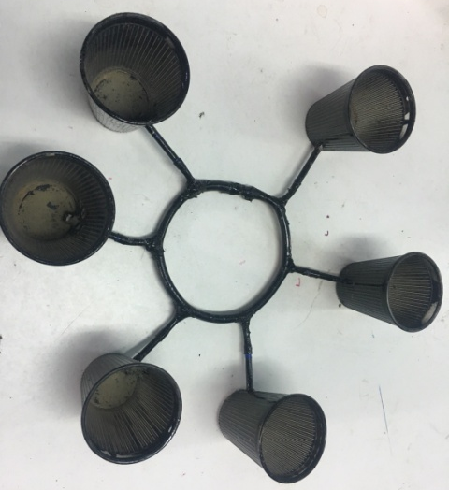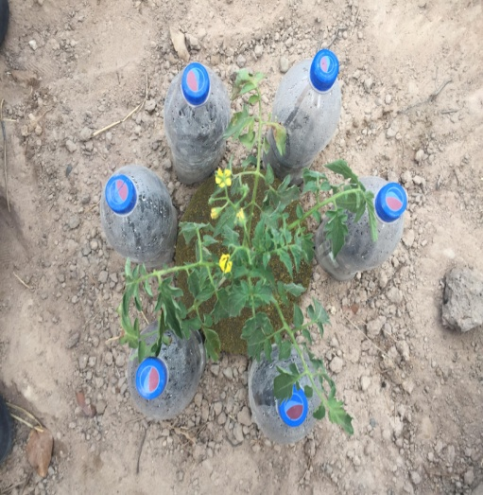

Past 3. Testing quality of equipment for watering plants like raining.
- Growtomato for 9 stems, then test the experiment.
Group 1 stem 1, 5 and 7 water by saving watering equipment.
Group 2 stem 2, 6 and 8 water by watering pot.
Group 3 stem 3, 4 and 9 don’t water.
Only water group 1 and 2, group 2 water on morning at 08:30 AM and evening at 16:30 PM per 100 cm³ and record volume using water every day.
- When complete week, measure soil moistureand growing of tomato stem then record result.
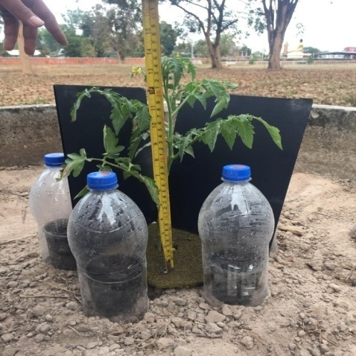
Researching Equipment for water plants like raining has result as follow.
Part 1. Research for quantity of moisture from equipment which has different quantity of bottles
test | Soil moisture(%) | Average moisture content per bottle(%)
2 bottle | 19.23 | 9.62
4 bottle | 38.74 | 9.69
6 bottle | 54.64 | 9.11
8 bottle | 74.53 | 9.31
No bottles | 7.54 | 7.54
From the table. If number of bottles increased moisture in soil will increased. But compared to the information provided That said, the soil moisture level is beneficial to plants.34% found that providing 4 bottles of water. Soil moisture is close to the water requirement of plants.So the researchers used 4 bottles of water.

Part 2: Fabrication of the mulch for use with watering devices.
Table 11 shows the soil properties before and after mulching.
test | Properties soil
 | pH | N (degree) | P  (degree) | K (  degree)
Pre-trial | 7±1.17 | Very low | Very low | Very low
After trial | 7±1.23 | Very low | Very low | Very low
After using 5 grams of coffee residue | 6.5±0.37 | Low | Very low | Low
After using 10 grams of coffee residue | 6.3±0.54 | moderate | Low | Low
After using 10 grams of coffee 15 residue | 5.8±0.14 | moderate | moderate | moderate
After using 20 grams of coffee residue | 5.2±.02 | high | moderate | moderate
From table to table. When measuring soil properties grown from different experiments. Found at 4 weeks Soil properties from ground cover with coffee residue.At 15 grams, soil properties are most suitable for horticulture.
The pH value was 5.8. Medium nitrogen, medium phosphorus and medium potassium.The ratio is then used in the kit to mimic the rain.

Performance testing
Table 2 records the amount of water used for irrigation in different ways.
Irrigation model | Amount of water used (Cubic centimeters)
Gardening Equipment | 840
Watering using a watering can | 2,100
From table to table. Give water plants in different ways. Use of gardening equipment to imitate rain. Less water is used than watering. It can save water up to 1,260 cubic centimeters. 60%
Irrigation equipment Watering with a watering can

Table 3: Measurement of Soil Moisture by Irrigation in Different Forms
Irrigation model | Soil moisture content (%)
Gardening Equipment | 34.73 ± 1.06
Watering using a watering can | 37.57 ± 0.66
Not watered | 15.07 ± 1.37
From table to table. When measuring soil moisture from watering plants in different ways. Irrigation with garden irrigation equipment imitates precipitation. The soil moisture is close to. Watering using a watering can Soil moisture content was only 15.07 ± 1.37.
Table 4: Potato Growth Detection from Different Plant Varieties
Irrigation model | Growth (cm)
 | height | Width of the shrub
Gardening Equipment | 17.03 ± 2.13 | 10.35± 1.36
Watering using a watering can | 16.53 ± 1.67 | 10.47± 1.27
Not watered | Chili peppers | Chili peppers
From table to table. When giving water in different ways. Irrigation with garden irrigation equipment imitates precipitation. And watering by using a watering lotus. Tomato growth is similar. If we do not give water, tomato plants can not live.
Irrigation equipment Watering with a watering can Not watered
Irrigation equipment Watering with a watering can Not watered
Use of gardening equipment to imitate rain. Can be used for gardening. It is based on the principle of rain together with the mulching of coffee grounds. Water is less than watering using a watering can. And can save water up to 1,260 cubic centimeters. 60% of soil moisture content. It is close to watering by using a common watering can. To give water to the tomatoes at the age of one month, the height and width of the sheath is similar.

